City of Boise
ADA Assessment

Appendix A – Library! At Bown Crossing

01/27/2021
Report # TO21-B014

Prepared by:

 | ID:  2579 | Facility:  Bown Crossing Library

Location: Children's Area Family Restroom
Schedule: 2021
Estimated Cost: $100.00

Priority Score 5
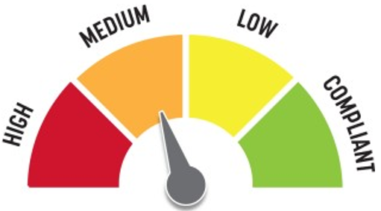
Quick Fix: Yes
Built Before ADA: No

VIOLATIONS
2010 ADA Standards for Accessible Design Codes §604.7
The toilet paper dispenser is located out of the accessible reach range.

RECOMMENDATIONS
Remount the toilet paper dispenser to 7” minimum and 9” maximum in front of the water closet measured to the centerline of the dispenser.
The outlet of the dispenser shall be 15” minimum and 48” maximum above the floor and shall not be located behind.

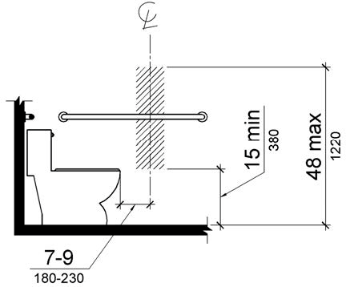

PHOTOGRAPH(S) OF THIS LOCATION

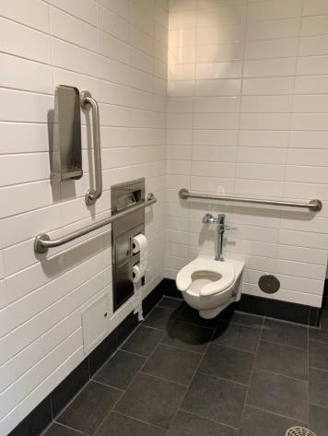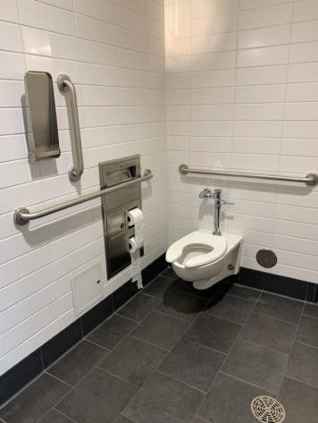

 | ID:  2583 | Facility:  Bown Crossing Library

Location: Children's Area Family Restroom
Schedule: 2021
Estimated Cost: $100.00

Priority Score 5
Quick Fix: Yes
Built Before ADA: No

VIOLATIONS
2010 ADA Standards for Accessible Design Codes §609.3
The space between the grab bar and the shelf is 9.5".

RECOMMENDATIONS
Relocate the shelf to a location that is at least a distance of 12" or greater above the grab bar. Ensure that the shelf is not greater than 48" above the floor.

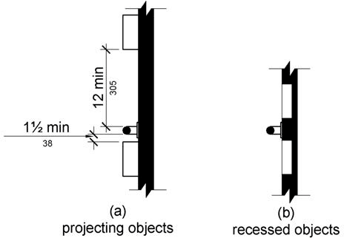

PHOTOGRAPH(S) OF THIS LOCATION

 | ID:  2540 | Facility:  Bown Crossing Library

Location: Exterior
Schedule: 2023
Estimated Cost: $1,000.00

Priority Score 10
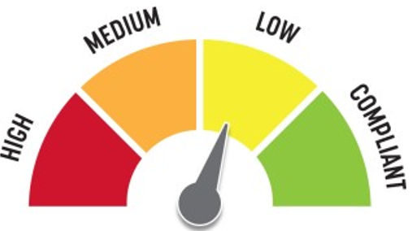
Quick Fix: No
Built Before ADA: No

VIOLATIONS
2010 ADA Standards for Accessible Design Codes §305.2
The clear floor space has a 2.2% slope.

RECOMMENDATIONS
Resurface the 30"x48" clear floor space to have a maximum slope of 2% in all directions.

PHOTOGRAPH(S) OF THIS LOCATION

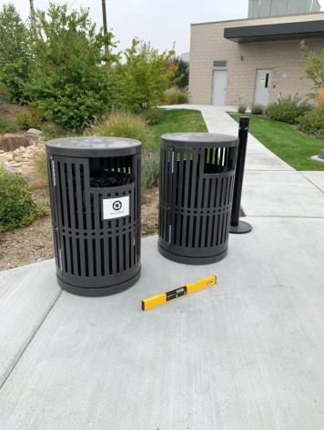

 | ID:  2539 | Facility:  Bown Crossing Library

Location: Exterior at Curbside Pick Up
Schedule: 2021
Estimated Cost: $100.00

Priority Score 3
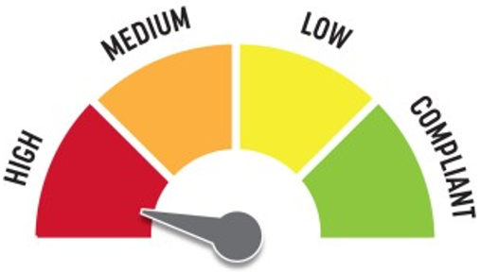
Quick Fix: Yes
Built Before ADA: No

VIOLATIONS
2010 ADA Standards for Accessible Design Codes §216.2, §703
There is no tactile sign identifying the permanent room

RECOMMENDATIONS
Install tactile signage to the right of the right hand door at a height of 48” minimum to 60” maximum above the floor, identifying room by name or room number.
Signs shall be Braille with raised lettering and should be placed on the wall in the center of an 18"x18" clear floor space.

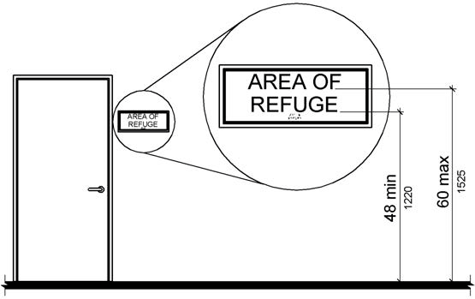

PHOTOGRAPH(S) OF THIS LOCATION

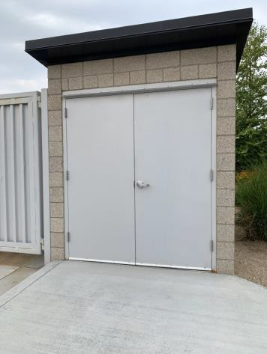

 | ID:  2569 | Facility:  Bown Crossing Library

Location: Kitchen
Schedule: 2021
Estimated Cost: $100.00

$100.00

Priority Score 8
Quick Fix: Yes
Built Before ADA: No

VIOLATIONS
2010 ADA Standards for Accessible Design Codes §308.2.2
The paper towel dispenser is outside of the obstructed forward reach range at 46" above the floor.

RECOMMENDATIONS
Lower the paper towel dispenser by 2" to meet the accessible reach range of 44" maximum above the floor.

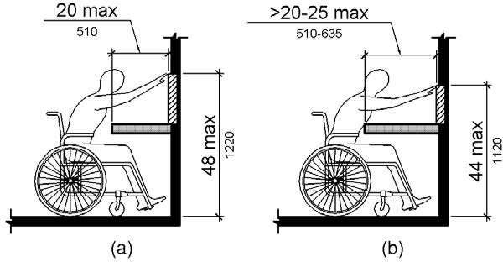

PHOTOGRAPH(S) OF THIS LOCATION

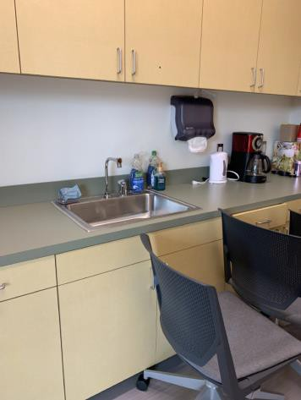

 | ID:  2568 | Facility:  Bown Crossing Library

Location: Kitchen
Schedule: 2022
Estimated Cost: $1,000.00

Priority Score 5
Quick Fix: No
Built Before ADA: No

VIOLATIONS
2010 ADA Standards for Accessible Design Codes §306.3.3
There is no knee clearance underneath the counter.

RECOMMENDATIONS
Provide knee clearance underneath the counter at the sink that is a minimum of 11" deep at 9" above the floor and 8" deep at 27" above the floor.

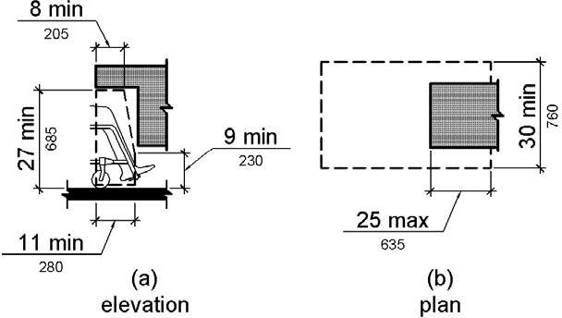

PHOTOGRAPH(S) OF THIS LOCATION

 | ID:  2534 | Facility:  Bown Crossing Library

Location: Library Returns
Schedule: 2021
Estimated Cost: $100.00

Priority Score 3
Quick Fix: Yes
Built Before ADA: No

VIOLATIONS
2010 ADA Standards for Accessible Design Codes §305.2
There is a 24" clear floor space to the book return boxes.

RECOMMENDATIONS
Relocate the book return boxes closer to the library to allow for a 30"x48" clear floor space.
Ensure the clear floor space has a maximum of 2% slope in all directions.

PHOTOGRAPH(S) OF THIS LOCATION

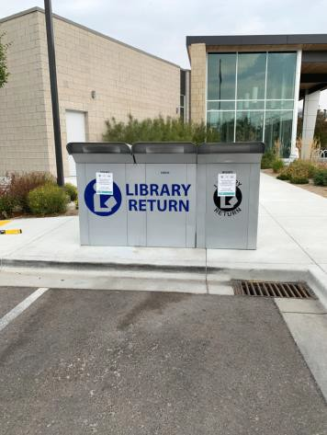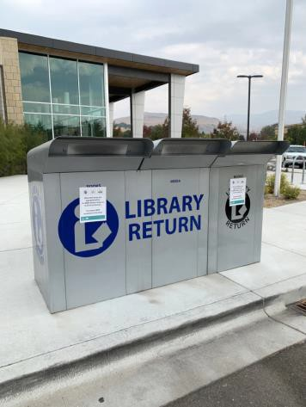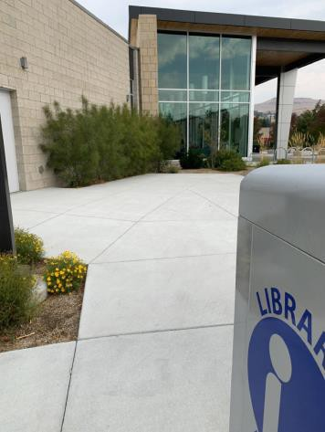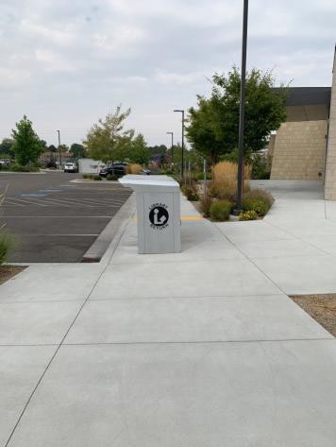

 | ID:  2529 | Facility:  Bown Crossing Library

Location: Main Entrance
Schedule: 2023
Estimated Cost: $1,000.00

Priority Score 10
Quick Fix: No
Built Before ADA: No

VIOLATIONS
2010 ADA Standards for Accessible Design Codes §305.2
The clear floor has a 2.4% slope.

RECOMMENDATIONS
Resurface the 30"x48" clear floor space to have a maximum slope of 2% in all directions.

PHOTOGRAPH(S) OF THIS LOCATION

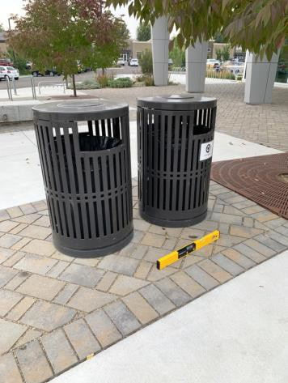

 | ID:  2532 | Facility:  Bown Crossing Library

Location: Main Entrance
Schedule: 2021
Estimated Cost: $2,500.00

Priority Score 3
Quick Fix: No
Built Before ADA: No

VIOLATIONS
2010 ADA Standards for Accessible Design Codes §403.3, §303.2
There is a 1" change in level. The running slope is 8.1%.

RECOMMENDATIONS
Reconstruct the bricks on the right side of the door to ensure that the slope does not exceed 5%.

PHOTOGRAPH(S) OF THIS LOCATION

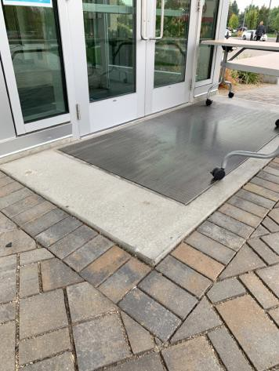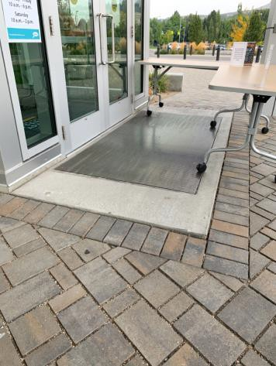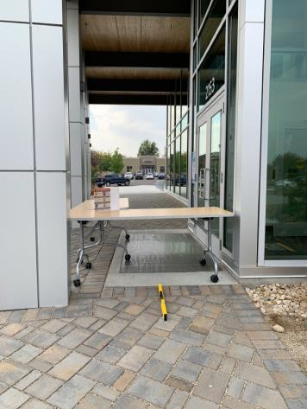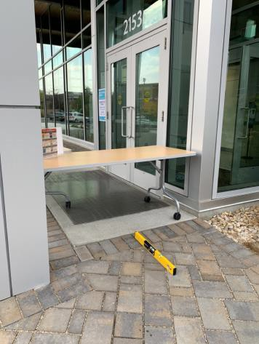

 | ID:  2567 | Facility:  Bown Crossing Library

Location: Main Entrance Drinking Fountains
Schedule: 2022
Estimated Cost: $1,000.00

Priority Score 6
Quick Fix: No
Built Before ADA: No

VIOLATIONS
2010 ADA Standards for Accessible Design Codes §602.4, §602.7
The spout heights of the drinking fountains are not compliant at 31" and 37" above the floor

RECOMMENDATIONS
Raise the existing tall drinking fountain in order to comply with the minimum spout height of 37" above the floor.

PHOTOGRAPH(S) OF THIS LOCATION

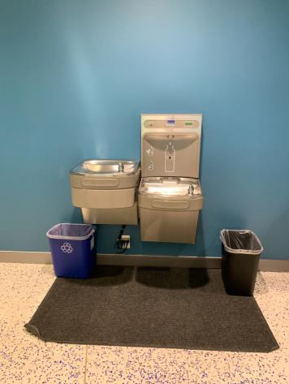

 | ID:  2548 | Facility:  Bown Crossing Library

Location: Main Entrance Men's Restroom
Schedule: 2021
Estimated Cost: $100.00

Priority Score 5
Quick Fix: Yes
Built Before ADA: No

VIOLATIONS
2010 ADA Standards for Accessible Design Codes §604.8.1.2
The door to the accessible water closet is not self closing. Either self-closing hinges are not installed on the door or if installed, they are defective.

RECOMMENDATIONS
Install or reinstall self-closing hinges on the door to ensure that the door is self-closing per the ADA requirements.

PHOTOGRAPH(S) OF THIS LOCATION

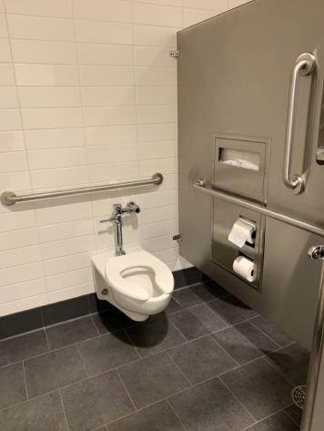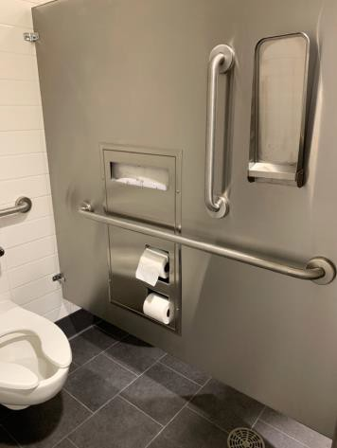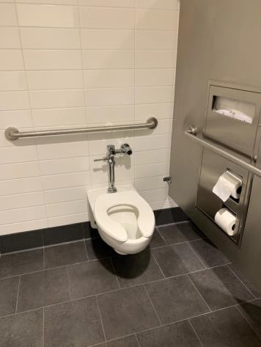

 | ID:  2552 | Facility:  Bown Crossing Library

Location: Main Entrance Men's Restroom
Schedule: 2021
Estimated Cost: $100.00

Priority Score 5
Quick Fix: Yes
Built Before ADA: No

VIOLATIONS
2010 ADA Standards for Accessible Design Codes §609.3
The space between the grab bar and the shelf is 9.5".

RECOMMENDATIONS
Relocate the shelf to a location that is at least a distance of 12" or greater above the grab bar. Ensure that the shelf is not greater than 48" above the floor.

PHOTOGRAPH(S) OF THIS LOCATION

 | ID:  2554 | Facility:  Bown Crossing Library

Location: Main Entrance Men's Restroom
Schedule: 2021
Estimated Cost: $100.00

Priority Score 5
Quick Fix: Yes
Built Before ADA: No

VIOLATIONS
2010 ADA Standards for Accessible Design Codes §604.7
The toilet paper dispenser is located out of the accessible reach range.

RECOMMENDATIONS
Remount the toilet paper dispenser to 7” minimum and 9” maximum in front of the water closet measured to the centerline of the dispenser.
The outlet of the dispenser shall be 15” minimum and 48” maximum above the floor and shall not be located behind.

PHOTOGRAPH(S) OF THIS LOCATION

 | ID:  2556 | Facility:  Bown Crossing Library

Location: Main Entrance Men's Restroom
Schedule: 2021
Estimated Cost: $100.00

Priority Score 5
Quick Fix: Yes
Built Before ADA: No

VIOLATIONS
2010 ADA Standards for Accessible Design Codes §307.2, §308.2.1
The sharps container is outside of the unobstructed forward reach range at 49.5" above the floor. The sharps container protrudes 4.75" into the circulation space at 49.5" above the floor.

RECOMMENDATIONS
Lower the sharps container by 1.5" to meet the accessible reach range of 48" maximum above the floor.
Recess the sharps container so it protrudes a maximum of 4" or place a cane detectable object beneath it.

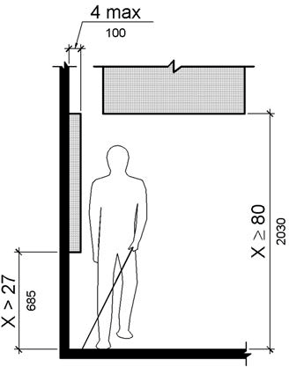

PHOTOGRAPH(S) OF THIS LOCATION

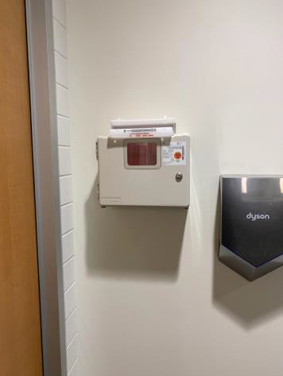

 | ID:  2557 | Facility:  Bown Crossing Library

Location: Main Entrance Men's Restroom
Schedule: 2021
Estimated Cost: $500.00

Priority Score 5
Quick Fix: Yes
Built Before ADA: No

VIOLATIONS
2010 ADA Standards for Accessible Design Codes §303.2
There is a 0.75" change in level.

RECOMMENDATIONS
Resurface the pathway to reduce the change in level to less than 0.25".

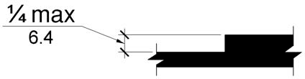

PHOTOGRAPH(S) OF THIS LOCATION

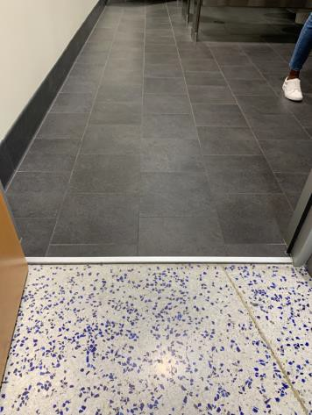

 | ID:  2553 | Facility:  Bown Crossing Library

Location: Main Entrance Men's Restroom
Schedule: 2022
Estimated Cost: $1,000.00

Priority Score 5
Quick Fix: No
Built Before ADA: No

VIOLATIONS
2010 ADA Standards for Accessible Design Codes §604.2
The centerline of the toilet is located 19" from the sidewall

RECOMMENDATIONS
Reposition the centerline of the toilet to be within 16" minimum and 18" maximum from the sidewall.

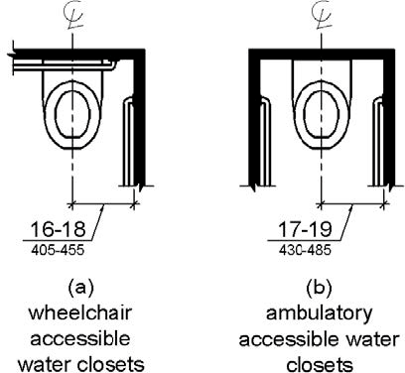

PHOTOGRAPH(S) OF THIS LOCATION

 | ID:  2528 | Facility:  Bown Crossing Library

Location: Main Entrance Parking
Schedule: 2021
Estimated Cost: $200.00

Priority Score 6
Quick Fix: Yes
Built Before ADA: No

VIOLATIONS
2010 ADA Standards for Accessible Design Codes §216.5
The parking signs identifying the accessible parking space do not meet the minimum height requirement of 60" from the ground.

RECOMMENDATIONS
Remount the accessible parking signs to ensure 60" minimum height from the ground.

PHOTOGRAPH(S) OF THIS LOCATION

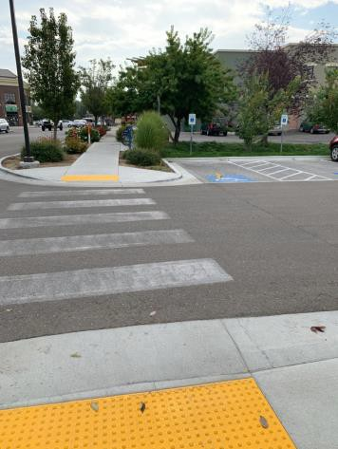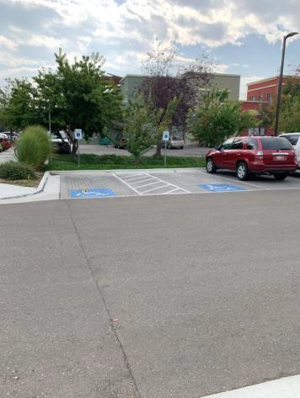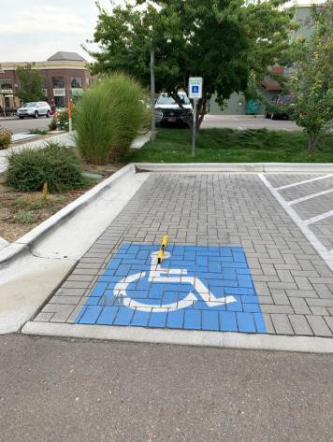

 | ID:  2526 | Facility:  Bown Crossing Library

Location: Main Entrance Parking
Schedule: 2021
Estimated Cost: $1,000.00

Priority Score 3
Quick Fix: No
Built Before ADA: No

VIOLATIONS
2010 ADA Standards for Accessible Design Codes §502.4
The parking space has a 2.6% slope.

RECOMMENDATIONS
Resurface the parking space to reduce the slope to a maximum of 2% in all directions.

PHOTOGRAPH(S) OF THIS LOCATION

 | ID:  2547 | Facility:  Bown Crossing Library

Location: Main Entrance Vox Poplar
Schedule: 2021
Estimated Cost: $100.00

Priority Score 5
Quick Fix: Yes
Built Before ADA: No

VIOLATIONS
2010 ADA Standards for Accessible Design Codes §307.2
The Vox Poplar art protrudes 14" into the circulation space at 71.5" above the floor.

RECOMMENDATIONS
Recess the Vox Poplar art so it protrudes a maximum of 4", lower it so the bottom edge is 27" maximum above the floor, or place a cane detectable object beneath it.

PHOTOGRAPH(S) OF THIS LOCATION

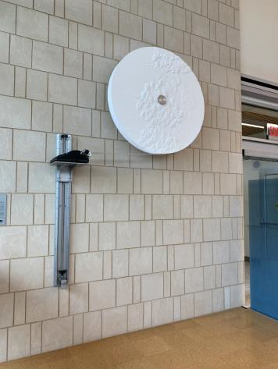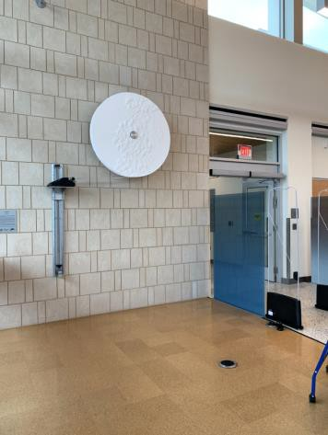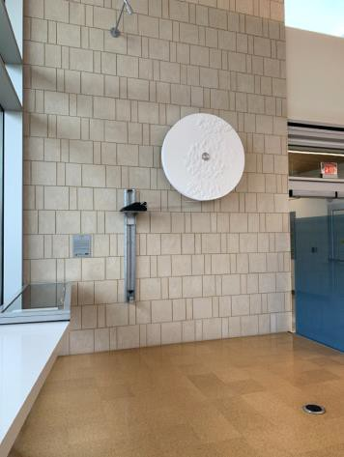

 | ID:  2558 | Facility:  Bown Crossing Library

Location: Main Entrance Women's Restroom
Schedule: 2021
Estimated Cost: $100.00

Priority Score 5
Quick Fix: Yes
Built Before ADA: No

VIOLATIONS
2010 ADA Standards for Accessible Design Codes §604.8.1.2
The door to the accessible water closet is not self closing. Either self-closing hinges are not installed on the door or if installed, they are defective.

RECOMMENDATIONS
Install or reinstall self-closing hinges on the door to ensure that the door is self-closing per the ADA requirements.

PHOTOGRAPH(S) OF THIS LOCATION

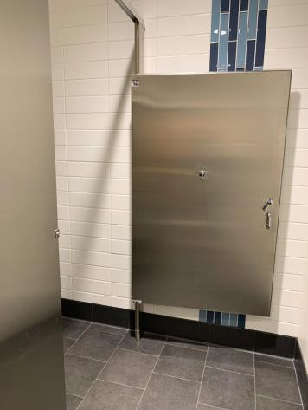

 | ID:  2562 | Facility:  Bown Crossing Library

Location: Main Entrance Women's Restroom
Schedule: 2021
Estimated Cost: $100.00

Priority Score 5
Quick Fix: Yes
Built Before ADA: No

VIOLATIONS
2010 ADA Standards for Accessible Design Codes §609.3
The space between the grab bar and shelf is 9.75".

RECOMMENDATIONS
Relocate the shelf to a location that is at least a distance of 12" or greater above the grab bar. Ensure that the shelf is not greater than 48" above the floor.

PHOTOGRAPH(S) OF THIS LOCATION

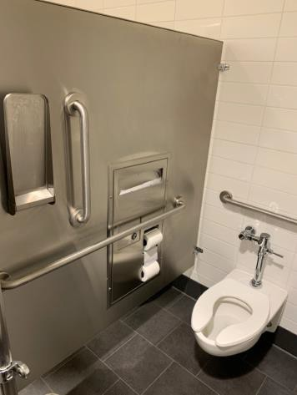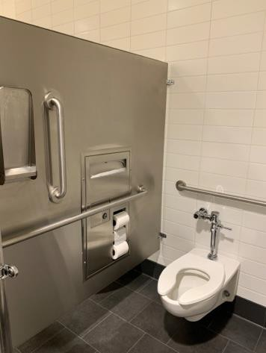

 | ID:  2564 | Facility:  Bown Crossing Library

Location: Main Entrance Women's Restroom
Schedule: 2021
Estimated Cost: $100.00

Priority Score 5
Quick Fix: Yes
Built Before ADA: No

VIOLATIONS
2010 ADA Standards for Accessible Design Codes §604.7
The toilet paper dispenser is located out of the accessible reach range.

RECOMMENDATIONS
Remount the toilet paper dispenser to 7” minimum and 9” maximum in front of the water closet measured to the centerline of the dispenser.
The outlet of the dispenser shall be 15” minimum and 48” maximum above the floor and shall not be located behind.

PHOTOGRAPH(S) OF THIS LOCATION

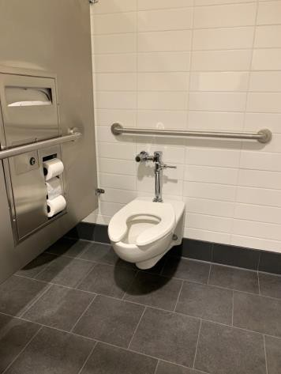

 | ID:  2565 | Facility:  Bown Crossing Library

Location: Main Entrance Women's Restroom
Schedule: 2021
Estimated Cost: $100.00

Priority Score 5
Quick Fix: Yes
Built Before ADA: No

VIOLATIONS
2010 ADA Standards for Accessible Design Codes §307.2, §308.2.1
The sharps container is outside of the unobstructed forward reach range at 49" above the floor. The sharps container protrudes 4.75" into the circulation space at 49" above the floor.

RECOMMENDATIONS
Lower the sharps container by 1" to meet the accessible reach range of 48" maximum above the floor.
Recess the sharps container so it protrudes a maximum of 4" or place a cane detectable object beneath

PHOTOGRAPH(S) OF THIS LOCATION

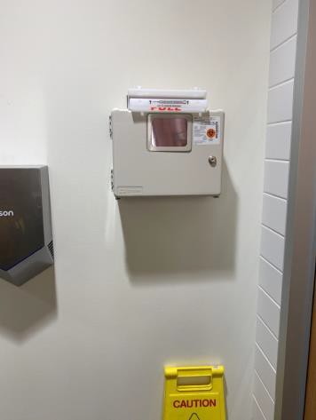

 | ID:  2566 | Facility:  Bown Crossing Library

Location: Main Entrance Women's Restroom
Schedule: 2021
Estimated Cost: $500.00

Priority Score 5
Quick Fix: Yes
Built Before ADA: No

VIOLATIONS
2010 ADA Standards for Accessible Design Codes §303.2
There is a 0.75" change in level.

RECOMMENDATIONS
Resurface the pathway to reduce the change in level to less than 0.25".

PHOTOGRAPH(S) OF THIS LOCATION

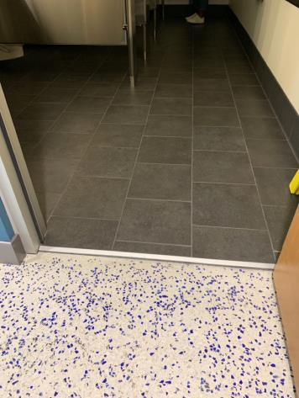

 | ID:  2563 | Facility:  Bown Crossing Library

Location: Main Entrance Woman's Restroom
Schedule: 2022
Estimated Cost: $1,000.00

Priority Score
Quick Fix: No
Built Before ADA: No

VIOLATIONS
2010 ADA Standards for Accessible Design Codes §604.2
The centerline of the toilet is located 18.5" from the sidewall.

RECOMMENDATIONS
Reposition the centerline of the toilet to be within 16" minimum and 18" maximum from the sidewall.

PHOTOGRAPH(S) OF THIS LOCATION

 | ID:  2573 | Facility:  Bown Crossing Library

Location: Meeting Room
Schedule: 2021
Estimated Cost: $0.00

Priority Score 0
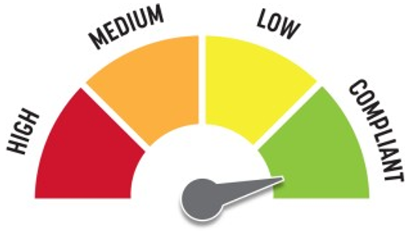
Quick Fix: Yes
Built Before ADA: No

VIOLATIONS
22010 ADA Standards for Accessible Design Codes §307.2
The TV protrudes 5" into the circulation space at 45.5" above the floor.

RECOMMENDATIONS
Ensure that the desk remains underneath the TV to provide cane detectability.

PHOTOGRAPH(S) OF THIS LOCATION

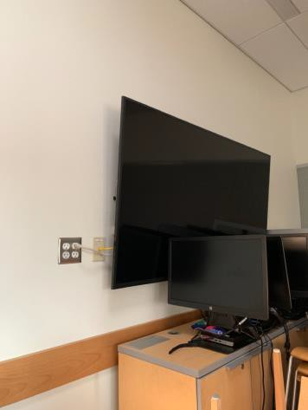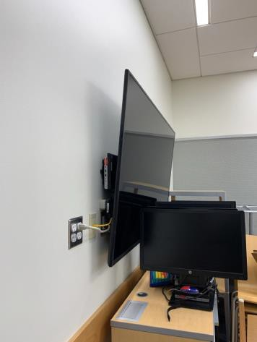

 | ID:  2574 | Facility:  Bown Crossing Library

Location: Multipurpose Room
Schedule: 2021
Estimated Cost: $100.00

Priority Score 3
Quick Fix: Yes
Built Before ADA: No

VIOLATIONS
2010 ADA Standards for Accessible Design Codes §216.4, §703
Doors serving as exits are not marked by tactile signage.

RECOMMENDATIONS
Place a tactile exit sign, that complies with §703.1, §703.2 and §703.5, identifying the exit doors.
Install missing signage at 48" minimum above the floor measured from the baseline of the lowest character and 60" maximum measured from the baseline of the highest character.

PHOTOGRAPH(S) OF THIS LOCATION

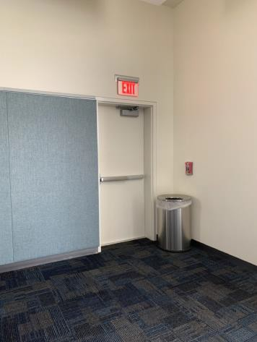

 | ID:  2575 | Facility:  Bown Crossing Library

Location: Multipurpose Room
Schedule: 2023
Estimated Cost: $3,000.00

Priority Score 8
Quick Fix: No
Built Before ADA: No

VIOLATIONS
2010 ADA Standards for Accessible Design Codes §707
The interactive touch screen does not have any sound or tactile components. Therefore, a visually impaired person would not be able to access the information provided by the kiosk.

RECOMMENDATIONS
Audio instructions must be provided that guide the user through all the functions of the machine. Tactile instructions must be provided informing the user on the method of activating the audio instructions.
Controls to operate the kiosk must meet the requirements of §707.

PHOTOGRAPH(S) OF THIS LOCATION

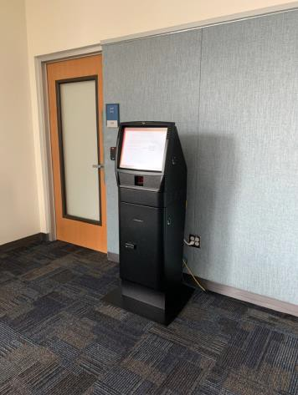

 | ID:  2541 | Facility:  Bown Crossing Library

Location: Nonfiction and Fiction Desks
Schedule: 2021
Estimated Cost: $200.00

Priority Score 5
Quick Fix: Yes
Built Before ADA: No

VIOLATIONS
2010 ADA Standards for Accessible Design Codes §307.2
The desks protrude 14.75" into the circulation space at 33" above the floor.

RECOMMENDATIONS
Extend the sides of the desks down so the bottom edge is 27" maximum above the floor.

PHOTOGRAPH(S) OF THIS LOCATION

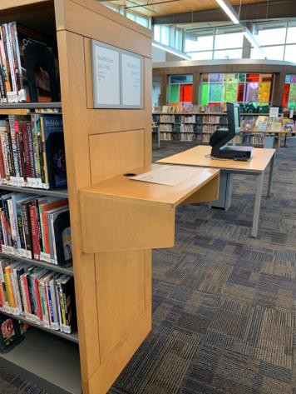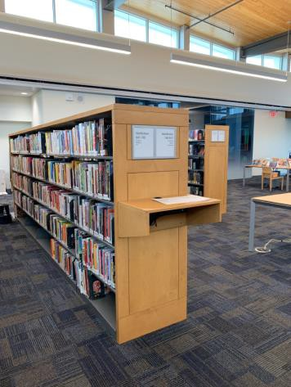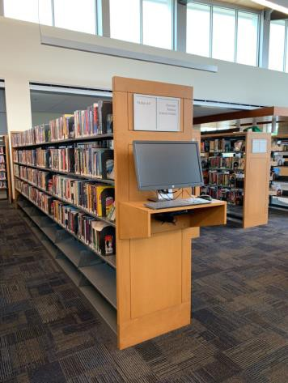

 | ID:  2535 | Facility:  Bown Crossing Library

Location: Parking by Curbside Pick Up
Schedule: 2021
Estimated Cost: $300.00

Priority Score 9
Quick Fix: Yes
Built Before ADA: No

VIOLATIONS
2010 ADA Standards for Accessible Design Codes §502.6
The parking signs identifying the accessible parking space do not meet the minimum height requirement of 60" from the ground.

RECOMMENDATIONS
Install an accessible parking sign at each accessible space at a minimum height of 60" above the ground.

PHOTOGRAPH(S) OF THIS LOCATION

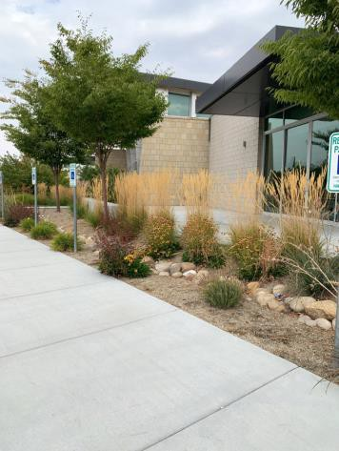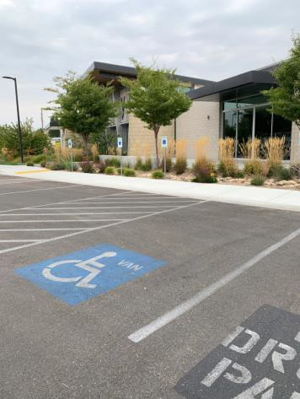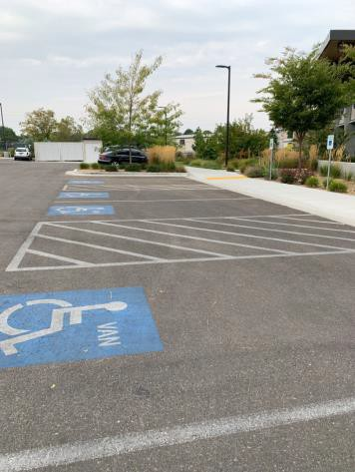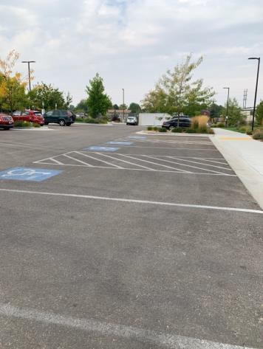

 | ID:  2608 | Facility:  Bown Crossing Library

Location: Push Button
Schedule: 2021
Estimated Cost: $2,500.00

Priority Score 3
Quick Fix: No
Built Before ADA: No

VIOLATIONS
2010 ADA Standards for Accessible Design Codes §305.2
The clear floor space has a 5% slope.

RECOMMENDATIONS
Reconstruct the 30"x48" clear floor space to have a maximum slope of 2% in all directions.

PHOTOGRAPH(S) OF THIS LOCATION

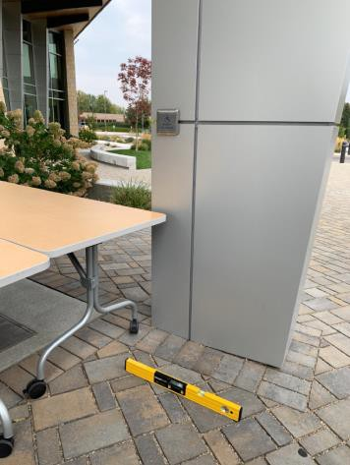

 | ID:  2543 | Facility:  Bown Crossing Library

Location: Reading Area
Schedule: 2021
Estimated Cost: $100.00

Priority Score 5
Quick Fix: Yes
Built Before ADA: No

VIOLATIONS
2010 ADA Standards for Accessible Design Codes §307.2
The mantle protrudes 7.25" into the circulation space at 64" above the floor.

RECOMMENDATIONS
Recess the mantle so it protrudes a maximum of 4", lower it so the bottom edge is 27" maximum above the floor, or place a cane detectable object beneath it.

PHOTOGRAPH(S) OF THIS LOCATION

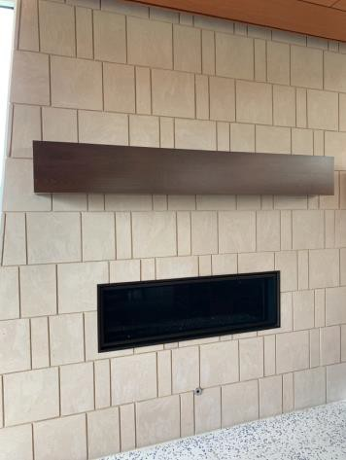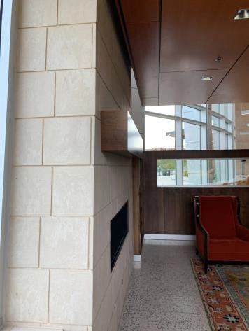

 | ID:  2546 | Facility:  Bown Crossing Library

Location: Reading Area
Schedule: 2021
Estimated Cost: $100.00

Priority Score 5
Quick Fix: Yes
Built Before ADA: No

VIOLATIONS
2010 ADA Standards for Accessible Design Codes §403.5.1
There is less than 36" for wheelchairs to pass between the blue couch, counters, blue chairs, and red chairs.

RECOMMENDATIONS
Rearrange the reading area to allow for a minimum of 36" between all the furniture, counters, and walls.

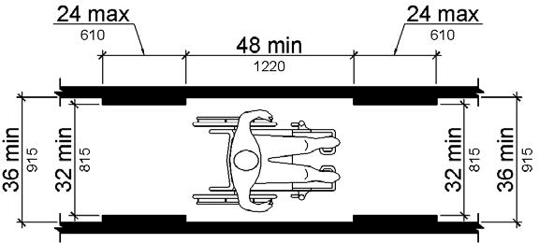

PHOTOGRAPH(S) OF THIS LOCATION

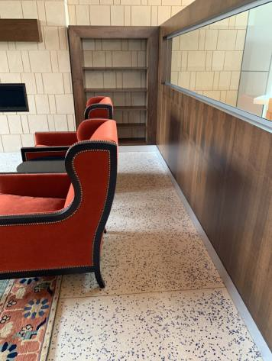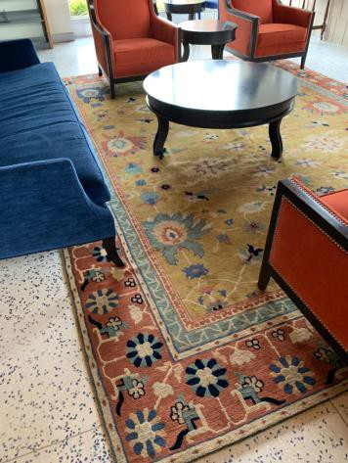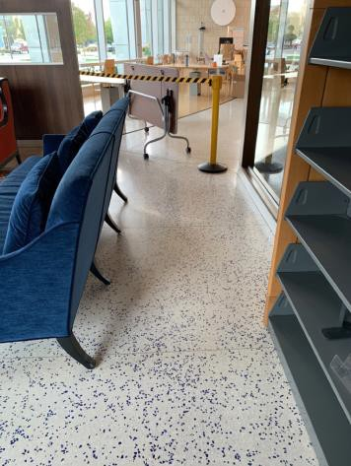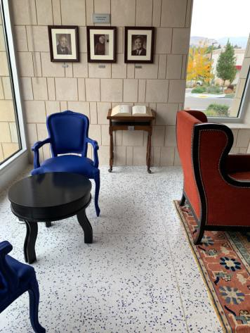

 | ID:  2542 | Facility:  Bown Crossing Library

Location: Shelves (Top Only)
Schedule: 2021
Estimated Cost: $100.00

Priority Score 8
Quick Fix: Yes
Built Before ADA: No

VIOLATIONS
2010 ADA Standards for Accessible Design Codes §308.2.1
The top shelves are outside of the unobstructed forward reach range at 65" above the floor.

RECOMMENDATIONS
Ensure that the library has a policy that provides assistance to employees and volunteers reaching for shelves that are located beyond 48” above the floor.

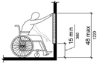

PHOTOGRAPH(S) OF THIS LOCATION

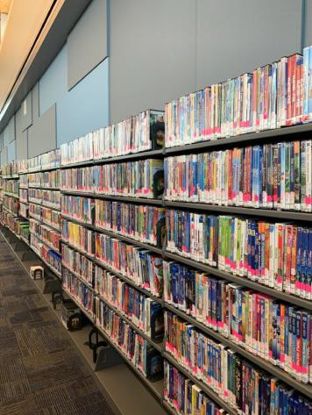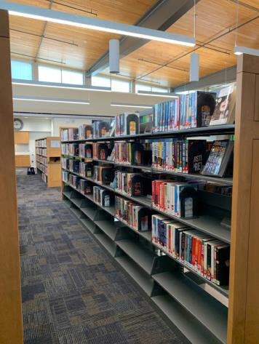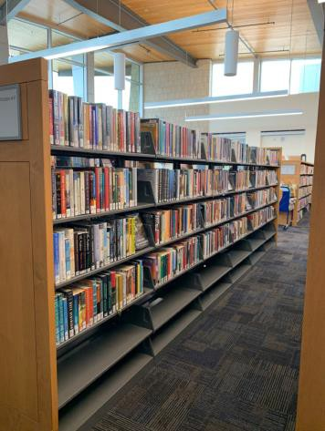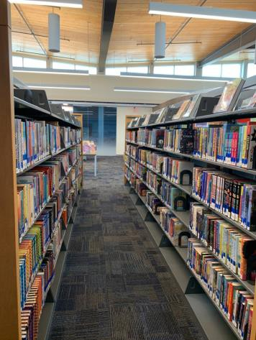

 | ID:  2605 | Facility:  Bown Crossing Library

Location: Staff Lounge
Schedule: 2021
Estimated Cost: $100.00

Priority Score 8
Quick Fix: Yes
Built Before ADA: No

VIOLATIONS
2010 ADA Standards for Accessible Design Codes §308.2.2
The paper towel dispenser is outside of the obstructed forward reach range at 47" above the floor however, the counter is 21" deep.

RECOMMENDATIONS
Lower the paper towel dispenser by 3" to meet the accessible reach range of 44" maximum above the floor.

PHOTOGRAPH(S) OF THIS LOCATION

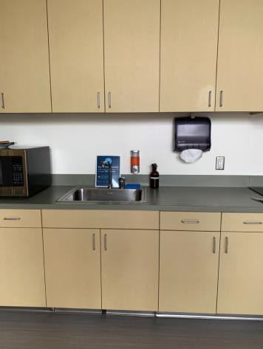

 | ID:  2604 | Facility:  Bown Crossing Library

Location: Staff Lounge
Schedule: 2022
Estimated Cost: $1,000.00

Priority Score 5
Quick Fix: No
Built Before ADA: No

VIOLATIONS
2010 ADA Standards for Accessible Design Codes §306.3.3
There is no knee clearance underneath the counter.

RECOMMENDATIONS
Provide knee clearance underneath the counter at the sink that is a minimum of 11" deep at 9" above the floor and 8" deep at 27" above the floor.

PHOTOGRAPH(S) OF THIS LOCATION

 | ID:  2588 | Facility:  Bown Crossing Library

Location: Staff Restroom
Schedule: 2021
Estimated Cost: $100.00

Priority Score 5
Quick Fix: Yes
Built Before ADA: No

VIOLATIONS
2010 ADA Standards for Accessible Design Codes §604.7
The toilet paper dispenser is located out of the accessible reach range.

RECOMMENDATIONS
Remount the toilet paper dispenser to 7” minimum and 9” maximum in front of the water closet measured to the centerline of the dispenser.
The outlet of the dispenser shall be 15” minimum and 48” maximum above the floor and shall not be located behind.

PHOTOGRAPH(S) OF THIS LOCATION

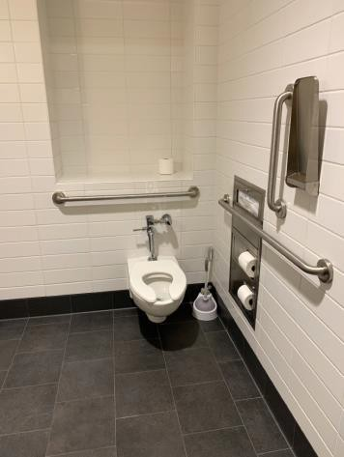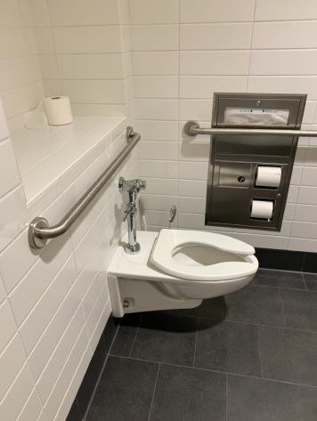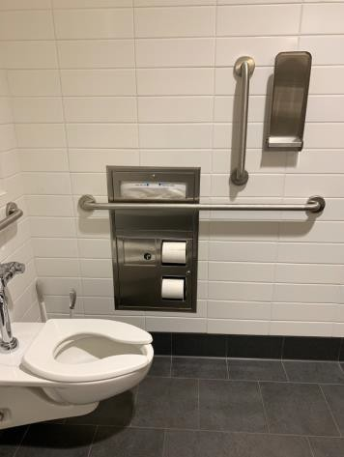

 | ID:  2592 | Facility:  Bown Crossing Library

Location: Staff Restroom
Schedule: 2021
Estimated Cost: $100.00

Priority Score 5
Quick Fix: Yes
Built Before ADA: No

VIOLATIONS
2010 ADA Standards for Accessible Design Codes §609.3
The space between the grab bar and shelf is 10".

RECOMMENDATIONS
Relocate the shelf to a location that is at least a distance of 12" or greater above the grab bar. Ensure that the shelf is not greater than 48" above the floor.

PHOTOGRAPH(S) OF THIS LOCATION

 | ID:  2596 | Facility:  Bown Crossing Library

Location: Staff Restroom
Schedule: 2021
Estimated Cost: $100.00

Priority Score 5
Quick Fix: Yes
Built Before ADA: No

VIOLATIONS
2010 ADA Standards for Accessible Design Codes §307.2
The shower curtain rod is 76" above the floor.

RECOMMENDATIONS
Raise the shower curtain rod to a minimum of 80" above the floor.

PHOTOGRAPH(S) OF THIS LOCATION

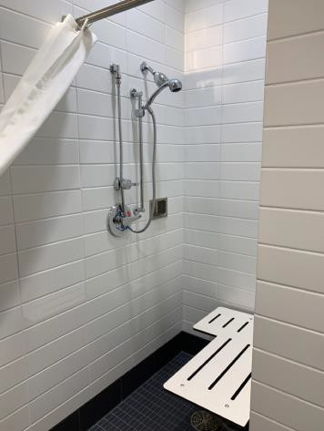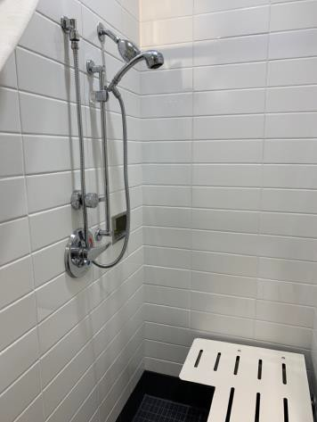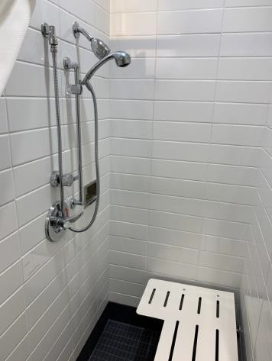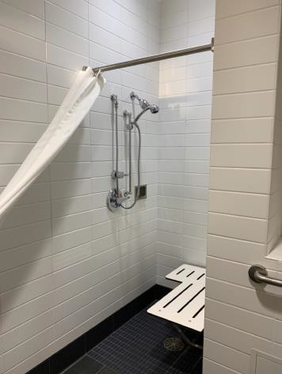

 | ID:  2586 | Facility:  Bown Crossing Library

Location: Staff Restroom
Schedule: 2021
Estimated Cost: $500.00

Priority Score 6
Quick Fix: Yes
Built Before ADA: No

VIOLATIONS
2010 ADA Standards for Accessible Design Codes §404.2.8.1
The time required for the door to shut is 3.08 seconds.

RECOMMENDATIONS
Adjust the closing speed to a minimum of 5 or more seconds.

PHOTOGRAPH(S) OF THIS LOCATION

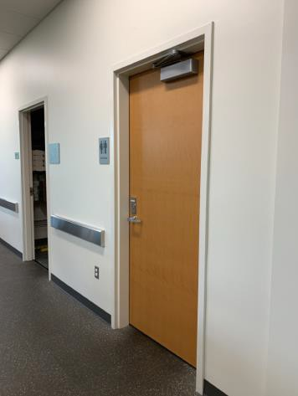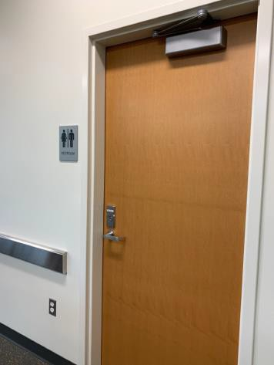

 | ID:  2594 | Facility:  Bown Crossing Library

Location: Staff Restroom
Schedule: 2021
Estimated Cost: $500.00

Priority Score 0
Quick Fix: Yes
Built Before ADA: No

VIOLATIONS
2010 ADA Standards for Accessible Design Codes §607.6
The adjustable shower head is 64" above the floor.

RECOMMENDATIONS
Consider remounting the vertical bar so its top is a maximum of 48" above the floor.

PHOTOGRAPH(S) OF THIS LOCATION

 | ID:  4482 | Facility:  Bown Crossing Library

Location: Staff Restroom
Schedule: 2022
Estimated Cost: $1,000.00

Priority Score 6
Quick Fix: No
Built Before ADA: No

VIOLATIONS
2010 ADA Standards for Accessible Design Codes §608.3, §609
There are no grab bars in the transfer shower.

RECOMMENDATIONS
Install grab bars across the control wall and back wall to a point 18" from the control wall at a maximum height of 36" above the bathroom floor.

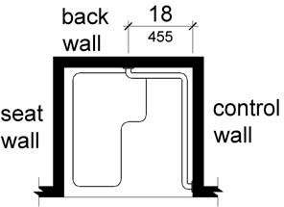

PHOTOGRAPH(S) OF THIS LOCATION

 | ID:  2595 | Facility:  Bown Crossing Library

Location: Staff Restroom
Schedule: 2022
Estimated Cost: $5,000.00

Priority Score 6
Quick Fix: No
Built Before ADA: No

VIOLATIONS
2010 ADA Standards for Accessible Design Codes §608.2.1
The shower dimensions do not meet the requirements for a transfer type shower at 34"x36".

RECOMMENDATIONS
Expand the transfer type shower compartment to meet the minimum dimensions of 36"x36" measured at the center points of opposing sides with a 36" wide minimum entry on the face of the shower compartment.

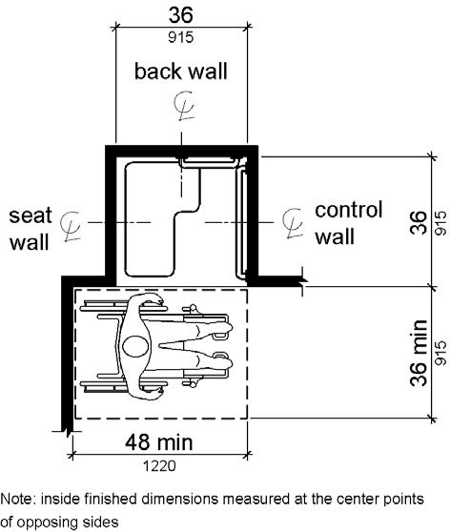

PHOTOGRAPH(S) OF THIS LOCATION

 | ID:  2603 | Facility:  Bown Crossing Library

Location: Staff Work Room
Schedule: 2021
Estimated Cost: $100.00

Priority Score 8
Quick Fix: Yes
Built Before ADA: No

VIOLATIONS
2010 ADA Standards for Accessible Design Codes §308.2.2
The paper towel dispenser is outside of the obstructed forward reach range at 45.4" above the floor.

RECOMMENDATIONS
Lower the paper towel dispenser by 1.5" to meet the accessible reach range of 44" maximum above the floor.

PHOTOGRAPH(S) OF THIS LOCATION

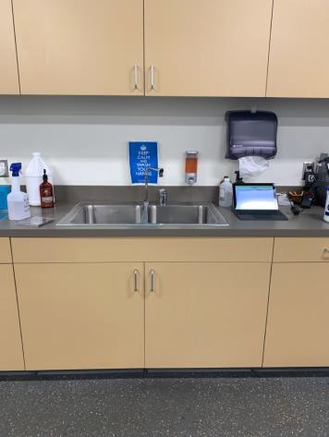

 | ID:  2602 | Facility:  Bown Crossing Library

Location: Staff Work Room
Schedule: 2022
Estimated Cost: $1,000.00

Priority Score 5
Quick Fix: No
Built Before ADA: No

VIOLATIONS
2010 ADA Standards for Accessible Design Codes §306.3.3
There is no knee clearance underneath the counter.

RECOMMENDATIONS
Provide knee clearance underneath the counter at the sink that is a minimum of 11" deep at 9" above the floor and 8" deep at 27" above the floor.

PHOTOGRAPH(S) OF THIS LOCATION

