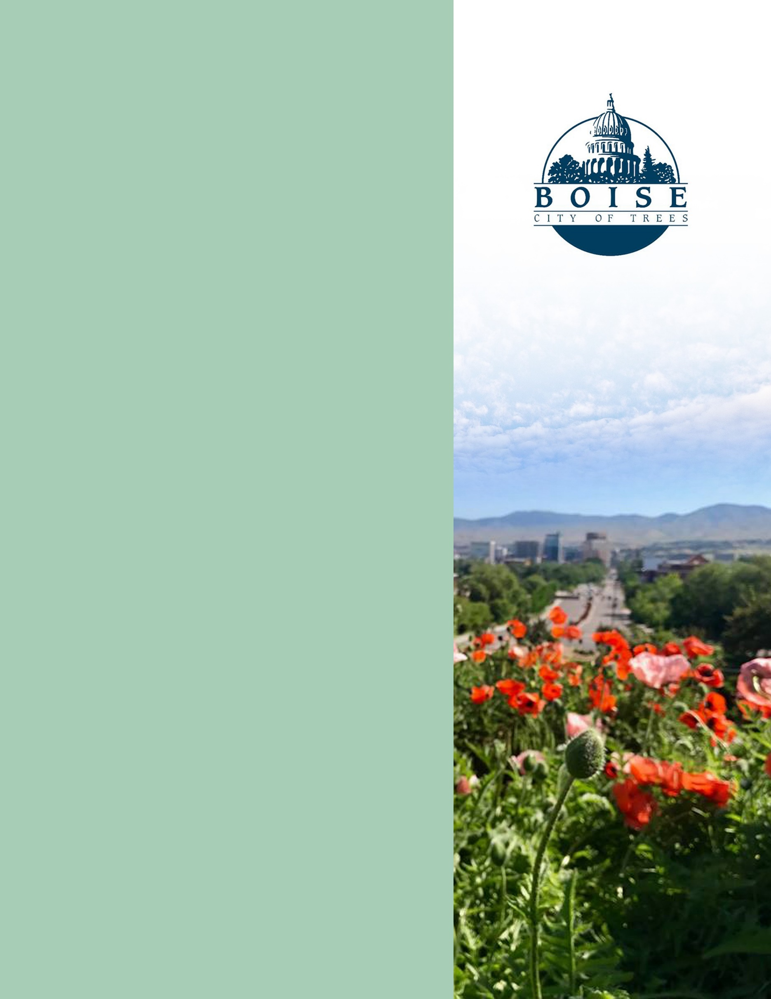

City of Boise ADA Assessment

Appendix A –City of Boise Zoo

03/12/2021
Report #TO21-B023

Prepared by:
 | ID:  2388 | Facility:  City of Boise Zoo

Location AED near Gift Shop Restroom
Schedule 2021
Estimated Cost: $100.00

Priority Score 5
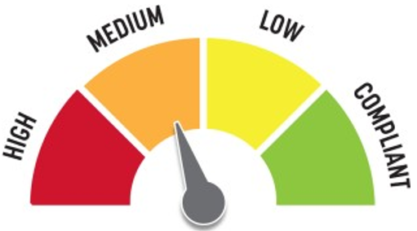
Quick Fix: Yes
Built before ADA: Yes

VIOLATIONS
2010 ADA Standards for Accessible Design Codes §307.2
The AED protrudes 6.5" into the circulation space at 38" above the floor.

RECOMMENDATIONS
Recess the AED so it protrudes a maximum of 4" or place a cane detectable object beneath it.

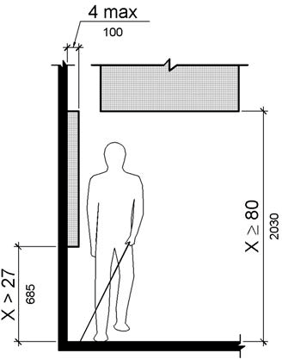

PHOTOGRAPH(S) OF THIS LOCATION

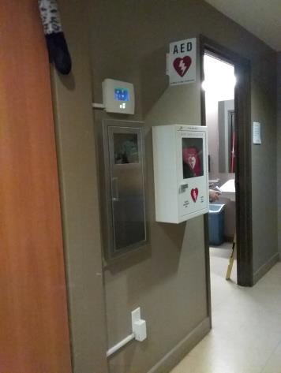

 | ID:  2870 | Facility:  City of Boise Zoo

Location African Plains Exhibit Animal Presentation Area
Schedule 2021
Estimated Cost: $100.00

Priority Score 5
Quick Fix: Yes
Built before ADA: Yes

VIOLATIONS
2010 ADA Standards for Accessible Design Codes §307.2
The box protrudes 9" into the circulation space at 36" above the floor.

RECOMMENDATIONS
Recess the box so it protrudes a maximum of 4" or place a cane detectable object beneath it.

PHOTOGRAPH(S) OF THIS LOCATION

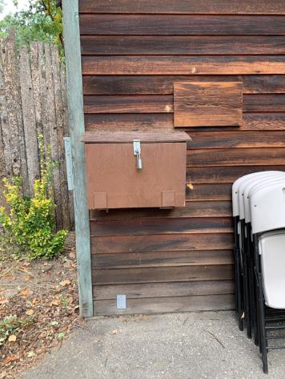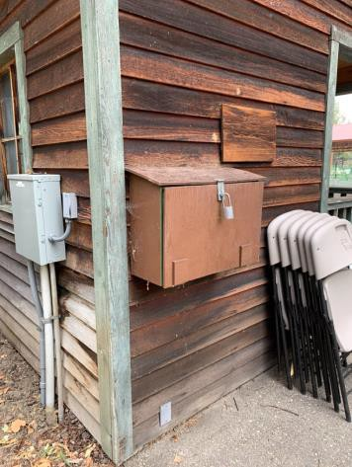

 | ID:  2871 | Facility:  City of Boise Zoo

Location African Plains Exhibit Animal Presentation Area
Schedule 2023
Estimated Cost: $1,000.00

Priority Score 8
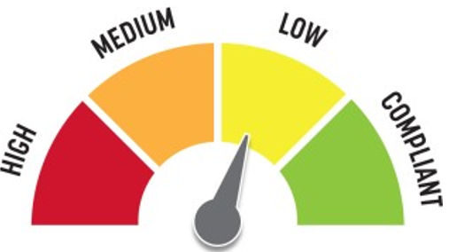
Quick Fix: No
Built before ADA: Yes

VIOLATIONS
2010 ADA Standards for Accessible Design Codes §903.4, §302.1, §305
There is not a firm, stable, and slip resistant route to the benches. The benches do not have back support.

RECOMMENDATIONS
Construct a firm, stable, and slip resistant accessible route with a maximum cross slope of 2% and maximum running slope of 5%.
For the purposes of achieving greater accessibility and Human Centric Design, consider installing back support to some of the benches.

PHOTOGRAPH(S) OF THIS LOCATION

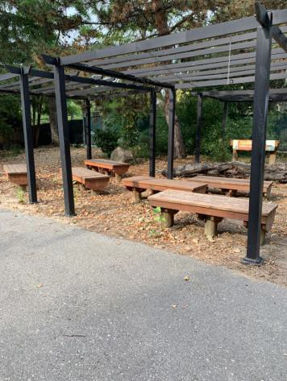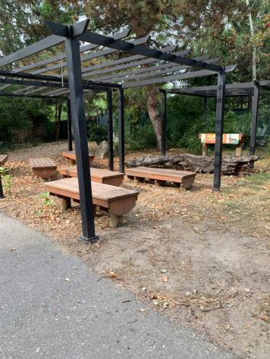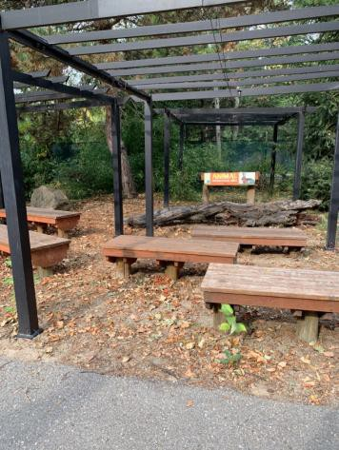

 | ID:  2872 | Facility:  City of Boise Zoo

Location African Plains Exhibit Animal Presentation Area
Schedule 2021
Estimated Cost: $5,000.00

Priority Score 3
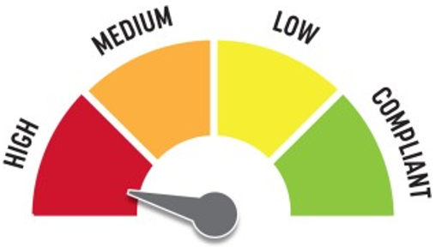
Quick Fix: No
Built before ADA: Yes

VIOLATIONS
2010 ADA Standards for Accessible Design Codes §403.3
Across the pathway, there is a 3% cross slope.

RECOMMENDATIONS
Resurface the route to reduce the cross slope to a maximum of 2%.

PHOTOGRAPH(S) OF THIS LOCATION

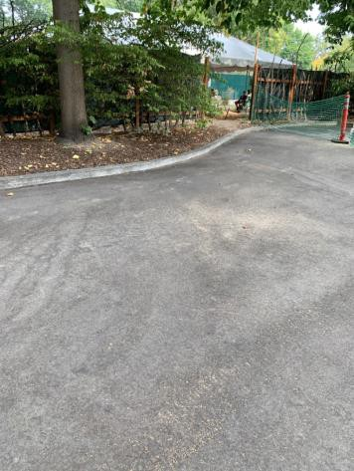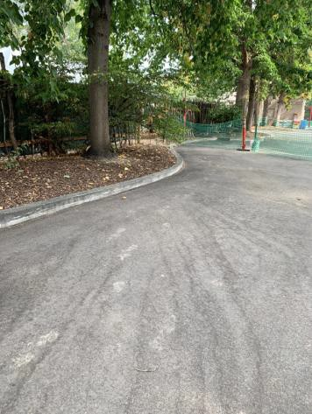

 | ID:  2868 | Facility:  City of Boise Zoo

Location African Plains Exhibit Travel Center
Schedule 2021
Estimated Cost: $100.00

Priority Score 5
Quick Fix: Yes
Built before ADA: Yes

VIOLATIONS
2010 ADA Standards for Accessible Design Codes §307.2
The lamp protrudes into the circulation space at 74" above the floor.

RECOMMENDATIONS
Raise it so the bottom edge is 80" maximum above the floor.

PHOTOGRAPH(S) OF THIS LOCATION

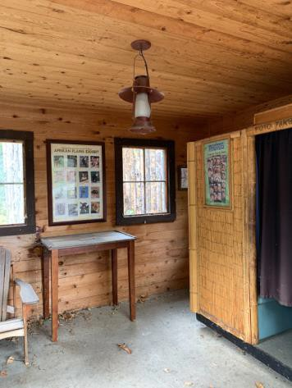

 | ID:  2869 | Facility:  City of Boise Zoo

Location African Plains Exhibit Travel Center
Schedule 2023
Estimated Cost: $2,000.00

Priority Score 8
Quick Fix: No
Built before ADA: Yes

VIOLATIONS
2010 ADA Standards for Accessible Design Codes §405
The photo booth is only accessible via a 7" step.

RECOMMENDATIONS
Add vertical access to the photo booth by installing a ramp. Ensure that the slope does not exceed 8.3%, handrails are provided, and there is sufficient room for a level landing at the top and bottom of the ramp.

PHOTOGRAPH(S) OF THIS LOCATION

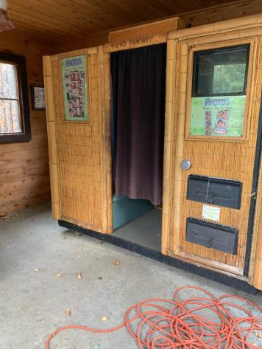

 | ID:  2991 | Facility:  City of Boise Zoo

Location African Plains Men's Restroom
Schedule 2021
Estimated Cost: $100.00

Priority Score 5
Quick Fix: Yes
Built before ADA: Yes

VIOLATIONS
2010 ADA Standards for Accessible Design Codes §307.2
The paper towel dispenser protrudes 10" into the circulation space at 42" above the floor.

RECOMMENDATIONS
Recess the paper towel dispenser so it protrudes a maximum of 4" or place a cane detectable object beneath it.

PHOTOGRAPH(S) OF THIS LOCATION

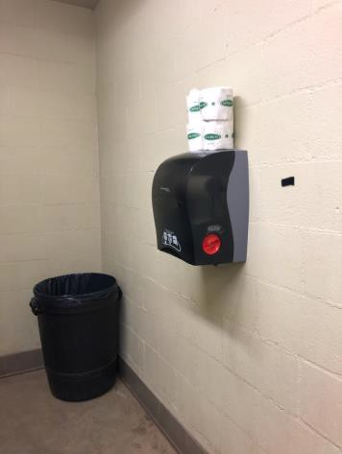

 | ID:  2993 | Facility:  City of Boise Zoo

Location African Plains Men's Restroom
Schedule 2021
Estimated Cost: $100.00

Priority Score 5
Quick Fix: Yes
Built before ADA: Yes

VIOLATIONS
2010 ADA Standards for Accessible Design Codes §604.7
The toilet paper dispenser is located out of the accessible reach range.

RECOMMENDATIONS
Remount the toilet paper dispenser to 7” minimum and 9” maximum in front of the water closet measured to the centerline of the dispenser.
The outlet of the dispenser shall be 15” minimum and 48” maximum above the floor and shall not be located behind the water closet.

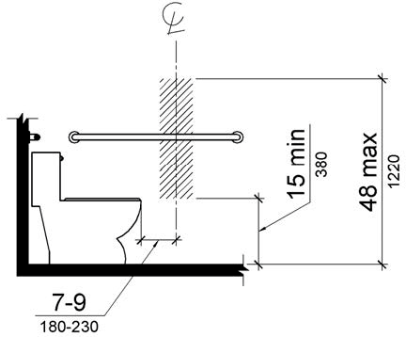

PHOTOGRAPH(S) OF THIS LOCATION

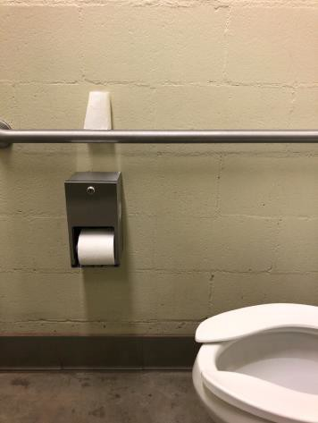

 | ID:  2995 | Facility:  City of Boise Zoo

Location African Plains Men's Restroom
Schedule 2021
Estimated Cost: $100.00

Priority Score 6
Quick Fix: Yes
Built before ADA: Yes

VIOLATIONS
2010 ADA Standards for Accessible Design Codes §703.4
The tactile sign identifying the room is not in the correct location at 62" above the floor.

RECOMMENDATIONS
Reinstall the sign on the latch side of the door at 48" minimum above the floor measured from the baseline of the lowest character and 60" maximum measured from the baseline of the highest character.

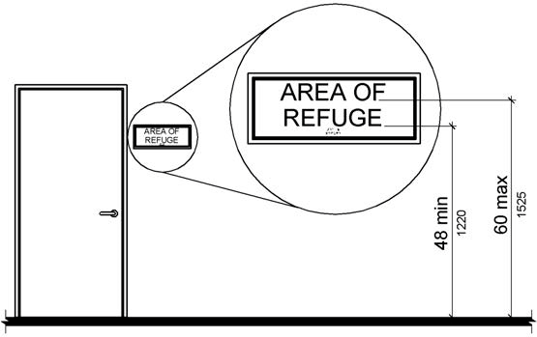

PHOTOGRAPH(S) OF THIS LOCATION

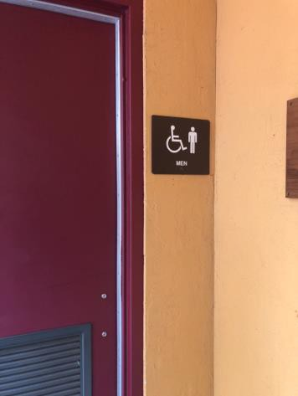

 | ID:  2994 | Facility:  City of Boise Zoo

Location African Plains Men's Restroom
Schedule 2021
Estimated Cost: $200.00

Priority Score 7
Quick Fix: Yes
Built before ADA: Yes

VIOLATIONS
2010 ADA Standards for Accessible Design Codes §309.4
The faucets require twisting of the wrist.

RECOMMENDATIONS
Replace the faucets with a lever handles that can be operated with a closed fist and without twisting the wrist.

PHOTOGRAPH(S) OF THIS LOCATION

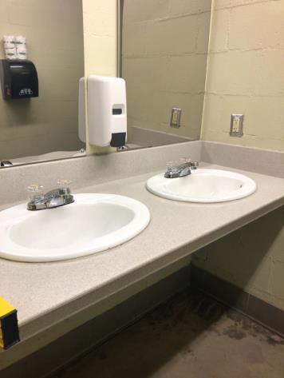

 | ID:  2992 | Facility:  City of Boise Zoo

Location African Plains Men's Restroom
Schedule 2022
Estimated Cost: $1,000.00

Priority Score 5
Quick Fix: No
Built before ADA: Yes

VIOLATIONS
2010 ADA Standards for Accessible Design Codes ICC A117.1 §604.5.1
The accessible water closet does not have a vertical grab bar.

RECOMMENDATIONS
Install an 18" long (minimum) vertical grab bar on the side wall. The grab bar shall be mounted with the bottom located at 39" minimum and 41" maximum above the floor.
The centerline of the vertical grab bar shall be located 39" minimum and 41" maximum from the real wall.

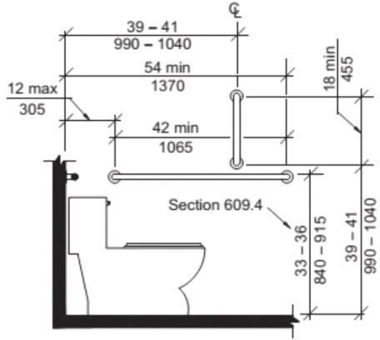

PHOTOGRAPH(S) OF THIS LOCATION

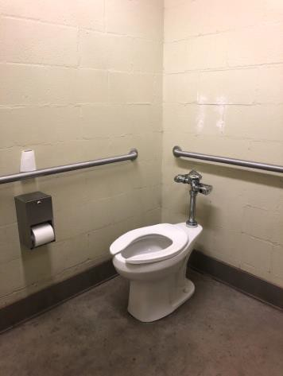

 | ID:  3417 | Facility:  City of Boise Zoo

Location African Plains Women’s Restroom
Schedule 2021
Estimated Cost: $100.00

Priority Score 6
Quick Fix: Yes
Built before ADA: Yes

VIOLATIONS
2010 ADA Standards for Accessible Design Codes §703.4
The tactile sign identifying the room is not in the correct location at 61" above the floor.

RECOMMENDATIONS
Reinstall the sign on the latch side of the door at 48" minimum above the floor measured from the baseline of the lowest character and 60" maximum measured from the baseline of the highest character.

PHOTOGRAPH(S) OF THIS LOCATION

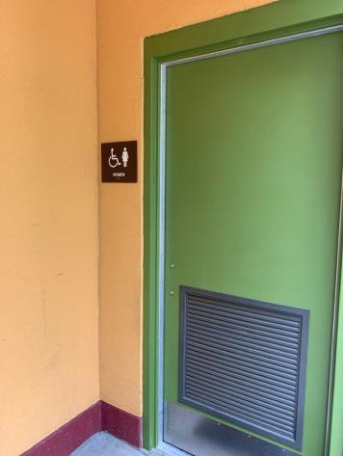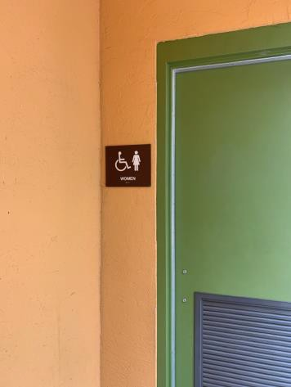

 | ID:  3233 | Facility:  City of Boise Zoo

Location African Ranger Station
Schedule 2021
Estimated Cost: $2,500.00

Priority Score 3
Quick Fix: No
Built before ADA: Yes

VIOLATIONS
2010 ADA Standards for Accessible Design Codes §403.3
The running slope is 6%.

RECOMMENDATIONS
Reconstruct the route to reduce the running slope to a maximum of 5%.

PHOTOGRAPH(S) OF THIS LOCATION

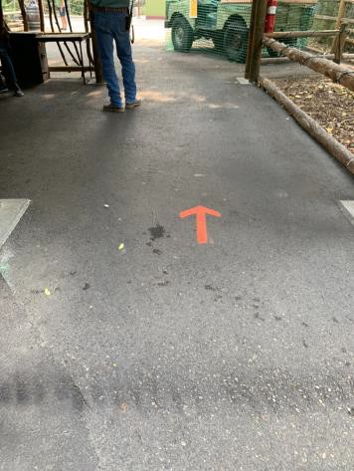

 | ID:  3572 | Facility:  City of Boise Zoo

Location African Ranger Station Jeep
Schedule 2023
Estimated Cost: $2,500.00

Priority Score 8
Quick Fix: No
Built before ADA: Yes

VIOLATIONS
2010 ADA Standards for Accessible Design Codes §405
The elevated component is only accessible a 2' step up.

RECOMMENDATIONS
Consider adding vertical access to this play component or adding an additional play component that can be accessed from ground level.

PHOTOGRAPH(S) OF THIS LOCATION

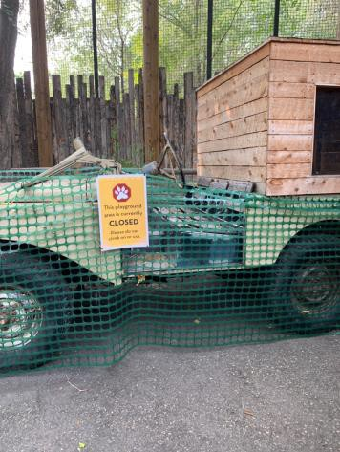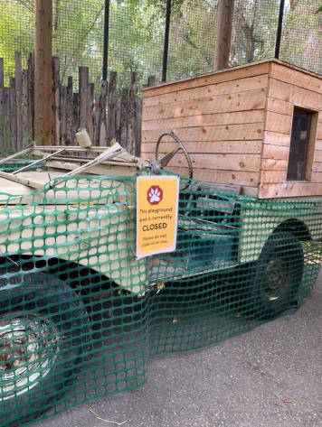

 | ID:  3515 | Facility:  City of Boise Zoo

Location African Ranger Station Jeep Bat Eared fox
Schedule 2022
Estimated Cost: $2,500.00

Priority Score 7
Quick Fix: No
Built before ADA: Yes

VIOLATIONS
2010 ADA Standards for Accessible Design Codes §305.2
The clear floor space adjacent to the garbage can has a 3.3% slope.

RECOMMENDATIONS
Reconstruct the 30"x48" clear floor space to have a maximum slope of 2% in all directions or relocate the garbage can to a level location.

PHOTOGRAPH(S) OF THIS LOCATION

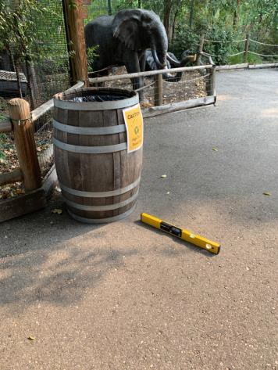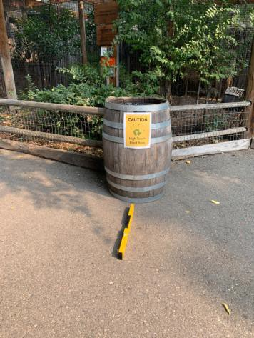

 | ID:  3703 | Facility:  City of Boise Zoo

Location African School House
Schedule 2023
Estimated Cost: $1,000.00

Priority Score 8
Quick Fix: No
Built before ADA: Yes

VIOLATIONS
2010 ADA Standards for Accessible Design Codes §221.2.1.1
There are no wheelchair spaces at the desks in the African School House.

RECOMMENDATIONS
Provide one wheelchair space at one of the three desks by removing a 36" portion of the bench from the end of the desk.
Ensure that there is knee clearance at a minimum of 11" deep at 9" above the floor and 8" deep at 27" above the floor.

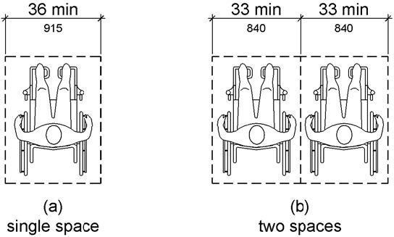

PHOTOGRAPH(S) OF THIS LOCATION

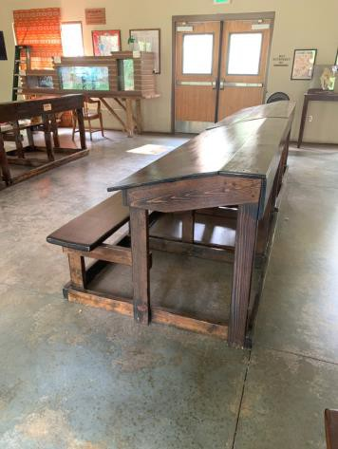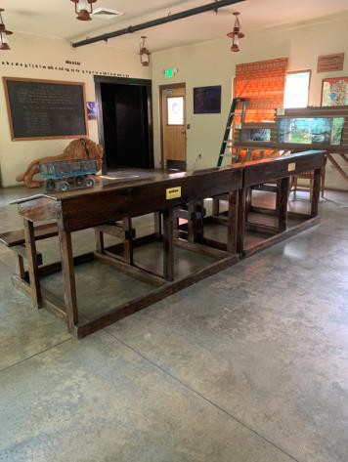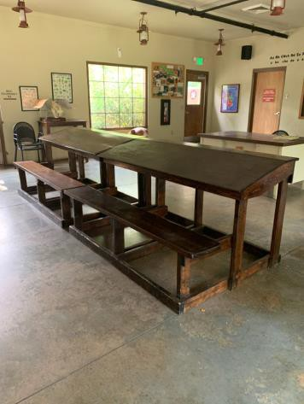

 | ID:  2356 | Facility:  City of Boise Zoo

Location Animal Care Staff Break/Office Area
Schedule 2021
Estimated Cost: $100.00

Priority Score 5
Quick Fix: Yes
Built before ADA: Yes

VIOLATIONS
2010 ADA Standards for Accessible Design Codes §307.2, §308.2.1
The first aid box is outside of the unobstructed forward reach range at 52" above the floor. The first aid box protrudes 7" into the circulation space at 52" above the floor.

RECOMMENDATIONS
Lower the first aid box by 4" to meet the accessible reach range of 15" minimum and 48" maximum above the floor.
Recess the first aid box so it protrudes a maximum of 4" or place a cane detectable object beneath it.

PHOTOGRAPH(S) OF THIS LOCATION

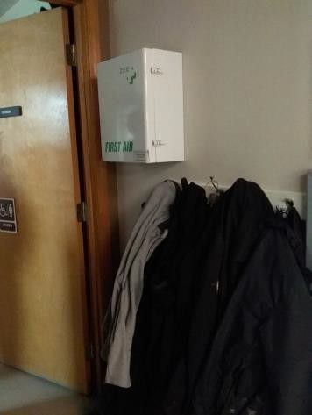

 | ID:  3333 | Facility:  City of Boise Zoo

Location Animal Care Staff Break/Office Area Men’s Restroom
Schedule 2021
Estimated Cost: $100.00

Priority Score 6
Quick Fix: Yes
Built before ADA: Yes

VIOLATIONS
2010 ADA Standards for Accessible Design Codes §703.4
The tactile sign identifying the room is not in the correct

RECOMMENDATIONS
Reinstall the sign on the latch side of the door at 48" minimum above the floor measured from the baseline of the lowest character and 60" maximum measured from the baseline of the highest character.

PHOTOGRAPH(S) OF THIS LOCATION

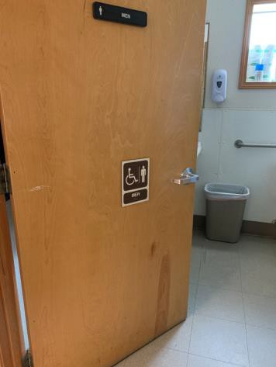

 | ID:  3334 | Facility:  City of Boise Zoo

Location Animal Care Staff Break/Office Area Men’s Restroom
Schedule 2021
Estimated Cost: $100.00

Priority Score 5
Quick Fix: Yes
Built before ADA: Yes

VIOLATIONS
2010 ADA Standards for Accessible Design Codes §604.7
The toilet paper dispenser is located out of the accessible reach range.

RECOMMENDATIONS
Remount the toilet paper dispenser to 7” minimum and 9” maximum in front of the water closet measured to the centerline of the dispenser.
The outlet of the dispenser shall be 15” minimum and 48” maximum above the floor and shall not be located behind the water closet.

PHOTOGRAPH(S) OF THIS LOCATION

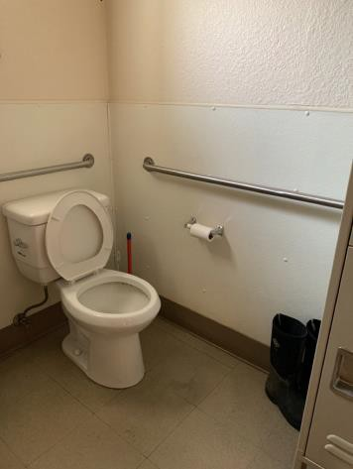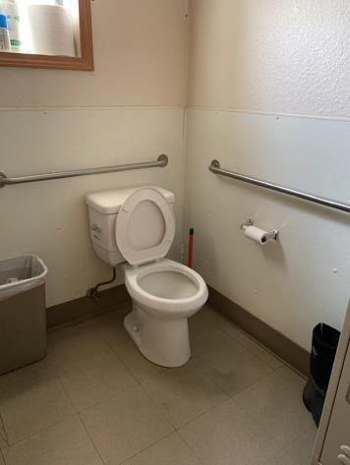

 | ID:  3335 | Facility:  City of Boise Zoo

Location Animal Care Staff Break/Office Area Men’s Restroom
Schedule 2022
Estimated Cost: $1,000.00

Priority Score 5
Quick Fix: No
Built before ADA: Yes

VIOLATIONS
2010 ADA Standards for Accessible Design Codes ICC A117.1 §604.5.1
The accessible water closet does not have a vertical grab bar.

RECOMMENDATIONS
Install an 18" long (minimum) vertical grab bar on the side wall. The grab bar shall be mounted with the bottom located at 39" minimum and 41" maximum above the floor.
The centerline of the vertical grab bar shall be located 39" minimum and 41" maximum from the real wall.

PHOTOGRAPH(S) OF THIS LOCATION

 | ID:  3106 | Facility:  City of Boise Zoo

Location Animal Care Staff Break/Office Area Ramp to Lunch Area
Schedule 2021
Estimated Cost: $500.00

Priority Score 3
Quick Fix: Yes
Built before ADA: Yes

VIOLATIONS
2010 ADA Standards for Accessible Design Codes §302.3
There is a 1" in the pathway posing a tripping hazard.

RECOMMENDATIONS
Fill in the gap to reduce the gap to a maximum of 0.5".

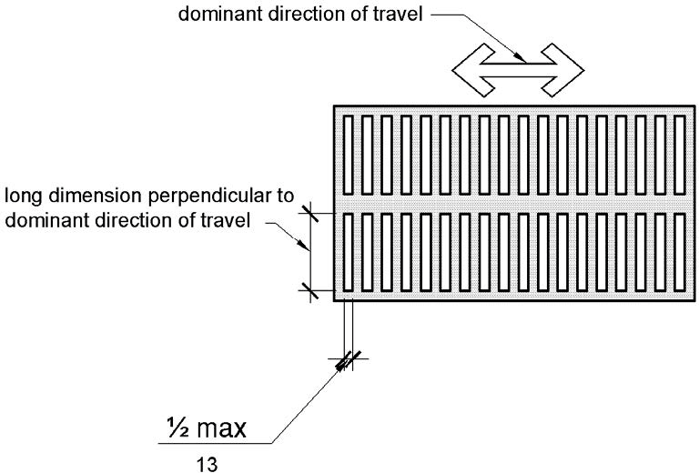

PHOTOGRAPH(S) OF THIS LOCATION

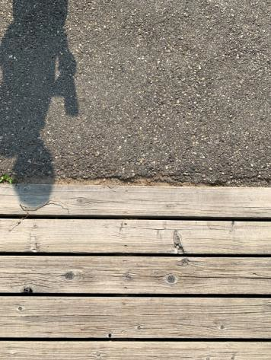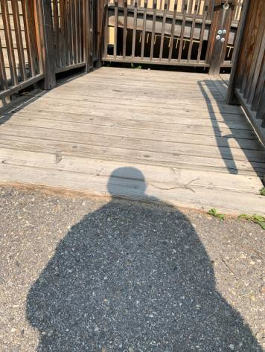

 | ID:  3533 | Facility:  City of Boise Zoo

Location Animal Care Staff Break/Office Area Ramp to Lunch Area
Schedule 2021
Estimated Cost: $1,000.00

Priority Score 3
Quick Fix: No
Built before ADA: Yes

VIOLATIONS
2010 ADA Standards for Accessible Design Codes §403.3
The cross slope is 3.1%.

RECOMMENDATIONS
Resurface the route to reduce the cross slope to a maximum of 2%.

PHOTOGRAPH(S) OF THIS LOCATION

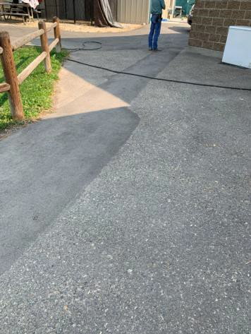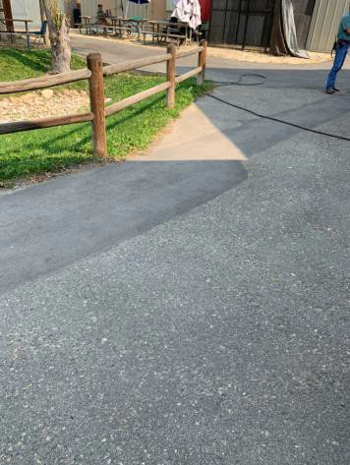

 | ID:  3697 | Facility:  City of Boise Zoo

Location Animal Care Staff Break/Office Area Ramp to Lunch Area
Schedule 2022
Estimated Cost: $5,000.00

Priority Score 7
Quick Fix: No
Built before ADA: Yes

VIOLATIONS
2010 ADA Standards for Accessible Design Codes §405.2
The running slope of the ramp is between 8% and 9%.

RECOMMENDATIONS
Reconstruct the ramp to reduce the running slope to a maximum of 8.3%.

PHOTOGRAPH(S) OF THIS LOCATION

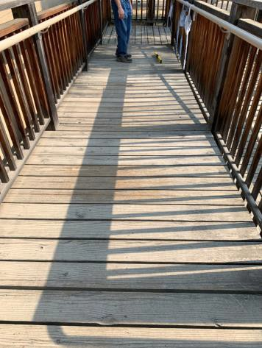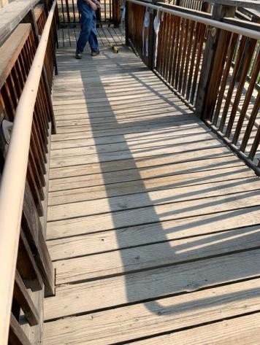

 | ID:  3393 | Facility:  City of Boise Zoo

Location Animal Care Staff Break/Office Area Women's Restroom
Schedule 2021
Estimated Cost: $100.00

Priority Score 6
Quick Fix: Yes
Built before ADA: Yes

VIOLATIONS
2010 ADA Standards for Accessible Design Codes §703.4
The tactile sign identifying the room is not in the correct location.

RECOMMENDATIONS
Reinstall the sign on the latch side of the door at 48" minimum above the floor measured from the baseline of the lowest character and 60" maximum measured from the baseline of the highest character.

PHOTOGRAPH(S) OF THIS LOCATION

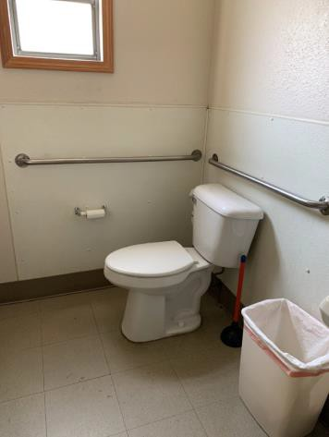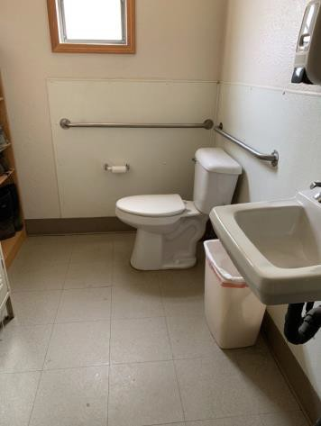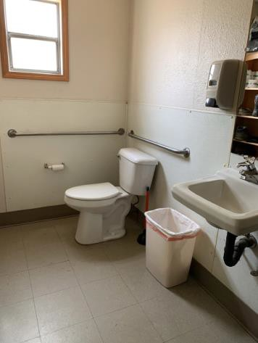

 | ID:  3397 | Facility:  City of Boise Zoo

Location Animal Care Staff Break/Office Area Women's Restroom
Schedule 2021
Estimated Cost: $100.00

Priority Score 5
Quick Fix: Yes
Built before ADA: Yes

VIOLATIONS
2010 ADA Standards for Accessible Design Codes §604.7
The toilet paper dispenser is located out of the accessible reach range.

RECOMMENDATIONS
Remount the toilet paper dispenser to 7” minimum and 9” maximum in front of the water closet measured to the centerline of the dispenser.
The outlet of the dispenser shall be 15” minimum and 48” maximum above the floor and shall not be located behind the water closet.

PHOTOGRAPH(S) OF THIS LOCATION

 | ID:  3394 | Facility:  City of Boise Zoo

Location Animal Care Staff Break/Office Area Women's Restroom
Schedule 2022
Estimated Cost: $1,000.00

Priority Score 5
Quick Fix: No
Built before ADA: Yes

VIOLATIONS
2010 ADA Standards for Accessible Design Codes §604.6
The flush control is located on the wall side of the toilet.

RECOMMENDATIONS
Either make the toilet flush automatically or relocate the flush control to be operated on the open side of the toilet.

PHOTOGRAPH(S) OF THIS LOCATION

 | ID:  3395 | Facility:  City of Boise Zoo

Location Animal Care Staff Break/Office Area Women's Restroom
Schedule 2022
Estimated Cost: $1,000.00

Priority Score 5
Quick Fix: No
Built before ADA: Yes

VIOLATIONS
2010 ADA Standards for Accessible Design Codes ICC A117.1 §604.5.1
The accessible water closet does not have a vertical grab bar.

RECOMMENDATIONS
Install an 18" long (minimum) vertical grab bar on the side wall. The grab bar shall be mounted with the bottom located at 39" minimum and 41" maximum above the floor.
The centerline of the vertical grab bar shall be located 39" minimum and 41" maximum from the rear wall.

PHOTOGRAPH(S) OF THIS LOCATION

 | ID:  3396 | Facility:  City of Boise Zoo

Location Animal Care Staff Break/Office Area Women's Restroom
Schedule 2022
Estimated Cost: $1,000.00

Priority Score 5
Quick Fix: No
Built before ADA: Yes

VIOLATIONS
2010 ADA Standards for Accessible Design Codes §604.5.1
The side grab bar is located 2" from the rear wall.

RECOMMENDATIONS
Replace the side grab bar with one that is a minimum of 42" long minimum, located 12" maximum from the rear wall and extending 54" minimum from the rear wall.

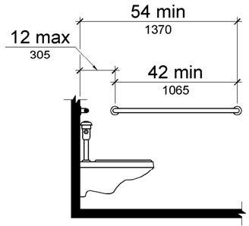

PHOTOGRAPH(S) OF THIS LOCATION

 | ID:  2357 | Facility:  City of Boise Zoo

Location Animal Care/Staff Break Room
Schedule 2021
Estimated Cost: $100.00

Priority Score 8
Quick Fix: Yes
Built before ADA: Yes

VIOLATIONS
2010 ADA Standards for Accessible Design Codes §308.2.1
The paper towel dispenser is outside of the unobstructed forward reach range at 52" above the floor.

RECOMMENDATIONS
Lower the paper towel dispenser by 4" to meet the accessible reach range of 48" maximum above the floor.

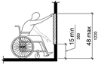

PHOTOGRAPH(S) OF THIS LOCATION

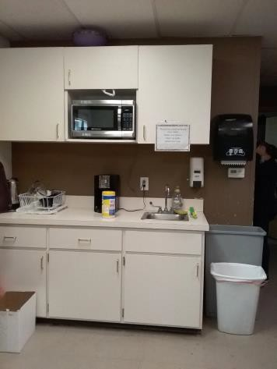

 | ID:  2358 | Facility:  City of Boise Zoo

Location Animal Care/Staff Break Room
Schedule 2022
Estimated Cost: $1,000.00

Priority Score 5
Quick Fix: No
Built before ADA: Yes

VIOLATIONS
2010 ADA Standards for Accessible Design Codes §606.3, §306.3.3
There is no knee clearance underneath the sink. The sink is 34.25" above the floor.

RECOMMENDATIONS
Provide knee clearance underneath the counter at the sink that is a minimum of 11" deep at 9" above the floor and 8" deep at 27" above the floor.
Lower the sink to the maximum height of 34" above the floor.

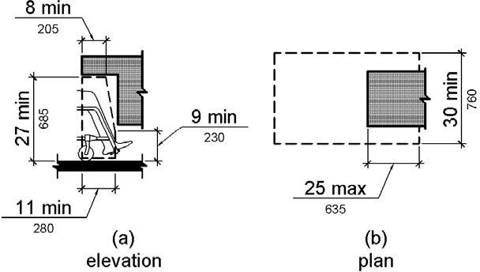

PHOTOGRAPH(S) OF THIS LOCATION

 | ID:  3031 | Facility:  City of Boise Zoo

Location Animal Health Complex
Schedule 2021
Estimated Cost: $100.00

Priority Score 5
Quick Fix: Yes
Built before ADA: Yes

VIOLATIONS
2010 ADA Standards for Accessible Design Codes §307.2
The electrical box protrudes 14" into the circulation space at 41" above the floor.

RECOMMENDATIONS
Place a cane detectable object beneath the electrical box.

PHOTOGRAPH(S) OF THIS LOCATION

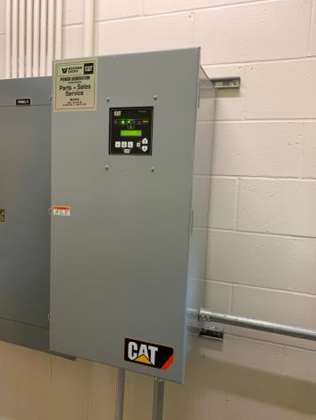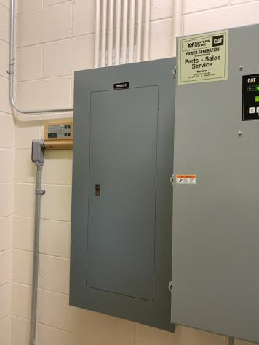

 | ID:  3731 | Facility:  City of Boise Zoo

Location Animal Health Complex
Schedule 2021
Estimated Cost: $100.00

Priority Score 5
Quick Fix: No
Built before ADA: Yes

VIOLATIONS
2010 ADA Standards for Accessible Design Codes §307.2
The electric box protrudes 6.25" into the circulation space at 33.5" above the floor.

RECOMMENDATIONS
Place a cane detectable object beneath the electrical box.

PHOTOGRAPH(S) OF THIS LOCATION

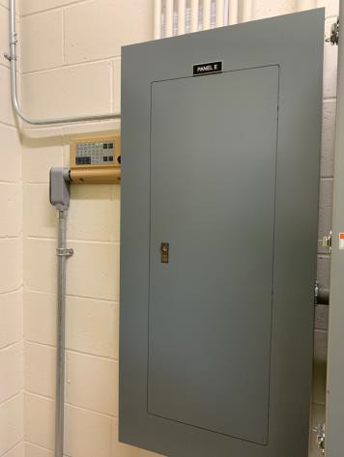

 | ID:  2353 | Facility:  City of Boise Zoo

Location Animal Hospital
Schedule 2021
Estimated Cost: $100.00

Priority Score 5
Quick Fix: Yes
Built before ADA: Yes

VIOLATIONS
2010 ADA Standards for Accessible Design Codes §307.2
The eye wash station protrudes 12" into the circulation space at 12" above the floor.

RECOMMENDATIONS
Place a cane detectable object beneath the eye wash station.

PHOTOGRAPH(S) OF THIS LOCATION

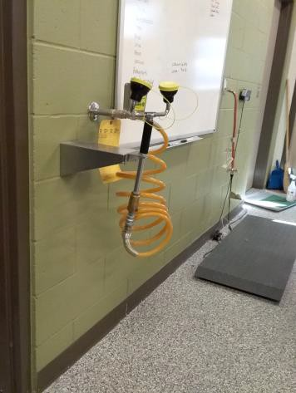

 | ID:  2352 | Facility:  City of Boise Zoo

Location Animal Hospital
Schedule 2023
Estimated Cost: $2,000.00

Priority Score 8
Quick Fix: No
Built before ADA: Yes

VIOLATIONS
2010 ADA Standards for Accessible Design Codes §306.3.3, §902.3, §606.3
The sink is 34.25" above the floor. The dining and work surface counter is 34.25" above the floor. There is no knee clearance underneath the sink.

RECOMMENDATIONS
Lower the sink to the maximum height of 34" above the floor.
Provide knee clearance underneath the counter at the sink that is a minimum of 11" deep at 9" above the floor and 8" deep at 27" above the floor.

PHOTOGRAPH(S) OF THIS LOCATION

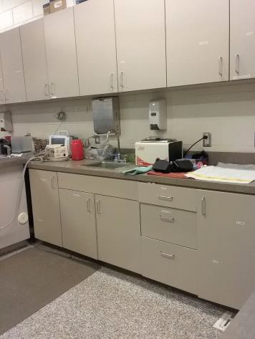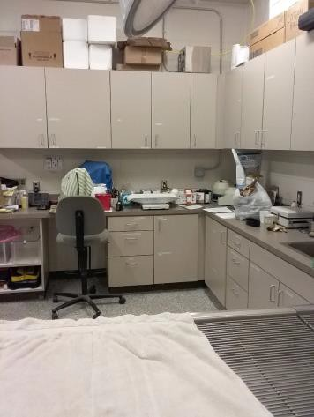

 | ID:  3218 | Facility:  City of Boise Zoo

Location Ant Eater Exit
Schedule 2021
Estimated Cost: $2,500.00

Priority Score 3
Quick Fix: No
Built before ADA: Yes

VIOLATIONS
2010 ADA Standards for Accessible Design Codes §403.3
The running slope is 7.7%.

RECOMMENDATIONS
Reconstruct the route to reduce the running slope to a maximum of 5%. Or install handrails at a minimum height of 34” and maximum of 38” above the ground. Make sure there are adequate handrail extensions and level landings at the top and bottom of the handrail.

PHOTOGRAPH(S) OF THIS LOCATION

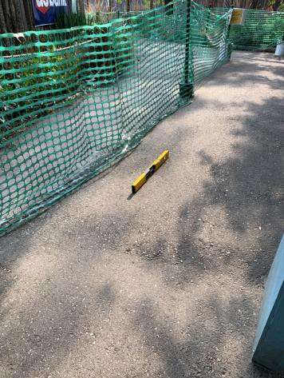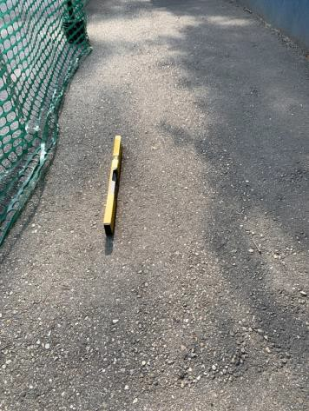

 | ID:  2338 | Facility:  City of Boise Zoo

Location Bat House Entrance
Schedule 2021
Estimated Cost: $2,500.00

Priority Score 3
Quick Fix: No
Built before ADA: Yes

VIOLATIONS
2010 ADA Standards for Accessible Design Codes §404.2.4.4
The entrance has a 4.2% slope.

RECOMMENDATIONS
Reconstruct the entryway to reduce the running slope to a maximum of 2% in all directions for a distance of 60" perpendicular to the door.

PHOTOGRAPH(S) OF THIS LOCATION

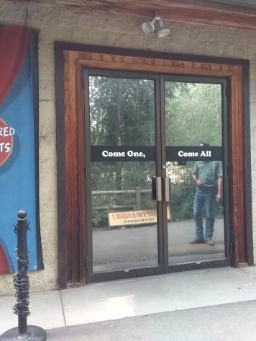

 | ID:  2346 | Facility:  City of Boise Zoo

Location Bench
Schedule 2021
Estimated Cost: $2,500.00

Priority Score 0
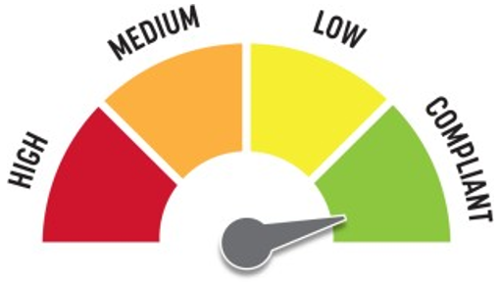
Quick Fix: No
Built before ADA: Yes

VIOLATIONS
2010 ADA Standards for Accessible Design Codes §305.2
The clear floor space has a 5.7% slope.

RECOMMENDATIONS
For the purposes of achieving greater accessibility and Human Centric Design, reconstruct the 30"x48" clear floor space to have a maximum slope of 2% in all directions.

PHOTOGRAPH(S) OF THIS LOCATION

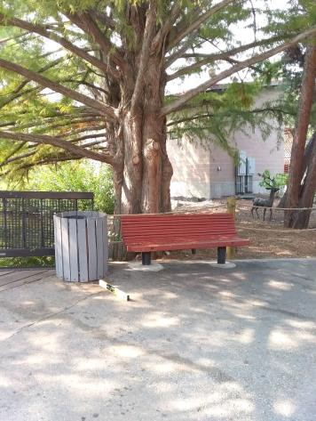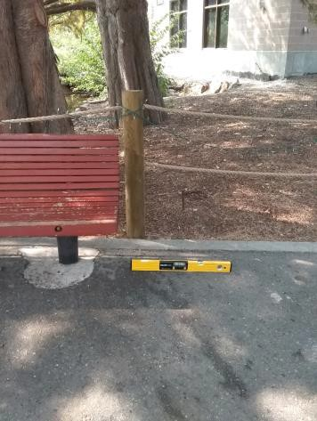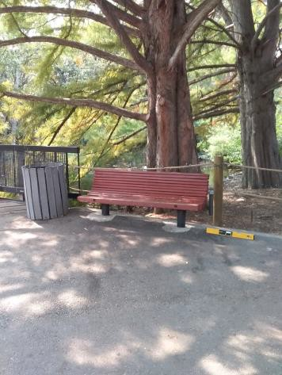

 | ID:  2348 | Facility:  City of Boise Zoo

Location Bench Across from Zoo Kitchen
Schedule 2023
Estimated Cost: $1,000.00

Priority Score 8
Quick Fix: No
Built before ADA: Yes

VIOLATIONS
2010 ADA Standards for Accessible Design Codes §903.2
There is no clear floor space next to the bench.

RECOMMENDATIONS
For the purposes of achieving greater accessibility and Human Centric Design, install a 30"x48" clear floor space at the end of the bench seat and parallel to the short axis of the bench.

PHOTOGRAPH(S) OF THIS LOCATION

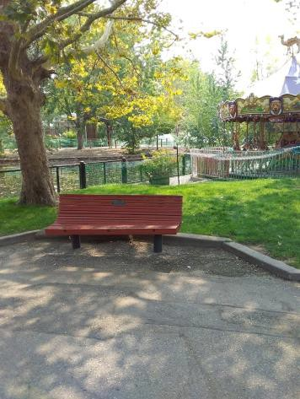

 | ID:  2384 | Facility:  City of Boise Zoo

Location Bench near Giraffe Slide
Schedule 2021
Estimated Cost: $100.00

Priority Score 5
Quick Fix: Yes
Built before ADA: Yes

VIOLATIONS
2010 ADA Standards for Accessible Design Codes §302.1, §305
There is not a firm, stable, and slip resistant route to the bench.

RECOMMENDATIONS
Relocate the bench adjacent to an accessible route.

PHOTOGRAPH(S) OF THIS LOCATION

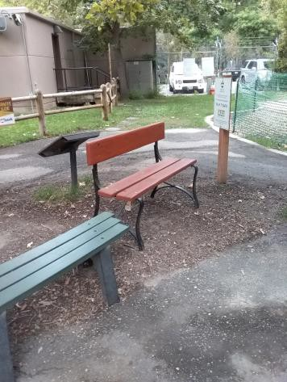

 | ID:  2344 | Facility:  City of Boise Zoo

Location Benches at Gorongosa Entrance
Schedule 2023
Estimated Cost: $5,000.00

Priority Score 8
Quick Fix: No
Built before ADA: Yes

VIOLATIONS
2010 ADA Standards for Accessible Design Codes §903.2
There is no clear floor space next to the benches.

RECOMMENDATIONS
For the purposes of achieving greater accessibility and Human Centric Design, install a 30"x48" clear floor space at the end of the bench seats and parallel to the short axis of the benches.

PHOTOGRAPH(S) OF THIS LOCATION

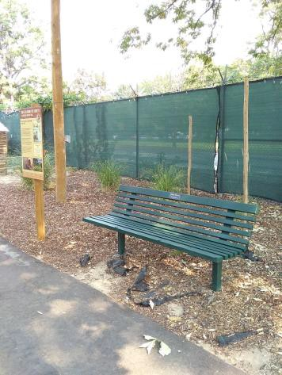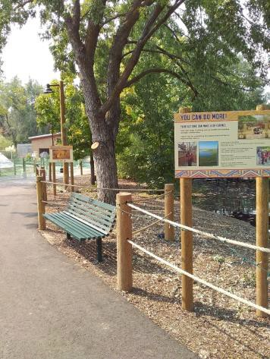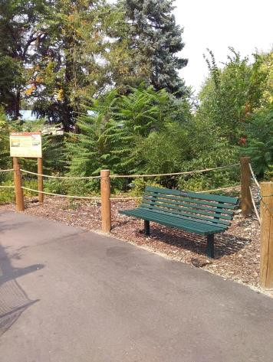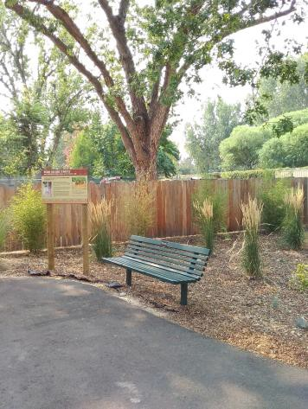

 | ID:  3171 | Facility:  City of Boise Zoo

Location Bird Holding Door B
Schedule 2021
Estimated Cost: $2,500.00

Priority Score 3
Quick Fix: No
Built before ADA: Yes

VIOLATIONS
2010 ADA Standards for Accessible Design Codes §404.2.4.4
The entrance has a 9% to 10% slope.

RECOMMENDATIONS
Reconstruct the entryway to reduce the running slope to a maximum of 2% in all directions for a distance of 60" perpendicular to the door.

PHOTOGRAPH(S) OF THIS LOCATION

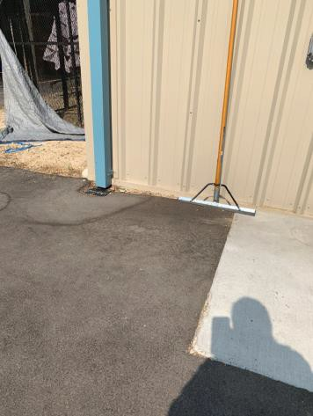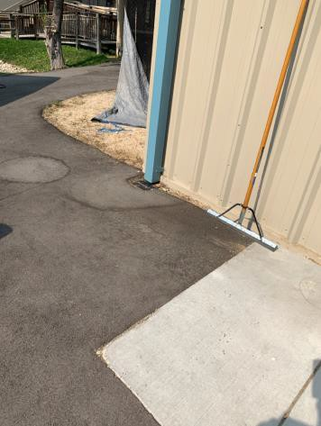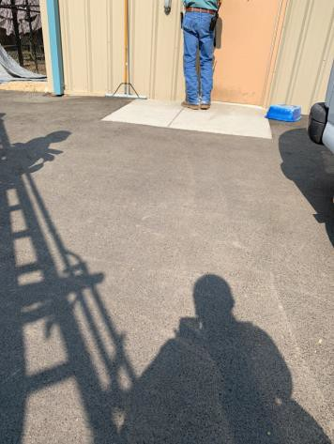

 | ID:  3075 | Facility:  City of Boise Zoo

Location Butterfly House
Schedule 2021
Estimated Cost: $2,500.00

Priority Score 3
Quick Fix: No
Built before ADA: Yes

VIOLATIONS
2010 ADA Standards for Accessible Design Codes §403.3
The cross slope is 6.8%.

RECOMMENDATIONS
Reconstruct the route to reduce the cross slope to a maximum of 2%.

PHOTOGRAPH(S) OF THIS LOCATION

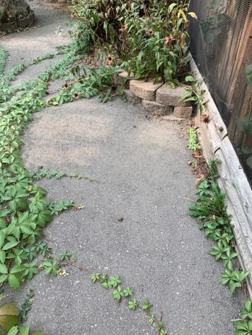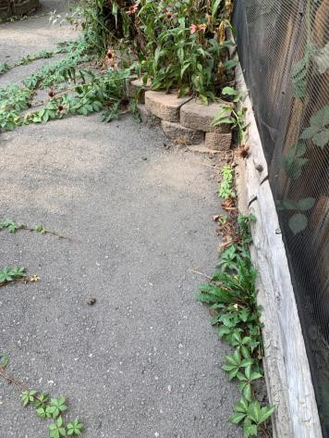

 | ID:  3725 | Facility:  City of Boise Zoo

Location Capybara
Schedule 2021
Estimated Cost: $1,000.00

Priority Score 3
Quick Fix: No
Built before ADA: Yes

VIOLATIONS
2010 ADA Standards for Accessible Design Codes §305.2
The clear floor space has a 2.6% cross slope and 4.5% running slope.

RECOMMENDATIONS
Resurface the 30"x48" clear floor space to have a maximum slope of 2% in all directions.

PHOTOGRAPH(S) OF THIS LOCATION

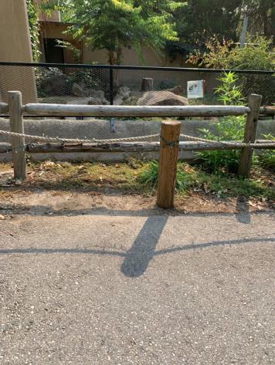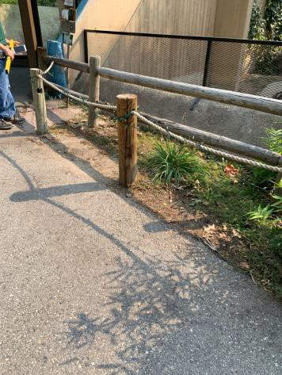

 | ID:  3079 | Facility:  City of Boise Zoo

Location Carousel
Schedule 2021
Estimated Cost: $500.00

Priority Score 7
Quick Fix: Yes
Built before ADA: Yes

VIOLATIONS
2010 ADA Standards for Accessible Design Codes §305.2
The clear floor space in front of the bench is 24"x30".

RECOMMENDATIONS
Rearrange the carousel seats to allow for a minimum clear floor space at the bench of 30"x48".

PHOTOGRAPH(S) OF THIS LOCATION

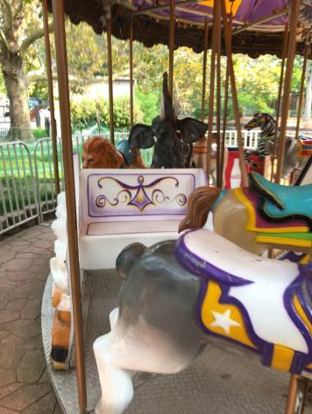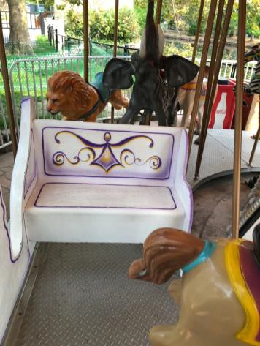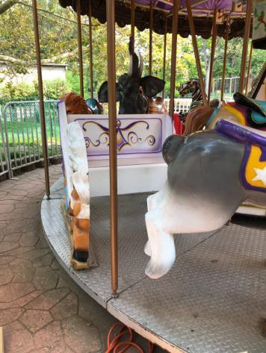

 | ID:  3080 | Facility:  City of Boise Zoo

Location Carousel
Schedule 2023
Estimated Cost: $2,500.00

Priority Score 7
Quick Fix: No
Built before ADA: Yes

VIOLATIONS
2010 ADA Standards for Accessible Design Codes §405
The carousel is only accessible via a 7" step.

RECOMMENDATIONS
Add vertical access to the amenity via a movable ramp. If a ramp is added, ensure that the slope does not exceed 8.3%, handrails are provided, and there is sufficient room for a level landing at the top and bottom of the ramp.

PHOTOGRAPH(S) OF THIS LOCATION

 | ID:  2325 | Facility:  City of Boise Zoo

Location Central Paving Entry Bridge
Schedule 2021
Estimated Cost: $2,500.00

Priority Score 3
Quick Fix: No
Built before ADA: Yes

VIOLATIONS
2010 ADA Standards for Accessible Design Codes §405.2, §505.2
There are no handrails.
The running slope of the ramp is 11.1%.

RECOMMENDATIONS
Install handrails at a minimum height of 34” and maximum of 38” above the ground. Make sure there are adequate handrail extensions both at the top and bottom of the handrail.
Reconstruct the ramp to reduce the running slope to a maximum of 8.3% or reconstruct the ramp to have a maximum slope of 5% with no handrails or level landings.

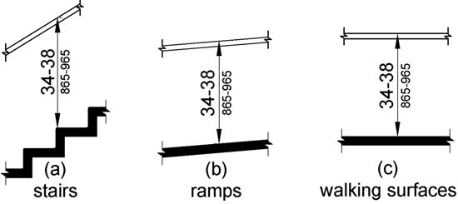

PHOTOGRAPH(S) OF THIS LOCATION

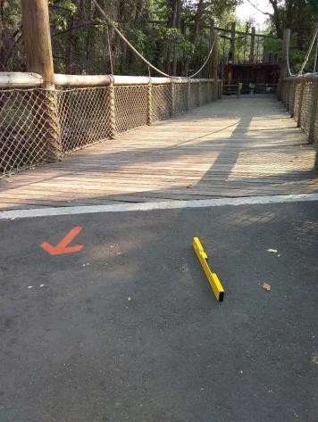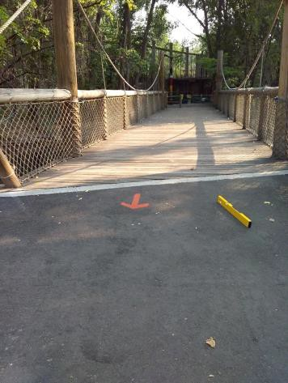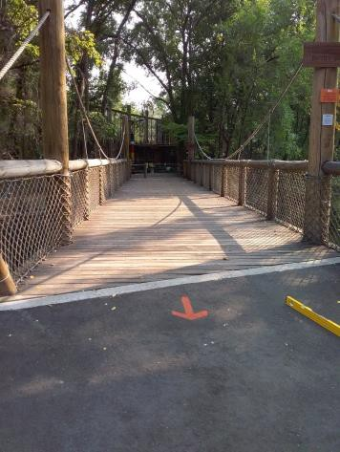

 | ID:  2324 | Facility:  City of Boise Zoo

Location Central Paving Entry Bridge Bench
Schedule 2021
Estimated Cost: $2,500.00

Priority Score 0
Quick Fix: No
Built before ADA: Yes

VIOLATIONS
2010 ADA Standards for Accessible Design Codes §305.2
The clear floor space has a 9.3% slope.

RECOMMENDATIONS
For the purposes of achieving greater accessibility and Human Centric Design, reconstruct the 30"x48" clear floor space to have a maximum slope of 2% in all directions.

PHOTOGRAPH(S) OF THIS LOCATION

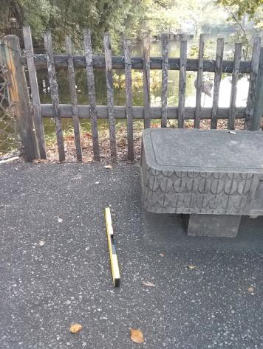

 | ID:  3438 | Facility:  City of Boise Zoo

Location Conservation Cruise
Schedule 2022
Estimated Cost: $1,000.00

Priority Score 6
Quick Fix: No
Built before ADA: Yes

VIOLATIONS
2010 ADA Standards for Accessible Design Codes §505.2
There are no handrails provided for boat loading/unloading.

RECOMMENDATIONS
Install handrails for boat loading/unloading at a minimum height of 34” and maximum of 38” above the ground.
Make sure there are adequate handrail extensions both at the top and bottom of the handrail.

PHOTOGRAPH(S) OF THIS LOCATION

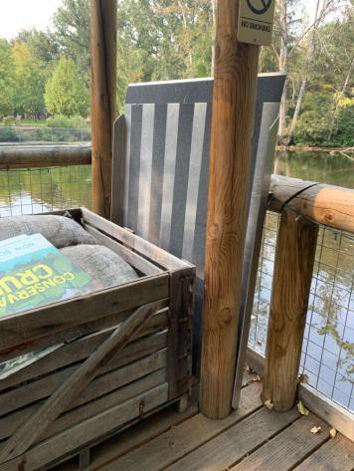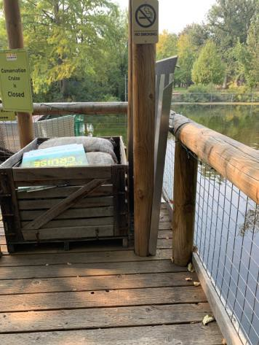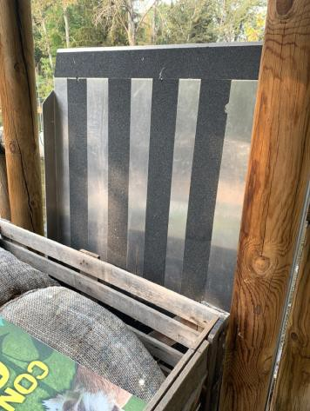

 | ID:  3508 | Facility:  City of Boise Zoo

Location Conservation Cruise
Schedule 2022
Estimated Cost: $1,000.00

Priority Score 5
Quick Fix: No
Built before ADA: Yes

VIOLATIONS
2010 ADA Standards for Accessible Design Codes §303.2
There is a change in level greater than 0.25".

RECOMMENDATIONS
Resurface the pathway to reduce the change in level to less than 0.25" or 0.5" if beveled.

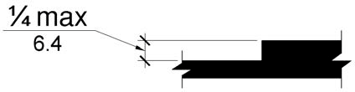

PHOTOGRAPH(S) OF THIS LOCATION

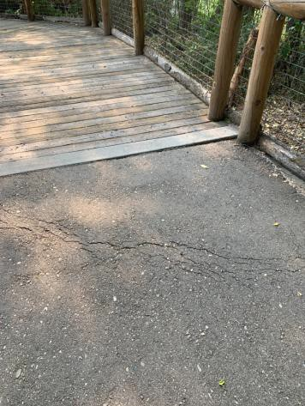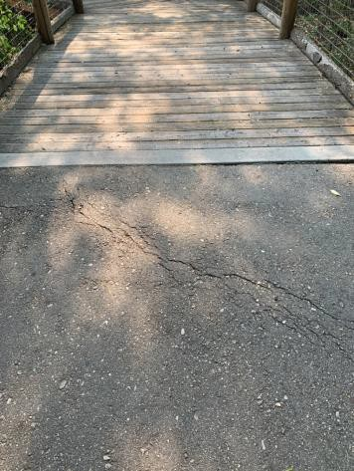

 | ID:  3509 | Facility:  City of Boise Zoo

Location Conservation Cruise
Schedule 2021
Estimated Cost: $2,500.00

3

Priority Score 5
Quick Fix: No
Built before ADA: Yes

VIOLATIONS
2010 ADA Standards for Accessible Design Codes §403.3
The running slope at the Conservation Cruise bridge is 7.9%.

RECOMMENDATIONS
Reconstruct the route to reduce the running slope to a maximum of 5% or install handrails and level landings.

PHOTOGRAPH(S) OF THIS LOCATION

 | ID:  3021 | Facility:  City of Boise Zoo

Location Eagle Viewing
Schedule 2021
Estimated Cost: $1,000.00

Priority Score 3
Quick Fix: No
Built before ADA: Yes

VIOLATIONS
2010 ADA Standards for Accessible Design Codes §305.2
The clear floor space has a 4% running slope.

RECOMMENDATIONS
Resurface the 30"x48" clear floor space to have a maximum slope of 2% in all directions.

PHOTOGRAPH(S) OF THIS LOCATION

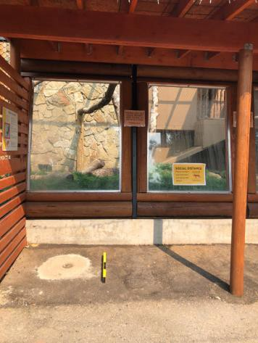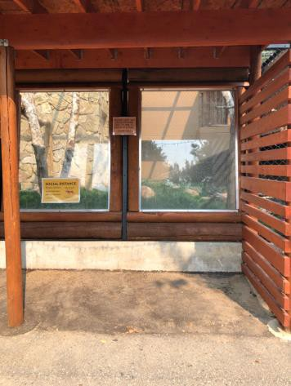

 | ID:  2362 | Facility:  City of Boise Zoo

Location Education Building
Schedule 2021
Estimated Cost: $100.00

Priority Score 5
Quick Fix: yes
Built before ADA: Yes

VIOLATIONS
2010 ADA Standards for Accessible Design Codes §307.2
The fire extinguisher protrudes 4.5" into the circulation space at 41" above the floor.

RECOMMENDATIONS
Recess the fire extinguisher so it protrudes a maximum of 4" or place a cane detectable object beneath it.

PHOTOGRAPH(S) OF THIS LOCATION

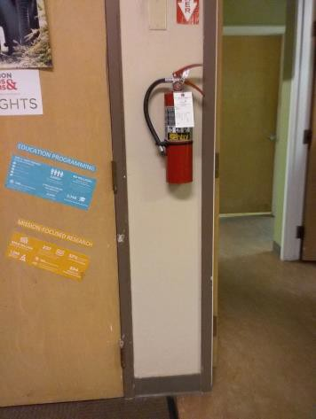

 | ID:  2364 | Facility:  City of Boise Zoo

Location Education Building
Schedule 2021
Estimated Cost: $100.00

Priority Score 5
Quick Fix: Yes
Built before ADA: Yes

VIOLATIONS
2010 ADA Standards for Accessible Design Codes §307.2, §308.2.1
The paper towel dispenser is outside of the unobstructed forward reach range at 51" above the floor.
The paper towel dispenser protrudes 51" into the circulation space at 8.5" above the floor.

RECOMMENDATIONS
Lower the paper towel dispenser by 3" to meet the accessible reach range of 48" maximum above the floor.
Recess the paper towel dispenser so it protrudes a maximum of 4" or place a cane detectable object beneath it.

PHOTOGRAPH(S) OF THIS LOCATION

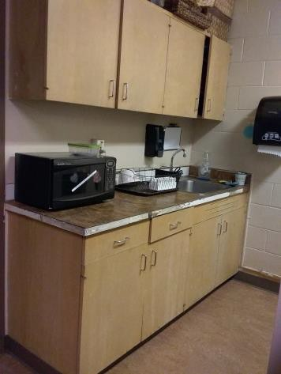

 | ID:  3663 | Facility:  City of Boise Zoo

Location Education Building
Schedule 2021
Estimated Cost: $100.00

Priority Score 7
Quick Fix: Yes
Built before ADA: Yes

VIOLATIONS
2010 ADA Standards for Accessible Design Codes §606.5
The pipes under the sink are not covered.

RECOMMENDATIONS
Wrap the pipes beneath the sink with soft protective wrap or plastic.

PHOTOGRAPH(S) OF THIS LOCATION

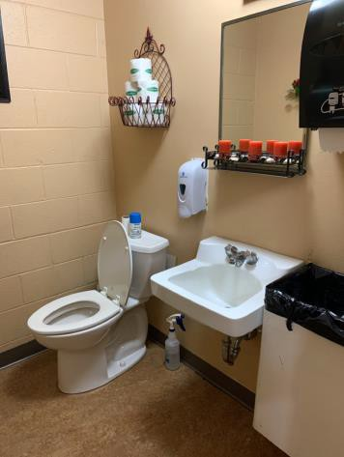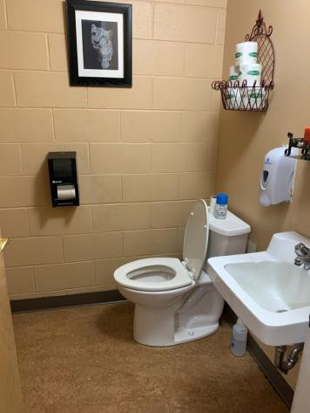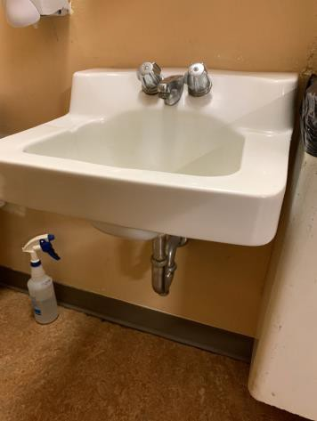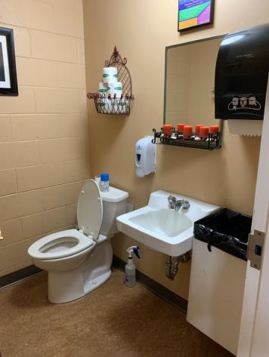

 | ID:  3664 | Facility:  City of Boise Zoo

Location Education Building
Schedule 2021
Estimated Cost: $100.00

Priority Score 5
Quick Fix: No
Built before ADA: Yes

VIOLATIONS
2010 ADA Standards for Accessible Design Codes §603.3
The mirror is too high to be accessible at 48" above the floor.

RECOMMENDATIONS
Lower the mirror its bottom edge is a maximum height of 40" above the floor.

PHOTOGRAPH(S) OF THIS LOCATION

 | ID:  3665 | Facility:  City of Boise Zoo

Location Education Building
Schedule 2021
Estimated Cost: $100.00

Priority Score 7
Quick Fix: Yes
Built before ADA: Yes

VIOLATIONS
2010 ADA Standards for Accessible Design Codes §309.4
The faucet requires twisting of the wrist.

RECOMMENDATIONS
Replace the faucet with one that can be operated with a closed fist and without twisting the wrist.

PHOTOGRAPH(S) OF THIS LOCATION

 | ID:  3666 | Facility:  City of Boise Zoo

Location Education Building
Schedule 2021
Estimated Cost: $100.00

Priority Score 8
Quick Fix: Yes
Built before ADA: Yes

VIOLATIONS
2010 ADA Standards for Accessible Design Codes §308.2.1
The paper towel dispenser is outside of the unobstructed forward reach range at 52" above the floor.

RECOMMENDATIONS
Lower the paper towel dispenser by 4" to meet the accessible reach range of 48" maximum above the floor.

PHOTOGRAPH(S) OF THIS LOCATION

 | ID:  3667 | Facility:  City of Boise Zoo

Location Education Building
Schedule 2021
Estimated Cost: $100.00

Priority Score 5
Quick Fix: Yes
Built before ADA: Yes

VIOLATIONS
2010 ADA Standards for Accessible Design Codes §604.7
The toilet paper dispenser is located out of the accessible reach range.

RECOMMENDATIONS
Remount the toilet paper dispenser to 7” minimum and 9” maximum in front of the water closet measured to the centerline of the dispenser.
The outlet of the dispenser shall be 15” minimum and 48” maximum above the floor and shall not be located behind the water closet.

PHOTOGRAPH(S) OF THIS LOCATION

 | ID:  3661 | Facility:  City of Boise Zoo

Location Education Building
Schedule 2022
Estimated Cost: $1,000.00

Priority Score 5
Quick Fix: No
Built before ADA: Yes

VIOLATIONS
2010 ADA Standards for Accessible Design Codes §604.6
The flush control is located on the wall side of the toilet.

RECOMMENDATIONS
Either make the toilet flush automatically or relocate the flush control to be operated on the open side of the toilet.

PHOTOGRAPH(S) OF THIS LOCATION

 | ID:  2363 | Facility:  City of Boise Zoo

Location Education Building
Schedule 2023
Estimated Cost: $2,000.00

Priority Score 8
Quick Fix: No
Built before ADA: Yes

VIOLATIONS
2010 ADA Standards for Accessible Design Codes §902.3, §306.3.3, §606.3
The sink is 36" above the floor. There is no knee clearance underneath the sink. The dining and work surface counter is 36" above the floor.

RECOMMENDATIONS
Lower the sink to the maximum height of 34" above the floor. Provide knee clearance underneath the counter at the sink that is a minimum of 11" deep at 9" above the floor and 8" deep at 27" above the floor.
A 30" portion of the dining and work surface must be no higher than 34” above the floor.

PHOTOGRAPH(S) OF THIS LOCATION

 | ID:  3155 | Facility:  City of Boise Zoo

Location Education Building
Schedule 2022
Estimated Cost: $2,000.00

Priority Score 5
Quick Fix: No
Built before ADA: Yes

VIOLATIONS
2010 ADA Standards for Accessible Design Codes §505.10.2, §505.10.3
There are no handrail extensions at the bottom of the stairs.

RECOMMENDATIONS
Install new handrails that have extensions at the slope of the stair flight for a horizontal distance at least equal to one tread depth beyond the last riser nosing.
Handrail extensions shall return the wall, guard or landing surface, or shall be continuous to the handrail of an adjacent stair flight.

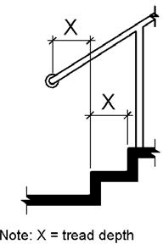

PHOTOGRAPH(S) OF THIS LOCATION

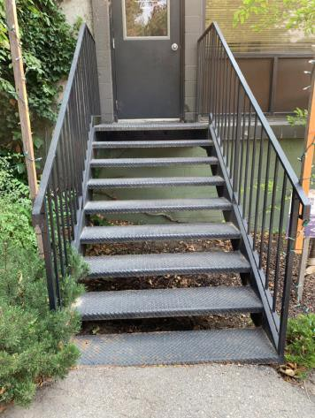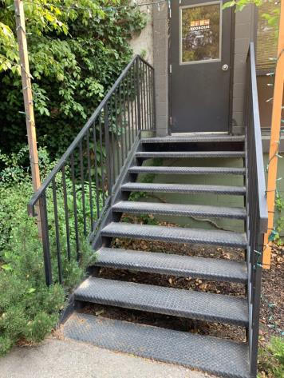

 | ID:  3662 | Facility:  City of Boise Zoo

Location Education Building
Schedule 2022
Estimated Cost: $2,500.00

Priority Score 5
Quick Fix: No
Built before ADA: Yes

VIOLATIONS
2010 ADA Standards for Accessible Design Codes §604.5, ICC A117.1 §604.5.1
The accessible water closet does not have a vertical grab bar. There are no grab bars.

RECOMMENDATIONS
Install an 18" long (minimum) vertical grab bar on the side wall. The grab bar shall be mounted with the bottom located at 39" minimum and 41" maximum above the floor.
Install a side and rear grab bar at a minimum height of 33” and maximum height of 36” above the finish floor. The side grab bar shall have a minimum length of 42”. The side grab bar shall begin at a maximum of 12” from the back wall.

PHOTOGRAPH(S) OF THIS LOCATION

 | ID:  3710 | Facility:  City of Boise Zoo

Location Education Building
Schedule 2021
Estimated Cost: $2,500.00

Priority Score 3
Quick Fix: No
Built before ADA: Yes

VIOLATIONS
2010 ADA Standards for Accessible Design Codes §304.2
The turning space leaving the education building has an 8% slope.

RECOMMENDATIONS
Reconstruct the turning space to reduce the slope to the maximum allowable 2% in all directions for a duration of at least 60".

PHOTOGRAPH(S) OF THIS LOCATION

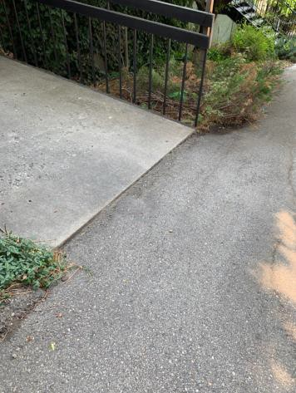

 | ID:  2365 | Facility:  City of Boise Zoo

Location Education Building Entrance
Schedule 2021
Estimated Cost: $5,000.00

Priority Score 3
Quick Fix: No
Built before ADA: Yes

VIOLATIONS
2010 ADA Standards for Accessible Design Codes §404.2.4.4
The entrance has a 12.7% slope.

RECOMMENDATIONS
Reconstruct the entryway to reduce the running slope to a maximum of 2% in all directions for a distance of 60" perpendicular to the door.
Leading to the door, ensure that the running slope does not exceed 5% or 8.3% if handrails and level landings are provided.

PHOTOGRAPH(S) OF THIS LOCATION

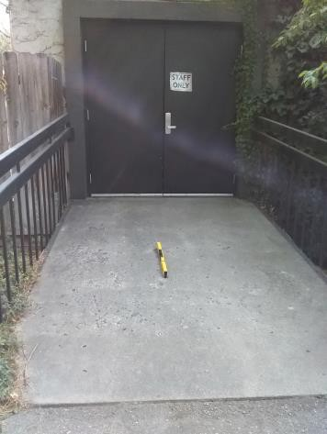

 | ID:  3170 | Facility:  City of Boise Zoo

Location Education Building Men’s Restroom by Condor Exhibit
Schedule 2021
Estimated Cost: $2,500.00

Priority Score 4
Quick Fix: No
Built before ADA: Yes

VIOLATIONS
2010 ADA Standards for Accessible Design Codes §404.2.4.1
There is not adequate maneuvering clearance to operate the door as the hallway is 40" wide.

RECOMMENDATIONS
Change the direction that the door swings or expand the area for which the door opens by removing obstructions to provide adequate maneuvering clearance of 60" perpendicular to the doorway.

PHOTOGRAPH(S) OF THIS LOCATION

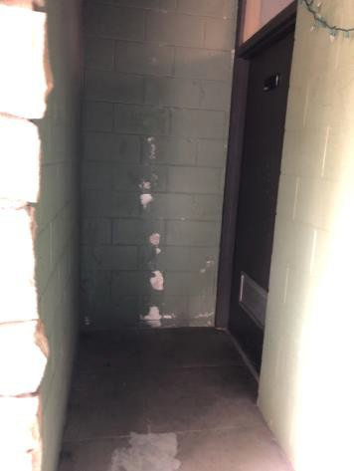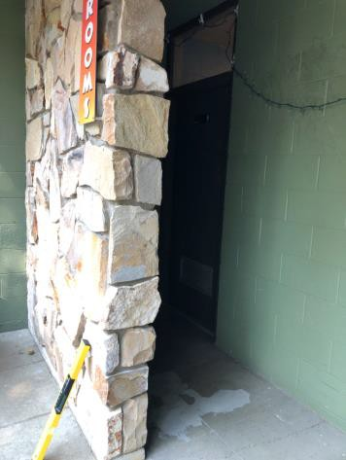

 | ID:  2361 | Facility:  City of Boise Zoo

Location Education Building towards Zoo Kitchen
Schedule 2021
Estimated Cost: $2,500.00

Priority Score 3
Quick Fix: No
Built before ADA: Yes

VIOLATIONS
2010 ADA Standards for Accessible Design Codes §403.3
The running slope reaches 12.1%.

RECOMMENDATIONS
Reconstruct the route to reduce the running slope to a maximum of 5% or 8.3% with handrails and level landings.

PHOTOGRAPH(S) OF THIS LOCATION

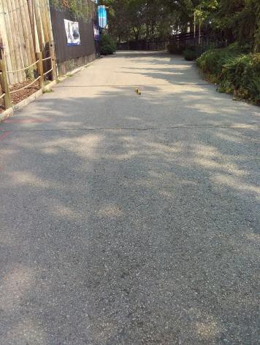

 | ID:  3070 | Facility:  City of Boise Zoo

Location Education Building Women’s Restroom
Schedule 2021
Estimated Cost: $100.00

Priority Score 5
Quick Fix: Yes
Built before ADA: Yes

VIOLATIONS
2010 ADA Standards for Accessible Design Codes §604.7
The toilet paper dispenser is located out of the accessible reach range.

RECOMMENDATIONS
Remount the toilet paper dispenser to 7” minimum and 9” maximum in front of the water closet measured to the centerline of the dispenser.
The outlet of the dispenser shall be 15” minimum and 48” maximum above the floor and shall not be located behind the water closet.

PHOTOGRAPH(S) OF THIS LOCATION

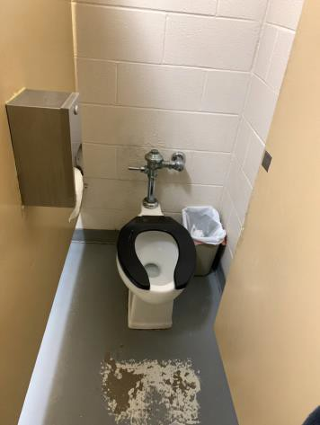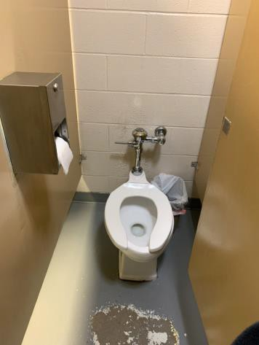

 | ID:  3680 | Facility:  City of Boise Zoo

Location Education Building Women’s Restroom
Schedule 2021
Estimated Cost: $100.00

Priority Score 3
Quick Fix: Yes
Built before ADA: Yes

VIOLATIONS
2010 ADA Standards for Accessible Design Codes §216.2, §703
There is no tactile sign identifying the permanent room.

RECOMMENDATIONS
Install tactile signage on the latch side of the doorway at a height of 48” minimum to 60” maximum above the floor, identifying room by name or room number.
Signs shall be Braille with raised lettering and should be placed on the wall in the center of an 18"x18" clear floor space.

PHOTOGRAPH(S) OF THIS LOCATION

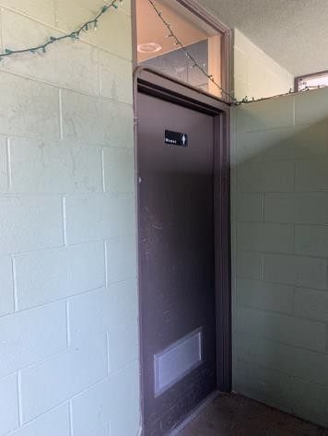

 | ID:  3739 | Facility:  City of Boise Zoo

Location Education Building Women’s Restroom
Schedule 2021
Estimated Cost: $100.00

Priority Score 8
Quick Fix: Yes
Built before ADA: Yes

VIOLATIONS
2010 ADA Standards for Accessible Design Codes §308.2.1
The paper towel dispenser is outside of the unobstructed forward reach range at 49.5" above the floor.

RECOMMENDATIONS
Lower the paper towel dispenser by 1.5" to meet the accessible reach range of 48" maximum above the floor.

PHOTOGRAPH(S) OF THIS LOCATION

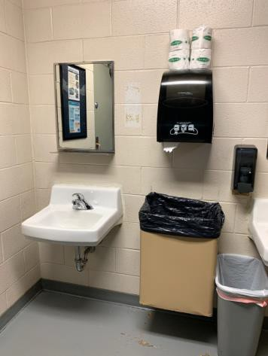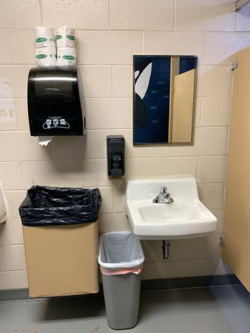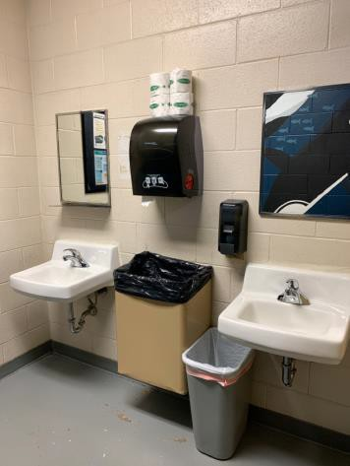

 | ID:  3737 | Facility:  City of Boise Zoo

Location Education Building Women’s Restroom
Schedule 2021
Estimated Cost: $200.00

Priority Score 7
Quick Fix: Yes
Built before ADA: Yes

VIOLATIONS
2010 ADA Standards for Accessible Design Codes §606.5
The pipes under the sinks are not covered.

RECOMMENDATIONS
Wrap the pipes beneath the sinks with soft protective wrap or plastic.

PHOTOGRAPH(S) OF THIS LOCATION

 | ID:  3738 | Facility:  City of Boise Zoo

Location Education Building Women’s Restroom
Schedule 2021
Estimated Cost: $200.00

Priority Score 7
Quick Fix:Yes
Built before ADA: Yes

VIOLATIONS
2010 ADA Standards for Accessible Design Codes §603.3
The mirrors are too high to be accessible at 46" above the floor.

RECOMMENDATIONS
Lower the mirrors so its bottom edge is a maximum height of 40" above the floor.

PHOTOGRAPH(S) OF THIS LOCATION

 | ID:  3068 | Facility:  City of Boise Zoo

Location Education Building Women’s Restroom
Schedule 2022
Estimated Cost: $5,000.00

Priority Score 5
Quick Fix: No
Built before ADA: Yes

VIOLATIONS
2010 ADA Standards for Accessible Design Codes §213.3.1, §604.8.2.1
There is not an accessible stall in the Education Building Women’s Restroom at 57" deep and 30" wide.

RECOMMENDATIONS
Expand the restroom to ensure 60" minimum measured perpendicular from the side wall and 56" minimum measured perpendicular from the rear wall.

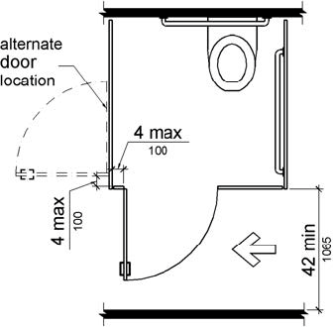

PHOTOGRAPH(S) OF THIS LOCATION

 | ID:  3122 | Facility:  City of Boise Zoo

Location Education Building Women’s Restroom by Condor Exhibit
Schedule 2021
Estimated Cost: $2,500.00

Priority Score 4
Quick Fix: No
Built before ADA: Yes

VIOLATIONS
2010 ADA Standards for Accessible Design Codes §404.2.4.1
There is not adequate maneuvering clearance to operate the door as the hallway is 40" wide.

RECOMMENDATIONS
Change the direction that the door swings or expand the area for which the door opens by removing obstructions to provide adequate maneuvering clearance of 60" perpendicular to the doorway.

PHOTOGRAPH(S) OF THIS LOCATION

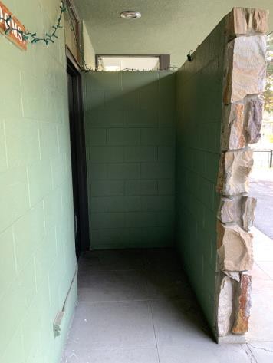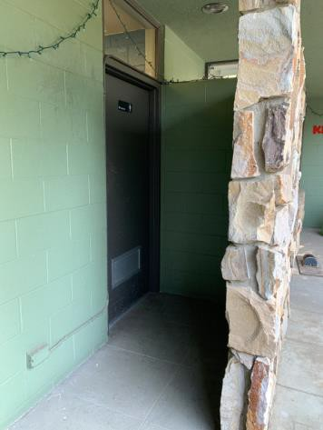

 | ID:  3043 | Facility:  City of Boise Zoo

Location Entire Facility
Schedule 2022
Estimated Cost: $500.00

Priority Score 5
Quick Fix: Yes
Built before ADA: Yes

VIOLATIONS
2010 ADA Standards for Accessible Design Codes §903.2
There is no clear floor space next to most of the benches throughout the zoo.

RECOMMENDATIONS
For the purposes of achieving greater accessibility and Human Centric Design, install a 30"x48" clear floor space at the end of the bench seat and parallel to the short axis of the bench or relocate the benches on the accessible route.

PHOTOGRAPH(S) OF THIS LOCATION

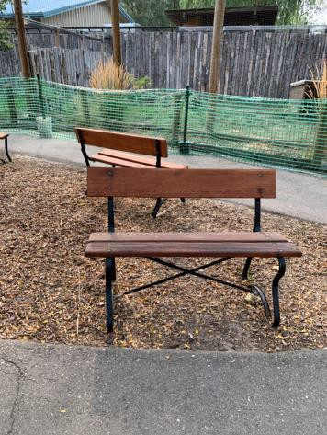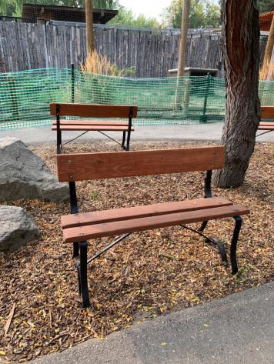

 | ID:  3654 | Facility:  City of Boise Zoo

Location Entire Facility
Schedule 2021
Estimated Cost: $500.00

Priority Score 0
Quick Fix: Yes
Built before ADA: Yes

VIOLATIONS
2010 ADA Standards for Accessible Design Codes §903.4
Benches throughout the zoo do not provide back support. Benches are located at the Giraffe viewing area, main entrance gate 1, central paving entry bridge, Serval Cat viewing, EO Wilson Science and Exhibit Hall in Gorongosa National Park, and the Education Building.

RECOMMENDATIONS
For the purposes of achieving greater accessibility and Human Centric Design, consider dispersing benches with back support throughout the zoo.

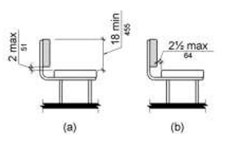

PHOTOGRAPH(S) OF THIS LOCATION

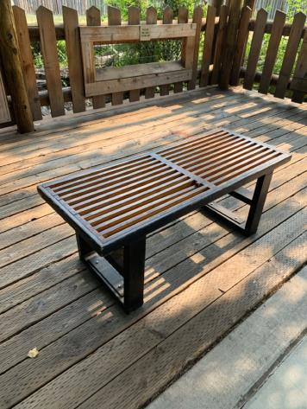 f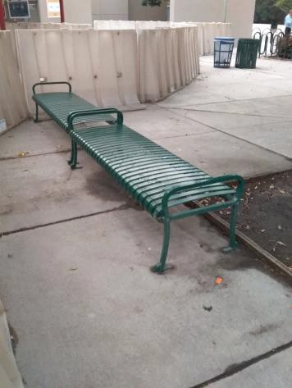 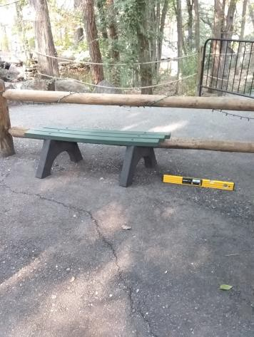

 | ID:  3501 | Facility:  City of Boise Zoo

Location Entire Facility
Schedule 2021
Estimated Cost: $19,000.00

Priority Score 3
Quick Fix: No
Built before ADA: Yes

VIOLATIONS
2010 ADA Standards for Accessible Design Codes §216.2, §703
There is no tactile signs identifying 190 permanent rooms

RECOMMENDATIONS
Install tactile signage on the latch side of all the doorways, leading to permanent rooms or places, at a height of 48” minimum to 60” maximum above the floor, identifying the room by name or room number.
Signs shall be Braille with raised lettering and should be placed on the wall in the center of an 18"x18" clear floor space.

PHOTOGRAPH(S) OF THIS LOCATION

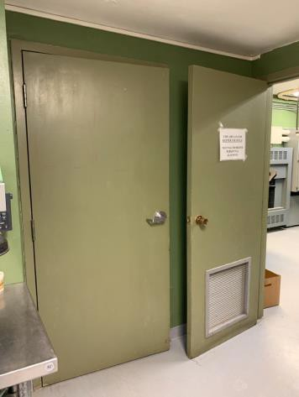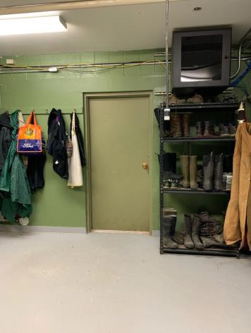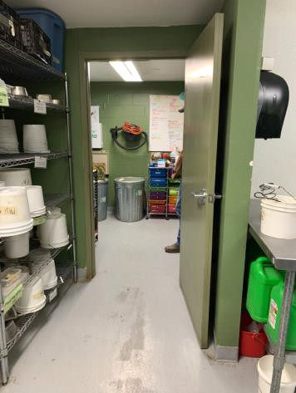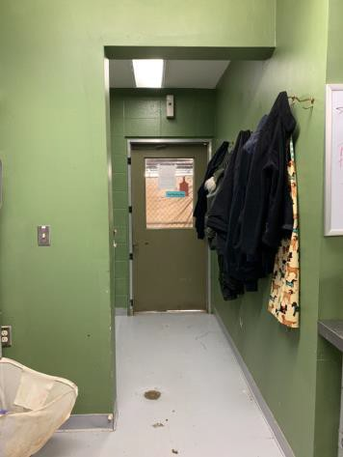

 | ID:  2891 | Facility:  City of Boise Zoo

Location Entrance
Schedule 2021
Estimated Cost: $1,000.00

Priority Score 3
Quick Fix: No
Built before ADA: Yes

VIOLATIONS
2010 ADA Standards for Accessible Design Codes §302.3
There are open grates in the pathway posing a tripping hazard.

RECOMMENDATIONS
Replace the grate with one that has gaps that are a maximum of 0.5”.

PHOTOGRAPH(S) OF THIS LOCATION

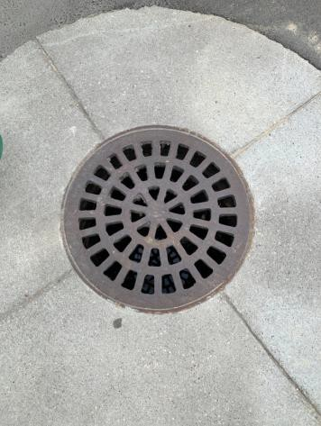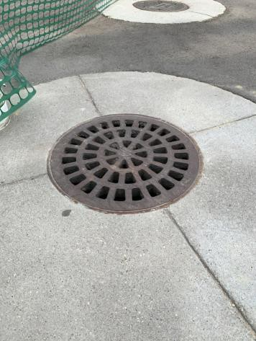

 | ID:  2866 | Facility:  City of Boise Zoo

Location Entrance Drinking Fountains
Schedule 2021
Estimated Cost: $500.00

Priority Score 10
Quick Fix: Yes
Built before ADA: Yes

VIOLATIONS
2010 ADA Standards for Accessible Design Codes §602, §307.2
The drinking fountains protrude 19" into the circulation path.

RECOMMENDATIONS
Place a drinking fountain skirt at this location to provide cane detectability.

PHOTOGRAPH(S) OF THIS LOCATION

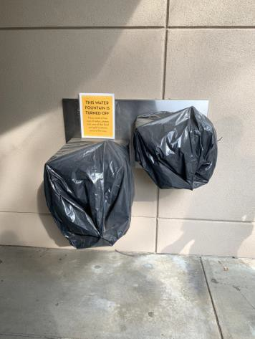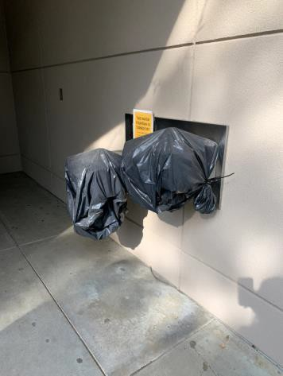

 | ID:  2856 | Facility:  City of Boise Zoo

Location Entrance Women’s Restroom
Schedule 2021
Estimated Cost: $100.00

3

Priority Score 5
Quick Fix: Yes
Built before ADA: Yes

VIOLATIONS
2010 ADA Standards for Accessible Design Codes §305.2
The clear floor space is obstructed by a door stop.

RECOMMENDATIONS
Remove the door stop from the sink's clear floor space.

PHOTOGRAPH(S) OF THIS LOCATION

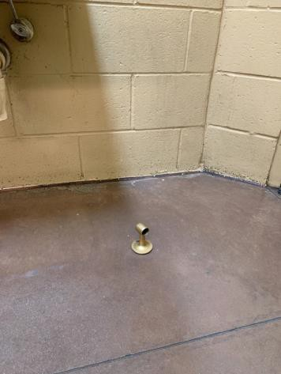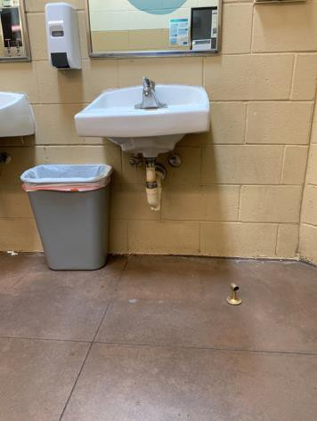

 | ID:  2857 | Facility:  City of Boise Zoo

Location Entrance Women’s Restroom
Schedule 2021
Estimated Cost: $100.00

Priority Score 5
Quick Fix: Yes
Built before ADA: Yes

VIOLATIONS
2010 ADA Standards for Accessible Design Codes §604.8.1.2
The door to the accessible water closet is not self closing. Either self-closing hinges are not installed on the door or if installed, they are defective.

RECOMMENDATIONS
Install or reinstall self-closing hinges on the door to ensure that the door is self-closing per the ADA requirements.

PHOTOGRAPH(S) OF THIS LOCATION

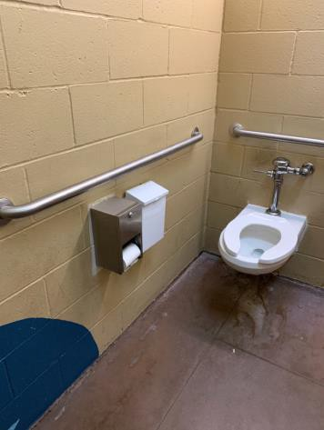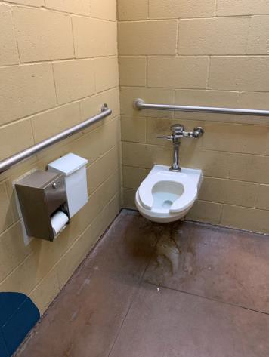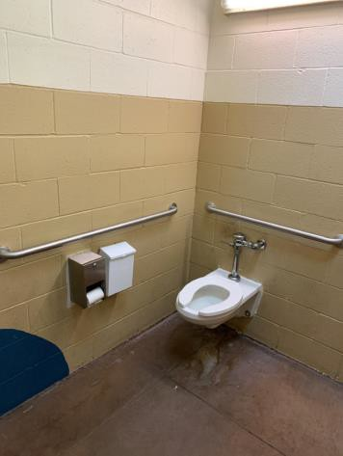

 | ID:  2861 | Facility:  City of Boise Zoo

Location Entrance Women’s Restroom
Schedule 2021
Estimated Cost: $100.00

Priority Score 5
Quick Fix: Yes
Built before ADA: Yes

VIOLATIONS
2010 ADA Standards for Accessible Design Codes §604.7
The toilet paper dispenser is located out of the accessible reach range at 13" from the rim.

RECOMMENDATIONS
Remount the toilet paper dispenser to 7” minimum and 9” maximum in front of the water closet measured to the centerline of the dispenser.
The outlet of the dispenser shall be 15” minimum and 48” maximum above the floor and shall not be located behind the water closet.

PHOTOGRAPH(S) OF THIS LOCATION

 | ID:  2862 | Facility:  City of Boise Zoo

Location Entrance Women’s Restroom
Schedule 2021
Estimated Cost: $100.00

Priority Score 5
Yes
Quick Fix: No
Built before ADA: Yes

VIOLATIONS
2010 ADA Standards for Accessible Design Codes §307.2, §308.2.1
The dispenser is outside of the unobstructed forward reach range at 48.75" above the floor. The dispenser protrudes 6.75" into the circulation space at 48.75" above the floor.

RECOMMENDATIONS
Lower the dispenser by 0.75" to meet the accessible reach range of 48" maximum above the floor.
Recess the dispenser so it protrudes a maximum of 4" or place a cane detectable object beneath it.

PHOTOGRAPH(S) OF THIS LOCATION

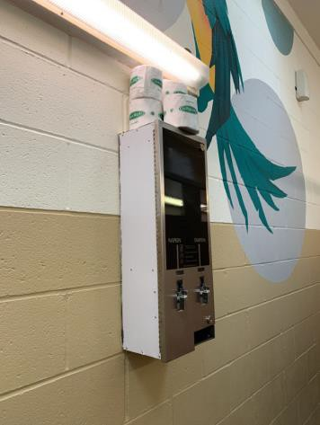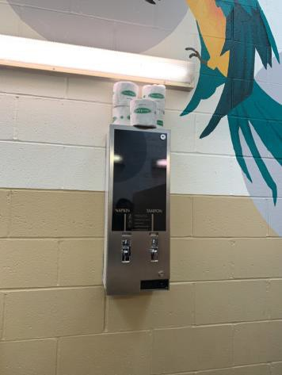

 | ID:  2863 | Facility:  City of Boise Zoo

Location Entrance Women’s Restroom
Schedule 2021
Estimated Cost: $100.00

Priority Score 5
Quick Fix: Yes
Built before ADA: Yes

VIOLATIONS
2010 ADA Standards for Accessible Design Codes §307.2
The paper towel dispenser protrudes 8.5" into the circulation space at 38.5" above the floor.

RECOMMENDATIONS
Recess the paper towel dispenser so it protrudes a maximum of 4" or place a cane detectable object beneath it.

PHOTOGRAPH(S) OF THIS LOCATION

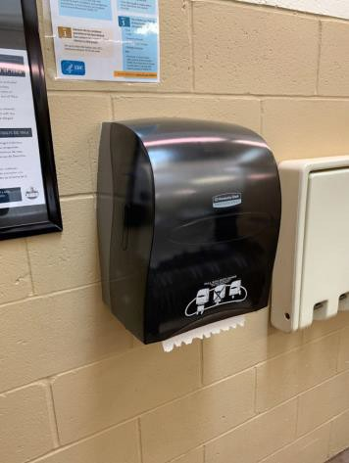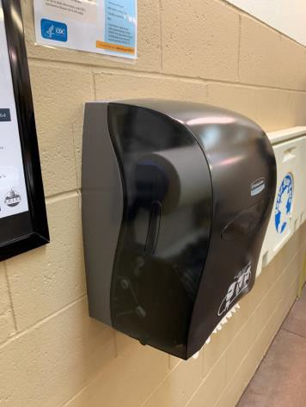

 | ID:  2864 | Facility:  City of Boise Zoo

Location Entrance Women’s Restroom
Schedule 2021
Estimated Cost: $200.00

Priority Score 7
Quick Fix: Yes
Built before ADA: Yes

VIOLATIONS
2010 ADA Standards for Accessible Design Codes §606.5
The pipes under the sinks are not covered.

RECOMMENDATIONS
Wrap the pipes beneath the sinks with soft protective wrap or plastic.

PHOTOGRAPH(S) OF THIS LOCATION

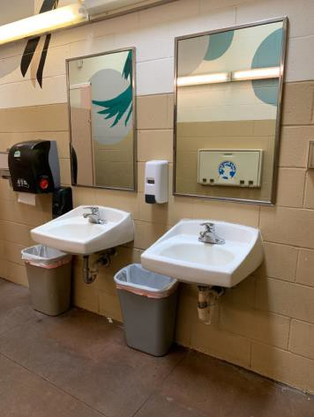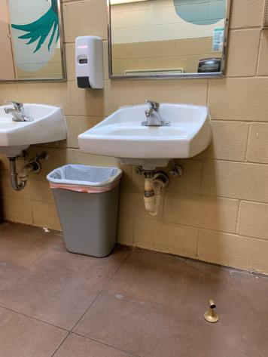

 | ID:  2865 | Facility:  City of Boise Zoo

Location Entrance Women’s Restroom
Schedule 2021
Estimated Cost: $200.00

Priority Score 7
Quick Fix: Yes
Built before ADA: Yes

VIOLATIONS
2010 ADA Standards for Accessible Design Codes §603.3
The mirrors are too high to be accessible at 41" above the floor.

RECOMMENDATIONS
Lower the mirrors so their bottom edges are a maximum height of 40" above the floor.

PHOTOGRAPH(S) OF THIS LOCATION

 | ID:  2860 | Facility:  City of Boise Zoo

Location Entrance Women’s Restroom
Schedule 2022
Estimated Cost: $1,000.00

Priority Score 5
Quick Fix: No
Built before ADA: Yes

VIOLATIONS
2010 ADA Standards for Accessible Design Codes §604.2
The centerline of the toilet is located 19" from the sidewall.

RECOMMENDATIONS
Reposition the centerline of the toilet to be within 16" minimum and 18" maximum from the sidewall.

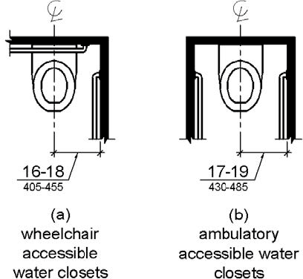

PHOTOGRAPH(S) OF THIS LOCATION

 | ID:  4490 | Facility:  City of Boise Zoo

Location Entrance Women’s Restroom
Schedule 2022
Estimated Cost: $1,000.00

Priority Score 5
Quick Fix: No
Built before ADA: Yes

VIOLATIONS
2010 ADA Standards for Accessible Design Codes ICC A117.1 §604.5.1
The accessible water closet does not have a vertical grab bar.

RECOMMENDATIONS
Install an 18" long (minimum) vertical grab bar on the side wall. The grab bar shall be mounted with the bottom located at 39" minimum and 41" maximum above the floor.
The centerline of the vertical grab bar shall be located 39" minimum and 41" maximum from the rear wall.

PHOTOGRAPH(S) OF THIS LOCATION

 | ID:  4491 | Facility:  City of Boise Zoo

Location Entrance Women’s Restroom
Schedule 2022
Estimated Cost: $1,000.00

Priority Score 5
Quick Fix: No
Built before ADA: Yes

VIOLATIONS
2010 ADA Standards for Accessible Design Codes §604.6
The flush control is located on the wall side of the toilet.

RECOMMENDATIONS
Either make the toilet flush automatically or relocate the flush control to be operated on the open side of the toilet.

PHOTOGRAPH(S) OF THIS LOCATION

 | ID:  2342 | Facility:  City of Boise Zoo

Location EO Wilson Science and Exhibit Hall
Schedule 2023
Estimated Cost: $3,000.00

Priority Score 8
Quick Fix: No
Built before ADA: Yes

VIOLATIONS
2010 ADA Standards for Accessible Design Codes §707
The interactive touch screen does not have any sound or tactile components. Therefore, a visually impaired person would not be able to access the information provided by the kiosk.

RECOMMENDATIONS
Audio instructions must be provided that guide the user through all the functions of the machine. Tactile instructions must be provided informing the user on the method of activating the audio instructions.

PHOTOGRAPH(S) OF THIS LOCATION

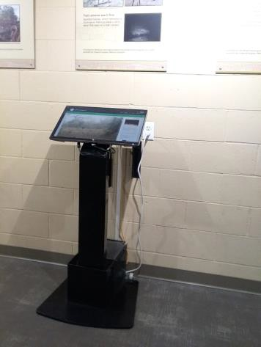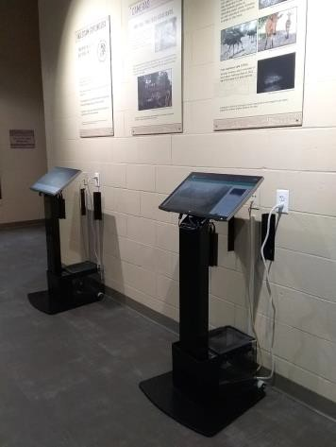

 | ID:  2996 | Facility:  City of Boise Zoo

Location EO Wilson Science and Exhibit Hall Men's Restroom
Schedule 2021
Estimated Cost: $2,500.00

Priority Score 5
Quick Fix: No
Built before ADA: Yes

VIOLATIONS
2010 ADA Standards for Accessible Design Codes §404.2.4.1
There is not adequate maneuvering clearance to operate the door at 47" wide. The FDC pipe is 11" deep protruding into the maneuvering clearance.

RECOMMENDATIONS
Change the direction that the door swings or expand the area for which the door opens by removing obstructions to provide adequate maneuvering clearance of 60" perpendicular to the doorway.

PHOTOGRAPH(S) OF THIS LOCATION

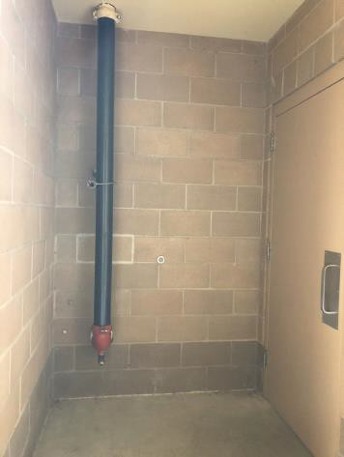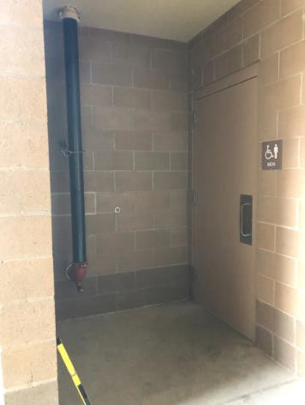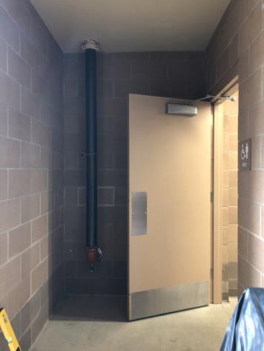

 | ID:  3520 | Facility:  City of Boise Zoo

Location EO Wilson Science and Exhibit Hall Women's Restroom
Schedule 2021
Estimated Cost: $100.00

Priority Score 5
Quick Fix: No
Built before ADA: Yes

VIOLATIONS
2010 ADA Standards for Accessible Design Codes §604.7
The toilet paper dispenser is located out of the accessible reach range at 5" in front of the rim.

RECOMMENDATIONS
Remount the toilet paper dispenser to 7” minimum and 9” maximum in front of the water closet measured to the centerline of the dispenser.
The outlet of the dispenser shall be 15” minimum and 48” maximum above the floor and shall not be located behind the water closet.

PHOTOGRAPH(S) OF THIS LOCATION

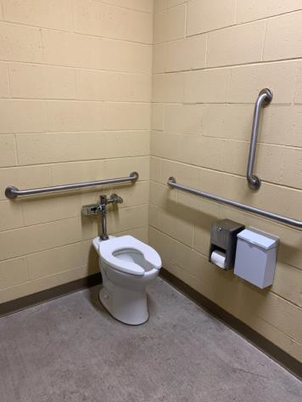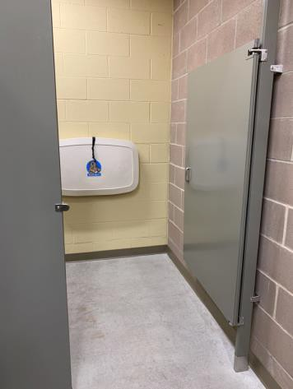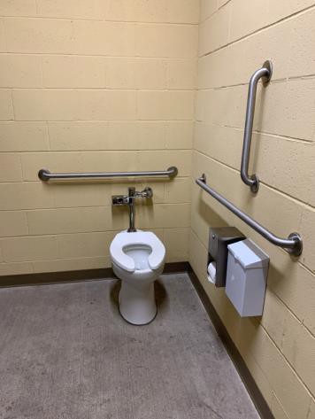

 | ID:  3521 | Facility:  City of Boise Zoo

Location EO Wilson Science and Exhibit Hall Women's Restroom
Schedule 2021
Estimated Cost: $100.00

Priority Score 5
Quick Fix: Yes
Built before ADA: Yes

VIOLATIONS
2010 ADA Standards for Accessible Design Codes §604.8.1.2
The door to the accessible water closet is not self closing. Either self-closing hinges are not installed on the door or if installed, they are defective.

RECOMMENDATIONS
Install or reinstall self-closing hinges on the door to ensure that the door is self-closing per the ADA requirements.

PHOTOGRAPH(S) OF THIS LOCATION

 | ID:  3519 | Facility:  City of Boise Zoo

Location EO Wilson Science and Exhibit Hall Women's Restroom
Schedule 2022
Estimated Cost: $1,000.00

Priority Score 5
Quick Fix: No
Built before ADA: Yes

VIOLATIONS
2010 ADA Standards for Accessible Design Codes §604.2
The centerline of the toilet is located 18.5" from the sidewall.

RECOMMENDATIONS
Reposition the centerline of the toilet to be within 16" minimum and 18" maximum from the sidewall.

PHOTOGRAPH(S) OF THIS LOCATION

 | ID:  3130 | Facility:  City of Boise Zoo

Location Farm Animals Exhibit
Schedule 2021
Estimated Cost: $500.00

Priority Score 3
Quick Fix: Yes
Built before ADA: Yes

VIOLATIONS
2010 ADA Standards for Accessible Design Codes §302.1
There is a change in level that pose tripping hazards in the accessible route.

RECOMMENDATIONS
Repave the area of the sidewalk to remove the change in level.

PHOTOGRAPH(S) OF THIS LOCATION

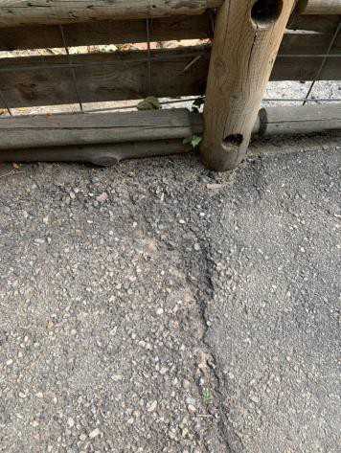

 | ID:  3212 | Facility:  City of Boise Zoo

Location Farm Animals Exhibit
Schedule 2021
Estimated Cost: $1,000.00

Priority Score 3
Quick Fix: No
Built before ADA: Yes

VIOLATIONS
2010 ADA Standards for Accessible Design Codes §403.3
The cross slope is 4%.

RECOMMENDATIONS
Resurface the route to reduce the cross slope to a maximum of 2%.

PHOTOGRAPH(S) OF THIS LOCATION

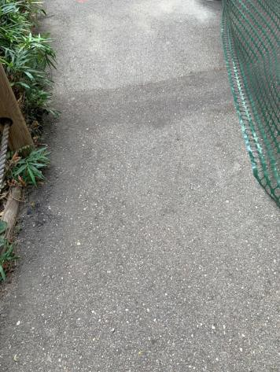

 | ID:  3755 | Facility:  City of Boise Zoo

Location Farm Animals Exhibit
Schedule 2021
Estimated Cost: $2,500.00

Priority Score 3
Quick Fix: No
Built before ADA: Yes

VIOLATIONS
2010 ADA Standards for Accessible Design Codes §403.3
The running slope is 9.5% and the cross slope is 10%.

RECOMMENDATIONS
Reconstruct the route to reduce the cross slope to a maximum of 2% and a maximum running slope of 5%.

PHOTOGRAPH(S) OF THIS LOCATION

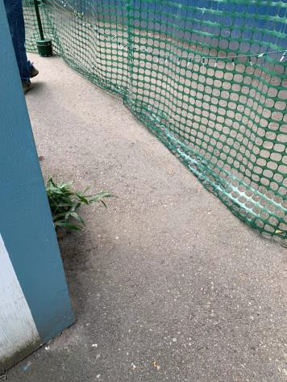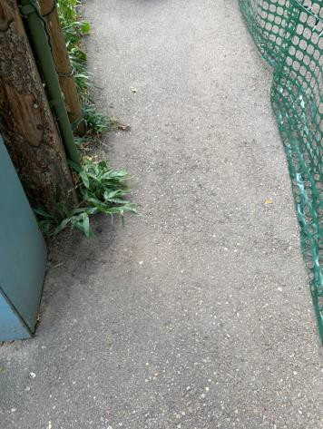

 | ID:  3481 | Facility:  City of Boise Zoo

Location Farm Animals Exhibit Food Dispenser Machines
Schedule 2022
Estimated Cost: $1,000.00

Priority Score 7
Quick Fix: No
Built before ADA: Yes

VIOLATIONS
2010 ADA Standards for Accessible Design Codes §305.2
The clear floor space has a 3.1% slope.

RECOMMENDATIONS
Resurface the 30"x48" clear floor space to have a maximum slope of 2% in all directions.

PHOTOGRAPH(S) OF THIS LOCATION

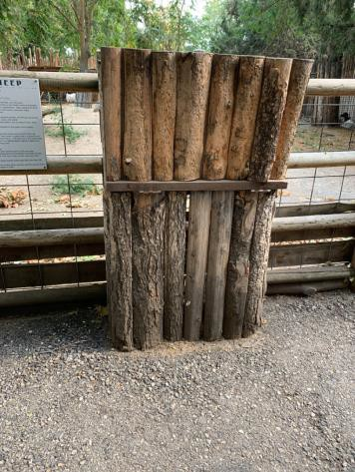

 | ID:  3652 | Facility:  City of Boise Zoo

Location Farm Animals Exhibit Stairs
Schedule 2022
Estimated Cost: $2,500.00

Priority Score 5
Quick Fix: No
Built before ADA: Yes

VIOLATIONS
2010 ADA Standards for Accessible Design Codes §505.3
The handrails are not continuous for the full length of each flight of stairs.

RECOMMENDATIONS
Extend the handrails to be continuous for the full length of each flight of stairs.

PHOTOGRAPH(S) OF THIS LOCATION

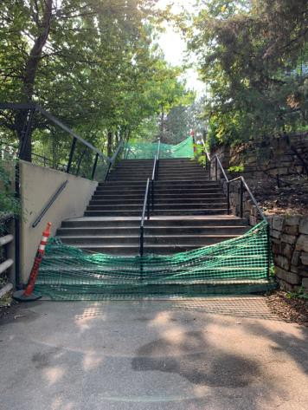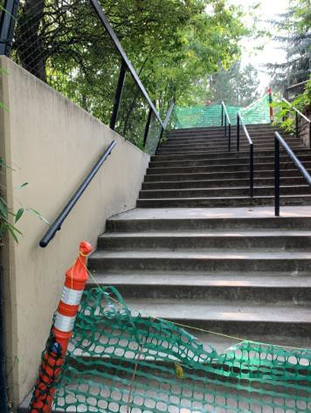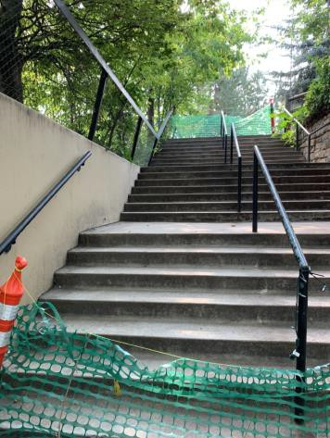

 | ID:  2351 | Facility:  City of Boise Zoo

Location FOZB (Friends of Zoo Boise)
Schedule 2022
Estimated Cost: $1,000.00

Priority Score 5
Quick Fix: No
Built before ADA: Yes

VIOLATIONS
2010 ADA Standards for Accessible Design Codes §505.4
Handrails are not located at a compliant height above the stair nosings

RECOMMENDATIONS
Lower the handrails to a minimum height of 34" and a maximum of 38" above the stair nosings. Ensure that the handrails are at a consistent height along the stair treads.

PHOTOGRAPH(S) OF THIS LOCATION

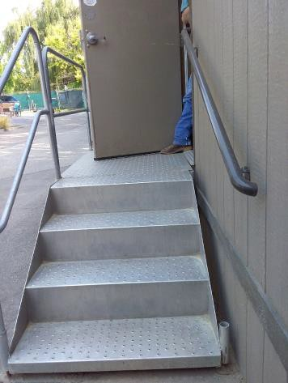

 | ID:  3429 | Facility:  City of Boise Zoo

Location Friends of Zoo Boise Kitchen
Schedule 2021
Estimated Cost: $100.00

Priority Score 8
Quick Fix: Yes
Built before ADA: Yes

VIOLATIONS
2010 ADA Standards for Accessible Design Codes §308.2.1
The paper towel dispenser is outside of the unobstructed forward reach range at 53" above the floor.

RECOMMENDATIONS
Lower the paper towel dispenser by 5" to meet the accessible reach range of 48" maximum above the floor.

PHOTOGRAPH(S) OF THIS LOCATION

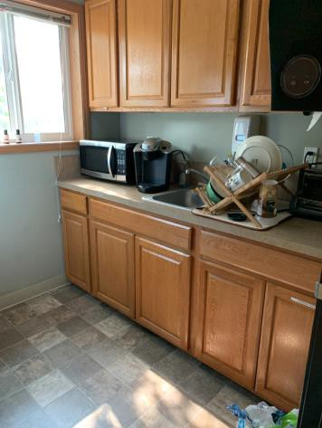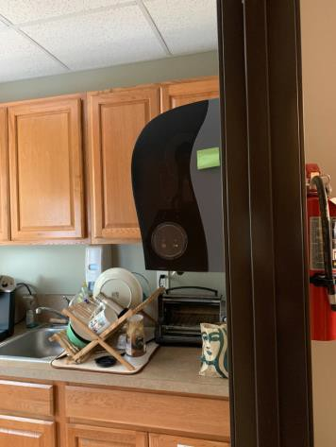

 | ID:  3430 | Facility:  City of Boise Zoo

Location Friends of Zoo Boise Kitchen
Schedule 2023
Estimated Cost: $1,000.00

Priority Score 8
Quick Fix: No
Built before ADA: Yes

VIOLATIONS
2010 ADA Standards for Accessible Design Codes §306.3.3, §606.3, §902.3
The dining and work surface counter is 34.5" above the floor. The sink is 34.5" above the floor. There is no knee clearance underneath the sink.

RECOMMENDATIONS
A 30" portion of the dining and work surface must be no higher than 34” above the floor. Lower the sink to the maximum height of 34" above the floor.
Provide knee clearance underneath the counter at the sink that is a minimum of 11" deep at 9" above the floor and 8" deep at 27" above the floor.

PHOTOGRAPH(S) OF THIS LOCATION

 | ID:  3327 | Facility:  City of Boise Zoo

Location Friends of Zoo Boise Restroom
Schedule 2021
Estimated Cost: $100.00

Priority Score 8
Quick Fix: Yes
Built before ADA: Yes

VIOLATIONS
2010 ADA Standards for Accessible Design Codes §308.2.1
The paper towel dispenser is outside of the unobstructed forward reach range at 51" above the floor.

RECOMMENDATIONS
Lower the paper towel dispenser by 3" to meet the accessible reach range of 48" maximum above the floor.

PHOTOGRAPH(S) OF THIS LOCATION

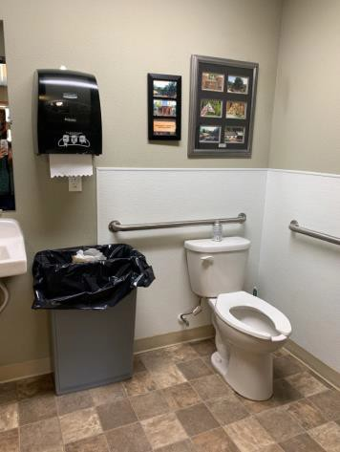

 | ID:  3329 | Facility:  City of Boise Zoo

Location Friends of Zoo Boise Restroom
Schedule 2021
Estimated Cost: $100.00

Priority Score 5
Quick Fix: Yes
Built before ADA: Yes

VIOLATIONS
2010 ADA Standards for Accessible Design Codes §604.8.1.2
The door to the accessible water closet is not self closing. Either self-closing hinges are not installed on the door or if installed, they are defective.

RECOMMENDATIONS
Install or reinstall self-closing hinges on the door to ensure that the door is self-closing per the ADA requirements.

PHOTOGRAPH(S) OF THIS LOCATION

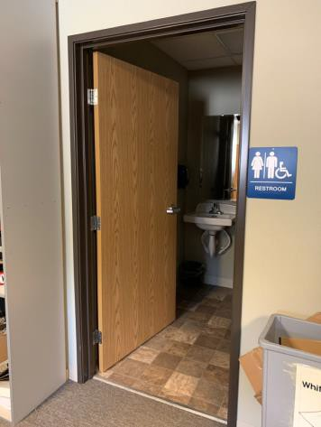

 | ID:  3328 | Facility:  City of Boise Zoo

Location Friends of Zoo Boise Restroom
Schedule 2021
Estimated Cost: $500.00

Priority Score 5
Quick Fix: Yes
Built before ADA: Yes

VIOLATIONS
2010 ADA Standards for Accessible Design Codes §604.5.1
The side grab bar extends 49" from the rear wall.

RECOMMENDATIONS
Remount the side grab bar 12" maximum from the rear wall and extending 54" minimum from the rear wall.

PHOTOGRAPH(S) OF THIS LOCATION

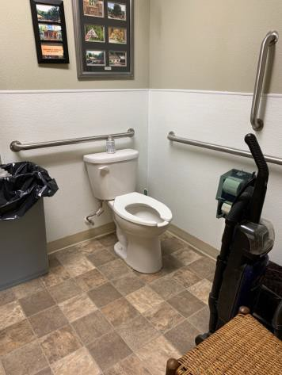

 | ID:  3073 | Facility:  City of Boise Zoo

Location Friends of Zoo Boise Wooden Ramp
Schedule 2022
Estimated Cost: $2,000.00

Priority Score 5
Quick Fix: No
Built before ADA: Yes

VIOLATIONS
2010 ADA Standards for Accessible Design Codes §505.10.1
The handrail extensions are 10".

RECOMMENDATIONS
Install new handrails that have handrail extensions that either return to a wall, guard, or the landing surface which extend at least 12" beyond the ramp run.

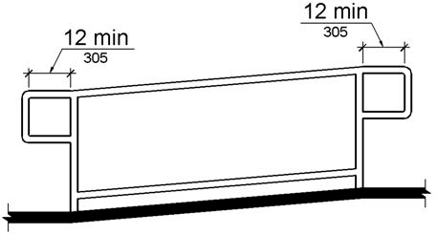

PHOTOGRAPH(S) OF THIS LOCATION

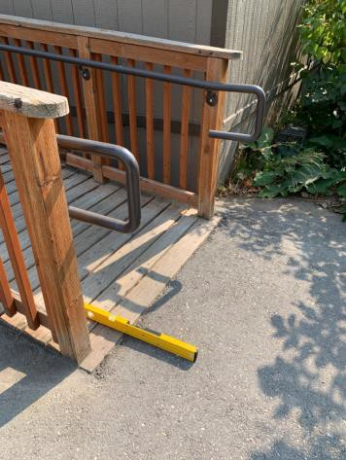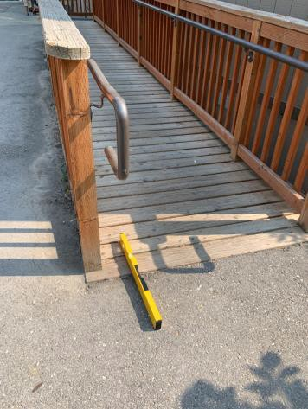

 | ID:  2347 | Facility:  City of Boise Zoo

Location Garbage Can Across from Zoo Kitchen
Schedule 2022
Estimated Cost: $2,500.00

Priority Score 7
Quick Fix: No
Built before ADA: Yes

VIOLATIONS
2010 ADA Standards for Accessible Design Codes §305.2
The clear floor space to the garbage can has a 5% slope.

RECOMMENDATIONS
Reconstruct the 30"x48" clear floor space to have a maximum slope of 2% in all directions or relocate the garbage can to a level area.

PHOTOGRAPH(S) OF THIS LOCATION

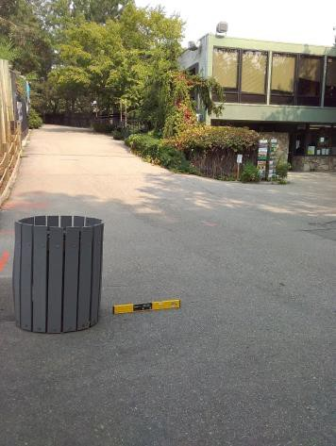

 | ID:  2341 | Facility:  City of Boise Zoo

Location Garbage Can at Gorongosa Entrance Across From Southern Ground Hornbill
Schedule 2022
Estimated Cost: $2,500.00

Priority Score 7
Quick Fix: No
Built before ADA: Yes

VIOLATIONS
2010 ADA Standards for Accessible Design Codes §305.2
The clear floor space to the garbage can has a 5% slope.

RECOMMENDATIONS
Reconstruct the 30"x48" clear floor space to have a maximum slope of 2% in all directions or relocate the garbage can to a level area.

PHOTOGRAPH(S) OF THIS LOCATION

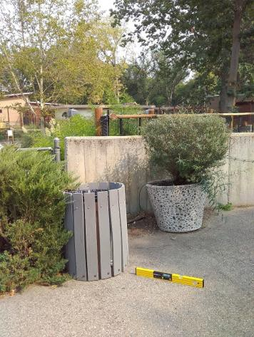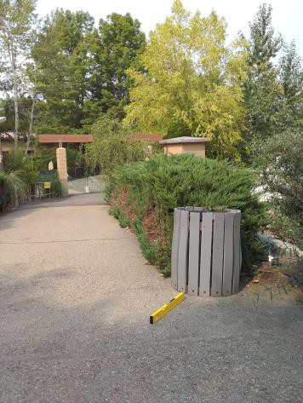

 | ID:  3589 | Facility:  City of Boise Zoo

Location Garbage Can at Sloth Bear Exhibit
Schedule 2022
Estimated Cost: $2,500.00

Priority Score 7
Quick Fix: No
Built before ADA: Yes

VIOLATIONS
2010 ADA Standards for Accessible Design Codes §305.2
The clear floor space has a 6% slope.

RECOMMENDATIONS
Reconstruct the 30"x48" clear floor space to have a maximum slope of 2% in all directions or relocate the garbage can to a level area.

PHOTOGRAPH(S) OF THIS LOCATION

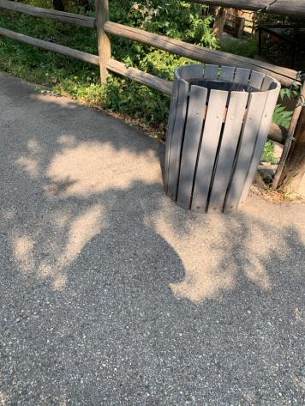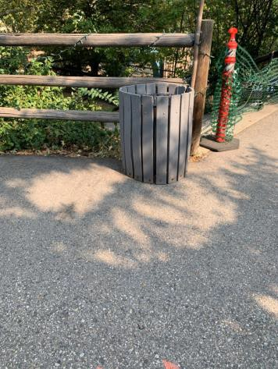

 | ID:  2333 | Facility:  City of Boise Zoo

Location Garbage Cans Across from Giraffe House
Schedule 2022
Estimated Cost: $2,500.00

Priority Score 7
Quick Fix: No
Built before ADA: Yes

VIOLATIONS
2010 ADA Standards for Accessible Design Codes §305.2
The clear floor space to the garbage cans has a 5.5% to 8.7% slope.

RECOMMENDATIONS
Reconstruct the 30"x48" clear floor space to have a maximum slope of 2% in all directions or relocate the garbage cans adjacent to a level area.

PHOTOGRAPH(S) OF THIS LOCATION

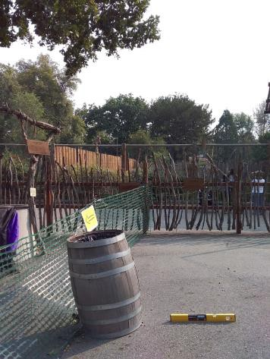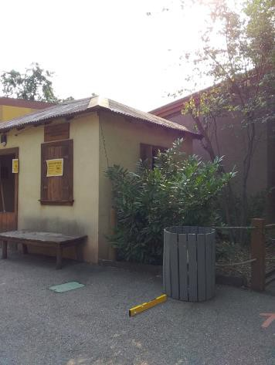

 | ID:  3011 | Facility:  City of Boise Zoo

Location Gift Shop Employee Restroom
Schedule 2021
Estimated Cost: $100.00

Priority Score 5
Quick Fix: Yes
Built before ADA: Yes

VIOLATIONS
2010 ADA Standards for Accessible Design Codes §604.7
The toilet paper dispenser is located out of the accessible reach range.

RECOMMENDATIONS
Remount the toilet paper dispenser to 7” minimum and 9” maximum in front of the water closet measured to the centerline of the dispenser.
The outlet of the dispenser shall be 15” minimum and 48” maximum above the floor and shall not be located behind the water closet.

PHOTOGRAPH(S) OF THIS LOCATION

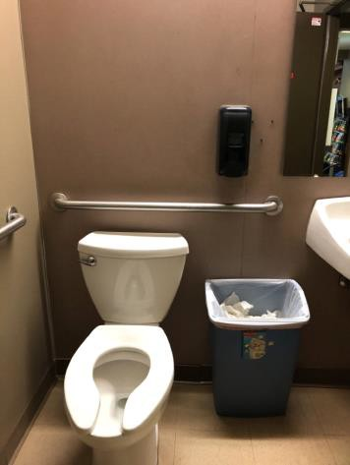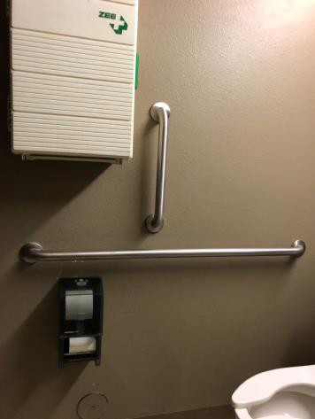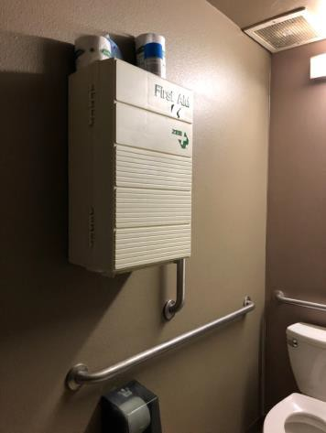

 | ID:  3012 | Facility:  City of Boise Zoo

Location Gift Shop Employee Restroom
Schedule 2021
Estimated Cost: $100.00

Priority Score 5
Quick Fix: Yes
Built before ADA: Yes

VIOLATIONS
2010 ADA Standards for Accessible Design Codes §307.2
The first aid box protrudes 9" into the circulation space.

RECOMMENDATIONS
Recess the first aid box so it protrudes a maximum of 4" or relocate it.

PHOTOGRAPH(S) OF THIS LOCATION

 | ID:  3588 | Facility:  City of Boise Zoo

Location Gift Shop Employee Restroom
Schedule 2021
Estimated Cost: $100.00

Priority Score 5
Quick Fix: Yes
Built before ADA: Yes

VIOLATIONS
2010 ADA Standards for Accessible Design Codes §308.2.1, §307.2
The paper towel dispenser protrudes into the circulation space at 52" above the floor.
The paper towel dispenser is outside of the unobstructed forward reach range at 52" above the floor.

RECOMMENDATIONS
Recess the paper towel dispenser so it protrudes a maximum of 4" or place a cane detectable object beneath it.
Lower the paper towel dispenser by 4" to meet the accessible reach range of 48" maximum above the floor.

PHOTOGRAPH(S) OF THIS LOCATION

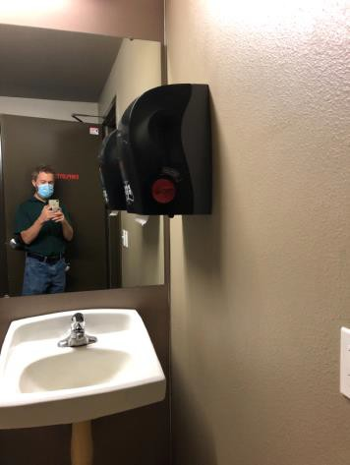

 | ID:  3419 | Facility:  City of Boise Zoo

Location Gift Shop Employee Restroom
Schedule 2022
Estimated Cost: $1,000.00

Priority Score 5
Quick Fix: No
Built before ADA: Yes

VIOLATIONS
2010 ADA Standards for Accessible Design Codes §604.6
The flush control is located on the wall side of the toilet.

RECOMMENDATIONS
Either make the toilet flush automatically or relocate the flush control to be operated on the open side of the toilet.

PHOTOGRAPH(S) OF THIS LOCATION

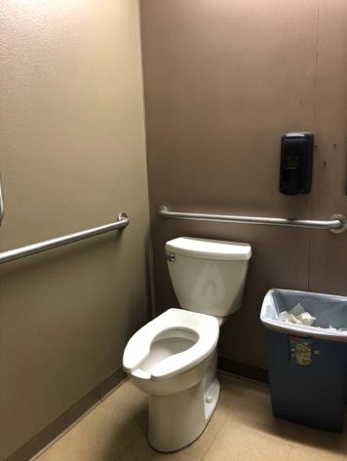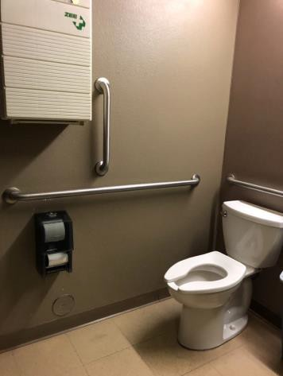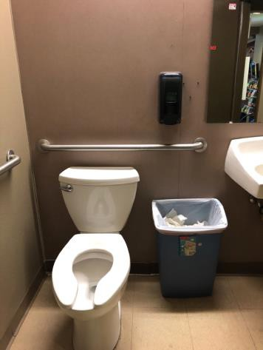

 | ID:  3102 | Facility:  City of Boise Zoo

Location Giraffe Slide
Schedule 2021
Estimated Cost: $100.00

Priority Score 8
Quick Fix: Yes
Built before ADA: Yes

VIOLATIONS
2010 ADA Standards for Accessible Design Codes §308.2.1
The hand sanitizer dispenser is outside of the unobstructed forward reach range at 53" above the floor.

RECOMMENDATIONS
Lower the hand sanitizer dispenser by 5" to meet the accessible reach range of 48" maximum above the floor.

PHOTOGRAPH(S) OF THIS LOCATION

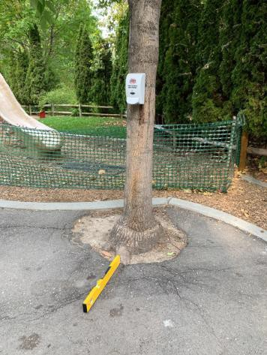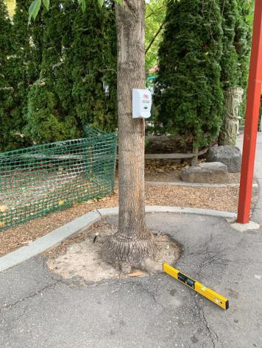

 | ID:  3101 | Facility:  City of Boise Zoo

Location Giraffe Slide
Schedule 2022
Estimated Cost: $2,500.00

Priority Score 7
Quick Fix: No
Built before ADA: Yes

VIOLATIONS
2010 ADA Standards for Accessible Design Codes §305.2
The clear floor space has a 5.4% slope and is not a full 30"x48".

RECOMMENDATIONS
Reconstruct the 30"x48" clear floor space to have a maximum slope of 2% in all directions.

PHOTOGRAPH(S) OF THIS LOCATION

 | ID:  3454 | Facility:  City of Boise Zoo

Location Giraffe Slide
Schedule 2021
Estimated Cost: $5,000.00

Priority Score 3
Quick Fix: No
Built before ADA: Yes

VIOLATIONS
2010 ADA Standards for Accessible Design Codes §302.1, ASTM F1951-99
The giraffe slide is not accessible. There are changes in level that pose tripping hazards on the route to the giraffe slide.
The playground surface is not stable, firm, and slip resistant.

RECOMMENDATIONS
Install an accessible play element in addition to the giraffe slide. Repave the area of the sidewalk to remove the change in level.
Replace the mulch with an accessible playground surface material such as pour-in-place rubber, rubber tiles, artificial grass, and engineered wood fiber.

PHOTOGRAPH(S) OF THIS LOCATION

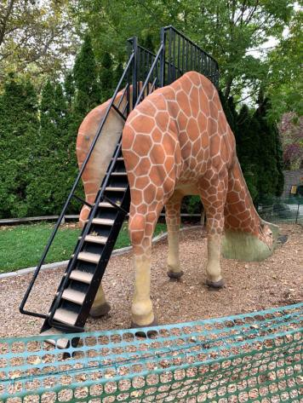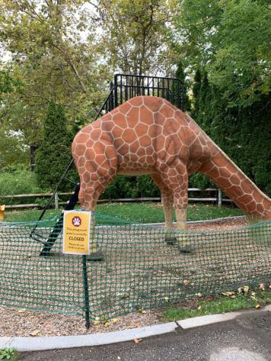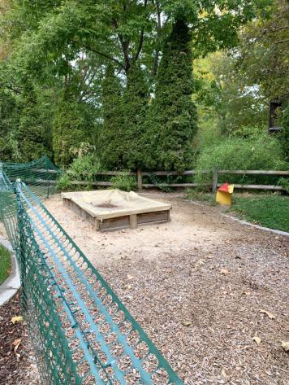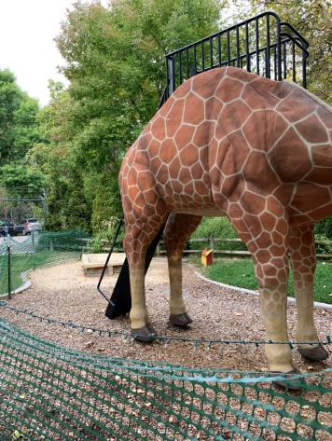

 | ID:  3342 | Facility:  City of Boise Zoo

Location Giraffes Viewing
Schedule 2021
Estimated Cost: $1,000.00

Priority Score 3
Quick Fix: No
Built before ADA: Yes

VIOLATIONS
2010 ADA Standards for Accessible Design Codes §305.2
The clear floor space has a 2.6% to 2.7% slope.

RECOMMENDATIONS
Resurface the 30"x48" clear floor space to have a maximum slope of 2% in all directions.

PHOTOGRAPH(S) OF THIS LOCATION

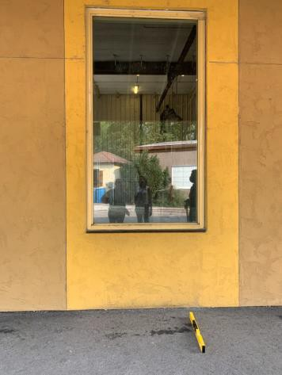

 | ID:  3350 | Facility:  City of Boise Zoo

Location Giraffes Viewing
Schedule 2022
Estimated Cost: $2,500.00

Priority Score 7
Quick Fix: No
Built before ADA: Yes

VIOLATIONS
2010 ADA Standards for Accessible Design Codes §405.2
The running slope of the ramp is 9.4%.

RECOMMENDATIONS
Reconstruct the ramp to reduce the running slope to a maximum of 8.3%.

PHOTOGRAPH(S) OF THIS LOCATION

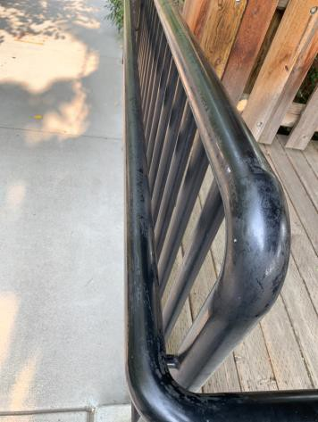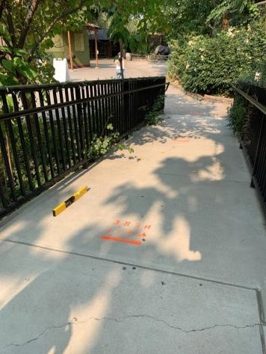

 | ID:  3354 | Facility:  City of Boise Zoo

Location Giraffes Viewing
Schedule 2021
Estimated Cost: $2,500.00

Priority Score 3
Quick Fix: No
Built before ADA: Yes

VIOLATIONS
2010 ADA Standards for Accessible Design Codes §405.7, §304.2
The turning space has a 12% slope.
There is not a level landing at the bottom of the ramp.

RECOMMENDATIONS
Reconstruct the turning space to reduce the slope to the maximum of 2% in all directions.
Install a level landing at the bottom of the ramp. Landings shall be as wide as the widest ramp run leading to the landing and 60" long minimum.

PHOTOGRAPH(S) OF THIS LOCATION

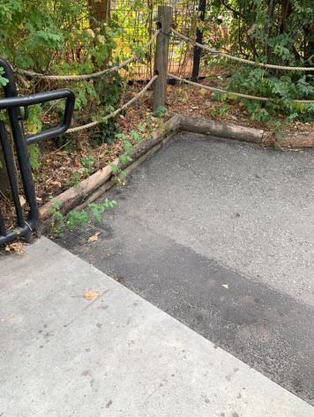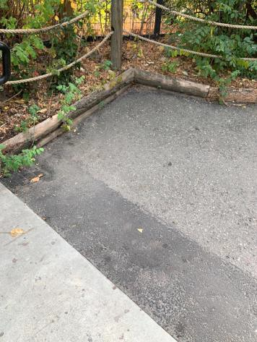

 | ID:  3389 | Facility:  City of Boise Zoo

Location Giraffes Viewing
Schedule 2021
Estimated Cost: $2,500.00

Priority Score 3
Quick Fix: No
Built before ADA: Yes

VIOLATIONS
2010 ADA Standards for Accessible Design Codes §403.3
The cross slope is 5%.

RECOMMENDATIONS
Reconstruct the route to reduce the cross slope to a maximum of 2%.

PHOTOGRAPH(S) OF THIS LOCATION

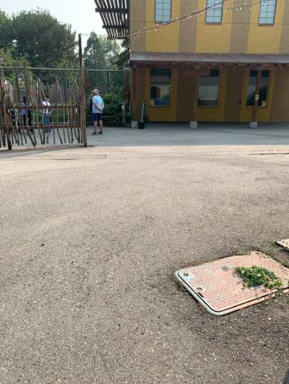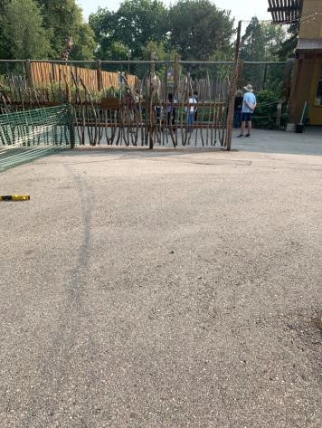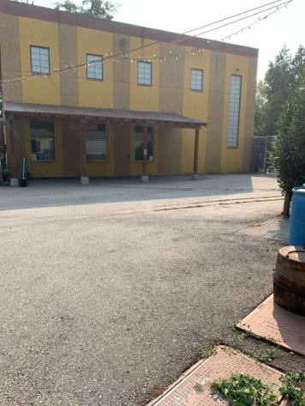

 | ID:  3543 | Facility:  City of Boise Zoo

Location Giraffes Viewing
Schedule 2021
Estimated Cost: $2,500.00

Priority Score 3
Quick Fix: No
Built before ADA: Yes

VIOLATIONS
2010 ADA Standards for Accessible Design Codes §403.3
The cross slope is 4.5%.

RECOMMENDATIONS
Reconstruct the route to reduce the cross slope to a maximum of 2%.

PHOTOGRAPH(S) OF THIS LOCATION

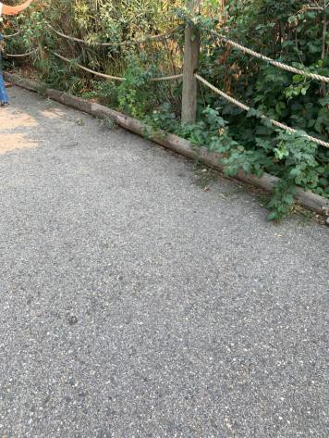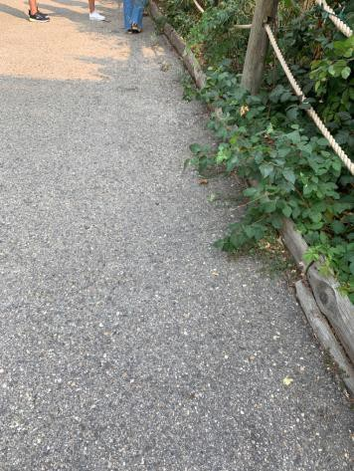

 | ID:  3595 | Facility:  City of Boise Zoo

Location Giraffes Viewing
Schedule 2021
Estimated Cost: $2,500.00

Priority Score 3
Quick Fix: No
Built before ADA: Yes

VIOLATIONS
2010 ADA Standards for Accessible Design Codes §403.3
The cross slope is 10.5%.

RECOMMENDATIONS
Reconstruct the route to reduce the cross slope to a maximum of 2%.

PHOTOGRAPH(S) OF THIS LOCATION

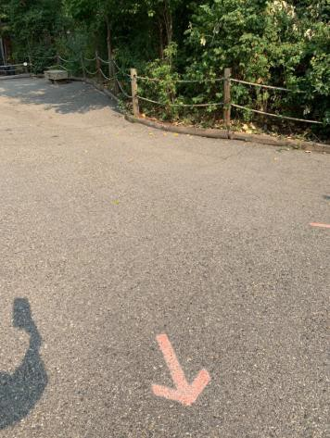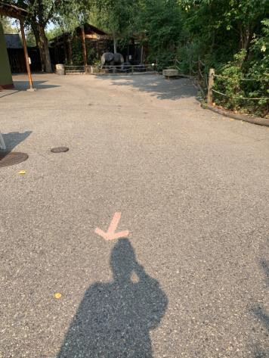

 | ID:  3759 | Facility:  City of Boise Zoo

Location Giraffes Viewing
Schedule 2021
Estimated Cost: $2,500.00

Priority Score 3
Quick Fix: No
Built before ADA: Yes

VIOLATIONS
2010 ADA Standards for Accessible Design Codes §405.7.1
The landing has a 2.3% cross slope and 4.6% running slope.

RECOMMENDATIONS
Reconstruct the top landing to have a maximum slope of 2% in all directions.

PHOTOGRAPH(S) OF THIS LOCATION

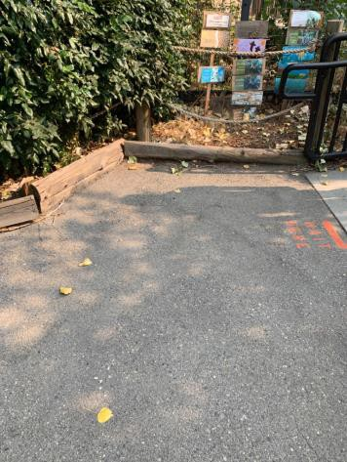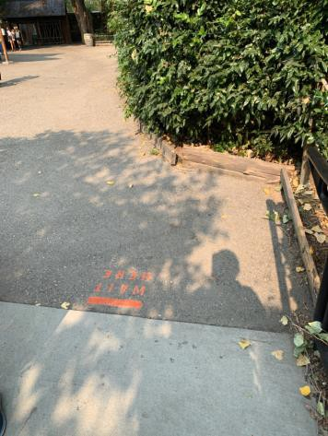

 | ID:  2340 | Facility:  City of Boise Zoo

Location Gorongosa Entrance at Southern Ground Hornbill
Schedule 2021
Estimated Cost: $2,500.00

Priority Score 3
Quick Fix: No
Built before ADA: Yes

VIOLATIONS
2010 ADA Standards for Accessible Design Codes §305.2
The clear floor space at the Southern Ground Hornbill viewing has a 5% slope.

RECOMMENDATIONS
Reconstruct a minimum of a 30"x48" clear floor space to have a maximum slope of 2% in all directions.

PHOTOGRAPH(S) OF THIS LOCATION

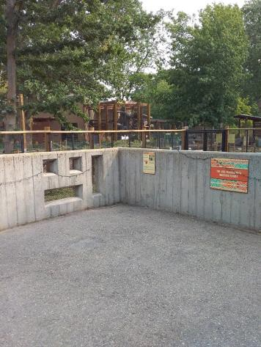

 | ID:  3308 | Facility:  City of Boise Zoo

Location Greater Rhea Exhibit
Schedule 2021
Estimated Cost: $1,000.00

Priority Score 3
Quick Fix: No
Built before ADA: Yes

VIOLATIONS
2010 ADA Standards for Accessible Design Codes §403.3
The cross slope is 3%.

RECOMMENDATIONS
Resurface the route to reduce the cross slope to a maximum of 2%.

PHOTOGRAPH(S) OF THIS LOCATION

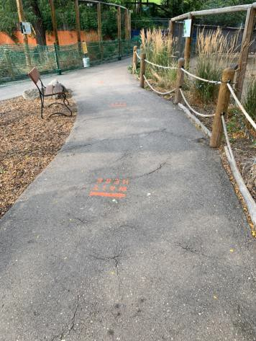

 | ID:  3388 | Facility:  City of Boise Zoo

Location Horned Owl Exhibit
Schedule 2021
Estimated Cost: $2,500.00

Priority Score 3
Quick Fix: No
Built before ADA: Yes

VIOLATIONS
2010 ADA Standards for Accessible Design Codes §305.2
The clear floor space at the Horned Owl viewing has excessive running slopes.

RECOMMENDATIONS
Reconstruct a minimum of a 30"x48" clear floor space to have a maximum slope of 2% in all directions.

PHOTOGRAPH(S) OF THIS LOCATION

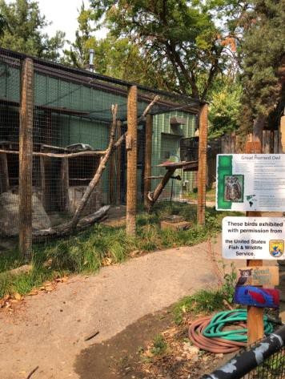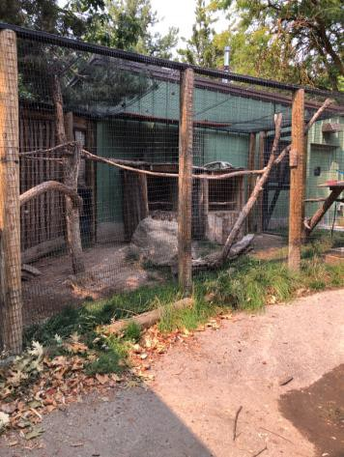

 | ID:  2391 | Facility:  City of Boise Zoo

Location Jack and Esther Simplot Multipurpose Room
Schedule 2021
Estimated Cost: $100.00

Priority Score 3
Quick Fix: Yes
Built before ADA: Yes

VIOLATIONS
2010 ADA Standards for Accessible Design Codes §216.2, §703
There is no tactile sign identifying the permanent room.

RECOMMENDATIONS
Install tactile signage to the right of the right hand door at a height of 48” minimum to 60” maximum above the floor, identifying room by name or room number.
Signs shall be Braille with raised lettering and should be placed on the wall in the center of an 18"x18" clear floor space.

PHOTOGRAPH(S) OF THIS LOCATION

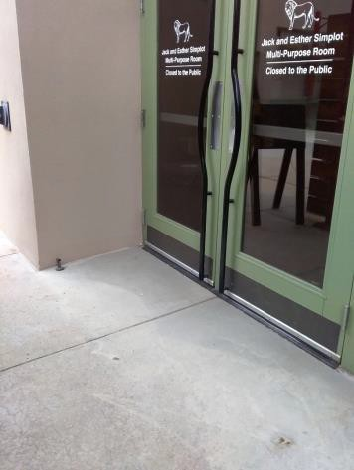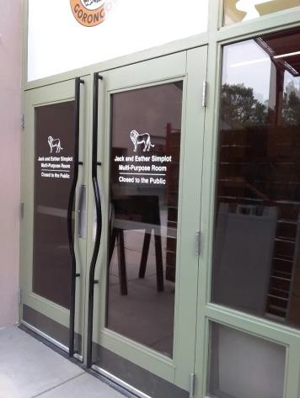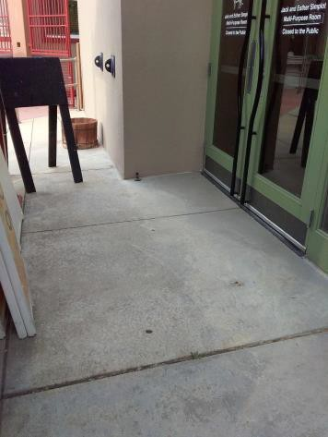

 | ID:  2389 | Facility:  City of Boise Zoo

Location Jack and Esther Simplot Multipurpose Room
Schedule 2022
Estimated Cost: $1,000.00

Priority Score 5
Quick Fix: No
Built before ADA: Yes

VIOLATIONS
2010 ADA Standards for Accessible Design Codes §306.3.3
There is no knee clearance underneath the sink.

RECOMMENDATIONS
Provide knee clearance underneath the counter at the sink that is a minimum of 11" deep at 9" above the floor and 8" deep at 27" above the floor.

PHOTOGRAPH(S) OF THIS LOCATION

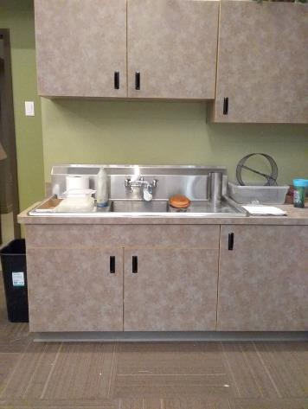

 | ID:  2390 | Facility:  City of Boise Zoo

Location Jack and Esther Simplot Multipurpose Room
Schedule 2021
Estimated Cost: $1,000.00

Priority Score 3
Quick Fix: No
Built before ADA: Yes

VIOLATIONS
2010 ADA Standards for Accessible Design Codes §404.2.4.4
The entrance has a 3.1% slope.

RECOMMENDATIONS
Resurface the entryway to reduce the running slope to a maximum of 2% in all directions for a distance of 60" perpendicular to the doorway.

PHOTOGRAPH(S) OF THIS LOCATION

 | ID:  2334 | Facility:  City of Boise Zoo

Location Kajiji Kitchen
Schedule 2021
Estimated Cost: $1,000.00

Priority Score 5
Quick Fix: No
Built before ADA: Yes

VIOLATIONS
2010 ADA Standards for Accessible Design Codes §606.3
The sink is 35" above the floor.

RECOMMENDATIONS
Lower the sink to the maximum height of 34" above the floor.

PHOTOGRAPH(S) OF THIS LOCATION

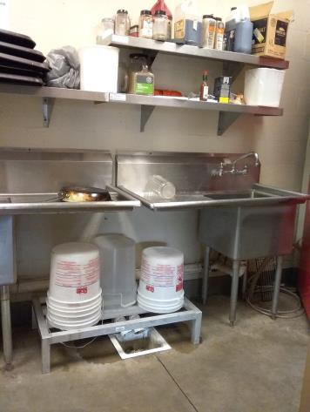

 | ID:  3736 | Facility:  City of Boise Zoo

Location Kijiji Cafe
Schedule 2022
Estimated Cost: $1,000.00

Priority Score 5
Quick Fix: No
Built before ADA: Yes

VIOLATIONS
2010 ADA Standards for Accessible Design Codes §303.2
There is a 1" change in level.

RECOMMENDATIONS
Resurface the pathway to reduce the change in level to a maximum of 0.25" or 0.5" if beveled.

PHOTOGRAPH(S) OF THIS LOCATION

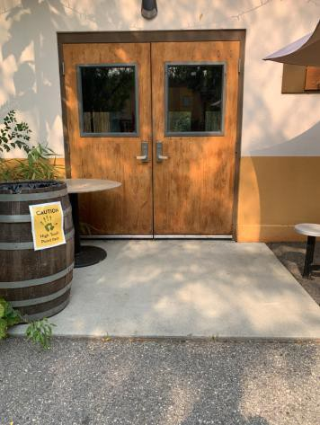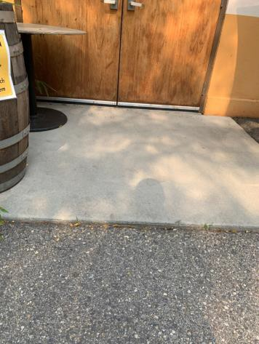

 | ID:  3452 | Facility:  City of Boise Zoo

Location Kijiji Cafe
Schedule 2021
Estimated Cost: $1,000.00

Priority Score 4
Quick Fix: No
Built before ADA: Yes

VIOLATIONS
2010 ADA Standards for Accessible Design Codes §904.4.1
The counter is 37" above the ground.

RECOMMENDATIONS
A portion of the service counter must be no higher than 36" above the ground for a horizontal distance of 36".

PHOTOGRAPH(S) OF THIS LOCATION

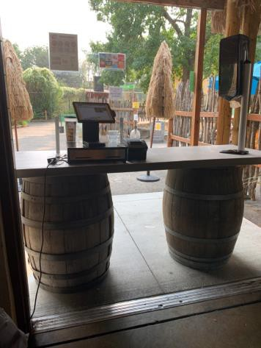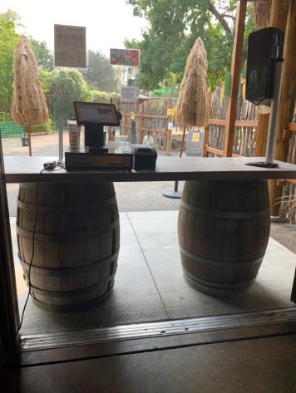

 | ID:  3083 | Facility:  City of Boise Zoo

Location Kijiji Women’s Restroom
Schedule 2021
Estimated Cost: $100.00

Priority Score 5
Quick Fix: Yes
Built before ADA: Yes

VIOLATIONS
2010 ADA Standards for Accessible Design Codes §604.8.1.2
The door to the accessible water closet is not self closing. Either self-closing hinges are not installed on the door or if installed, they are defective.

RECOMMENDATIONS
Install or reinstall self-closing hinges on the door to ensure that the door is self-closing per the ADA requirements.

PHOTOGRAPH(S) OF THIS LOCATION

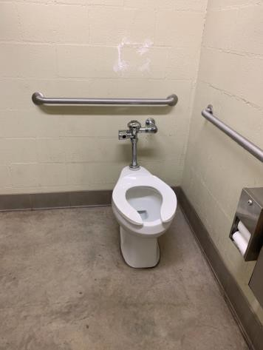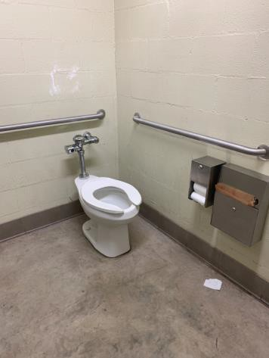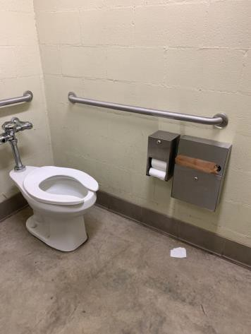

 | ID:  3168 | Facility:  City of Boise Zoo

Location Kijiji Women’s Restroom
Schedule 2021
Estimated Cost: $100.00

Priority Score 7
Quick Fix: Yes
Built before ADA: Yes

VIOLATIONS
2010 ADA Standards for Accessible Design Codes §606.5
The pipes under the sink are not covered.

RECOMMENDATIONS
Wrap the pipes beneath the sink with soft protective wrap or plastic.

PHOTOGRAPH(S) OF THIS LOCATION

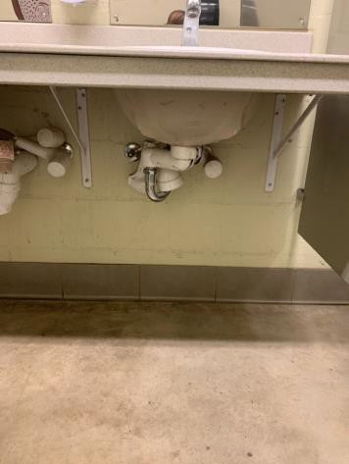

 | ID:  3522 | Facility:  City of Boise Zoo

Location Kijiji Women’s Restroom
Schedule 2021
Estimated Cost: $100.00

Priority Score 5
Quick Fix: Yes
Built before ADA: Yes

VIOLATIONS
2010 ADA Standards for Accessible Design Codes §307.2
The paper towel dispenser protrudes 8.5" into the circulation space at 43.5" above the floor.

RECOMMENDATIONS
Recess the paper towel dispenser so it protrudes a maximum of 4" or place a cane detectable object beneath it.

PHOTOGRAPH(S) OF THIS LOCATION

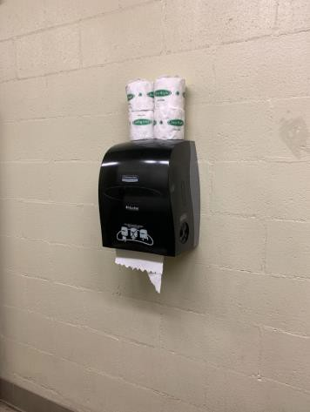

 | ID:  3086 | Facility:  City of Boise Zoo

Location Kijiji Women’s Restroom
Schedule 2022
Estimated Cost: $1,000.00

Priority Score 5
Quick Fix: No
Built before ADA: Yes

VIOLATIONS
2010 ADA Standards for Accessible Design Codes ICC A117.1 §604.5.1
The accessible water closet does not have a vertical grab bar.

RECOMMENDATIONS
Install an 18" long (minimum) vertical grab bar on the side wall. The grab bar shall be mounted with the bottom located at 39" minimum and 41" maximum above the floor.
The centerline of the vertical grab bar shall be located 39" minimum and 41" maximum from the rear wall.

PHOTOGRAPH(S) OF THIS LOCATION

 | ID:  3740 | Facility:  City of Boise Zoo

Location Kijiji Women’s Restroom
Schedule 2022
Estimated Cost: $1,500.00

Priority Score 6
Quick Fix: No
Built before ADA: Yes

VIOLATIONS
2010 ADA Standards for Accessible Design Codes §602.4, §602.7, §602, §307.2
The drinking fountains protrude 18" into the circulation path.
The height of the tall drinking fountain is not compliant with a spout height of 36.75" above the ground.

RECOMMENDATIONS
Place drinking fountain skirts at this location to provide cane detectability.
Raise the existing tall drinking fountain in order to comply with the 38" minimum spout height above the ground.

PHOTOGRAPH(S) OF THIS LOCATION

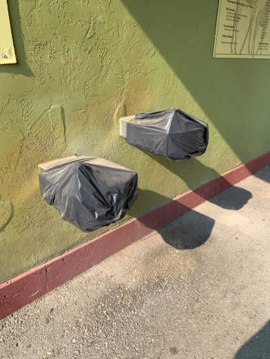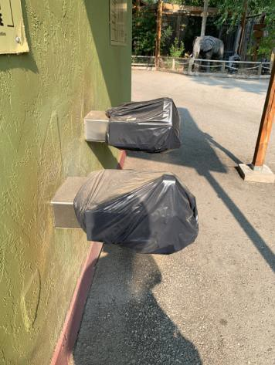

 | ID:  3719 | Facility:  City of Boise Zoo

Location Kinkajou South American Loop
Schedule 2022
Estimated Cost: $2,500.00

Priority Score 7
Quick Fix: No
Built before ADA: Yes

VIOLATIONS
2010 ADA Standards for Accessible Design Codes §305.2, §405
The elevated viewing window is only accessible via a 1.5" step.
The clear floor space at the exhibit's viewing window has a 2.5% slope.

RECOMMENDATIONS
Reconstruct the cement pad adjacent to the viewing window so it is flush with the surrounding ground and has a maximum of a 2% slope in all directions.
Reconstruct a minimum of a 30"x48" clear floor space to have a maximum slope of 2% in all directions.

PHOTOGRAPH(S) OF THIS LOCATION

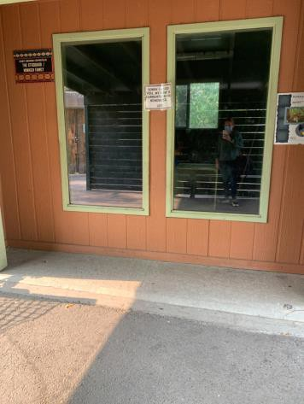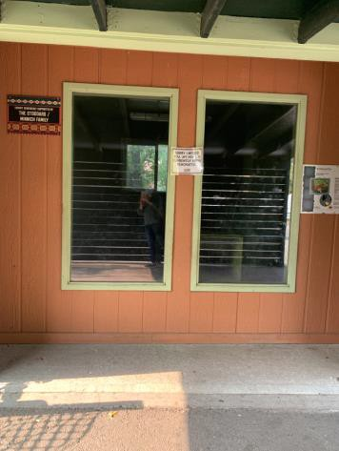

 | ID:  2326 | Facility:  City of Boise Zoo

Location Lions Pathway
Schedule 2021
Estimated Cost: $3,000.00

Priority Score 3
Quick Fix: No
Built before ADA: Yes

VIOLATIONS
2010 ADA Standards for Accessible Design Codes §403.3
The running slope reaches 9%.

RECOMMENDATIONS
Reconstruct the route to reduce the running slope to a maximum of 5% or 8.3% if handrails are level landings are provided.

PHOTOGRAPH(S) OF THIS LOCATION

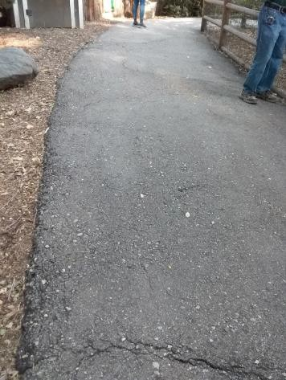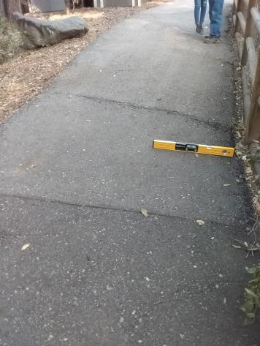

 | ID:  3733 | Facility:  City of Boise Zoo

Location Main Entrance Gate 1 Boutique Gift Shop
Schedule 2021
Estimated Cost: $4,000.00

Priority Score 3
Quick Fix: No
Built before ADA: Yes

VIOLATIONS
2010 ADA Standards for Accessible Design Codes §403.3
The cross slope is 7.6%.

RECOMMENDATIONS
Reconstruct the route to reduce the cross slope to a maximum of 2%.

PHOTOGRAPH(S) OF THIS LOCATION

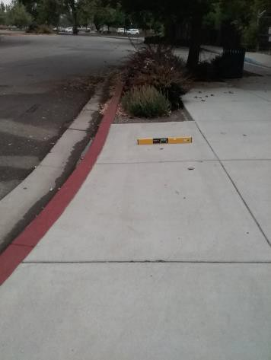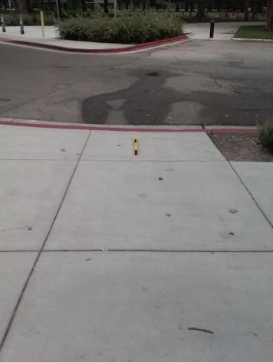

 | ID:  3416 | Facility:  City of Boise Zoo

Location Main Entrance Gate 1 Boutique Gift Shop
Schedule 2021
Estimated Cost: $5,000.00

Priority Score 3
Quick Fix: No
Built before ADA: Yes

VIOLATIONS
2010 ADA Standards for Accessible Design Codes §404.2.4.4
The entrance to the boutique gift shop has a 8.8% slope.

RECOMMENDATIONS
Reconstruct the entryway to reduce the running slope to a maximum of 2% in all directions for a distance of 60" perpendicular to the door.
Leading to the door, ensure that the running slope does not exceed 5% or 8.3% if handrails and level landings are provided.

PHOTOGRAPH(S) OF THIS LOCATION

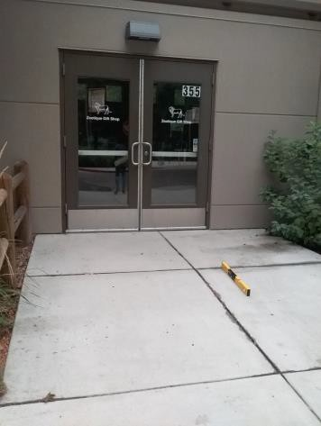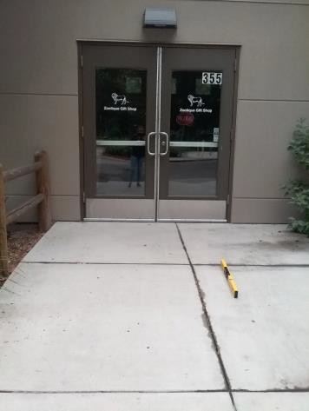

 | ID:  3587 | Facility:  City of Boise Zoo

Location Main Entrance Parking
Schedule 2021
Estimated Cost: $200.00

Priority Score 9
Quick Fix: Yes
Built before ADA: Yes

VIOLATIONS
2010 ADA Standards for Accessible Design Codes §216.5
The parking signs identifying the accessible parking space do not meet the minimum height requirement of 60" from the ground.

RECOMMENDATIONS
Remount the accessible parking signs to ensure 60" minimum height from the ground.

PHOTOGRAPH(S) OF THIS LOCATION

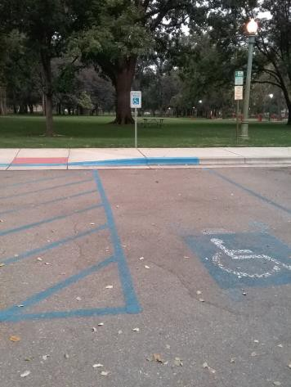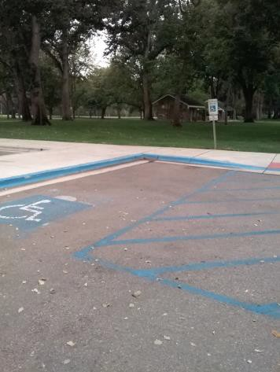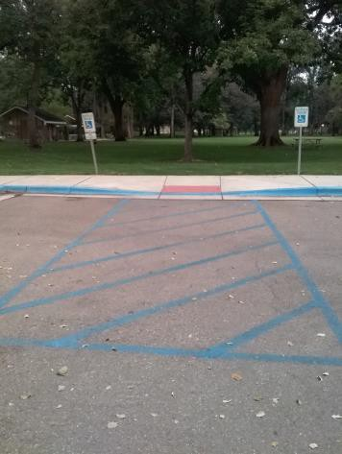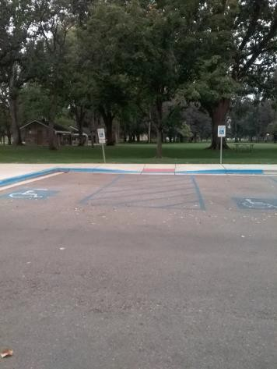

 | ID:  3586 | Facility:  City of Boise Zoo

Location Main Entrance Parking
Schedule 2021
Estimated Cost: $1,000.00

Priority Score 3
Quick Fix: No
Built before ADA: Yes

VIOLATIONS
2010 ADA Standards for Accessible Design Codes §502.2
One of the accessible parking space is not of sufficient width at 88" wide.

RECOMMENDATIONS
Expand the accessible parking space to a minimum of 96" wide.

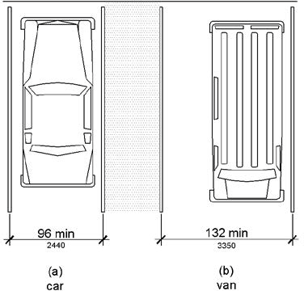

PHOTOGRAPH(S) OF THIS LOCATION

 | ID:  3493 | Facility:  City of Boise Zoo

Location Main Entrance Parking Adjacent to Park
Schedule 2023
Estimated Cost: $2,000.00

Priority Score 9
Quick Fix: No
Built before ADA: Yes

VIOLATIONS
2010 ADA Standards for Accessible Design Codes §502
The painted lines for the accessible parking spaces are faded.

RECOMMENDATIONS
Restripe and repaint the accessible parking spaces, access aisles, and ISA symbols.

PHOTOGRAPH(S) OF THIS LOCATION

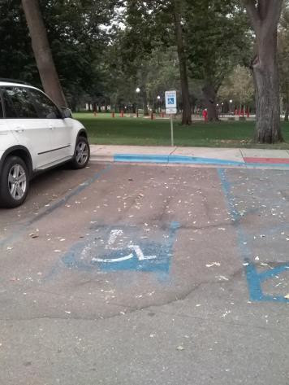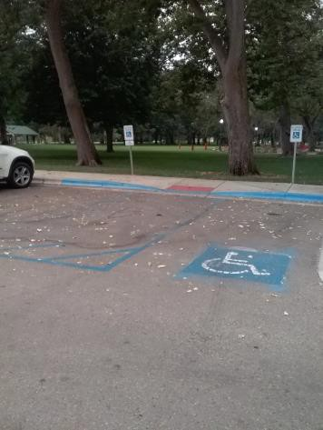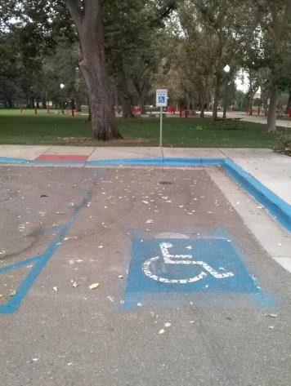

 | ID:  3492 | Facility:  City of Boise Zoo

Location Main Entrance Parking Adjacent to Park
Schedule 2021
Estimated Cost: $2,500.00

Priority Score 3
Quick Fix: No
Built before ADA: Yes

VIOLATIONS
2010 ADA Standards for Accessible Design Codes §208.2.4
There are no marked "Van accessible" spaces.

RECOMMENDATIONS
Install a 132" wide van accessible parking space for every six accessible parking spaces. Where a 96" wide accessible parking space is provided, a 96" wide access aisle can also be considered an accessible.
Add a “van accessible” parking sign at a minimum height of 60" above the ground.

PHOTOGRAPH(S) OF THIS LOCATION

 | ID:  3145 | Facility:  City of Boise Zoo

Location Main Entrance Parking Adjacent to Park
Schedule 2021
Estimated Cost: $3,500.00

Priority Score 3
Quick Fix: No
Built before ADA: Yes

VIOLATIONS
2010 ADA Standards for Accessible Design Codes §406.4, §405.2
The running slope of the curb ramp is 10%.
There is no landing provided at the top of the curb ramp.

RECOMMENDATIONS
Reconstruct the curb ramp to reduce the running slope to a maximum of 8.3%.
Install a landing at the top of the curb ramp with a minimum clear length of 36" or reconstruct the ramp as a parallel curb ramp.

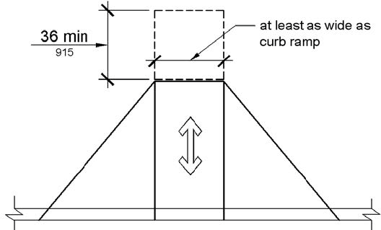

PHOTOGRAPH(S) OF THIS LOCATION

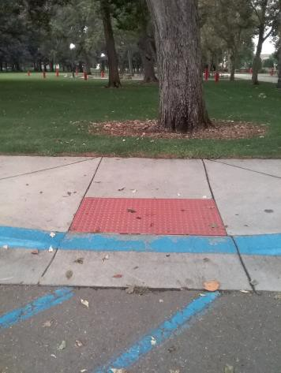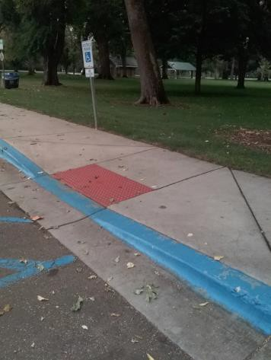

 | ID:  3281 | Facility:  City of Boise Zoo

Location Main Entrance Parking Crosswalk
Schedule 2023
Estimated Cost: $1,000.00

Priority Score 9
Quick Fix: No
Built before ADA: Yes

VIOLATIONS
2010 ADA Standards for Accessible Design Codes General Guidance
The crosswalk paint is fading.

RECOMMENDATIONS
For the purposes of achieving greater accessibility and Human Centric Design, restripe the crosswalk to make it more visible to motorists.

PHOTOGRAPH(S) OF THIS LOCATION

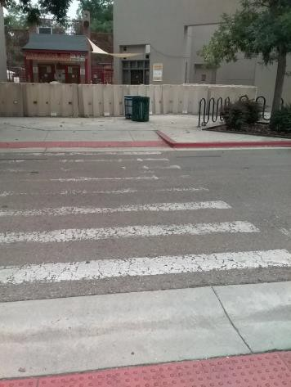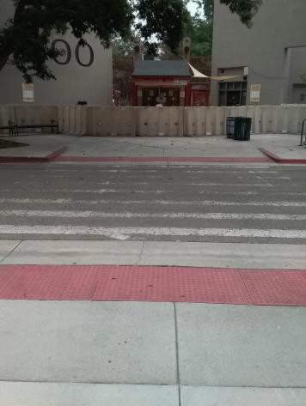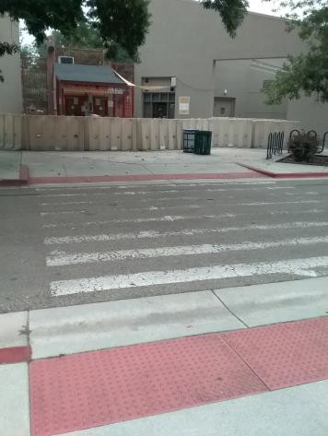

 | ID:  3469 | Facility:  City of Boise Zoo

Location Main Entrance Parking Gate 1
Schedule 2021
Estimated Cost: $5,000.00

Priority Score 3
Quick Fix: No
Built before ADA: No

VIOLATIONS
2010 ADA Standards for Accessible Design Codes §208.2.4, §502.4
The parking spaces have a running slope between 3% and 4%.
There are no marked "Van Accessible" spaces as existing accessible spaces are 77", 94", and 97" wide.

RECOMMENDATIONS
Resurface the parking spaces to reduce the slope to a maximum of 2% in all directions. Install a 132" wide van accessible parking space for every six accessible parking spaces.
Where a 96" wide accessible parking space is provided, a 96" wide access aisle can also be considered an accessible. Add a “van accessible” parking sign at a minimum height of 60" above the ground.

PHOTOGRAPH(S) OF THIS LOCATION

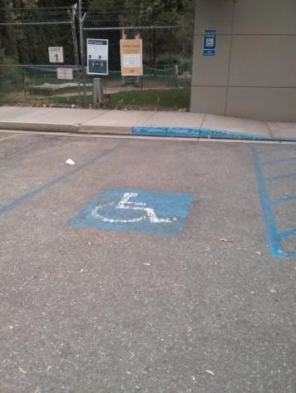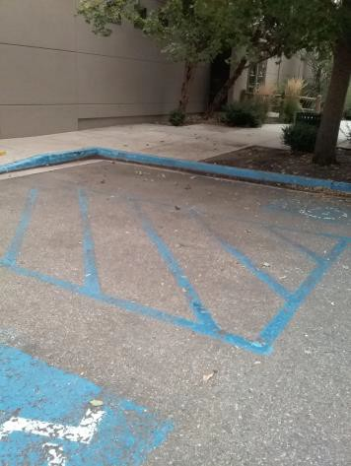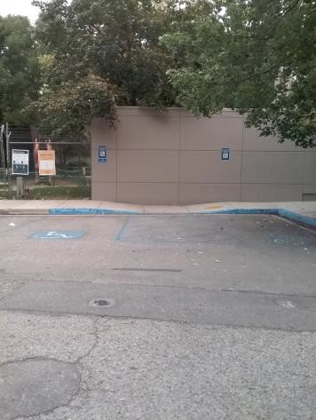

 | ID:  3579 | Facility:  City of Boise Zoo

Location Main Entrance Parking Gate 10
Schedule 2021
Estimated Cost: $200.00

Priority Score 9
Quick Fix: Yes
Built before ADA: Yes

VIOLATIONS
2010 ADA Standards for Accessible Design Codes §502.6
Two parking signs identifying the accessible parking spaces do not meet the minimum height requirement of 60" above the ground.

RECOMMENDATIONS
Reinstall the accessible parking signs at each accessible space at a minimum height of 60" above the ground.

PHOTOGRAPH(S) OF THIS LOCATION

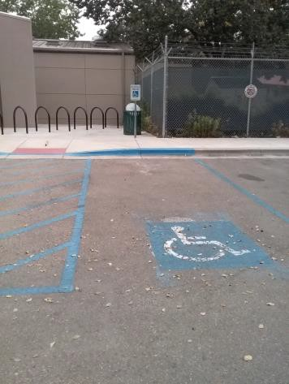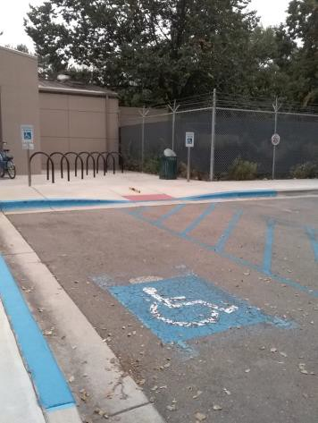

 | ID:  3578 | Facility:  City of Boise Zoo

Location Main Entrance Parking Gate 10
Schedule 2021
Estimated Cost: $5,000.00

Priority Score 3
Quick Fix: No
Built before ADA: Yes

VIOLATIONS
2010 ADA Standards for Accessible Design Codes §502.2, §502.4
The parking spaces and access aisle have a 3.3% running slope.
One of the accessible parking space is not of sufficient width at 88" wide.

RECOMMENDATIONS
Resurface the parking spaces and access aisles to reduce the slope to a maximum of 2% in all directions.
Expand the accessible parking space to be a minimum width of 96", or 132" if designated as a van accessible parking space. Ensure the adjacent access aisle remains 60" wide.

PHOTOGRAPH(S) OF THIS LOCATION

 | ID:  3732 | Facility:  City of Boise Zoo

Location Main Entrance Parking Gate 9
Schedule 2022
Estimated Cost: $2,500.00

Priority Score 7
Quick Fix: No
Built before ADA: Yes

VIOLATIONS
2010 ADA Standards for Accessible Design Codes §405.2
The running slope of the curb ramp is 9.2%.

RECOMMENDATIONS
Reconstruct the curb ramp to reduce the running slope to a maximum of 8.3%.

PHOTOGRAPH(S) OF THIS LOCATION

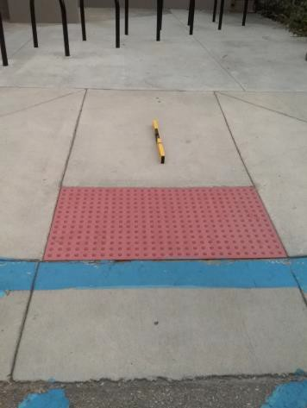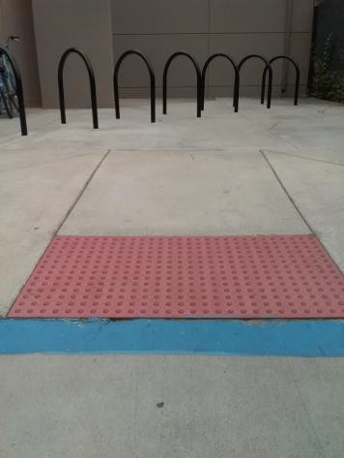

 | ID:  3633 | Facility:  City of Boise Zoo

Location Main Entrance Tickets
Schedule 2021
Estimated Cost: $2,500.00

Priority Score 3
Quick Fix: No
Built before ADA: Yes

VIOLATIONS
2010 ADA Standards for Accessible Design Codes §305.2
The clear floor space has a 3.2% slope.

RECOMMENDATIONS
Reconstruct a minimum of 30"x48" clear floor space adjacent to the ticket booth to have a maximum slope of 2% in all directions.

PHOTOGRAPH(S) OF THIS LOCATION

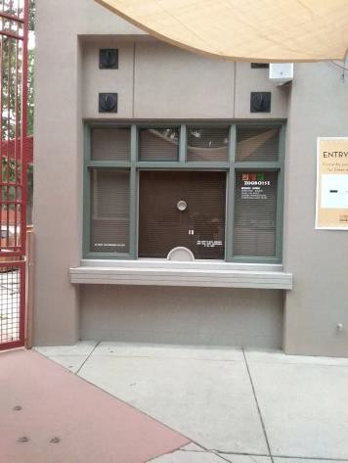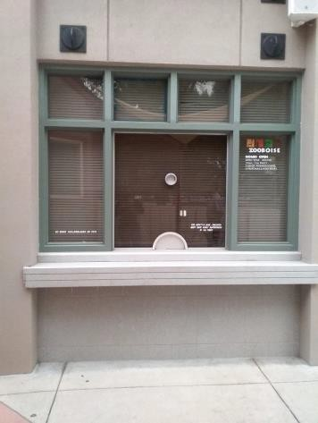

 | ID:  2873 | Facility:  City of Boise Zoo

Location Meeting Area
Schedule 2023
Estimated Cost: $7,500.00

Priority Score 3
Quick Fix: No
Built before ADA: Yes

VIOLATIONS
2010 ADA Standards for Accessible Design Codes §405
The meeting area under the tent is only accessible via a 2.5" step and via a dirt and mulch surface.

RECOMMENDATIONS
Add a curb ramp with a slope not exceeding 8.3%. Ensure there is a level landing at the top of the curb. Ensure the path leading to and within the tent is made from a firm, stable, and slip resistant material.

PHOTOGRAPH(S) OF THIS LOCATION

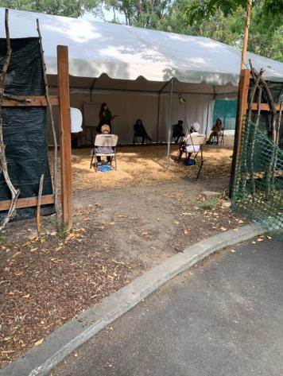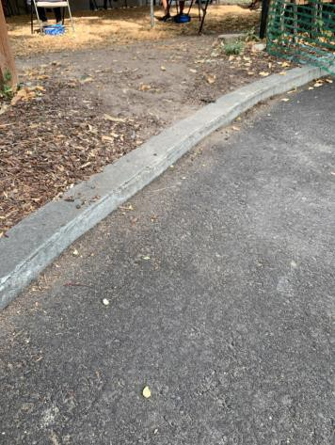

 | ID:  3701 | Facility:  City of Boise Zoo

Location Men's Restroom by Condor Exhibit
Schedule 2021
Estimated Cost: $100.00

Priority Score 7
Quick Fix: Yes
Built before ADA: Yes

VIOLATIONS
2010 ADA Standards for Accessible Design Codes §309.4
The faucet requires twisting of the wrist.

RECOMMENDATIONS
Replace the faucet with one that can be operated with a closed fist and without twisting the wrist.

PHOTOGRAPH(S) OF THIS LOCATION

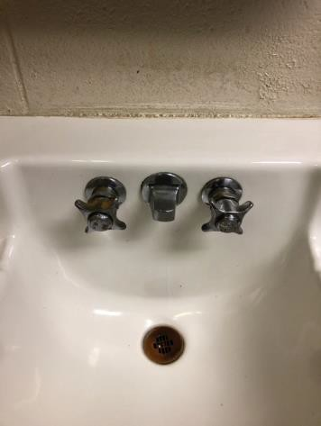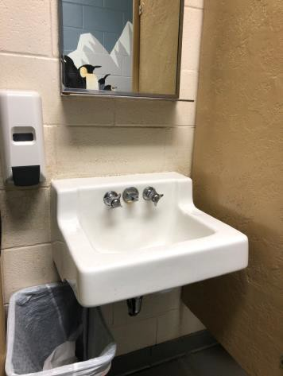

 | ID:  3748 | Facility:  City of Boise Zoo

Location Men's Restroom by Condor Exhibit
Schedule 2021
Estimated Cost: $100.00

Priority Score 3
Quick Fix: Yes
Built before ADA: Yes

VIOLATIONS
2010 ADA Standards for Accessible Design Codes §216.2, §703
There is no tactile sign identifying the permanent room.

RECOMMENDATIONS
Install tactile signage on the latch side of the doorway at a height of 48” minimum to 60” maximum above the floor, identifying room by name or room number.
Signs shall be Braille with raised lettering and should be placed on the wall in the center of an 18"x18" clear floor space

PHOTOGRAPH(S) OF THIS LOCATION

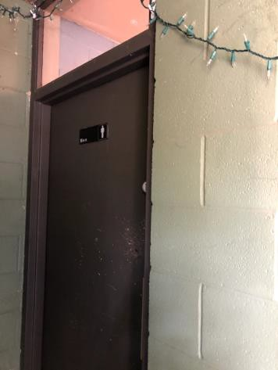

 | ID:  3353 | Facility:  City of Boise Zoo

Location Men's Restroom by Condor Exhibit
Schedule 2021
Estimated Cost: $200.00

Priority Score 7
Quick Fix: Yes
Built before ADA: Yes

VIOLATIONS
2010 ADA Standards for Accessible Design Codes §606.5
The pipes under the sinks are not covered.

RECOMMENDATIONS
Wrap the pipes beneath the sinks with soft protective wrap or plastic.

PHOTOGRAPH(S) OF THIS LOCATION

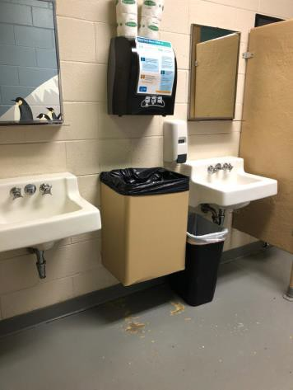

 | ID: | Facility:  City of Boise Zoo

Location:
Schedule:
Estimated Cost:

Priority Score 7
Quick Fix: Yes
Built before ADA: Yes

VIOLATIONS

RECOMMENDATIONS

PHOTOGRAPH(S) OF THIS LOCATION

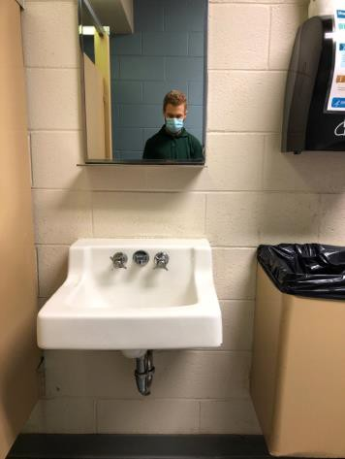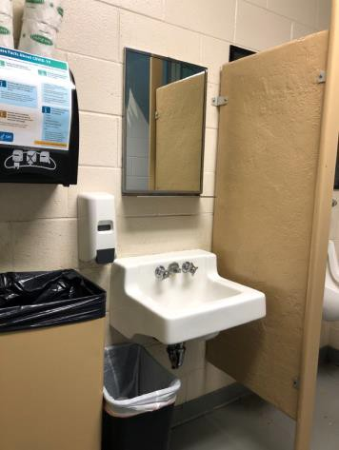

 | ID:  3689 | Facility:  City of Boise Zoo

Location Men's Restroom by Condor Exhibit
Schedule 2022
Estimated Cost: $1,000.00

Priority Score 5
Quick Fix: No
Built before ADA: Yes

VIOLATIONS
2010 ADA Standards for Accessible Design Codes §605.2
The urinal is 24" above the floor.

RECOMMENDATIONS
Lower one urinal so its rim is a maximum of 17" above the floor.

PHOTOGRAPH(S) OF THIS LOCATION

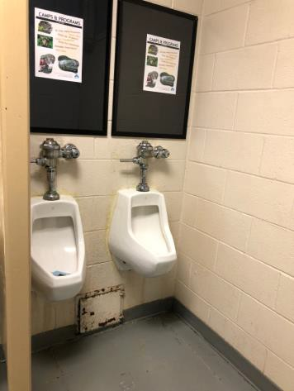

 | ID:  3260 | Facility:  City of Boise Zoo

Location Men's Restroom by Condor Exhibit
Schedule 2022
Estimated Cost: $2,500.00

Priority Score 5
Quick Fix: No
Built before ADA: Yes

VIOLATIONS
2010 ADA Standards for Accessible Design Codes §213.3.1, §604.8.1.1
There is not an accessible stall in the Men's Restroom by Condor Exhibit.

RECOMMENDATIONS
Either expand the toilet compartment or make the restroom a single-use stall so that the accessible stall is a minimum of 60" wide and 59" deep. Remount the toilet so the flush control is on the open side of the wall.
Mount compliant grab bars

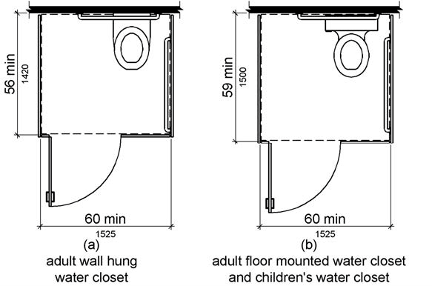

PHOTOGRAPH(S) OF THIS LOCATION

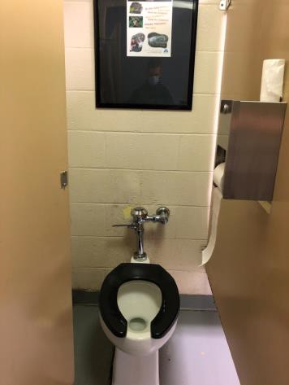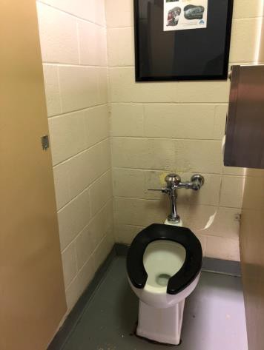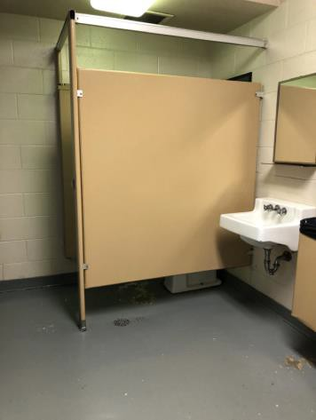

 | ID:  2286 | Facility:  City of Boise Zoo

Location Men's Restroom by Entrance
Schedule 2021
Estimated Cost: $100.00

Priority Score 7
Quick Fix: Yes
Built before ADA: Yes

VIOLATIONS
2010 ADA Standards for Accessible Design Codes §309.4
There is no door handle on the inside of the stall door.

RECOMMENDATIONS
Add a door handle to allow users to pull open the door. Ensure that the handle can be operated with a closed fist and without twisting the wrist.

PHOTOGRAPH(S) OF THIS LOCATION

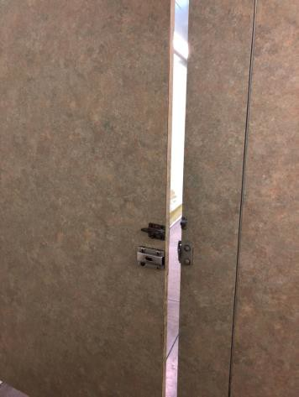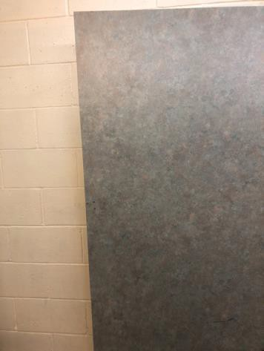

 | ID:  2287 | Facility:  City of Boise Zoo

Location Men's Restroom by Entrance
Schedule 2021
Estimated Cost: $100.00

Priority Score 8
Quick Fix: Yes
Built before ADA: Yes

VIOLATIONS
2010 ADA Standards for Accessible Design Codes §308.2.1
The hook is outside of the unobstructed forward reach range at 68" above the floor.

RECOMMENDATIONS
Lower the hook by 20" to meet the accessible reach range of 48" maximum above the floor.

PHOTOGRAPH(S) OF THIS LOCATION

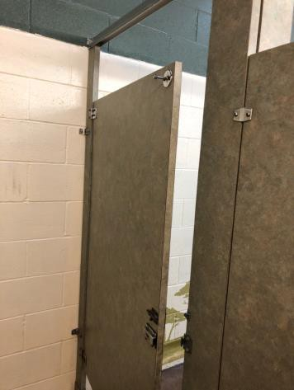

 | ID:  2288 | Facility:  City of Boise Zoo

Location Men's Restroom by Entrance
Schedule 2021
Estimated Cost: $100.00

Priority Score 5
Quick Fix: Yes
Built before ADA: Yes

VIOLATIONS
2010 ADA Standards for Accessible Design Codes §604.7
The toilet paper dispenser is located out of the accessible reach range at 16" in front of the toilet.

RECOMMENDATIONS
Remount the toilet paper dispenser to 7” minimum and 9” maximum in front of the water closet measured to the centerline of the dispenser.
The outlet of the dispenser shall be 15” minimum and 48” maximum above the floor and shall not be located behind the water closet.

PHOTOGRAPH(S) OF THIS LOCATION

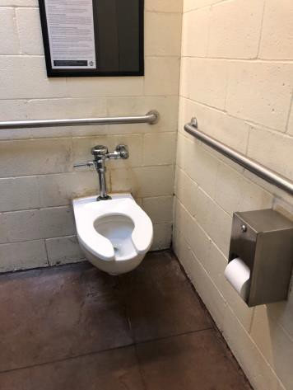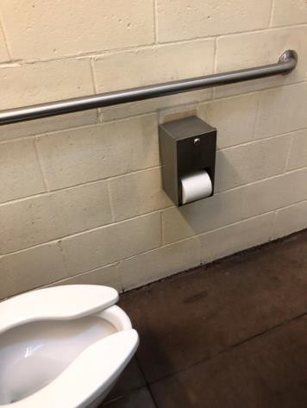

 | ID:  2290 | Facility:  City of Boise Zoo

Location Men's Restroom by Entrance
Schedule 2021
Estimated Cost: $100.00

Priority Score 5
Quick Fix: Yes
Built before ADA: Yes

VIOLATIONS
2010 ADA Standards for Accessible Design Codes §604.8.1.2
The door to the accessible water closet is not self closing. Either self-closing hinges are not installed on the door or if installed, they are defective.

RECOMMENDATIONS
Install or reinstall self-closing hinges on the door to ensure that the door is self-closing per the ADA requirements.

PHOTOGRAPH(S) OF THIS LOCATION

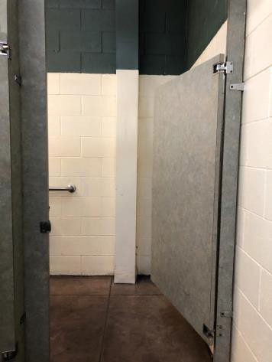

 | ID:  2284 | Facility:  City of Boise Zoo

Location Men's Restroom by Entrance
Schedule 2021
Estimated Cost: $200.00

Priority Score 4
Quick Fix: Yes
Built before ADA: Yes

VIOLATIONS
2010 ADA Standards for Accessible Design Codes §307.2, §404.2.4.1
There is not adequate maneuvering clearance to operate the door due to the paper towel dispenser protruding 10" into the circulation space.

RECOMMENDATIONS
Relocate the paper towel dispenser so that there is a clear floor space extending 18" from the latch side of the door, for a depth of 60" perpendicular from the doorway.
Ensure that the paper towel dispenser does not protrude more than 4" into the restroom.

PHOTOGRAPH(S) OF THIS LOCATION

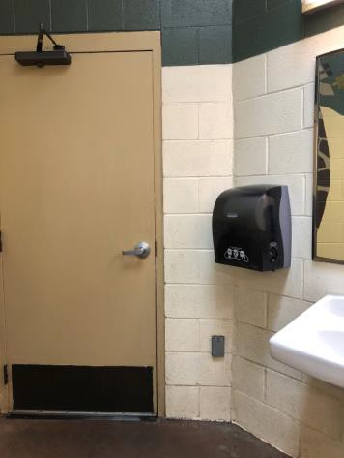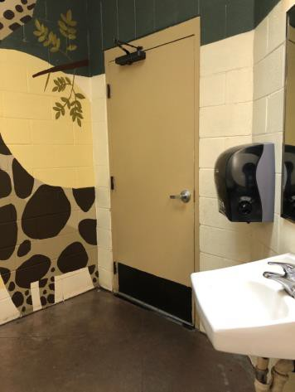

 | ID:  2285 | Facility:  City of Boise Zoo

Location Men's Restroom by Entrance
Schedule 2022
Estimated Cost: $1,000.00

Priority Score 5
Quick Fix: No
Built before ADA: Yes

VIOLATIONS
2010 ADA Standards for Accessible Design Codes §605.2
The urinal is 19" above the floor.

RECOMMENDATIONS
Lower the urinal to a maximum height of 17" above the floor.

PHOTOGRAPH(S) OF THIS LOCATION

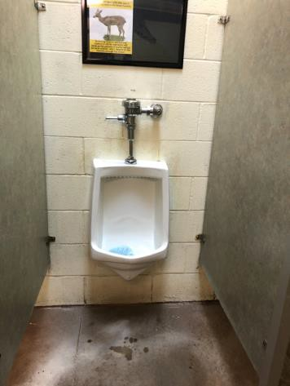

 | ID:  2289 | Facility:  City of Boise Zoo

Location Men's Restroom by Entrance
Schedule 2022
Estimated Cost: $1,000.00

Priority Score 5
Quick Fix: No
Built before ADA: Yes

VIOLATIONS
The accessible water closet does not have a vertical grab bar.

RECOMMENDATIONS
Install an 18" long (minimum) vertical grab bar on the side wall. The grab bar shall be mounted with the bottom located at 39" minimum and 41" maximum above the floor.
The centerline of the vertical grab bar shall be located 39" minimum and 41" maximum from the rear wall.

PHOTOGRAPH(S) OF THIS LOCATION

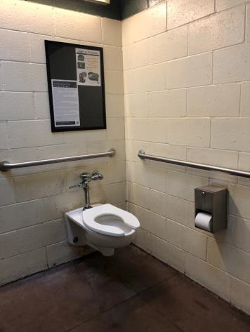

 | ID:  3571 | Facility:  City of Boise Zoo

Location Mobile Vendor Carts
Schedule 2023
Estimated Cost: $2,000.00

Priority Score 8
Quick Fix: No
Built before ADA: Yes

VIOLATIONS
2010 ADA Standards for Accessible Design Codes §904.4.1
The counters are 39" and 35" above the ground.

RECOMMENDATIONS
A portion of the service counter must be no higher than 36" above the floor for a horizontal distance of 36".

PHOTOGRAPH(S) OF THIS LOCATION

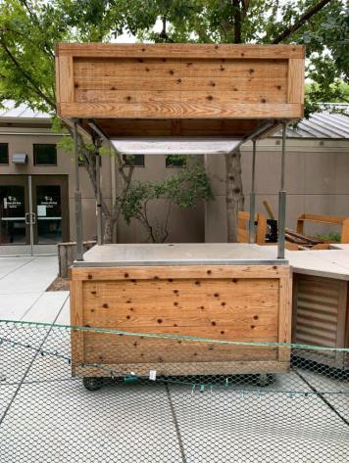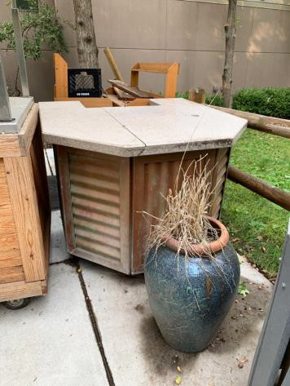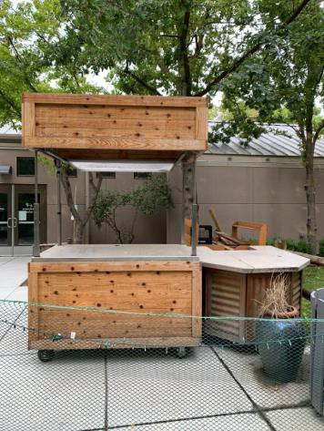

 | ID:  2332 | Facility:  City of Boise Zoo

Location Nagel Beverage Boardwalk
Schedule 2021
Estimated Cost: $2,500.00

Priority Score 3
Quick Fix: No
Built before ADA: Yes

VIOLATIONS
2010 ADA Standards for Accessible Design Codes §403.3
The cross slope is 3%.

RECOMMENDATIONS
Reconstruct the route to reduce the cross slope to a maximum of 2%.

PHOTOGRAPH(S) OF THIS LOCATION

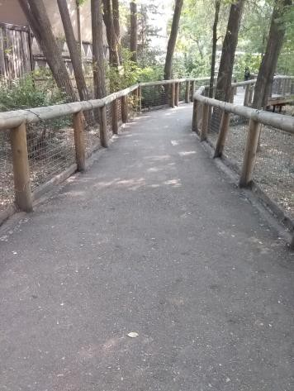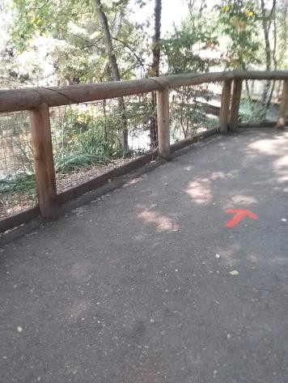

 | ID:  2327 | Facility:  City of Boise Zoo

Location Nagel Beverage Boardwalk
Schedule 2021
Estimated Cost: $5,000.00

Priority Score 3
Quick Fix: No
Built before ADA: Yes

VIOLATIONS
2010 ADA Standards for Accessible Design Codes §403.3
The cross slope is 15%.

RECOMMENDATIONS
Reconstruct the route to reduce the cross slope to a maximum of 2%.

PHOTOGRAPH(S) OF THIS LOCATION

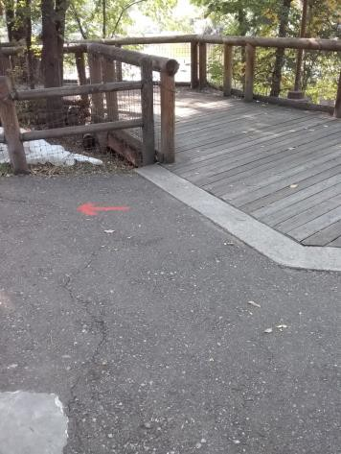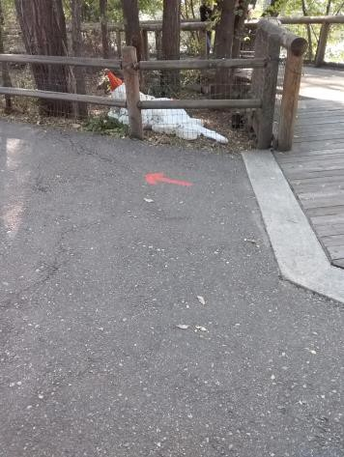

 | ID:  3167 | Facility:  City of Boise Zoo

Location North Parking by Gate 1
Schedule 2022
Estimated Cost: $2,500.00

Priority Score 7
Quick Fix: No
Built before ADA: Yes

VIOLATIONS
2010 ADA Standards for Accessible Design Codes §405.2
The running slope of the curb ramp is 10.8%.

RECOMMENDATIONS
Reconstruct the curb ramp to reduce the running slope to a maximum of 8.3%.

PHOTOGRAPH(S) OF THIS LOCATION

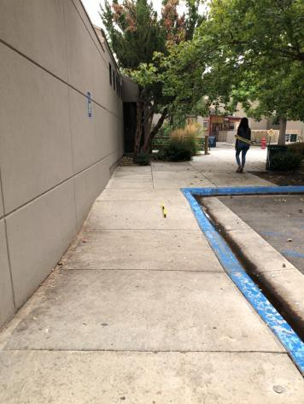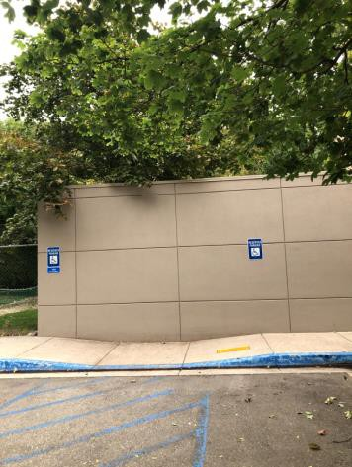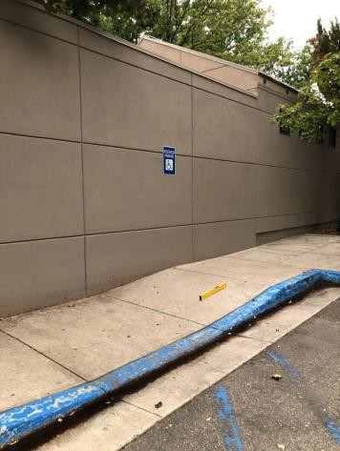

 | ID:  3166 | Facility:  City of Boise Zoo

Location North Parking by Gate 1
Schedule 2021
Estimated Cost: $2,500.00

Priority Score 3
Quick Fix: No
Built before ADA: Yes

VIOLATIONS
2010 ADA Standards for Accessible Design Codes §405.7.1
The landing has a 3% slope.

RECOMMENDATIONS
Reconstruct the top landing to have a maximum slope of 2% in all directions.

PHOTOGRAPH(S) OF THIS LOCATION

 | ID:  2343 | Facility:  City of Boise Zoo

Location Olive Baboon Viewing
Schedule 2021
Estimated Cost: $2,500.00

Priority Score 3
Quick Fix: No
Built before ADA: Yes

VIOLATIONS
2010 ADA Standards for Accessible Design Codes §305.2
The clear floor space at the Olive Baboon viewing has a 4.1% slope.

RECOMMENDATIONS
Reconstruct a minimum of a 30"x48" clear floor space to have a maximum slope of 2% in all directions.

PHOTOGRAPH(S) OF THIS LOCATION

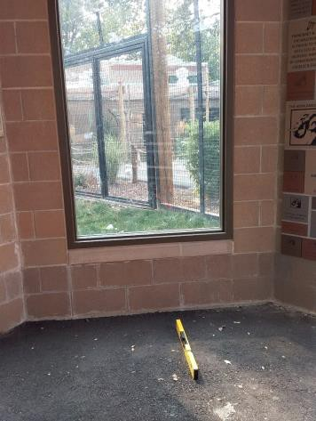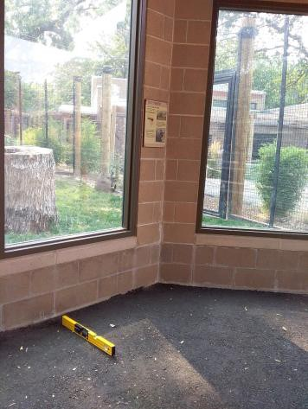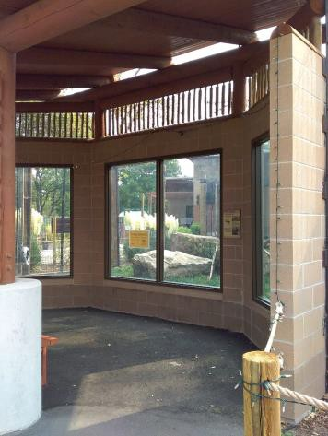

 | ID:  3457 | Facility:  City of Boise Zoo

Location Orangutan Path
Schedule 2021
Estimated Cost: $1,000.00

Priority Score 3
Quick Fix: No
Built before ADA: Yes

VIOLATIONS
2010 ADA Standards for Accessible Design Codes §403.3
The cross slope is 2.5%.

RECOMMENDATIONS
Resurface the route to reduce the cross slope to a maximum of 2%.

PHOTOGRAPH(S) OF THIS LOCATION

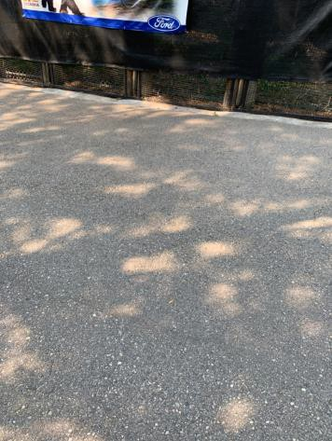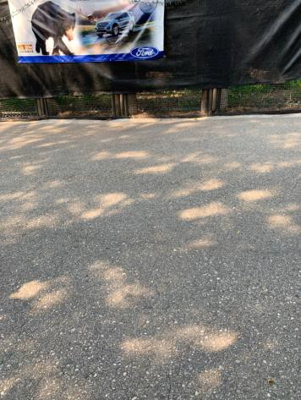

 | ID:  3582 | Facility:  City of Boise Zoo

Location Orangutan Path
Schedule 2021
Estimated Cost: $3,500.00

Priority Score 3
Quick Fix: No
Built before ADA: Yes

VIOLATIONS
2010 ADA Standards for Accessible Design Codes §304.2, §302.3
There is a 2" gap in the walkway.
The turning space has a 13.2% slope.

RECOMMENDATIONS
Fill in the gap to reduce the gap to a maximum of 0.5" in width. Reconstruct the turning space to reduce the slope to the maximum allowable 2% in all directions.

PHOTOGRAPH(S) OF THIS LOCATION

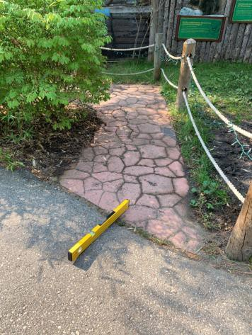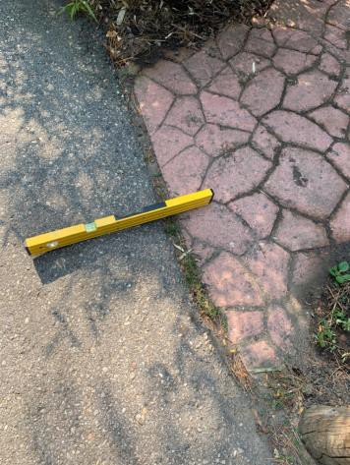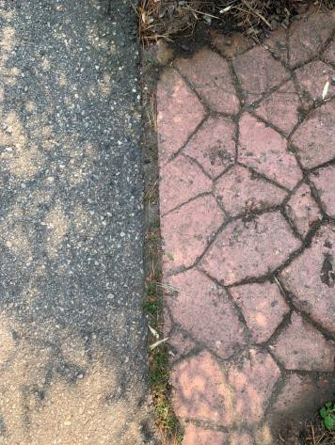

 | ID:  3154 | Facility:  City of Boise Zoo

Location Orangutan Path
Schedule 2021
Estimated Cost: $5,000.00

Priority Score 3
Quick Fix: No
Built before ADA: Yes

VIOLATIONS
2010 ADA Standards for Accessible Design Codes §403.3
The running slope reaches 8.4%.

RECOMMENDATIONS
Either resurface the path to ensure the running slope does not exceed 8.3%, install handrails, and level landings. Or reconstruct the route to have a maximum running slope of 5%.

PHOTOGRAPH(S) OF THIS LOCATION

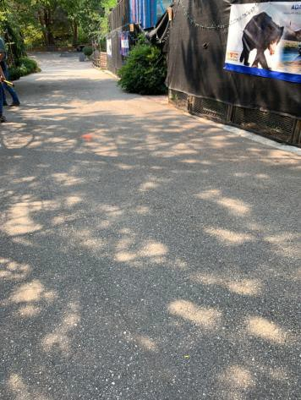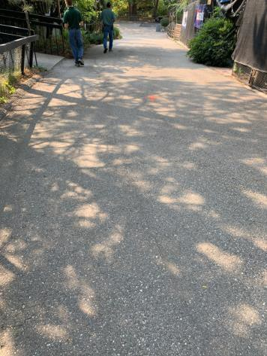

 | ID:  3708 | Facility:  City of Boise Zoo

Location Parakeet
Schedule 2021
Estimated Cost: $2,500.00

Priority Score 3
Quick Fix: No
Built before ADA: Yes

VIOLATIONS
2010 ADA Standards for Accessible Design Codes §403.3
The cross slope is 5%.

RECOMMENDATIONS
Reconstruct the route to reduce the cross slope to a maximum of 2%.

PHOTOGRAPH(S) OF THIS LOCATION

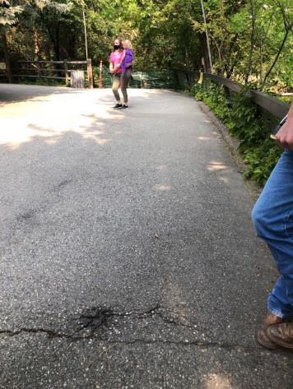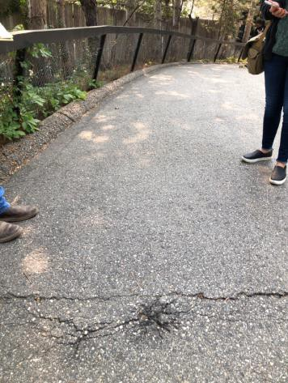

 | ID:  3709 | Facility:  City of Boise Zoo

Location Parakeet Pathway
Schedule 2021
Estimated Cost: $1,000.00

Priority Score 3
Quick Fix: No
Built before ADA: Yes

VIOLATIONS
2010 ADA Standards for Accessible Design Codes §302.1
There are tripping hazards in the accessible route causing changes in level.

RECOMMENDATIONS
Repave the area of the sidewalk to remove the bump.

PHOTOGRAPH(S) OF THIS LOCATION

 | ID:  3095 | Facility:  City of Boise Zoo

Location Parque Nacional da Gorongosa
Schedule 2021
Estimated Cost: $5,000.00

Priority Score 3
Quick Fix: No
Built before ADA: Yes

VIOLATIONS
2010 ADA Standards for Accessible Design Codes §403.3
The cross slope ranges from 2.7% to 4.1%.

RECOMMENDATIONS
Reconstruct the route to reduce the cross slope to a maximum of 2% and a maximum running slope of 5%.

PHOTOGRAPH(S) OF THIS LOCATION

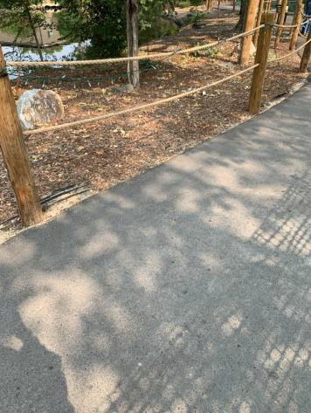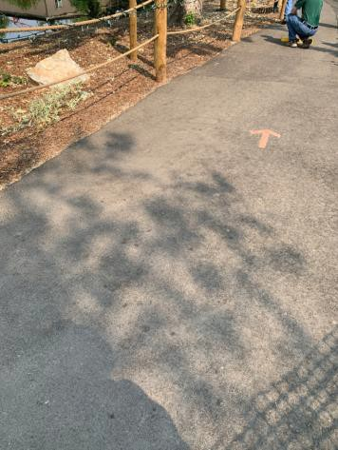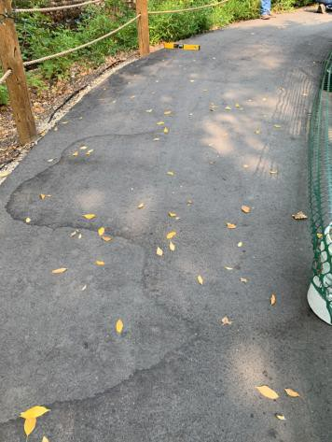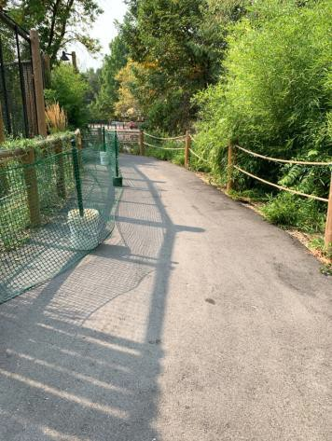

 | ID:  3642 | Facility:  City of Boise Zoo

Location Parque Nacional da Gorongosa African Wild Dog Viewing
Schedule 2021
Estimated Cost: $100.00

Priority Score 5
Quick Fix: Yes
Built before ADA: Yes

VIOLATIONS
2010 ADA Standards for Accessible Design Codes §307.2
The fire extinguisher protrudes 5" into the circulation space at 32" above the floor.

RECOMMENDATIONS
Recess the fire extinguisher so it protrudes a maximum of 4", lower it so the bottom edge is 27" maximum above the floor, or place a cane detectable object beneath it.

PHOTOGRAPH(S) OF THIS LOCATION

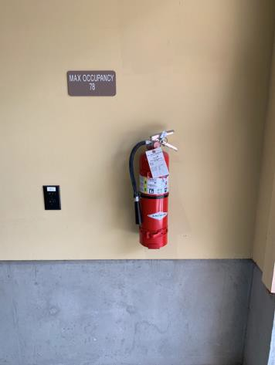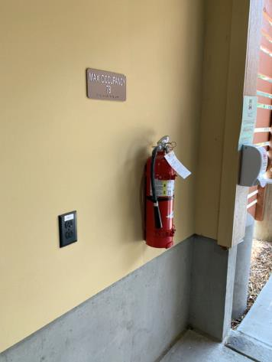

 | ID: | Facility:  City of Boise Zoo

Location:
Schedule:
Estimated Cost:

Priority Score 3
Quick Fix: No
Built before ADA: Yes

VIOLATIONS

RECOMMENDATIONS

PHOTOGRAPH(S) OF THIS LOCATION

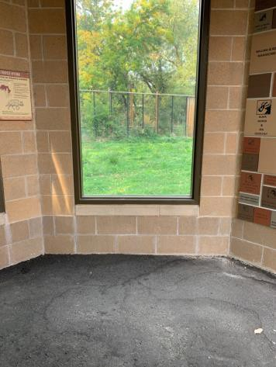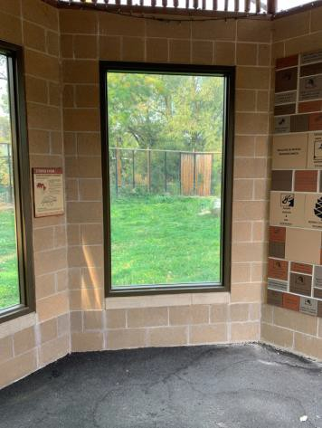

 | ID:  3415 | Facility:  City of Boise Zoo

Location Parque Nacional da Gorongosa African Wild Dog Viewing
Schedule 2021
Estimated Cost: $2,500.00

Priority Score 3
Quick Fix: No
Built before ADA: Yes

VIOLATIONS
2010 ADA Standards for Accessible Design Codes §304.2
The turning space has a 3.5% to 3.8% slope.

RECOMMENDATIONS
Reconstruct the turning space to reduce the slope to the maximum allowable 2% in all directions.

PHOTOGRAPH(S) OF THIS LOCATION

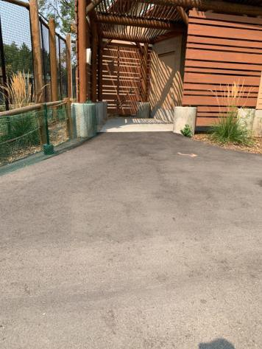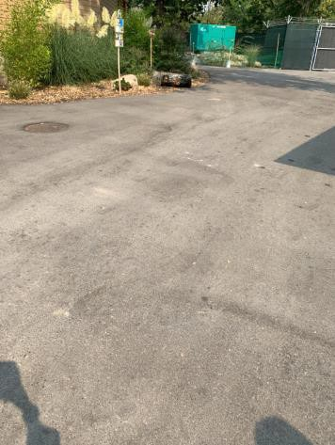

 | ID:  3357 | Facility:  City of Boise Zoo

Location Parque Nacional da Gorongosa Bats
Schedule 2021
Estimated Cost: $2,000.00

Priority Score 3
Quick Fix: No
Built before ADA: Yes

VIOLATIONS
2010 ADA Standards for Accessible Design Codes §305.2
The clear floor space at the viewing windows have 2.8% and 2.6% slopes.

RECOMMENDATIONS
Reconstruct a minimum of a 30"x48" clear floor space to have a maximum slope of 2% in all directions.

PHOTOGRAPH(S) OF THIS LOCATION

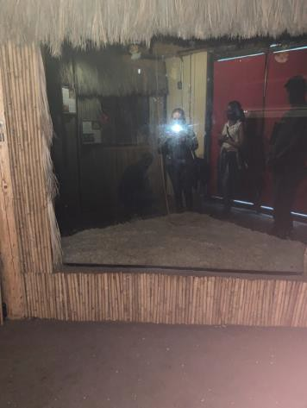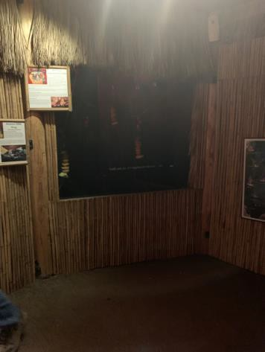

 | ID:  3593 | Facility:  City of Boise Zoo

Location Parque Nacional da Gorongosa Chitengo Camp
Schedule 2021
Estimated Cost: $1,000.00

Priority Score 3
Quick Fix: No
Built before ADA: Yes

VIOLATIONS
2010 ADA Standards for Accessible Design Codes §403.3
The cross slope is 2.6%.

RECOMMENDATIONS
Resurface the route to reduce the cross slope to a maximum of 2%.

PHOTOGRAPH(S) OF THIS LOCATION

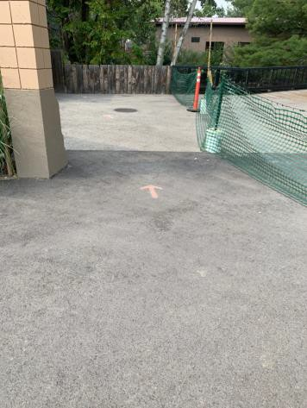

 | ID:  3407 | Facility:  City of Boise Zoo

Location Parque Nacional da Gorongosa Chitengo Camp
Schedule 2021
Estimated Cost: $2,500.00

Priority Score 3
Quick Fix: No
Built before ADA: Yes

VIOLATIONS
2010 ADA Standards for Accessible Design Codes §403.3
The cross slope is 6.9%.

RECOMMENDATIONS
Reconstruct the route to reduce the cross slope to a maximum of 2%.

PHOTOGRAPH(S) OF THIS LOCATION

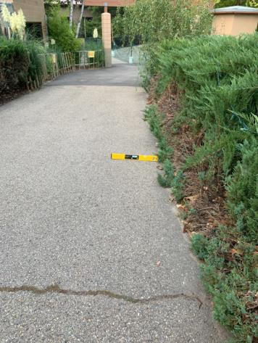

 | ID:  3305 | Facility:  City of Boise Zoo

Location Parque Nacional da Gorongosa Chitengo Camp
Schedule 2021
Estimated Cost: $5,000.00

Priority Score 3
Quick Fix: No
Built before ADA: Yes

VIOLATIONS
2010 ADA Standards for Accessible Design Codes §302.1, §305
There is not a firm, stable, and slip resistant route to the Chitengo Camp tents.

RECOMMENDATIONS
Replace the mulch with a firm, stable, and slip resistant surface, such as engineered wood fiber.
Ensure that the running slope is a maximum of 5% and the cross slope is a maximum of 2% so that, a minimum of 5% tents are accessible.

PHOTOGRAPH(S) OF THIS LOCATION

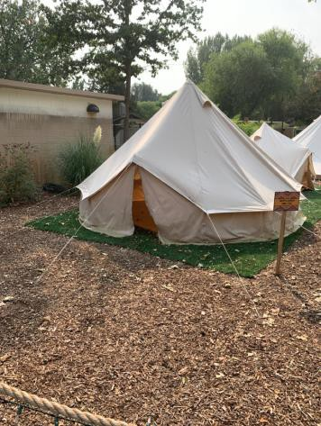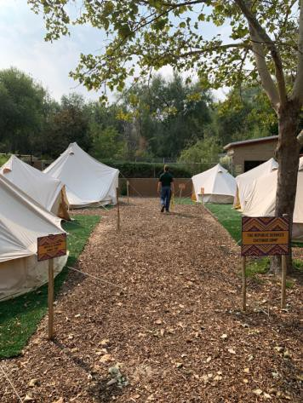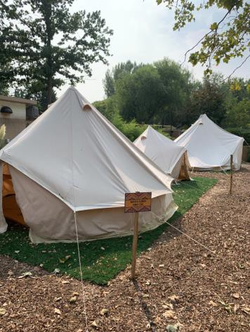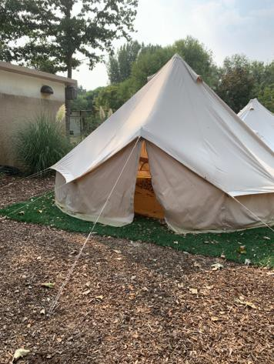

 | ID:  3537 | Facility:  City of Boise Zoo

Location Parque Nacional da Gorongosa Crocodiles
Schedule 2022
Estimated Cost: $1,000.00

Priority Score 7
Quick Fix: No
Built before ADA: Yes

VIOLATIONS
2010 ADA Standards for Accessible Design Codes §305.2
The clear floor space has a 2.5% slope.

RECOMMENDATIONS
Resurface the 30"x48" clear floor space to have a maximum slope of 2% in all directions.

PHOTOGRAPH(S) OF THIS LOCATION

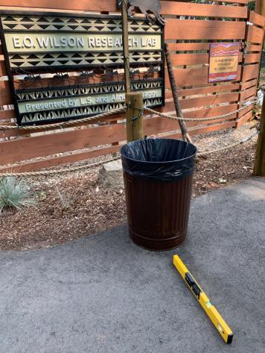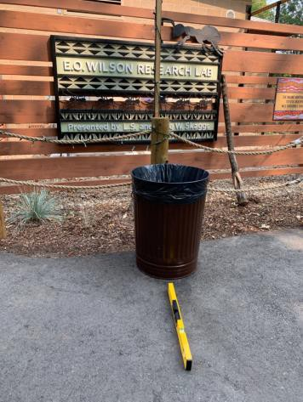

 | ID:  3526 | Facility:  City of Boise Zoo

Location Parque Nacional da Gorongosa EO Wilson Research Center
Schedule 2021
Estimated Cost: $100.00

Priority Score 5
Quick Fix: Yes
Built before ADA: Yes

VIOLATIONS
2010 ADA Standards for Accessible Design Codes §307.2
The TV protrudes 14.25" into the circulation space at 60" above the floor.

RECOMMENDATIONS
Recess the TV so it protrudes a maximum of 4", raise it so the bottom edge is 80" maximum above the floor, or place a cane detectable object beneath it.

PHOTOGRAPH(S) OF THIS LOCATION

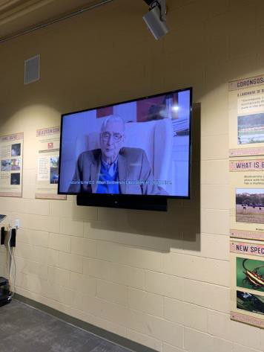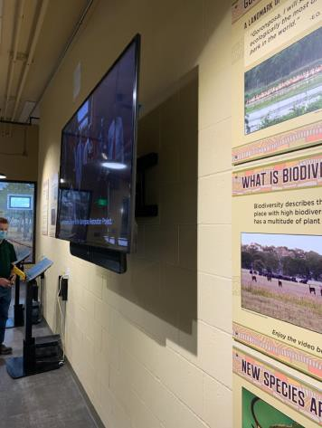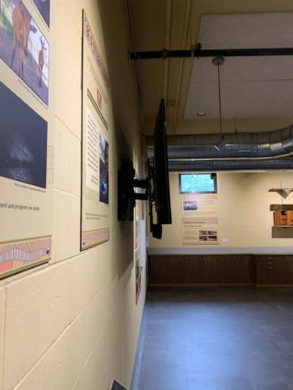

 | ID:  3630 | Facility:  City of Boise Zoo

Location Parque Nacional da Gorongosa EO Wilson Research Center
Schedule 2021
Estimated Cost: $100.00

Priority Score 5
Quick Fix: Yes
Built before ADA: Yes

VIOLATIONS
2010 ADA Standards for Accessible Design Codes §307.2
The TV protrudes 12" into the circulation space at 60" above the floor.

RECOMMENDATIONS
Recess the TV so it protrudes a maximum of 4", raise it so the bottom edge is 80" maximum above the floor, or place a cane detectable object beneath it.

PHOTOGRAPH(S) OF THIS LOCATION

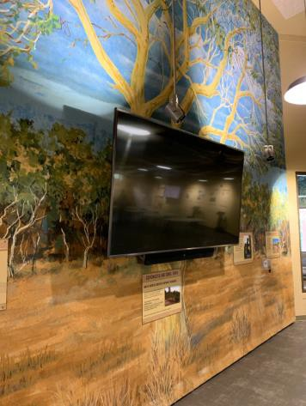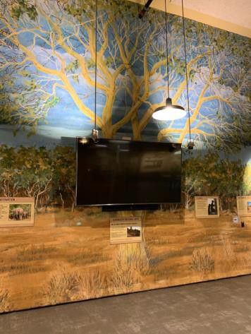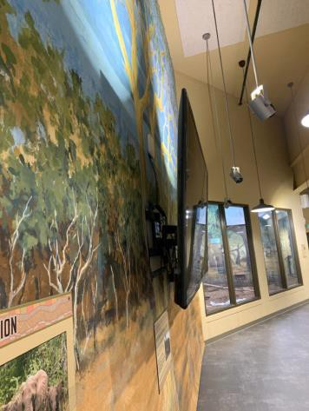

 | ID:  3385 | Facility:  City of Boise Zoo

Location Parque Nacional da Gorongosa EO Wilson Research Center
Schedule 2022
Estimated Cost: $1,000.00

Priority Score 5
Quick Fix: No
Built before ADA: Yes

VIOLATIONS
2010 ADA Standards for Accessible Design Codes §505.10
There are no handrail extensions for the ramp.

RECOMMENDATIONS
Extend the ramp handrails 12” horizontally beyond the top and bottom of ramp runs.

PHOTOGRAPH(S) OF THIS LOCATION

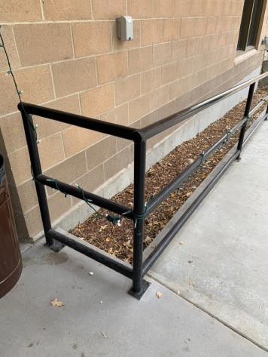

 | ID:  3658 | Facility:  City of Boise Zoo

Location Parque Nacional da Gorongosa EO Wilson Research Center
Schedule 2022
Estimated Cost: $1,000.00

Priority Score 7
Quick Fix: No
Built before ADA: Yes

VIOLATIONS
2010 ADA Standards for Accessible Design Codes §305.2
The clear floor space at the informational sign has a 3% cross slope.

RECOMMENDATIONS
Resurface the 30"x48" clear floor space to have a maximum slope of 2% in all directions.

PHOTOGRAPH(S) OF THIS LOCATION

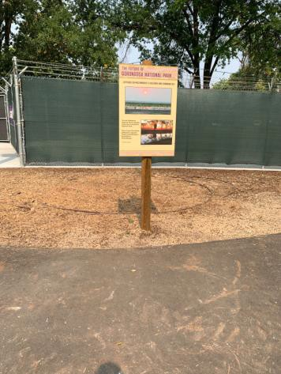

 | ID:  3386 | Facility:  City of Boise Zoo

Location Parque Nacional da Gorongosa EO Wilson Research Center
Schedule 2022
Estimated Cost: $2,000.00

Priority Score 5
Quick Fix: No
Built before ADA: Yes

VIOLATIONS
2010 ADA Standards for Accessible Design Codes §505.4
Handrails are not located at a compliant height above the stair nosings at 39.5" above the stair nosings.

RECOMMENDATIONS
Lower the handrails to a minimum height of 34" and a maximum of 38" above the stair nosings. Ensure that the handrails are at a consistent height along the stair treads.

PHOTOGRAPH(S) OF THIS LOCATION

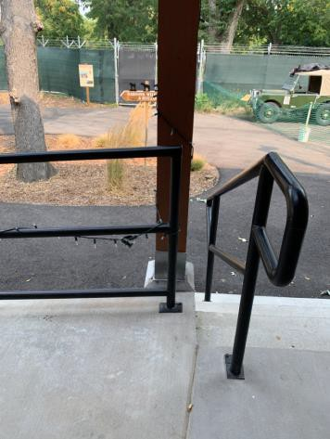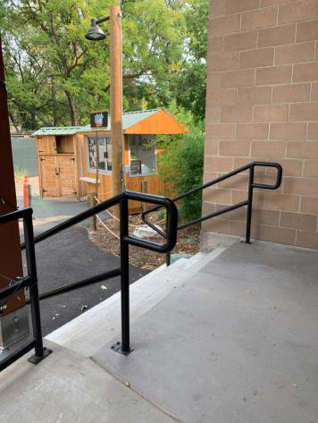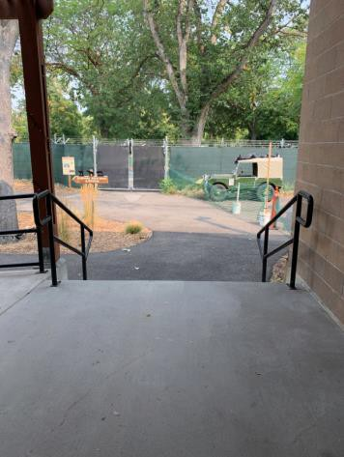

 | ID:  3570 | Facility:  City of Boise Zoo

Location Parque Nacional da Gorongosa EO Wilson Research Center
Schedule 2021
Estimated Cost: $2,500.00

Priority Score 3
Quick Fix: No
Built before ADA: Yes

VIOLATIONS
2010 ADA Standards for Accessible Design Codes §404.2.4.4
The entrance has a 6.5% slope.

RECOMMENDATIONS
Reconstruct the entryway to reduce the running slope to a maximum of 2% in all directions for a distance of 60" perpendicular to the doorway.

PHOTOGRAPH(S) OF THIS LOCATION

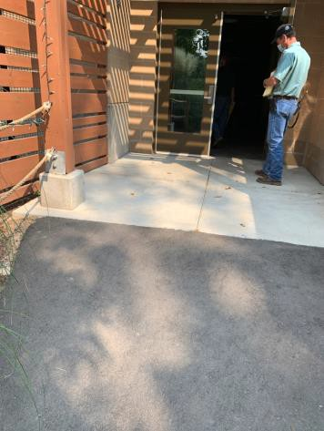

 | ID:  3640 | Facility:  City of Boise Zoo

Location Parque Nacional da Gorongosa Lion House
Schedule 2021
Estimated Cost: $100.00

Priority Score 5
Quick Fix: Yes
Built before ADA: Yes

VIOLATIONS
2010 ADA Standards for Accessible Design Codes §307.2
The TV protrudes 50" into the circulation space at 9.5" above the floor.

RECOMMENDATIONS
Recess the TV so it protrudes a maximum of 4", raise it so the bottom edge is 80" maximum above the floor, or place a cane detectable object beneath it.

PHOTOGRAPH(S) OF THIS LOCATION

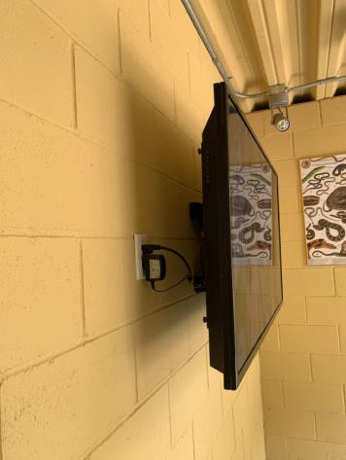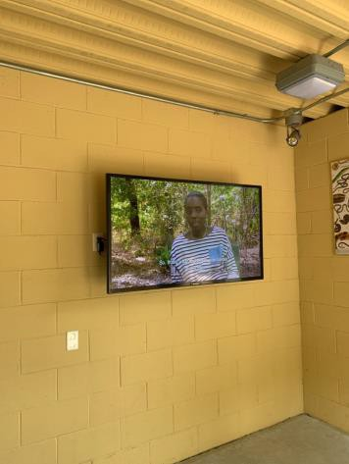

 | ID:  3114 | Facility:  City of Boise Zoo

Location Parque Nacional da Gorongosa Nyala
Schedule 2021
Estimated Cost: $500.00

Priority Score 3
Quick Fix: Yes
Built before ADA: Yes

VIOLATIONS
2010 ADA Standards for Accessible Design Codes §303.3
The change in level between 0.25" and 0.5" is not beveled.

RECOMMENDATIONS
Bevel the change in level with a slope not steeper than 1:2.

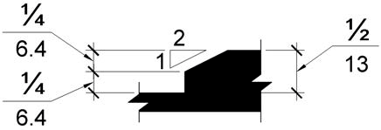

PHOTOGRAPH(S) OF THIS LOCATION

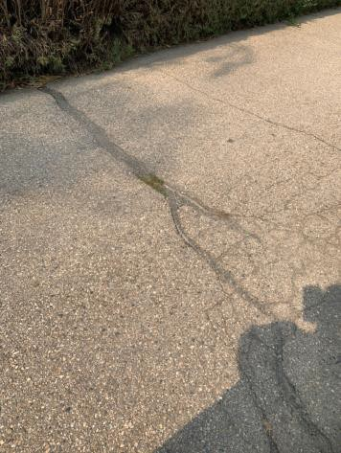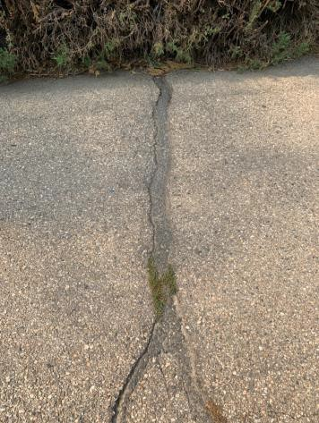

 | ID:  3002 | Facility:  City of Boise Zoo

Location Parque Nacional da Gorongosa Nyala
Schedule 2021
Estimated Cost: $2,500.00

Priority Score 3
Quick Fix: No
Built before ADA: Yes

VIOLATIONS
2010 ADA Standards for Accessible Design Codes §305.2
The clear floor space at the Nyala viewing has a 3.9% running slope.

RECOMMENDATIONS
Reconstruct a minimum of a 30"x48" clear floor space to have a maximum slope of 2% in all directions.

PHOTOGRAPH(S) OF THIS LOCATION

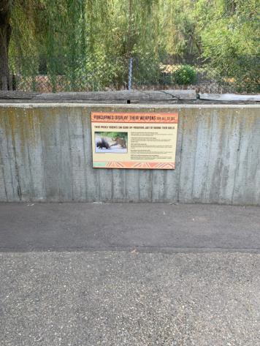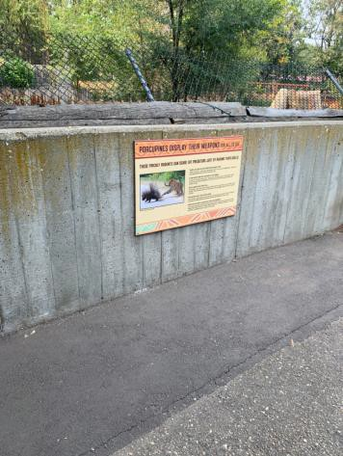

 | ID:  3163 | Facility:  City of Boise Zoo

Location Parque Nacional da Gorongosa Otters
Schedule 2021
Estimated Cost: $2,500.00

Priority Score 3
Quick Fix: No
Built before ADA: Yes

VIOLATIONS
2010 ADA Standards for Accessible Design Codes §305.2
The clear floor space at the Otters viewing has a 3.8% cross slope and 4.6% running slope.

RECOMMENDATIONS
Reconstruct a minimum of a 30"x48" clear floor space to have a maximum slope of 2% in all directions.

PHOTOGRAPH(S) OF THIS LOCATION

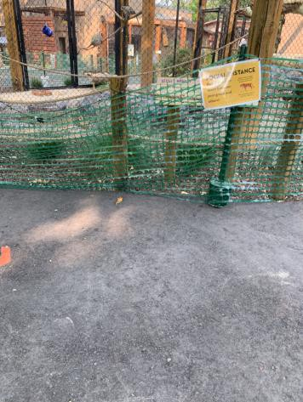

 | ID:  3612 | Facility:  City of Boise Zoo

Location Parque Nacional da Gorongosa Warthog
Schedule 2021
Estimated Cost: $2,000.00

Priority Score 3
Quick Fix: No
Built before ADA: Yes

VIOLATIONS
2010 ADA Standards for Accessible Design Codes §305.2
The clear floor space has a 3.1% slope at the middle window and 2.3% at the side window.

RECOMMENDATIONS
Reconstruct a minimum of a 30"x48" clear floor space to have a maximum slope of 2% in all directions.

PHOTOGRAPH(S) OF THIS LOCATION

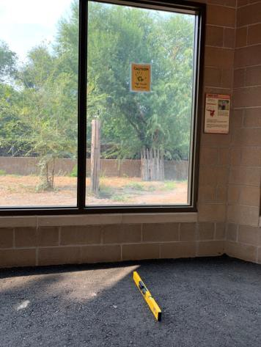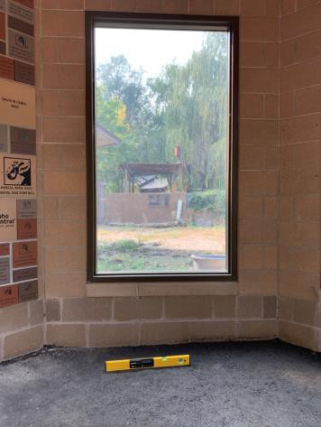

 | ID:  3507 | Facility:  City of Boise Zoo

Location Parque Nacional da Gorongosa Warthog
Schedule 2021
Estimated Cost: $2,500.00

Priority Score 3
Quick Fix: No
Built before ADA: Yes

VIOLATIONS
2010 ADA Standards for Accessible Design Codes §305.2
The clear floor space for the Warthog viewing area has a 10.5% slope.

RECOMMENDATIONS
Reconstruct a minimum of a 30"x48" clear floor space to have a maximum slope of 2% in all directions.

PHOTOGRAPH(S) OF THIS LOCATION

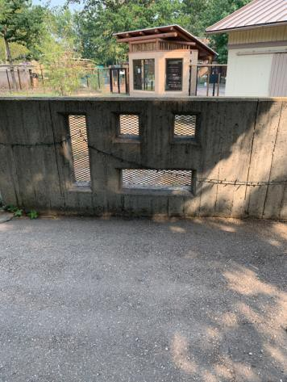

 | ID:  2999 | Facility:  City of Boise Zoo

Location Parque Nacional da Gorongosa Zebra
Schedule 2022
Estimated Cost: $1,000.00

Priority Score 5
Quick Fix: No
Built before ADA: Yes

VIOLATIONS
2010 ADA Standards for Accessible Design Codes §303.2
There is a change in level greater than 0.25".

RECOMMENDATIONS
Resurface the pathway to reduce the change in level to a maximum of 0.25" or 0.5" if beveled.

PHOTOGRAPH(S) OF THIS LOCATION

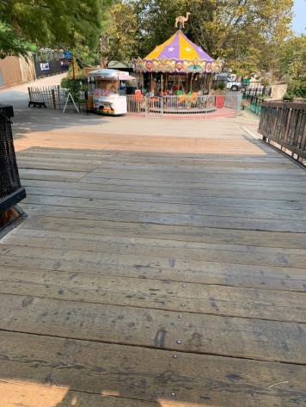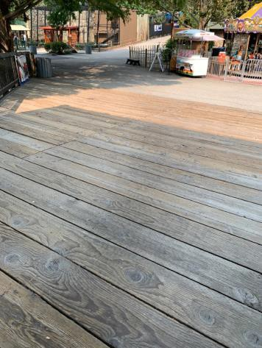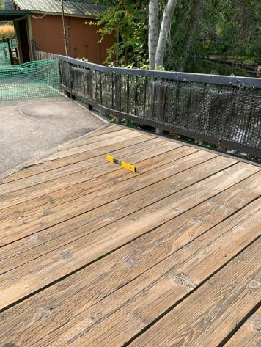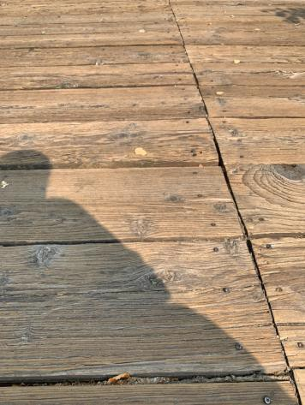

 | ID:  3361 | Facility:  City of Boise Zoo

Location Parque Nacional da Gorongosa Zebra
Schedule 2021
Estimated Cost: $1,000.00

Priority Score 3
Quick Fix: No
Built before ADA: Yes

VIOLATIONS
2010 ADA Standards for Accessible Design Codes §305.2
The clear floor space at the Zebra viewing has a 3% slope.

RECOMMENDATIONS
Reconstruct a minimum of a 30"x48" clear floor space to have a maximum slope of 2% in all directions.

PHOTOGRAPH(S) OF THIS LOCATION

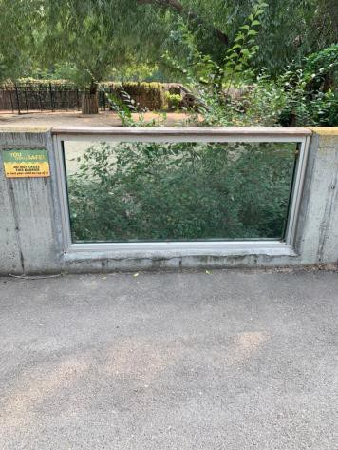

 | ID:  3754 | Facility:  City of Boise Zoo

Location Parque Nacional da Gorongosa Zebra
Schedule 2021
Estimated Cost: $2,500.00

Priority Score 3
Quick Fix: No
Built before ADA: Yes

VIOLATIONS
2010 ADA Standards for Accessible Design Codes §305.2
The clear floor space at the Zebra viewing has a 10% slope.

RECOMMENDATIONS
Reconstruct a minimum of a 30"x48" clear floor space to have a maximum slope of 2% in all directions.

PHOTOGRAPH(S) OF THIS LOCATION

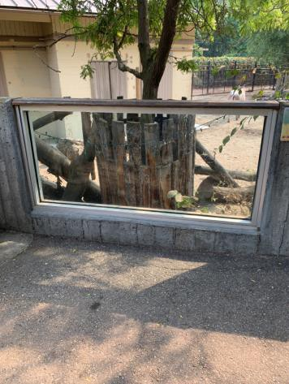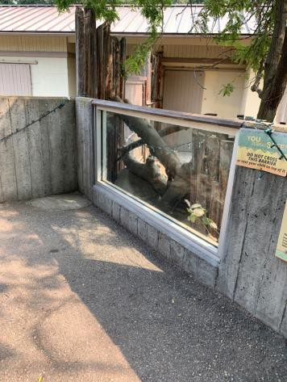

 | ID: | Facility:  City of Boise Zoo

Location:
Schedule:
Estimated Cost:

Priority Score 6
Quick Fix: No
Built before ADA: Yes

VIOLATIONS

RECOMMENDATIONS

PHOTOGRAPH(S) OF THIS LOCATION

 | ID:  2997 | Facility:  City of Boise Zoo

Location Parque Nacional da Gorongosa Zebra
Schedule 2021
Estimated Cost: $7,500.00

Priority Score 3
Quick Fix: No
Built before ADA: Yes

VIOLATIONS
2010 ADA Standards for Accessible Design Codes §403.3
The cross slope is 3%.

RECOMMENDATIONS
Reconstruct the route to reduce the cross slope to a maximum of 2%.

PHOTOGRAPH(S) OF THIS LOCATION

 | ID:  2371 | Facility:  City of Boise Zoo

Location Path to Climbing Statues
Schedule 2021
Estimated Cost: $1,000.00

Priority Score 3
Quick Fix: No
Built before ADA: Yes

VIOLATIONS
2010 ADA Standards for Accessible Design Codes §403.3
The running slope reaches 6.2%.

RECOMMENDATIONS
Resurface the route to reduce the running slope to a maximum of 5%.

PHOTOGRAPH(S) OF THIS LOCATION

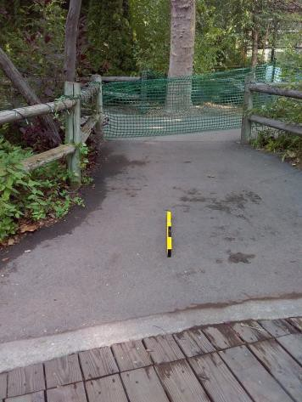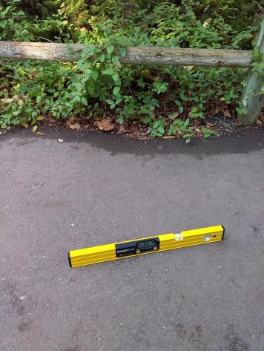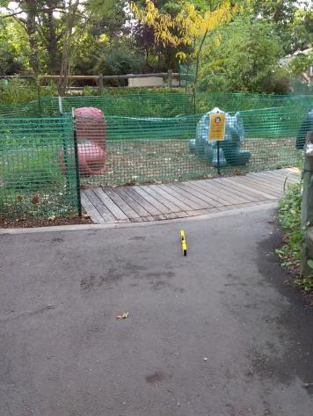

 | ID:  2367 | Facility:  City of Boise Zoo

Location Path to Sloth Bear Viewing
Schedule 2021
Estimated Cost: $2,500.00

Priority Score 3
Quick Fix: No
Built before ADA: Yes

VIOLATIONS
2010 ADA Standards for Accessible Design Codes §403.3
The cross slope reaches 5.5%.

RECOMMENDATIONS
Reconstruct the route to reduce the cross slope to a maximum of 2%.

PHOTOGRAPH(S) OF THIS LOCATION

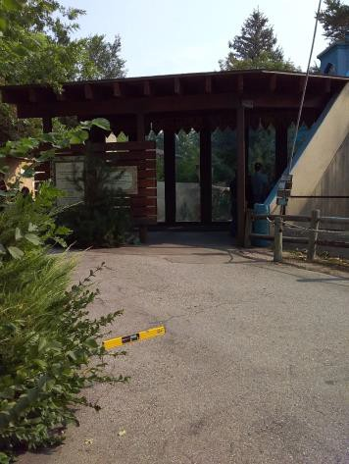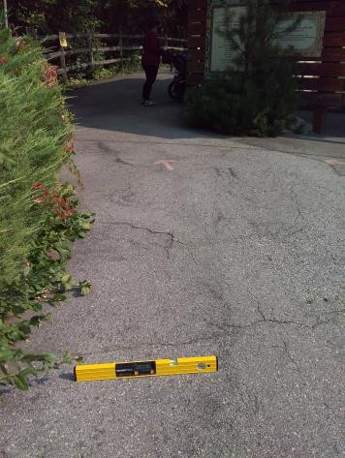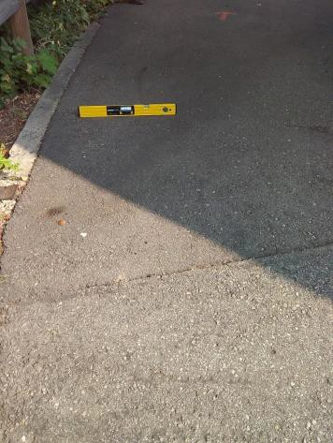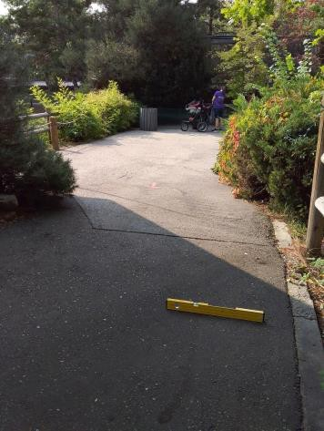

 | ID:  2337 | Facility:  City of Boise Zoo

Location Penguin House
Schedule 2023
Estimated Cost: $3,000.00

Priority Score 8
Quick Fix: No
Built before ADA: Yes

VIOLATIONS
2010 ADA Standards for Accessible Design Codes §308.2.1
The coin slot is outside of the unobstructed forward reach range at 52" above the floor.

RECOMMENDATIONS
Lower the coin slot by 4" to meet the accessible reach range of 48" maximum above the floor.
This may require replacing the machine.

PHOTOGRAPH(S) OF THIS LOCATION

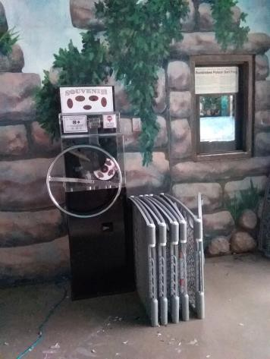

 | ID:  3650 | Facility:  City of Boise Zoo

Location Peregrine Exhibit
Schedule 2021
Estimated Cost: $2,500.00

Priority Score 3
Quick Fix: No
Built before ADA: Yes

VIOLATIONS
2010 ADA Standards for Accessible Design Codes §305.2
The clear floor space at the Peregrine viewing has a 4.3% slope.

RECOMMENDATIONS
Reconstruct a minimum of a 30"x48" clear floor space to have a maximum slope of 2% in all directions.

PHOTOGRAPH(S) OF THIS LOCATION

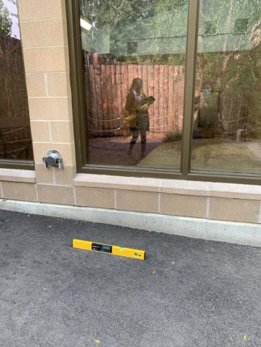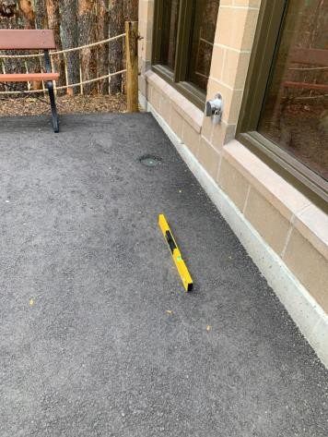

 | ID:  3172 | Facility:  City of Boise Zoo

Location Prairie Dog Exhibit
Schedule 2021
Estimated Cost: $1,000.00

Priority Score 3
Quick Fix: No
Built before ADA: Yes

VIOLATIONS
2010 ADA Standards for Accessible Design Codes §403.3
The cross slope is 3%.

RECOMMENDATIONS
Resurface the route to reduce the cross slope to a maximum of 2%.

PHOTOGRAPH(S) OF THIS LOCATION

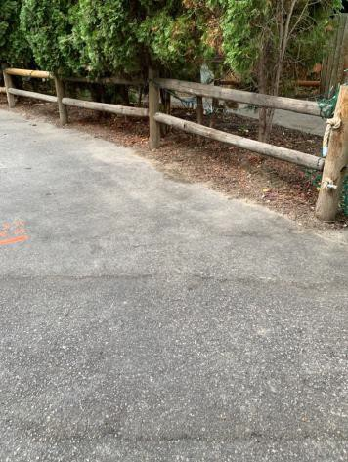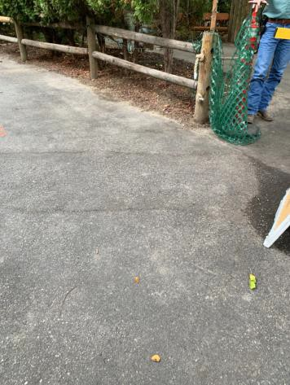

 | ID:  2372 | Facility:  City of Boise Zoo

Location Pupil Room - Butterfly Sanctuary
Schedule 2022
Estimated Cost: $4,000.00

Priority Score 7
Quick Fix: No
Built before ADA: Yes

VIOLATIONS
2010 ADA Standards for Accessible Design Codes §405
The elevated component is only accessible via a step.

RECOMMENDATIONS
Add vertical access to the amenity via a ramp. If a ramp is added, ensure that the slope does not exceed 8.3%, handrails are provided, and there is sufficient room for a level landing at the top and bottom of the ramp.

PHOTOGRAPH(S) OF THIS LOCATION

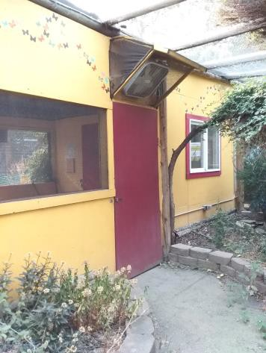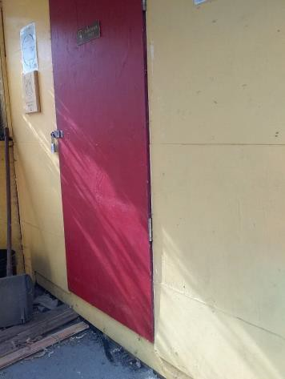

 | ID:  3524 | Facility:  City of Boise Zoo

Location Ramp to Bear Viewing
Schedule 2021
Estimated Cost: $1,000.00

Priority Score 3
Quick Fix: No
Built before ADA: Yes

VIOLATIONS
2010 ADA Standards for Accessible Design Codes §304.2
The turning space has a 2.8% slope.

RECOMMENDATIONS
Resurface the turning space to reduce the slope to the maximum allowable 2% in all directions.

PHOTOGRAPH(S) OF THIS LOCATION

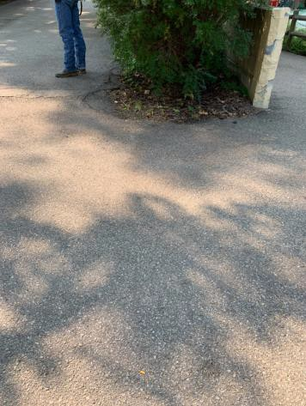

 | ID:  3314 | Facility:  City of Boise Zoo

Location Ramp to Bear Viewing
Schedule 2022
Estimated Cost: $2,500.00

Priority Score 7
Quick Fix: No
Built before ADA: Yes

VIOLATIONS
2010 ADA Standards for Accessible Design Codes §305.2
The clear floor space has a 4.3% slope.

RECOMMENDATIONS
Reconstruct the 30"x48" clear floor space to have a maximum slope of 2% in all directions.

PHOTOGRAPH(S) OF THIS LOCATION

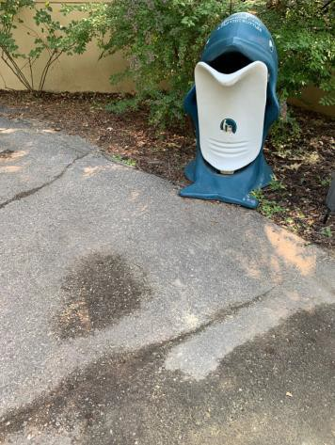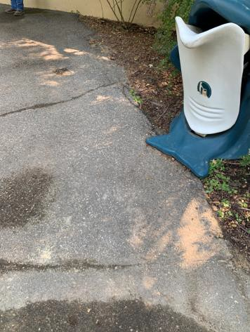

 | ID:  3300 | Facility:  City of Boise Zoo

Location Ramp to Bear Viewing
Schedule 2021
Estimated Cost: $4,000.00

Priority Score 3
Quick Fix: No
Built before ADA: Yes

VIOLATIONS
2010 ADA Standards for Accessible Design Codes §403.3
The cross slope is 7.6%.

RECOMMENDATIONS
Reconstruct the route to reduce the cross slope to a maximum of 2%.

PHOTOGRAPH(S) OF THIS LOCATION

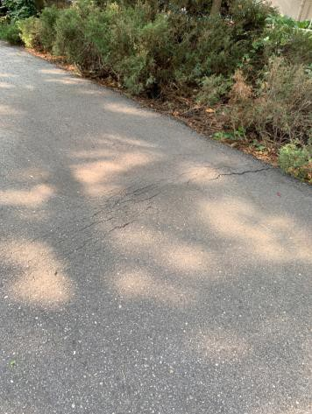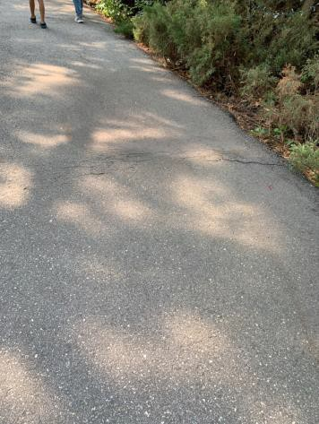

 | ID:  3104 | Facility:  City of Boise Zoo

Location Ramp to Bear Viewing
Schedule 2021
Estimated Cost: $10,000.00

Priority Score 3
Quick Fix: No
Built before ADA: Yes

VIOLATIONS
2010 ADA Standards for Accessible Design Codes §405.2, §405.3, §505.2
There are no handrails.
The running slope of the ramp is 9.6%. The cross slope of the ramp is 2.6%.

RECOMMENDATIONS
Reconstruct the path to ensure that the cross slope does not exceed 2%. The running slope must not exceed 8.3% and have level landings and handrails mounted between 34" and 38" above the ground.

PHOTOGRAPH(S) OF THIS LOCATION

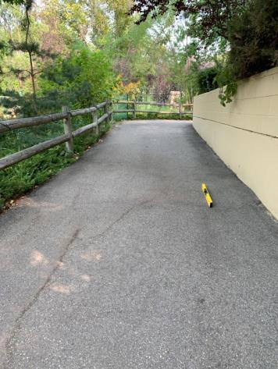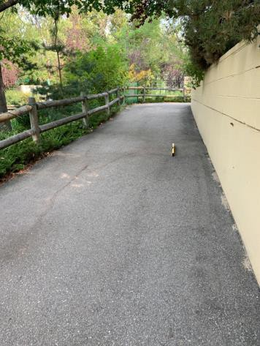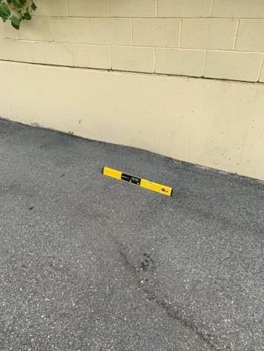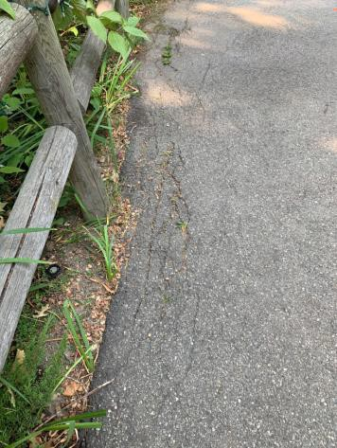

 | ID:  3671 | Facility:  City of Boise Zoo

Location Ramp to Bear Viewing
Schedule 2021
Estimated Cost: $10,000.00

Priority Score 3
Quick Fix: No
Built before ADA: Yes

VIOLATIONS
2010 ADA Standards for Accessible Design Codes §403.3, §302.1
A section of the pavement is uneven posing a tripping hazard and causing a running slope of 12.3%.

RECOMMENDATIONS
Reconstruct the pathway to ensure that the uneven section of asphalt is level, with vertical changes in elevation not exceeding 0.25".

PHOTOGRAPH(S) OF THIS LOCATION

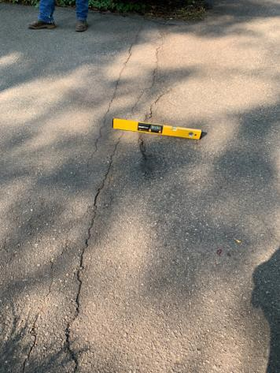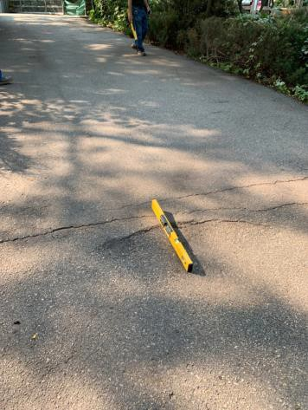

 | ID:  2360 | Facility:  City of Boise Zoo

Location Recycling Cans near Zoo Kitchen
Schedule 2022
Estimated Cost: $2,500.00

Priority Score 7
Quick Fix: No
Built before ADA: Yes

VIOLATIONS
2010 ADA Standards for Accessible Design Codes §305.2
The clear floor space has a 3.2% slope.

RECOMMENDATIONS
Reconstruct the 30"x48" clear floor space to have a maximum slope of 2% in all directions.

PHOTOGRAPH(S) OF THIS LOCATION

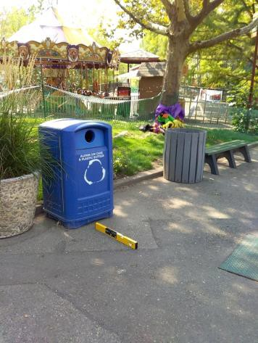

 | ID:  3380 | Facility:  City of Boise Zoo

Location Red Panda Exhibit
Schedule 2021
Estimated Cost: $10,000.00

Priority Score 3
Quick Fix: No
Built before ADA: Yes

VIOLATIONS
2010 ADA Standards for Accessible Design Codes §302.1
The Red Panda exhibit viewing area is not a firm, stable, and slip resistant surface and contains cross slope of up to 3.5%.

RECOMMENDATIONS
Pave the viewing area with a stable, firm, and slip resistant surface ensuring that it has compliant running and cross slopes.

PHOTOGRAPH(S) OF THIS LOCATION

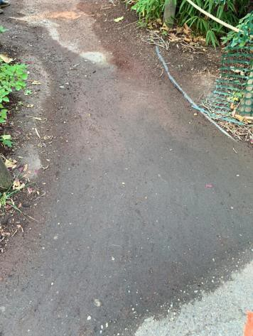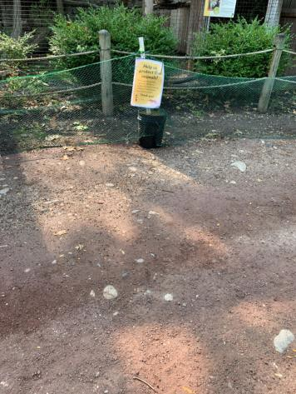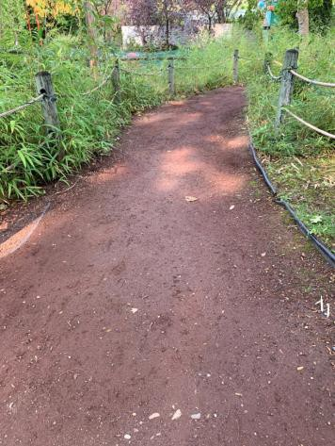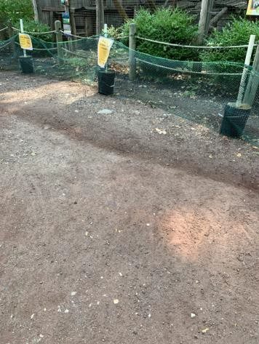

 | ID:  3236 | Facility:  City of Boise Zoo

Location Red Panda Exhibit Class Area
Schedule 2021
Estimated Cost: $1,000.00

Priority Score 3
Quick Fix: No
Built before ADA: Yes

VIOLATIONS
2010 ADA Standards for Accessible Design Codes §226.1, §902, §305, §306
The provided picnic tables do not have an accessible clear space for a wheelchair user.

RECOMMENDATIONS
Add/replace picnic tables so that at least 5% of the seating is wheelchair accessible.
Ensure that the wheelchair accessible seating has a clear floor space of 30" x 48" with a slope not steeper than 2% and that the tables have sufficient knee and toe clearance.

PHOTOGRAPH(S) OF THIS LOCATION

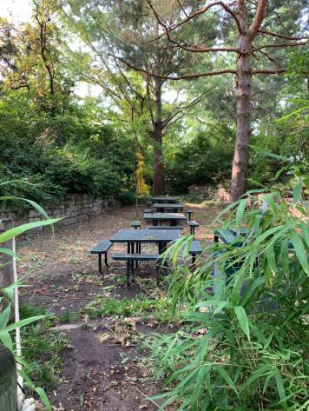

 | ID:  3237 | Facility:  City of Boise Zoo

Location Red Panda Exhibit Class Area
Schedule 2021
Estimated Cost: $5,000.00

Priority Score 3
Quick Fix: No
Built before ADA: Yes

VIOLATIONS
2010 ADA Standards for Accessible Design Codes §405, §302.1, §305
There is not a firm, stable, and slip resistant route to the picnic tables. The elevated component is only accessible via stairs.

RECOMMENDATIONS
Construct a firm, stable, and slip resistant accessible route with a maximum cross slope of 2% and maximum running slope of 5%.
Add vertical access to the amenity. If a ramp is added, ensure that the slope does not exceed 8.3%, handrails are provided, and there is sufficient room for a level landing at the top and bottom of the ramp.

PHOTOGRAPH(S) OF THIS LOCATION

 | ID:  3252 | Facility:  City of Boise Zoo

Location Red Panda Play Area
Schedule 2021
Estimated Cost: $1,000.00

Priority Score 3
Quick Fix: No
Built before ADA: Yes

VIOLATIONS
2010 ADA Standards for Accessible Design Codes §304.2
The turning space has a 4% slope.

RECOMMENDATIONS
Resurface the turning space to reduce the slope to the maximum allowable 2% in all directions.

PHOTOGRAPH(S) OF THIS LOCATION

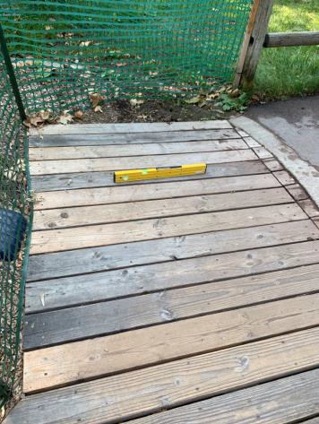

 | ID:  3214 | Facility:  City of Boise Zoo

Location Red Panda Play Area
Schedule 2021
Estimated Cost: $2,500.00

Priority Score 3
Quick Fix: No
Built before ADA: Yes

VIOLATIONS
2010 ADA Standards for Accessible Design Codes §304.2
The turning space has a 3.5% slope.

RECOMMENDATIONS
Reconstruct the turning space to reduce the slope to the maximum allowable 2% in all directions.

PHOTOGRAPH(S) OF THIS LOCATION

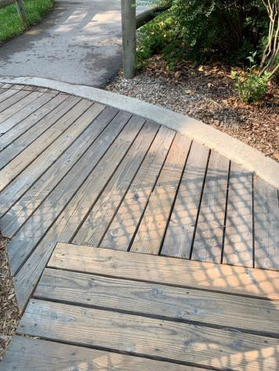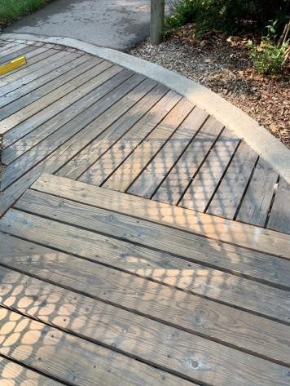

 | ID:  3280 | Facility:  City of Boise Zoo

Location Red Panda Play Area
Schedule 2021
Estimated Cost: $5,000.00

Priority Score 3
Quick Fix: No
Built before ADA: Yes

VIOLATIONS
2010 ADA Standards for Accessible Design Codes ASTM F1951-99
The play area surface is not stable, firm, and slip resistant.

RECOMMENDATIONS
Replace the mulch with an accessible playground surface material such as pour-in-place rubber, rubber tiles, artificial grass, or engineered wood fiber.

PHOTOGRAPH(S) OF THIS LOCATION

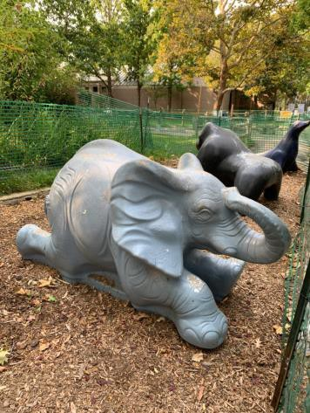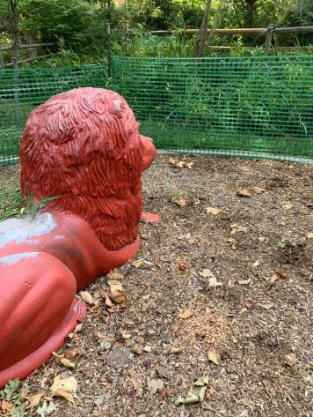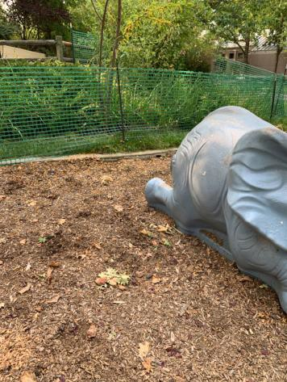

 | ID:  2336 | Facility:  City of Boise Zoo

Location Route from Penguin House Towards Nyala Exhibit
Schedule 2021
Estimated Cost: $2,500.00

Priority Score 3
Quick Fix: No
Built before ADA: Yes

VIOLATIONS
2010 ADA Standards for Accessible Design Codes §403.3, §303.3
The recessed paw prints are a tripping hazard due to them being recessed up to 0.5". The running slope is 8%.

RECOMMENDATIONS
Fill in the paw prints as to not exceed 0.25" in depth.
Reconstruct the route to reduce the running slope to a maximum of 5%.

PHOTOGRAPH(S) OF THIS LOCATION

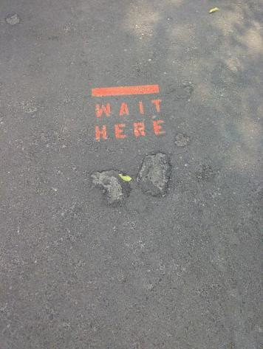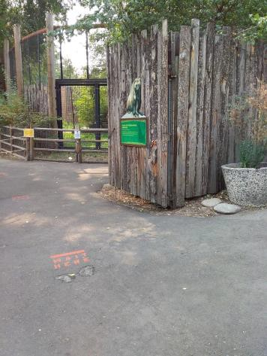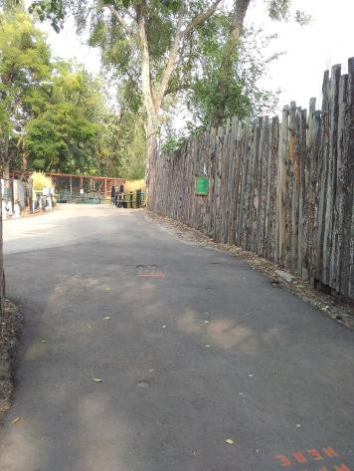

 | ID:  2877 | Facility:  City of Boise Zoo

Location Sarus Crane
Schedule 2021
Estimated Cost: $100.00

Priority Score 5
Quick Fix: Yes
Built before ADA: Yes

VIOLATIONS
2010 ADA Standards for Accessible Design Codes §307.2
The box protrudes 6" into the circulation space at 54" above the floor.

RECOMMENDATIONS
Recess the box so it protrudes a maximum of 4", lower it so the bottom edge is 27" maximum above the floor, or place a cane detectable object beneath it.

PHOTOGRAPH(S) OF THIS LOCATION

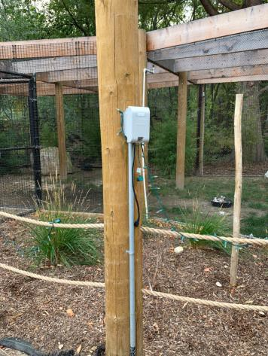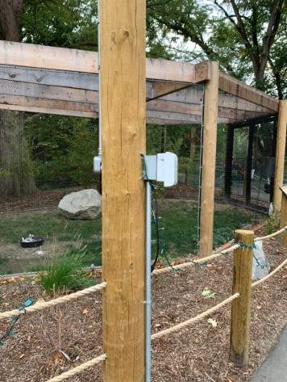

 | ID:  2876 | Facility:  City of Boise Zoo

Location Sarus Crane
Schedule 2021
Estimated Cost: $2,500.00

Priority Score 3
Quick Fix: No
Built before ADA: Yes

VIOLATIONS
2010 ADA Standards for Accessible Design Codes §305.2
The clear floor space has a 3.5% slope.

RECOMMENDATIONS
Reconstruct the 30"x48" clear floor space to have a maximum slope of 2% in all directions.

PHOTOGRAPH(S) OF THIS LOCATION

 | ID:  2878 | Facility:  City of Boise Zoo

Location Sarus Crane Indoor Viewing
Schedule 2021
Estimated Cost: $2,500.00

Priority Score 3
Quick Fix: No
Built before ADA: Yes

VIOLATIONS
2010 ADA Standards for Accessible Design Codes §305.2
The clear floor space at the Sarus Crane viewing has a 3.1% running slope.

RECOMMENDATIONS
Reconstruct a minimum of a 30"x48" clear floor space to have a maximum slope of 2% in all directions.

PHOTOGRAPH(S) OF THIS LOCATION

 | ID:  2880 | Facility:  City of Boise Zoo

Location Seating Area
Schedule 2022
Estimated Cost: $2,000.00

Priority Score 7
Quick Fix: No
Built before ADA: Yes

VIOLATIONS
2010 ADA Standards for Accessible Design Codes §305.2
The clear floor space has a 4.1% slope.

RECOMMENDATIONS
Resurface the 30"x48" clear floor space to have a maximum slope of 2% in all directions.

PHOTOGRAPH(S) OF THIS LOCATION

 | ID:  2879 | Facility:  City of Boise Zoo

Location Seating Area
Schedule 2021
Estimated Cost: $5,000.00

Priority Score 3
Quick Fix: No
Built before ADA: Yes

VIOLATIONS
2010 ADA Standards for Accessible Design Codes §226.1, §902, §305, §306
The provided picnic tables do not have accessible clear spaces for a wheelchair user.

RECOMMENDATIONS
Add/replace picnic tables so that at least 5% of the seating is wheelchair accessible.
Ensure that the wheelchair accessible seating has a clear floor space of 30" x 48" with a slope not steeper than 2% and that the tables have sufficient knee and toe clearance.

PHOTOGRAPH(S) OF THIS LOCATION

 | ID:  2329 | Facility:  City of Boise Zoo

Location Serval Cat
Schedule 2021
Estimated Cost: $1,000.00

Priority Score 3
Quick Fix: No
Built before ADA: Yes

VIOLATIONS
2010 ADA Standards for Accessible Design Codes §403.3
The cross slope is 4%.

RECOMMENDATIONS
Resurface the route to reduce the cross slope to a maximum of 2%.

PHOTOGRAPH(S) OF THIS LOCATION

 | ID:  2330 | Facility:  City of Boise Zoo

Location Serval Cat
Schedule 2021
Estimated Cost: $2,500.00

Priority Score 0
Quick Fix: No
Built before ADA: Yes

VIOLATIONS
2010 ADA Standards for Accessible Design Codes §305.2
The clear floor space has a 3.2% slope.

RECOMMENDATIONS
For the purposes of achieving greater accessibility and Human Centric Design, reconstruct the 30"x48" clear floor space to have a maximum slope of 2% in all directions or relocate the bench to an area adjacent to a level 30"x48"

PHOTOGRAPH(S) OF THIS LOCATION

 | ID:  3164 | Facility:  City of Boise Zoo

Location Sloth Bear
Schedule 2021
Estimated Cost: $2,500.00

Priority Score 3
Quick Fix: No
Built before ADA: Yes

VIOLATIONS
2010 ADA Standards for Accessible Design Codes §403.3
The running slope is 12.6%.

RECOMMENDATIONS
Reconstruct the route to reduce the running slope to a maximum of 5% or 8.3% slope with level landings and handrails.

PHOTOGRAPH(S) OF THIS LOCATION

 | ID:  3418 | Facility:  City of Boise Zoo

Location Sloth Bear
Schedule 2021
Estimated Cost: $2,500.00

Priority Score 3
Quick Fix: No
Built before ADA: Yes

VIOLATIONS
2010 ADA Standards for Accessible Design Codes §403.3
The running slope is 11.2%.

RECOMMENDATIONS
Reconstruct the route to reduce the running slope to a maximum of 5% or 8.3% slope with level landings and handrails.

PHOTOGRAPH(S) OF THIS LOCATION

 | ID:  3500 | Facility:  City of Boise Zoo

Location Sloth Bear
Schedule 2021
Estimated Cost: $2,500.00

Priority Score 3
Quick Fix: No
Built before ADA: Yes

VIOLATIONS
2010 ADA Standards for Accessible Design Codes §305.2
The clear floor space at the Sloth Bear viewing has a 3.6% slope.

RECOMMENDATIONS
Reconstruct a minimum of a 30"x48" clear floor space to have a maximum slope of 2% in all directions.

PHOTOGRAPH(S) OF THIS LOCATION

 | ID:  3679 | Facility:  City of Boise Zoo

Location Sloth Bear
Schedule 2021
Estimated Cost: $2,500.00

Priority Score 3
Quick Fix: No
Built before ADA: Yes

VIOLATIONS
2010 ADA Standards for Accessible Design Codes §403.3
The cross slope leading to the Sloth Bear is 5.5%.

RECOMMENDATIONS
Reconstruct the route to reduce the cross slope to a maximum of 2%.

PHOTOGRAPH(S) OF THIS LOCATION

 | ID:  3032 | Facility:  City of Boise Zoo

Location Sloth Bear Viewing Area Exit Ramp
Schedule 2021
Estimated Cost: $2,500.00

Priority Score 3
Quick Fix: No
Built before ADA: Yes

VIOLATIONS
2010 ADA Standards for Accessible Design Codes §403.3
The running slope of the ramp exiting the Sloth Bear viewing area is 12.5%.

RECOMMENDATIONS
Reconstruct the route to reduce the running slope to a maximum of 5% or 8.3% slope with level landings and handrails.

PHOTOGRAPH(S) OF THIS LOCATION

 | ID:  2383 | Facility:  City of Boise Zoo

Location Small Animal Kingdom (SAK)
Schedule 2021
Estimated Cost: $1,000.00

Priority Score 3
Quick Fix: No
Built before ADA: Yes

VIOLATIONS
2010 ADA Standards for Accessible Design Codes §403.3
The running slope is 8.2%.

RECOMMENDATIONS
Reconstruct the route to reduce the running slope to a maximum of 5% or 8.3% slope with level landings and handrails.

PHOTOGRAPH(S) OF THIS LOCATION

 | ID:  3420 | Facility:  City of Boise Zoo

Location Small Animal Kingdom (SAK)
Schedule 2021
Estimated Cost: $1,000.00

Priority Score 3
Quick Fix: No
Built before ADA: Yes

VIOLATIONS
2010 ADA Standards for Accessible Design Codes §403.3
The running slope is 5.1%.

RECOMMENDATIONS
Resurface the route to reduce the running slope to a maximum of 5%.

PHOTOGRAPH(S) OF THIS LOCATION

 | ID:  3018 | Facility:  City of Boise Zoo

Location Small Animal Kingdom (SAK)
Schedule 2021
Estimated Cost: $2,500.00

Priority Score 3
Quick Fix: No
Built before ADA: Yes

VIOLATIONS
2010 ADA Standards for Accessible Design Codes §305.2
The clear floor space has a 4% slope.

RECOMMENDATIONS
For the purposes of achieving greater accessibility and Human Centric Design, reconstruct the 30"x48" clear floor space to have a maximum slope of 2% in all directions or relocate the bench to an area adjacent to a level 30"x48" c

PHOTOGRAPH(S) OF THIS LOCATION

 | ID:  3763 | Facility:  City of Boise Zoo

Location Small Animal Kingdom (SAK)
Schedule 2021
Estimated Cost: $2,500.00

Priority Score 3
Quick Fix: No
Built before ADA: Yes

VIOLATIONS
2010 ADA Standards for Accessible Design Codes §304.2
The turning space has a 3.8% slope.

RECOMMENDATIONS
Reconstruct the turning space to reduce the slope to the maximum allowable 2% in all directions.

PHOTOGRAPH(S) OF THIS LOCATION

 | ID:  2382 | Facility:  City of Boise Zoo

Location Small Animal Kingdom (SAK) - Gila Monster
Schedule 2021
Estimated Cost: $2,500.00

Priority Score 3
Quick Fix: No
Built before ADA: Yes

VIOLATIONS
2010 ADA Standards for Accessible Design Codes §305.2
The clear floor space has a 5.8% running slope.

RECOMMENDATIONS
Reconstruct a minimum of a 30"x48" clear floor space to have a maximum slope of 2% in all directions.

PHOTOGRAPH(S) OF THIS LOCATION

 | ID:  2373 | Facility:  City of Boise Zoo

Location Small Animal Kingdom (SAK) - Path Leading Zoo Farm
Schedule 2022
Estimated Cost: $1,000.00

Priority Score 5
Quick Fix: No
Built before ADA: Yes

VIOLATIONS
2010 ADA Standards for Accessible Design Codes §303.2
There is a 1.5" change in level.

RECOMMENDATIONS
Resurface the pathway to reduce the change in level to less than 0.25" or 0.5" if beveled.

PHOTOGRAPH(S) OF THIS LOCATION

 | ID:  2377 | Facility:  City of Boise Zoo

Location Small Animal Kingdom (SAK) - Path Leaving Rain Forest
Schedule 2021
Estimated Cost: $100.00

Priority Score 7
Quick Fix: Yes
Built before ADA: Yes

VIOLATIONS
2010 ADA Standards for Accessible Design Codes §302.1, §305
There is not a firm, stable, and slip resistant route to the trash can.

RECOMMENDATIONS
Relocate the trash can adjacent to a level section of the accessible route.

PHOTOGRAPH(S) OF THIS LOCATION

 | ID:  2375 | Facility:  City of Boise Zoo

Location Small Animal Kingdom (SAK) - Path Leaving Rain Forest
Schedule 2022
Estimated Cost: $1,000.00

Priority Score 7
Quick Fix: No
Built before ADA: Yes

VIOLATIONS
2010 ADA Standards for Accessible Design Codes §305.2
The clear floor space has a 2.5% slope.

RECOMMENDATIONS
Resurface the 30"x48" clear floor space to have a maximum slope of 2% in all directions.

PHOTOGRAPH(S) OF THIS LOCATION

 | ID:  2376 | Facility:  City of Boise Zoo

Location Small Animal Kingdom (SAK) - Path Leaving Rain Forest
Schedule 2021
Estimated Cost: $2,500.00

Priority Score 3
Quick Fix: No
Built before ADA: Yes

VIOLATIONS
2010 ADA Standards for Accessible Design Codes §403.3
The cross slope is 6.1%.

RECOMMENDATIONS
Reconstruct the route to reduce the cross slope to a maximum of 2%.

PHOTOGRAPH(S) OF THIS LOCATION

 | ID:  2374 | Facility:  City of Boise Zoo

Location Small Animal Kingdom (SAK) - Path Leaving Tiger Area
Schedule 2021
Estimated Cost: $1,000.00

Priority Score 3
Quick Fix: No
Built before ADA: Yes

VIOLATIONS
2010 ADA Standards for Accessible Design Codes §403.3
The cross slope reaches 2.6%.

RECOMMENDATIONS
Resurface the route to reduce the cross slope to a maximum of 2%.

PHOTOGRAPH(S) OF THIS LOCATION

 | ID:  2380 | Facility:  City of Boise Zoo

Location Small Animal Kingdom (SAK) - Rain Forest Entrance
Schedule 2021
Estimated Cost: $2,500.00

Priority Score 3
Quick Fix: No
Built before ADA: Yes

VIOLATIONS
2010 ADA Standards for Accessible Design Codes §404.2.4.4
The entrance has a 5.5% running slope and 4.3% cross slope.

RECOMMENDATIONS
Reconstruct the entryway to reduce the running slope to a maximum of 2% in all directions for a distance of 60" perpendicular to the doorway.

PHOTOGRAPH(S) OF THIS LOCATION

 | ID:  2379 | Facility:  City of Boise Zoo

Location Small Animal Kingdom (SAK) - Rain Forest Exit
Schedule 2022
Estimated Cost: $1,000.00

Priority Score 5
Quick Fix: No
Built before ADA: Yes

VIOLATIONS
2010 ADA Standards for Accessible Design Codes §303.2
There is a 2" change in level.

RECOMMENDATIONS
Resurface the pathway to reduce the change in level to less than 0.25" or 0.5" if beveled.

PHOTOGRAPH(S) OF THIS LOCATION

 | ID:  2378 | Facility:  City of Boise Zoo

Location Small Animal Kingdom (SAK) - Rain Forest Exit
Schedule 2021
Estimated Cost: $1,000.00

Priority Score 3
Quick Fix: No
Built before ADA: Yes

VIOLATIONS
2010 ADA Standards for Accessible Design Codes §403.3
The running slope reaches 6.3%.

RECOMMENDATIONS
Resurface the route to reduce the running slope to a maximum of 5%.

PHOTOGRAPH(S) OF THIS LOCATION

 | ID:  2381 | Facility:  City of Boise Zoo

Location Small Animal Kingdom (SAK) - Trash Can near Rain Forest Pole
Schedule 2021
Estimated Cost: $100.00

Priority Score 7
Quick Fix: Yes
Built before ADA: Yes

VIOLATIONS
2010 ADA Standards for Accessible Design Codes §302.1, §305
There is not a firm, stable, and slip resistant route to the trash can.

RECOMMENDATIONS
Relocate the trash can adjacent to a level section of the accessible route.

PHOTOGRAPH(S) OF THIS LOCATION

 | ID:  3219 | Facility:  City of Boise Zoo

Location Small Animal Kingdom (SAK) Green Slide
Schedule 2022
Estimated Cost: $2,500.00

Priority Score 5
Quick Fix: No
Built before ADA: Yes

VIOLATIONS
2010 ADA Standards for Accessible Design Codes §505.2, §505.10.2, §505.10.3
There are no handrail extensions at the top and bottom of the stairs. There is a handrail on one side.

RECOMMENDATIONS
Install new handrails that have extensions at the slope of the stair flight for a horizontal distance at least equal to one tread depth beyond the last riser nosing.
Install an additional handrail at a minimum height of 34” and maximum of 38” above the ground. Handrail extensions shall return to the guard or landing surface.

PHOTOGRAPH(S) OF THIS LOCATION

 | ID:  3221 | Facility:  City of Boise Zoo

Location Small Animal Kingdom (SAK) Green Slide
Schedule 2021
Estimated Cost: $2,500.00

Priority Score 3
Quick Fix: No
Built before ADA: Yes

VIOLATIONS
2010 ADA Standards for Accessible Design Codes §304.2
The turning space has a 3.7% slope.

RECOMMENDATIONS
Reconstruct the turning space to reduce the slope to the maximum allowable 2% in all directions.

PHOTOGRAPH(S) OF THIS LOCATION

 | ID:  3221 | Facility:  City of Boise Zoo

Location Small Animal Kingdom (SAK) Green Slide
Schedule 2021
Estimated Cost: $2,500.00

Priority Score 3
Quick Fix: No
Built before ADA: Yes

VIOLATIONS
2010 ADA Standards for Accessible Design Codes §304.2
The turning space has a 3.7% slope.

RECOMMENDATIONS
Reconstruct the turning space to reduce the slope to the maximum allowable 2% in all directions.

PHOTOGRAPH(S) OF THIS LOCATION

 | ID:  4492 | Facility:  City of Boise Zoo

Location Small Animal Kingdom (SAK) Green Slide
Schedule 2022
Estimated Cost: $5,000.00

Priority Score 4
Quick Fix: No
Built before ADA: Yes

VIOLATIONS
2010 ADA Standards for Accessible Design Codes §504.3
Open risers are not permitted.

RECOMMENDATIONS
Replace the stairs to ensure that the risers are closed.

PHOTOGRAPH(S) OF THIS LOCATION

 | ID:  3724 | Facility:  City of Boise Zoo

Location Small Animal Kingdom (SAK) Green Tree Python
Schedule 2021
Estimated Cost: $1,000.00

Priority Score 3
Quick Fix: No
Built before ADA: Yes

VIOLATIONS
2010 ADA Standards for Accessible Design Codes §305.2
The clear floor space at the Green Tree Python viewing has a 3% slope.

RECOMMENDATIONS
Reconstruct a minimum of a 30"x48" clear floor space to have a maximum slope of 2% in all directions.

PHOTOGRAPH(S) OF THIS LOCATION

 | ID:  3125 | Facility:  City of Boise Zoo

Location Small Animal Kingdom (SAK) Komodo Dragon
Schedule 2021
Estimated Cost: $2,500.00

Priority Score 3
Quick Fix: No
Built before ADA: Yes

VIOLATIONS
2010 ADA Standards for Accessible Design Codes §305.2
The clear floor space at the Komodo Dragon viewing has a 3.3% slope.

RECOMMENDATIONS
Reconstruct a minimum of a 30"x48" clear floor space to have a maximum slope of 2% in all directions.

PHOTOGRAPH(S) OF THIS LOCATION

 | ID:  3551 | Facility:  City of Boise Zoo

Location Small Animal Kingdom (SAK) Lemur
Schedule 2021
Estimated Cost: $2,500.00

Priority Score 3
Quick Fix: No
Built before ADA: Yes

VIOLATIONS
2010 ADA Standards for Accessible Design Codes §305.2
The clear floor space at the Lemur viewing has a 3.9% to 5%.

RECOMMENDATIONS
Reconstruct a minimum of a 30"x48" clear floor space to have a maximum slope of 2% in all directions.

PHOTOGRAPH(S) OF THIS LOCATION

 | ID:  3525 | Facility:  City of Boise Zoo

Location Small Animal Kingdom (SAK) New Animal Exhibit
Schedule 2021
Estimated Cost: $1,000.00

Priority Score 3
Quick Fix: No
Built before ADA: Yes

VIOLATIONS
2010 ADA Standards for Accessible Design Codes §305.2
The clear floor space at the New Animal Exhibit viewing has a 3% slope.

RECOMMENDATIONS
Reconstruct a minimum of a 30"x48" clear floor space to have a maximum slope of 2% in all directions.

PHOTOGRAPH(S) OF THIS LOCATION

 | ID:  3303 | Facility:  City of Boise Zoo

Location Small Animal Kingdom (SAK) Playground
Schedule 2021
Estimated Cost: $5,000.00

Priority Score 3
Quick Fix: No
Built before ADA: Yes

VIOLATIONS
2010 ADA Standards for Accessible Design Codes ASTM F1951-99
The playground surface is not stable, firm, and slip resistant.

RECOMMENDATIONS
Replace the mulch with an accessible playground surface material such as pour-in-place rubber, rubber tiles, artificial grass, or engineered wood fiber.

PHOTOGRAPH(S) OF THIS LOCATION

 | ID:  3427 | Facility:  City of Boise Zoo

Location Small Animal Kingdom (SAK) Rainforest Exit
Schedule 2021
Estimated Cost: $4,000.00

Priority Score 3
Quick Fix: No
Built before ADA: Yes

VIOLATIONS
2010 ADA Standards for Accessible Design Codes §302.1, §305, §226.1, §902, §306
The provided picnic table does not have an accessible clear space for a wheelchair user. There is not a firm, stable, and slip resistant route to the picnic table.

RECOMMENDATIONS
Add/replace picnic tables so that at least 5% of the seating is wheelchair accessible. Construct a firm, stable, and slip resistant accessible route with a maximum cross slope of 2% and maximum running slope of 5%.
Ensure that the wheelchair accessible seating has a clear floor space of 30" x 48" with a slope not steeper than 2% and that the tables have sufficient knee and toe clearance.

PHOTOGRAPH(S) OF THIS LOCATION

 | ID:  3199 | Facility:  City of Boise Zoo

Location Small Animal Kingdom (SAK) Rainforest Exit/Tiger Exhibit
Schedule 2022
Estimated Cost: $1,000.00

Priority Score 7
Quick Fix: No
Built before ADA: Yes

VIOLATIONS
2010 ADA Standards for Accessible Design Codes §302.1, §305
There is not a firm, stable, and slip resistant route to the play feature.

RECOMMENDATIONS
Replace the mulch with an accessible playground surface material such as pour-in-place rubber, rubber tiles, artificial grass, or engineered wood fiber.

PHOTOGRAPH(S) OF THIS LOCATION

 | ID:  3536 | Facility:  City of Boise Zoo

Location Small Animal Kingdom (SAK) Rainforest Exit/Tiger Exhibit
Schedule 2021
Estimated Cost: $1,000.00

Priority Score 3
Quick Fix: No
Built before ADA: Yes

VIOLATIONS
2010 ADA Standards for Accessible Design Codes §403.3
The cross slope is 2.4%.

RECOMMENDATIONS
Resurface the route to reduce the cross slope to a maximum of 2%.

PHOTOGRAPH(S) OF THIS LOCATION

 | ID:  3182 | Facility:  City of Boise Zoo

Location Small Animal Kingdom (SAK) Rainforest Exit/Tiger Exhibit
Schedule 2021
Estimated Cost: $2,500.00

Priority Score 3
Quick Fix: No
Built before ADA: Yes

VIOLATIONS
2010 ADA Standards for Accessible Design Codes §403.3
The cross slope is 4.9%.

RECOMMENDATIONS
Reconstruct the route to reduce the cross slope to a maximum of 2%.

PHOTOGRAPH(S) OF THIS LOCATION

 | ID:  3431 | Facility:  City of Boise Zoo

Location Small Animal Kingdom (SAK) Rainforest Exit/Tiger Exhibit
Schedule 2021
Estimated Cost: $2,500.00

Priority Score 3
Quick Fix: No
Built before ADA: Yes

VIOLATIONS
2010 ADA Standards for Accessible Design Codes §302.1, §305
There is not a firm, stable, and slip resistant route to the bench.

RECOMMENDATIONS
For the purposes of achieving greater accessibility and Human Centric Design, construct a 30"x48" clear floor space to have a maximum slope of 2% in all directions or relocate the bench to an area adjacent to a level 30"x48" clear

PHOTOGRAPH(S) OF THIS LOCATION

 | ID:  3425 | Facility:  City of Boise Zoo

Location Small Animal Kingdom (SAK) Rainforest Exit/Tiger Exhibit
Schedule 2021
Estimated Cost: $5,000.00

Priority Score 5
Quick Fix: No
Built before ADA: Yes

VIOLATIONS
2010 ADA Standards for Accessible Design Codes §403.3
The running slope of the wood bridge at the beginning is 10% and the ranges from 5.5% to 7%.

RECOMMENDATIONS
Reconstruct the entrance to the bridge to ensure that the slope does not exceed 8.3%. Add handrails and edge protection on the bridge and ensure that there are level landings on both sides.

PHOTOGRAPH(S) OF THIS LOCATION

 | ID:  3694 | Facility:  City of Boise Zoo

Location Small Animal Kingdom (SAK) Rosy Boa
Schedule 2021
Estimated Cost: $2,500.00

Priority Score 3
Quick Fix: No
Built before ADA: Yes

VIOLATIONS
2010 ADA Standards for Accessible Design Codes §305.2
The clear floor space at the Rosy Boa has a 3.2% slope.

RECOMMENDATIONS
Reconstruct a minimum of a 30"x48" clear floor space to have a maximum slope of 2% in all directions.

PHOTOGRAPH(S) OF THIS LOCATION

 | ID:  3360 | Facility:  City of Boise Zoo

Location Small Animal Kingdom (SAK) Slender Tailed Meerkat
Schedule 2021
Estimated Cost: $2,500.00

Priority Score 3
Quick Fix: No
Built before ADA: Yes

VIOLATIONS
2010 ADA Standards for Accessible Design Codes §403.3
The cross slope is 3.1%.

RECOMMENDATIONS
Reconstruct the route to reduce the cross slope to a maximum of 2%

PHOTOGRAPH(S) OF THIS LOCATION

 | ID:  2885 | Facility:  City of Boise Zoo

Location Snow Leopard Garbage Can
Schedule 2022
Estimated Cost: $1,000.00

Priority Score 7
Quick Fix: No
Built before ADA: Yes

VIOLATIONS
2010 ADA Standards for Accessible Design Codes §305.2
The clear floor space has a 3.5% slope.

RECOMMENDATIONS
Resurface the 30"x48" clear floor space to have a maximum slope of 2% in all directions.

PHOTOGRAPH(S) OF THIS LOCATION

 | ID:  2886 | Facility:  City of Boise Zoo

Location Snow Leopard Garbage Can
Schedule 2022
Estimated Cost: $1,000.00

Priority Score 7
Quick Fix: No
Built before ADA: Yes

VIOLATIONS
2010 ADA Standards for Accessible Design Codes §305.2
The clear floor space has a 2.8% slope.

RECOMMENDATIONS
Resurface the 30"x48" clear floor space to have a maximum slope of 2% in all directions.

PHOTOGRAPH(S) OF THIS LOCATION

 | ID:  2887 | Facility:  City of Boise Zoo

Location Snow Leopard Viewing
Schedule 2021
Estimated Cost: $2,500.00

Priority Score 3
Quick Fix: No
Built before ADA: Yes

VIOLATIONS
2010 ADA Standards for Accessible Design Codes §305.2
The clear floor space at the Snow Leopard viewing has a running slope between 3% and 6%.

RECOMMENDATIONS
Reconstruct a minimum of a 30"x48" clear floor space to have a maximum slope of 2% in all directions.

PHOTOGRAPH(S) OF THIS LOCATION

 | ID:  2875 | Facility:  City of Boise Zoo

Location Soala Viewing
Schedule 2022
Estimated Cost: $1,000.00

Priority Score 6
Quick Fix: No
Built before ADA: Yes

VIOLATIONS
2010 ADA Standards for Accessible Design Codes §505.2
There are no handrails.

RECOMMENDATIONS
Install handrails at a minimum height of 34” and maximum of 38” above the ground. Make sure there are adequate handrail extensions both at the top and bottom of the handrail.

PHOTOGRAPH(S) OF THIS LOCATION

 | ID:  2890 | Facility:  City of Boise Zoo

Location Soala Viewing
Schedule 2021
Estimated Cost: $1,000.00

Priority Score 1
Quick Fix: No
Built before ADA: Yes

VIOLATIONS
2010 ADA Standards for Accessible Design Codes §405.7
There is not a level landing at the top of the ramp.

RECOMMENDATIONS
Install a level landing at the top of the ramp. Landings shall be as wide as the widest ramp run leading to the landing and 60" long minimum.

PHOTOGRAPH(S) OF THIS LOCATION

 | ID:  2888 | Facility:  City of Boise Zoo

Location Soala Viewing
Schedule 2021
Estimated Cost: $1,000.00

Priority Score 6
Quick Fix: No
Built before ADA: Yes

VIOLATIONS
2010 ADA Standards for Accessible Design Codes §505.2
There are no handrails.

RECOMMENDATIONS
Install handrails at a minimum height of 34” and maximum of 38” above the ground. Make sure there are adequate handrail extensions both at the top and bottom of the handrail.

PHOTOGRAPH(S) OF THIS LOCATION

 | ID:  2874 | Facility:  City of Boise Zoo

Location Soala Viewing
Schedule 2021
Estimated Cost: $4,000.00

Priority Score 3
Quick Fix: No
Built before ADA: Yes

VIOLATIONS
2010 ADA Standards for Accessible Design Codes §405.7
There are not level landings at the top and bottom of the ramp on either side.

RECOMMENDATIONS
Install level landings at the top and bottom of the ramp. Landings shall be as wide as the widest ramp run leading to the landing and 60" long minimum.

PHOTOGRAPH(S) OF THIS LOCATION

 | ID:  3030 | Facility:  City of Boise Zoo

Location South American Loop
Schedule 2022
Estimated Cost: $1,000.00

Priority Score 5
Quick Fix: No
Built before ADA: Yes

VIOLATIONS
2010 ADA Standards for Accessible Design Codes §303.2
There is a 1" change in level.

RECOMMENDATIONS
Resurface the pathway to reduce the change in level to less than 0.25" or 0.5" if beveled.

PHOTOGRAPH(S) OF THIS LOCATION

 | ID:  3677 | Facility:  City of Boise Zoo

Location South American Loop
Schedule 2021
Estimated Cost: $2,500.00

Priority Score 1
Quick Fix: No
Built before ADA: Yes

VIOLATIONS
The ramp has a 13.9% cross slope in front of the Coati.

RECOMMENDATIONS
Reconstruct the ramp to have a cross slope of 2% or less.

PHOTOGRAPH(S) OF THIS LOCATION

 | ID:  3408 | Facility:  City of Boise Zoo

Location South American Loop Capybara to Penguin Pavilion
Schedule 2022
Estimated Cost: $1,000.00

Priority Score 5
Quick Fix: No
Built before ADA: Yes

VIOLATIONS
2010 ADA Standards for Accessible Design Codes §505.10
There are no handrail extensions for the ramp.

RECOMMENDATIONS
Extend the ramp handrails 12” horizontally beyond the top and bottom of ramp runs.

PHOTOGRAPH(S) OF THIS LOCATION

 | ID:  3409 | Facility:  City of Boise Zoo

Location South American Loop Capybara to Penguin Pavilion
Schedule 2021
Estimated Cost: $2,500.00

Priority Score 3
Quick Fix: No
Built before ADA: Yes

VIOLATIONS
2010 ADA Standards for Accessible Design Codes §405.7.1
The top landing has a 3.5% slope.

RECOMMENDATIONS
Reconstruct the top landing to have a maximum slope of 2% in all directions.

PHOTOGRAPH(S) OF THIS LOCATION

 | ID:  3596 | Facility:  City of Boise Zoo

Location South American Loop Penguin Pavilion
Schedule 2023
Estimated Cost: $1,000.00

Priority Score 8
Quick Fix: No
Built before ADA: Yes

VIOLATIONS
2010 ADA Standards for Accessible Design Codes §902.3
The sink and work surface counter is 35" above the floor.

RECOMMENDATIONS
Although not a public use area, should an employee with a disability request it, a sink and counter no higher than 34" should be provided.

PHOTOGRAPH(S) OF THIS LOCATION

 | ID:  3532 | Facility:  City of Boise Zoo

Location South American Loop Penguin Pavilion
Schedule 2022
Estimated Cost: $2,500.00

Priority Score 7
Quick Fix: No
Built before ADA: Yes

VIOLATIONS
2010 ADA Standards for Accessible Design Codes §305.2
The clear floor space has a 4.2% slope.

RECOMMENDATIONS
Reconstruct the 30"x48" clear floor space to have a maximum slope of 2% in all directions.

PHOTOGRAPH(S) OF THIS LOCATION

 | ID:  3377 | Facility:  City of Boise Zoo

Location South American Loop Penguin Pavilion
Schedule 2021
Estimated Cost: $4,000.00

Priority Score 0
Quick Fix: No
Built before ADA: Yes

VIOLATIONS
2010 ADA Standards for Accessible Design Codes §405, §404.2.2
The active leaf does not have a clear opening width of 32". The elevated component is only accessible via a 5" step.

RECOMMENDATIONS
Expand the opening width of the active leaf to ensure a clear opening width of greater than 32".
Add vertical access to the amenity via a ramp. If a ramp is added, ensure that the slope does not exceed 8.3%, handrails are provided, and there is sufficient room for a level landing at the top and bottom of the ramp.

PHOTOGRAPH(S) OF THIS LOCATION

 | ID:  2883 | Facility:  City of Boise Zoo

Location Stage
Schedule 2021
Estimated Cost: $1,000.00

Priority Score 3
Quick Fix: No
Built before ADA: Yes

VIOLATIONS
2010 ADA Standards for Accessible Design Codes §406.4
There is no level landing provided at the bottom of the ramp.

RECOMMENDATIONS
Install a level landing at the bottom of the ramp with a minimum clear length of 36" and a slope no greater than 2% in all directions.

PHOTOGRAPH(S) OF THIS LOCATION

 | ID:  2884 | Facility:  City of Boise Zoo

Location Stage
Schedule 2022
Estimated Cost: $2,000.00

Priority Score 5
Quick Fix: No
Built before ADA: Yes

VIOLATIONS
2010 ADA Standards for Accessible Design Codes §505.10.1
The handrails extend 9" at the top above the ramp run and stairwell.

RECOMMENDATIONS
Install new handrails that have handrail extensions that either return to a wall, guard, or the landing surface which extend at least 12" beyond the ramp run and stairwell.

PHOTOGRAPH(S) OF THIS LOCATION

 | ID:  2882 | Facility:  City of Boise Zoo

Location Stage
Schedule 2021
Estimated Cost: $4,000.00

Priority Score 3
Quick Fix: No
Built before ADA: Yes

VIOLATIONS
2010 ADA Standards for Accessible Design Codes §405.2
The running slope at the top of the ramp is 9.5%.

RECOMMENDATIONS
Reconstruct the top of the ramp to reduce the running slope to a maximum of 8.3%.

PHOTOGRAPH(S) OF THIS LOCATION

 | ID:  2386 | Facility:  City of Boise Zoo

Location Stairs Across from Gift Shop
Schedule 2022
Estimated Cost: $1,000.00

Priority Score 5
Quick Fix: No
Built before ADA: Yes

VIOLATIONS
2010 ADA Standards for Accessible Design Codes §505.10.2, §505.10.3
There are no handrail extensions at the top and bottom of the stairs.

RECOMMENDATIONS
Install new handrails that have extensions at the slope of the stair flight for a horizontal distance at least equal to one tread depth beyond the last riser nosing.
Handrail extensions shall return the wall, guard or landing surface, or shall be continuous to the handrail of an adjacent stair flight.

PHOTOGRAPH(S) OF THIS LOCATION

 | ID:  2366 | Facility:  City of Boise Zoo

Location Stairs near Bear Viewing
Schedule 2022
Estimated Cost: $1,000.00

Priority Score 6
Quick Fix: No
Built before ADA: Yes

VIOLATIONS
2010 ADA Standards for Accessible Design Codes §505.2
There is a handrail on one side of the stairs.

RECOMMENDATIONS
Install an additional handrail at a minimum height of 34” and maximum of 38” above the ground. Make sure there are adequate handrail extensions both at the top and bottom of the handrail.

PHOTOGRAPH(S) OF THIS LOCATION

 | ID:  2370 | Facility:  City of Boise Zoo

Location Stairs to Amphitheater
Schedule 2022
Estimated Cost: $1,000.00

Priority Score 5
Quick Fix: No
Built before ADA: Yes

VIOLATIONS
2010 ADA Standards for Accessible Design Codes §505.10.2
There are no handrail extensions at the top of the stairs.

RECOMMENDATIONS
Install new handrails with extensions that extend at least 12" horizontally above the landing beginning directly above the first stair riser nosing.

PHOTOGRAPH(S) OF THIS LOCATION

 | ID:  2369 | Facility:  City of Boise Zoo

Location Stairs to Amphitheater
Schedule 2022
Estimated Cost: $2,000.00

Priority Score 5
Quick Fix: No
Built before ADA: Yes

VIOLATIONS
2010 ADA Standards for Accessible Design Codes §505.4
Handrails are not located at a compliant height above the stair nosings.

RECOMMENDATIONS
Lower the handrails to a minimum height of 34" and a maximum of 38" above the stair nosings. Ensure that the handrails are at a consistent height along the stair treads.

PHOTOGRAPH(S) OF THIS LOCATION

 | ID:  2855 | Facility:  City of Boise Zoo

Location Temporary Exit
Schedule 2021
Estimated Cost: $2,500.00

Priority Score 3
Quick Fix: No
Built before ADA: Yes

VIOLATIONS
2010 ADA Standards for Accessible Design Codes §403.3
The running slope is 8%.

RECOMMENDATIONS
Reconstruct the route to reduce the running slope to a maximum of 5% or install handrails and ensure level landings are present.

PHOTOGRAPH(S) OF THIS LOCATION

 | ID:  2392 | Facility:  City of Boise Zoo

Location Ticket Booth
Schedule 2023
Estimated Cost: $2,000.00

Priority Score 7
Quick Fix: No
Built before ADA: Yes

VIOLATIONS
2010 ADA Standards for Accessible Design Codes §405, §309.4
The door knob requires twisting of the wrist.
The elevated component is only accessible via a step.

RECOMMENDATIONS
Replace the door knob with a lever handle that can be operated with a closed fist and without twisting the wrist.
If requested by an employee with a disability, add a ramp with a slope not exceeding 8.3% with handrails. Ensure that a level landing is placed at the top of the ramp to allow for the maneuvering clearance at the doorway.

PHOTOGRAPH(S) OF THIS LOCATION

 | ID:  3319 | Facility:  City of Boise Zoo

Location Tiger Exhibit
Schedule 2022
Estimated Cost: $1,000.00

Priority Score 7
Quick Fix: No
Built before ADA: Yes

VIOLATIONS
2010 ADA Standards for Accessible Design Codes §305.2
The clear floor space has a 2.4% slope.

RECOMMENDATIONS
Resurface the 30"x48" clear floor space to have a maximum slope of 2% in all directions.

PHOTOGRAPH(S) OF THIS LOCATION

 | ID:  3534 | Facility:  City of Boise Zoo

Location Tiger Exhibit
Schedule 2022
Estimated Cost: $1,000.00

Priority Score 5
Quick Fix: No
Built before ADA: Yes

VIOLATIONS
2010 ADA Standards for Accessible Design Codes §303.2
The paw prints cause a 0.75" change in level.

RECOMMENDATIONS
Resurface the paw prints so that they are a maximum of 0.25" deep.

PHOTOGRAPH(S) OF THIS LOCATION

 | ID:  3082 | Facility:  City of Boise Zoo

Location Tiger Exhibit
Schedule 2021
Estimated Cost: $1,000.00

Priority Score 3
Quick Fix: No
Built before ADA: Yes

VIOLATIONS
2010 ADA Standards for Accessible Design Codes §305.2
The clear floor space at the Tiger viewing has a 2.9% slope.

RECOMMENDATIONS
Reconstruct a minimum of a 30"x48" clear floor space to have a maximum slope of 2% in all directions.

PHOTOGRAPH(S) OF THIS LOCATION

 | ID:  3405 | Facility:  City of Boise Zoo

Location Tiger Exhibit
Schedule 2021
Estimated Cost: $1,000.00

Priority Score 3
Quick Fix: No
Built before ADA: Yes

VIOLATIONS
2010 ADA Standards for Accessible Design Codes §302.1
There is a change in level that pose tripping hazards in the accessible route.

RECOMMENDATIONS
Repave the area of the sidewalk to remove the change in level.

PHOTOGRAPH(S) OF THIS LOCATION

 | ID:  3231 | Facility:  City of Boise Zoo

Location Tiger Exhibit
Schedule 2021
Estimated Cost: $2,500.00

Priority Score 3
Quick Fix: No
Built before ADA: Yes

VIOLATIONS
2010 ADA Standards for Accessible Design Codes §403.3
The cross slope is 6.4%.

RECOMMENDATIONS
Reconstruct the route to reduce the cross slope to a maximum of 2%.

PHOTOGRAPH(S) OF THIS LOCATION

 | ID:  3707 | Facility:  City of Boise Zoo

Location Tiger Exhibit
Schedule 2021
Estimated Cost: $2,500.00

Priority Score 3
Quick Fix: No
Built before ADA: Yes

VIOLATIONS
2010 ADA Standards for Accessible Design Codes §403.3
The cross slope is 10%.

RECOMMENDATIONS
Reconstruct the route to reduce the cross slope to a maximum of 2%.

PHOTOGRAPH(S) OF THIS LOCATION

 | ID:  2345 | Facility:  City of Boise Zoo

Location Trash Can Across from Carousel
Schedule 2022
Estimated Cost: $2,500.00

Priority Score 7
Quick Fix: No
Built before ADA: Yes

VIOLATIONS
2010 ADA Standards for Accessible Design Codes §305.2
The clear floor space in front of the garbage can has a 8% slope.

RECOMMENDATIONS
Reconstruct the 30"x48" clear floor space to have a maximum slope of 2% in all directions.

PHOTOGRAPH(S) OF THIS LOCATION

 | ID:  2385 | Facility:  City of Boise Zoo

Location Trash Can near Giraffe Slide
Schedule 2022
Estimated Cost: $1,000.00

Priority Score 7
Quick Fix: No
Built before ADA: Yes

VIOLATIONS
2010 ADA Standards for Accessible Design Codes §305.2
The clear floor space to the trash cans has a 3.5% slope.

RECOMMENDATIONS
Reconstruct the 30"x48" clear floor space to have a maximum slope of 2% in all directions.

PHOTOGRAPH(S) OF THIS LOCATION

 | ID:  2339 | Facility:  City of Boise Zoo

Location Trash Cans at Grevy's Zebra
Schedule 2022
Estimated Cost: $1,000.00

Priority Score 7
Quick Fix: No
Built before ADA: Yes

VIOLATIONS
2010 ADA Standards for Accessible Design Codes §305.2
The clear floor space to the trash cans has a 3.8% slope.

RECOMMENDATIONS
Reconstruct the 30"x48" clear floor space to have a maximum slope of 2% in all directions.

PHOTOGRAPH(S) OF THIS LOCATION

 | ID:  2368 | Facility:  City of Boise Zoo

Location Trash Cans to Bear Viewing
Schedule 2022
Estimated Cost: $1,000.00

Priority Score 7
Quick Fix: No
Built before ADA: Yes

VIOLATIONS
2010 ADA Standards for Accessible Design Codes §305.2
The clear floor space has a 2.8% slope.

RECOMMENDATIONS
Resurface the 30"x48" clear floor space to have a maximum slope of 2% in all directions.

PHOTOGRAPH(S) OF THIS LOCATION

 | ID:  2359 | Facility:  City of Boise Zoo

Location Zoo Kitchen
Schedule 2022
Estimated Cost: $1,000.00

Priority Score 5
Quick Fix: No
Built before ADA: Yes

VIOLATIONS
2010 ADA Standards for Accessible Design Codes §606.3
The sink is 39" above the floor.

RECOMMENDATIONS
Although not a public use area, should an employee with a disability request it, a sink and counter no higher than 34" should be provided.

PHOTOGRAPH(S) OF THIS LOCATION

 | ID:  3044 | Facility:  City of Boise Zoo

Location Zoo Kitchen
Schedule 2023
Estimated Cost: $2,000.00

Priority Score 8
Quick Fix: No
Built before ADA: Yes

VIOLATIONS
2010 ADA Standards for Accessible Design Codes §306.3.3, §902.3, §606.3
The sink is 36" above the floor. The dining and work surface counter is 36" above the floor. There is no knee clearance underneath the sink.

RECOMMENDATIONS
Although not a public use area, should an employee with a disability request it, a sink and counter no higher than 34" should be provided. Provide knee clearance underneath the counter at the sink that is a minimum of 11" deep at 9" above the floor and 8" deep at 27" above the floor.

PHOTOGRAPH(S) OF THIS LOCATION

 | ID:  3634 | Facility:  City of Boise Zoo

Location Zoo Kitchen Employee Only Entrance
Schedule 2021
Estimated Cost: $1,000.00

Priority Score 4
Quick Fix: No
Built before ADA: Yes

VIOLATIONS
2010 ADA Standards for Accessible Design Codes §404.2.4.1
There is not adequate maneuvering clearance to operate the door.

RECOMMENDATIONS
Change the direction that the door swings or expand the area for which the door opens by removing obstructions to provide adequate maneuvering clearance to allow for a minimum of 48" to the latch side of the door.

PHOTOGRAPH(S) OF THIS LOCATION

 | ID:  3560 | Facility:  City of Boise Zoo

Location Zoo Kitchen Restroom
Schedule 2021
Estimated Cost: $100.00

Priority Score 7
Quick Fix: Yes
Built before ADA: Yes

VIOLATIONS
2010 ADA Standards for Accessible Design Codes §603.3
The mirror is too high to be accessible at 51" above the floor.

RECOMMENDATIONS
Lower the mirror its bottom edge is a maximum height of 40" above the floor.

PHOTOGRAPH(S) OF THIS LOCATION

 | ID:  3561 | Facility:  City of Boise Zoo

Location Zoo Kitchen Restroom
Schedule 2021
Estimated Cost: $100.00

Priority Score 8
Quick Fix: Yes
Built before ADA: Yes

VIOLATIONS
2010 ADA Standards for Accessible Design Codes §308.2.1
The paper towel dispenser is outside of the unobstructed forward reach range at 50" above the floor.

RECOMMENDATIONS
Lower the paper towel dispenser by 2" to meet the accessible reach range of 48" maximum above the floor.

PHOTOGRAPH(S) OF THIS LOCATION

 | ID:  3564 | Facility:  City of Boise Zoo

Location Zoo Kitchen Restroom
Schedule 2021
Estimated Cost: $100.00

Priority Score 5
Quick Fix: Yes
Built before ADA: Yes

VIOLATIONS
2010 ADA Standards for Accessible Design Codes §604.7
The toilet paper dispenser is located out of the accessible reach range behind the rim of the toilet.

RECOMMENDATIONS
Remount the toilet paper dispenser to 7” minimum and 9” maximum in front of the water closet measured to the centerline of the dispenser.
The outlet of the dispenser shall be 15” minimum and 48” maximum above the floor and shall not be located behind the water closet.

PHOTOGRAPH(S) OF THIS LOCATION

 | ID:  3565 | Facility:  City of Boise Zoo

Location Zoo Kitchen Restroom
Schedule 2021
Estimated Cost: $200.00

Priority Score 5
Quick Fix: Yes
Built before ADA: Yes

VIOLATIONS
2010 ADA Standards for Accessible Design Codes §307.2
The shelves protrude 12" into the circulation space.

RECOMMENDATIONS
Remove the shelves.

PHOTOGRAPH(S) OF THIS LOCATION

 | ID:  3562 | Facility:  City of Boise Zoo

Location Zoo Kitchen Restroom
Schedule 2022
Estimated Cost: $1,000.00

Priority Score 5
Quick Fix: No
Built before ADA: Yes

VIOLATIONS
2010 ADA Standards for Accessible Design Codes §604.6
The flush control is located on the wall side of the toilet.

RECOMMENDATIONS
Either make the toilet flush automatically or relocate the flush control to be operated on the open side of the toilet.

PHOTOGRAPH(S) OF THIS LOCATION

 | ID:  3563 | Facility:  City of Boise Zoo

Location Zoo Kitchen Restroom
Schedule 2022
Estimated Cost: $1,000.00

Priority Score 5
Quick Fix: No
Built before ADA: Yes

VIOLATIONS
2010 ADA Standards for Accessible Design Codes §604.5.2
The rear grab bar is centered to the toilet.

RECOMMENDATIONS
Replace the rear grab bar with one that is a minimum of 36" long minimum and extends from the centerline of the water closet 12" minimum on one side and 24" minimum on the other.

PHOTOGRAPH(S) OF THIS LOCATION

 | ID:  3559 | Facility:  City of Boise Zoo

Location Zoo Kitchen Restroom
Schedule 2022
Estimated Cost: $1,000.00

Priority Score 5
Quick Fix: No
Built before ADA: Yes

VIOLATIONS
2010 ADA Standards for Accessible Design Codes §604.5.1
The side grab bar is located more than 12" from the rear wall.

RECOMMENDATIONS
Build out the sidewall to ensure that no sections are projecting out into the restroom.

PHOTOGRAPH(S) OF THIS LOCATION

