City of Boise ADA Assessment

Appendix A –Senior Citizen Center

1/8/2021
Report #TO20-B013

Prepared by:
 | ID:  2846 | Facility:  Senior Citizen Center

Location: A Room/Cafeteria (Meals on Wheels)
Schedule: 2022
Estimated Cost: $1,000.00

Priority Score 6
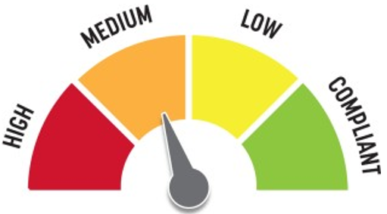
Quick Fix: No
Built before ADA: Yes

VIOLATIONS
2010 ADA Standards for Accessible Design Codes: §211.2, §602.4
There is only one drinking fountain provided and the spout is 38.5" above the floor.

RECOMMENDATIONS
Install an additional drinking fountain at a maximum spout height of 36" above the floor.

PHOTOGRAPH(S) OF THIS LOCATION

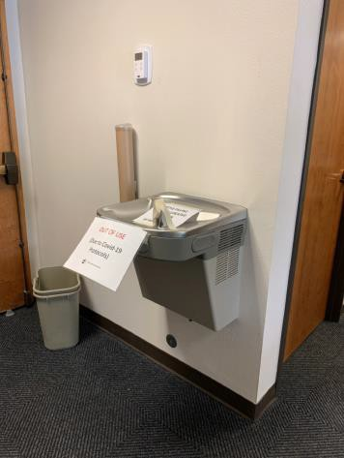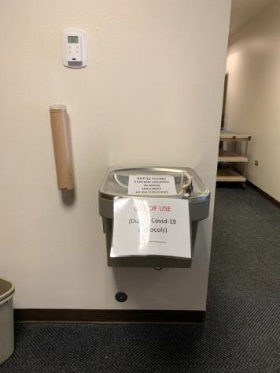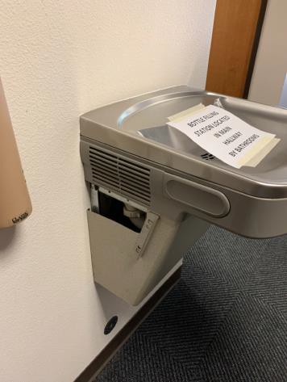

 | ID:  2847 | Facility:  Senior Citizen Center

Location: A Room/Cafeteria (Meals on Wheels)
Schedule: 2023
Estimated Cost: $2,000.00

Priority Score 8
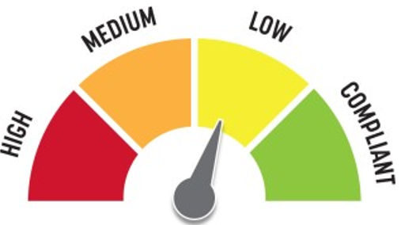
Quick Fix: No
Built before ADA: Yes

VIOLATIONS
2010 ADA Standards for Accessible Design Codes: §306.3.3, §902.3
The dining and work surface counter height exceeds the maximum height of 34" above the floor. There is no knee clearance underneath the sink.

RECOMMENDATIONS
A 30" portion of the dining and work surface must be no higher than 34” above the floor. Lower the sink to the maximum height of 34" above the floor.
Provide knee clearance underneath the counter at the sink that is a minimum of 11" deep at 9" above the floor and 8" deep at 27" above the floor.

PHOTOGRAPH(S) OF THIS LOCATION

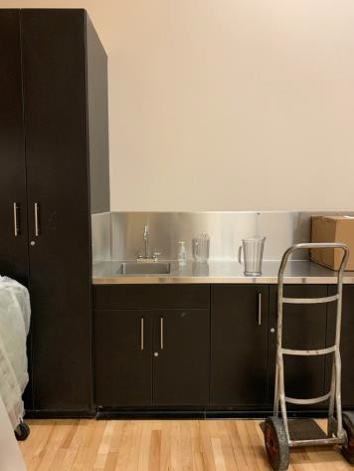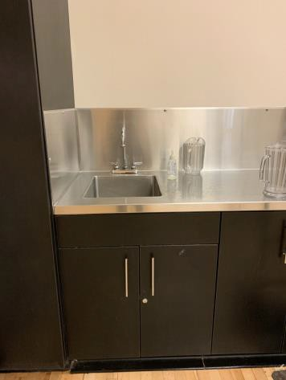

 | ID:  3 | Facility:  Senior Citizen Center

Location: A Room/Cafeteria (Meals on Wheels)
Schedule: 2023
Estimated Cost: $2,000.00

Priority Score 8
Quick Fix: No
Built before ADA: Yes

VIOLATIONS
2010 ADA Standards for Accessible Design Codes: §306.3.3, §902.3, §606.3
The sink is 37" above the floor. The dining surface counter height is at 37" above the floor, exceeding the maximum height.
The dining surface counter height is at 37" above the floor, exceeding the maximum height.

RECOMMENDATIONS
Lower the sink to the maximum height of 34" above the floor. A 30" portion of the dining and work surface must be no higher than 34” above the floor.
Provide knee clearance underneath the counter at the sink that is a minimum of 11" deep at 9" above the floor and 8" deep at 27" above the floor.

PHOTOGRAPH(S) OF THIS LOCATION

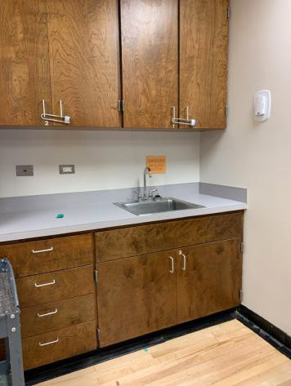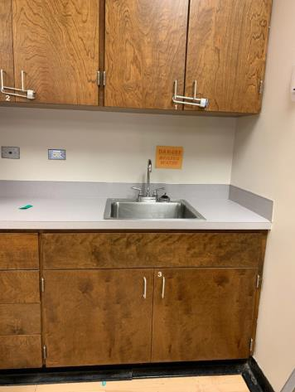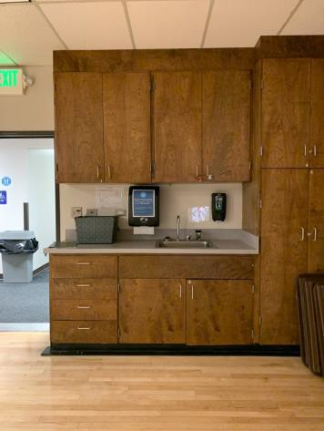

 | ID:  2834 | Facility:  Senior Citizen Center

Location: A Room/Cafeteria Men’s Restroom (Meals on Wheels)
Schedule: 2021
Estimated Cost: $100.00

Priority Score 5
Quick Fix: Yes
Built before ADA: Yes

VIOLATIONS
2010 ADA Standards for Accessible Design Codes: §307.2
The paper towel dispenser protrudes 8.25" into the circulation space at 48" above the floor.

RECOMMENDATIONS
Recess the paper towel dispenser so it protrudes a maximum of 4", lower it so the bottom edge is 27" maximum above the floor, or place a cane detectable object beneath it.

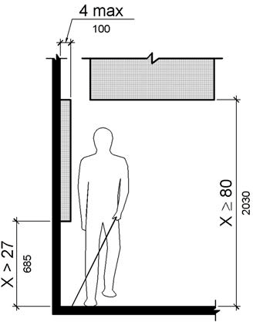

PHOTOGRAPH(S) OF THIS LOCATION

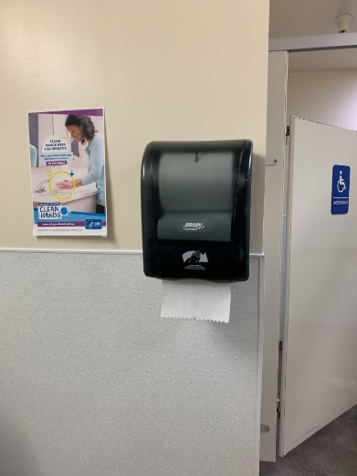

 | ID:  2838 | Facility:  Senior Citizen Center

Location: A Room/Cafeteria Men’s Restroom (Meals on Wheels)
Schedule: 2021
Estimated Cost: $100.00

Priority Score 5
Quick Fix: Yes
Built before ADA: Yes

VIOLATIONS
2010 ADA Standards for Accessible Design Codes: §609.3
The space between the grab bar and the toilet seat cover dispenser is 4".

RECOMMENDATIONS
Relocate the toilet seat cover dispenser to a location that is at least a distance of 12" or greater away from the grab bar.
Ensure that the dispenser is at a maximum height of 48" above the floor.

PHOTOGRAPH(S) OF THIS LOCATION

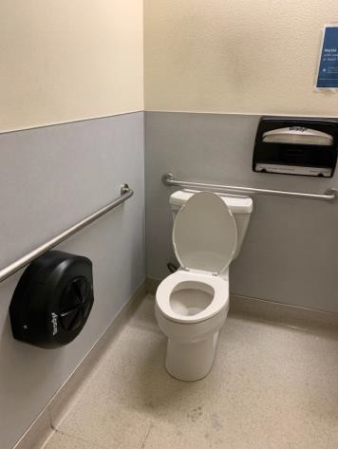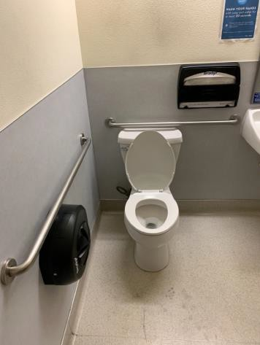

 | ID:  6 | Facility:  Senior Citizen Center

Location: A Room/Cafeteria Men’s Restroom (Meals on Wheels)
Schedule: 2021
Estimated Cost: $100.00

Priority Score 8
Quick Fix: Yes
Built before ADA: Yes

VIOLATIONS
2010 ADA Standards for Accessible Design Codes: §308.2.1
The hook is outside of the unobstructed forward reach range at 49" above the floor.

RECOMMENDATIONS
Lower the hook by 11" to meet the accessible reach range of 48" maximum above the floor.

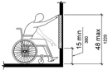

PHOTOGRAPH(S) OF THIS LOCATION

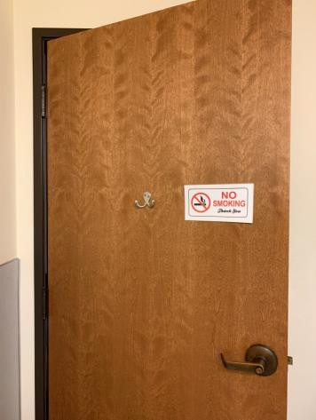

 | ID:  4475 | Facility:  Senior Citizen Center

Location: A Room/Cafeteria Men’s Restroom (Meals on Wheels)
Schedule: 2022
Estimated Cost: $1,000.00

Priority Score 5
Quick Fix: No
Built before ADA: Yes

VIOLATIONS
2010 ADA Standards for Accessible Design Codes: ICC A117.1 §604.5.1
The accessible water closet does not have a vertical grab bar.

RECOMMENDATIONS
Install an 18" long (minimum) vertical grab bar on the side wall. The grab bar shall be mounted with the bottom located at 39" minimum and 41" maximum above the floor. The centerline of the vertical grab bar

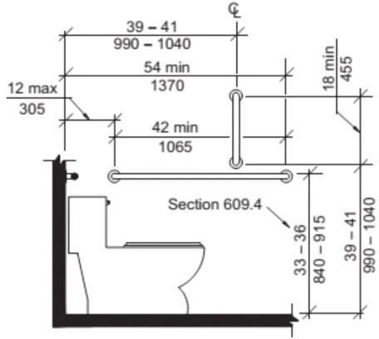

PHOTOGRAPH(S) OF THIS LOCATION

 | ID:  2840 | Facility:  Senior Citizen Center

Location: A Room/Cafeteria Women’s Restroom (Meals on Wheels)
Schedule: 2021
Estimated Cost: $100.00

Priority Score 5
Quick Fix: Yes
Built before ADA: Yes

VIOLATIONS
2010 ADA Standards for Accessible Design Codes: §307.2
The paper towel dispenser protrudes 8" into the circulation space at 48" above the floor.

RECOMMENDATIONS
Recess the paper towel dispenser so it protrudes a maximum of 4", lower it so the bottom edge is 27" maximum above the floor, or place a cane detectable object beneath it.

PHOTOGRAPH(S) OF THIS LOCATION

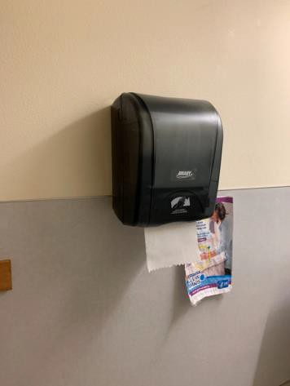

 | ID:  2844 | Facility:  Senior Citizen Center

Location: A Room/Cafeteria Women’s Restroom (Meals on Wheels)
Schedule: 2021
Estimated Cost: $100.00

Priority Score 5
Quick Fix: Yes
Built before ADA: Yes

VIOLATIONS
2010 ADA Standards for Accessible Design Codes: §609.3
The space between the grab bar and the toilet seat cover dispenser is 4".

RECOMMENDATIONS
Relocate the toilet seat cover to a location that is at least a distance of 12" or greater away from the grab bar.

PHOTOGRAPH(S) OF THIS LOCATION

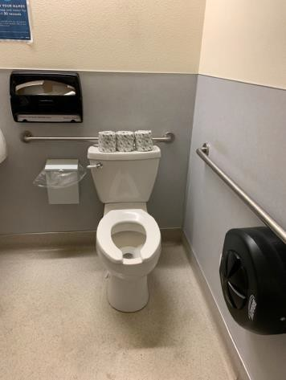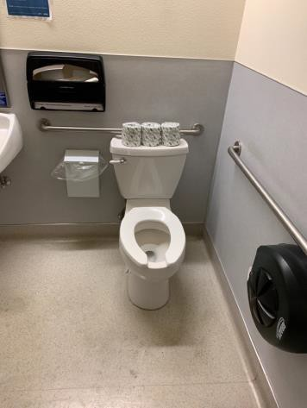

 | ID:  10 | Facility:  Senior Citizen Center

Location: A Room/Cafeteria Women’s Restroom (Meals on Wheels)
Schedule: 2021
Estimated Cost: $100.00

Priority Score 8
Quick Fix: Yes
Built before ADA: Yes

VIOLATIONS
2010 ADA Standards for Accessible Design Codes: §308.2.1
The hook is outside of the unobstructed forward reach range at 59" above the floor.

RECOMMENDATIONS
Lower the hook by 11" to meet the accessible reach range of 48" maximum above the floor.

PHOTOGRAPH(S) OF THIS LOCATION

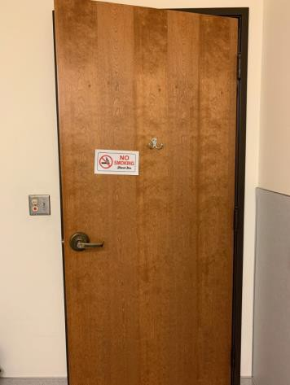

 | ID:  2841 | Facility:  Senior Citizen Center

Location: A Room/Cafeteria Women’s Restroom (Meals on Wheels)
Schedule: 2022
Estimated Cost: $1,000.00

Priority Score 5
Quick Fix: No
Built before ADA: Yes

VIOLATIONS
2010 ADA Standards for Accessible Design Codes: §604.2
The toilet is located 19" from the sidewall.

RECOMMENDATIONS
Reposition the toilet to be within 16" minimum and 18" maximum from the sidewall.

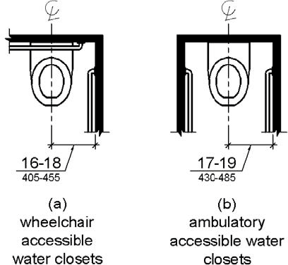

PHOTOGRAPH(S) OF THIS LOCATION

 | ID:  4476 | Facility:  Senior Citizen Center

Location: A Room/Cafeteria Women’s Restroom (Meals on Wheels)
Schedule: 2022
Estimated Cost: $1,000.00

Priority Score 5
Quick Fix: No
Built before ADA: Yes

VIOLATIONS
2010 ADA Standards for Accessible Design Codes: ICC A117.1 §604.5.1
The accessible water closet does not have a vertical grab bar.

RECOMMENDATIONS
Install an 18" long (minimum) vertical grab bar on the side wall. The grab bar shall be mounted with the bottom located at 39" minimum and 41" maximum above the floor.
The centerline of the vertical grab bar shall be located 39" minimum and 41" maximum from the rear wall.

PHOTOGRAPH(S) OF THIS LOCATION

 | ID:  2830 | Facility:  Senior Citizen Center

Location: C Room
Schedule: 2021
Estimated Cost: $100.00

Priority Score 5
Quick Fix: Yes
Built before ADA: Yes

VIOLATIONS
2010 ADA Standards for Accessible Design Codes: §307.2
The camera protrudes 6" into the circulation space at 72" above the floor.

RECOMMENDATIONS
Recess the camera so it protrudes a maximum of 4", raise it so the bottom edge is 80" maximum above the floor, or place a cane detectable object beneath it.

PHOTOGRAPH(S) OF THIS LOCATION

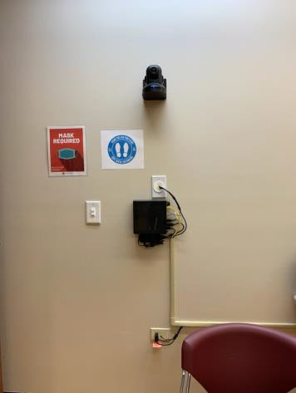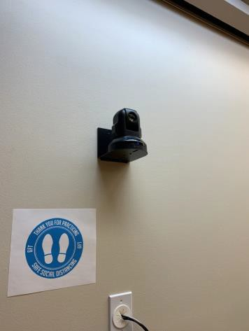

 | ID:  3023 | Facility:  Senior Citizen Center

Location: Drop Off Area
Schedule: 2021
Estimated Cost: $5,000.00

Priority Score 3
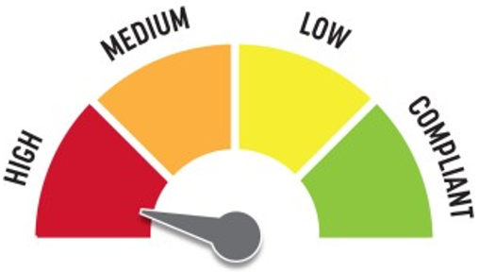
Quick Fix: No
Built before ADA: Yes

VIOLATIONS
2010 ADA Standards for Accessible Design Codes: §503.2, §502.3, §503.3
There is no curb ramp to provide an accessible route from the access aisle to the accessible path. There is no access aisle.
The passenger loading zoning vehicular pull-up space does not meet the minimum dimensions required under the 2010 ADA Standards.

RECOMMENDATIONS
Install a curb ramp that is compliant with §406. Install an access aisle adjacent to the vehicle pull-up space that is 60" wide and extends the length of the space.
Expand the vehicular pull-up space to be a minimum of 96" wide and 20' long.

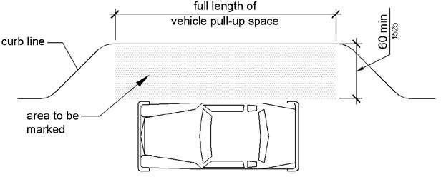

PHOTOGRAPH(S) OF THIS LOCATION

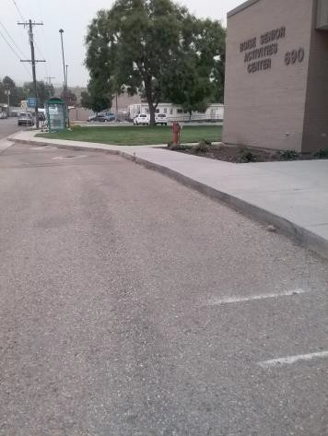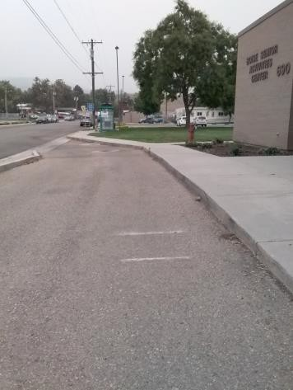

 | ID:  3074 | Facility:  Senior Citizen Center

Location: Drop Off Area
Schedule: 2021
Estimated Cost: $5,000.00

Priority Score 3
Quick Fix: No
Built before ADA: Yes

VIOLATIONS
2010 ADA Standards for Accessible Design Codes: §403.3
The running slope is 6.5% and the cross slope is 3%.

RECOMMENDATIONS
Reconstruct the sidewalk adjacent to the passenger loading zone to ensure that running slope and cross slope do not exceed 2% in any direction.

PHOTOGRAPH(S) OF THIS LOCATION

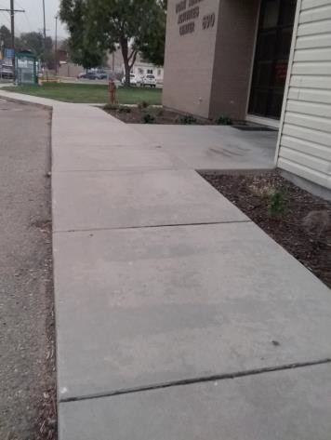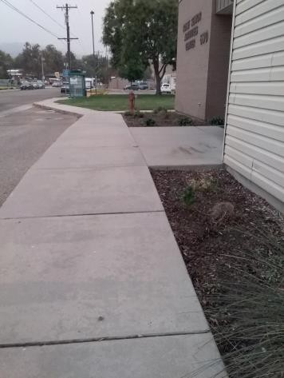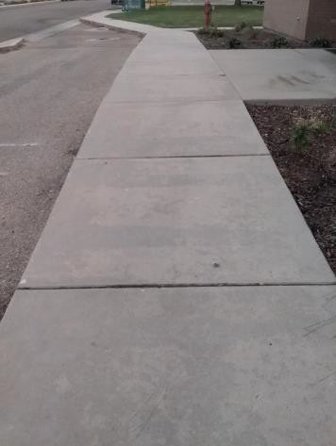

 | ID:  2833 | Facility:  Senior Citizen Center

Location: E Room Hallway
Schedule: 2021
Estimated Cost: $100.00

Priority Score 5
Quick Fix: Yes
Built before ADA: Yes

VIOLATIONS
2010 ADA Standards for Accessible Design Codes: §307.2
The fire extinguisher protrudes 4.5" into the circulation space at 33" above the floor.

RECOMMENDATIONS
Recess the fire extinguisher so it protrudes a maximum of 4", lower it so the bottom edge is 27" maximum above the floor, or place a cane detectable object beneath it.

PHOTOGRAPH(S) OF THIS LOCATION

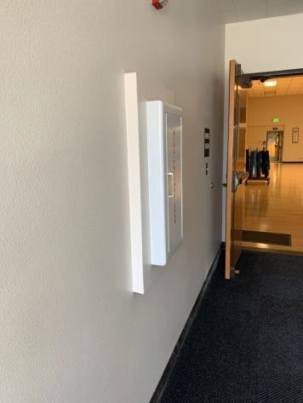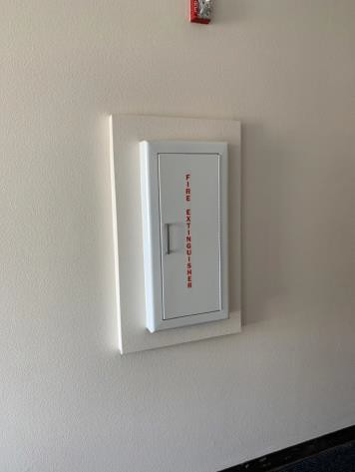

 | ID:  2812 | Facility:  Senior Citizen Center

Location: Entrance Unisex Restroom
Schedule: 2021
Estimated Cost: $100.00

Priority Score 5
Quick Fix: Yes
Built before ADA: Yes

VIOLATIONS
2010 ADA Standards for Accessible Design Codes: §604.7
The toilet paper dispenser is located out of the accessible reach range.

RECOMMENDATIONS
Remount the toilet paper dispenser to 7” minimum and 9” maximum in front of the water closet measured to the centerline of the dispenser.
The outlet of the dispenser shall be 15” minimum and 48” maximum above the floor and shall not be located behind.

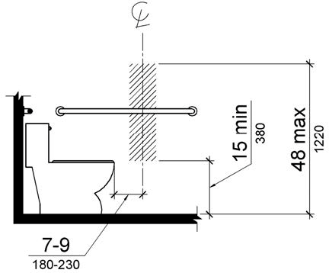

PHOTOGRAPH(S) OF THIS LOCATION

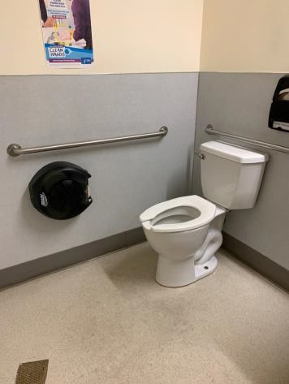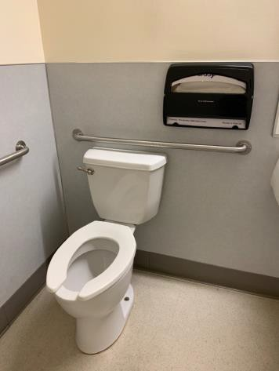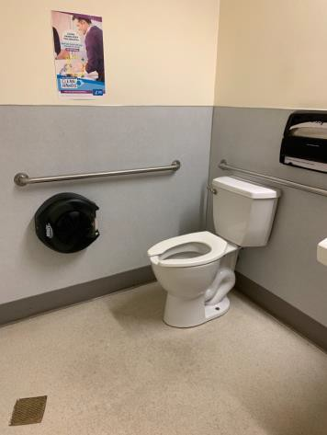

 | ID:  2813 | Facility:  Senior Citizen Center

Location: Entrance Unisex Restroom
Schedule: 2021
Estimated Cost: $100.00

Priority Score 5
Quick Fix: Yes
Built before ADA: Yes

VIOLATIONS
2010 ADA Standards for Accessible Design Codes: §609.3
The space between the grab bar and the toilet seat cover dispenser is 4".

RECOMMENDATIONS
Relocate the toilet seat covers to a location that is at least a distance of 12" or greater away from the grab bar.

PHOTOGRAPH(S) OF THIS LOCATION

 | ID:  2809 | Facility:  Senior Citizen Center

Location: Entrance Unisex Restroom
Schedule: 2021
Estimated Cost: $500.00

Priority Score 5
Quick Fix: Yes
Built before ADA: Yes

VIOLATIONS
2010 ADA Standards for Accessible Design Codes: §604.5.1
The side grab bar is located 11.5" from the rear wall.

RECOMMENDATIONS
Remount the side grab bar 12" maximum from the rear wall and extending 54" minimum from the rear wall.

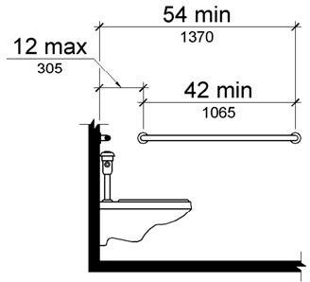

PHOTOGRAPH(S) OF THIS LOCATION

 | ID:  2810 | Facility:  Senior Citizen Center

Location: Entrance Unisex Restroom
Schedule: 2022
Estimated Cost: $1,000.00

Priority Score 5
Quick Fix: No
Built before ADA: Yes

VIOLATIONS
2010 ADA Standards for Accessible Design Codes: §604.6
The flush control is located on the wall side of the toilet.

RECOMMENDATIONS
Either make the toilet flush automatically or relocate the flush control to be operated on the open side of the toilet.

PHOTOGRAPH(S) OF THIS LOCATION

 | ID:  2811 | Facility:  Senior Citizen Center

Location: Entrance Unisex Restroom
Schedule: 2022
Estimated Cost: $1,000.00

Priority Score 5
Quick Fix: No
Built before ADA: Yes

VIOLATIONS
2010 ADA Standards for Accessible Design Codes: §604.2
The toilet is located 18.5" from the sidewall.

RECOMMENDATIONS
Reposition the toilet to be within 16" minimum and 18" maximum from the sidewall.

PHOTOGRAPH(S) OF THIS LOCATION

 | ID:  4477 | Facility:  Senior Citizen Center

Location: Entrance Unisex Restroom
Schedule: 2022
Estimated Cost: $1,000.00

Priority Score 5
Quick Fix: No
Built before ADA: Yes

VIOLATIONS
2010 ADA Standards for Accessible Design Codes: ICC A117.1 §604.5.1
The accessible water closet does not have a vertical grab bar.

RECOMMENDATIONS
Install an 18" long (minimum) vertical grab bar on the side wall. The grab bar shall be mounted with the bottom located at 39" minimum and 41" maximum above the floor.
The centerline of the vertical grab bar shall be located 39" minimum and 41" maximum from the rear wall.

PHOTOGRAPH(S) OF THIS LOCATION

 | ID:  2824 | Facility:  Senior Citizen Center

Location: Entrance Women’s Ambulatory Restroom
Schedule: 2021
Estimated Cost: $100.00

Priority Score 5
Quick Fix: Yes
Built before ADA: Yes

VIOLATIONS
2010 ADA Standards for Accessible Design Codes: §604.7
The toilet paper dispenser is located out of the accessible reach range.

RECOMMENDATIONS
Remount the toilet paper dispenser to 7” minimum and 9” maximum in front of the water closet measured to the centerline of the dispenser.
The outlet of the dispenser shall be 15” minimum and 48” maximum above the floor and shall not be located behind.

PHOTOGRAPH(S) OF THIS LOCATION

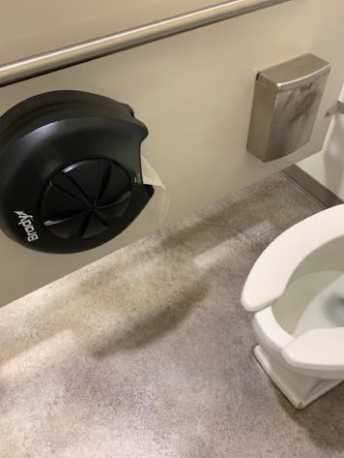

 | ID:  2825 | Facility:  Senior Citizen Center

Location: Entrance Women’s Ambulatory Restroom
Schedule: 2021
Estimated Cost: $100.00

Priority Score 5
Quick Fix: Yes
Built before ADA: Yes

VIOLATIONS
2010 ADA Standards for Accessible Design Codes: §604.8.2.2
The door of the ambulatory restroom stall swings into the minimum required area.

RECOMMENDATIONS
Replace the hinges to allow for an outward swing instead of an inward swing.

PHOTOGRAPH(S) OF THIS LOCATION

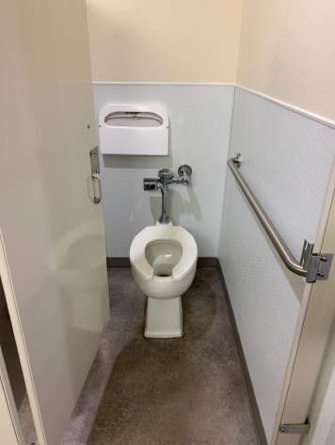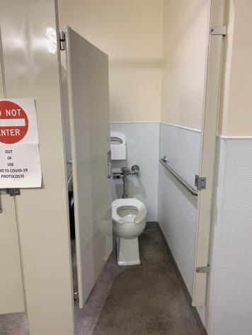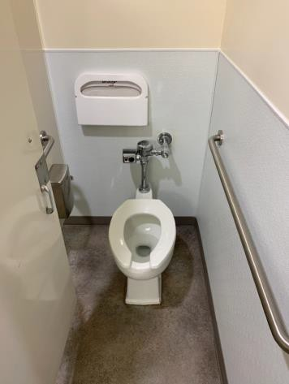

 | ID:  2823 | Facility:  Senior Citizen Center

Location: Entrance Women’s Ambulatory Restroom
Schedule: 2022
Estimated Cost: $1,000.00

Priority Score 5
Quick Fix: No
Built before ADA: Yes

VIOLATIONS
2010 ADA Standards for Accessible Design Codes: §604.2
The toilet is located 20" from the sidewall.

RECOMMENDATIONS
Reposition the toilet to be within 17" minimum and 19" maximum from the sidewall.

PHOTOGRAPH(S) OF THIS LOCATION

 | ID:  2815 | Facility:  Senior Citizen Center

Location: Entrance Women’s Restroom
Schedule: 2021
Estimated Cost: $100.00

Priority Score 5
Quick Fix: Yes
Built before ADA: Yes

VIOLATIONS
2010 ADA Standards for Accessible Design Codes: §604.8.1.2
The door to the accessible water closet is not self closing. Either self-closing hinges are not installed on the door or if installed, they are defective.

RECOMMENDATIONS
Install or reinstall self-closing hinges on the door to ensure that the door is self-closing per the ADA requirements.

PHOTOGRAPH(S) OF THIS LOCATION

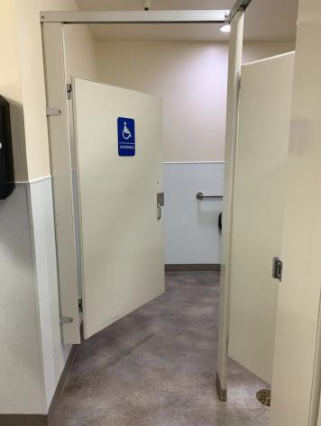

 | ID:  2820 | Facility:  Senior Citizen Center

Location: Entrance Women’s Restroom
Schedule: 2021
Estimated Cost: $100.00

Priority Score 5
Quick Fix: Yes
Built before ADA: Yes

VIOLATIONS
2010 ADA Standards for Accessible Design Codes: §604.7
The toilet paper dispenser is located out of the accessible reach range.

RECOMMENDATIONS
Remount the toilet paper dispenser to 7” minimum and 9” maximum in front of the water closet measured to the centerline of the dispenser.
The outlet of the dispenser shall be 15” minimum and 48” maximum above the floor and shall not be located behind.

PHOTOGRAPH(S) OF THIS LOCATION

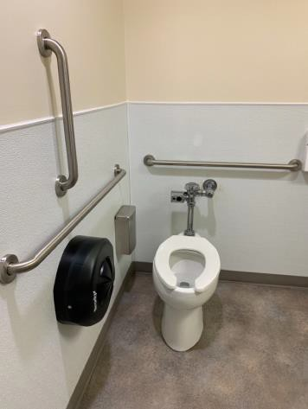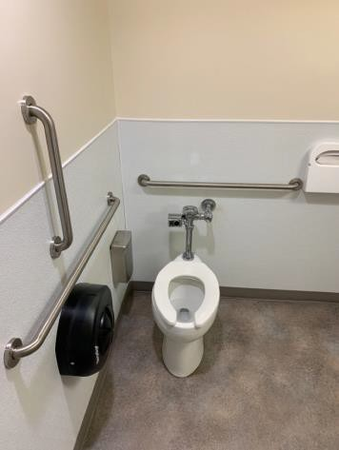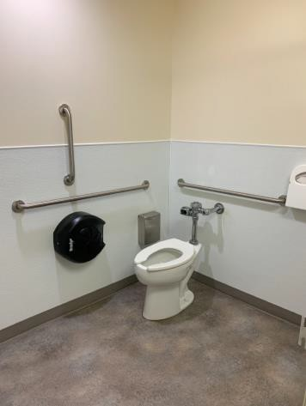

 | ID:2826 | Facility:  Senior Citizen Center

Location: Entrance Women’s Restroom
Schedule: 2021
Estimated Cost: $200.00

Priority Score 5
Quick Fix: Yes
Built before ADA: Yes

VIOLATIONS
2010 ADA Standards for Accessible Design Codes: §307.2
The paper towel dispensers protrude 8" into the circulation space at 42.25" above the floor.

RECOMMENDATIONS
Recess the paper towel dispensers so they protrude a maximum of 4" or place a cane detectable object beneath them.

PHOTOGRAPH(S) OF THIS LOCATION

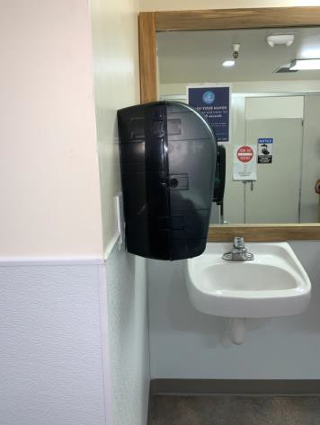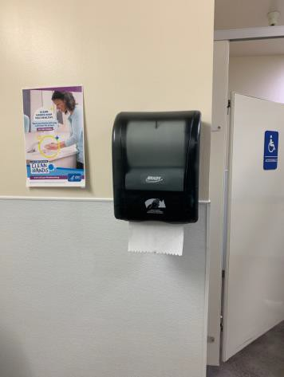

 | ID:  3001 | Facility:  Senior Citizen Center

Location: Exit Only Ramp
Schedule: 2021
Estimated Cost: $1,000.00

Priority Score 3
Quick Fix: No
Built before ADA: Yes

VIOLATIONS
2010 ADA Standards for Accessible Design Codes: §404.2.4.4
Although this doorway is only used as an exit, the slope at the door is 3%.

RECOMMENDATIONS
Resurface the entryway to reduce the running slope to a maximum of 2% in all directions.

PHOTOGRAPH(S) OF THIS LOCATION

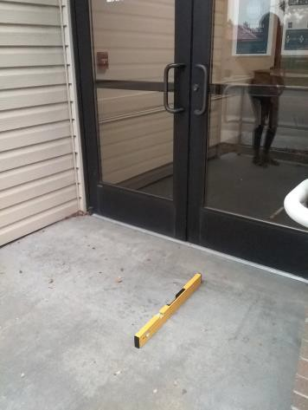

 | ID: | Facility:  Senior Citizen Center

Location:
Schedule:
Estimated Cost:

Priority Score 5
Quick Fix: Yes
Built before ADA: Yes

VIOLATIONS
2010 ADA Standards for Accessible Design Codes §308.2.1

RECOMMENDATIONS

PHOTOGRAPH(S) OF THIS LOCATION

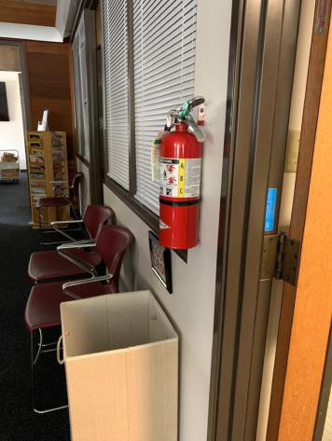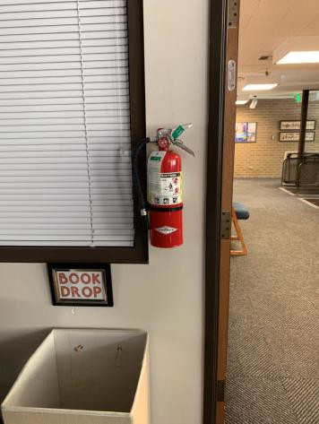

 | ID:  2807 | Facility:  Senior Citizen Center

Location: Library Conference Room
Schedule: 2021
Estimated Cost: $100.00

Priority Score 5
Quick Fix: Yes
Built before ADA: Yes

VIOLATIONS
2010 ADA Standards for Accessible Design Codes: §307.2
The TV protrudes 5" into the circulation space at 58" above the floor.

RECOMMENDATIONS
Recess the TV so it protrudes a maximum of 4", raise it so the bottom edge is 80" maximum above the floor, or place a cane detectable object beneath it.

PHOTOGRAPH(S) OF THIS LOCATION

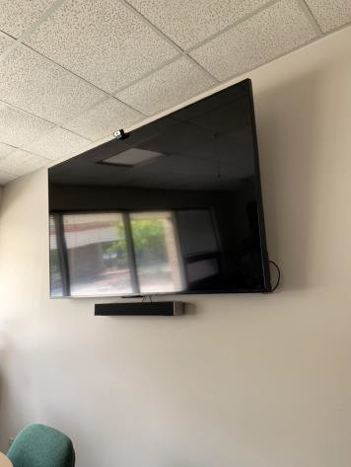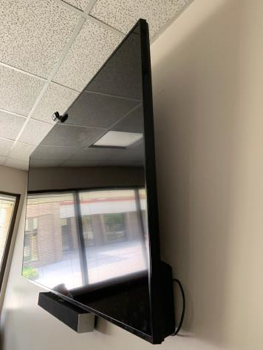

 | ID:  2806 | Facility:  Senior Citizen Center

Location: Main Entrance
Schedule: 2021
Estimated Cost: $2,000.00

Priority Score 3
Quick Fix: No
Built before ADA: Yes

VIOLATIONS
2010 ADA Standards for Accessible Design Codes: §404.2.4.4, §304.2
The entrance has a 3.3% slope at the door and 2.8% slope in the turning space.

RECOMMENDATIONS
Reconstruct the entryway and the turning space to reduce the running slope to a maximum of 2% in all directions for a distance of 60".

PHOTOGRAPH(S) OF THIS LOCATION

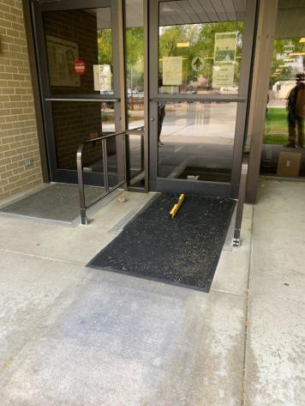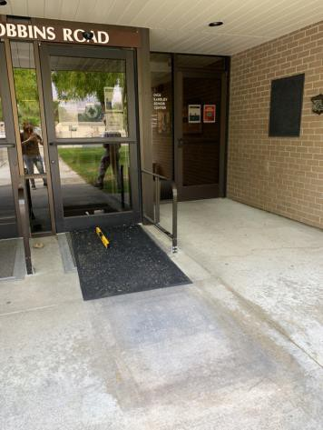

 | ID:  2269 | Facility:  Senior Citizen Center

Location: Men's Restroom by Thrift Shop
Schedule: 2021
Estimated Cost: $100.00

Priority Score 5
Quick Fix: Yes
Built before ADA: Yes

VIOLATIONS
2010 ADA Standards for Accessible Design Codes: §307.2
The paper towel dispenser protrudes 9" into the circulation space at 48" above the floor.

RECOMMENDATIONS
Recess the paper towel dispenser so it protrudes a maximum of 4" or place a cane detectable object beneath it.

PHOTOGRAPH(S) OF THIS LOCATION

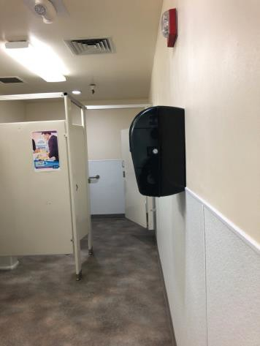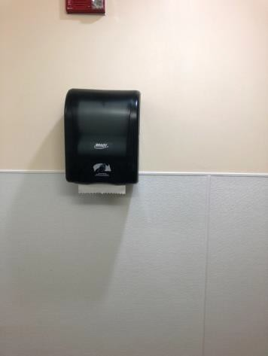

 | ID:  2270 | Facility:  Senior Citizen Center

Location: Men's Restroom by Thrift Shop
Schedule: 2021
Estimated Cost: $100.00

Priority Score 0
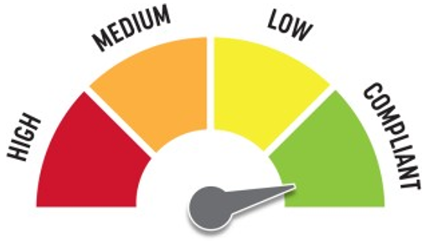
Quick Fix: Yes
Built before ADA: Yes

VIOLATIONS
2010 ADA Standards for Accessible Design Codes: General Guidance
The toilet paper dispenser is rotated 90 degrees.

RECOMMENDATIONS
For the purposes of achieving greater accessibility and Human Centric Design, rotate the toilet paper dispenser 90 degrees to the right.

PHOTOGRAPH(S) OF THIS LOCATION

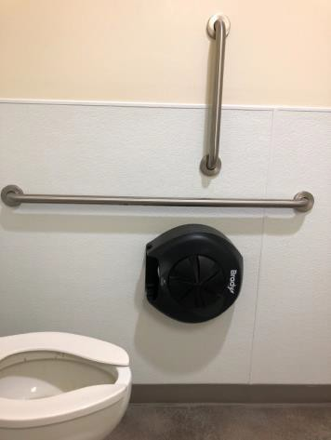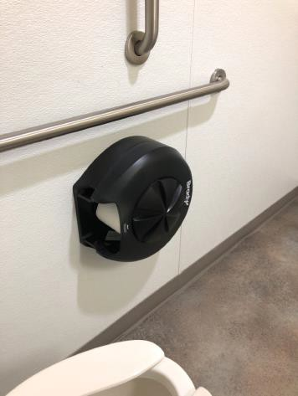

 | ID:  2272 | Facility:  Senior Citizen Center

Location: Men's Restroom by Thrift Shop
Schedule: 2021
Estimated Cost: $100.00

Priority Score 5
Quick Fix: Yes
Built before ADA: Yes

VIOLATIONS
2010 ADA Standards for Accessible Design Codes: §604.8.1.2
The door to the accessible water closet is not self closing. Either self-closing hinges are not installed on the door or if installed, they are defective.

RECOMMENDATIONS
Install or reinstall self-closing hinges on the door to ensure that the door is self-closing per the ADA requirements.

PHOTOGRAPH(S) OF THIS LOCATION

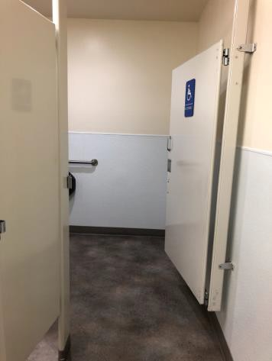

 | ID:  2273 | Facility:  Senior Citizen Center

Location: Men's Restroom by Thrift Shop
Schedule: 2022
Estimated Cost: $1,000.00

Priority Score 5
Quick Fix: No
Built before ADA: Yes

VIOLATIONS
2010 ADA Standards for Accessible Design Codes: §605.2
The urinals are 24" above the floor.

RECOMMENDATIONS
Lower at least one of the urinals to a maximum height of 17" above the floor.

PHOTOGRAPH(S) OF THIS LOCATION

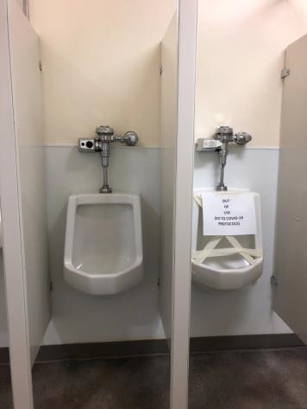

 | ID:  2829 | Facility:  Senior Citizen Center

Location: Office Halfway
Schedule: 2021
Estimated Cost: $100.00

Priority Score 5
Quick Fix: Yes
Built before ADA: Yes

VIOLATIONS
2010 ADA Standards for Accessible Design Codes: §307.2
The AED protrudes 7" into the circulation space at 48" above the floor.

RECOMMENDATIONS
Recess the AED so it protrudes a maximum of 4", lower it so the bottom edge is 27" maximum above the floor, or place a cane detectable object beneath it.

PHOTOGRAPH(S) OF THIS LOCATION

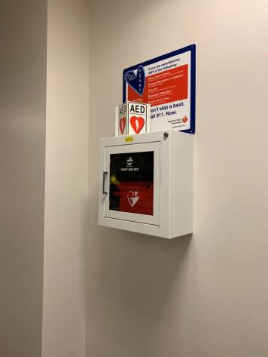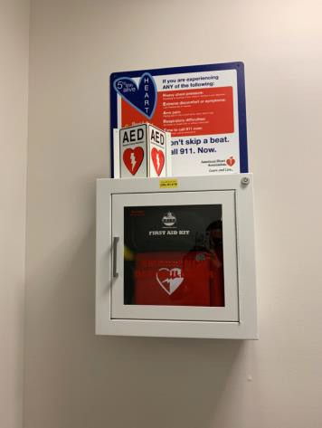

 | ID:  2832 | Facility:  Senior Citizen Center

Location: Pool Room
Schedule: 2021
Estimated Cost: $100.00

Priority Score 8
Quick Fix: Yes
Built before ADA: Yes

VIOLATIONS
2010 ADA Standards for Accessible Design Codes: §308.2.1
The telephone is outside of the unobstructed forward reach range at 58" above the floor.

RECOMMENDATIONS
Lower the telephone by 10" to meet the accessible reach range of 48" maximum above the floor.

PHOTOGRAPH(S) OF THIS LOCATION

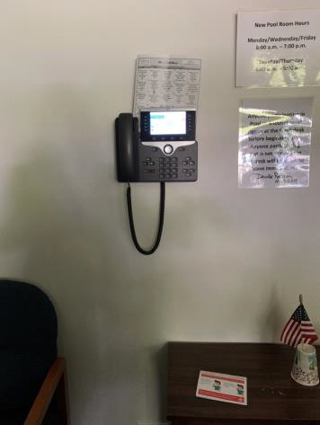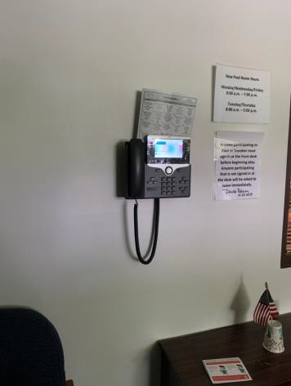

 | ID:  2831 | Facility:  Senior Citizen Center

Location: Thermostats
Schedule: 2021
Estimated Cost: $200.00

Priority Score 8
Quick Fix: Yes
Built before ADA: Yes

VIOLATIONS
2010 ADA Standards for Accessible Design Codes: §308.2.1
The thermostats are outside of the unobstructed forward reach range at 65" above the floor.

RECOMMENDATIONS
Lower the thermostats by 17" to meet the accessible reach range of 48" maximum above the floor.

PHOTOGRAPH(S) OF THIS LOCATION

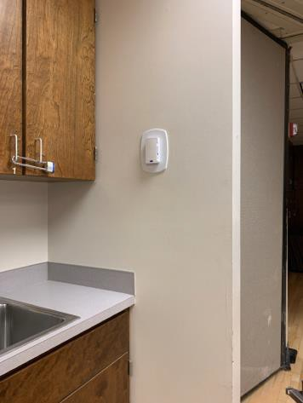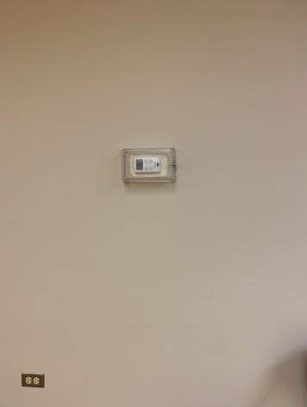

 | ID:  2827 | Facility:  Senior Citizen Center

Location: Thrift Store Changing Room
Schedule: 2022
Estimated Cost: $1,000.00

Priority Score 5
Quick Fix: No
Built before ADA: Yes

VIOLATIONS
2010 ADA Standards for Accessible Design Codes: §304.3
The changing room is 32" wide, which is not wide enough to allow accessibility to persons with disabilities.

RECOMMENDATIONS
Relocate the partition to widen the changing room to allow for a circular or T-shaped turning space. The circular space shall be at least 60" in diameter.
The T-shaped space shall be within 60" square minimum with arms and base 36" wide minimum. Each arm shall be clear of obstructions 12" minimum in each direction and the base shall be clear of obstructions 24" minimum.

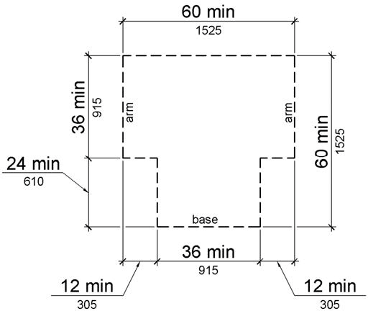

PHOTOGRAPH(S) OF THIS LOCATION

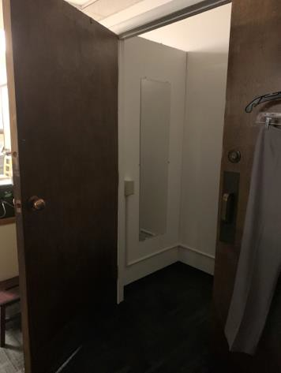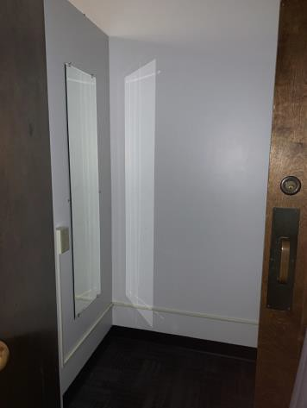

 | ID:  2828 | Facility:  Senior Citizen Center

Location: Thrift Store Drinking Fountain
Schedule: 2022
Estimated Cost: $1,000.00

Priority Score 6
Quick Fix: No
Built before ADA: Yes

VIOLATIONS
2010 ADA Standards for Accessible Design Codes: §211.2, §602.4
There is only one drinking fountain provided and the spout is 37" above the floor.

RECOMMENDATIONS
Install an additional drinking fountain at a maximum spout height of 36" above the floor.

PHOTOGRAPH(S) OF THIS LOCATION

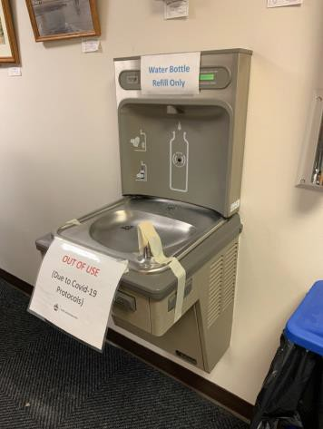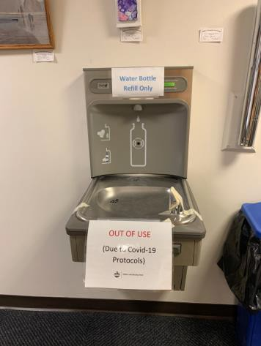

 | ID:  2814 | Facility:  Senior Citizen Center

Location: Women's Restroom
Schedule: 2021
Estimated Cost: $100.00

Priority Score 6
Quick Fix: Yes
Built before ADA: Yes

VIOLATIONS
2010 ADA Standards for Accessible Design Codes: §404.2.8.1
The time required for the door to shut is 3.3 seconds.

RECOMMENDATIONS
Adjust the closing speed to a minimum of 5 or more seconds.

PHOTOGRAPH(S) OF THIS LOCATION

