City of Boise ADA Assessment

Appendix A –Lowell Pool

11/20/2020
Report #TO20-B004

Prepared by:
 | ID:  3775 | Facility:  Lowell Pool

Location: Mechanical Rooms
Schedule: 2021
Estimated Cost: $200.00

Priority Score 3
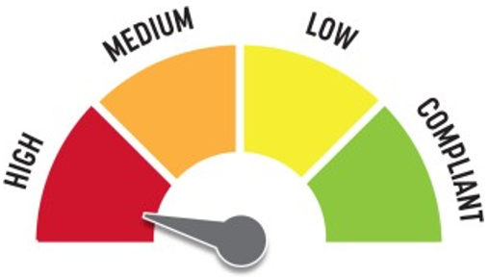
Quick Fix: Yes
Built before ADA: Yes

VIOLATIONS
2010 ADA Standards for Accessible Design Codes: §216.2, §703
There is no tactile sign identifying the permanent room.

RECOMMENDATIONS
Install tactile signage on the latch side of the doorway at a height of 48” minimum to 60” maximum above the floor, identifying room by name or room number.
Signs shall be Braille with raised lettering and should be placed on the wall in the center of an 18"x18" clear floor space.

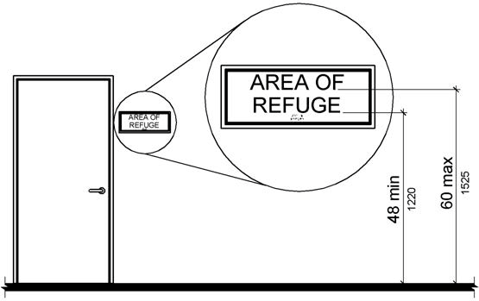

PHOTOGRAPH(S) OF THIS LOCATION

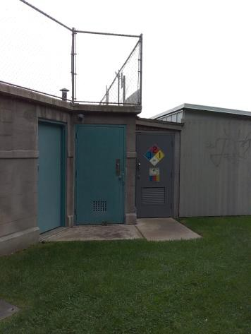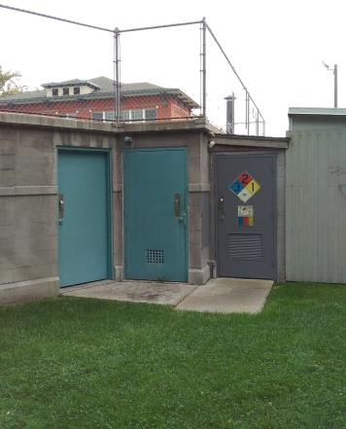

 | ID:  3283 | Facility:  Lowell Pool

Location: Men and Women's Locker Room
Schedule: 2022
Estimated Cost: $4,000.00

Priority Score 3
Quick Fix: No
Built before ADA: Yes

VIOLATIONS
2010 ADA Standards for Accessible Design Codes: §505.4, §505.10.2
Handrails are provided only on one side, and there are no handrail extensions at the top of the stairs.
The stair handrails are located 30" and 31" above the stair nosings. Both violations are located outside the men and women's locker rooms.

RECOMMENDATIONS
Install new handrails on both sides of the stairs with extensions that extend at least 12" horizontally above the landing beginning directly above the first stair riser nosing.
Ensure that handrails are installed at a minimum height of 34" and a maximum of 38" above the stair nosings. The height shall be consistent along the stair treads.

PHOTOGRAPH(S) OF THIS LOCATION

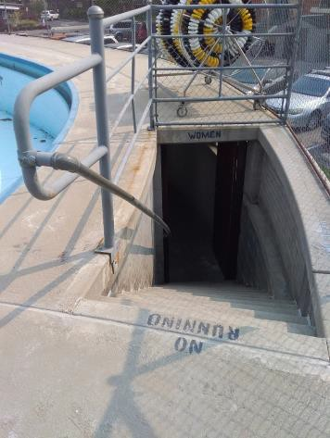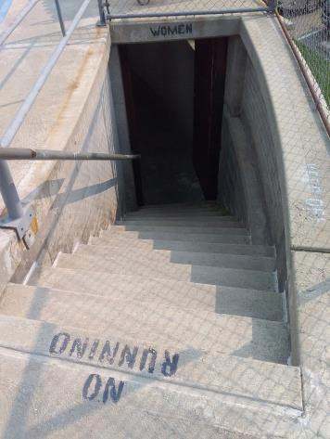

 | ID:  4462 | Facility:  Lowell Pool

Location: Men and Women's Locker Room
Schedule: 2022
Estimated Cost: $50,000.00

Priority Score 3
Quick Fix: No
Built before ADA: Yes

VIOLATIONS
2010 ADA Standards for Accessible Design Codes: §407
The stairs are not accessible for persons in wheelchair.

RECOMMENDATIONS
Construct a 60"x60" elevator with a 36" wide door connecting the pool deck to the proposed accessible locker rooms. Controls shall be installed at 48" maximum above the floor and emergency controls at 38" above the floor.</d Ensure car position indicators provide verbal announcements of stops. Floor designations shall be provided on both hoistway door jambs and a tactile star shall be provided on the main entry

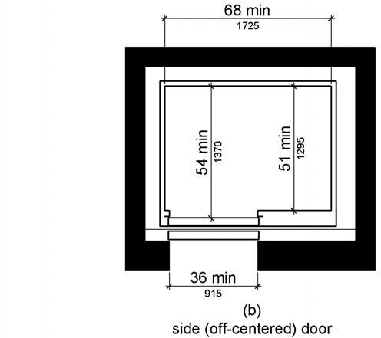

PHOTOGRAPH(S) OF THIS LOCATION

 | ID:  3048 | Facility:  Lowell Pool

Location: Men and Women's Locker Room
Schedule: 2022
Estimated Cost: $80,000.00

Priority Score 5
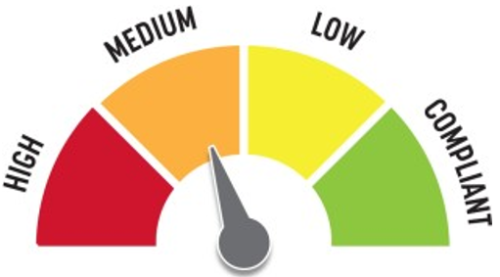
Quick Fix: No
Built before ADA: Yes

VIOLATIONS
2010 ADA Standards for Accessible Design Codes: §308, §604, §608
There is not an accessible shower or stall provided in the men and women's locker room. The shower dimensions do not meet the requirements for a transfer type shower at 43"x31".
The stalls provided are too small to be accessible.

RECOMMENDATIONS
Due to the historic nature and limited space of the facility, consider constructing an adjacent facility containing an accessible locker rooms, showers, and restroom stalls.
Elements in the accessible shall comply with Section 2.9 of the Lowell Report.

PHOTOGRAPH(S) OF THIS LOCATION

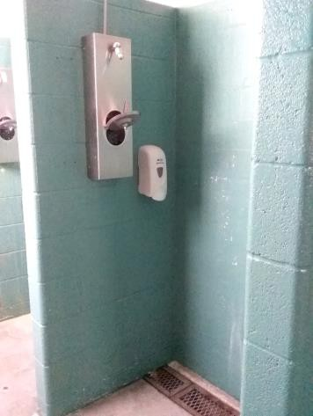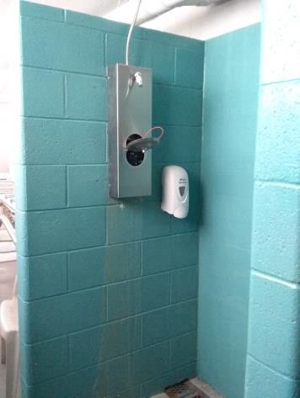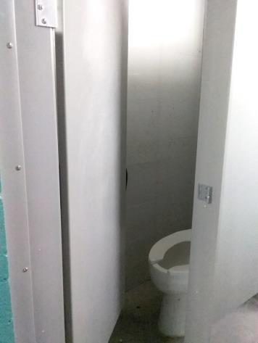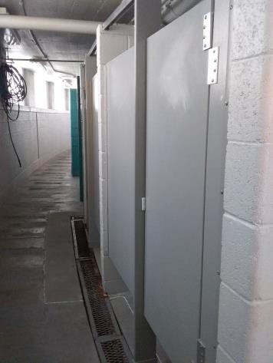

 | ID:  3609 | Facility:  Lowell Pool

Location: Men and Women's Locker Rooms
Schedule: 2021
Estimated Cost: $3,000.00

Priority Score 3
Quick Fix: No
Built before ADA: Yes

VIOLATIONS
2010 ADA Standards for Accessible Design Codes: §302.3
The grates in the men and women's locker room path are not stable.

RECOMMENDATIONS
Replace the grates throughout the locker rooms and ensure that they are secure and stable. Ensure that the openings in the grate is less than 0.5”.

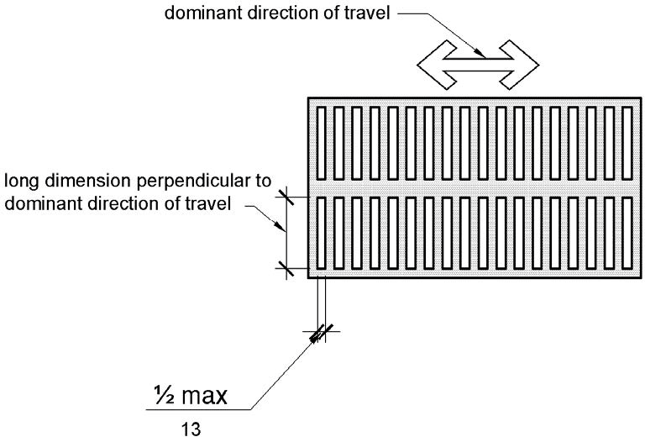

PHOTOGRAPH(S) OF THIS LOCATION

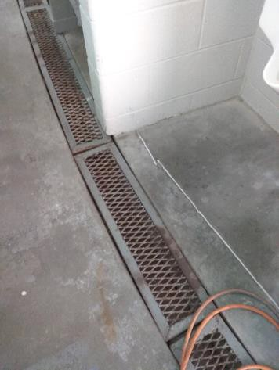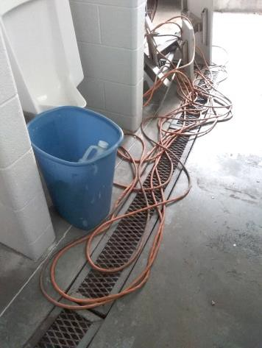

 | ID:  3412 | Facility:  Lowell Pool

Location: Men's Locker Room
Schedule: 2021
Estimated Cost: $100.00

Priority Score 3
Quick Fix: Yes
Built before ADA: Yes

VIOLATIONS
2010 ADA Standards for Accessible Design Codes: §216.2, §703
There is no tactile sign identifying the permanent room.

RECOMMENDATIONS
Install tactile signage on the latch side of the doorway at a height of 48” minimum to 60” maximum above the floor, identifying room by name or room number.
Signs shall be Braille with raised lettering and should be placed on the wall in the center of an 18"x18" clear floor space.

PHOTOGRAPH(S) OF THIS LOCATION

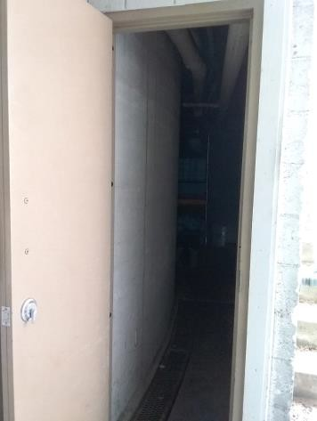

 | ID:  3254 | Facility:  Lowell Pool

Location: Men's Locker Room
Schedule: 2022
Estimated Cost: $200.00

Priority Score 5
Quick Fix: Yes
Built before ADA: Yes

VIOLATIONS
2010 ADA Standards for Accessible Design Codes: §307.2
The hose protrudes 6" into the circulation space at 63" above the floor.
The air conditioning unit protrudes 7" into the circulation space at 78" above the floor.

RECOMMENDATIONS
Recess the hose and air conditioning unit so they protrude a maximum of 4", lower them so the bottom edge is 27" maximum above the floor, or place a cane detectable object beneath it.

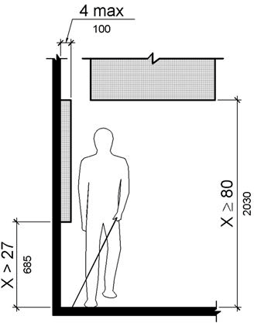

PHOTOGRAPH(S) OF THIS LOCATION

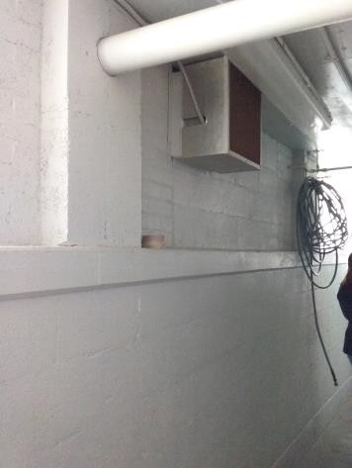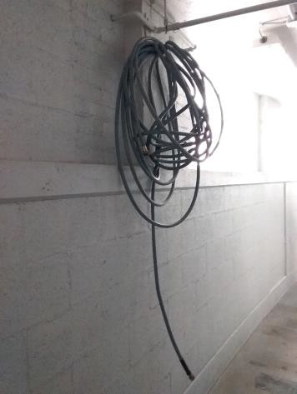

 | ID:  3307 | Facility:  Lowell Pool

Location: Men's Locker Room
Schedule: 2022
Estimated Cost: $200.00

Priority Score 7
Quick Fix: Yes
Built before ADA: Yes

VIOLATIONS
2010 ADA Standards for Accessible Design Codes: §606.5
The pipes under the sink are not covered.

RECOMMENDATIONS
Wrap the pipes beneath the sink with soft protective wrap or plastic.

PHOTOGRAPH(S) OF THIS LOCATION

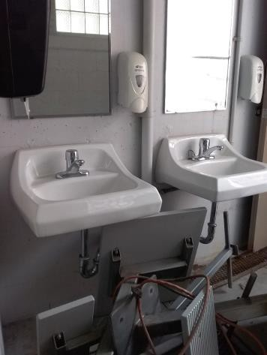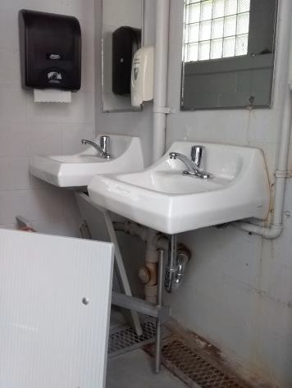

 | ID:  3186 | Facility:  Lowell Pool

Location: Men's Locker Room
Schedule: 2022
Estimated Cost: $1,000.00

Priority Score 5
Quick Fix: No
Built before ADA: Yes

VIOLATIONS
2010 ADA Standards for Accessible Design Codes: §903.3
The benches in the men's locker room are 14" deep.

RECOMMENDATIONS
Install a new accessible bench that is at least 42" long and 20" minimum to 24" maximum deep.

PHOTOGRAPH(S) OF THIS LOCATION

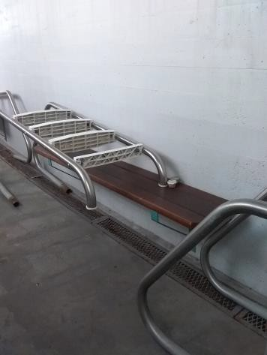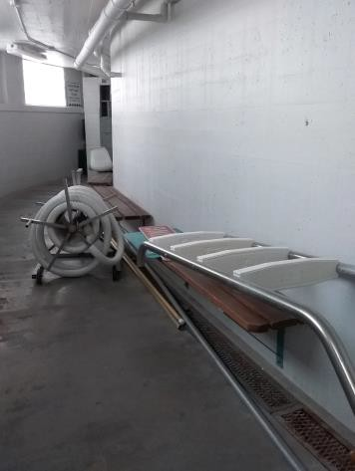

 | ID:  3341 | Facility:  Lowell Pool

Location: Men's Locker Room
Schedule: 2022
Estimated Cost: $1,000.00

Priority Score 6
Quick Fix: No
Built before ADA: Yes

VIOLATIONS
2010 ADA Standards for Accessible Design Codes: §211.2, §307.2, §602.7
There is only one drinking fountain in the men's locker room provided at 33" above the floor. The drinking fountain protrudes 16" into the circulation path.

RECOMMENDATIONS
Install an additional drinking fountain at a minimum height of 38" and maximum of 43" above the floor.
Place a drinking fountain skirt at this location to provide cane detectability.

PHOTOGRAPH(S) OF THIS LOCATION

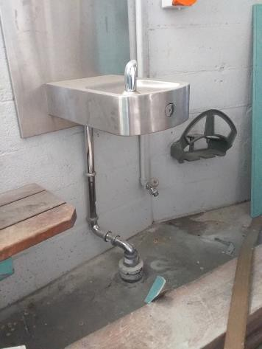

 | ID:  3472 | Facility:  Lowell Pool

Location: Men's Locker Room
Schedule: 2021
Estimated Cost: $2,000.00

Priority Score 3
Quick Fix: No
Built before ADA: Yes

VIOLATIONS
2010 ADA Standards for Accessible Design Codes: §304.3.1
There is not an adequate turning space in the men's locker room.

RECOMMENDATIONS
Expand the space to provide a Circular or T-Shaped turning space. The circular turning space shall have a minimum diameter of 60".
The T-Shaped space shall be 60" square minimum with arms and base 36" wide minimum. Each arm shall be clear of obstructions 12" minimum in each direction. The base shall be clear of obstruction 24" minimum.

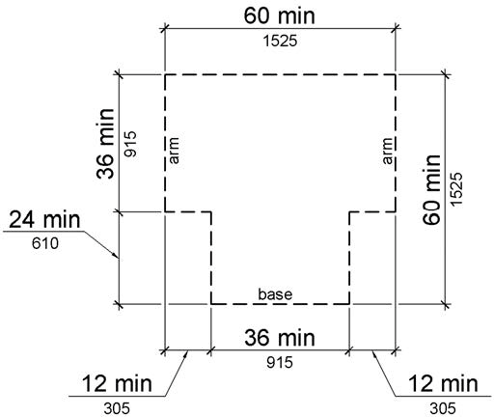

PHOTOGRAPH(S) OF THIS LOCATION

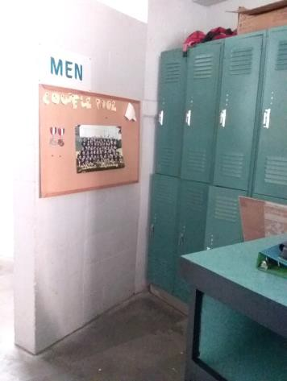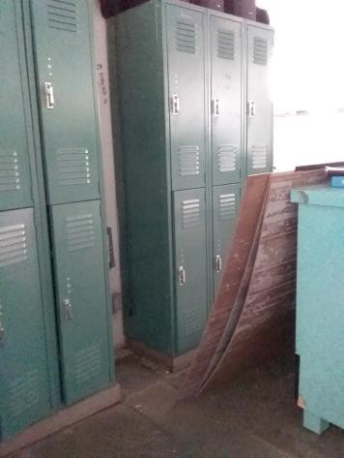

 | ID:  2342 | Facility:  Lowell Pool

Location: Parking Lot
Schedule: 2023
Estimated Cost: $100.00

Priority Score 9
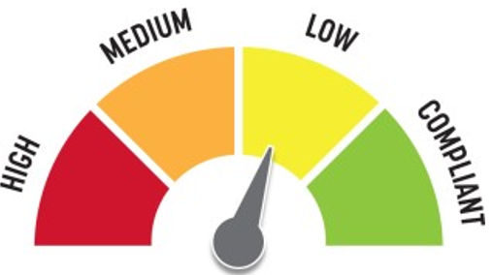
Quick Fix: Yes
Built before ADA: Yes

VIOLATIONS
2010 ADA Standards for Accessible Design Codes: §502.6
The accessible parking sign is 46" above the floor.

RECOMMENDATIONS
Remount the accessible parking sign at a minimum height of 60" above the ground.

PHOTOGRAPH(S) OF THIS LOCATION

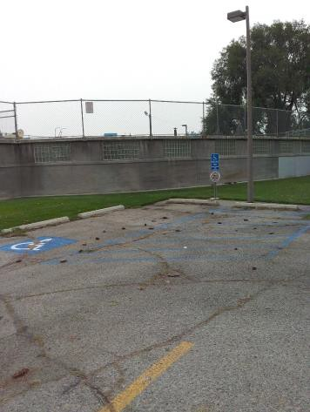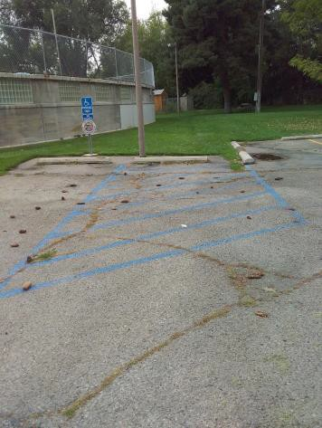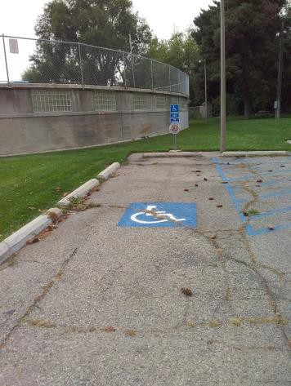

 | ID:  3636 | Facility:  Lowell Pool

Location: Parking Lot
Schedule: 2022
Estimated Cost: $100.00

Priority Score 6
Quick Fix: Yes
Built before ADA: Yes

VIOLATIONS
2010 ADA Standards for Accessible Design Codes: §302.1, §305
There is not a firm, stable, and slip resistant route to the garbage can. There is no clear floor space to access the garbage can.

RECOMMENDATIONS
Relocate the garbage to be adjacent to the accessible route or another firm, stable, and slip resistant surface with clear floor space of 30"x48". Ensure that the clear floor space has a maximum slope of 2% in all directions.

PHOTOGRAPH(S) OF THIS LOCATION

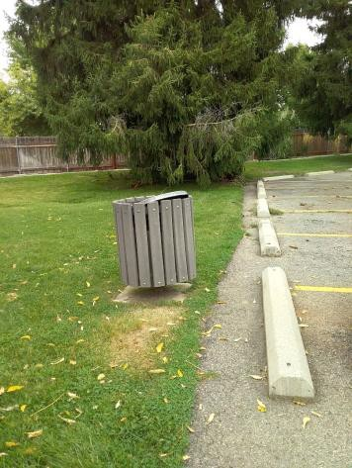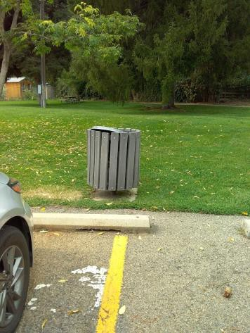

 | ID:  3243 | Facility:  Lowell Pool

Location: Parking Lot
Schedule: 2022
Estimated Cost: $2,000.00

Priority Score 5
Quick Fix: No
Built before ADA: Yes

VIOLATIONS
2010 ADA Standards for Accessible Design Codes: §303.2
There is a change in level greater than 0.25" in the accessible parking space and access aisle creating tripping hazards.

RECOMMENDATIONS
Resurface the parking spaces and access aisle to reduce the changes in level to less than 0.25".
Ensure that there is a maximum slope of 2% in all directions.

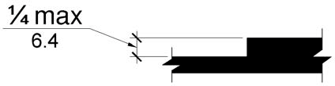

PHOTOGRAPH(S) OF THIS LOCATION

 | ID:  3426 | Facility:  Lowell Pool

Location: Picnic Tables
Schedule: 2022
Estimated Cost: $5,000.00

Priority Score 6
Quick Fix: No
Built before ADA: Yes

VIOLATIONS
2010 ADA Standards for Accessible Design Codes: §302.1, §305, §902.4
The picnic tables are not compliant because there is no wheelchair seating available. There is not a firm, stable, and slip resistant route to the picnic tables.

RECOMMENDATIONS
Install a new accessible picnic table at a minimum height of 28" and maximum of 34". Provide knee clearance that is a minimum of 11" deep at 9" above the floor and 8" deep at 27" above the floor.
Construct a firm, stable, and slip resistant accessible route with a maximum cross slope of 2% and maximum running slope of 5%.

PHOTOGRAPH(S) OF THIS LOCATION

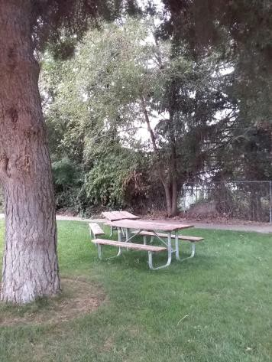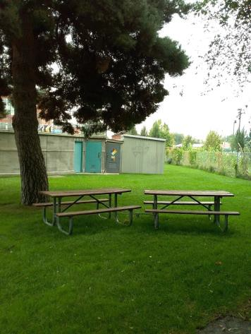

 | ID:  3336 | Facility:  Lowell Pool

Location: Pool Deck
Schedule: 2021
Estimated Cost: $20,000.00

Priority Score 1
Quick Fix: No
Built before ADA: Yes

VIOLATIONS
2010 ADA Standards for Accessible Design Codes: §242.2, §1009
The pool has a circumference of approximately 250 linear feet with no accessible means of entry from the deck into the water.

RECOMMENDATIONS
Install a pool lift complying with §1009. Ensure that adjacent to the lift is a 30"x48" clear floor space with a maximum slope of 2% in all directions.

PHOTOGRAPH(S) OF THIS LOCATION

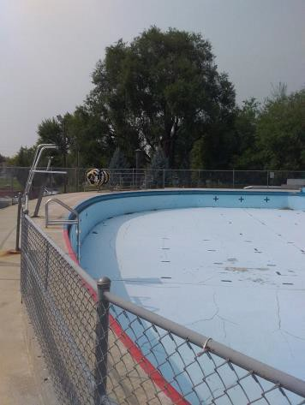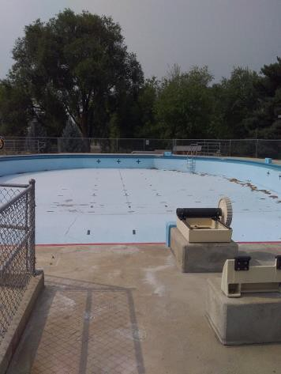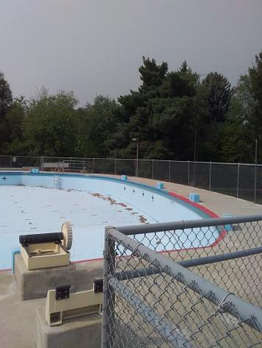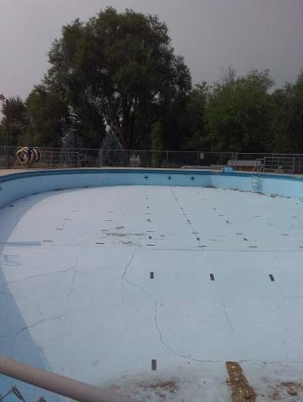

 | ID:  3089 | Facility:  Lowell Pool

Location: Pool Entrance Check-In Area
Schedule: 2023
Estimated Cost: $100.00

Priority Score 8
Quick Fix: Yes
Built before ADA: Yes

VIOLATIONS
2010 ADA Standards for Accessible Design Codes: §308.2.1
The microwave is outside of the unobstructed forward reach range at 49" above the floor.

RECOMMENDATIONS
Lower the microwave by 1" to meet the accessible reach range of 15" minimum and 48" maximum above the floor.

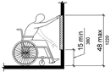

PHOTOGRAPH(S) OF THIS LOCATION

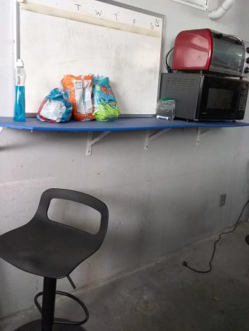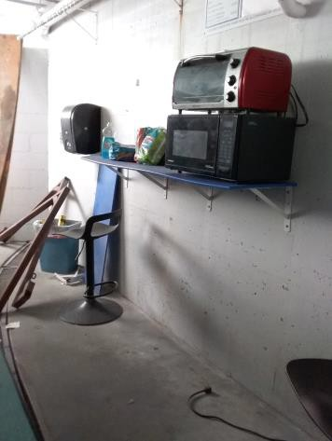

 | ID:  3090 | Facility:  Lowell Pool

Location: Pool Entrance Check-In Area
Schedule: 2023
Estimated Cost: $100.00

Priority Score 8
Quick Fix: Yes
Built before ADA: Yes

VIOLATIONS
2010 ADA Standards for Accessible Design Codes: §308.2.1
The toaster is outside of the unobstructed forward reach range at 58" above the floor.

RECOMMENDATIONS
Lower the toaster by 10" to meet the accessible reach range of 15" minimum and 48" maximum above the floor.

PHOTOGRAPH(S) OF THIS LOCATION

 | ID:  3088 | Facility:  Lowell Pool

Location: Pool Entrance Check-In Area
Schedule: 2022
Estimated Cost: $100.00

Priority Score 5
Quick Fix: Yes
Built before ADA: Yes

VIOLATIONS
2010 ADA Standards for Accessible Design Codes: §307.2
The shelf protrudes 15" into the circulation space at 43" above the floor.

RECOMMENDATIONS
Place a cane detectable object on either edge of the shelf.

PHOTOGRAPH(S) OF THIS LOCATION

 | ID:  3290 | Facility:  Lowell Pool

Location: Pool Entrance Check-In Area
Schedule: 2022
Estimated Cost: $100.00

Priority Score 5
Quick Fix: Yes
Built before ADA: Yes

VIOLATIONS
2010 ADA Standards for Accessible Design Codes: §307.2
The paper towel dispenser protrudes 8" into the circulation space at 44" above the floor.

RECOMMENDATIONS
Recess the paper towel dispenser so it protrudes a maximum of 4", lower it so the bottom edge is 27" maximum above the floor, or place a cane detectable object beneath it.

PHOTOGRAPH(S) OF THIS LOCATION

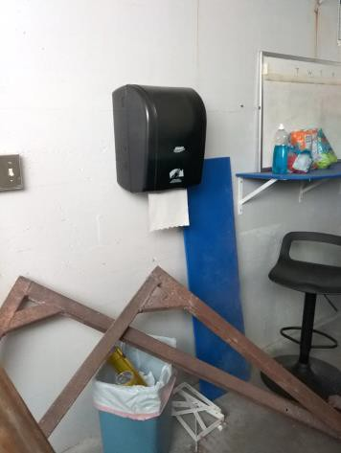

 | ID:  3352 | Facility:  Lowell Pool

Location: Pool Entrance Check-In Area
Schedule: 2021
Estimated Cost: $1,000.00

Priority Score 4
Quick Fix: No
Built before ADA: Yes

VIOLATIONS
2010 ADA Standards for Accessible Design Codes: §904.4.1
The counter in the pool entrance check-in area is 42" above the floor.

RECOMMENDATIONS
Lower a section of the counter by at least 6" to meet the required maximum height of 36" above the finish floor for a horizontal distance of 36".

PHOTOGRAPH(S) OF THIS LOCATION

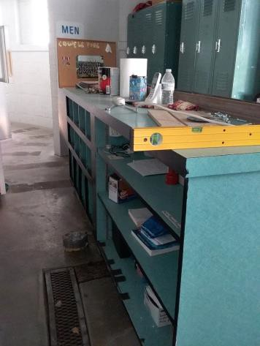

 | ID:  3753 | Facility:  Lowell Pool

Location: Pool Entrance Check-In Area
Schedule: 2021
Estimated Cost: $10,000.00

Priority Score 3
Quick Fix: No
Built before ADA: Yes

VIOLATIONS
2010 ADA Standards for Accessible Design Codes: §304.3.1
There is not an adequate turning space in the check-in area.

RECOMMENDATIONS
Expand the space to provide a Circular or T-shaped turning space. The circular turning space shall have a minimum diameter of 60".
The T-Shaped space shall be 60" square minimum with arms and base 36" wide minimum. Each arm shall be clear of obstructions 12" minimum in each direction. The base shall be clear of obstruction 24" minimum.

PHOTOGRAPH(S) OF THIS LOCATION

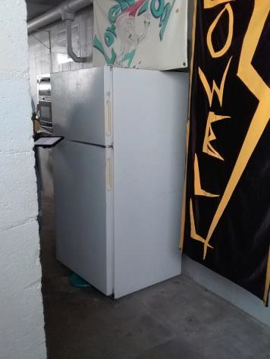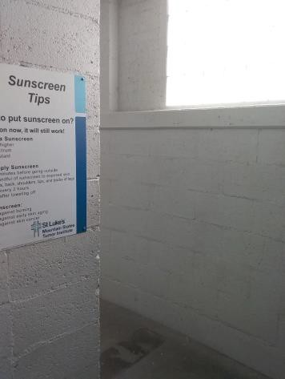

 | ID:  3112 | Facility:  Lowell Pool

Location: Route from Parking to the Entrance
Schedule: 2021
Estimated Cost: $5,000.00

Priority Score 3
Quick Fix: No
Built before ADA: Yes

VIOLATIONS
2010 ADA Standards for Accessible Design Codes: §403.3
The running slope of the route connecting the accessible parking space to the entrance reaches 15%.

RECOMMENDATIONS
Resurface the route to reduce the running slope to a maximum of 5%. Ensure that the cross slope is a maximum of 2%.

PHOTOGRAPH(S) OF THIS LOCATION

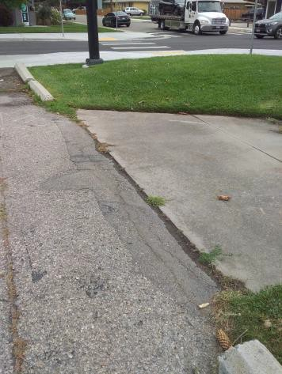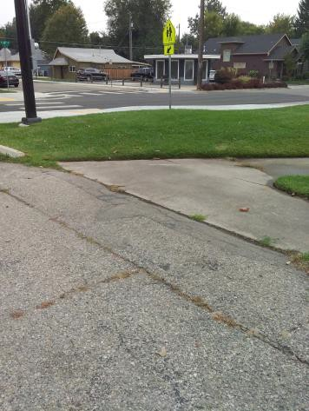

 | ID:  3374 | Facility:  Lowell Pool

Location: Women's Locker Room
Schedule: 2022
Estimated Cost: $100.00

Priority Score 5
Quick Fix: Yes
Built before ADA: Yes

VIOLATIONS
2010 ADA Standards for Accessible Design Codes: §307.2
The paper towel dispenser protrudes 8" into the circulation space at 48" above the floor.

RECOMMENDATIONS
Recess the paper towel dispenser so it protrudes a maximum of 4", lower it so the bottom edge is 27" maximum above the floor, or place a cane detectable object beneath it.

PHOTOGRAPH(S) OF THIS LOCATION

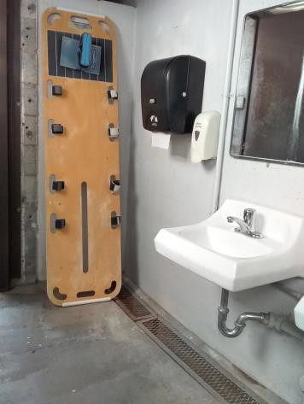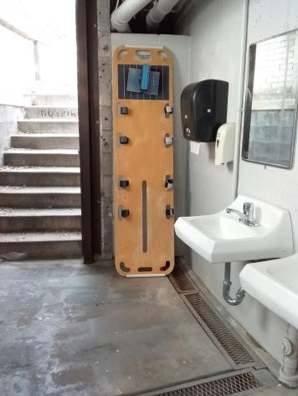

 | ID:  3255 | Facility:  Lowell Pool

Location: Women's Locker Room
Schedule: 2022
Estimated Cost: $200.00

Priority Score 5
Quick Fix: Yes
Built before ADA: Yes

VIOLATIONS
2010 ADA Standards for Accessible Design Codes: §307.2, §308.2.1
The hose and hooks holding them are outside of the unobstructed forward reach range at 50" above the floor and protrude into the circulation space.

RECOMMENDATIONS
Lower the hooks by 2" to meet the accessible reach range of 15" minimum and 48" maximum above the floor.
Recess the hose to protrude a maximum of 4", lower it so the bottom edge is 27" maximum above the floor, or place a cane detectable object beneath it.

PHOTOGRAPH(S) OF THIS LOCATION

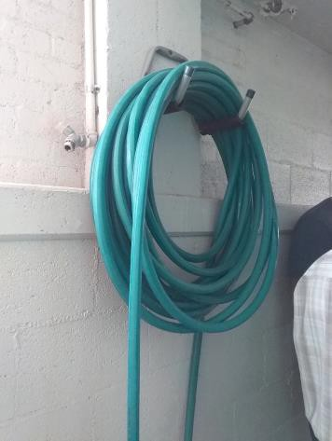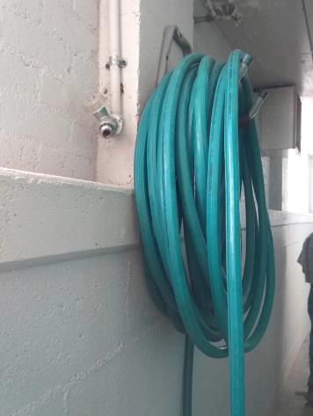

 | ID:  3480 | Facility:  Lowell Pool

Location: Women's Locker Room
Schedule: 2022
Estimated Cost: $200.00

Priority Score 7
Quick Fix: Yes
Built before ADA: Yes

VIOLATIONS
2010 ADA Standards for Accessible Design Codes: §606.5
The pipes under the sinks are not covered.

RECOMMENDATIONS
Wrap the pipes beneath the sinks with soft protective wrap or plastic.

PHOTOGRAPH(S) OF THIS LOCATION

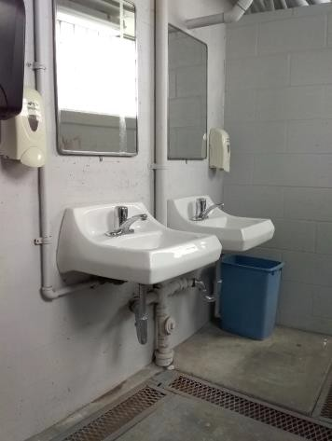

 | ID:  3299 | Facility:  Lowell Pool

Location: Women's Locker Room
Schedule: 2022
Estimated Cost: $500.00

Priority Score 5
Quick Fix: Yes
Built before ADA: Yes

VIOLATIONS
2010 ADA Standards for Accessible Design Codes: §307.2
The electrical box in the women's locker room protrudes 7" into the circulation space at 78" above the floor.

RECOMMENDATIONS
Recess the electrical box so it protrudes a maximum of 4", or place a cane detectable object beneath it.

PHOTOGRAPH(S) OF THIS LOCATION

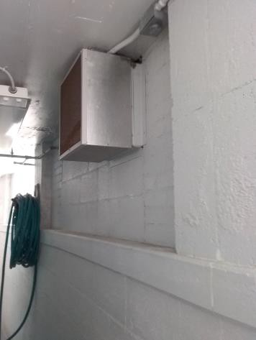

 | ID:  3606 | Facility:  Lowell Pool

Location: Women's Locker Room
Schedule: 2021
Estimated Cost: $5,000.00

Priority Score 3
Quick Fix: No
Built before ADA: Yes

VIOLATIONS
2010 ADA Standards for Accessible Design Codes: §403.3
The cross slope is 2.3% throughout the Women's Locker Room.

RECOMMENDATIONS
Resurface the route to reduce the cross slope to a maximum of 2%.

PHOTOGRAPH(S) OF THIS LOCATION

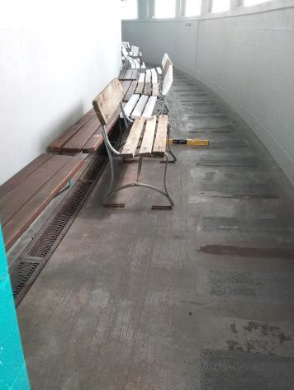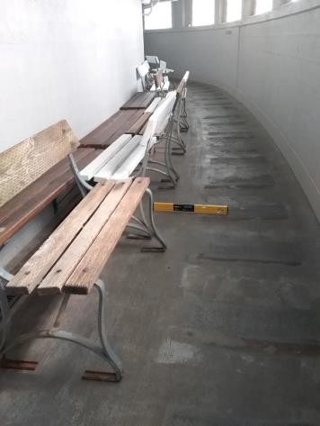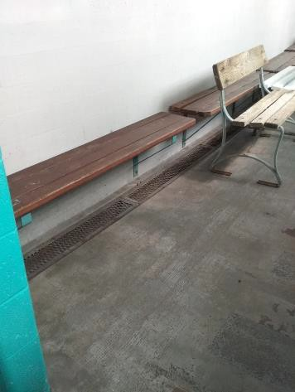

 | ID:  3465 | Facility:  Lowell Pool

Location: Women's Locker Room
Schedule: 2022
Estimated Cost: $20,000.00

Priority Score 6
Quick Fix: No
Built before ADA: Yes

VIOLATIONS
2010 ADA Standards for Accessible Design Codes: §213.3.1, §604
There is not an accessible stall in the women's locker room.

RECOMMENDATIONS
Due to space constraints, construct an accessible exterior restroom as suggested in Section 2.9 of the Lowell Report at least 60" deep and 35" to 37" wide.

PHOTOGRAPH(S) OF THIS LOCATION

