City of Boise ADA Assessment

Appendix A –Ivywild Pool House

12/4/2020
Report #TO20-B005

Prepared by:
 | ID:  1959 | Facility:  Ivywild Pool House

Location: Concession Stand
Schedule: 2023
Estimated Cost: $100.00

Priority Score 8
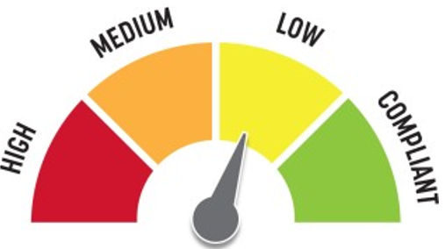
Quick Fix: Yes
Built before ADA: Yes

VIOLATIONS
2010 ADA Standards for Accessible Design Codes: §308.2.1
The paper towel dispenser is outside of the unobstructed forward reach range at 61.5" above the floor.

RECOMMENDATIONS
Lower the paper towel dispenser by 13.5" to meet the accessible reach range of 15" minimum and 48" maximum above the floor.

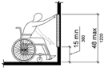

PHOTOGRAPH(S) OF THIS LOCATION

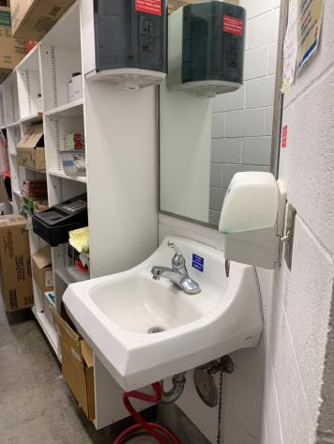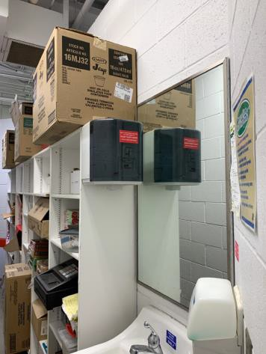

 | ID:  1957 | Facility:  Ivywild Pool House

Location: Concession Stand
Schedule: 2022
Estimated Cost: $100.00

Priority Score 7
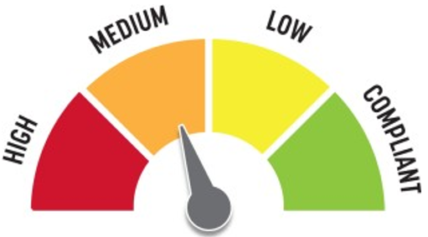
Quick Fix: Yes
Built before ADA: Yes

VIOLATIONS
2010 ADA Standards for Accessible Design Codes: §606.5
The pipes under the sink are not covered.

RECOMMENDATIONS
Wrap the pipes beneath the sink with soft protective wrap or plastic.

PHOTOGRAPH(S) OF THIS LOCATION

 | ID:  1958 | Facility:  Ivywild Pool House

Location: Concession Stand
Schedule: 2022
Estimated Cost: $100.00

Priority Score 7
Quick Fix: Yes
Built before ADA: Yes

VIOLATIONS
2010 ADA Standards for Accessible Design Codes: §603.3
The mirror is too high to be accessible at 42" above the floor.

RECOMMENDATIONS
Lower the mirror its bottom edge is a maximum height of 40" above the floor.

PHOTOGRAPH(S) OF THIS LOCATION

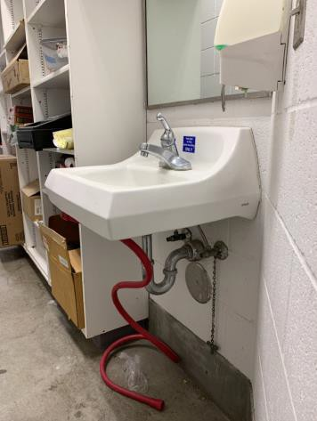

 | ID:  1961 | Facility:  Ivywild Pool House

Location: Concession Stand
Schedule: 2021
Estimated Cost: $1,000.00

Priority Score 4
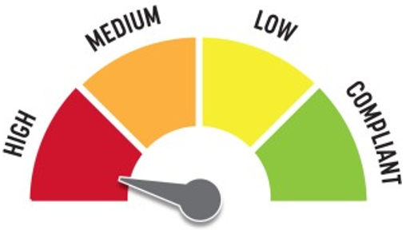
Quick Fix: No
Built before ADA: Yes

VIOLATIONS
2010 ADA Standards for Accessible Design Codes: §904.4.1
The counter is 36.75" above the ground.

RECOMMENDATIONS
A portion of the service counter must be no higher than 36” above the floor for a horizontal distance of 36”.

PHOTOGRAPH(S) OF THIS LOCATION

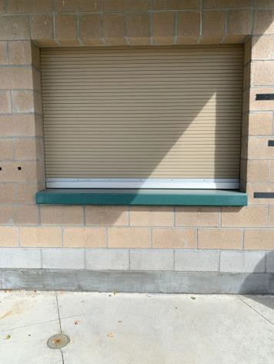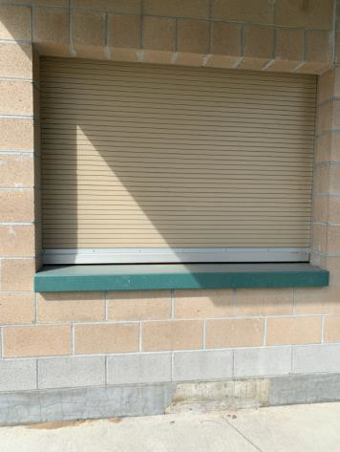

 | ID:  1988 | Facility:  Ivywild Pool House

Location: Employee Area
Schedule: 2023
Estimated Cost: $100.00

Priority Score 8
Quick Fix: Yes
Built before ADA: Yes

VIOLATIONS
2010 ADA Standards for Accessible Design Codes: §308.2.1
The hooks are outside of the unobstructed forward reach range at 55" above the floor.

RECOMMENDATIONS
Lower the hooks by 7" to meet the accessible reach range of 15" minimum and 48" maximum above the floor.

PHOTOGRAPH(S) OF THIS LOCATION

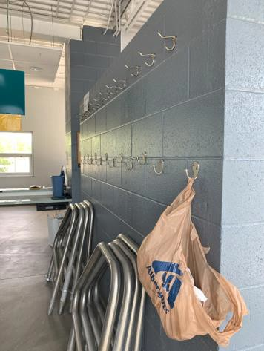

 | ID:  1937 | Facility:  Ivywild Pool House

Location: Entrance
Schedule: 2022
Estimated Cost: $1,000.00

Priority Score 7
Quick Fix: No
Built before ADA: Yes

VIOLATIONS
2010 ADA Standards for Accessible Design Codes: §305.2
The clear floor space at the garbage can has a 2.2% slope.

RECOMMENDATIONS
Resurface the 30"x48" clear floor space to have a maximum slope of 2% slope.

PHOTOGRAPH(S) OF THIS LOCATION

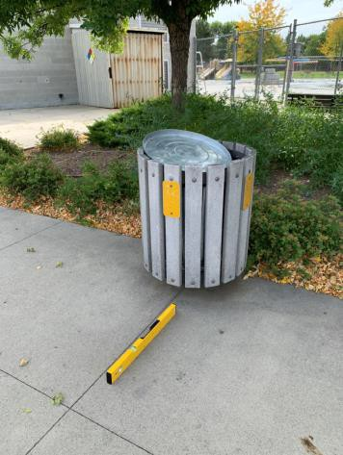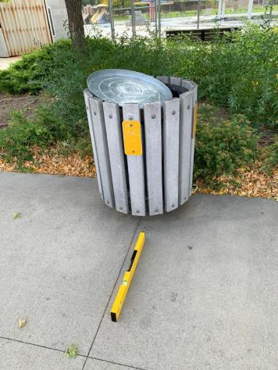

 | ID:  1938 | Facility:  Ivywild Pool House

Location: Entrance
Schedule: 2021
Estimated Cost: $1,000.00

Priority Score 3
Quick Fix: No
Built before ADA: Yes

VIOLATIONS
2010 ADA Standards for Accessible Design Codes: §404.2.4.4
The main entrance's maneuvering clearance has a 2.4% slope.

RECOMMENDATIONS
Resurface the entryway to reduce the slope to a maximum of 2% in all directions.

PHOTOGRAPH(S) OF THIS LOCATION

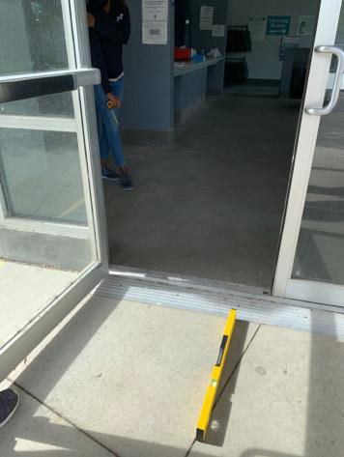

 | ID:  1934 | Facility:  Ivywild Pool House

Location: Exterior Concession Stand
Schedule: 2021
Estimated Cost: $300.00

Priority Score 3
Quick Fix: Yes
Built before ADA: Yes

VIOLATIONS
2010 ADA Standards for Accessible Design Codes: §216.2, §703
There is no tactile sign identifying the permanent room.

RECOMMENDATIONS
Install tactile signage on the latch side of the doorway at a height of 48” minimum to 60” maximum above the floor, identifying room by name or room number.
Signs shall be Braille with raised lettering and should be placed on the wall in the center of an 18"x18" clear floor space.

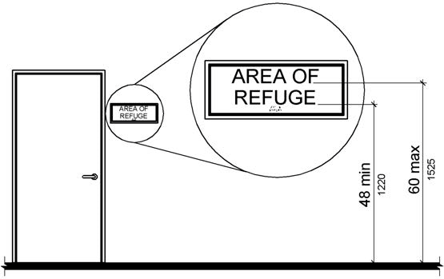

PHOTOGRAPH(S) OF THIS LOCATION

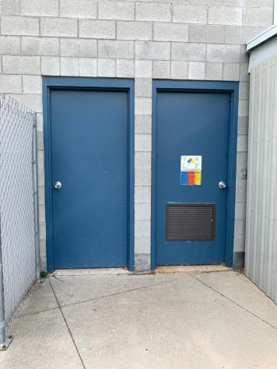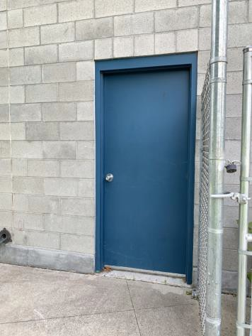

 | ID:  4463 | Facility:  Ivywild Pool House

Location: Exterior Concession Stand
Schedule: 2022
Estimated Cost: $500.00

Priority Score 7
Quick Fix: Yes
Built before ADA: Yes

VIOLATIONS
2010 ADA Standards for Accessible Design Codes: §309.4
The door knob requires twisting of the wrist.

RECOMMENDATIONS
Replace the door knob with a lever handle that can be operated with a closed fist and without twisting the wrist.

PHOTOGRAPH(S) OF THIS LOCATION

 | ID:  1933 | Facility:  Ivywild Pool House

Location: Exterior Concession Stand
Schedule: 2022
Estimated Cost: $1,000.00

Priority Score 7
Quick Fix: No
Built before ADA: Yes

VIOLATIONS
2010 ADA Standards for Accessible Design Codes: §305.2
The clear floor space at the garbage can has a 2.8% slope.

RECOMMENDATIONS
Resurface the 30"x48" clear floor space to have a maximum slope of 2% slope.

PHOTOGRAPH(S) OF THIS LOCATION

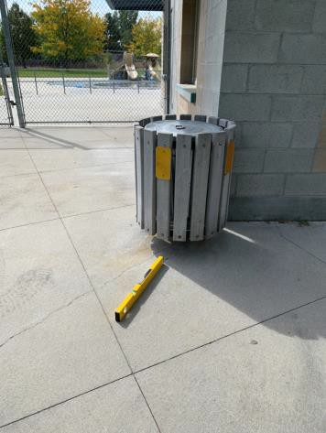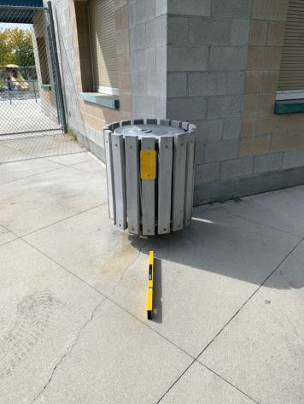

 | ID:  1935 | Facility:  Ivywild Pool House

Location: Exterior Restrooms
Schedule: 2021
Estimated Cost: $200.00

Priority Score 3
Quick Fix: Yes
Built before ADA: Yes

VIOLATIONS
2010 ADA Standards for Accessible Design Codes: §703.4
The tactile signs identifying the rooms are not in the correct locations.

RECOMMENDATIONS
Reinstall the sign on the latch side of the doors at 48" minimum above the floor measured from the baseline of the lowest character and 60" maximum measured from the baseline of the highest character.

PHOTOGRAPH(S) OF THIS LOCATION

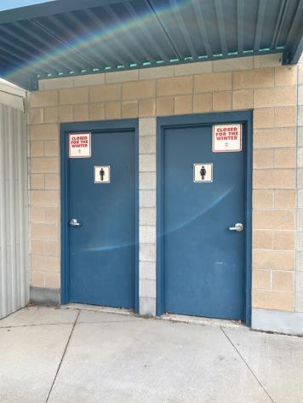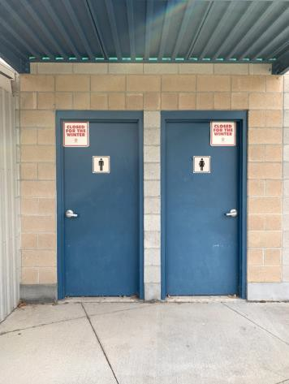

 | ID:  1936 | Facility:  Ivywild Pool House

Location: Exterior Restrooms
Schedule: 2022
Estimated Cost: $500.00

Priority Score 5
Quick Fix: Yes
Built before ADA: Yes

VIOLATIONS
2010 ADA Standards for Accessible Design Codes: §404.2.5
The threshold at the restroom doorway is 0.75" high.

RECOMMENDATIONS
Reduce the metal lip on the door to no more than 0.5" to 0.75" if beveled on each side.

PHOTOGRAPH(S) OF THIS LOCATION

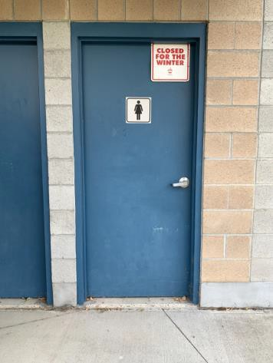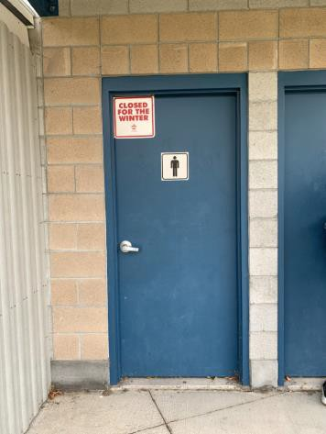

 | ID:  1987 | Facility:  Ivywild Pool House

Location: Locker Rooms
Schedule: 2023
Estimated Cost: $100.00

Priority Score 8
Quick Fix: Yes
Built before ADA: Yes

VIOLATIONS
2010 ADA Standards for Accessible Design Codes: §703.4
The tactile sign identifying the room is not in the correct location.

RECOMMENDATIONS
Reinstall the sign on the latch side of the door at 48" minimum above the floor measured from the baseline of the lowest character and 60" maximum measured from the baseline of the highest character.

PHOTOGRAPH(S) OF THIS LOCATION

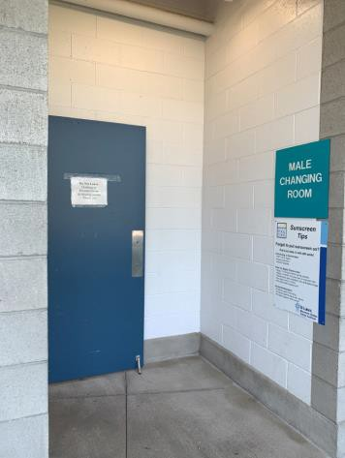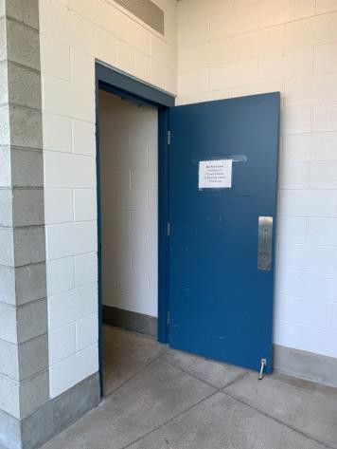

 | ID:  1980 | Facility:  Ivywild Pool House

Location: Men’s Locker Room
Schedule: 2023
Estimated Cost: $100.00

Priority Score 8
Quick Fix: Yes
Built before ADA: Yes

VIOLATIONS
2010 ADA Standards for Accessible Design Codes: §308.2.1
The hooks are outside of the unobstructed forward reach range at 55" above the floor.

RECOMMENDATIONS
Lower the hooks by 7" to meet the accessible reach range of 15" minimum and 48" maximum above the floor.

PHOTOGRAPH(S) OF THIS LOCATION

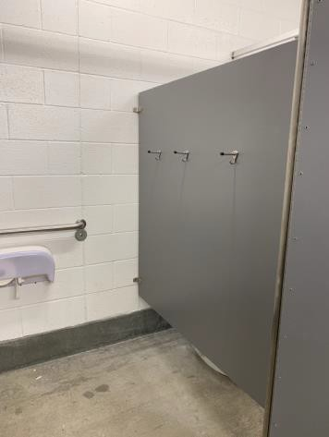

 | ID:  1972 | Facility:  Ivywild Pool House

Location: Men’s Locker Room
Schedule: 2022
Estimated Cost: $100.00

Priority Score 6
Quick Fix: Yes
Built before ADA: Yes

VIOLATIONS
2010 ADA Standards for Accessible Design Codes: §609.3, §607.6
The adjustable shower head bar is missing and the top part of the bar is broken.

RECOMMENDATIONS
Install a new shower head with a 59" long minimum hose to allow for a user to sit or stand.
Ensure that the shower head is located at least a distance of 12" or greater away from the grab bar.

PHOTOGRAPH(S) OF THIS LOCATION

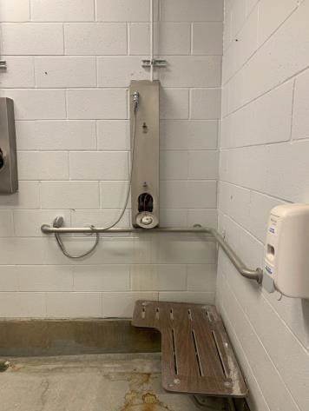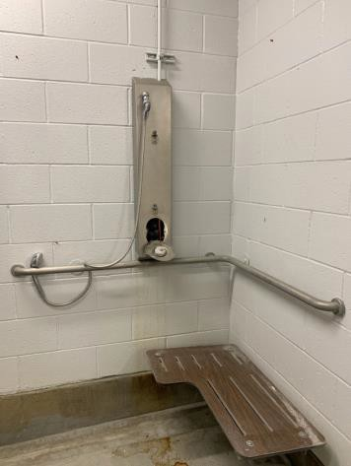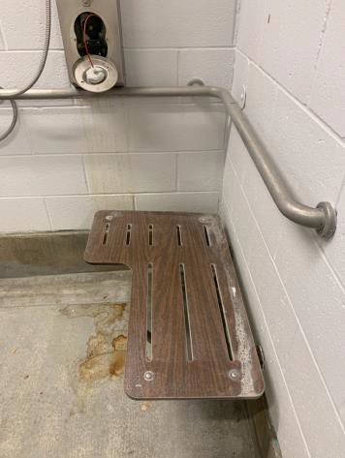

 | ID:  1976 | Facility:  Ivywild Pool House

Location: Men’s Locker Room
Schedule: 2022
Estimated Cost: $100.00

Priority Score 5
Quick Fix: Yes
Built before ADA: Yes

VIOLATIONS
2010 ADA Standards for Accessible Design Codes: §307.2
The soap dispenser protrudes 4.5" into the circulation space at 40" above the floor.

RECOMMENDATIONS
Recess the soap dispenser so it protrudes a maximum of 4", lower it so the bottom edge is 27" maximum above the floor, or place a cane detectable object beneath it.

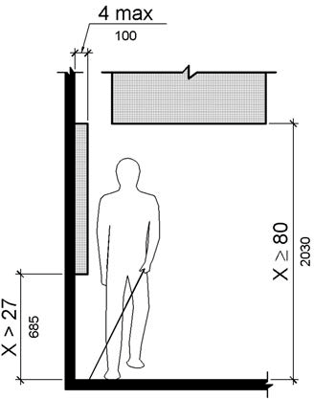

PHOTOGRAPH(S) OF THIS LOCATION

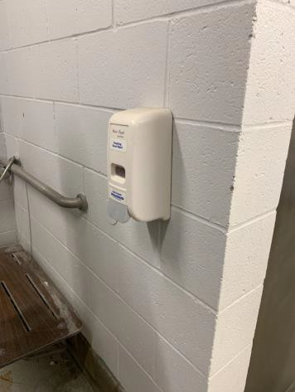

 | ID:  1981 | Facility:  Ivywild Pool House

Location: Men’s Locker Room
Schedule: 2022
Estimated Cost: $100.00

Priority Score 5
Quick Fix: Yes
Built before ADA: Yes

VIOLATIONS
2010 ADA Standards for Accessible Design Codes: §604.8.1.2
The door to the accessible water closet is not self closing.
Either self-closing hinges are not installed on the door or if installed, they are defective.

RECOMMENDATIONS
Install or reinstall self-closing hinges on the door to ensure that the door is self-closing per the ADA requirements.

PHOTOGRAPH(S) OF THIS LOCATION

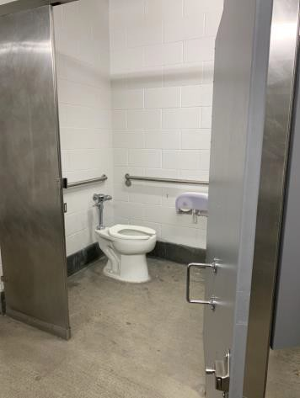

 | ID:  1985 | Facility:  Ivywild Pool House

Location: Men’s Locker Room
Schedule: 2022
Estimated Cost: $100.00

Priority Score 5
Quick Fix: Yes
Built before ADA: Yes

VIOLATIONS
2010 ADA Standards for Accessible Design Codes: §307.2
The hand dryer protrudes 8" into the circulation space at 43.5" above the floor.

RECOMMENDATIONS
Recess the hand dryer so it protrudes a maximum of 4", lower it so the bottom edge is 27" maximum above the floor, or place a cane detectable

PHOTOGRAPH(S) OF THIS LOCATION

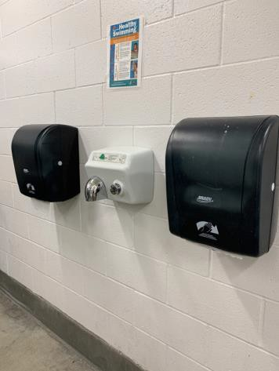

 | ID:  1982 | Facility:  Ivywild Pool House

Location: Men’s Locker Room
Schedule: 2022
Estimated Cost: $200.00

Priority Score 7
Quick Fix: Yes
Built before ADA: Yes

VIOLATIONS
2010 ADA Standards for Accessible Design Codes: §606.5
The pipes under the sinks are not covered.

RECOMMENDATIONS
Wrap the pipes beneath the sinks with soft protective wrap or plastic.

PHOTOGRAPH(S) OF THIS LOCATION

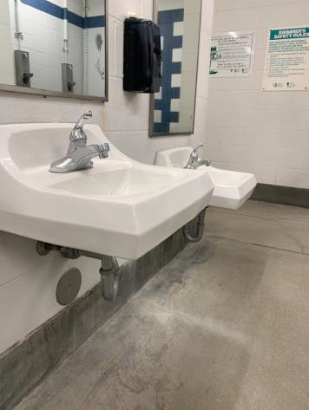

 | ID:  1984 | Facility:  Ivywild Pool House

Location: Men’s Locker Room
Schedule: 2022
Estimated Cost: $200.00

Priority Score 5
Quick Fix: Yes
Built before ADA: Yes

VIOLATIONS
2010 ADA Standards for Accessible Design Codes: §307.2
The paper towel dispensers protrude 8" into the circulation space at 41" above the floor.

RECOMMENDATIONS
Recess the paper towel dispensers so they protrude a maximum of 4", lower them so the bottom edge is 27" maximum above the floor, or place a cane detectable object beneath them.

PHOTOGRAPH(S) OF THIS LOCATION

 | ID:  1974 | Facility:  Ivywild Pool House

Location: Men’s Locker Room
Schedule: 2022
Estimated Cost: $500.00

Priority Score 6
Quick Fix: Yes
Built before ADA: Yes

VIOLATIONS
2010 ADA Standards for Accessible Design Codes: §608.5.1
The shower controls are 70" above the floor.

RECOMMENDATIONS
Adjust the height of shower controls to a minimum height of 38" and a maximum height of 48" above the floor.

PHOTOGRAPH(S) OF THIS LOCATION

 | ID:  1986 | Facility:  Ivywild Pool House

Location: Men’s Locker Room
Schedule: 2022
Estimated Cost: $500.00

Priority Score 5
Quick Fix: Yes
Built before ADA: Yes

VIOLATIONS
2010 ADA Standards for Accessible Design Codes: §903.3
The benches in the men's locker room are 11.5" deep.

RECOMMENDATIONS
Install one new bench that is at least 42" long and 20" to 24" inches deep. The accessible bench shall have a back support or be affixed to a wall.

PHOTOGRAPH(S) OF THIS LOCATION

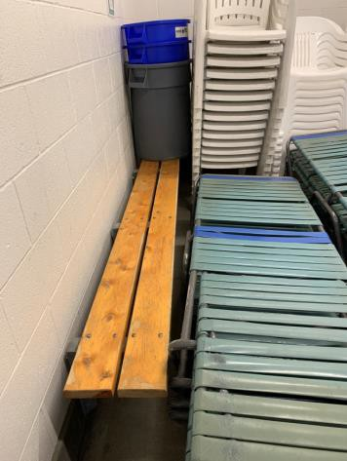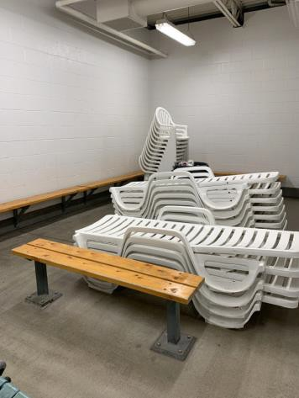

 | ID:  4468 | Facility:  Ivywild Pool House

Location: Men’s Locker Room
Schedule: 2022
Estimated Cost: $500.00

Priority Score 5
Quick Fix: No
Built before ADA: Yes

VIOLATIONS
2010 ADA Standards for Accessible Design Codes: §604.5.1
The side grab bar is located 7.5" from the rear wall.

RECOMMENDATIONS
Remount the side grab bar 12" maximum from the rear wall and extending 54" minimum from the rear wall.

PHOTOGRAPH(S) OF THIS LOCATION

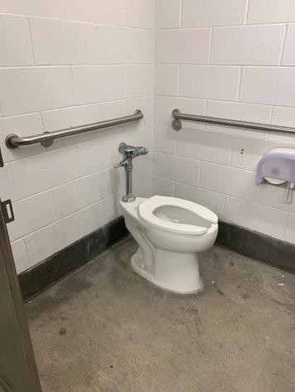

 | ID:  1977 | Facility:  Ivywild Pool House

Location: Men’s Locker Room
Schedule: 2022
Estimated Cost: $1,000.00

Priority Score 5
Quick Fix: No
Built before ADA: Yes

VIOLATIONS
2010 ADA Standards for Accessible Design Codes: §604.5.2
The rear grab bar is located 7" from the side wall.

RECOMMENDATIONS
Replace the rear grab bar with one that is a minimum of 36" long minimum and extends from the centerline of the water closet 12" minimum on one side and 24" minimum on the other.

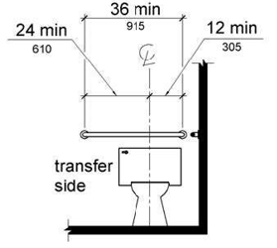

PHOTOGRAPH(S) OF THIS LOCATION

 | ID:  1978 | Facility:  Ivywild Pool House

Location: Men’s Locker Room
Schedule: 2022
Estimated Cost: $1,000.00

Priority Score 5
Quick Fix: No
Built before ADA: Yes

VIOLATIONS
2010 ADA Standards for Accessible Design Codes: ICC A117.1 §604.5.1
The accessible water closet does not have a vertical grab bar.

RECOMMENDATIONS
Install an 18" long (minimum) vertical grab bar, mounted with the bottom located at 39" minimum and 41" maximum above the floor.
The centerline of the vertical grab bar shall be located 39" minimum and 41" maximum from the rear wall.

PHOTOGRAPH(S) OF THIS LOCATION

 | ID:  1979 | Facility:  Ivywild Pool House

Location: Men’s Locker Room
Schedule: 2022
Estimated Cost: $1,000.00

Priority Score 5
Quick Fix: No
Built before ADA: Yes

VIOLATIONS
2010 ADA Standards for Accessible Design Codes: §604.2
The toilet is located 19.5" from the sidewall.

RECOMMENDATIONS
Reposition the toilet to be within 16" minimum and 18" maximum from the sidewall.

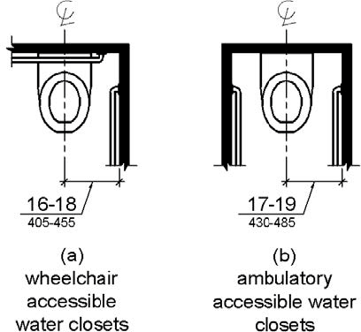

PHOTOGRAPH(S) OF THIS LOCATION

 | ID:  1983 | Facility:  Ivywild Pool House

Location: Men’s Locker Room
Schedule: 2022
Estimated Cost: $1,000.00

Priority Score 5
Quick Fix: No
Built before ADA: Yes

VIOLATIONS
2010 ADA Standards for Accessible Design Codes: §605.2
The urinal is 17.5" above the floor.

RECOMMENDATIONS
Lower the urinal to a maximum height of 17"above the floor.

PHOTOGRAPH(S) OF THIS LOCATION

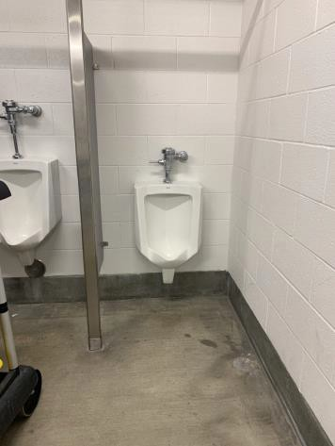

 | ID:  1970 | Facility:  Ivywild Pool House

Location: Men’s Locker Room Pool Deck
Schedule: 2021
Estimated Cost: $1,000.00

Priority Score 3
Quick Fix: No
Built before ADA: Yes

VIOLATIONS
2010 ADA Standards for Accessible Design Codes: §404.2.4.4
The maneuvering clearance at the entrance has a 4.8% cross slope and 3% running slope.

RECOMMENDATIONS
Resurface the entryway to reduce the slope to a maximum of 2% in all directions.

PHOTOGRAPH(S) OF THIS LOCATION

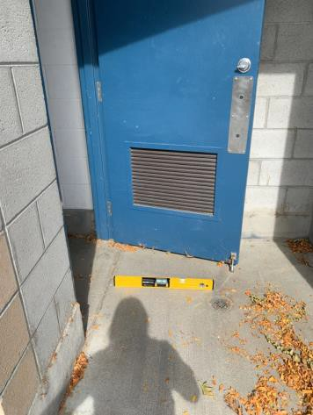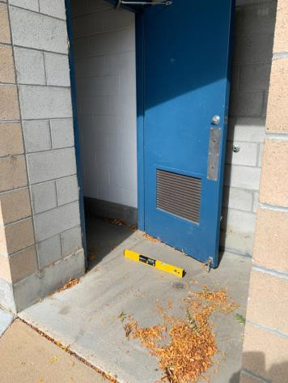

 | ID:  1927 | Facility:  Ivywild Pool House

Location: Parking
Schedule: 2023
Estimated Cost: $200.00

Priority Score 9
Quick Fix: Yes
Built before ADA: Yes

VIOLATIONS
2010 ADA Standards for Accessible Design Codes: §502.6
One accessible parking sign is missing and the existing accessible parking sign is 33.5" above the ground.

RECOMMENDATIONS
Install an accessible parking sign and remount the existing accessible sign to ensure that the sign is at a minimum height of 60" above the ground.

PHOTOGRAPH(S) OF THIS LOCATION

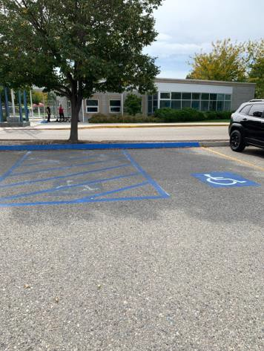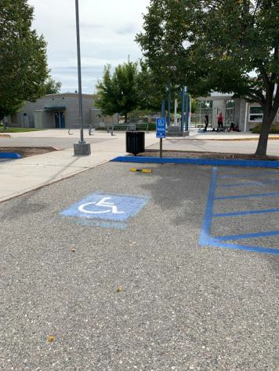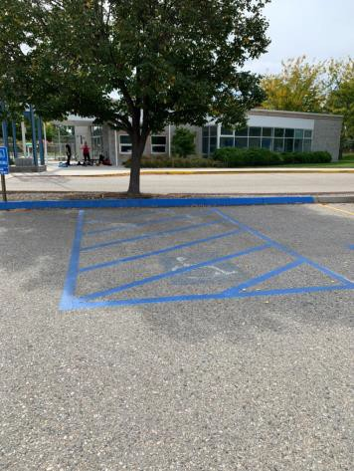

 | ID:  1932 | Facility:  Ivywild Pool House

Location: Parking
Schedule: 2023
Estimated Cost: $200.00

Priority Score 9
Quick Fix: Yes
Built before ADA: Yes

VIOLATIONS
2010 ADA Standards for Accessible Design Codes: §502.6
The accessible parking space signs are 37" and 33" above the ground.

RECOMMENDATIONS
Remount the accessible parking signs at each accessible space at a minimum height of 60" above the ground.

PHOTOGRAPH(S) OF THIS LOCATION

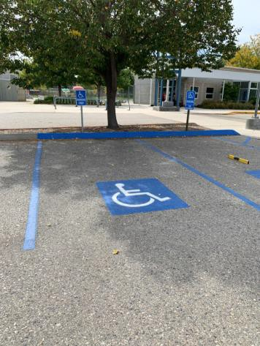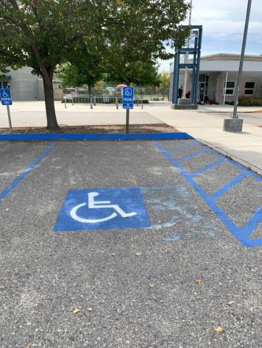

 | ID: | Facility:  Ivywild Pool House

Location:
Schedule:
Estimated Cost:

Priority Score 9
Quick Fix: Yes
Built before ADA: Yes

VIOLATIONS
2010 ADA Standards for Accessible Design Codes §308.2.1

RECOMMENDATIONS

PHOTOGRAPH(S) OF THIS LOCATION

f
 | ID:  1928 | Facility:  Ivywild Pool House

Location: Parking
Schedule: 2021
Estimated Cost: $1,000.00

Priority Score 2
Quick Fix: No
Built before ADA: Yes

VIOLATIONS
2010 ADA Standards for Accessible Design Codes: §208.2.4
There are no marked "Van Accessible" spaces.

RECOMMENDATIONS
Add a “Van Accessible” parking sign at a minimum height of 60" above the ground.

PHOTOGRAPH(S) OF THIS LOCATION

 | ID:  1930 | Facility:  Ivywild Pool House

Location: Parking
Schedule: 2021
Estimated Cost: $1,000.00

Priority Score 2
Quick Fix: No
Built before ADA: Yes

VIOLATIONS
2010 ADA Standards for Accessible Design Codes: §502.3
One space does not have an access aisle.

RECOMMENDATIONS
Install one access aisle connecting the accessible parking spaces to an accessible route.
Two parking spaces shall be permitted to share a common access aisle. Each access aisle shall be 60” wide.

PHOTOGRAPH(S) OF THIS LOCATION

 | ID:  1931 | Facility:  Ivywild Pool House

Location: Parking
Schedule: 2021
Estimated Cost: $1,000.00

Priority Score 2
Quick Fix: No
Built before ADA: Yes

VIOLATIONS
2010 ADA Standards for Accessible Design Codes: §502.3
The access aisle is 45" wide. (the accessible parking space is 108" wide)

RECOMMENDATIONS
Repaint the accessible parking spaces and access aisles so that all accessible car parking spaces are a minimum of 96" wide and their adjacent access aisles are a minimum of 60” wide.

PHOTOGRAPH(S) OF THIS LOCATION

 | ID:  1964 | Facility:  Ivywild Pool House

Location: Pool Deck
Schedule: 2022
Estimated Cost: $100.00

Priority Score 7
Quick Fix: Yes
Built before ADA: Yes

VIOLATIONS
2010 ADA Standards for Accessible Design Codes: §305.2
The clear floor space at the garbage can has a 2.5% slope.

RECOMMENDATIONS
Resurface the 30"x48" clear floor space to have a maximum slope of 2% slope.

PHOTOGRAPH(S) OF THIS LOCATION

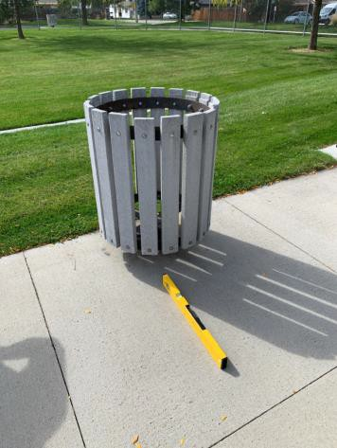

 | ID:  1969 | Facility:  Ivywild Pool House

Location: Pool Deck
Schedule: 2021
Estimated Cost: $300.00

Priority Score 3
Quick Fix: Yes
Built before ADA: Yes

VIOLATIONS
2010 ADA Standards for Accessible Design Codes: §216.2, §703
There are no tactile signs identifying the permanent rooms.

RECOMMENDATIONS
Install tactile signage on the latch side of the doorway at a height of 48” minimum to 60” maximum above the floor, identifying room by name or room number.
Signs shall be Braille with raised lettering and should be placed on the wall in the center of an 18"x18" clear floor space.

PHOTOGRAPH(S) OF THIS LOCATION

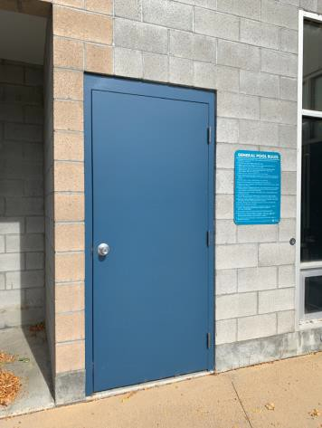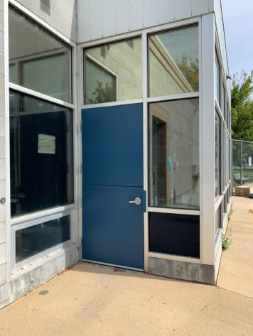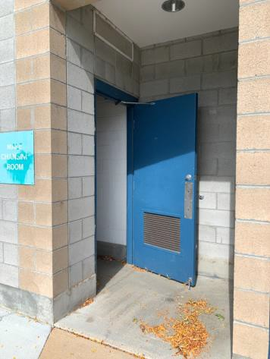

 | ID:  1962 | Facility:  Ivywild Pool House

Location: Pool Deck
Schedule: 2022
Estimated Cost: $1,000.00

Priority Score 7
Quick Fix: No
Built before ADA: Yes

VIOLATIONS
2010 ADA Standards for Accessible Design Codes: §305.2
The clear floor space at the garbage can has a 2.3% slope.

RECOMMENDATIONS
Resurface the 30"x48" clear floor space to have a maximum slope of 2% slope.

PHOTOGRAPH(S) OF THIS LOCATION

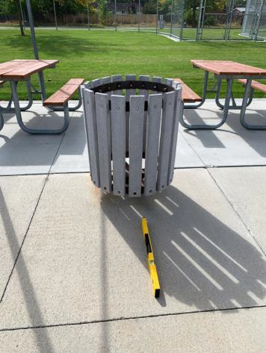

 | ID:  1965 | Facility:  Ivywild Pool House

Location: Pool Deck
Schedule: 2022
Estimated Cost: $1,000.00

Priority Score 6
Quick Fix: No
Built before ADA: Yes

VIOLATIONS
2010 ADA Standards for Accessible Design Codes: §211.2, §602.7
There is only one drinking fountain provided at 32" above the floor.

RECOMMENDATIONS
Install an additional drinking fountain at a minimum height of 38" and maximum of 43" above the floor.

PHOTOGRAPH(S) OF THIS LOCATION

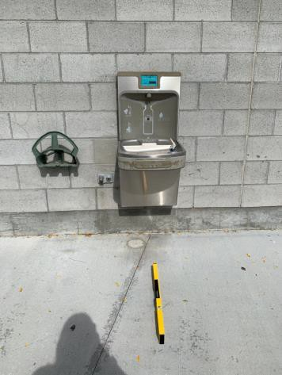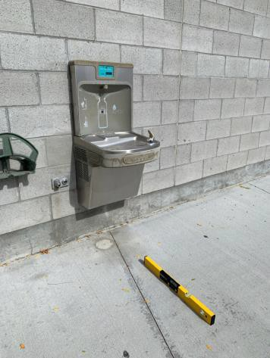

 | ID:  1963 | Facility:  Ivywild Pool House

Location: Pool Deck
Schedule: 2021
Estimated Cost: $1,000.00

Priority Score 3
Quick Fix: No
Built before ADA: Yes

VIOLATIONS
2010 ADA Standards for Accessible Design Codes: §226.1, §902, §305, §306
The provided picnic table does not have an accessible clear space for a wheelchair user.

RECOMMENDATIONS
Add/replace picnic tables so that at least 5% of the seating is wheelchair accessible.
Ensure that the wheelchair accessible seating has a clear floor space of 30" x 48" with a slope not steeper than 2% and that the tables have sufficient knee and toe clearance.

PHOTOGRAPH(S) OF THIS LOCATION

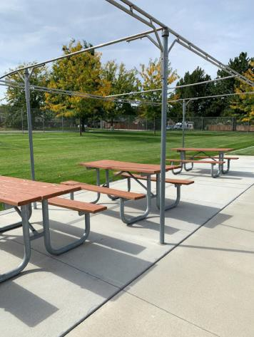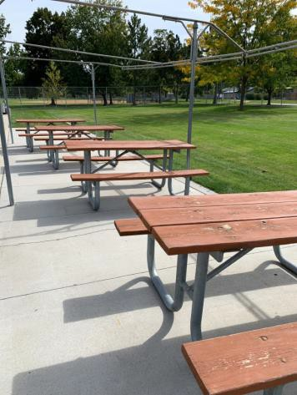

 | ID:  1966 | Facility:  Ivywild Pool House

Location: Pool Deck
Schedule: 2021
Estimated Cost: $1,000.00

Priority Score 3
Quick Fix: No
Built before ADA: Yes

VIOLATIONS
2010 ADA Standards for Accessible Design Codes: §305.2
The clear floor space at the drinking fountain has a 6.1% slope.

RECOMMENDATIONS
Reconstruct the 30"x48" clear floor space to have a maximum slope of 2% slope.

PHOTOGRAPH(S) OF THIS LOCATION

 | ID:  1967 | Facility:  Ivywild Pool House

Location: Pool Deck
Schedule: 2021
Estimated Cost: $5,000.00

Priority Score 3
Quick Fix: No
Built before ADA: Yes

VIOLATIONS
2010 ADA Standards for Accessible Design Codes: §1009.3.2, §1009.3.3
The pool has a sloped entry that was unable to be assessed due to the pool being covered for the winter season.

RECOMMENDATIONS
When the pool is uncovered, ensure that the sloped entry extends to a minimum depth of 24" and a maximum depth of 30".
Install at least two handrails on the sloped entry with a minimum clear width of 33" and maximum of 38". The handrails shall have a minimum height of 34" and maximum of 38" above the floor.

PHOTOGRAPH(S) OF THIS LOCATION

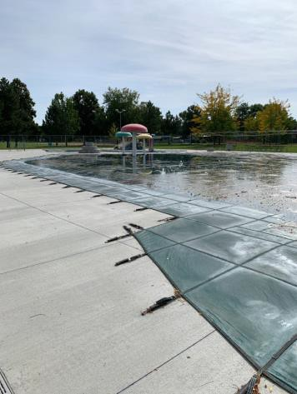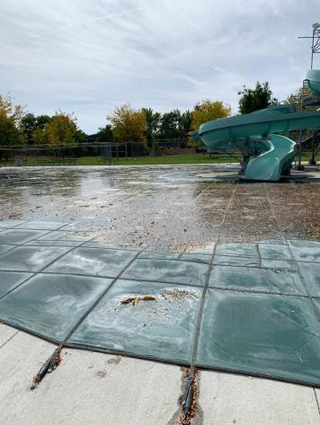

 | ID:  1968 | Facility:  Ivywild Pool House

Location: Pool Deck Sunscreen Dispenser
Schedule: 2021
Estimated Cost: $1,000.00

Priority Score 3
Quick Fix: No
Built before ADA: Yes

VIOLATIONS
2010 ADA Standards for Accessible Design Codes: §305.2
The clear floor space at the sunscreen dispenser has a 4.4% slope.

RECOMMENDATIONS
Reconstruct the 30"x48" clear floor space to have a maximum slope of 2% slope.

PHOTOGRAPH(S) OF THIS LOCATION

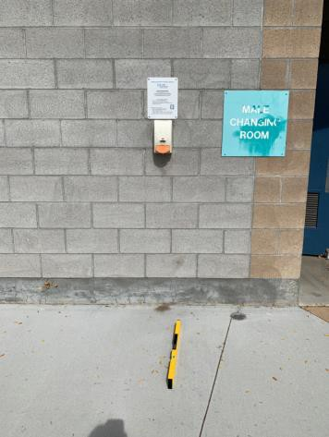

 | ID:  1274 | Facility:  Ivywild Pool House

Location: Tennis Court Parking
Schedule: 2023
Estimated Cost: $500.00

Priority Score 9
Quick Fix: Yes
Built before ADA: Yes

VIOLATIONS
2010 ADA Standards for Accessible Design Codes: §502.6, §502.3.2
The accessible parking sign is 45" above the ground and not centered. The access aisle does not extend the full length of the parking space.

RECOMMENDATIONS
Remount the accessible parking sign at a minimum height of 60" above the ground.
Paint the access aisle so it extends the full length of the parking space it serves.

PHOTOGRAPH(S) OF THIS LOCATION

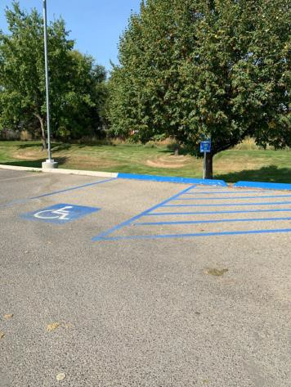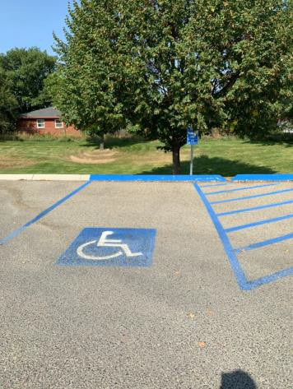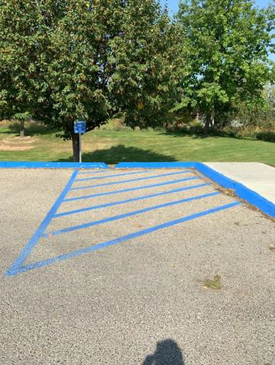

 | ID:  1269 | Facility:  Ivywild Pool House

Location: Tennis Court Parking
Schedule: 2022
Estimated Cost: $500.00

Priority Score 7
Quick Fix: Yes
Built before ADA: Yes

VIOLATIONS
2010 ADA Standards for Accessible Design Codes: §705
The curb ramp does not have a detectable warning.

RECOMMENDATIONS
Install a detectable warning that contrasts visually with the adjacent surface with either light-on-dark, or dark-on-light.

PHOTOGRAPH(S) OF THIS LOCATION

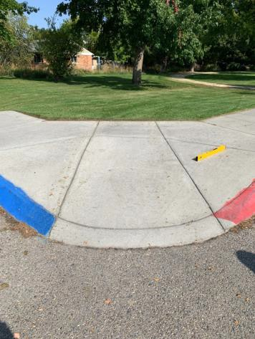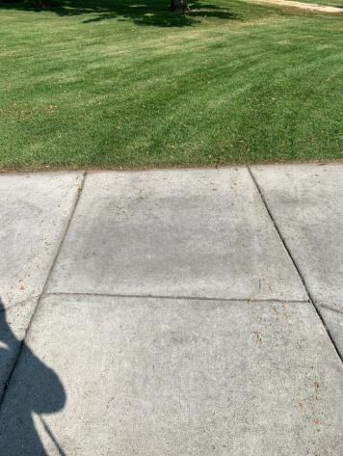

 | ID:  1953 | Facility:  Ivywild Pool House

Location: Women’s Locker Room
Schedule: 2023
Estimated Cost: $100.00

Priority Score 8
Quick Fix: Yes
Built before ADA: Yes

VIOLATIONS
2010 ADA Standards for Accessible Design Codes: §308.2.1
The shower head is outside of the unobstructed forward reach range at 70" above the floor.

RECOMMENDATIONS
Lower the shower head by 22" to meet the accessible reach range of 15" minimum and 48" maximum above the floor.
Ensure that the shower head is located at least a distance of 12" or greater away from the grab bar.

PHOTOGRAPH(S) OF THIS LOCATION

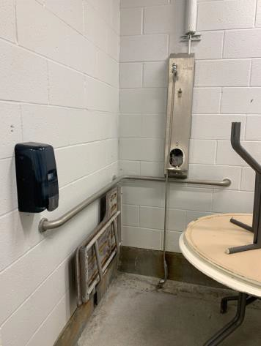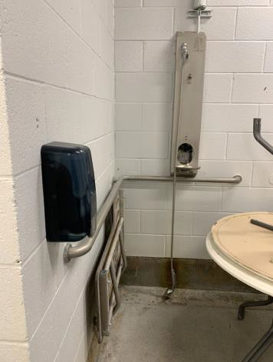

 | ID:  1943 | Facility:  Ivywild Pool House

Location: Women’s Locker Room
Schedule: 2022
Estimated Cost: $100.00

Priority Score 5
Quick Fix: Yes
Built before ADA: Yes

VIOLATIONS
2010 ADA Standards for Accessible Design Codes: §604.8.1.2
The door to the accessible water closet is not self closing.
Either self-closing hinges are not installed on the door or if installed, they are defective.

RECOMMENDATIONS
Install or reinstall self-closing hinges on the door to ensure that the door is self-closing per the ADA requirements.

PHOTOGRAPH(S) OF THIS LOCATION

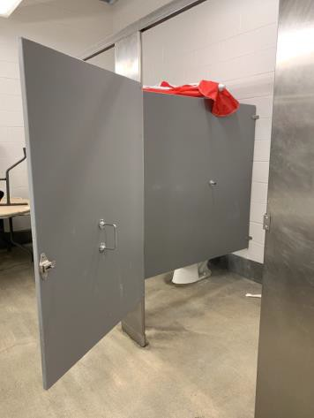

 | ID:  1948 | Facility:  Ivywild Pool House

Location: Women’s Locker Room
Schedule: 2022
Estimated Cost: $100.00

Priority Score 5
Quick Fix: Yes
Built before ADA: Yes

VIOLATIONS
2010 ADA Standards for Accessible Design Codes: §604.8.1.2
The door to the accessible water closet is not self closing.
Either self-closing hinges are not installed on the door or if installed, they are defective.

RECOMMENDATIONS
Install or reinstall self-closing hinges on the door to ensure that the door is self-closing per the ADA requirements.

PHOTOGRAPH(S) OF THIS LOCATION

 | ID:  1952 | Facility:  Ivywild Pool House

Location: Women’s Locker Room
Schedule: 2022
Estimated Cost: $100.00

Priority Score 6
Quick Fix: Yes
Built before ADA: Yes

VIOLATIONS
2010 ADA Standards for Accessible Design Codes: §607.6
The adjustable shower head is broken.

RECOMMENDATIONS
Replace the adjustable shower head. Ensure that there is a 59" long hose to allow for a user to sit or stand.

PHOTOGRAPH(S) OF THIS LOCATION

 | ID:  1950 | Facility:  Ivywild Pool House

Location: Women’s Locker Room
Schedule: 2021
Estimated Cost: $100.00

Priority Score 4
Quick Fix: Yes
Built before ADA: Yes

VIOLATIONS
2010 ADA Standards for Accessible Design Codes: §608.3.1
The shower seat is located in the wrong location, under the grab bar.

RECOMMENDATIONS
Install a partition across the control wall and back wall, then relocate the seat to be location on the partition. The partition shall act as a seat wall.

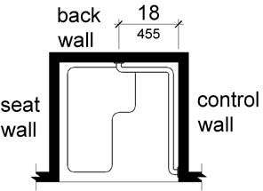

PHOTOGRAPH(S) OF THIS LOCATION

 | ID:  1954 | Facility:  Ivywild Pool House

Location: Women’s Locker Room
Schedule: 2023
Estimated Cost: $200.00

Priority Score 8
Quick Fix: Yes
Built before ADA: Yes

VIOLATIONS
2010 ADA Standards for Accessible Design Codes: §308.2.1
The hooks are outside of the unobstructed forward reach range at 56" above the floor.

RECOMMENDATIONS
Lower the hooks by 8" to meet the accessible reach range of 15" minimum and 48" maximum above the floor.

PHOTOGRAPH(S) OF THIS LOCATION

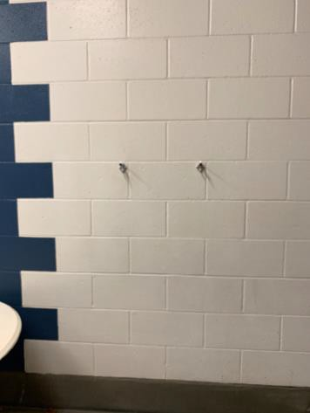

 | ID:  1940 | Facility:  Ivywild Pool House

Location: Women’s Locker Room
Schedule: 2022
Estimated Cost: $200.00

Priority Score 5
Quick Fix: Yes
Built before ADA: Yes

VIOLATIONS
2010 ADA Standards for Accessible Design Codes: §307.2
The paper towel dispensers protrude 8" into the circulation space at 41.25" above the floor.

RECOMMENDATIONS
Recess the paper towel dispensers so they protrudes a maximum of 4", lower them so the bottom edge is 27" maximum above the floor, or place a cane detectable object beneath them.

PHOTOGRAPH(S) OF THIS LOCATION

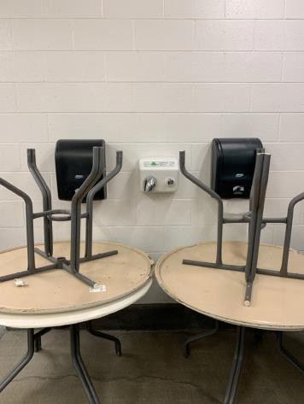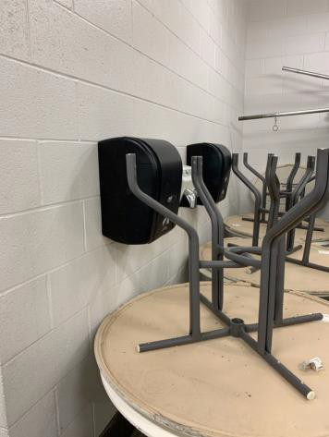

 | ID:  1942 | Facility:  Ivywild Pool House

Location: Women’s Locker Room
Schedule: 2022
Estimated Cost: $200.00

Priority Score 7
Quick Fix: Yes
Built before ADA: Yes

VIOLATIONS
2010 ADA Standards for Accessible Design Codes: §606.5
The pipes under the sinks are not covered.

RECOMMENDATIONS
Wrap the pipes beneath the sinks with soft protective wrap or plastic.

PHOTOGRAPH(S) OF THIS LOCATION

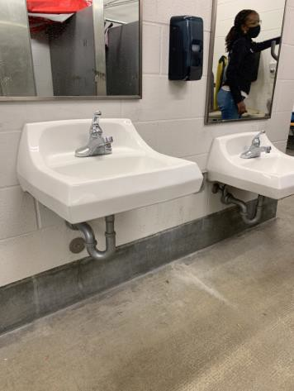

 | ID:  1939 | Facility:  Ivywild Pool House

Location: Women’s Locker Room
Schedule: 2022
Estimated Cost: $500.00

Priority Score 5
Quick Fix: Yes
Built before ADA: Yes

VIOLATIONS
2010 ADA Standards for Accessible Design Codes: §903.3
There benches the women's locker room are 12" deep.

RECOMMENDATIONS
Install one new bench that is at least 42" long and 20" to 24" inches deep. The accessible bench shall have a back support or be affixed to a wall.

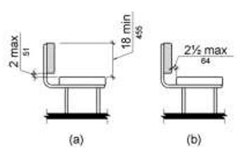

PHOTOGRAPH(S) OF THIS LOCATION

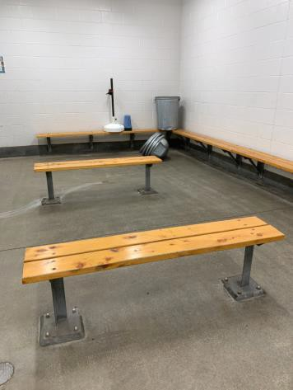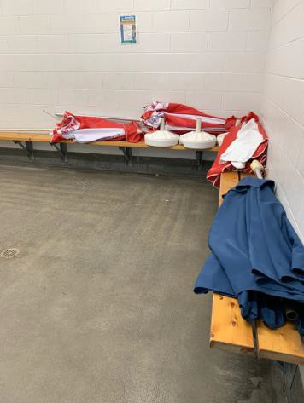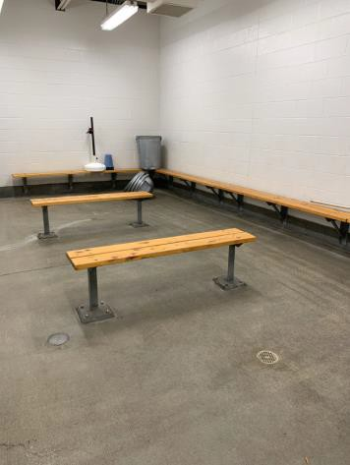

 | ID:  4465 | Facility:  Ivywild Pool House

Location: Women’s Locker Room
Schedule: 2022
Estimated Cost: $500.00

Priority Score 5
Quick Fix: Yes
Built before ADA: Yes

VIOLATIONS
2010 ADA Standards for Accessible Design Codes: §604.7
The toilet paper dispenser is not located in an accessible position at 12" in front of the toilet.

RECOMMENDATIONS
Remount the toilet paper dispenser so that the centerline is located 7" minimum to 9" maximum in front of the toilet.

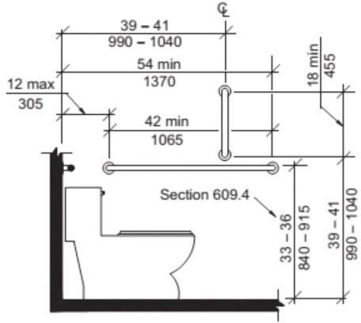

PHOTOGRAPH(S) OF THIS LOCATION

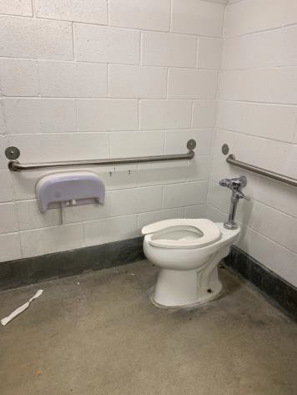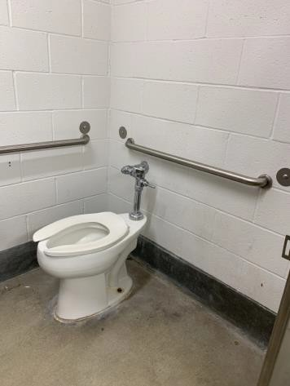

 | ID:  1955 | Facility:  Ivywild Pool House

Location: Women’s Locker Room
Schedule: 2021
Estimated Cost: $500.00

Priority Score 3
Quick Fix: Yes
Built before ADA: Yes

VIOLATIONS
2010 ADA Standards for Accessible Design Codes: §303.3
The change in level between 0.25" and 0.5" is not beveled.

RECOMMENDATIONS
Bevel the change in level with a slope not steeper than 1:2.

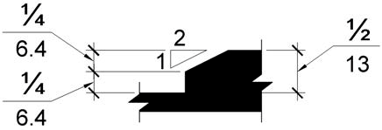

PHOTOGRAPH(S) OF THIS LOCATION

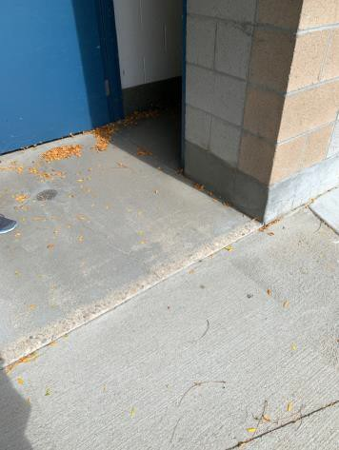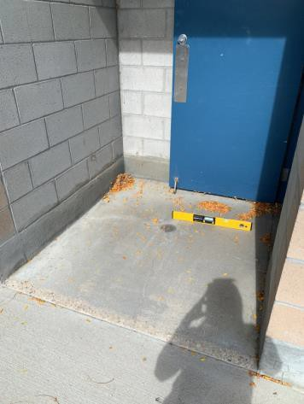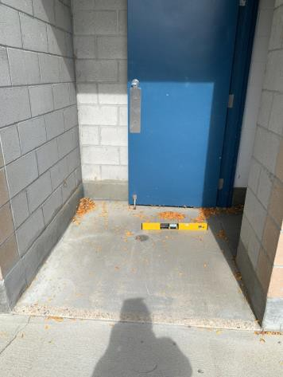

 | ID:  1947 | Facility:  Ivywild Pool House

Location: Women’s Locker Room
Schedule: 2022
Estimated Cost: $1,000.00

Priority Score 5
Quick Fix: No
Built before ADA: Yes

VIOLATIONS
2010 ADA Standards for Accessible Design Codes: ICC A117.1 §604.5.1
The accessible water closet does not have a vertical grab bar.

RECOMMENDATIONS
Install an 18" long (minimum) vertical grab bar, mounted with the bottom located at 39" minimum and 41" maximum above the floor.
The centerline of the vertical grab bar shall be located 39" minimum and 41" maximum from the rear wall.

PHOTOGRAPH(S) OF THIS LOCATION

 | ID:  1956 | Facility:  Ivywild Pool House

Location: Women’s Locker Room
Schedule: 2021
Estimated Cost: $1,000.00

Priority Score 3
Quick Fix: No
Built before ADA: Yes

VIOLATIONS
2010 ADA Standards for Accessible Design Codes: §404.2.4.4
The maneuvering clearance at the entrance has a 2.8% cross slope and 4.5% running slope.

RECOMMENDATIONS
Resurface the entryway to reduce the running slope to a maximum of 2% in all directions.

PHOTOGRAPH(S) OF THIS LOCATION

