City of Boise ADA Assessment

Appendix A –Boise Depot

02/19/2021
Report #TO21-B020

Prepared by:
 | ID:  2233 | Facility:  Boise Depot

Location: Back Stairwell
Schedule: 2022
Estimated Cost: $1,000.00

Priority Score 5
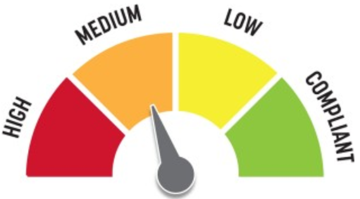
Quick Fix: No
Built before ADA: Yes

VIOLATIONS
2010 ADA Standards for Accessible Design Codes §505.4
Handrails are not located at a compliant height at 33" above the stair nosings.

RECOMMENDATIONS
Raise the handrails to a minimum height of 34" and a maximum of 38" above the stair nosings. Ensure that the handrails are at a consistent height along the stair treads.

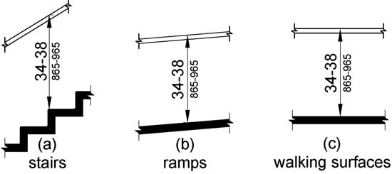

PHOTOGRAPH(S) OF THIS LOCATION

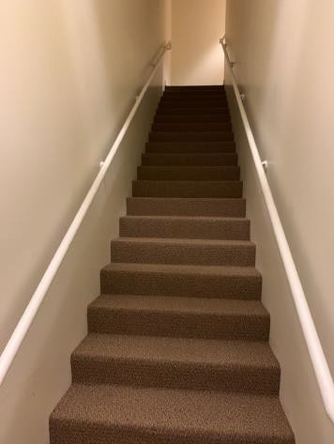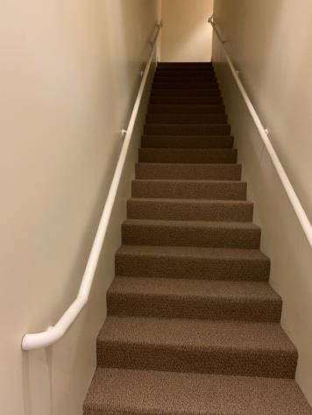

 | ID:  2202 | Facility:  Boise Depot

Location: Brides Room
Schedule: 2021
Estimated Cost: $100.00

Priority Score 8
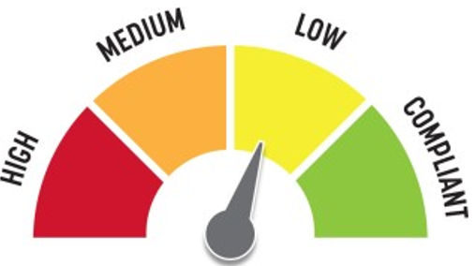
Quick Fix: Yes
Built before ADA: Yes

VIOLATIONS
2010 ADA Standards for Accessible Design Codes §308.2.1
The hooks are outside of the unobstructed forward reach range at 48.5" and 78" above the floor.

RECOMMENDATIONS
Lower the hooks by 0.5" to meet the accessible reach range of 48" maximum above the floor.

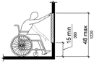

PHOTOGRAPH(S) OF THIS LOCATION

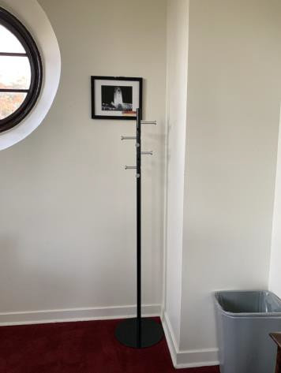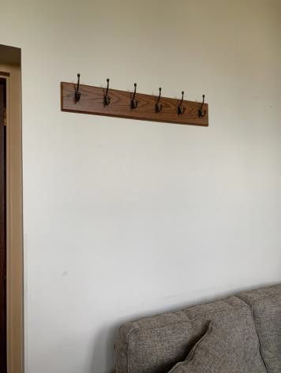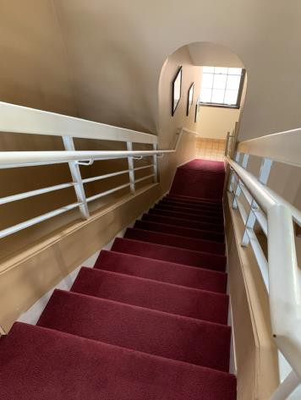

 | ID:  2201 | Facility:  Boise Depot

Location: Brides Room Stairs
Schedule: 2023
Estimated Cost: $2,500.00

Priority Score 8
Quick Fix: No
Built before ADA: Yes

VIOLATIONS
2010 ADA Standards for Accessible Design Codes §405
The Brides Room is only accessible via stairs.

RECOMMENDATIONS
Add vertical access to the amenity. An alternative to adding vertical access would be to ensure that a secondary bride's room is located on the first floor.

PHOTOGRAPH(S) OF THIS LOCATION

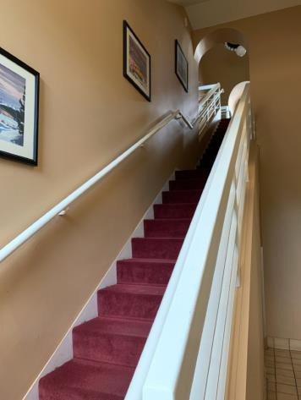

 | ID:  2424 | Facility:  Boise Depot

Location: Crosswalk
Schedule: 2022
Estimated Cost: $1,000.00

Priority Score 5
Quick Fix: No
Built before ADA: Yes

VIOLATIONS
2010 ADA Standards for Accessible Design Codes §303.2
There is a 1" change in level.

RECOMMENDATIONS
Resurface the pathway to reduce the change in level to less than 0.25" or 0.5" if beveled.

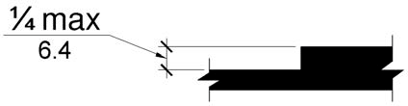

PHOTOGRAPH(S) OF THIS LOCATION

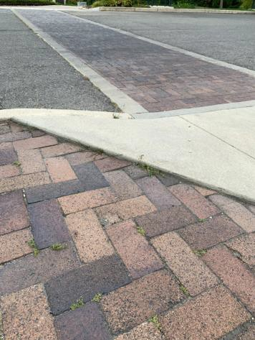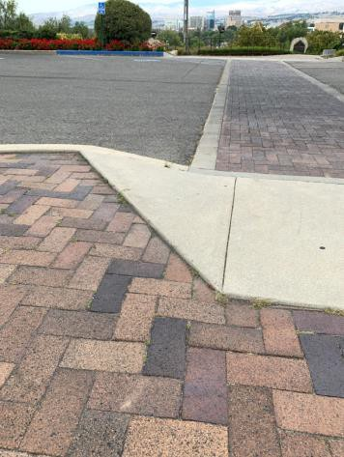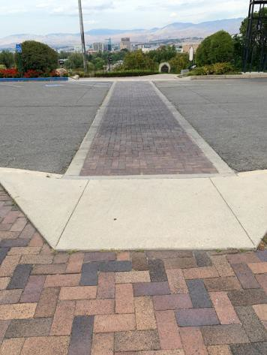

 | ID:  2425 | Facility:  Boise Depot

Location: Crosswalk
Schedule: 2022
Estimated Cost: $1,000.00

Priority Score 7
Quick Fix: No
Built before ADA: Yes

VIOLATIONS
2010 ADA Standards for Accessible Design Codes §705
The curb ramps do not have detectable warnings.

RECOMMENDATIONS
Install detectable warnings that contrast visually with the adjacent surface with either light-on-dark, or dark-on-light, are the width of the curb ramp, and have a depth of 24".

PHOTOGRAPH(S) OF THIS LOCATION

 | ID:  2426 | Facility:  Boise Depot

Location: Crosswalk
Schedule: 2022
Estimated Cost: $1,000.00

Priority Score 7
Quick Fix: No
Built before ADA: Yes

VIOLATIONS
2010 ADA Standards for Accessible Design Codes §705
The curb ramps do not have detectable warnings.

RECOMMENDATIONS
Install detectable warnings that contrast visually with the adjacent surface with either light-on-dark, or dark-on-light, are the width of the curb ramp, and have a depth of 24".

PHOTOGRAPH(S) OF THIS LOCATION

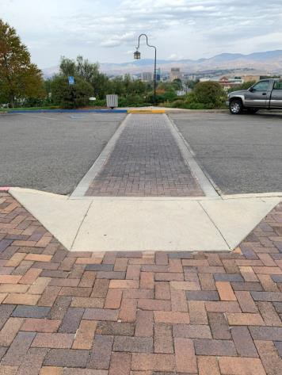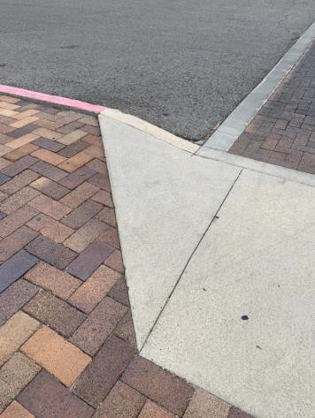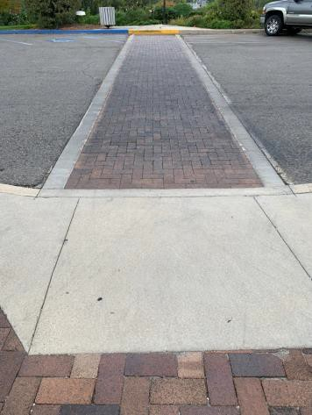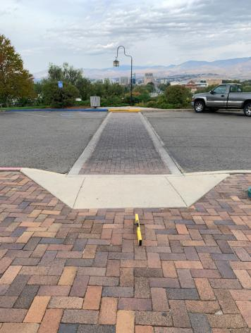

 | ID:  2428 | Facility:  Boise Depot

Location: Crosswalk
Schedule: 2021
Estimated Cost: $1,000.00

Priority Score 3
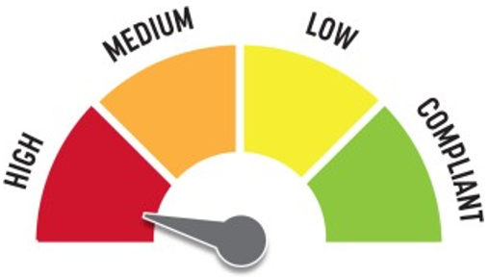
Quick Fix: No
Built before ADA: Yes

VIOLATIONS
2010 ADA Standards for Accessible Design Codes §406.3
The curb ramp flares have a 15.3% slope.

RECOMMENDATIONS
Resurface the curb ramp flares to ensure a maximum slope of 10%.

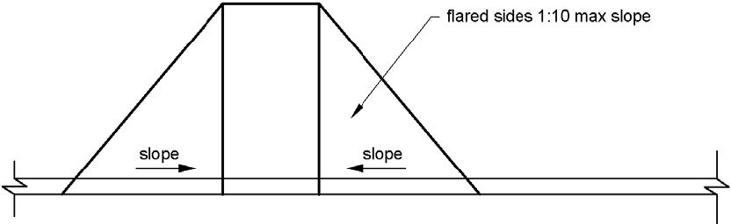

PHOTOGRAPH(S) OF THIS LOCATION

 | ID:  2427 | Facility:  Boise Depot

Location: Crosswalk
Schedule: 2022
Estimated Cost: $2,500.00

Priority Score 7
Quick Fix: No
Built before ADA: Yes

VIOLATIONS
2010 ADA Standards for Accessible Design Codes §405.2
The running slope of the curb ramp is 10.3%.

RECOMMENDATIONS
Reconstruct the curb ramp to reduce the running slope to a maximum of 8.3%.

PHOTOGRAPH(S) OF THIS LOCATION

 | ID:  2429 | Facility:  Boise Depot

Location: Crosswalk
Schedule: 2021
Estimated Cost: $2,500.00

Priority Score 3
Quick Fix: No
Built before ADA: Yes

VIOLATIONS
2010 ADA Standards for Accessible Design Codes §405.7.1
The top landing has a 6.8% running slope.

RECOMMENDATIONS
Reconstruct the top landing to have a maximum slope of 2% in all directions.

PHOTOGRAPH(S) OF THIS LOCATION

 | ID:  2214 | Facility:  Boise Depot

Location: Depot Printer Room
Schedule: 2021
Estimated Cost: $100.00

Priority Score 7
Quick Fix: Yes
Built before ADA: Yes

VIOLATIONS
2010 ADA Standards for Accessible Design Codes §309.4
The door knob requires twisting of the wrist.

RECOMMENDATIONS
Replace the door knob with a lever handle that can be operated with a closed fist and without twisting the wrist.

PHOTOGRAPH(S) OF THIS LOCATION

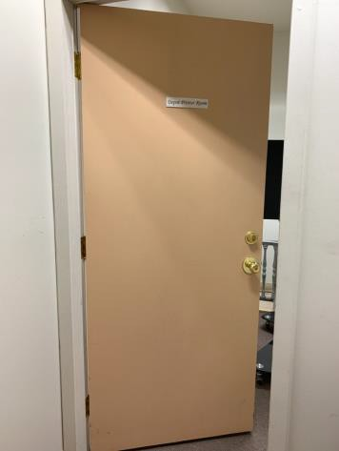

 | ID:  2249 | Facility:  Boise Depot

Location: Elevator Foyer
Schedule: 2021
Estimated Cost: $100.00

Priority Score 5
Quick Fix: Yes
Built before ADA: Yes

VIOLATIONS
2010 ADA Standards for Accessible Design Codes §307.2
The AED protrudes 6" into the circulation space at 43.25" above the floor.

RECOMMENDATIONS
Recess the AED so it protrudes a maximum of 4", lower it so the bottom edge is 27" maximum above the floor, or place a cane detectable object beneath it.

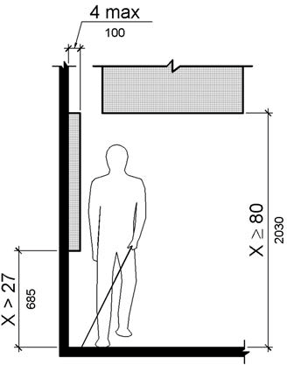

PHOTOGRAPH(S) OF THIS LOCATION

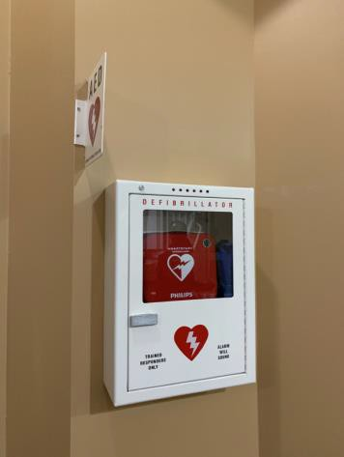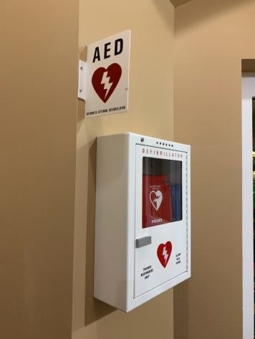

 | ID:  2217 | Facility:  Boise Depot

Location: Entire Facility
Schedule: 2021
Estimated Cost: $4,700.00

Priority Score 3
Quick Fix: Yes
Built before ADA: Yes

VIOLATIONS
2010 ADA Standards for Accessible Design Codes §216.2, §703
There are no tactile signs identifying 47 permanent rooms.

RECOMMENDATIONS
Install tactile signage on the latch side of the doorway at a height of 48” minimum to 60” maximum above the floor, identifying room by name or room number.
Signs shall be Braille with raised lettering and should be placed on the wall in the center of an 18"x18" clear floor space.

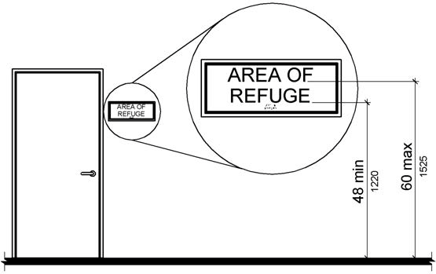

PHOTOGRAPH(S) OF THIS LOCATION

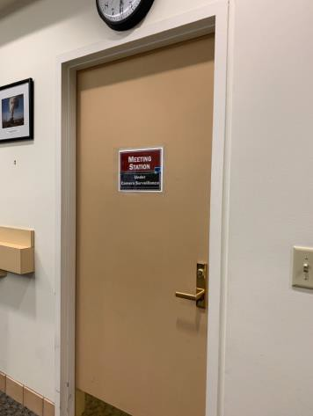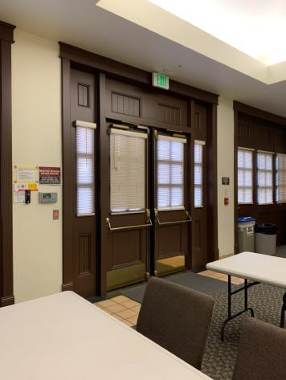

 | ID:  2190 | Facility:  Boise Depot

Location: Great Hall Kitchen
Schedule: 2023
Estimated Cost: $1,000.00

Priority Score 8
Quick Fix: No
Built before ADA: Yes

VIOLATIONS
2010 ADA Standards for Accessible Design Codes §902.3
The dining and work surface counter is 36" above the floor.

RECOMMENDATIONS
A 30" portion of the dining and work surface must be no higher than 34” above the floor.

PHOTOGRAPH(S) OF THIS LOCATION

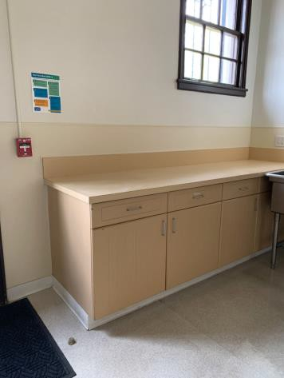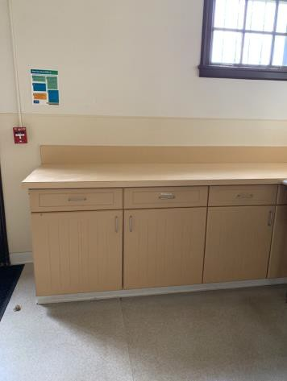

 | ID:  2213 | Facility:  Boise Depot

Location: Great Hall Main Entrance
Schedule: 2021
Estimated Cost: $500.00

Priority Score 5
Quick Fix: Yes
Built before ADA: Yes

VIOLATIONS
2010 ADA Standards for Accessible Design Codes §404.2.6
Between the two hinged doors, the length is 42.75".

RECOMMENDATIONS
Reverse the swing of one of the doors to ensure that the distance between the two doors when open is a minimum of 48".

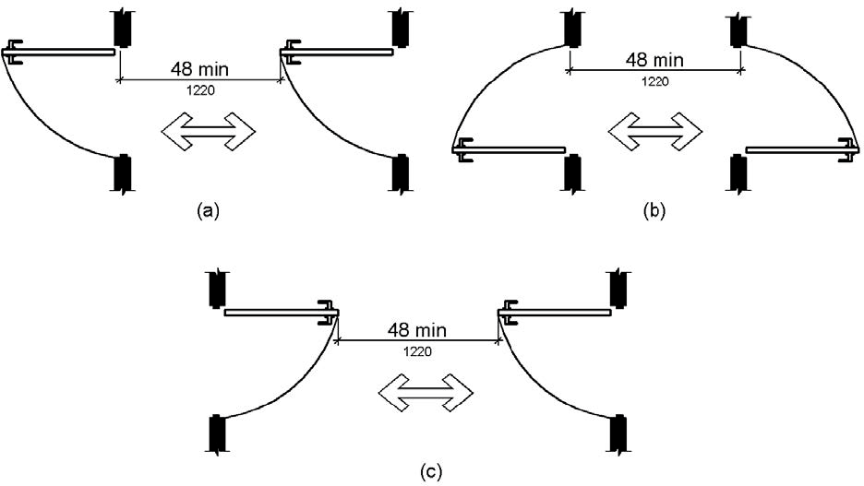

PHOTOGRAPH(S) OF THIS LOCATION

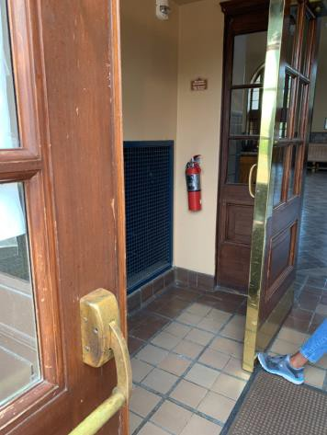

 | ID:  2196 | Facility:  Boise Depot

Location: Great Hall Men’s Restroom
Schedule: 2021
Estimated Cost: $100.00

Priority Score 3
Quick Fix: Yes
Built before ADA: Yes

VIOLATIONS
2010 ADA Standards for Accessible Design Codes §308.2.1, §609.3
The space between the grab bar and the toilet seat covers is 6.25".
The toilet seat covers are outside of the unobstructed forward reach range at 49" above the floor.

RECOMMENDATIONS
Relocate the toilet seat covers to a location that is at least a distance of 12" or greater above the grab bar.
Lower the toilet seat covers by 1" to meet the accessible reach range of 15" minimum and 48" maximum above the floor.

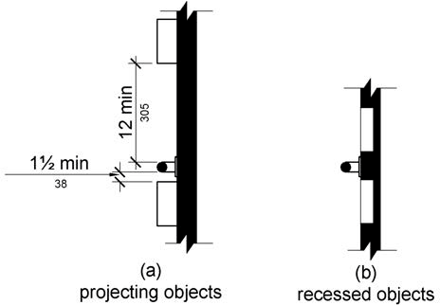

PHOTOGRAPH(S) OF THIS LOCATION

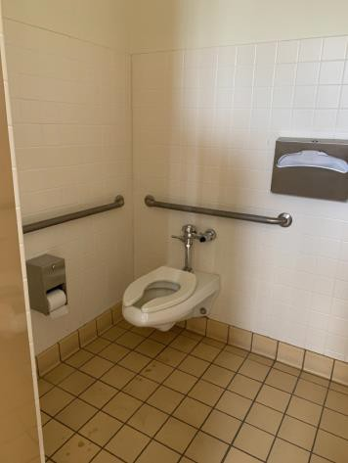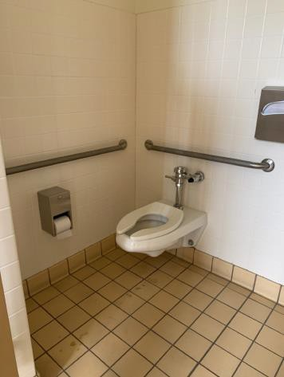

 | ID:  2197 | Facility:  Boise Depot

Location: Great Hall Men's Restroom
Schedule: 2021
Estimated Cost: $100.00

Priority Score 5
Quick Fix: Yes
Built before ADA: Yes

VIOLATIONS
2010 ADA Standards for Accessible Design Codes §604.8.1.2
The door to the accessible water closet is not self closing. Either self-closing hinges are not installed on the door or if installed, they are defective.

RECOMMENDATIONS
Install or reinstall self-closing hinges on the door to ensure that the door is self-closing per the ADA requirements.

PHOTOGRAPH(S) OF THIS LOCATION

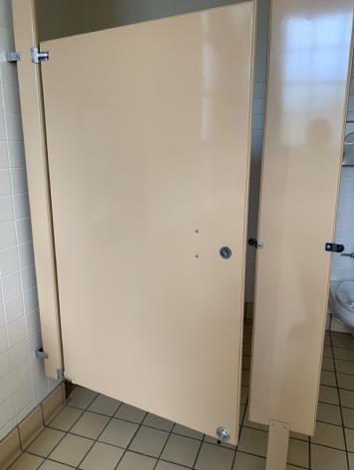

 | ID:  2199 | Facility:  Boise Depot

Location: Great Hall Men’s Restroom
Schedule: 2021
Estimated Cost: $100.00

Priority Score 7
Quick Fix: Yes
Built before ADA: Yes

VIOLATIONS
2010 ADA Standards for Accessible Design Codes §606.5
The pipes under the sink are not covered.

RECOMMENDATIONS
Wrap the pipes beneath the sink with soft protective wrap or plastic.

PHOTOGRAPH(S) OF THIS LOCATION

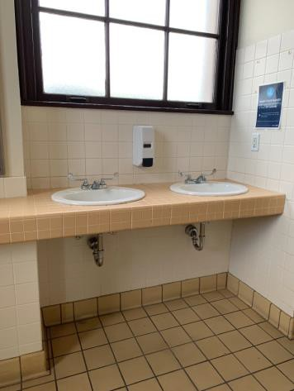

 | ID:  2192 | Facility:  Boise Depot

Location: Great Hall Men’s Restroom
Schedule: 2021
Estimated Cost: $500.00

Priority Score 5
Quick Fix: Yes
Built before ADA: Yes

VIOLATIONS
2010 ADA Standards for Accessible Design Codes §604.5.2
The rear grab bar is located 11.5" to the center of the toilet.

RECOMMENDATIONS
Remount the rear grab bar 12" from the centerline of the water closet minimum on one side and 24" minimum on the other.

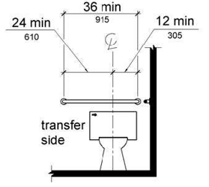

PHOTOGRAPH(S) OF THIS LOCATION

 | ID:  2193 | Facility:  Boise Depot

Location: Great Hall Men’s Restroom
Schedule: 2021
Estimated Cost: $500.00

Priority Score 5
Quick Fix: Yes
Built before ADA: Yes

VIOLATIONS
2010 ADA Standards for Accessible Design Codes §604.5.1
The side grab bar is located 6" from the rear wall.

RECOMMENDATIONS
Remount the side grab bar 12" maximum from the rear wall and extending 54" minimum from the rear wall.

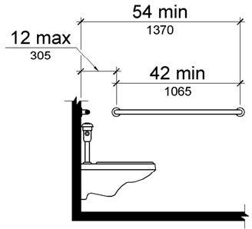

PHOTOGRAPH(S) OF THIS LOCATION

 | ID:  2191 | Facility:  Boise Depot

Location: Great Hall Men’s Restroom
Schedule: 2021
Estimated Cost: $500.00

Priority Score 5
Quick Fix: No
Built before ADA: Yes

VIOLATIONS
2010 ADA Standards for Accessible Design Codes §404.2.5
The threshold at the doorway exceeds the maximum allowable of 0.5".

RECOMMENDATIONS
Reduce the metal lip on the door to no more than 0.5" to 0.75" if beveled on each side.

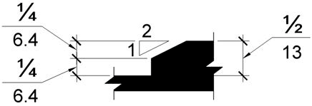

PHOTOGRAPH(S) OF THIS LOCATION

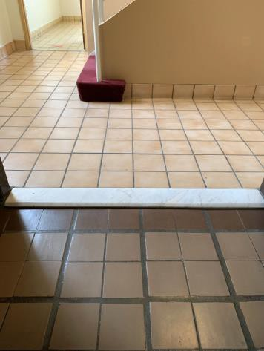

 | ID:  2194 | Facility:  Boise Depot

Location: Great Hall Men’s Restroom
Schedule: 2022
Estimated Cost: $1,000.00

Priority Score 5
Quick Fix: No
Built before ADA: Yes

VIOLATIONS
2010 ADA Standards for Accessible Design Codes §604.6
The flush control is located on the wall side of the toilet.

RECOMMENDATIONS
Either make the toilet flush automatically or relocate the flush control to be operated on the open side of the toilet.

PHOTOGRAPH(S) OF THIS LOCATION

 | ID:  2195 | Facility:  Boise Depot

Location: Great Hall Men’s Restroom
Schedule: 2022
Estimated Cost: $1,000.00

Priority Score 5
Quick Fix: No
Built before ADA: Yes

VIOLATIONS
2010 ADA Standards for Accessible Design Codes §604.2
The centerline of the toilet is located 20" from the sidewall.

RECOMMENDATIONS
Reposition the centerline of the toilet to be within 16" minimum and 18" maximum from the sidewall.

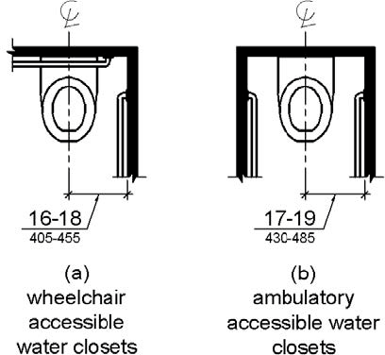

PHOTOGRAPH(S) OF THIS LOCATION

 | ID:  2198 | Facility:  Boise Depot

Location: Great Hall Men’s Restroom
Schedule: 2022
Estimated Cost: $1,000.00

Priority Score 5
Quick Fix: No
Built before ADA: Yes

VIOLATIONS
2010 ADA Standards for Accessible Design Codes §605.2
The urinal is 18" above the floor.

RECOMMENDATIONS
Lower at least one of the urinals to a maximum height of 17" above the floor.

PHOTOGRAPH(S) OF THIS LOCATION

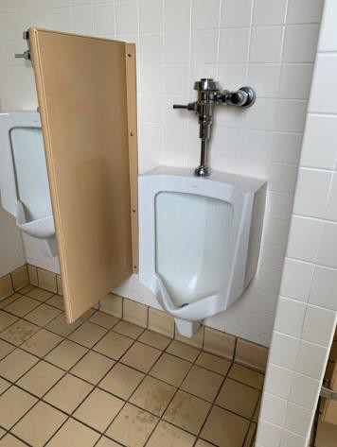

 | ID:  4474 | Facility:  Boise Depot

Location: Great Hall Men’s Restroom
Schedule: 2022
Estimated Cost: $1,000.00

Priority Score 5
Quick Fix: No
Built before ADA: Yes

VIOLATIONS
2010 ADA Standards for Accessible Design Codes ICC A117.1 §604.5.1
The accessible water closet does not have a vertical grab bar.

RECOMMENDATIONS
Install an 18" long (minimum) vertical grab bar on the side wall. The grab bar shall be mounted with the bottom located at 39" minimum and 41" maximum above the floor.
The centerline of the vertical grab bar shall be located 39" minimum and 41" maximum from the real wall.

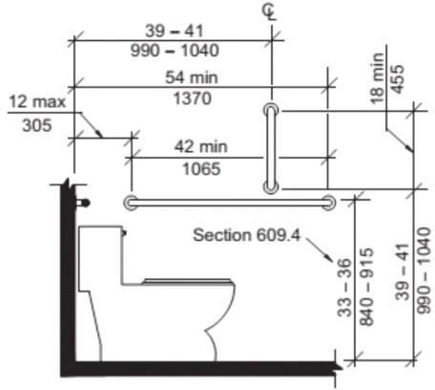

PHOTOGRAPH(S) OF THIS LOCATION

 | ID:  2182 | Facility:  Boise Depot

Location: Great Hall Railroad Exit
Schedule: 2021
Estimated Cost: $500.00

Priority Score 5
Quick Fix: Yes
Built before ADA: Yes

VIOLATIONS
2010 ADA Standards for Accessible Design Codes §404.2.6
Between the two hinged doors, the length is 46".

RECOMMENDATIONS
Reverse the swing of one of the doors to ensure that the distance between the two doors when open is a minimum of 48".

PHOTOGRAPH(S) OF THIS LOCATION

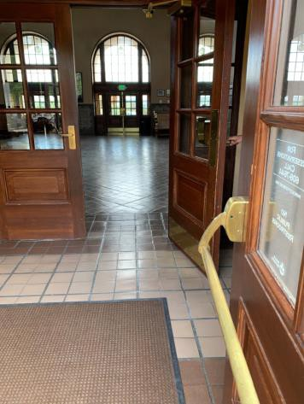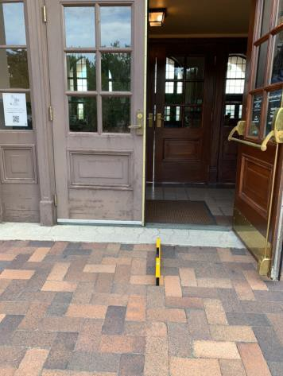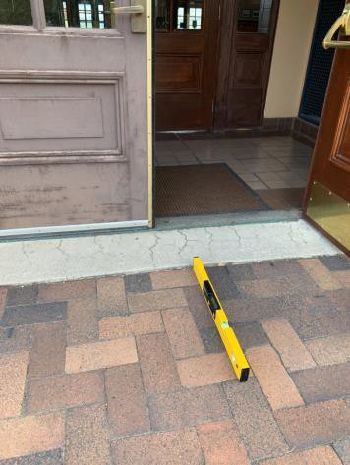

 | ID:  2184 | Facility:  Boise Depot

Location: Great Hall Railroad Exit
Schedule: 2021
Estimated Cost: $500.00

Priority Score 3
Quick Fix: Yes
Built before ADA: Yes

VIOLATIONS
2010 ADA Standards for Accessible Design Codes §303.3
The change in level between 0.25" and 0.5" is not beveled.

RECOMMENDATIONS
Bevel the change in level with a slope not steeper than 1:2.

PHOTOGRAPH(S) OF THIS LOCATION

 | ID:  2183 | Facility:  Boise Depot

Location: Great Hall Railroad Exit
Schedule: 2021
Estimated Cost: $2,500.00

Priority Score 3
Quick Fix: No
Built before ADA: Yes

VIOLATIONS
2010 ADA Standards for Accessible Design Codes §404.2.4.4
The entrance has a 3.2% slope.

RECOMMENDATIONS
Reconstruct the entryway to reduce the running slope to a maximum of 2% in all directions for a distance of 60".

PHOTOGRAPH(S) OF THIS LOCATION

 | ID:  2203 | Facility:  Boise Depot

Location: Great Hall Women’s Restroom
Schedule: 2021
Estimated Cost: $100.00

Priority Score 5
Quick Fix: Yes
Built before ADA: Yes

VIOLATIONS
2010 ADA Standards for Accessible Design Codes §604.8.1.2
The door to the accessible water closet is not self closing. Either self-closing hinges are not installed on the door or if installed, they are defective.

RECOMMENDATIONS
Install or reinstall self-closing hinges on the door to ensure that the door is self-closing per the ADA requirements.

PHOTOGRAPH(S) OF THIS LOCATION

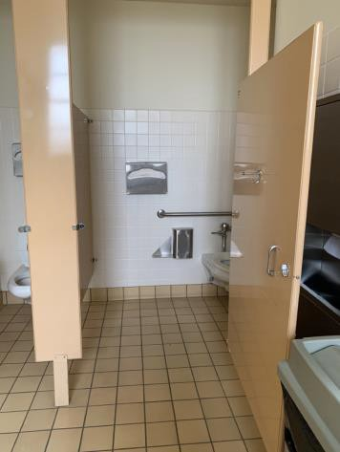

 | ID:  2204 | Facility:  Boise Depot

Location: Great Hall Women’s Restroom
Schedule: 2021
Estimated Cost: $100.00

Priority Score 8
Quick Fix: Yes
Built before ADA: Yes

VIOLATIONS
2010 ADA Standards for Accessible Design Codes §308.2.1
The hook is outside of the unobstructed forward reach range at 51.5" above the floor.

RECOMMENDATIONS
Lower the hook by 3.5" to meet the accessible reach range of 48" maximum above the floor.

PHOTOGRAPH(S) OF THIS LOCATION

 | ID:  2206 | Facility:  Boise Depot

Location: Great Hall Women’s Restroom
Schedule: 2021
Estimated Cost: $100.00

Priority Score 5
Quick Fix: Yes
Built before ADA: Yes

VIOLATIONS
2010 ADA Standards for Accessible Design Codes §604.7
The toilet paper dispenser is located out of the accessible reach range.

RECOMMENDATIONS
Remount the toilet paper dispenser to 7” minimum and 9” maximum in front of the water closet measured to the centerline of the dispenser.
The outlet of the dispenser shall be 15” minimum and 48” maximum above the floor and shall not be located behind.

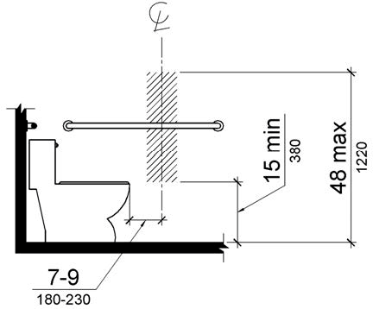

PHOTOGRAPH(S) OF THIS LOCATION

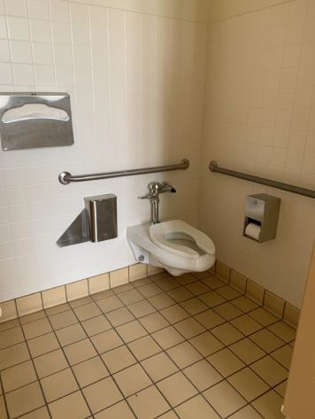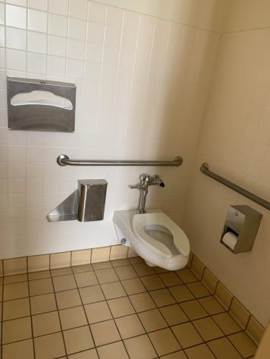

 | ID:  2209 | Facility:  Boise Depot

Location: Great Hall Women’s Restroom
Schedule: 2021
Estimated Cost: $100.00

Priority Score 3
Quick Fix: Yes
Built before ADA: Yes

VIOLATIONS
2010 ADA Standards for Accessible Design Codes §609.3, §308.2.1
The toilet seat covers are outside of the unobstructed forward reach range at 49.5" above the floor. The space between the grab bar and the toilet seat covers is 6.25".

RECOMMENDATIONS
Lower the toilet seat covers by 1.5" to meet the accessible reach range of 48" maximum above the floor.
Relocate the toilet seat covers to a location that is at least a distance of 12" or greater above the grab bar.

PHOTOGRAPH(S) OF THIS LOCATION

 | ID:  2210 | Facility:  Boise Depot

Location: Great Hall Women's Restroom
Schedule: 2021
Estimated Cost: $200.00

Priority Score 7
Quick Fix: Yes
Built before ADA: Yes

VIOLATIONS
2010 ADA Standards for Accessible Design Codes §606.5
The pipes under the sink are not covered.

RECOMMENDATIONS
Wrap the pipes beneath the sink with soft protective wrap or plastic.

PHOTOGRAPH(S) OF THIS LOCATION

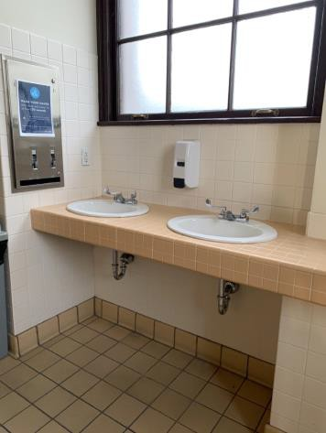

 | ID:  2207 | Facility:  Boise Depot

Location: Great Hall Women’s Restroom
Schedule: 2021
Estimated Cost: $500.00

Priority Score 5
Quick Fix: Yes
Built before ADA: Yes

VIOLATIONS
2010 ADA Standards for Accessible Design Codes §604.5.1
The side grab bar is located 6" from the rear wall.

RECOMMENDATIONS
Remount the side grab bar 12" maximum from the rear wall and extending 54" minimum from the rear wall.

PHOTOGRAPH(S) OF THIS LOCATION

 | ID:  2205 | Facility:  Boise Depot

Location: Great Hall Women’s Restroom
Schedule: 2022
Estimated Cost: $1,000.00

Priority Score 5
Quick Fix: No
Built before ADA: Yes

VIOLATIONS
2010 ADA Standards for Accessible Design Codes §604.2
The centerline of the toilet is located 18.5" from the sidewall.

RECOMMENDATIONS
Reposition the centerline of the toilet to be within 16" minimum and 18" maximum from the sidewall.

PHOTOGRAPH(S) OF THIS LOCATION

 | ID:  2211 | Facility:  Boise Depot

Location: Great Hall Women’s Restroom
Schedule: 2022
Estimated Cost: $1,000.00

Priority Score 5
Quick Fix: No
Built before ADA: Yes

VIOLATIONS
2010 ADA Standards for Accessible Design Codes §404.2.5
The threshold at the doorway exceeds the maximum allowable of 0.5".

RECOMMENDATIONS
Reduce the metal lip on the door to no more than 0.5" to 0.75" if beveled on each side.

PHOTOGRAPH(S) OF THIS LOCATION

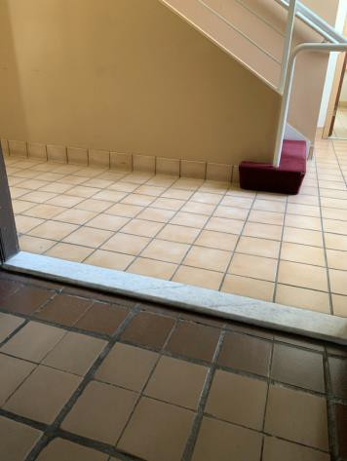

 | ID:  2244 | Facility:  Boise Depot

Location: International Festival and Events Association
Schedule: 2021
Estimated Cost: $300.00

Priority Score 3
Quick Fix: Yes
Built before ADA: Yes

VIOLATIONS
2010 ADA Standards for Accessible Design Codes §216.2, §703
There is no tactile sign identifying the permanent rooms.

RECOMMENDATIONS
Install tactile signage on the latch side of the doorway at a height of 48” minimum to 60” maximum above the floor, identifying room by name or room number.
Signs shall be Braille with raised lettering and should be placed on the wall in the center of an 18"x18" clear floor space.

PHOTOGRAPH(S) OF THIS LOCATION

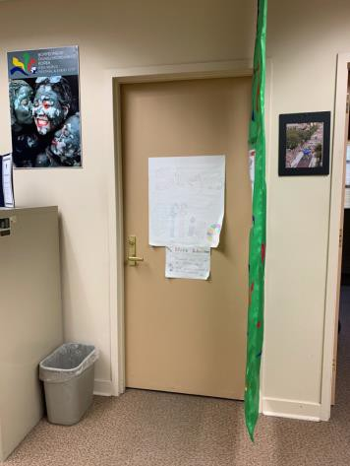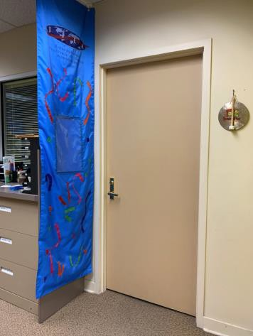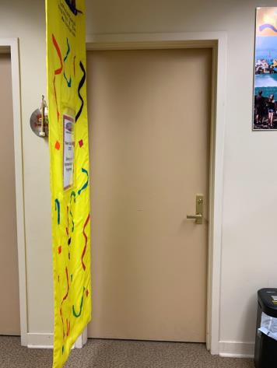

 | ID:  2245 | Facility:  Boise Depot

Location: International Festival and Events Association
Schedule: 2022
Estimated Cost: $1,000.00

Priority Score 6
Quick Fix: No
Built before ADA: Yes

VIOLATIONS
2010 ADA Standards for Accessible Design Codes §211.2, §602.7
There is only one drinking fountain provided at 35" above the floor.

RECOMMENDATIONS
Install an additional drinking fountain at a minimum spout height of 38" and maximum of 43" above the floor.

PHOTOGRAPH(S) OF THIS LOCATION

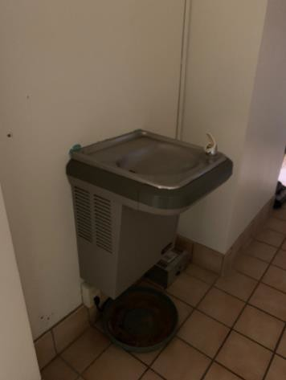

 | ID:  2235 | Facility:  Boise Depot

Location: International Festival and Events Association
Schedule: 2021
Estimated Cost: $1,000.00

Priority Score 4
Quick Fix: No
Built before ADA: Yes

VIOLATIONS
2010 ADA Standards for Accessible Design Codes §904.4.1
The counter is 42.75" above the floor.

RECOMMENDATIONS
A portion of the service counter must be no higher than 36" above the floor for a horizontal distance of 36".

PHOTOGRAPH(S) OF THIS LOCATION

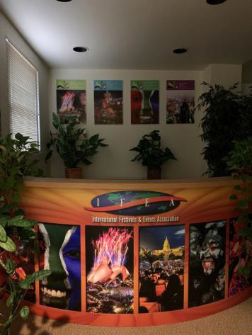

 | ID: | Facility:  Boise Depot

Location: International Festival and Events Association Kitchen
Schedule: 2021
Estimated Cost: $100.00

Priority Score 8
Quick Fix: Yes
Built before ADA: Yes

VIOLATIONS
2010 ADA Standards for Accessible Design Codes §308.2.1
The paper towel dispenser is outside of the unobstructed forward reach range at 52" above the floor.

RECOMMENDATIONS
Lower the paper towel dispenser by 4" to meet the accessible reach range of 48" maximum above the floor.

PHOTOGRAPH(S) OF THIS LOCATION

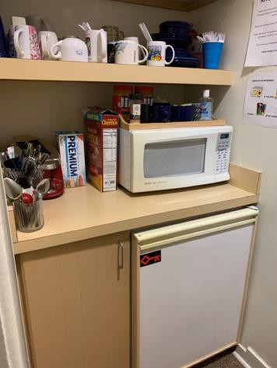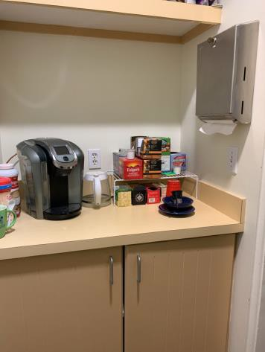

 | ID:  2242 | Facility:  Boise Depot

Location: International Festival and Events Association Kitchen
Schedule: 2023
Estimated Cost: $1,000.00

Priority Score 8
Quick Fix: No
Built before ADA: Yes

VIOLATIONS
2010 ADA Standards for Accessible Design Codes §902.3
The dining and work surface counter is 36" above the floor.

RECOMMENDATIONS
A 30" portion of the dining and work surface must be no higher than 34” above the floor.

PHOTOGRAPH(S) OF THIS LOCATION

 | ID:  2246 | Facility:  Boise Depot

Location: International Festival and Events Association Men’s Restroom
Schedule: 2021
Estimated Cost: $200.00:

Priority Score 7
Quick Fix: Yes
Built before ADA: Yes

VIOLATIONS
2010 ADA Standards for Accessible Design Codes §606.5
The pipes under the sinks are not covered.

RECOMMENDATIONS
Wrap the pipes beneath the sinks with soft protective wrap or plastic.

PHOTOGRAPH(S) OF THIS LOCATION

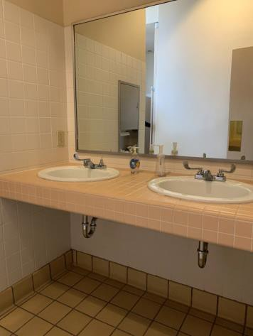

 | ID:  2250 | Facility:  Boise Depot

Location: International Festival and Events Association Men’s Restroom
Schedule: 2022
Estimated Cost: $1,000.00

Priority Score 5
Quick Fix: No
Built before ADA: Yes

VIOLATIONS
2010 ADA Standards for Accessible Design Codes §605.2
The urinals are 25" above the floor.

RECOMMENDATIONS
Lower at least one of the urinals to a maximum height of 17" above the floor.

PHOTOGRAPH(S) OF THIS LOCATION

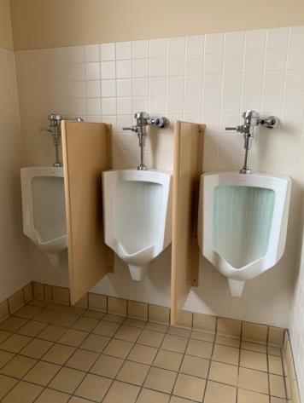

 | ID:  2248 | Facility:  Boise Depot

Location: International Festival and Events Association Men’s Restroom
Schedule: 2022
Estimated Cost: $5,000.00

Priority Score 7
Quick Fix: No
Built before ADA: Yes

VIOLATIONS
2010 ADA Standards for Accessible Design Codes §604.8.1.1
The toilet compartments are too small at 33.5" wide and 58" deep.

RECOMMENDATIONS
Combine the two non-accessible stalls into one 60" wide wheelchair accessible toilet stall, complying with §604.8.

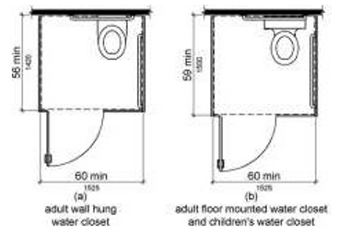

PHOTOGRAPH(S) OF THIS LOCATION

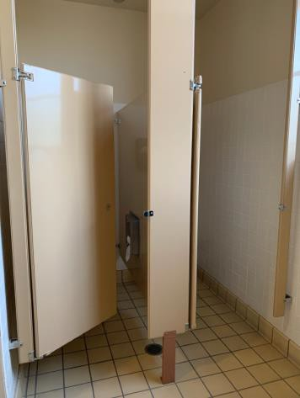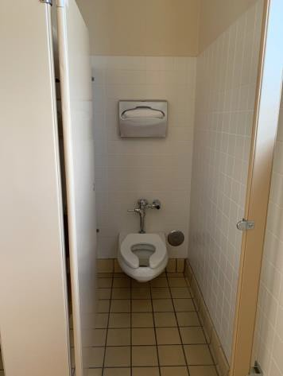

 | ID:  2239 | Facility:  Boise Depot

Location: International Festival and Events Association Women's Restroom
Schedule: 2021
Estimated Cost: $100.00

Priority Score 8
Quick Fix: Yes
Built before ADA: Yes

VIOLATIONS
2010 ADA Standards for Accessible Design Codes §308.2.1
The dispenser is outside of the unobstructed forward reach range at 51" above the floor.

RECOMMENDATIONS
Lower the dispenser by 3" to meet the accessible reach range of 48" maximum above the floor.

PHOTOGRAPH(S) OF THIS LOCATION

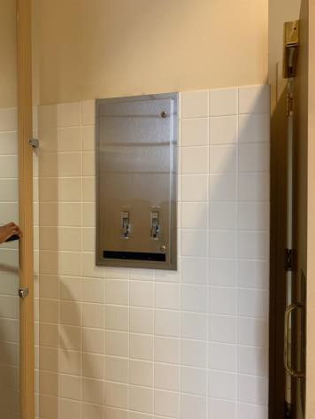

 | ID:  2241 | Facility:  Boise Depot

Location: International Festival and Events Association Women's Restroom
Schedule: 2021
Estimated Cost: $200.00

Priority Score 7
Quick Fix: Yes
Built before ADA: Yes

VIOLATIONS
2010 ADA Standards for Accessible Design Codes §606.5
The pipes under the sinks are not covered.

RECOMMENDATIONS
Wrap the pipes beneath the sinks with soft protective wrap or plastic.

PHOTOGRAPH(S) OF THIS LOCATION

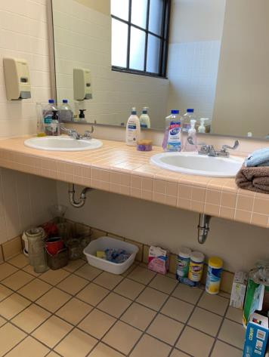

 | ID:  2237 | Facility:  Boise Depot

Location: International Festival and Events Association Women's Restroom
Schedule: 2022
Estimated Cost: $5,000.00

Priority Score 7
Quick Fix: No
Built before ADA: Yes

VIOLATIONS
2010 ADA Standards for Accessible Design Codes §604.8.1.1
The toilet compartments are too small at 33" wide and 58" deep.

RECOMMENDATIONS
Combine the two non-accessible stalls into one 60" wide wheelchair accessible toilet stall, complying with §604.8.

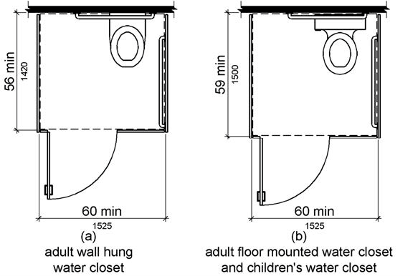

PHOTOGRAPH(S) OF THIS LOCATION

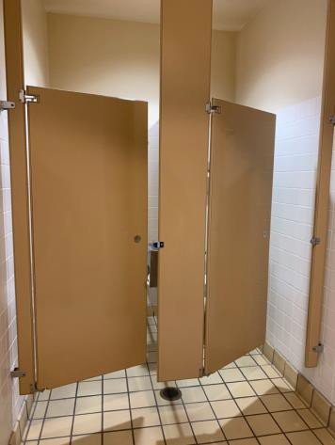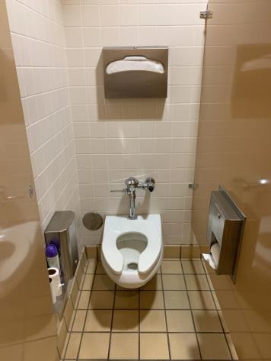

 | ID:  2421 | Facility:  Boise Depot

Location: Locomotive
Schedule: 2022
Estimated Cost: $1,000.00

Priority Score 5
Quick Fix: No
Built before ADA: Yes

VIOLATIONS
2010 ADA Standards for Accessible Design Codes §303.2
There is a 1" change in level at the numbers.

RECOMMENDATIONS
Resurface the pathway to reduce the change in level to less than 0.25" or 0.5" if beveled.

PHOTOGRAPH(S) OF THIS LOCATION

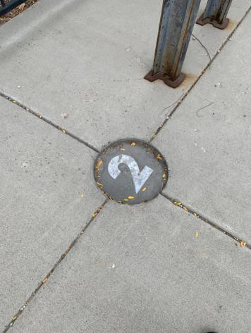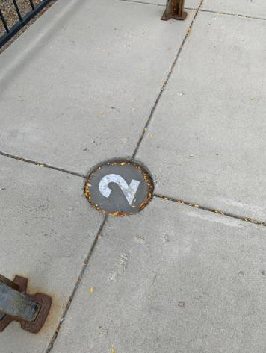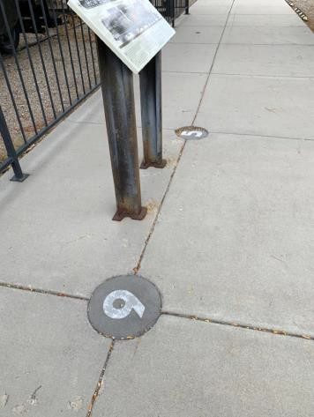

 | ID:  2422 | Facility:  Boise Depot

Location: Locomotive
Schedule: 2021
Estimated Cost: $1,000.00

Priority Score 3
Quick Fix: No
Built before ADA: Yes

VIOLATIONS
2010 ADA Standards for Accessible Design Codes §226.1, §902, §305, §306
The provided picnic table does not have an accessible clear space for a wheelchair user.

RECOMMENDATIONS
Add/replace picnic tables so that at least 5% of the seating is wheelchair accessible.
Ensure that the wheelchair accessible seating has a clear floor space of 30" x 48" with a slope not steeper than 2% and that the tables have sufficient knee and toe clearance.

PHOTOGRAPH(S) OF THIS LOCATION

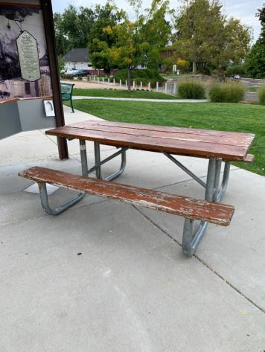

 | ID:  2423 | Facility:  Boise Depot

Location: Main Entrance Door
Schedule: 2021
Estimated Cost: $2,500.00

Priority Score 3
Quick Fix: No
Built before ADA: Yes

VIOLATIONS
2010 ADA Standards for Accessible Design Codes §404.2.4.4
The entrance has a 3.2% slope.

RECOMMENDATIONS
Reconstruct the entryway to reduce the running slope to a maximum of 2% in all directions for a distance of 60".

PHOTOGRAPH(S) OF THIS LOCATION

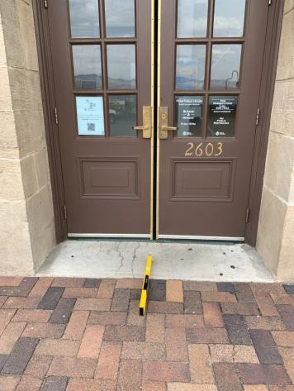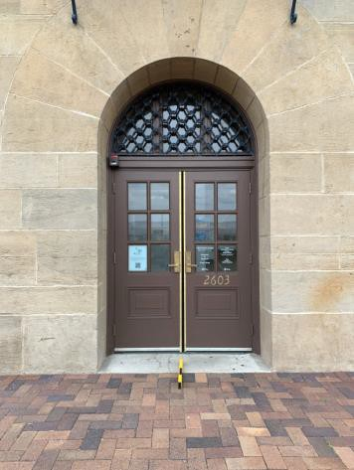

 | ID:  2216 | Facility:  Boise Depot

Location: Meeting Station
Schedule: 2021
Estimated Cost: $100.00

Priority Score 5
Quick Fix: Yes
Built before ADA: Yes

VIOLATIONS
2010 ADA Standards for Accessible Design Codes §307.2
The counter protrudes 20.5" into the circulation space at 32.5" above the floor.

RECOMMENDATIONS
Extend the sides of the counter down so the bottom edge is 27" maximum above the floor to provide cane detectability.

PHOTOGRAPH(S) OF THIS LOCATION

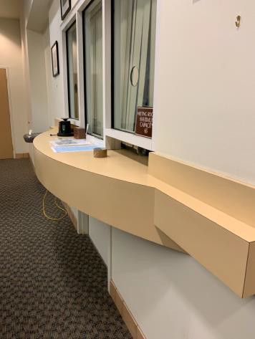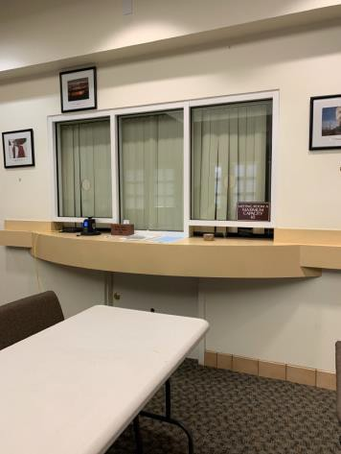

 | ID:  2215 | Facility:  Boise Depot

Location: Meeting Station
Schedule: 2022
Estimated Cost: $1,000.00

Priority Score 6
Quick Fix: No
Built before ADA: Yes

VIOLATIONS
2010 ADA Standards for Accessible Design Codes §211.2, §602.7
There is only one drinking fountain provided at 33.5" above the floor.

RECOMMENDATIONS
Install an additional drinking fountain at a minimum spout height of 38" and maximum of 43" above the floor.

PHOTOGRAPH(S) OF THIS LOCATION

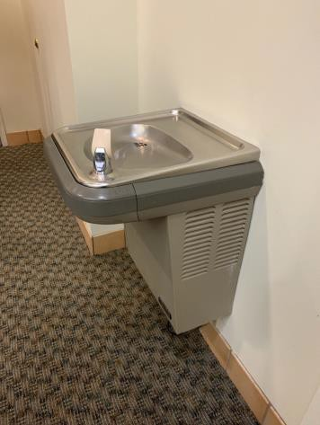

 | ID:  2230 | Facility:  Boise Depot

Location: Meeting Station Men’s Restroom
Schedule: 2021
Estimated Cost: $100.00

Priority Score 5
Quick Fix: Yes
Built before ADA: Yes

VIOLATIONS
2010 ADA Standards for Accessible Design Codes §604.7
The toilet paper dispenser is located out of the accessible reach range.

RECOMMENDATIONS
Remount the toilet paper dispenser to 7” minimum and 9” maximum in front of the water closet measured to the centerline of the dispenser.
The outlet of the dispenser shall be 15” minimum and 48” maximum above the floor and shall not be located

PHOTOGRAPH(S) OF THIS LOCATION

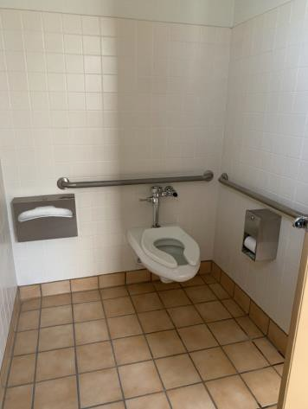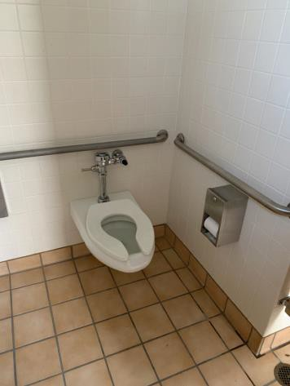

 | ID:  2231 | Facility:  Boise Depot

Location: Meeting Station Men’s Restroom
Schedule: 2021
Estimated Cost: $100.00

Priority Score 8
Quick Fix: Yes
Built before ADA: Yes

VIOLATIONS
2010 ADA Standards for Accessible Design Codes §308.2.1
The hook is outside of the unobstructed forward reach range at 60" above the floor.

RECOMMENDATIONS
Lower the hook by 12" to meet the accessible reach range of 48" maximum above the floor.

PHOTOGRAPH(S) OF THIS LOCATION

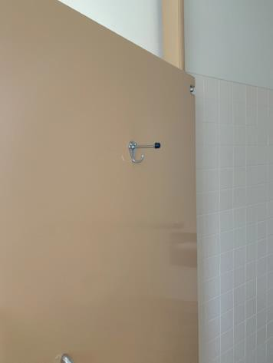

 | ID:  2226 | Facility:  Boise Depot

Location: Meeting Station Men’s Restroom
Schedule: 2022
Estimated Cost: $1,000.00

Priority Score 5
Quick Fix: No
Built before ADA: Yes

VIOLATIONS
2010 2010 ADA Standards for Accessible Design Codes §604.5.1
The side grab bar is located 4" from the rear wall and is 37" long.

RECOMMENDATIONS
Replace the side grab bar with one that is a minimum of 42" long minimum, located 12" maximum from the rear wall and extending 54" minimum from the rear wall.

PHOTOGRAPH(S) OF THIS LOCATION

 | ID:  2228 | Facility:  Boise Depot

Location: Meeting Station Men’s Restroom
Schedule: 2022
Estimated Cost: $1,000.00

Priority Score 5
Quick Fix: No
Built before ADA: Yes

VIOLATIONS
2010 ADA Standards for Accessible Design Codes ICC A117.1 §604.5.1
The accessible water closet does not have a vertical grab bar.

RECOMMENDATIONS
Install an 18" long (minimum) vertical grab bar on the side wall. The grab bar shall be mounted with the bottom located at 39" minimum and 41" maximum above the floor.
The centerline of the vertical grab bar shall be located 39" minimum and 41" maximum from the real wall.

PHOTOGRAPH(S) OF THIS LOCATION

 | ID:  2229 | Facility:  Boise Depot

Location: Meeting Station Men’s Restroom
Schedule: 2022
Estimated Cost: $1,000.00

Priority Score 5
Quick Fix: No
Built before ADA: Yes

VIOLATIONS
2010 ADA Standards for Accessible Design Codes §604.2, §604.4
The toilet is 20" above the floor.
The toilet is located 20.5" from the sidewall.

RECOMMENDATIONS
Lower the toilet seat to comply with the maximum height of 19” above the floor measured to the top of the seat.
Reposition the toilet to be within 16" minimum and 18" maximum from the sidewall.

PHOTOGRAPH(S) OF THIS LOCATION

 | ID:  2176 | Facility:  Boise Depot

Location: Meeting Station Parking
Schedule: 2021
Estimated Cost: $200.00

Priority Score 9
Quick Fix: Yes
Built before ADA: Yes

VIOLATIONS
2010 ADA Standards for Accessible Design Codes §502.6
The parking signs identifying the accessible parking space do not meet the minimum height requirement of 60" from the ground.

RECOMMENDATIONS
Remount the accessible parking signs at each accessible space at a minimum height of 60" above the ground.

PHOTOGRAPH(S) OF THIS LOCATION

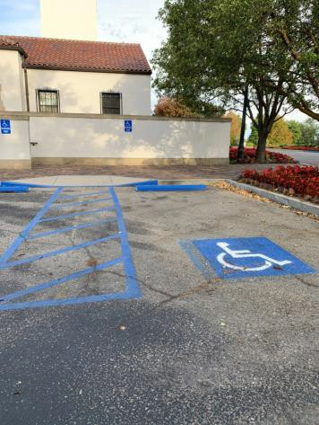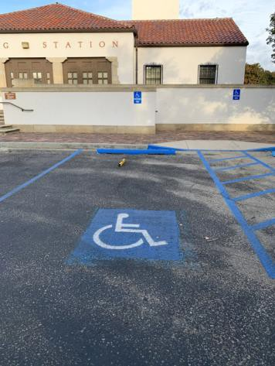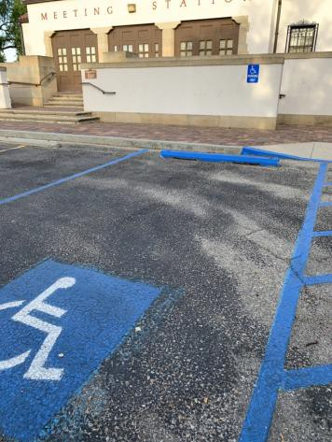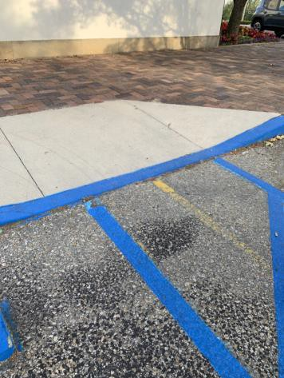

 | ID:  2179 | Facility:  Boise Depot

Location: Meeting Station Parking
Schedule: 2022
Estimated Cost: $1,000.00

Priority Score 7
Quick Fix: No
Built before ADA: Yes

VIOLATIONS
2010 ADA Standards for Accessible Design Codes §405.2
The running slope of the curb ramp is 8.8%.

RECOMMENDATIONS
Resurface the curb ramp to reduce the running slope to a maximum of 8.3%.

PHOTOGRAPH(S) OF THIS LOCATION

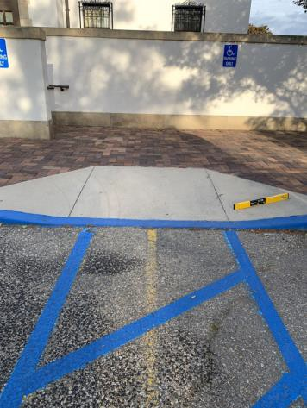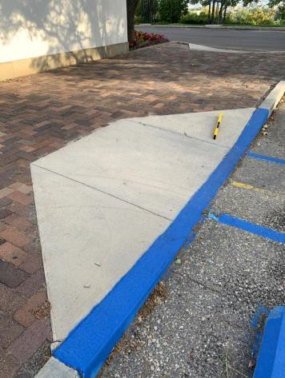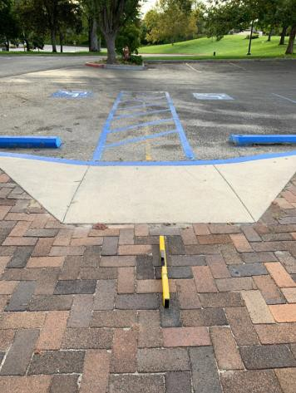

 | ID:  2178 | Facility:  Boise Depot

Location: Meeting Station Parking
Schedule: 2021
Estimated Cost: $1,000.00

Priority Score 2
Quick Fix: No
Built before ADA: Yes

VIOLATIONS
2010 ADA Standards for Accessible Design Codes §208.2.4
There are no marked "Van Accessible" spaces.

RECOMMENDATIONS
Install one 132" wide van accessible parking space. Add a “van accessible” parking sign at a minimum height of 60" above the ground.

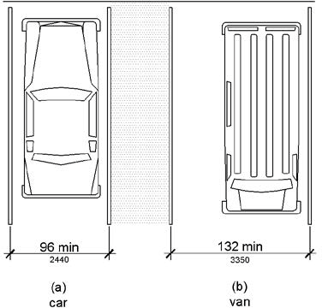

PHOTOGRAPH(S) OF THIS LOCATION

 | ID:  2175 | Facility:  Boise Depot

Location: Meeting Station Parking
Schedule: 2021
Estimated Cost: $2,000.00

Priority Score 3
Quick Fix: No
Built before ADA: Yes

VIOLATIONS
2010 ADA Standards for Accessible Design Codes §406.3
The curb ramp flares have slopes ranging from 10.6% to 12.2%.

RECOMMENDATIONS
Resurface the curb ramp flares to ensure a maximum slope of 10%.

PHOTOGRAPH(S) OF THIS LOCATION

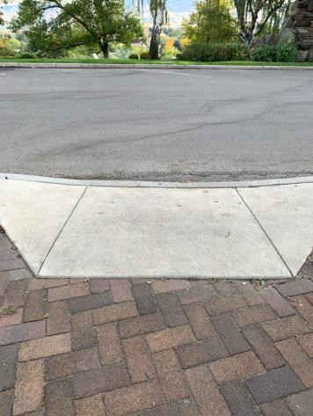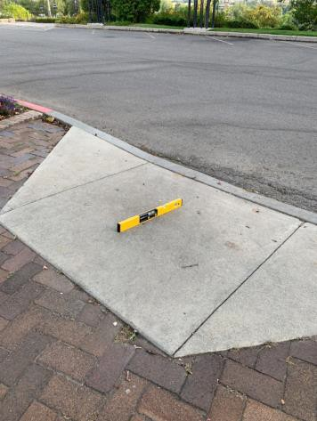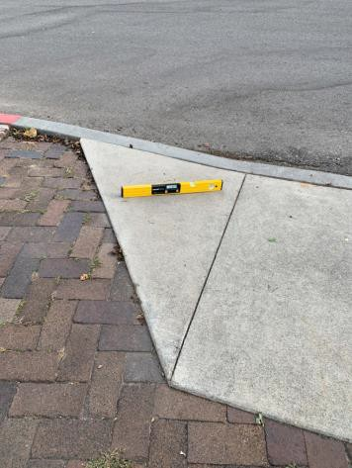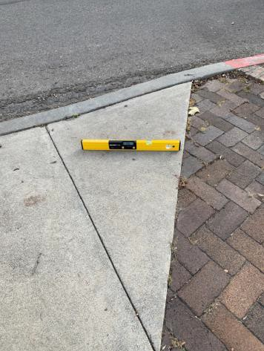

 | ID:  2177 | Facility:  Boise Depot

Location: Meeting Station Parking
Schedule: 2021
Estimated Cost: $2,000.00

Priority Score 3
Quick Fix: No
Built before ADA: Yes

VIOLATIONS
2010 ADA Standards for Accessible Design Codes §502.3, §502.4
The top of the parking space and access aisle has a 3.6% slope. The access aisle is 54" wide.

RECOMMENDATIONS
Repaint the accessible parking spaces and access aisles so that all accessible car parking spaces are a minimum of 96" wide, van parking spaces are a minimum of 132" wide, and their adjacent access aisles are a minimum of 60” wide. Resurface the parking space and access aisle to reduce the slope to a maximum of 2% in all directions.

PHOTOGRAPH(S) OF THIS LOCATION

 | ID:  2174 | Facility:  Boise Depot

Location: Meeting Station Parking
Schedule: 2022
Estimated Cost: $2,500.00

Priority Score 7
Quick Fix: No
Built before ADA: Yes

VIOLATIONS
2010 ADA Standards for Accessible Design Codes §405.2
The running slope of the curb ramp is 9.3%.

RECOMMENDATIONS
Reconstruct the curb ramp to reduce the running slope to a maximum of 8.3%.

PHOTOGRAPH(S) OF THIS LOCATION

 | ID:  2181 | Facility:  Boise Depot

Location: Meeting Station Parking
Schedule: 2021
Estimated Cost: $2,500.00

Priority Score 3
Quick Fix: No
Built before ADA: Yes

VIOLATIONS
2010 ADA Standards for Accessible Design Codes §405.7.1
The top landing has a 4.7% slope.

RECOMMENDATIONS
Reconstruct the top landing to have a maximum slope of 2% in all directions.

PHOTOGRAPH(S) OF THIS LOCATION

 | ID:  2180 | Facility:  Boise Depot

Location: Meeting Station Parking
Schedule: 2021
Estimated Cost: $5,000.00

Priority Score 3
Quick Fix: No
Built before ADA: Yes

VIOLATIONS
2010 ADA Standards for Accessible Design Codes §406.3
The curb ramp flares have a 13.9% and 16.1% slope.

RECOMMENDATIONS
Reconstruct the curb ramp flares to ensure a maximum slope of 10%.

PHOTOGRAPH(S) OF THIS LOCATION

 | ID:  2218 | Facility:  Boise Depot

Location: Meeting Station Women’s Restroom
Schedule: 2021
Estimated Cost: $100.00

Priority Score 5
Quick Fix: Yes
Built before ADA: Yes

VIOLATIONS
2010 ADA Standards for Accessible Design Codes §604.8.1.2
The door to the accessible water closet is not self closing. Either self-closing hinges are not installed on the door or if installed, they are defective.

RECOMMENDATIONS
Install or reinstall self-closing hinges on the door to ensure that the door is self-closing per the ADA requirements.

PHOTOGRAPH(S) OF THIS LOCATION

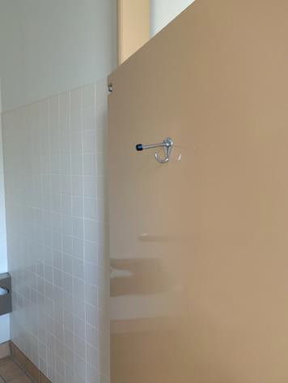

 | ID:  2219 | Facility:  Boise Depot

Location: Meeting Station Women’s Restroom
Schedule: 2021
Estimated Cost: $100.00

Priority Score 8
Quick Fix: Yes
Built before ADA: Yes

VIOLATIONS
2010 ADA Standards for Accessible Design Codes §308.2.1
The hook is outside of the unobstructed forward reach range at 59.5" above the floor.

RECOMMENDATIONS
Lower the hook by 11.5" to meet the accessible reach range of 15" minimum and 48" maximum above the floor.

PHOTOGRAPH(S) OF THIS LOCATION

 | ID:  2222 | Facility:  Boise Depot

Location: Meeting Station Women’s Restroom
Schedule: 2021
Estimated Cost: $100.00

Priority Score 5
Quick Fix: Yes
Built before ADA: Yes

VIOLATIONS
2010 ADA Standards for Accessible Design Codes §604.7
The toilet paper dispenser is located out of the accessible reach range.

RECOMMENDATIONS
Remount the toilet paper dispenser to 7” minimum and 9” maximum in front of the water closet measured to the centerline of the dispenser.
The outlet of the dispenser shall be 15” minimum and 48” maximum above the floor and shall not be located behind.

PHOTOGRAPH(S) OF THIS LOCATION

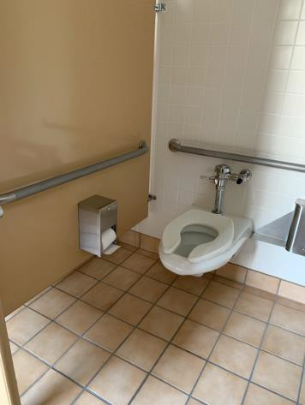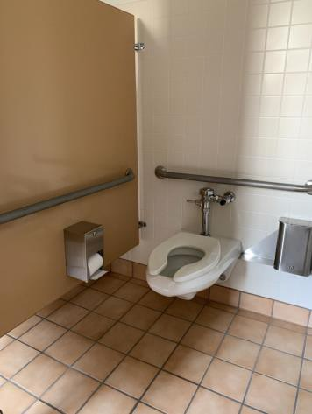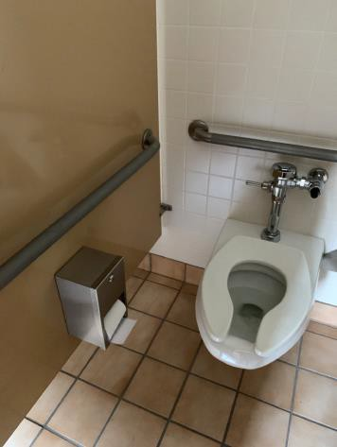

 | ID:  2223 | Facility:  Boise Depot

Location: Meeting Station Women’s Restroom
Schedule: 2021
Estimated Cost: $500.00

Priority Score 5
Quick Fix: Yes
Built before ADA: Yes

VIOLATIONS
2010 ADA Standards for Accessible Design Codes §604.5.2
The rear grab bar is located 11" to the center of the toilet.

RECOMMENDATIONS
Remount the rear grab bar 12" from the centerline of the water closet minimum on one side and 24" minimum on the other.

PHOTOGRAPH(S) OF THIS LOCATION

 | ID:  2224 | Facility:  Boise Depot

Location: Meeting Station Women’s Restroom
Schedule: 2021
Estimated Cost: $500.00

Priority Score 5
Quick Fix: Yes
Built before ADA: Yes

VIOLATIONS
2010 ADA Standards for Accessible Design Codes §604.5.1
The side grab bar is located 6" from the rear wall.

RECOMMENDATIONS
Remount the side grab bar 12" maximum from the rear wall and extending 54" minimum from the rear wall.

PHOTOGRAPH(S) OF THIS LOCATION

 | ID:  2220 | Facility:  Boise Depot

Location: Meeting Station Women’s Restroom
Schedule: 2022
Estimated Cost: $1,000.00

Priority Score 5
Quick Fix: No
Built before ADA: Yes

VIOLATIONS
2010 ADA Standards for Accessible Design Codes §604.6
The flush control is located on the wall side of the toilet.

RECOMMENDATIONS
Either make the toilet flush automatically or relocate the flush control to be operated on the open side of the toilet.

PHOTOGRAPH(S) OF THIS LOCATION

 | ID:  2221 | Facility:  Boise Depot

Location: Meeting Station Women’s Restroom
Schedule: 2022
Estimated Cost: $1,000.00

Priority Score 5
Quick Fix: No
Built before ADA: Yes

VIOLATIONS
2010 ADA Standards for Accessible Design Codes §604.2, §604.4
The toilet is 20" above the floor.
The toilet is located 20.5" from the sidewall.

RECOMMENDATIONS
Lower the toilet seat to comply with the maximum height of 19” above the floor measured to the top of the seat.
Reposition the toilet to be within 16" minimum and 18" maximum from the sidewall.

PHOTOGRAPH(S) OF THIS LOCATION

 | ID:  2225 | Facility:  Boise Depot

Location: Meeting Station Women’s Restroom
Schedule: 2022
Estimated Cost: $1,000.00

Priority Score 5
Quick Fix: No
Built before ADA: Yes

VIOLATIONS
2010 ADA Standards for Accessible Design Codes ICC A117.1 §604.5.1
The accessible water closet does not have a vertical grab bar.

RECOMMENDATIONS
Install an 18" long (minimum) vertical grab bar on the side wall. The grab bar shall be mounted with the bottom located at 39" minimum and 41" maximum above the floor.
The centerline of the vertical grab bar shall be located 39" minimum and 41" maximum from the real wall.

PHOTOGRAPH(S) OF THIS LOCATION

 | ID:  2435 | Facility:  Boise Depot

Location: Parking
Schedule: 2021
Estimated Cost: $100.00

Priority Score 9
Quick Fix: Yes
Built before ADA: Yes

VIOLATIONS
2010 ADA Standards for Accessible Design Codes §502.6
The signage present identifying the accessible parking spaces is not centered.

RECOMMENDATIONS
Install an accessible parking sign at each accessible space at a minimum height of 60" above the ground centered to the parking space.

PHOTOGRAPH(S) OF THIS LOCATION

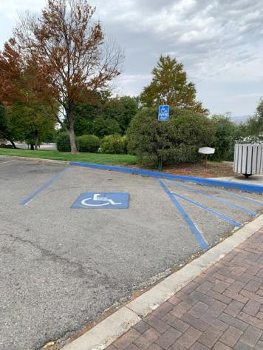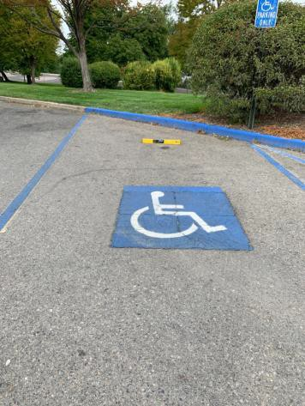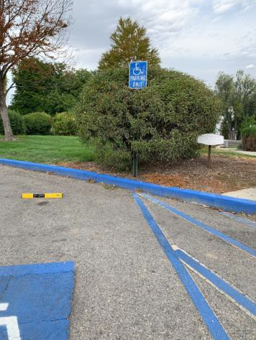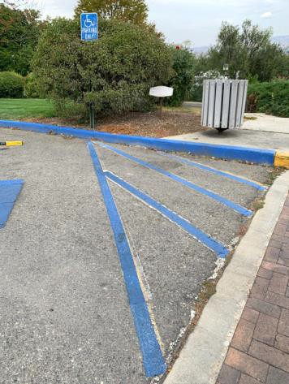

 | ID:  2432 | Facility:  Boise Depot

Location: Parking
Schedule: 2022
Estimated Cost: $1,000.00

Priority Score 7
Quick Fix: No
Built before ADA: Yes

VIOLATIONS
2010 ADA Standards for Accessible Design Codes §502.4
The parking space has a 2.1% cross slope.

RECOMMENDATIONS
Resurface the parking space to reduce the slope to a maximum of 2% in all directions.

PHOTOGRAPH(S) OF THIS LOCATION

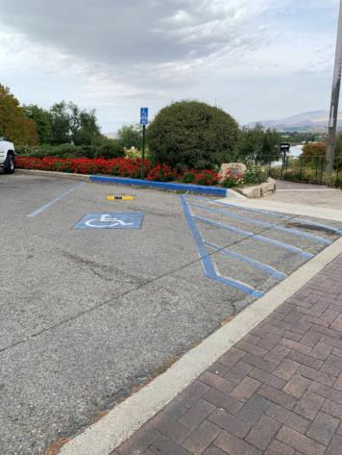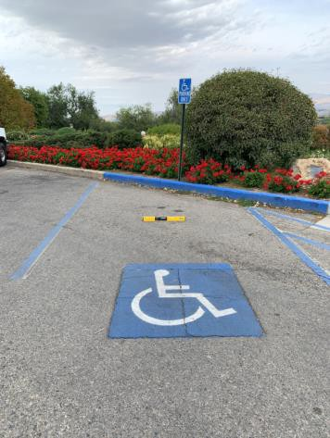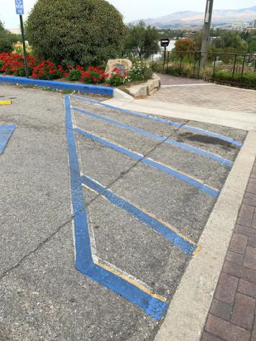

 | ID:  2431 | Facility:  Boise Depot

Location: Parking
Schedule: 2021
Estimated Cost: $1,000.00

Priority Score 3
Quick Fix: No
Built before ADA: Yes

VIOLATIONS
2010 ADA Standards for Accessible Design Codes §502.3.2
The access aisle does not run the full length of the accessible parking space and is not 60" wide for the entire length.

RECOMMENDATIONS
Install access aisles connecting the accessible parking spaces to an accessible route. Two parking spaces shall be permitted to share a common access aisle.
Each access aisle shall be 60” wide for the entire length.

PHOTOGRAPH(S) OF THIS LOCATION

 | ID:  2434 | Facility:  Boise Depot

Location: Parking
Schedule: 2021
Estimated Cost: $1,000.00

Priority Score 2
Quick Fix: No
Built before ADA: Yes

VIOLATIONS
2010 ADA Standards for Accessible Design Codes §208.2.4
There are no marked "Van Accessible" spaces.

RECOMMENDATIONS
Install one 132" wide van accessible parking space. Add a “van accessible” parking sign at a minimum height of 60" above the ground.

PHOTOGRAPH(S) OF THIS LOCATION

 | ID:  2436 | Facility:  Boise Depot

Location: Parking
Schedule: 2021
Estimated Cost: $1,000.00

Priority Score 3
Quick Fix: No
Built before ADA: Yes

VIOLATIONS
2010 ADA Standards for Accessible Design Codes §502.3.2
The access aisle does not run the full length of the accessible parking space and is not 60" wide for the entire length.

RECOMMENDATIONS
Install access aisles connecting the accessible parking spaces to an accessible route. Two parking spaces shall be permitted to share a common access aisle.
Each access aisle shall be 60” wide for the entire length.

PHOTOGRAPH(S) OF THIS LOCATION

 | ID:  2437 | Facility:  Boise Depot

Location: Parking
Schedule: 2021
Estimated Cost: $1,000.00

Priority Score 3
Quick Fix: No
Built before ADA: Yes

VIOLATIONS
2010 ADA Standards for Accessible Design Codes §502.4
The parking space has a 2.6% slope.

RECOMMENDATIONS
Resurface the parking space to reduce the slope to a maximum of 2% in all directions.

PHOTOGRAPH(S) OF THIS LOCATION

 | ID:  2173 | Facility:  Boise Depot

Location: Roadway leading to Meeting Station Parking
Schedule: 2022
Estimated Cost: $1,000.00

Priority Score 7
Quick Fix: No
Built before ADA: Yes

VIOLATIONS
2010 ADA Standards for Accessible Design Codes §705
The curb ramps do not have detectable warnings.

RECOMMENDATIONS
Install detectable warnings that contrast visually with the adjacent surface with either light-on-dark, or dark-on-light, are the width of the curb ramp, and have a depth of 24".

PHOTOGRAPH(S) OF THIS LOCATION

