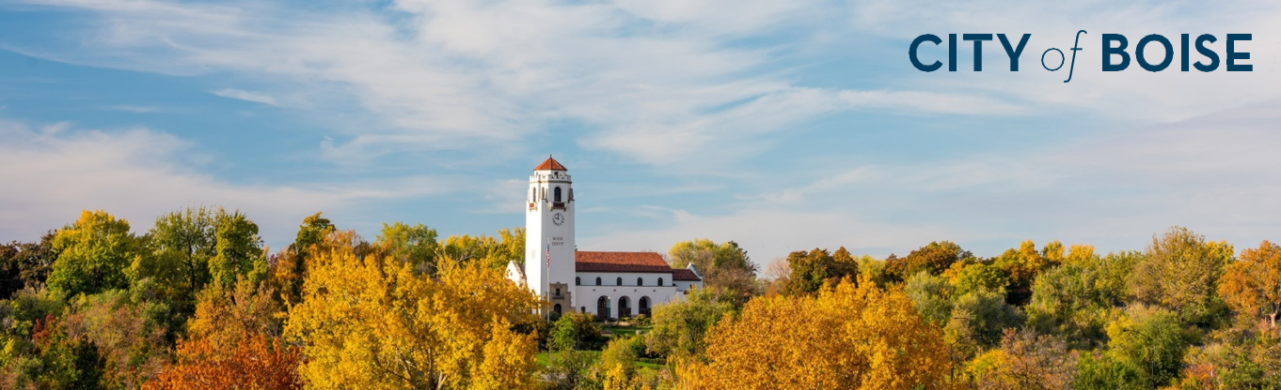

FACILITIES REMEDIATION PLAN

This draft remediation schedule outlines how the city will address the 2,381 barriers to access that were identified by a consultant. The methodology used to create the schedule included: was developed with community feedback regarding prioritization, alignment with current and future construction or remodeling projects; maximizing dollars and labor costs; and staff capacity.
As this plan is currently drafted, projects will begin in 2022 with projected completion of all remediations by end of year 2028.
COMMON BARRIERS | PROJECT STATUS
The most common barriers found include:  - Civil barriers (slopes of pedestrian pathways, curb ramps, parking, etc.)  - Architectural barriers (reach range, knee clearance, counter height, etc.)  - Bathroom deficiencies (uncovered pipes under sinks, missing grab bars, lack of self-closing doors, etc.)  - Cane detection not provided for protruding objects in pathways  - Signage not containing tactile and braille components | Many violations listed in this draft will be remedied by incorporating them into a future project, particularly for Zoo Boise they will be undergoing major renovations over the next few years.  Because the Boise Airport, Water Renewal facilities, and 20 Mile South Farm are not funded by community dollars (general funds, “G”), these remediations are broken out to reflect their separate funding sources. This is then reflected in the “Cumulative Running Total.”  Currently, 49 projects have status as “Viability?” This is due to a variety of environmental and structural factors that may be unique to each facility. For example, Zoo Boise lies on a flood plain which can cause cross and running slopes of paths to settle at unpredictable levels. Additionally, multiple facilities have interactive kiosks that are missing audio and tactile components. This will require additional research to locate a compliant kiosk manufacturer for each program’s needs. All violations marked as “Viability?” will need to be individually investigated for possible remediation.  As labor and material costs significantly fluctuate, staff have built in contingency funds each year to remain proactive in achieving full and barrier-free access on schedule as much as possible.  As of Spring 2022, 573 identified violations have been remedied or currently in progress. These violations have thus been removed from the schedule.

