City of Boise ADA Assessment

Appendix A –Library! Capitol

10/28/2020
Report #TO20-B001

Prepared by:
 | ID:  1258 | Facility:  Capitol Library

Location: Crosswalk by Book Returns
Schedule: 2021
Estimated Cost: $0.00

Priority Score 8
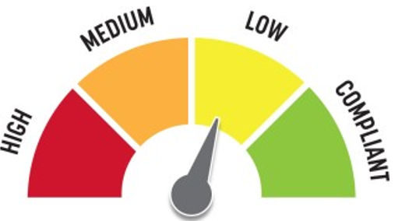
Quick Fix: Yes
Built before ADA: Yes

VIOLATIONS
2010 ADA Standards for Accessible Design Codes: §405
The pedestrian push button is located 43.5" above the floor. There is a step up adjacent to a ramped surface.

RECOMMENDATIONS
The reach range is accessible, however, for purposes of achieving greater accessibility, relocate the pedestrian push button to be adjacent to a level area.
If the accessible parking space is relocated, this improvement is not required unless requested by an employee with a disability.

PHOTOGRAPH(S) OF THIS LOCATION

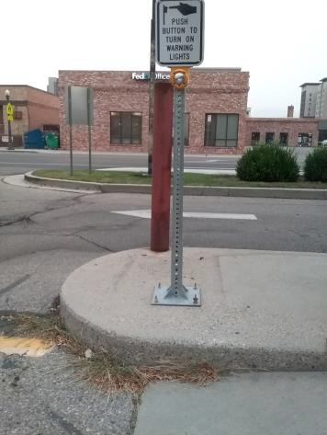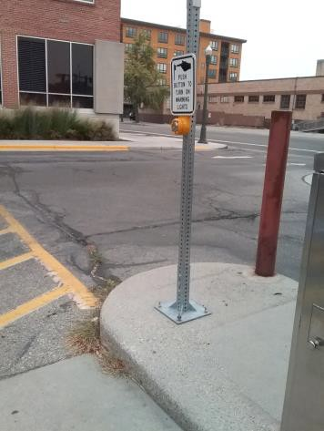

 | ID:  1086 | Facility:  Capitol Library

Location: 1st Floor Hays Auditorium Women's Restroom
Schedule: 2023
Estimated Cost: $100.00

Priority Score 10
Quick Fix: Yes
Built before ADA: Yes

VIOLATIONS
2010 ADA Standards for Accessible Design Codes: §307.2
The sharps container protrudes 4.75" into the circulation path at 38" above the floor.

RECOMMENDATIONS
Recess the sharps container so it protrudes a maximum of 4", lower it so the bottom edge is 27" maximum above the floor, or place a cane- detectable object beneath it.

PHOTOGRAPH(S) OF THIS LOCATION

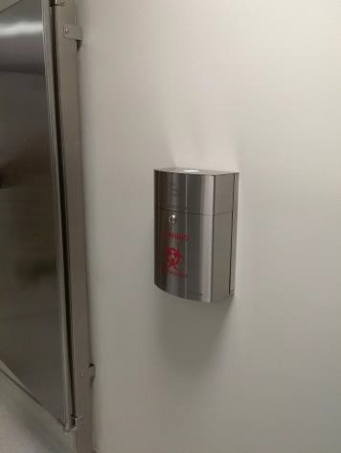

 | ID:  1087 | Facility:  Capitol Library

Location: 1st Floor Hays Auditorium Women's Restroom
Schedule: 2023
Estimated Cost: $100.00

Priority Score 10
Quick Fix: Yes
Built before ADA: Yes

VIOLATIONS
2010 ADA Standards for Accessible Design Codes: §307.2
The dispenser protrudes 5.75" into the circulation path at 35" above the floor.

RECOMMENDATIONS
Recess the dispenser so it protrudes a maximum of 4", lower it so the bottom edge is 27" maximum above the floor, or place a cane-detectable object beneath it.

PHOTOGRAPH(S) OF THIS LOCATION

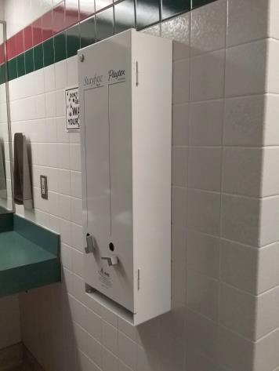

 | ID:  1095 | Facility:  Capitol Library

Location: 1st Floor Youth Services Staff Workroom
Schedule: 2023
Estimated Cost: $100.00

Priority Score 10
Quick Fix: Yes
Built before ADA: Yes

VIOLATIONS
2010 ADA Standards for Accessible Design Codes: §307.2
The paper towel dispenser protrudes 9" into the circulation path at 40" above the floor.

RECOMMENDATIONS
Recess the dispenser so it protrudes a maximum of 4", lower it so the bottom edge is 27" maximum above the floor, or place a cane-detectable object beneath it.

PHOTOGRAPH(S) OF THIS LOCATION

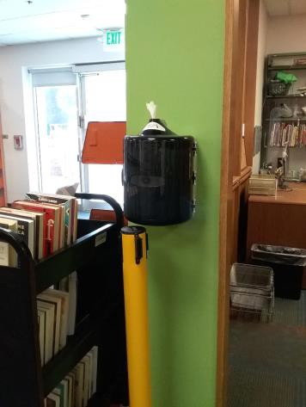

 | ID:  1105 | Facility:  Capitol Library

Location: 1st Floor Mail Room
Schedule: 2023
Estimated Cost: $100.00

Priority Score 8
Quick Fix: Yes
Built before ADA: Yes

VIOLATIONS
2010 ADA Standards for Accessible Design Codes: §308.2.1
The hangers are outside of the unobstructed forward reach range at 64" above the floor.

RECOMMENDATIONS
Lower the hangers by 16" to meet the accessible reach range of 15" minimum and 48" maximum above the floor. Or add a secondary lower railing located within the accessible reach range.

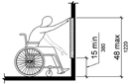

PHOTOGRAPH(S) OF THIS LOCATION

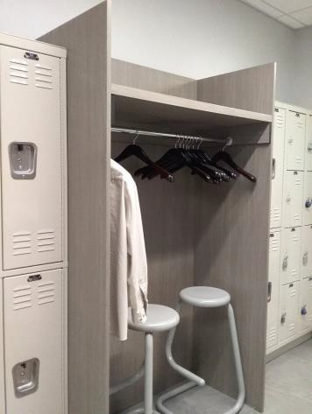

 | ID:  2212 | Facility:  Capitol Library

Location: 3rd Floor Women's Restroom
Schedule: 2023
Estimated Cost: $100.00

Priority Score 8
Quick Fix: Yes
Built before ADA: Yes

VIOLATIONS
2010 ADA Standards for Accessible Design Codes: §308.2.1
The hook is outside of the unobstructed forward reach range at 63" above the floor.

RECOMMENDATIONS
Lower the hook by 15" to meet the accessible reach range of 48" maximum above the floor.

PHOTOGRAPH(S) OF THIS LOCATION

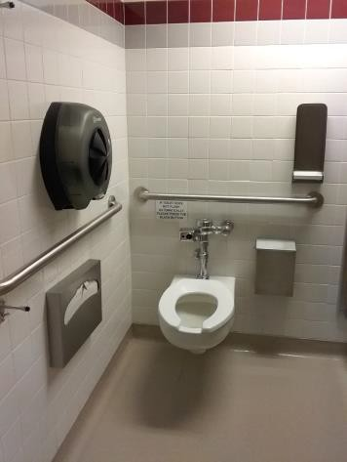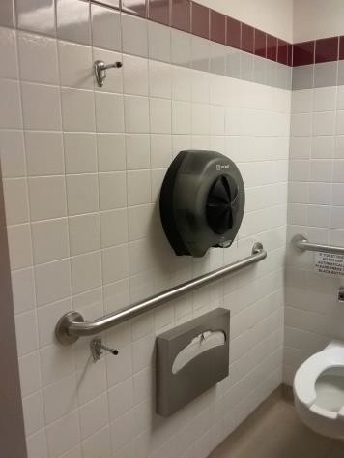

 | ID:  1131 | Facility:  Capitol Library

Location: 3rd Floor All Users Restroom
Schedule: 2023
Estimated Cost: $100.00

Priority Score 8
Quick Fix: Yes
Built before ADA: Yes

VIOLATIONS
2010 ADA Standards for Accessible Design Codes: §308.2.2
The hooks are outside of the obstructed forward reach range at 64" above the floor.

RECOMMENDATIONS
Lower the hooks by 16" to meet the accessible reach range of 15" minimum and 48" maximum above the floor.

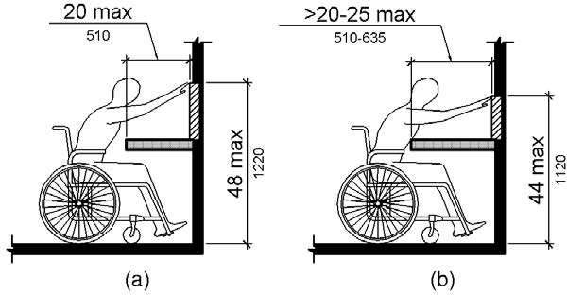

PHOTOGRAPH(S) OF THIS LOCATION

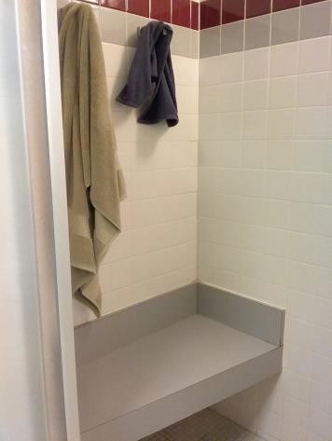

 | ID:  1146 | Facility:  Capitol Library

Location: 3rd Floor All Users Restroom
Schedule: 2023
Estimated Cost: $100.00

Priority Score 8
Quick Fix: Yes
Built before ADA: Yes

VIOLATIONS
2010 ADA Standards for Accessible Design Codes: §308.2.1
The hooks are outside of the unobstructed forward reach range at 52" above the floor.

RECOMMENDATIONS
Lower the hooks by 4" to meet the accessible reach range of 15" minimum and 48" maximum above the floor.

PHOTOGRAPH(S) OF THIS LOCATION

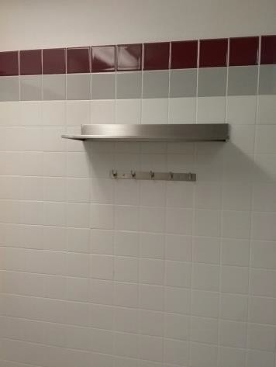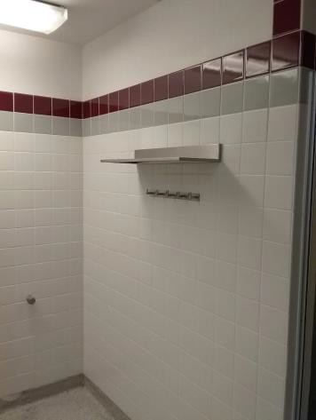

 | ID:  1161 | Facility:  Capitol Library

Location: 4th Floor Kitchen
Schedule: 2023
Estimated Cost: $100.00

Priority Score 8
Quick Fix: Yes
Built before ADA: Yes

VIOLATIONS
2010 ADA Standards for Accessible Design Codes: §308.2.2
The paper towel dispenser is outside of the obstructed forward reach range at 58" above the floor.

RECOMMENDATIONS
Lower the paper towel dispenser by 10" to meet the accessible reach range of 15" minimum and 48" maximum above the floor.

PHOTOGRAPH(S) OF THIS LOCATION

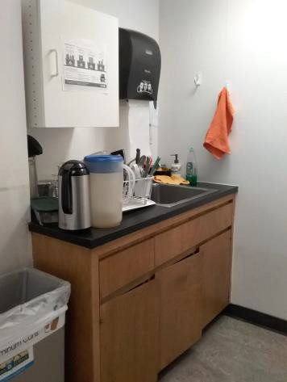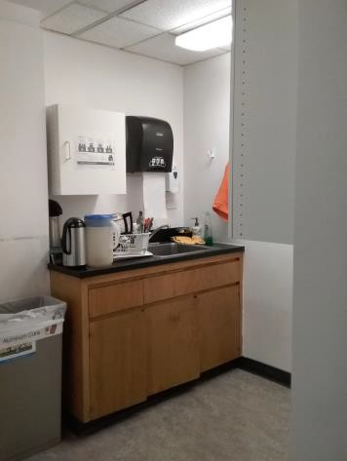

 | ID:  1168 | Facility:  Capitol Library

Location: 4th Floor Women's Ambulatory Restroom
Schedule: 2023
Estimated Cost: $100.00

Priority Score 8
Quick Fix: Yes
Built before ADA: Yes

VIOLATIONS
2010 ADA Standards for Accessible Design Codes: §308.2.1
The hook is outside of the unobstructed forward reach range at 69" above the floor.

RECOMMENDATIONS
Lower the hook by 21" to meet the accessible reach range of 15" minimum and 48" maximum above the floor.

PHOTOGRAPH(S) OF THIS LOCATION

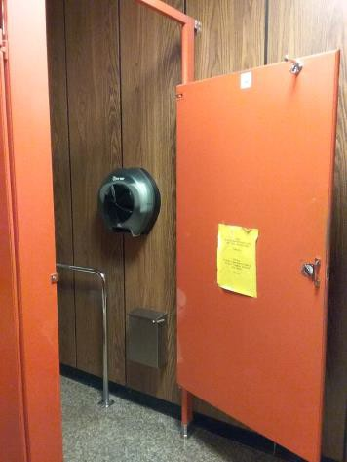

 | ID:  1173 | Facility:  Capitol Library

Location: 4th Floor Women's Ambulatory Restroom
Schedule: 2023
Estimated Cost: $100.00

Priority Score 8
Quick Fix: Yes
Built before ADA: Yes

VIOLATIONS
2010 ADA Standards for Accessible Design Codes: §308.2.1
The hook is outside of the unobstructed forward reach range at 50.75" above the floor.

RECOMMENDATIONS
Lower the hook by 2.75" to meet the accessible reach range of 15" minimum and 48" maximum above the floor.

PHOTOGRAPH(S) OF THIS LOCATION

 | ID:  1181 | Facility:  Capitol Library

Location: 2nd Floor Men's Restroom
Schedule: 2023
Estimated Cost: $100.00

Priority Score 8
Quick Fix: Yes
Built before ADA: Yes

VIOLATIONS
2010 ADA Standards for Accessible Design Codes: §308.2.1
The hooks are outside of the unobstructed forward reach range at 63.5" above the floor.

RECOMMENDATIONS
Lower the hooks by 15.5" or install a secondary lower hook to meet the accessible reach range of 15" minimum and 48" maximum above the floor.

PHOTOGRAPH(S) OF THIS LOCATION

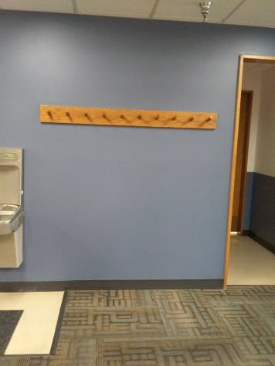

 | ID:  1188 | Facility:  Capitol Library

Location: 4th Floor Staff Break Room Vending Machine
Schedule: 2023
Estimated Cost: $100.00

Priority Score 8
Quick Fix: Yes
Built before ADA: Yes

VIOLATIONS
2010 ADA Standards for Accessible Design Codes: §308.2.1
The payment controls on the vending machine are outside of the unobstructed forward reach range at 52" above the floor.

RECOMMENDATIONS
Replace the vending machine with one that has controls located within the accessible reach range of 15" minimum and 48" maximum above the floor.

PHOTOGRAPH(S) OF THIS LOCATION

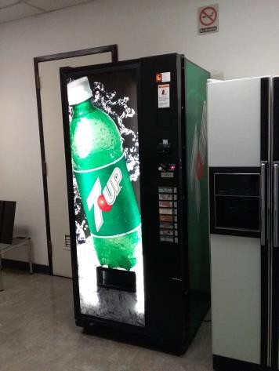

 | ID:  1226 | Facility:  Capitol Library

Location: 3rd Floor Comments Box
Schedule: 2023
Estimated Cost: $100.00

Priority Score 8
Quick Fix: Yes
Built before ADA: Yes

VIOLATIONS
2010 ADA Standards for Accessible Design Codes: §308.2.2
The comments box is outside of the obstructed forward reach range at 58" above the floor.

RECOMMENDATIONS
Lower the comments box by 10" to meet the accessible reach range of 15" minimum and 48" maximum above the floor.

PHOTOGRAPH(S) OF THIS LOCATION

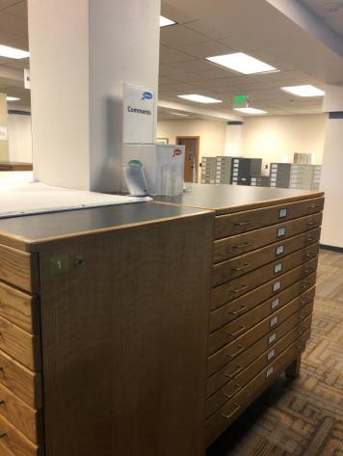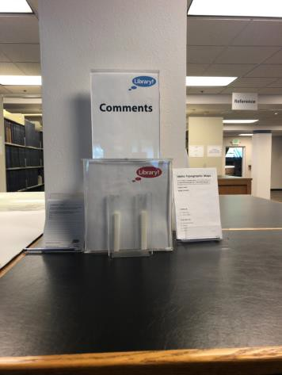

 | ID:  1245 | Facility:  Capitol Library

Location: SW of the Library Building
Schedule: 2023
Estimated Cost: $100.00

Priority Score 9
Quick Fix: Yes
Built before ADA: Yes

VIOLATIONS
2010 ADA Standards for Accessible Design Codes: §502.6
One parking space is missing the signage identifying the accessible parking spaces. The parking space is located near Idaho Anne Frank Human Rights Memorial.

RECOMMENDATIONS
Install an accessible parking sign at each accessible space at a minimum height of 60" above the ground.

PHOTOGRAPH(S) OF THIS LOCATION

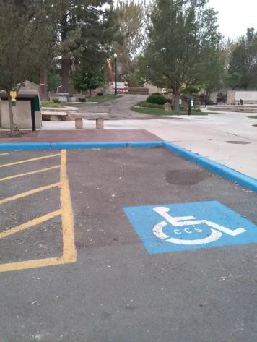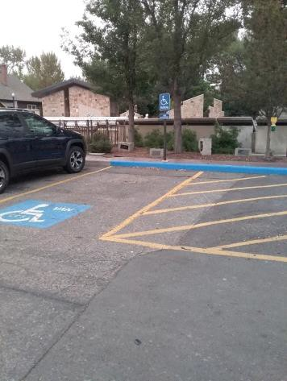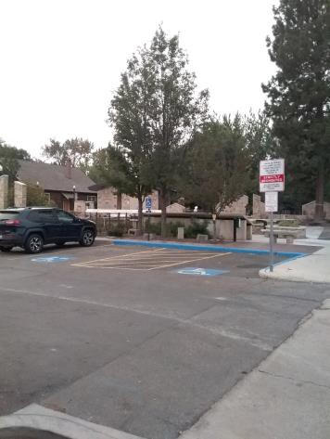

 | ID:  1249 | Facility:  Capitol Library

Location: SW of the Library Building
Schedule: 2023
Estimated Cost: $100.00

Priority Score 9
Quick Fix: Yes
Built before ADA: Yes

VIOLATIONS
2010 ADA Standards for Accessible Design Codes: §502.6
The accessible parking sign is 56.5" above the ground. The parking space is located by Idaho Anne Frank Human Rights Memorial.

RECOMMENDATIONS
Remount the accessible parking sign at the accessible space at a minimum height of 60" above the ground.

PHOTOGRAPH(S) OF THIS LOCATION

 | ID:  1262 | Facility:  Capitol Library

Location: Parking by Book Returns
Schedule: 2023
Estimated Cost: $100.00

Priority Score 9
Quick Fix: Yes
Built before ADA: Yes

VIOLATIONS
2010 ADA Standards for Accessible Design Codes: §502.6
The sign is 29.5" above the ground.

RECOMMENDATIONS
Remount the accessible parking sign at each accessible space at a minimum height of 60" above the ground.

PHOTOGRAPH(S) OF THIS LOCATION

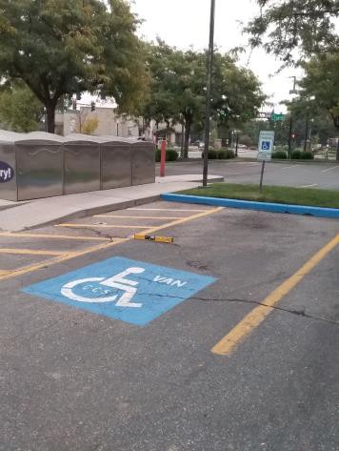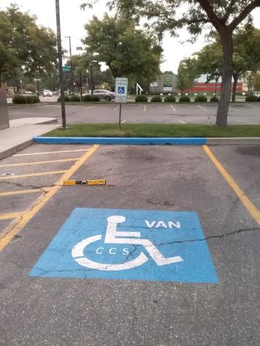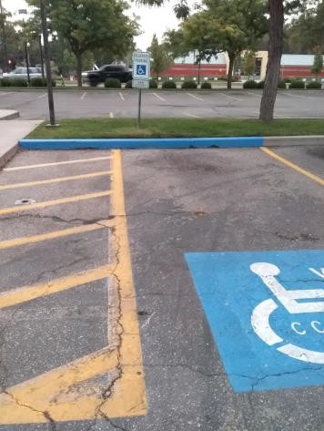

 | ID:  1079 | Facility:  Capitol Library

Location: 1st Floor Book Return
Schedule: 2022
Estimated Cost: $100.00

Priority Score 5
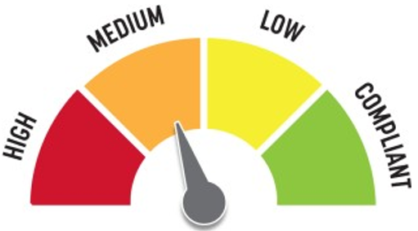
Quick Fix: Yes
Built before ADA: Yes

VIOLATIONS
2010 ADA Standards for Accessible Design Codes: §307.2
The shelf protrudes 8" into the circulation space at 28" above the floor.

RECOMMENDATIONS
Lower the shelf by 1" to 27" maximum above the floor, or provide cane detectability by placing an object underneath both ends of the counter.

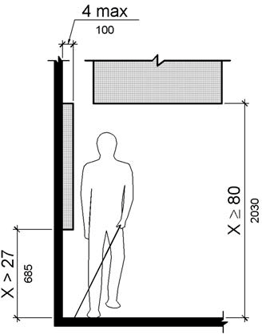

PHOTOGRAPH(S) OF THIS LOCATION

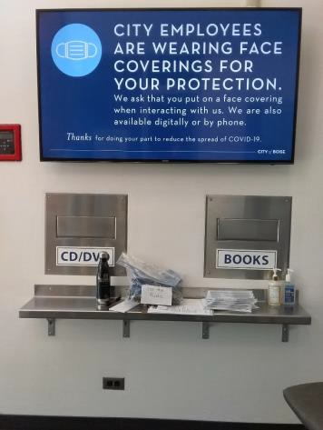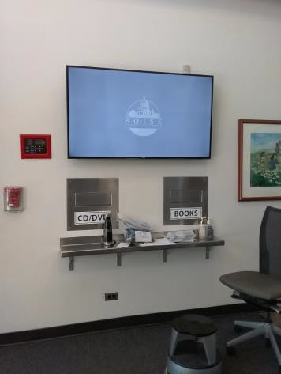

 | ID:  1080 | Facility:  Capitol Library

Location: 1st Floor Lobby
Schedule: 2022
Estimated Cost: $100.00

Priority Score 5
Quick Fix: Yes
Built before ADA: Yes

VIOLATIONS
2010 ADA Standards for Accessible Design Codes: §307.2
The charging station protrudes 4.5" into the circulation space at 38" above the floor.

RECOMMENDATIONS
Reduce the protrusion depth to a maximum of 4” by recessing it or provide cane detectability by placing an object underneath.

PHOTOGRAPH(S) OF THIS LOCATION

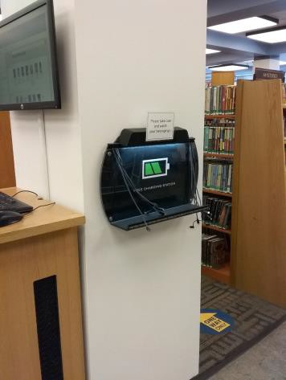

 | ID:  1081 | Facility:  Capitol Library

Location: 1st Floor Lobby
Schedule: 2022
Estimated Cost: $100.00

Priority Score 5
Quick Fix: Yes
Built before ADA: Yes

VIOLATIONS
2010 ADA Standards for Accessible Design Codes: §307.2
The fire extinguisher protrudes 6" into the circulation space at 30.5" above the floor.

RECOMMENDATIONS
Recess the fire extinguisher so it protrudes a maximum of 4", lower it so the bottom edge is 27" maximum above the floor, or place a cane- detectable object beneath it.

PHOTOGRAPH(S) OF THIS LOCATION

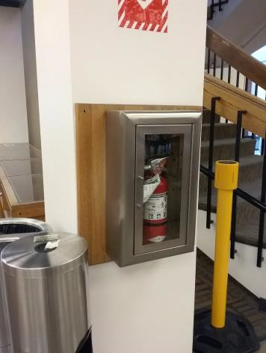

 | ID:  1083 | Facility:  Capitol Library

Location: 1st Floor Hays Auditorium Women's Restroom
Schedule: 2022
Estimated Cost: $100.00

Priority Score 5
Quick Fix: Yes
Built before ADA: Yes

VIOLATIONS
2010 ADA Standards for Accessible Design Codes: §609.3
The toilet paper dispenser is located 4.5" above the side grab bar.

RECOMMENDATIONS
Relocate the toilet paper dispenser so that the bottom edge is at a location that is at least 12" or greater above the grab bar.
Ensure that the center of the toilet paper dispenser is located 7" minimum to 9" maximum in front of the toilet and a maximum height of 48" above the floor.

PHOTOGRAPH(S) OF THIS LOCATION

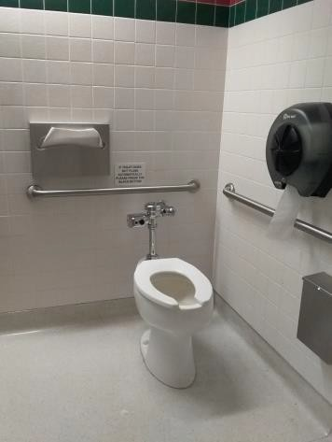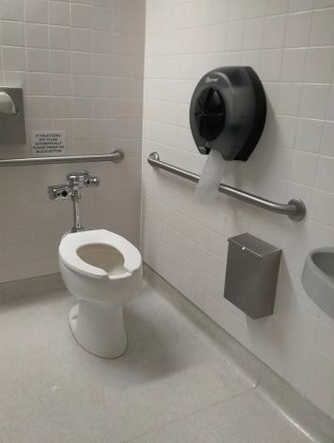

 | ID:  1085 | Facility:  Capitol Library

Location: 1st Floor Hays Auditorium Women's Restroom
Schedule: 2022
Estimated Cost: $100.00

Priority Score 5
Quick Fix: Yes
Built before ADA: Yes

VIOLATIONS
2010 ADA Standards for Accessible Design Codes: §609.3
The toilet seat cover dispenser is located 2.75" above the rear grab bar.

RECOMMENDATIONS
Relocate the toilet seat cover dispenser so that the bottom edge is at a location that is at least 12" or greater above the grab bar. Ensure that the dispenser is at a maximum height of 48" above the floor.

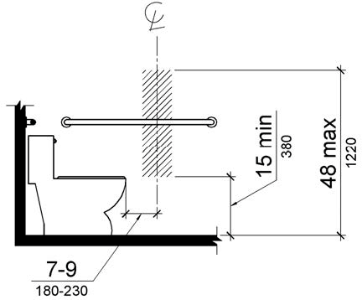

PHOTOGRAPH(S) OF THIS LOCATION

 | ID:  1091 | Facility:  Capitol Library

Location: 1st Floor Youth Services Girl's Restroom
Schedule: 2022
Estimated Cost: $100.00

Priority Score 7
Quick Fix: Yes
Built before ADA: Yes

VIOLATIONS
2010 ADA Standards for Accessible Design Codes: §603.3
The mirror is located at 48" above the floor, too high to be accessible.

RECOMMENDATIONS
Lower the mirror so the bottom edge is a maximum height of 40" above the floor.

PHOTOGRAPH(S) OF THIS LOCATION

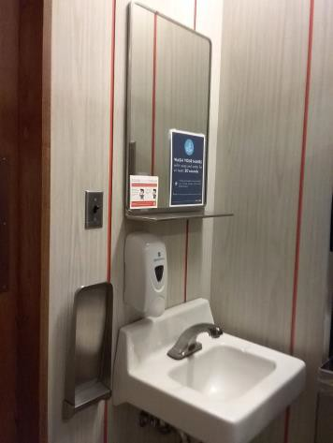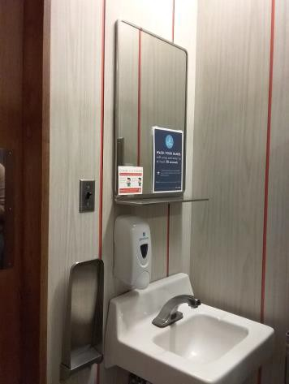

 | ID:  1092 | Facility:  Capitol Library

Location: 1st Floor Youth Services Girl's Restroom
Schedule: 2022
Estimated Cost: $100.00

Priority Score 5
Quick Fix: Yes
Built before ADA: Yes

VIOLATIONS
2010 ADA Standards for Accessible Design Codes: §307.2
The dispenser protrudes 5.5" into the circulation space at 31" above the floor.

RECOMMENDATIONS
Recess the dispenser so it protrudes a maximum of 4", lower it so the bottom edge is 27" maximum above the floor, or place a cane-detectable object beneath it.

PHOTOGRAPH(S) OF THIS LOCATION

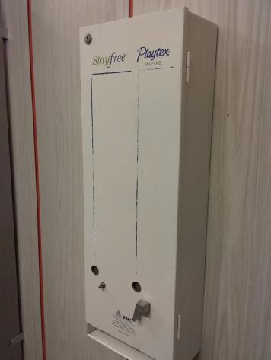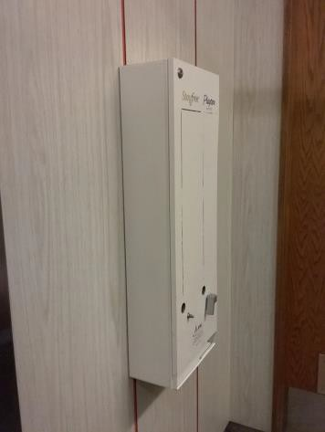

 | ID:  1093 | Facility:  Capitol Library

Location: 1st Floor Youth Services Girl's Restroom
Schedule: 2022
Estimated Cost: $100.00

Priority Score 7
Quick Fix: Yes
Built before ADA: Yes

VIOLATIONS
2010 ADA Standards for Accessible Design Codes: §606.5
The pipes under the sink are not covered.

RECOMMENDATIONS
Wrap the pipes beneath the sink with soft protective wrap or plastic.

PHOTOGRAPH(S) OF THIS LOCATION

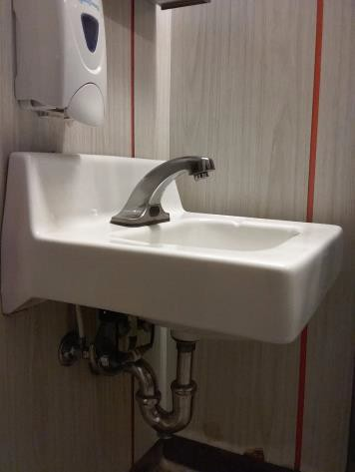

 | ID:  1098 | Facility:  Capitol Library

Location: 1st Floor Women's Restroom
Schedule: 2022
Estimated Cost: $100.00

Priority Score 5
Quick Fix: Yes
Built before ADA: Yes

VIOLATIONS
2010 ADA Standards for Accessible Design Codes: §604.7
The toilet paper dispenser is 5" in front of the toilet.

RECOMMENDATIONS
Remount the toilet paper dispenser so that its center is located 7" minimum to 9" maximum in front of the toilet. Ensure that the height is within the accessible reach range of 15" minimum to 48" maximum above the floor.
If mounted above the grab bar, ensure that the bottom edge of the dispenser at least 12" above the grab bar.

PHOTOGRAPH(S) OF THIS LOCATION

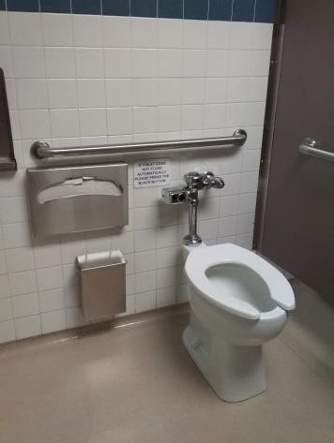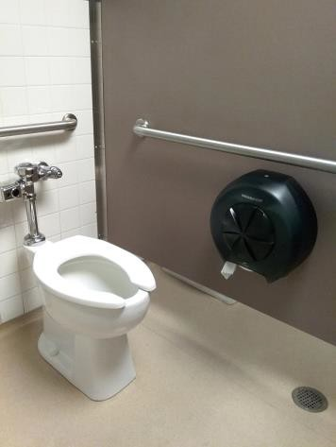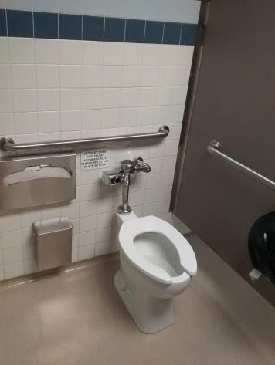

 | ID: | Facility:  Capitol Library

Location: 1st Floor Women's Restroom
Schedule: 2022
Estimated Cost: $100.00

Priority Score 5
Quick Fix: Yes
Built before ADA: Yes

VIOLATIONS
2010 ADA Standards for Accessible Design Codes: §307.2
The sharps dispenser protrudes 4.75" into the circulation space at 45" above the floor.

RECOMMENDATIONS
Recess the dispenser so it protrudes a maximum of 4", lower it so the bottom edge is 27" maximum above the floor, or place a cane- detectable object beneath it.

PHOTOGRAPH(S) OF THIS LOCATION

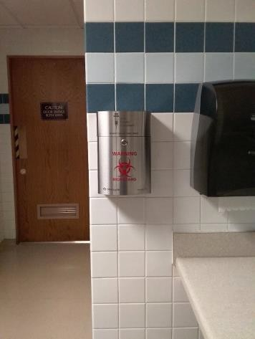

 | ID:  1102 | Facility:  Capitol Library

Location: 1st Floor Women's Restroom
Schedule: 2022
Estimated Cost: $100.00

Priority Score 5
Quick Fix: Yes
Built before ADA: Yes

VIOLATIONS
2010 ADA Standards for Accessible Design Codes: §307.2
The dispenser protrudes 5.75" into the circulation space at 30" above the floor.

RECOMMENDATIONS
Recess the dispenser so it protrudes a maximum of 4", lower it so the bottom edge is 27" maximum above the floor, or place a cane-detectable object beneath it.

PHOTOGRAPH(S) OF THIS LOCATION

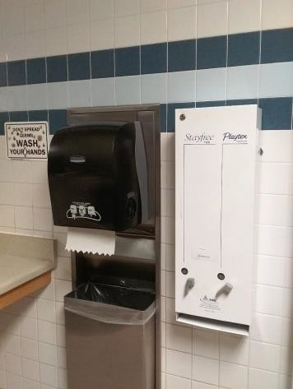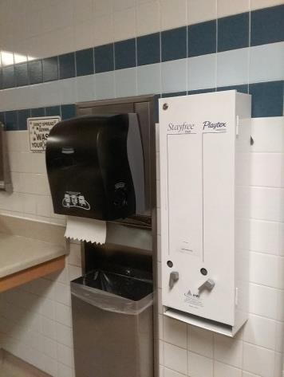

 | ID:  1102 | Facility:  Capitol Library

Location: 1st Floor Deliveries Garage
Schedule: 2022
Estimated Cost: $100.00

Priority Score 7
Quick Fix: Yes
Built before ADA: Yes

VIOLATIONS
2010 ADA Standards for Accessible Design Codes: §307.2
The fire extinguisher protrudes 4.5" into the circulation space at 28.5" above the floor.

RECOMMENDATIONS
Recess the fire extinguisher so it protrudes a maximum of 4", lower it so the bottom edge is 27" maximum above the floor, or place a cane-detectable object beneath it.

PHOTOGRAPH(S) OF THIS LOCATION

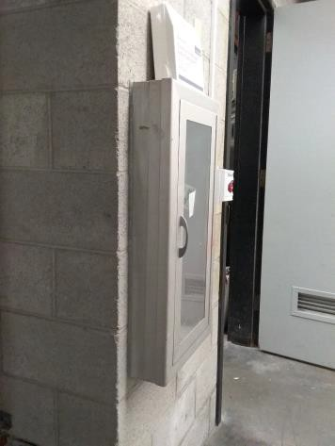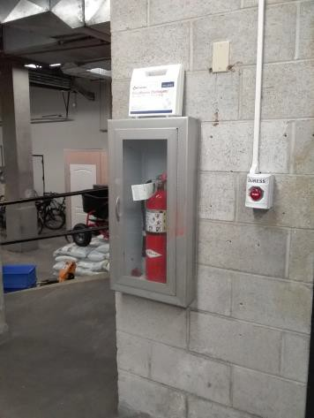

 | ID:  1103 | Facility:  Capitol Library

Location: 1st Floor ATS
Schedule: 2022
Estimated Cost: $100.00

Priority Score 5
Quick Fix: Yes
Built before ADA: Yes

VIOLATIONS
2010 ADA Standards for Accessible Design Codes: §307.2
The shelf protrudes 6.5" into the circulation space at 45" above the floor.

RECOMMENDATIONS
Reduce the shelf protrusion depth to a maximum of 4” or lower it so the bottom edge is 27" maximum above the floor, or remove it.

PHOTOGRAPH(S) OF THIS LOCATION

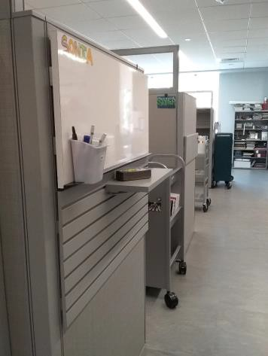
 | ID:  1106 | Facility:  Capitol Library

Location: 1st Floor Mail Room
Schedule: 2022
Estimated Cost: $100.00

Priority Score 5
Quick Fix: Yes
Built before ADA: Yes

VIOLATIONS
2010 ADA Standards for Accessible Design Codes: §307.2, §308.2.1
The paper towel dispenser is outside of the unobstructed forward reach range at 53" above the floor. The paper towel dispenser protrudes 9" into the circulation space at 53" above the floor.

RECOMMENDATIONS
Lower the paper towel dispenser by 5" to meet the accessible reach range of 15" minimum and 48" maximum above the floor.
Recess the dispenser so it protrudes a maximum of 4", lower it so the bottom edge is 27" maximum above the floor, or place a cane- detectable object beneath it.

PHOTOGRAPH(S) OF THIS LOCATION

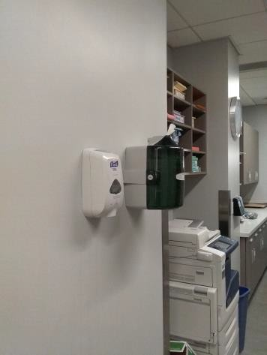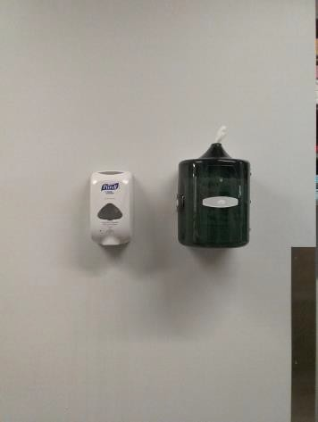

 | ID:  1109 | Facility:  Capitol Library

Location: 2nd Floor Women's Ambulatory Restroom
Schedule: 2022
Estimated Cost: $100.00

Priority Score 5
Quick Fix: Yes
Built before ADA: Yes

VIOLATIONS
2010 ADA Standards for Accessible Design Codes: §609.3
The space between the grab bar and the toilet paper dispenser is 5".

RECOMMENDATIONS
Remount the toilet paper dispenser so that its center is located 7” minimum to 9” maximum in front of the toilet. The bottom edge of the dispenser shall be at least 12" above the side grab bar.
Ensure that the height is within the accessible reach range of 15” minimum to 48” maximum above the floor.

PHOTOGRAPH(S) OF THIS LOCATION

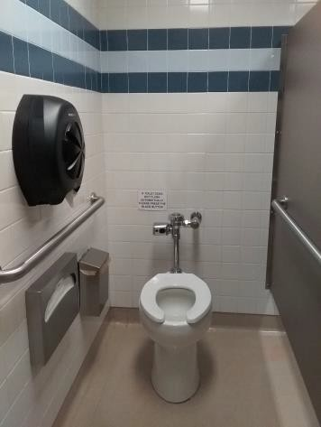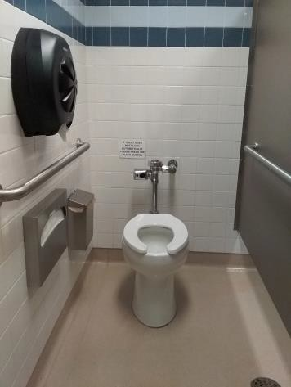

 | ID:  1112 | Facility:  Capitol Library

Location: 2nd Floor Women's Restroom
Schedule: 2022
Estimated Cost: $100.00

Priority Score 5
Quick Fix: Yes
Built before ADA: Yes

VIOLATIONS
2010 ADA Standards for Accessible Design Codes: §307.2, §308.2.1
The paper towel dispenser is outside of the unobstructed forward reach range at 49" above the floor. The paper towel dispenser protrudes 8.5" into the circulation space at 49" above the floor.

RECOMMENDATIONS
Lower the paper towel dispenser by 1" to meet the accessible reach range of 15" minimum and 48" maximum above the floor. Ensure that the trash can underneath the paper towel dispenser is always there to provide cane detectability.

PHOTOGRAPH(S) OF THIS LOCATION

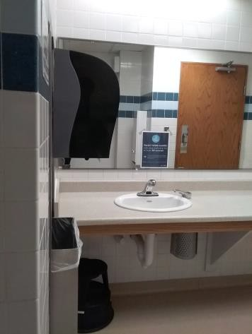

 | ID:  1113 | Facility:  Capitol Library

Location: 2nd Floor TV at Philosophy and Psychology Bookshelves
Schedule: 2022
Estimated Cost: $100.00

Priority Score 5
Quick Fix: Yes
Built before ADA: Yes

VIOLATIONS
2010 ADA Standards for Accessible Design Codes: §307.2
The TV protrudes 5" into the circulation space.

RECOMMENDATIONS
Recess the TV to reduce the protrusion depth to a maximum of 4" or lower it so that the bottom edge is at a maximum height of 27".

PHOTOGRAPH(S) OF THIS LOCATION

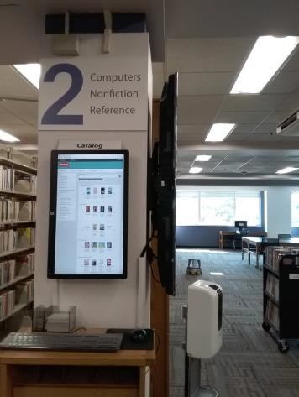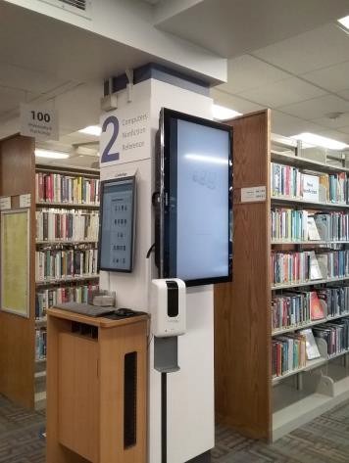

 | ID:  1116 | Facility:  Capitol Library

Location: 3rd Floor Women's Restroom
Schedule: 2022
Estimated Cost: $100.00

Priority Score 5
Quick Fix: Yes
Built before ADA: Yes

VIOLATIONS
2010 ADA Standards for Accessible Design Codes: §604.8.1.2
The door to the accessible water closet is not self closing. Either self-closing hinges are not installed on the door or if installed, they are defective.

RECOMMENDATIONS
Install or reinstall self-closing hinges on the door to ensure that the door is self-closing per ADA requirements.

PHOTOGRAPH(S) OF THIS LOCATION

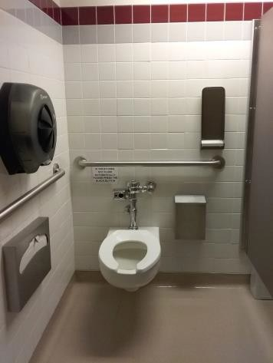

 | ID:  1118 | Facility:  Capitol Library

Location: 3rd Floor Women's Restroom
Schedule: 2022
Estimated Cost: $100.00

Priority Score 5
Quick Fix: Yes
Built before ADA: Yes

VIOLATIONS
2010 ADA Standards for Accessible Design Codes: §609.3
The space between the grab bar and the toilet paper dispenser is 3.5".

RECOMMENDATIONS
Remount the toilet paper dispenser so that its center is located 7” minimum to 9” maximum in front of the toilet. The bottom edge of the dispenser shall be at a maximum height of 12" above the grab bar.
Ensure that the height is within the accessible reach range of 15” minimum to 48” maximum above the floor.

PHOTOGRAPH(S) OF THIS LOCATION

 | ID:  1120 | Facility:  Capitol Library

Location: 3rd Floor Women's Restroom
Schedule: 2022
Estimated Cost: $100.00

Priority Score 5
Quick Fix: Yes
Built before ADA: Yes

VIOLATIONS
2010 ADA Standards for Accessible Design Codes: §604.7
The toilet paper dispenser lines up with the rim of the toilet which is not an accessible position.

RECOMMENDATIONS
Remount the toilet paper dispenser so that its center is located 7" minimum to 9" maximum in front of the toilet. The bottom edge of the dispenser shall be at a maximum height of 12” above the grab bar.
Ensure that the height is within the accessible reach range of 15” minimum to 48” maximum above the floor.

PHOTOGRAPH(S) OF THIS LOCATION

 | ID:  1122 | Facility:  Capitol Library

Location: 3rd Floor Women's Restroom
Schedule: 2022
Estimated Cost: $100.00

Priority Score 5
Quick Fix: Yes
Built before ADA: Yes

VIOLATIONS
2010 ADA Standards for Accessible Design Codes: §609.3
The space between the grab bar and the shelf is 3.75".

RECOMMENDATIONS
Relocate the shelf to a location that is at least 12" or greater away from the top of the grab bar. Ensure that the shelf is located at a height not exceeding 48" above the floor.

PHOTOGRAPH(S) OF THIS LOCATION

 | ID:  1123 | Facility:  Capitol Library

Location: 3rd Floor Women's Restroom
Schedule: 2022
Estimated Cost: $100.00

Priority Score 5
Quick Fix: Yes
Built before ADA: Yes

VIOLATIONS
2010 ADA Standards for Accessible Design Codes: §307.2
The sharps dispenser protrudes 4.75" into the circulation space at 43" above the floor.

RECOMMENDATIONS
Recess the dispenser so it protrudes a maximum of 4", lower it so the bottom edge is 27" maximum above the floor, or place a cane-detectable object beneath it.

PHOTOGRAPH(S) OF THIS LOCATION

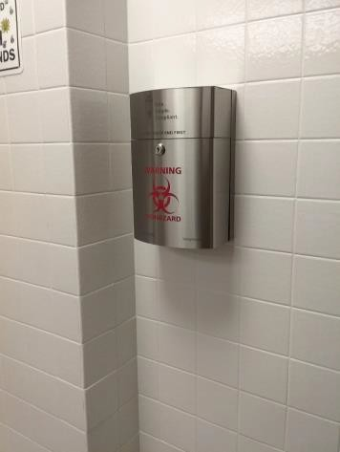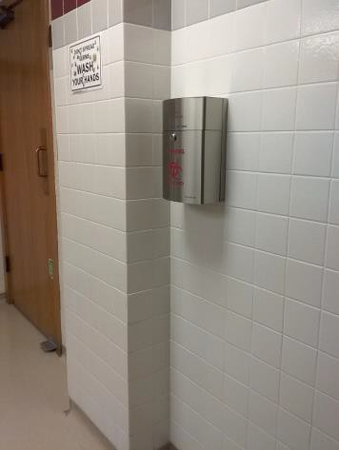

 | ID:  1125 | Facility:  Capitol Library

Location: 3rd Floor Women's Restroom
Schedule: 2022
Estimated Cost: $100.00

Priority Score 5
Quick Fix: Yes
Built before ADA: Yes

VIOLATIONS
2010 ADA Standards for Accessible Design Codes: §307.2
The dispenser protrudes 6" into the circulation space at 42" above the floor.

RECOMMENDATIONS
Reduce the protrusion depth to a maximum of 4” by relocating it or provide cane detectability by placing an object underneath. or lower the dispenser to a height not exceeding 27" above the floor.

PHOTOGRAPH(S) OF THIS LOCATION

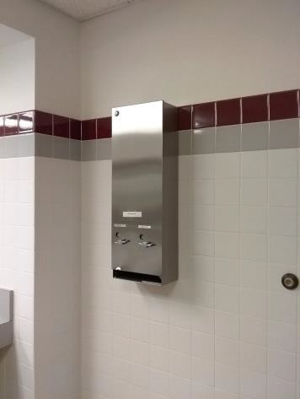

 | ID:  1136 | Facility:  Capitol Library

Location: 3rd Floor All Users Restroom
Schedule: 2022
Estimated Cost: $100.00

Priority Score 5
Quick Fix: Yes
Built before ADA: Yes

VIOLATIONS
2010 ADA Standards for Accessible Design Codes: §604.7
The toilet paper dispenser is 13" in front of the toilet.

RECOMMENDATIONS
Remount the toilet paper dispenser so that it is located 7" minimum to 9" maximum in front of the toilet. Ensure that the height is within the accessible reach range of 15" minimum to 48" maximum above the floor.
If mounted above the side grab bar, the bottom edge of the dispenser shall be at a maximum height of 12” above the grab bar.

PHOTOGRAPH(S) OF THIS LOCATION

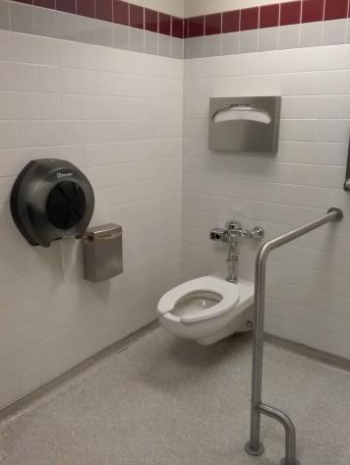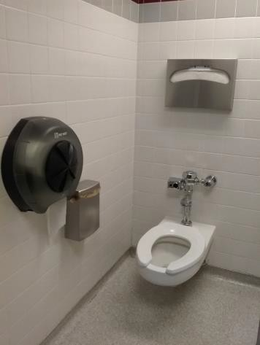

 | ID:  1137 | Facility:  Capitol Library

Location: 3rd Floor All Users Restroom
Schedule: 2022
Estimated Cost: $100.00

Priority Score 7
Quick Fix: Yes
Built before ADA: Yes

VIOLATIONS
2010 ADA Standards for Accessible Design Codes: §606.5
The pipes under the sink are not covered.

RECOMMENDATIONS
Wrap the pipes beneath the sink with soft protective wrap or plastic.

PHOTOGRAPH(S) OF THIS LOCATION

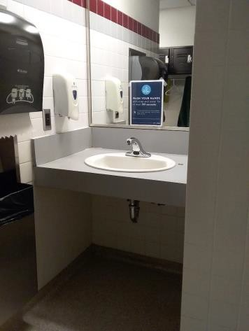

 | ID:  1138 | Facility:  Capitol Library

Location: 3rd Floor All Users Restroom
Schedule: 2022
Estimated Cost: $100.00

Priority Score 5
Quick Fix: Yes
Built before ADA: Yes

VIOLATIONS
2010 ADA Standards for Accessible Design Codes: §307.2
The shelf protrudes 8" into the circulation space at 62.25" above the floor.

RECOMMENDATIONS
Reduce the protrusion depth to a maximum of 4” by relocating it or provide cane detectability by placing an object underneath.

PHOTOGRAPH(S) OF THIS LOCATION

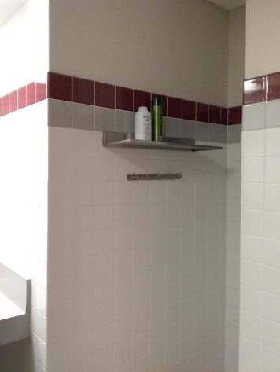

 | ID:  1145 | Facility:  Capitol Library

Location: 3rd Floor All Users Restroom
Schedule: 2022
Estimated Cost: $100.00

Priority Score 5
Quick Fix: Yes
Built before ADA: Yes

VIOLATIONS
2010 ADA Standards for Accessible Design Codes: §307.2
The shelf protrudes 8" into the circulation space at 57.5" above the floor.

RECOMMENDATIONS
Reduce the protrusion depth to a maximum of 4” by relocating it or provide cane detectability by placing an object underneath. or lower the shelf to a height not exceeding 27" above the floor.

PHOTOGRAPH(S) OF THIS LOCATION

 | ID:  1151 | Facility:  Capitol Library

Location: 3rd Floor All Users Restroom
Schedule: 2022
Estimated Cost: $100.00

Priority Score 7
Quick Fix: Yes
Built before ADA: Yes

VIOLATIONS
2010 ADA Standards for Accessible Design Codes: §606.5
The pipes under the sink are not covered.

RECOMMENDATIONS
Wrap the pipes beneath the sink with soft protective wrap or plastic.

PHOTOGRAPH(S) OF THIS LOCATION

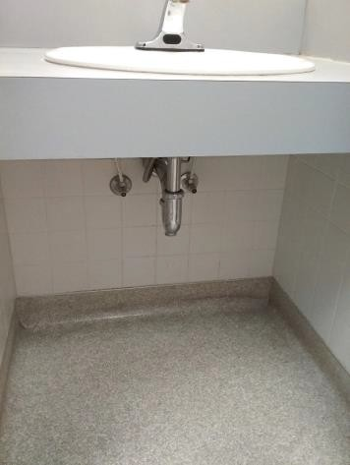

 | ID:  1156 | Facility:  Capitol Library

Location: 3rd Floor Reference Desk
Schedule: 2022
Estimated Cost: $100.00

Priority Score 5
Quick Fix: Yes
Built before ADA: Yes

VIOLATIONS
2010 ADA Standards for Accessible Design Codes: §307.2
The AED protrudes 6" into the circulation path at 46" above the floor.

RECOMMENDATIONS
Reduce the protrusion depth to a maximum of 4” by relocating it or provide cane detectability by placing an object underneath.

PHOTOGRAPH(S) OF THIS LOCATION

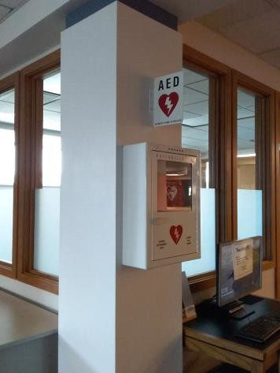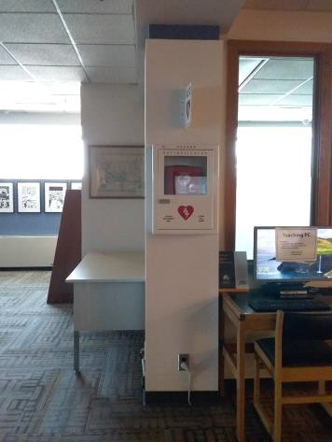

 | ID:  1157 | Facility:  Capitol Library

Location: 3rd Floor Reference Desk
Schedule: 2022
Estimated Cost: $100.00

Priority Score 5
Quick Fix: Yes
Built before ADA: Yes

VIOLATIONS
2010 ADA Standards for Accessible Design Codes: §307.2
The paper towel dispenser protrudes 8" into the circulation space at 43" above the floor.

RECOMMENDATIONS
Reduce the protrusion depth to a maximum of 4” by relocating it or provide cane detectability by placing an object underneath. or lower the dispenser to a height not exceeding 27" above the floor.

PHOTOGRAPH(S) OF THIS LOCATION

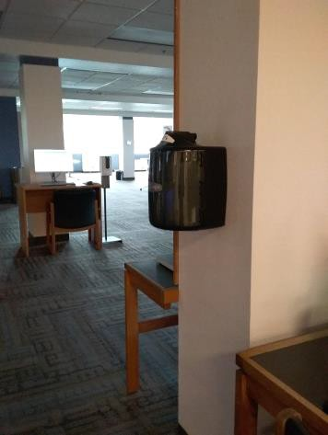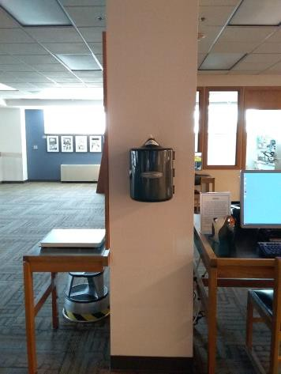

 | ID:  1160 | Facility:  Capitol Library

Location: 4th Floor Kitchen
Schedule: 2022
Estimated Cost: $100.00

Priority Score 5
Quick Fix: Yes
Built before ADA: Yes

VIOLATIONS
2010 ADA Standards for Accessible Design Codes: §307.2
The cabinet protrudes 12" into the circulation space at 46" above the floor.

RECOMMENDATIONS
Reduce the protrusion depth to a maximum of 4” by relocating it or provide cane detectability by placing an object underneath.

PHOTOGRAPH(S) OF THIS LOCATION

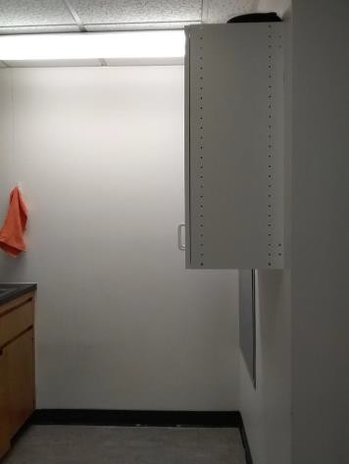

 | ID:  1163 | Facility:  Capitol Library

Location: 4th Floor Women's Ambulatory Restroom
Schedule: 2022
Estimated Cost: $100.00

Priority Score 5
Quick Fix: Yes
Built before ADA: Yes

VIOLATIONS
2010 ADA Standards for Accessible Design Codes: §604.8.1.2
The door to the accessible water closet is not self closing. Either self-closing hinges are not installed on the door or if installed, they are defective.

RECOMMENDATIONS
Install or reinstall self-closing hinges on the door to ensure that the door is self-closing per the ADA requirements.

PHOTOGRAPH(S) OF THIS LOCATION

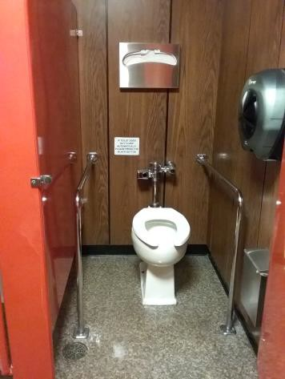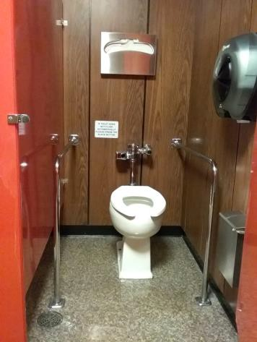

 | ID:  1172 | Facility:  Capitol Library

Location: 4th Floor Women's Ambulatory Restroom
Schedule: 2022
Estimated Cost: $100.00

Priority Score 5
Quick Fix: Yes
Built before ADA: Yes

VIOLATIONS
2010 ADA Standards for Accessible Design Codes: §307.2
The dispenser protrudes 5.75" into the circulation space at 39.25" above the floor.

RECOMMENDATIONS
Reduce the protrusion depth to a maximum of 4” by relocating it or provide cane detectability by placing an object underneath.

PHOTOGRAPH(S) OF THIS LOCATION

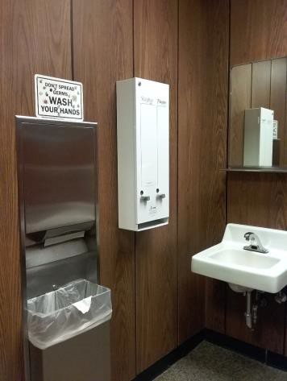

 | ID:  1174 | Facility:  Capitol Library

Location: 4th Floor Women's Ambulatory Restroom
Schedule: 2022
Estimated Cost: $100.00

Priority Score 5
Quick Fix: Yes
Built before ADA: Yes

VIOLATIONS
2010 ADA Standards for Accessible Design Codes: §307.2, §308.2.1
The shelf is outside of the unobstructed forward reach range at 64.75" above the floor. The shelf protrudes 7" into the circulation space at 64.75" above the floor.

RECOMMENDATIONS
Lower the shelf by 16.75" to meet the accessible reach range of 15" minimum and 48" maximum above the floor. Reduce the protrusion depth to a maximum of 4” by relocating it or provide cane detectability by placing an object underneath.

PHOTOGRAPH(S) OF THIS LOCATION

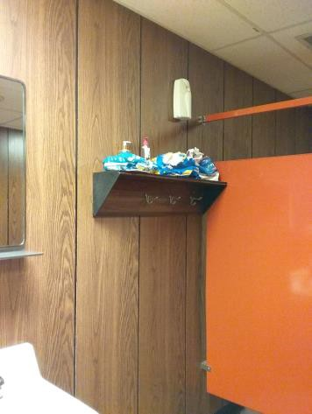

 | ID:  1183 | Facility:  Capitol Library

Location: 3rd Floor Reference Desk
Schedule: 2022
Estimated Cost: $100.00

Priority Score 5
Quick Fix: Yes
Built before ADA: Yes

VIOLATIONS
2010 ADA Standards for Accessible Design Codes: §307.2
The paper towel dispenser protrudes 9.5" into the circulation space at 43" above the floor.

RECOMMENDATIONS
Reduce the protrusion depth to a maximum of 4” by relocating it or provide cane detectability by placing an object underneath.

PHOTOGRAPH(S) OF THIS LOCATION

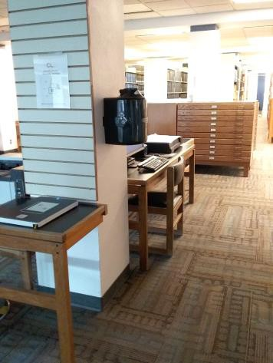

 | ID:  1189 | Facility:  Capitol Library

Location: Learning Center
Schedule: 2022
Estimated Cost: $100.00

Priority Score 5
Quick Fix: Yes
Built before ADA: Yes

VIOLATIONS
2010 ADA Standards for Accessible Design Codes: §307.2
The fire extinguisher protrudes 6.5" into the circulation space at 39" above the floor.

RECOMMENDATIONS
The extinguisher is not located in an accessible path, however, for purposes of achieving greater accessibility and Human Centric Design, recess the fire extinguisher so it protrudes a maximum of 4", lower it so the bottom edge is 27" maximum above the floor, or place a cane- detectable object beneath it.

PHOTOGRAPH(S) OF THIS LOCATION

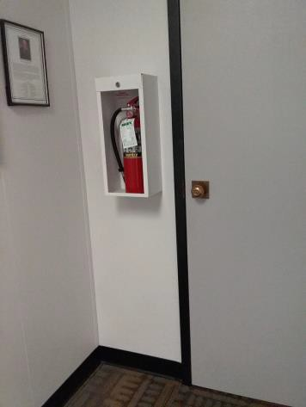

 | ID:  1202 | Facility:  Capitol Library

Location: 1st Floor Youth Services Boy's Restroom
Schedule: 2022
Estimated Cost: $100.00

Priority Score 7
Quick Fix: Yes
Built before ADA: Yes

VIOLATIONS
2010 ADA Standards for Accessible Design Codes: §606.5
The pipes under the sink are not covered.

RECOMMENDATIONS
Wrap the pipes beneath the sink with soft protective wrap or plastic.

PHOTOGRAPH(S) OF THIS LOCATION

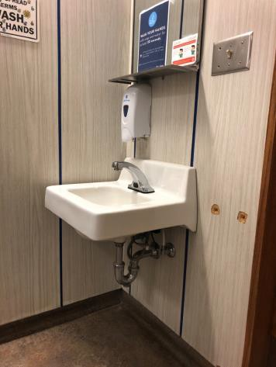

 | ID:  1207 | Facility:  Capitol Library

Location: 1st Floor Men's Restroom
Schedule: 2022
Estimated Cost: $100.00

Priority Score 7
Quick Fix: Yes
Built before ADA: Yes

VIOLATIONS
2010 ADA Standards for Accessible Design Codes: §309.4
There is no door handle on the inside of the stall door.

RECOMMENDATIONS
Add a door handle to allow users to pull open the door. Ensure that the handle can be operated with a closed fist and without twisting the wrist.

PHOTOGRAPH(S) OF THIS LOCATION

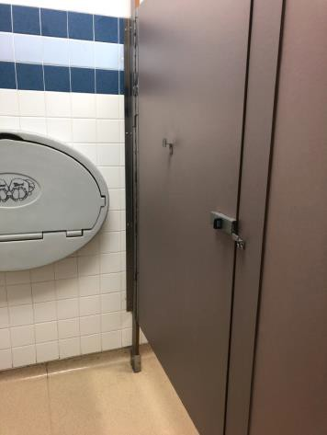

 | ID:  1214 | Facility:  Capitol Library

Location: 2nd Floor Men's Restroom
Schedule: 2022
Estimated Cost: $100.00

Priority Score 5
Quick Fix: Yes
Built before ADA: Yes

VIOLATIONS
2010 ADA Standards for Accessible Design Codes: §609.3
The space between the grab bar and toilet paper dispenser is 4".

RECOMMENDATIONS
Relocate the toilet paper dispenser to a location that is at least a distance of 12" or greater away from the grab bar. Ensure that the dispenser is at a height not exceeding 48" above the ground.
The center of the toilet paper dispenser shall be located 7" minimum to 9" maximum in front of the toilet.

PHOTOGRAPH(S) OF THIS LOCATION

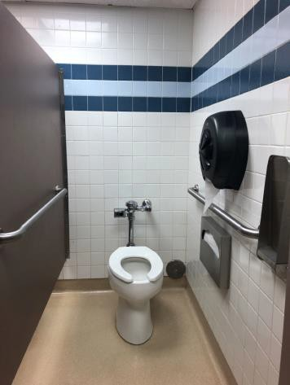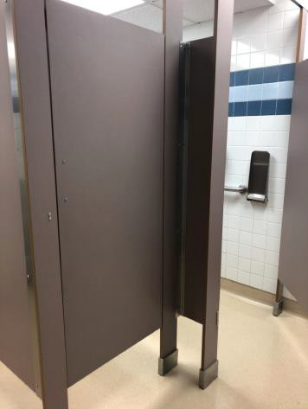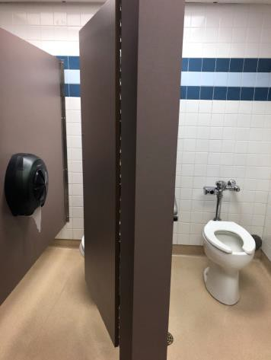

 | ID:  1221 | Facility:  Capitol Library

Location: 3rd Floor Men's Restroom
Schedule: 2022
Estimated Cost: $100.00

Priority Score 5
Quick Fix: Yes
Built before ADA: Yes

VIOLATIONS
2010 ADA Standards for Accessible Design Codes: §609.3
The space between the side grab bar and the toilet paper dispenser is 3".

RECOMMENDATIONS
Relocate the toilet paper dispenser to a location that is at least a distance of 12" or greater away from the grab bar. Ensure that the dispenser is at a height not exceeding 48" above the ground.
The center of the toilet paper dispenser shall be located 7" minimum to 9" maximum in front of the toilet.

PHOTOGRAPH(S) OF THIS LOCATION

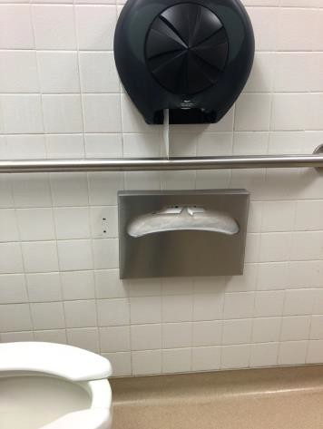

 | ID:  1224 | Facility:  Capitol Library

Location: 3rd Floor Men's Restroom
Schedule: 2022
Estimated Cost: $100.00

Priority Score 5
Quick Fix: Yes
Built before ADA: Yes

VIOLATIONS
2010 ADA Standards for Accessible Design Codes: §307.2
The paper towel dispenser protrudes 10" into the circulation space.

RECOMMENDATIONS
The dispenser is not located in an accessible path, however, for purposes of achieving greater accessibility and Human Centric Design, recess the dispenser so it protrudes a maximum of 4".
Lower it so the bottom edge is 27" maximum above the floor, or ensure that the trash can is always under the dispenser to provide cane detectability.

PHOTOGRAPH(S) OF THIS LOCATION

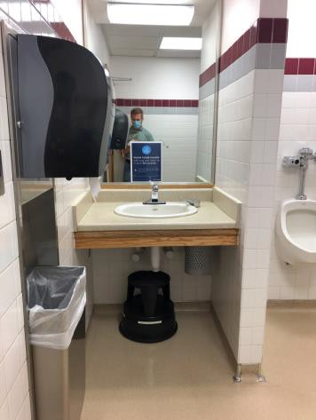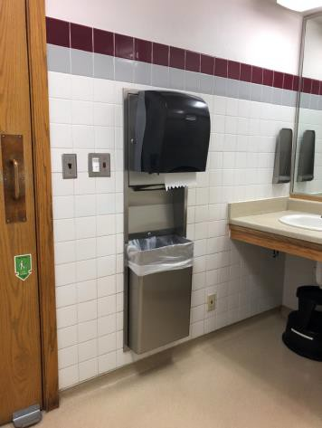

 | ID:  1232 | Facility:  Capitol Library

Location: 4th Floor Men's Restroom
Schedule: 2022
Estimated Cost: $100.00

Priority Score 5
Quick Fix: Yes
Built before ADA: Yes

VIOLATIONS
2010 ADA Standards for Accessible Design Codes: §604.7
The toilet paper dispenser is not located in an accessible position.

RECOMMENDATIONS
Remount the toilet paper dispenser so that it is located 7" minimum to 9" maximum in front of the toilet. Ensure that the height is within the accessible reach range of 15" minimum to 48" maximum above the floor. If mounted above the side grab bar, the bottom edge of the dispenser shall be 12" maximum above the grab bar.

PHOTOGRAPH(S) OF THIS LOCATION

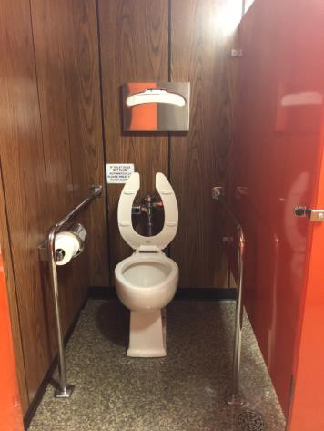

 | ID:  1238 | Facility:  Capitol Library

Location: 4th Floor Men's Restroom
Schedule: 2022
Estimated Cost: $100.00

Priority Score 6
Quick Fix: Yes
Built before ADA: Yes

VIOLATIONS
2010 ADA Standards for Accessible Design Codes: §703.4
The tactile sign identifying the room is not in the correct location.

RECOMMENDATIONS
Reinstall the sign on the latch side of the door at 48" minimum above the floor measured from the baseline of the lowest character and 60" maximum measured from the baseline of the highest character.

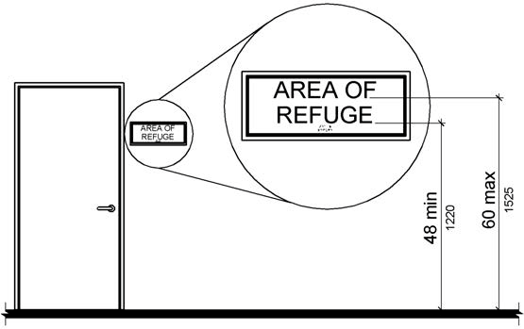

PHOTOGRAPH(S) OF THIS LOCATION

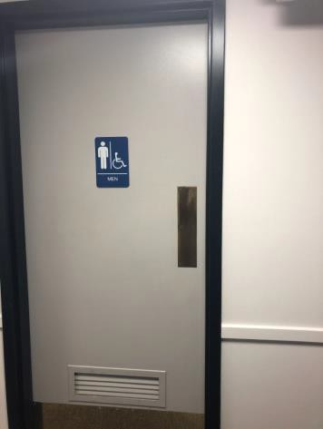

 | ID:  1252 | Facility:  Capitol Library

Location: Main Entrance
Schedule: 2022
Estimated Cost: $100.00

Priority Score 5
Quick Fix: Yes
Built before ADA: Yes

VIOLATIONS
2010 ADA Standards for Accessible Design Codes: §305.3
There is not adequate clear floor space to access the push button.

RECOMMENDATIONS
Relocate the garbage can to ensure that a minimum clear and level floor space of 30"x48" is available by the push button.

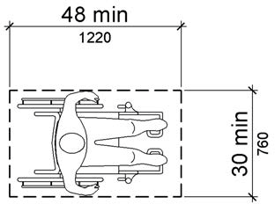

PHOTOGRAPH(S) OF THIS LOCATION

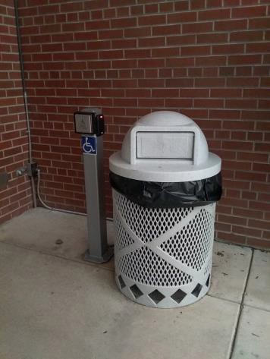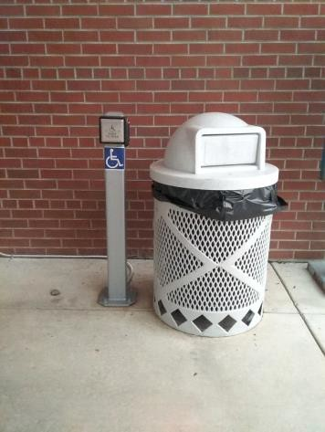

 | ID:  1190 | Facility:  Capitol Library

Location: 4th Floor Accounting Area
Schedule: 2021
Estimated Cost: $100.00

Priority Score 5
Quick Fix: Yes
Built before ADA: Yes

VIOLATIONS
2010 ADA Standards for Accessible Design Codes: §307.2
The fire extinguisher protrudes 5" into the circulation space at 29.5" above the floor.

RECOMMENDATIONS
Recess the fire extinguisher so it protrudes a maximum of 4", lower it so the bottom edge is 27" maximum above the floor, or place a cane detectable object beneath it.

PHOTOGRAPH(S) OF THIS LOCATION

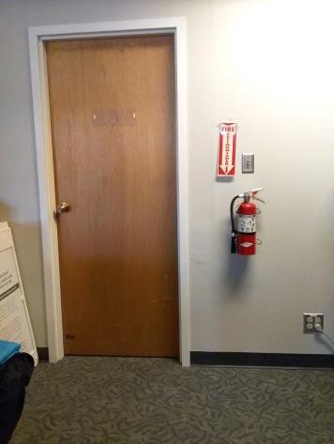

 | ID:  1211 | Facility:  Capitol Library

Location: 1st Floor ATS
Schedule: 2021
Estimated Cost: $100.00

Priority Score 5
Quick Fix: Yes
Built before ADA: Yes

VIOLATIONS
2010 ADA Standards for Accessible Design Codes: §307.2
The first aid box protrudes 5.5" into the circulation space.

RECOMMENDATIONS
Recess the box so it protrudes a maximum of 4", lower it so the bottom edge is 27" maximum above the floor, or place a cane detectable object beneath it.

PHOTOGRAPH(S) OF THIS LOCATION

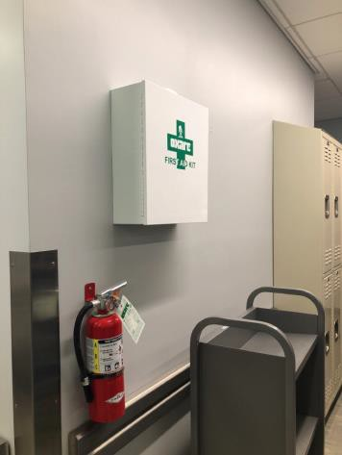

 | ID:  1233 | Facility:  Capitol Library

Location: 4th Floor Men's Restroom
Schedule: 2023
Estimated Cost: $200.00

Priority Score 8
Quick Fix: Yes
Built before ADA: Yes

VIOLATIONS
2010 ADA Standards for Accessible Design Codes: §308.2.1
The toilet seat cover dispenser and coat hook are outside of the unobstructed forward reach range at 54" and 57" above the floor.

RECOMMENDATIONS
Lower the toilet seat cover dispenser by 6" and the coat hook by 9" to meet the accessible reach range of 15" minimum and 48" maximum above the floor.

PHOTOGRAPH(S) OF THIS LOCATION

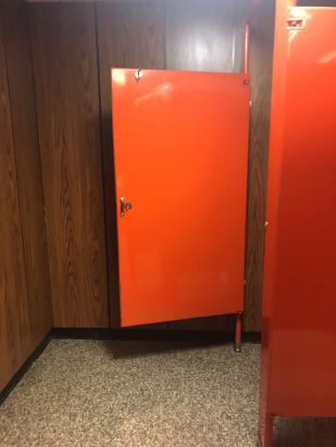

 | ID:  1101 | Facility:  Capitol Library

Location: 1st Floor Deliveries Garage
Schedule: 2022
Estimated Cost: $200.00

Priority Score 5
Quick Fix: Yes
Built before ADA: Yes

VIOLATIONS
2010 ADA Standards for Accessible Design Codes: §307.2
The fire extinguisher protrudes 5" into the circulation space at 29" above the floor. The fire extinguisher sign protrudes 4.5" into the circulation space at 70" above the floor.

RECOMMENDATIONS
Reduce the protrusion depth to a maximum of 4” by relocating it or provide cane detectability by placing an object underneath. or lower the extinguishers to a height not exceeding 27” above the floor.

PHOTOGRAPH(S) OF THIS LOCATION

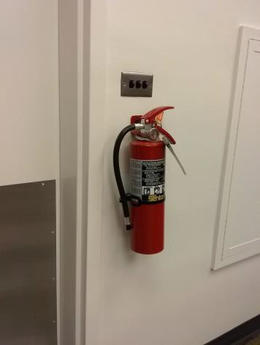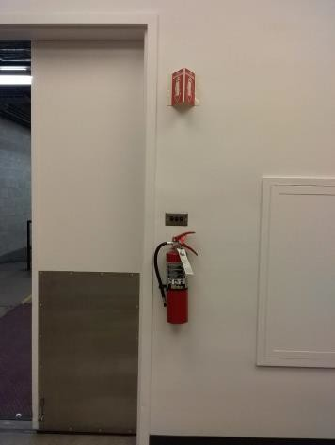

 | ID:  1111 | Facility:  Capitol Library

Location: 2nd Floor Women's Restroom
Schedule: 2022
Estimated Cost: $200.00

Priority Score 5
Quick Fix: Yes
Built before ADA: Yes

VIOLATIONS
2010 ADA Standards for Accessible Design Codes: §307.2
The tampon dispenser protrudes 5.5" into the circulation space at 30" above the floor. The sharps dispenser protrudes 4.75" at 44.5" above the floor.

RECOMMENDATIONS
Reduce the protrusion depth to a maximum of 4” by relocating it or provide cane detectability by placing an object underneath. Or lower the dispensers to a height not exceeding 27" above the floor.

PHOTOGRAPH(S) OF THIS LOCATION

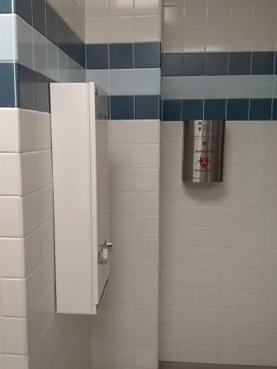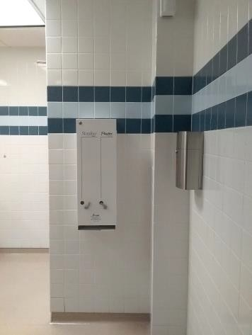

 | ID:  1115 | Facility:  Capitol Library

Location: 2nd Floor TVs
Schedule: 2022
Estimated Cost: $200.00

Priority Score 5
Quick Fix: Yes
Built before ADA: Yes

VIOLATIONS
2010 ADA Standards for Accessible Design Codes: §307.2
The TVs protrude 5" into the circulation space at 66" above the floor.

RECOMMENDATIONS
Reduce the protrusion depth to a maximum of 4” by relocating it or provide cane detectability by placing an object underneath.

PHOTOGRAPH(S) OF THIS LOCATION

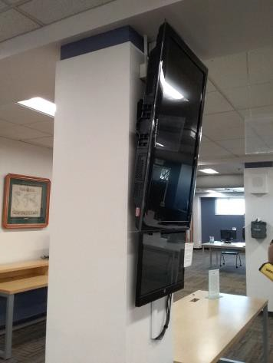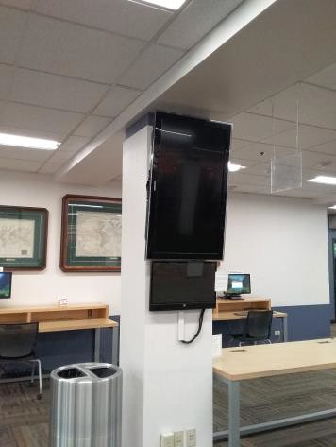

 | ID:  1152 | Facility:  Capitol Library

Location: 3rd Floor All Users Restroom
Schedule: 2022
Estimated Cost: $200.00

Priority Score 5
Quick Fix: Yes
Built before ADA: Yes

VIOLATIONS
2010 ADA Standards for Accessible Design Codes: §307.2, §308.2.1
The shelf is outside of the unobstructed forward reach range at 63" above the floor. The shelf protrudes 8" into the circulation space at 63" above the floor.
The dispenser protrudes 6" into the circulation space at 43.5" above the floor.

RECOMMENDATIONS
Lower the shelf by 15" to meet the accessible reach range of 15" minimum and 48" maximum above the floor.
Reduce the protrusion depth to a maximum of 4” by relocating it or provide cane detectability by placing an object underneath.

PHOTOGRAPH(S) OF THIS LOCATION

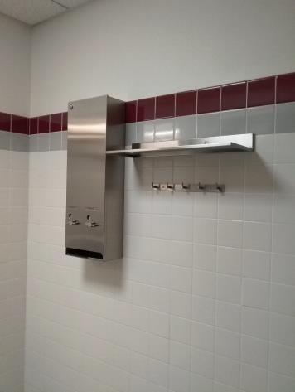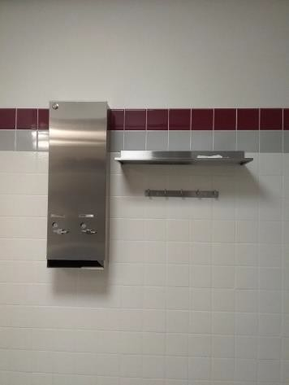

 | ID:  1170 | Facility:  Capitol Library

Location: 4th Floor Women's Ambulatory Restroom
Schedule: 2022
Estimated Cost: $200.00

Priority Score 7
Quick Fix: Yes
Built before ADA: Yes

VIOLATIONS
2010 ADA Standards for Accessible Design Codes: §606.5
The pipes under the sinks are not covered.

RECOMMENDATIONS
Wrap the pipes beneath the sinks with soft protective wrap or plastic.

PHOTOGRAPH(S) OF THIS LOCATION

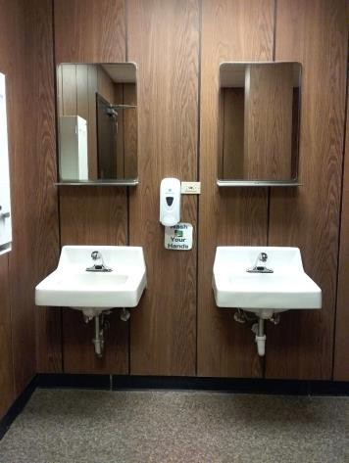

 | ID:  1171 | Facility:  Capitol Library

Location: 4th Floor Women's Ambulatory Restroom
Schedule: 2022
Estimated Cost: $200.00

Priority Score 7
Quick Fix: Yes
Built before ADA: Yes

VIOLATIONS
2010 ADA Standards for Accessible Design Codes: §603.3
The mirrors are too high to be accessible at 52" above the floor.

RECOMMENDATIONS
Lower the mirrors so the bottom edge is at a maximum height of 40" above the floor.

PHOTOGRAPH(S) OF THIS LOCATION

 | ID:  1196 | Facility:  Capitol Library

Location: 1st Floor Hays Auditorium Men's Restroom
Schedule: 2022
Estimated Cost: $200.00

Priority Score 5
Quick Fix: Yes
Built before ADA: Yes

VIOLATIONS
2010 ADA Standards for Accessible Design Codes: §609.3, §604.7
The toilet paper dispenser is located behind the rim of the toilet. The space between the grab bar and the toilet paper dispenser and the toilet seat covers is 4".

RECOMMENDATIONS
Remount the toilet paper dispenser so that it is located 7" minimum to 9" maximum in front of the toilet. Ensure that the height is within the accessible reach range of 15" minimum to 48" maximum above the floor.
Relocate the toilet paper and seat cover dispensers to a location that is at least a distance of 12" or greater above the grab bar.

PHOTOGRAPH(S) OF THIS LOCATION

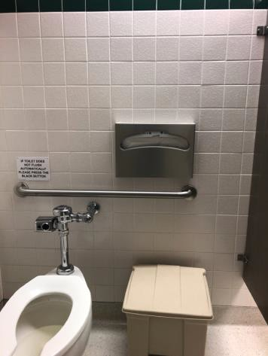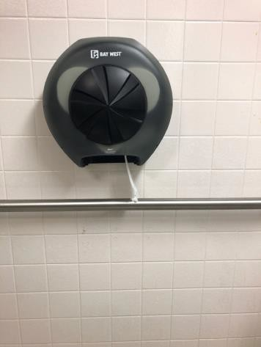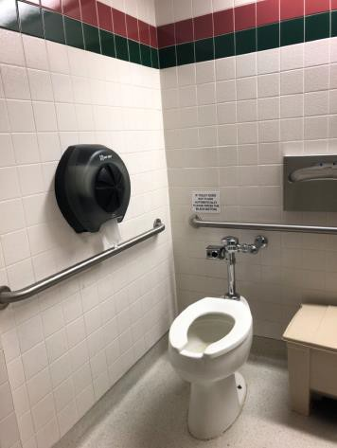

 | ID:  1209 | Facility:  Capitol Library

Location: 1st Floor Men's Restroom
Schedule: 2022
Estimated Cost: $200.00

Priority Score 5
Quick Fix: Yes
Built before ADA: Yes

VIOLATIONS
2010 ADA Standards for Accessible Design Codes: §609.3
The space between the grab bar and the toilet paper dispenser and toilet seat covers is 3".

RECOMMENDATIONS
Relocate the toilet paper dispenser and toilet seat covers to a location that is at least a distance of 12" or greater above the grab bar.

PHOTOGRAPH(S) OF THIS LOCATION

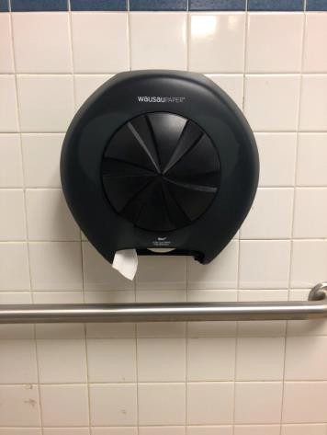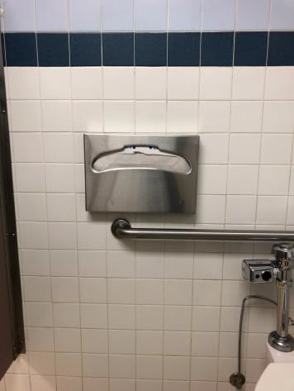

 | ID:  1215 | Facility:  Capitol Library

Location: 2nd Floor Men's Restroom
Schedule: 2022
Estimated Cost: $200.00

Priority Score 5
Quick Fix: Yes
Built before ADA: Yes

VIOLATIONS
2010 ADA Standards for Accessible Design Codes: §307.2, §308.2.1
The shelf is outside of the unobstructed forward reach range at 63" above the floor. The paper towel dispenser protrudes 10" into the circulation space. The shelf protrudes 12" into the circulation space at 63" above the floor.

RECOMMENDATIONS
Lower the shelf by 15" to meet the accessible reach range of 15" minimum and 48" maximum above the floor.
The objects are not located in an accessible path, however, for purposes of achieving greater accessibility and Human Centric Design, lower them so the bottom edge is 27" maximum above the floor, or place a cane-detectable object beneath them.

PHOTOGRAPH(S) OF THIS LOCATION

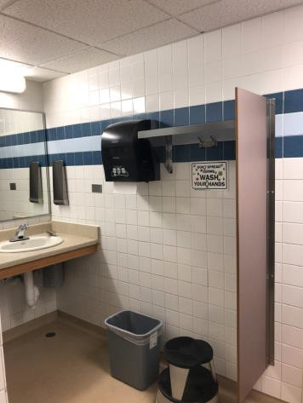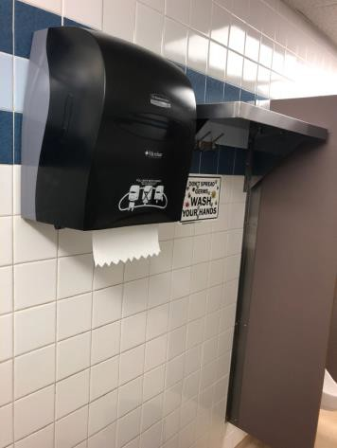

 | ID:  1266 | Facility:  Capitol Library

Location: Parking
Schedule: 2023
Estimated Cost: $300.00

Priority Score 9
Quick Fix: Yes
Built before ADA: Yes

VIOLATIONS
2010 ADA Standards for Accessible Design Codes: §502.6
The signage identifying the accessible parking spaces is 29.5" and 39.5" above the ground.

RECOMMENDATIONS
Remount the accessible parking sign at each accessible space at a minimum height of 60" above the ground.

PHOTOGRAPH(S) OF THIS LOCATION

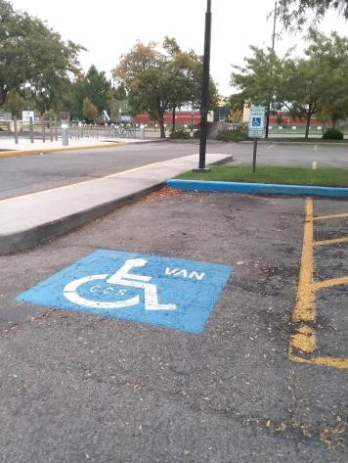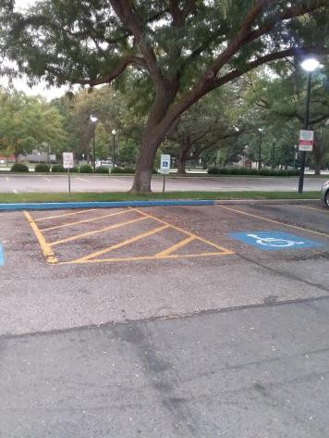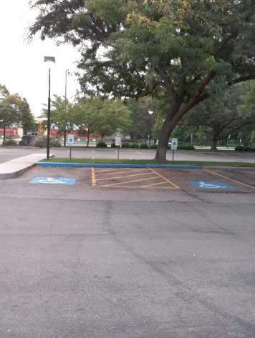

 | ID:  1182 | Facility:  Capitol Library

Location: 2nd Floor Paper Towel Dispensers
Schedule: 2022
Estimated Cost: $300.00

Priority Score 5
Quick Fix: Yes
Built before ADA: Yes

VIOLATIONS
2010 ADA Standards for Accessible Design Codes: §307.2
There are three paper towel dispensers protruding 9" into the circulation space at heights ranging from 44" to 49.5" above the floor.

RECOMMENDATIONS
Reduce the protrusion depth to a maximum of 4” by relocating it or provide cane detectability by placing an object underneath.

PHOTOGRAPH(S) OF THIS LOCATION

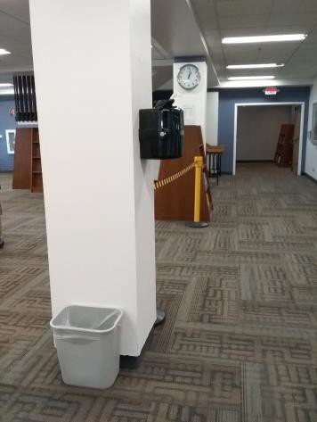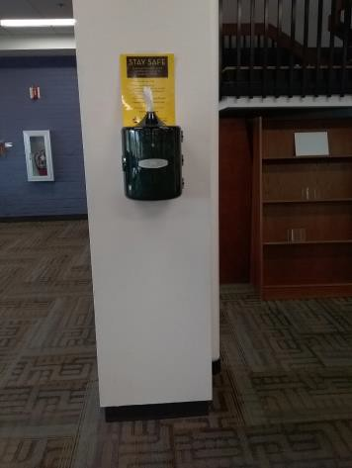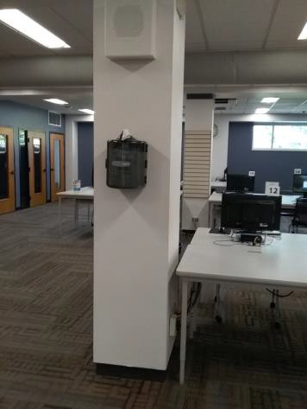

 | ID:  1201 | Facility:  Capitol Library

Location: 1st Floor Youth Services Boy's Restroom
Schedule: 2022
Estimated Cost: $300.00

Priority Score 5
Quick Fix: Yes
Built before ADA: Yes

VIOLATIONS
2010 ADA Standards for Accessible Design Codes: §308.1, §603.3
The mirror is too high to be accessible at 49" above the floor. The paper towel dispenser is outside of the unobstructed children's forward reach range at 45" above the floor.

RECOMMENDATIONS
Lower the mirror to the maximum height of 40" above the floor. Therefore relocate the soap dispenser to the sidewall at a maximum height of 44" above the floor.
Lower the paper towel dispenser to be between 16" and 44" above the floor.

PHOTOGRAPH(S) OF THIS LOCATION

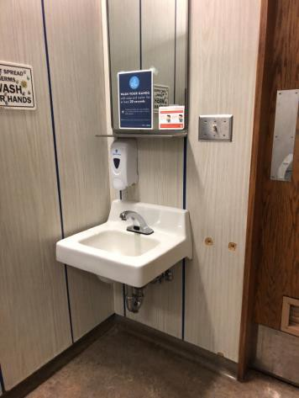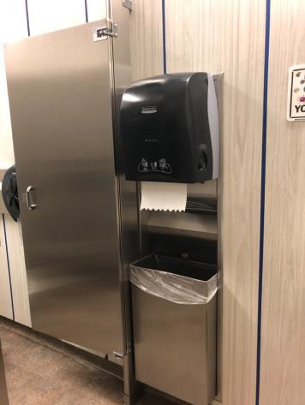

 | ID:  1236 | Facility:  Capitol Library

Location: 4th Floor Men's Restroom
Schedule: 2022
Estimated Cost: $300.00

Priority Score 7
Quick Fix: Yes
Built before ADA: Yes

VIOLATIONS
2010 ADA Standards for Accessible Design Codes: §603.3
The mirrors are too high to be accessible at 52" above the floor.

RECOMMENDATIONS
Lower the mirrors to the maximum height of 40" above the floor.

PHOTOGRAPH(S) OF THIS LOCATION

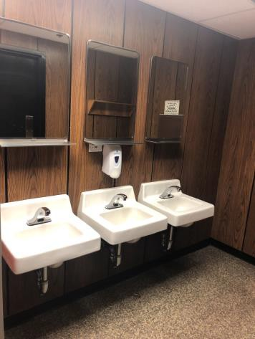

 | ID:  1237 | Facility:  Capitol Library

Location: 4th Floor Men's Restroom
Schedule: 2022
Estimated Cost: $300.00

Priority Score 7
Quick Fix: Yes
Built before ADA: Yes

VIOLATIONS
2010 ADA Standards for Accessible Design Codes: §606.5
The pipes under the sink are not covered.

RECOMMENDATIONS
Wrap the pipes beneath the sink with soft protective wrap or plastic.

PHOTOGRAPH(S) OF THIS LOCATION

 | ID:  1108 | Facility:  Capitol Library

Location: 2nd Floor Women's Ambulatory Restroom
Schedule: 2022
Estimated Cost: $500.00

Priority Score 5
Quick Fix: Yes
Built before ADA: Yes

VIOLATIONS
2010 ADA Standards for Accessible Design Codes: §604.5.1
The side grab bars are 33" long.

RECOMMENDATIONS
Replace the side grab bar with one that is a minimum of 42" long minimum, located 12" maximum from the rear wall and extending 54" from the rear wall.

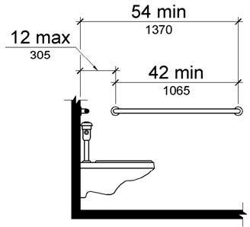

PHOTOGRAPH(S) OF THIS LOCATION

 | ID:  1127 | Facility:  Capitol Library

Location: 3rd Floor All Users Restroom
Schedule: 2022
Estimated Cost: $500.00

Priority Score 6
Quick Fix: Yes
Built before ADA: Yes

VIOLATIONS
2010 ADA Standards for Accessible Design Codes: §607.6
The shower spray unit is fixed.

RECOMMENDATIONS
Install a new shower spray unit that has a 59" long minimum hose to be used both as a fixed-position shower head and as a hand-held shower.

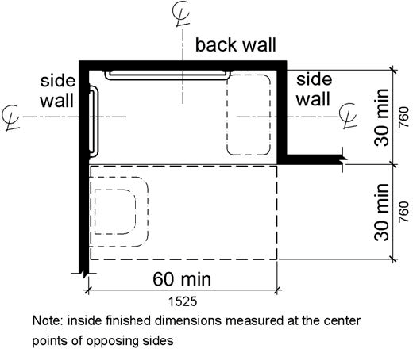

PHOTOGRAPH(S) OF THIS LOCATION

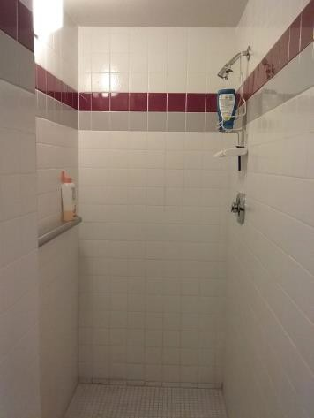

 | ID:  1129 | Facility:  Capitol Library

Location: 3rd Floor All Users Restroom
Schedule: 2022
Estimated Cost: $500.00

Priority Score 5
Quick Fix: Yes
Built before ADA: Yes

VIOLATIONS
2010 ADA Standards for Accessible Design Codes: §609.4
The shower grab bar is installed at 42.5" above the ground.

RECOMMENDATIONS
Lower the grab bar to a minimum height of 33” and 36” maximum above the ground measured to the top of gripping surface.

PHOTOGRAPH(S) OF THIS LOCATION

 | ID:  1130 | Facility:  Capitol Library

Location: 3rd Floor All Users Restroom
Schedule: 2022
Estimated Cost: $500.00

Priority Score 5
Quick Fix: No
Built before ADA: Yes

VIOLATIONS
2010 ADA Standards for Accessible Design Codes: §903.3
The bench is located 16" above the floor and 11" deep.

RECOMMENDATIONS
Install a new bench that is 20" to 24" inches deep.

PHOTOGRAPH(S) OF THIS LOCATION

 | ID:  1142 | Facility:  Capitol Library

Location: 3rd Floor All Users Restroom
Schedule: 2022
Estimated Cost: $500.00

Priority Score 5
Quick Fix: Yes
Built before ADA: Yes

VIOLATIONS
2010 ADA Standards for Accessible Design Codes: §609.4
The grab bar is 43" above the floor.

RECOMMENDATIONS
Lower the grab bar to a minimum height of 33” and 36” maximum above the ground measured to the top of gripping surface.

PHOTOGRAPH(S) OF THIS LOCATION

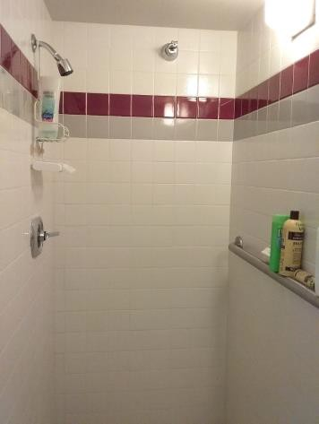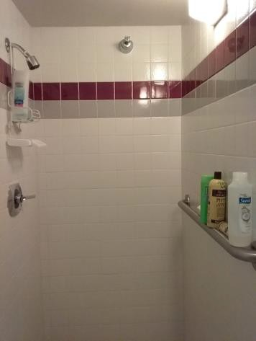

 | ID:  1144 | Facility:  Capitol Library

Location: 3rd Floor All Users Restroom
Schedule: 2022
Estimated Cost: $500.00

Priority Score 5
Quick Fix: Yes
Built before ADA: Yes

VIOLATIONS
2010 ADA Standards for Accessible Design Codes: §903.3
The bench is not deep or long enough at 17" and 11" wide.

RECOMMENDATIONS
Install a new bench that is at least 42" long and 20" to 24" inches deep.

PHOTOGRAPH(S) OF THIS LOCATION

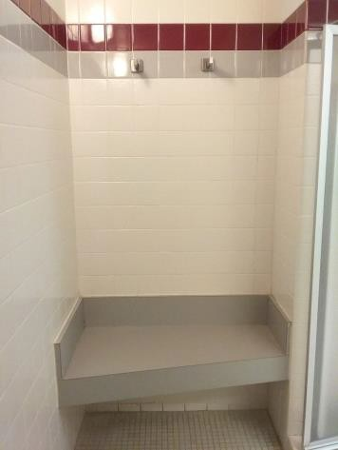

 | ID:  1198 | Facility:  Capitol Library

Location: 1st Floor Hays Auditorium Men's Restroom
Schedule: 2022
Estimated Cost: $500.00

Priority Score 5
Quick Fix: Yes
Built before ADA: Yes

VIOLATIONS
2010 ADA Standards for Accessible Design Codes: §604.5.2
The rear grab bar is located 10.5" to the center of the toilet.

RECOMMENDATIONS
Remount the rear grab bar to extend from the centerline of the water closet 12" minimum on one side and 24" minimum on the other.

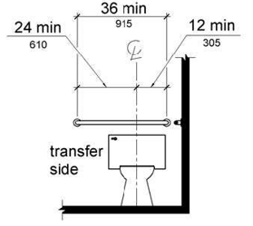

PHOTOGRAPH(S) OF THIS LOCATION

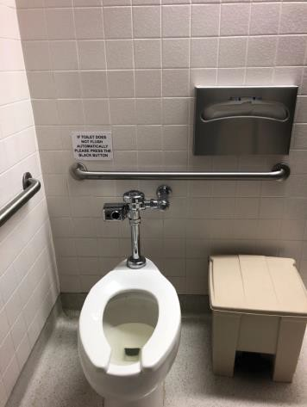

 | ID:  1210 | Facility:  Capitol Library

Location: 1st Floor Men's Restroom
Schedule: 2022
Estimated Cost: $500.00

Priority Score 5
Quick Fix: Yes
Built before ADA: Yes

VIOLATIONS
2010 ADA Standards for Accessible Design Codes: ICC A117.1 §604.5.1
The accessible water closet does not have a vertical grab bar per Idaho Statues.

RECOMMENDATIONS
Install an 18" long (minimum) vertical grab bar on the side wall. The grab bar shall be mounted with the bottom located at 39" minimum and 41" maximum above the floor.
The centerline of the vertical grab bar shall be located 39" minimum and 41" maximum from the real wall.

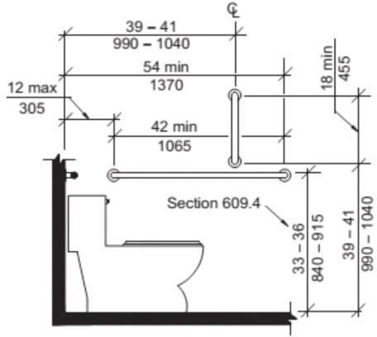

PHOTOGRAPH(S) OF THIS LOCATION

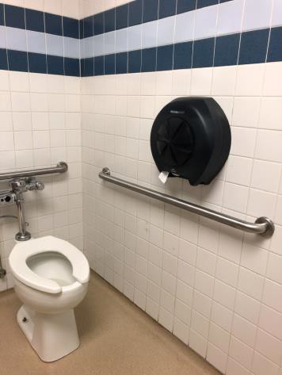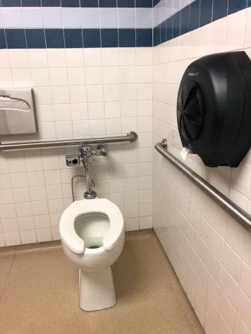

 | ID:  1177 | Facility:  Capitol Library

Location: 1st Floor Hays Auditorium
Schedule: 2023
Estimated Cost: $1,000.00

Priority Score 8
Quick Fix: No
Built before ADA: Yes

VIOLATIONS
2010 ADA Standards for Accessible Design Codes: §902.3
The dining and work surface counter is 36" above the floor.

RECOMMENDATIONS
A portion of the dining and work surface must be no higher than 34” above the ground.

PHOTOGRAPH(S) OF THIS LOCATION

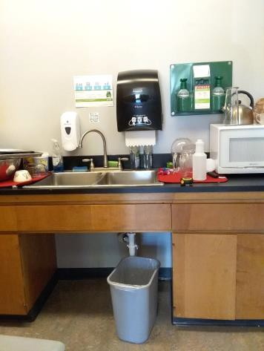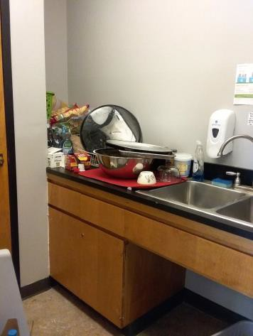

 | ID:  1084 | Facility:  Capitol Library

Location: 1st Floor Hays Auditorium Women's Restroom
Schedule: 2022
Estimated Cost: $1,000.00

Priority Score 5
Quick Fix: No
Built before ADA: Yes

VIOLATIONS
2010 ADA Standards for Accessible Design Codes: §604.2
The toilet is 19" from the sidewall.

RECOMMENDATIONS
Reposition the toilet to be within 16" minimum and 18" maximum from the toilet's centerline.

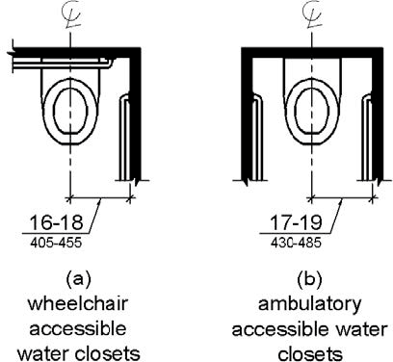

PHOTOGRAPH(S) OF THIS LOCATION

 | ID:  1104 | Facility:  Capitol Library

Location: 1st Floor ATS
Schedule: 2022
Estimated Cost: $1,000.00

Priority Score 5
Quick Fix: No
Built before ADA: Yes

VIOLATIONS
2010 ADA Standards for Accessible Design Codes: §306.3.3
There is no knee clearance underneath the counter.

RECOMMENDATIONS
Provide knee clearance underneath the counter at the sink that is a minimum of 11" deep at 9" above the floor and 8" deep at 27" above the floor.

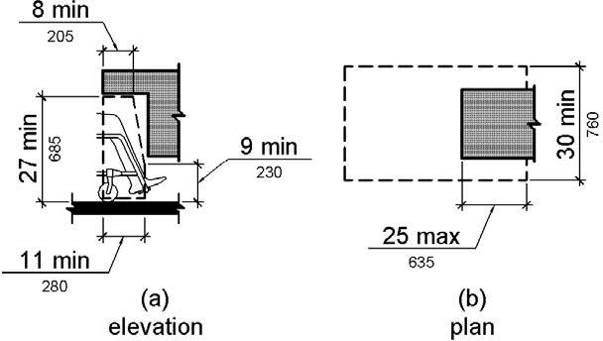

PHOTOGRAPH(S) OF THIS LOCATION

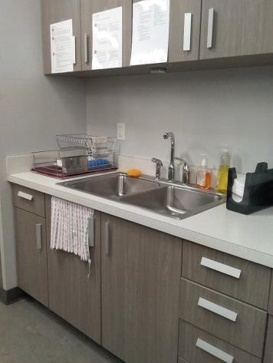

 | ID:  1128 | Facility:  Capitol Library

Location: 3rd Floor All Users Restroom
Schedule: 2022
Estimated Cost: $1,000.00

Priority Score 6
Quick Fix: No
Built before ADA: Yes

VIOLATIONS
2010 ADA Standards for Accessible Design Codes: §610.3.1, §610.3.2
The shower does not have a seat.

RECOMMENDATIONS
Install a permanent shower seat between 17" and 19" above the floor. The shower seat dimensions and shape shall comply with §610.3.

PHOTOGRAPH(S) OF THIS LOCATION

 | ID:  1134 | Facility:  Capitol Library

Location: 3rd Floor All Users Restroom
Schedule: 2022
Estimated Cost: $1,000.00

Priority Score 5
Quick Fix: No
Built before ADA: Yes

VIOLATIONS
2010 ADA Standards for Accessible Design Codes: §604.5.1
The side grab bar is 30" long.

RECOMMENDATIONS
Replace the side grab bar with one that is a minimum of 42" long minimum, located 12" maximum from the rear wall and extending 54" from the rear wall.
Locate the side grab bar on the wall side.

PHOTOGRAPH(S) OF THIS LOCATION

 | ID:  1143 | Facility:  Capitol Library

Location: 3rd Floor All Users Restroom
Schedule: 2022
Estimated Cost: $1,000.00

Priority Score 6
Quick Fix: No
Built before ADA: Yes

VIOLATIONS
2010 ADA Standards for Accessible Design Codes: §610.3.1, §610.3.2
The shower does not have a seat.

RECOMMENDATIONS
Install a permanent shower seat between 17" and 19" above the floor. The shower seat dimensions and shape shall comply with §610.3.

PHOTOGRAPH(S) OF THIS LOCATION

 | ID:  1147 | Facility:  Capitol Library

Location: 3rd Floor All Users Restroom
Schedule: 2022
Estimated Cost: $1,000.00

Priority Score 5
Quick Fix: No
Built before ADA: Yes

VIOLATIONS
2010 ADA Standards for Accessible Design Codes: §604.5.1, §604.5.2
There is no rear grab bar. The side grab bar is 29" long.

RECOMMENDATIONS
Install a rear grab bar that is a minimum of 36" long minimum and extends from the centerline of the water closet 12" minimum on one side and 24" minimum on the other.
Install a side grab bar on the wall side that is a minimum of 42" long minimum, located 12" maximum from the real wall and extending 54" from the rear wall.

PHOTOGRAPH(S) OF THIS LOCATION

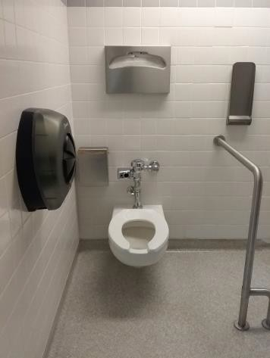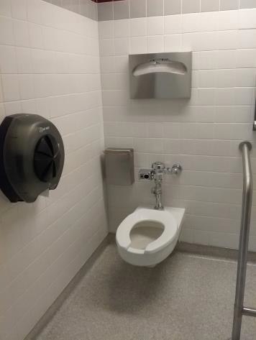

 | ID:  1159 | Facility:  Capitol Library

Location: 4th Floor Kitchen
Schedule: 2022
Estimated Cost: $1,000.00

Priority Score 5
Quick Fix: No
Built before ADA: Yes

VIOLATIONS
2010 ADA Standards for Accessible Design Codes: §902.3, §306.3.3
There is no knee clearance underneath the counter. The dining and work surface counter is 36" above the floor.

RECOMMENDATIONS
Provide knee clearance underneath the counter at the sink that is a minimum of 11" deep at 9" above the floor and 8" deep at 27" above the floor.
A portion of the dining and work surface must be no higher than 34” above the floor.

PHOTOGRAPH(S) OF THIS LOCATION

 | ID:  1194 | Facility:  Capitol Library

Location: 1st Floor Hays Auditorium Men's Restroom
Schedule: 2022
Estimated Cost: $1,000.00

Priority Score 5
Quick Fix: No
Built before ADA: Yes

VIOLATIONS
2010 ADA Standards for Accessible Design Codes: §605.2
The urinal height is 25" above the floor.

RECOMMENDATIONS
Lower the urinal so its rim is a maximum height 17" above the floor.

PHOTOGRAPH(S) OF THIS LOCATION

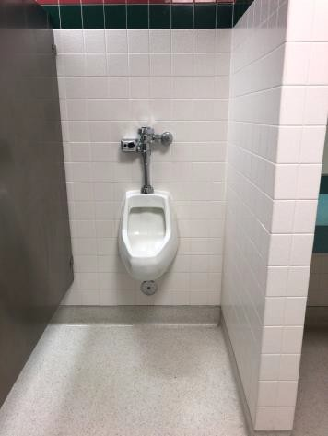

 | ID:  1208 | Facility:  Capitol Library

Location: 1st Floor Men's Restroom
Schedule: 2022
Estimated Cost: $1,000.00

Priority Score 5
Quick Fix: No
Built before ADA: Yes

VIOLATIONS
2010 ADA Standards for Accessible Design Codes: §604.2
The toilet is 19" from the sidewall.

RECOMMENDATIONS
Reposition the toilet to be within 16" minimum and 18" maximum from the sidewall.

PHOTOGRAPH(S) OF THIS LOCATION

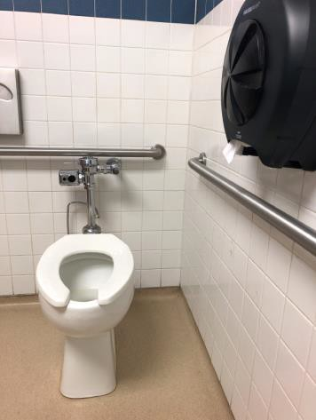

 | ID:  1212 | Facility:  Capitol Library

Location: Stairwell
Schedule: 2022
Estimated Cost: $1,000.00

Priority Score 6
Quick Fix: No
Built before ADA: Yes

VIOLATIONS
2010 ADA Standards for Accessible Design Codes: §505.2
There are no handrails.

RECOMMENDATIONS
Install handrails at a minimum height of 34” and maximum of 38” above the ground. Make sure there are adequate handrail extensions both at the top and bottom of the handrail.
Handrails shall extend 12" at the top of the stair flight, and at the bottom, they shall return to a wall, guard, or landing surface.

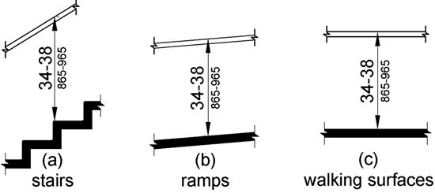

PHOTOGRAPH(S) OF THIS LOCATION

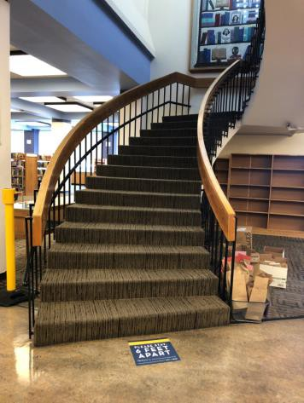

 | ID:  1218 | Facility:  Capitol Library

Location: 3rd Floor Admin Corner Office
Schedule: 2022
Estimated Cost: $1,000.00

Priority Score 5
Quick Fix: No
Built before ADA: Yes

VIOLATIONS
2010 ADA Standards for Accessible Design Codes: §306.3.3
There is no knee clearance underneath the counter.

RECOMMENDATIONS
Provide knee clearance underneath the counter at the sink that is a minimum of 11" deep at 9" above the floor and 8" deep at 27" above the floor.

PHOTOGRAPH(S) OF THIS LOCATION

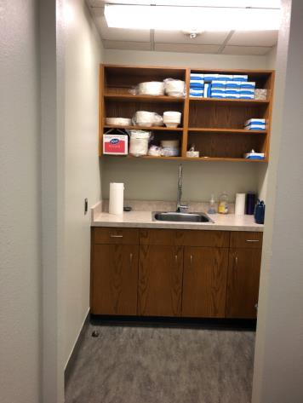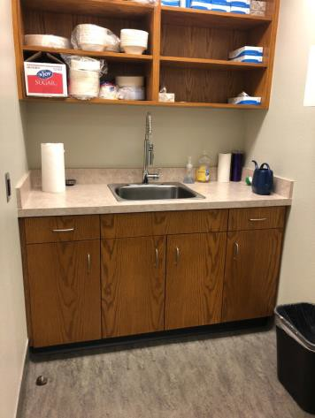

 | ID:  1220 | Facility:  Capitol Library

Location: 3rd Floor Men's Restroom
Schedule: 2022
Estimated Cost: $1,000.00

Priority Score 5
Quick Fix: No
Built before ADA: Yes

VIOLATIONS
2010 ADA Standards for Accessible Design Codes: §605.2
The urinal rim is 24" above the floor.

RECOMMENDATIONS
Lower the urinal so the rim is a maximum height of 17" above the floor.

PHOTOGRAPH(S) OF THIS LOCATION

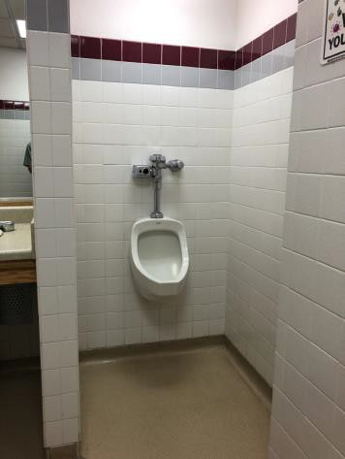

 | ID:  1230 | Facility:  Capitol Library

Location: 4th Floor Men's Restroom
Schedule: 2022
Estimated Cost: $1,000.00

Priority Score 5
Quick Fix: No
Built before ADA: Yes

VIOLATIONS
2010 ADA Standards for Accessible Design Codes: §404.2.6
The distance between the two hinged or pivoted doors is 36", which is lower than the 48" required.

RECOMMENDATIONS
Remove one of the doors to ensure adequate maneuvering clearance of 48" between the two doorways.

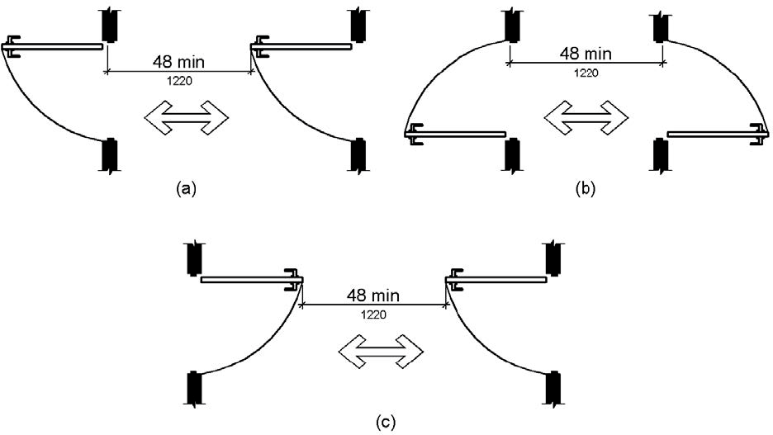

PHOTOGRAPH(S) OF THIS LOCATION

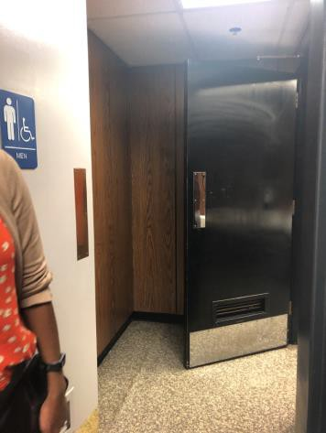

 | ID:  1231 | Facility:  Capitol Library

Location:
Schedule:
Estimated Cost:

Priority Score 7
Quick Fix: No
Built before ADA: Yes

VIOLATIONS
2010 ADA Standards for Accessible Design Codes: §604.8.1.1
The toilet compartment size is too small at 56" deep and 38" wide.

RECOMMENDATIONS
Combine the two non-accessible stalls into one 60" wide wheelchair accessible toilet stall, complying with §604.8.

PHOTOGRAPH(S) OF THIS LOCATION

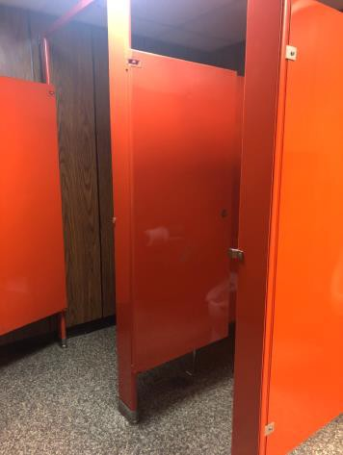

 | ID:  1235 | Facility:  Capitol Library

Location: 4th Floor Men's Restroom
Schedule: 2022
Estimated Cost: $1,000.00

Priority Score 5
Quick Fix: No
Built before ADA: Yes

VIOLATIONS
2010 ADA Standards for Accessible Design Codes: §605.2
The urinals are 23" above the floor.

RECOMMENDATIONS
Lower at least one of the urinals to a maximum height of 17"above the floor.

PHOTOGRAPH(S) OF THIS LOCATION

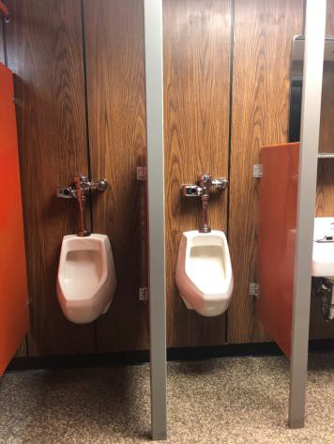

 | ID:  1243 | Facility:  Capitol Library

Location: Book Return Crosswalk in Parking Lot
Schedule: 2022
Estimated Cost: $1,000.00

Priority Score 5
Quick Fix: No
Built before ADA: Yes

VIOLATIONS
2010 ADA Standards for Accessible Design Codes: §303.2
The crack in the pavement is 2.5" wide and 1.5" deep.

RECOMMENDATIONS
Resurface the pathway to reduce the change in level to less than 0.25".

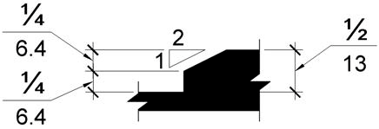

PHOTOGRAPH(S) OF THIS LOCATION

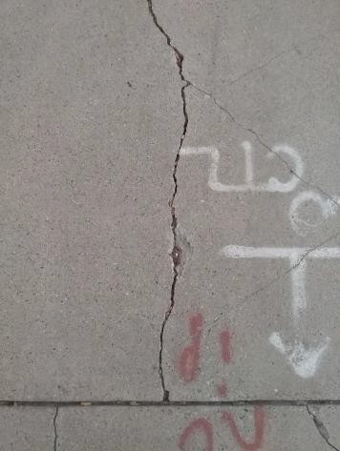

 | ID:  1253 | Facility:  Capitol Library

Location: Main Entrance
Schedule: 2022
Estimated Cost: $1,000.00

Priority Score 5
Quick Fix: No
Built before ADA: Yes

VIOLATIONS
2010 ADA Standards for Accessible Design Codes: §505.10.1
Handrails extension are located in an area with a 3% running slope.

RECOMMENDATIONS
Extensions are required at the top and bottom of the ramp run. After a ramp run, there must be level landings with a maximum slope of 2%. Extend the handrails so that the handrail extensions are located in an area with slopes not exceeding 2%. The handrail extensions shall either return to a wall, guard, or the landing surface which extend at least 12" beyond the ramp run.

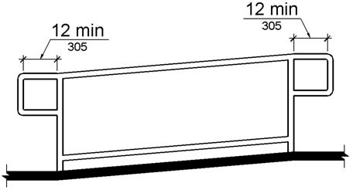

PHOTOGRAPH(S) OF THIS LOCATION

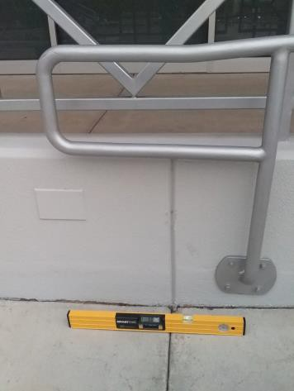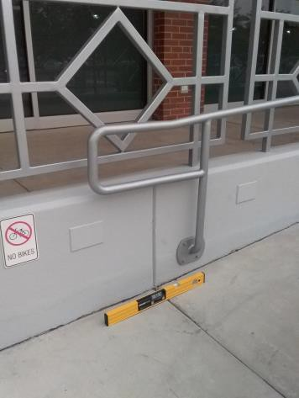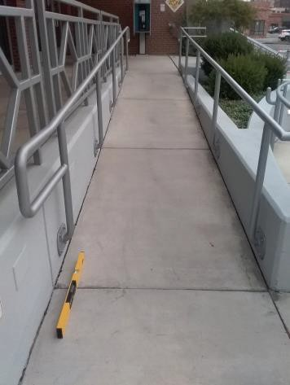

 | ID:  1158 | Facility:  Capitol Library

Location: 3rd Floor Reference Desk
Schedule: 2021
Estimated Cost: $1,000.00

Priority Score 4
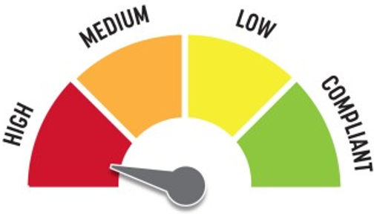
Quick Fix: No
Built before ADA: Yes

VIOLATIONS
2010 ADA Standards for Accessible Design Codes: §904.4.1
The counter is 42" above the floor.

RECOMMENDATIONS
A portion of the service counter must be no higher than 36” above the floor for a horizontal distance of 36”.

PHOTOGRAPH(S) OF THIS LOCATION

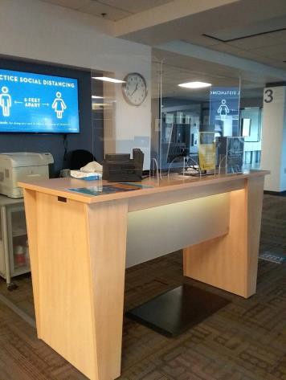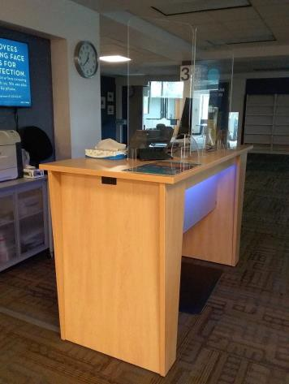

 | ID:  1193 | Facility:  Capitol Library

Location: 1st Floor Hays Auditorium Men's Restroom
Schedule: 2021
Estimated Cost: $1,000.00

Priority Score 5
Quick Fix: No
Built before ADA: Yes

VIOLATIONS
2010 ADA Standards for Accessible Design Codes: §307.2
The paper towel dispenser is 10" deep and protrudes 6" beyond

RECOMMENDATIONS
The dispenser is not located in an accessible path, however, for purposes of achieving greater accessibility and Human Centric Design, recess the dispenser so it protrudes a maximum of 4".
Lower it so the bottom edge is 27" maximum above the floor, or place a cane-detectable object beneath it.

PHOTOGRAPH(S) OF THIS LOCATION

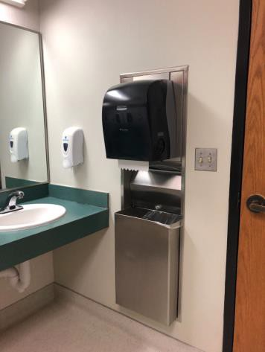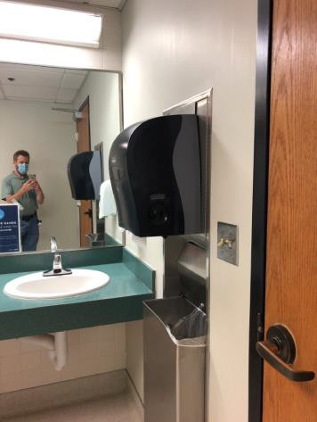

 | ID:  1200 | Facility:  Capitol Library

Location: 1st Floor Youth Services Boy's Restroom
Schedule: 2021
Estimated Cost: $1,000.00

Priority Score 3
Quick Fix: No
Built before ADA: Yes

VIOLATIONS
2010 ADA Standards for Accessible Design Codes: §404.2.4
The maneuvering clearance at the restroom door is not accessible.

RECOMMENDATIONS
Relocate the table to provide a maneuvering clearance 60" perpendicular to the door and 18" parallel to the door.

PHOTOGRAPH(S) OF THIS LOCATION

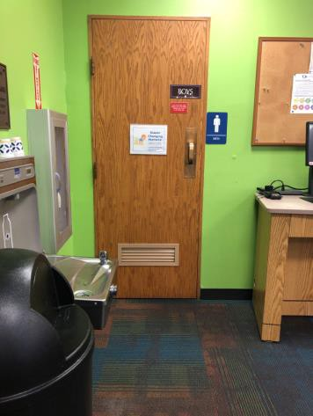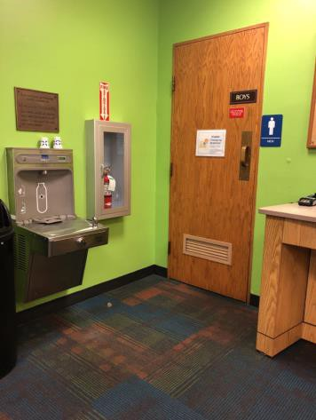

 | ID:  1268 | Facility:  Capitol Library

Location: Parking
Schedule: 2021
Estimated Cost: $1,000.00

Priority Score 3
Quick Fix: No
Built before ADA: Yes

VIOLATIONS
2010 ADA Standards for Accessible Design Codes: §208.2
There is a total of 143 spaces and only 3 spaces are designated as accessible.

RECOMMENDATIONS
Pave two additional accessible spaces 96" wide and 60" access aisle. Ensure that the slope is a maximum of 2% in all direction.

PHOTOGRAPH(S) OF THIS LOCATION

 | ID:  1204 | Facility:  Capitol Library

Location: 1st Floor Youth Services Staff Workroom
Schedule: 2022
Estimated Cost: $1,500.00

Priority Score 5
Quick Fix: No
Built before ADA: Yes

VIOLATIONS
2010 ADA Standards for Accessible Design Codes: §902.3, §306.3.3
There is no knee clearance underneath the counter. The dining and work surface counter is 36" above the floor.

RECOMMENDATIONS
Provide knee clearance underneath the counter at the sink that is a minimum of 11" deep at 9" above the floor and 8" deep at 27" above the floor. A portion of the dining and work surface must be no higher than 34” above the floor.

PHOTOGRAPH(S) OF THIS LOCATION

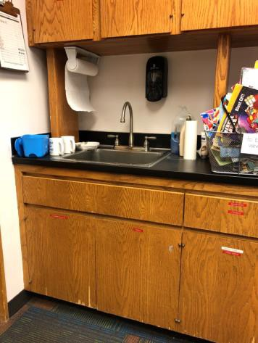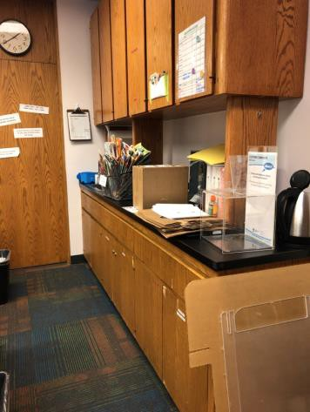

 | ID:  1175 | Facility:  Capitol Library

Location: Friends of the Library Storage
Schedule: 2023
Estimated Cost: $2,000.00

Priority Score 8
Quick Fix: No
Built before ADA: Yes

VIOLATIONS
2010 ADA Standards for Accessible Design Codes: §403.5.1
The shelves are too close together and there is not a clear width of 36" for wheelchairs to pass. The distances are 29" and 32".

RECOMMENDATIONS
Move the shelves to provide a minimum distance of 36" between the shelves. This is an employee work area and remediation is required only if requested by a qualified employee.
Ensure that the library has a policy that provides assistance to employees and volunteers reaching for shelves that are located beyond 48” above the floor.

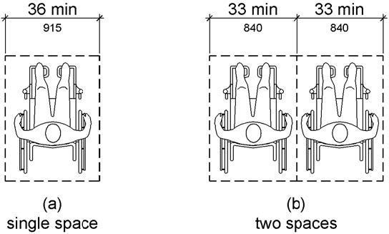

PHOTOGRAPH(S) OF THIS LOCATION

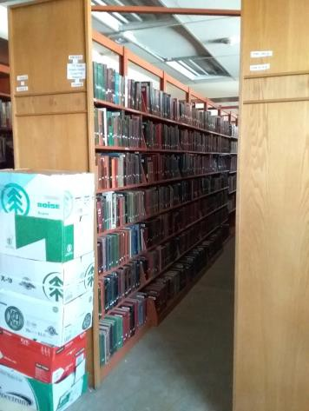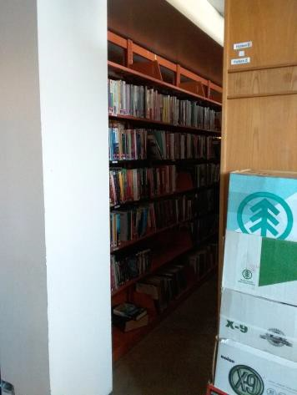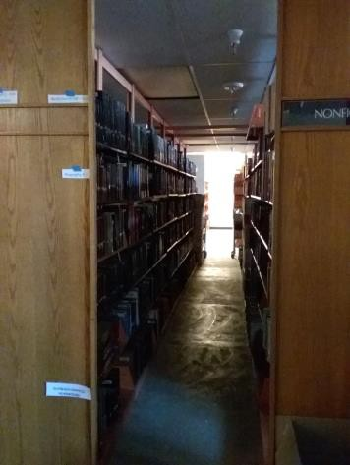

 | ID:  1088 | Facility:  Capitol Library

Location: 1st Floor Hays Auditorium
Schedule: 2022
Estimated Cost: $2,000.00

Priority Score 6
Quick Fix: No
Built before ADA: Yes

VIOLATIONS
2010 ADA Standards for Accessible Design Codes: §211.2, §602.7
There is only one drinking fountain provided.

RECOMMENDATIONS
Install an additional drinking fountain at a minimum spout height of 38" and maximum of 43" above the floor.

PHOTOGRAPH(S) OF THIS LOCATION

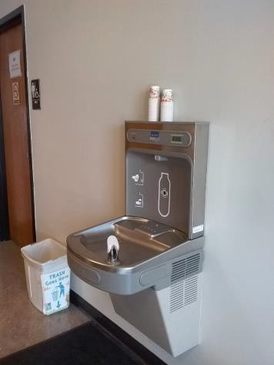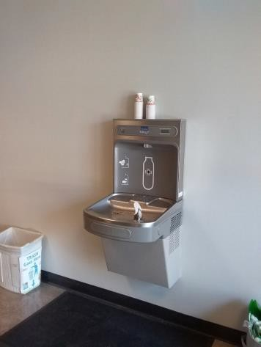

 | ID:  1090 | Facility:  Capitol Library

Location: 1st Floor Youth Services Girl's Restroom
Schedule: 2022
Estimated Cost: $2,000.00

Priority Score 7
Quick Fix: No
Built before ADA: Yes

VIOLATIONS
2010 ADA Standards for Accessible Design Codes: §604.8.1.1
The toilet compartment size is too small.

RECOMMENDATIONS
Combine the two non-accessible stalls into one 60" wide wheelchair accessible toilet stall. Add grab bars at a minimum height of 33" and 36" maximum above the floor.

PHOTOGRAPH(S) OF THIS LOCATION

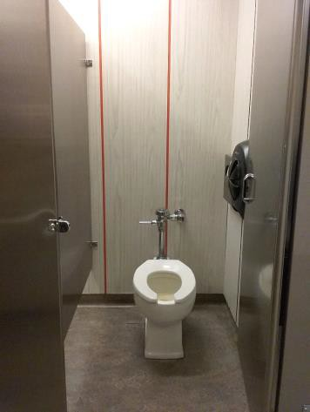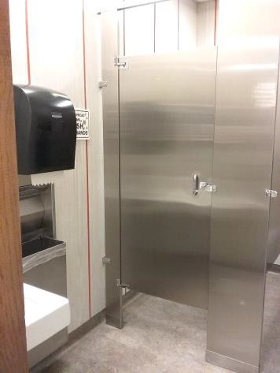

 | ID:  1107 | Facility:  Capitol Library

Location: 1st Floor Women's Restroom
Schedule: 2022
Estimated Cost: $2,000.00

Priority Score 6
Quick Fix: No
Built before ADA: Yes

VIOLATIONS
2010 ADA Standards for Accessible Design Codes: §211.2, §602.7
There is only one drinking fountain provided.

RECOMMENDATIONS
Install an additional drinking fountain at a minimum spout height of 38" and maximum of 43" above the floor.

PHOTOGRAPH(S) OF THIS LOCATION

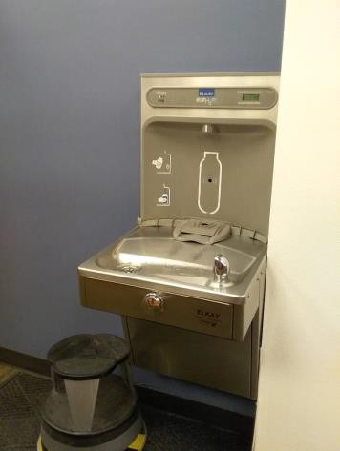

 | ID:  1133 | Facility:  Capitol Library

Location: 3rd Floor All Users Restroom
Schedule: 2022
Estimated Cost: $2,000.00

Priority Score 5
Quick Fix: No
Built before ADA: Yes

VIOLATIONS
2010 ADA Standards for Accessible Design Codes: §604.5.1, §604.5.2
There is no rear grab bar. The side grab bar is 30" long.

RECOMMENDATIONS
Install a rear grab bar that is a minimum of 36" long minimum and extends from the centerline of the water closet 12" minimum on one side and 24" minimum on the other.
Replace the side grab bar with one that is a minimum of 42" long minimum, located 12" maximum from the rear wall and extending 54" from the rear wall. Locate the side grab bar on the wall side.

PHOTOGRAPH(S) OF THIS LOCATION

 | ID:  1155 | Facility:  Capitol Library

Location: 3rd Floor Drinking Fountain
Schedule: 2022
Estimated Cost: $2,000.00

Priority Score 6
Quick Fix: No
Built before ADA: Yes

VIOLATIONS
2010 ADA Standards for Accessible Design Codes: §211.2, §602.7
There is only one drinking fountain provided at a spout height of 33" above the floor.

RECOMMENDATIONS
Install an additional drinking fountain at a minimum spout height of 38" and maximum of 43" above the floor.

PHOTOGRAPH(S) OF THIS LOCATION

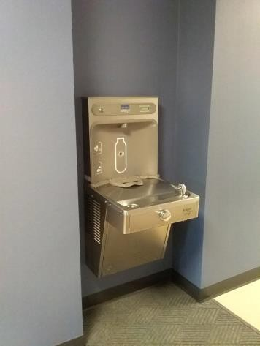

 | ID:  1162 | Facility:  Capitol Library

Location: 4th Floor Restrooms
Schedule: 2022
Estimated Cost: $2,000.00

Priority Score 6
Quick Fix: No
Built before ADA: Yes

VIOLATIONS
2010 ADA Standards for Accessible Design Codes: §211.2, §602.4, §703.4.2
There is only one drinking fountain provided at 36.5".

RECOMMENDATIONS
Lower the current drinking fountain to a maximum of 36" above the floor. Install an additional drinking fountain at a minimum height of 38" and maximum of 43" above the floor.
Relocate the drinking fountain to prove a 18"x18" clear floor space in front of the restroom sign.

PHOTOGRAPH(S) OF THIS LOCATION

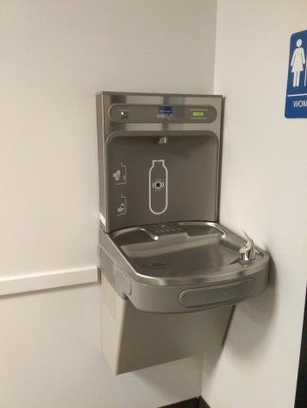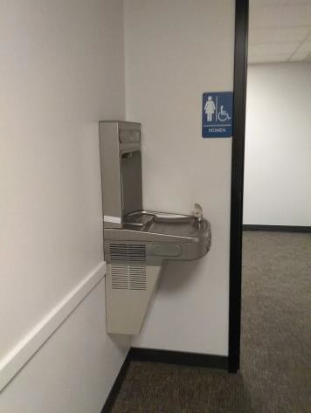

 | ID:  1165 | Facility:  Capitol Library

Location: 4th Floor Women's Ambulatory Restroom
Schedule: 2022
Estimated Cost: $2,000.00

Priority Score 5
Quick Fix: No
Built before ADA: Yes

VIOLATIONS
2010 ADA Standards for Accessible Design Codes: §604.5.1
The side grab bars are not long enough.

RECOMMENDATIONS
Replace the side grab bars with ones that are a minimum of 42" long minimum, located 12" maximum from the rear wall and extending 54" from the rear wall.

PHOTOGRAPH(S) OF THIS LOCATION

 | ID:  1178 | Facility:  Capitol Library

Location: 1st Floor Youth Services
Schedule: 2022
Estimated Cost: $2,000.00

Priority Score 6
Quick Fix: No
Built before ADA: Yes

VIOLATIONS
2010 ADA Standards for Accessible Design Codes: §211.2, §602.7
There is only one drinking fountain provided.

RECOMMENDATIONS
Install an additional drinking fountain at a minimum height of 38" and maximum of 43" above the floor.

PHOTOGRAPH(S) OF THIS LOCATION

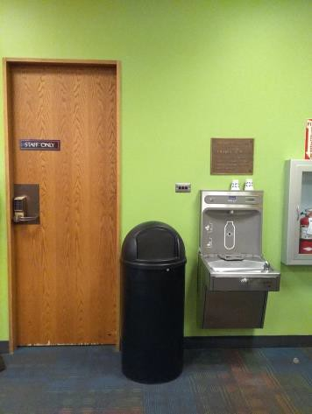

 | ID:  1179 | Facility:  Capitol Library

Location: 1st Floor
Schedule: 2022
Estimated Cost: $2,000.00

Priority Score 5
Quick Fix: No
Built before ADA: Yes

VIOLATIONS
2010 ADA Standards for Accessible Design Codes: §405.2, §505.2, §505.10.1
There is a handrail on one side. Handrails do not extend at least 12" beyond the ramp run. The running slope of the ramp is 13.5%.

RECOMMENDATIONS
Install a handrail on the wall at a minimum height of 34” and maximum of 38” above the ground. Extend the ramp handrails 12” horizontally beyond the top and bottom of ramp run.
Reconstruct the ramp to reduce the running slope to less than 8.3%. Provide a 60" level landing for every 30" of length.

PHOTOGRAPH(S) OF THIS LOCATION

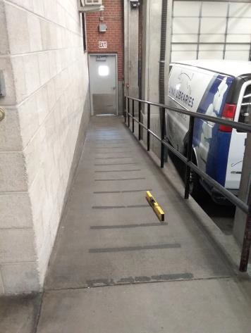

 | ID:  1186 | Facility:  Capitol Library

Location: 3rd Floor Staff Break Room
Schedule: 2022
Estimated Cost: $2,000.00

Priority Score 5
Quick Fix: No
Built before ADA: Yes

VIOLATIONS
2010 ADA Standards for Accessible Design Codes: §306.3.3, §902.3
The dining and work surface counter is 36" above the floor. There is no knee clearance underneath the counter. The suggestion box protrudes 6” into the circulation space at 39” above the floor. The shelf protrudes 19.5” into the circulation space at 41.75” above the floor.

RECOMMENDATIONS
A portion of the dining and work surface must be no higher than 34” above the floor. Provide knee clearance underneath the counter at the sink that is a minimum of 11" deep at 9" above the floor and 8" deep at 27" above the floor. Lower the shelf and box so the bottom edge is 27” maximum above the floor, or place a cane detectable object beneath them.

PHOTOGRAPH(S) OF THIS LOCATION

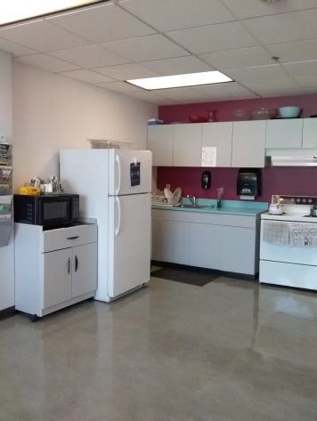

 | ID:  1187 | Facility:  Capitol Library

Location: 3rd Floor Staff Break Room
Schedule: 2022
Estimated Cost: $2,000.00

Priority Score 6
Quick Fix: No
Built before ADA: Yes

VIOLATIONS
2010 ADA Standards for Accessible Design Codes: §211.2, §602.7
There is only one drinking fountain provided.

RECOMMENDATIONS
Install an additional drinking fountain at a minimum height of 38" and maximum of 43" above the floor.

PHOTOGRAPH(S) OF THIS LOCATION

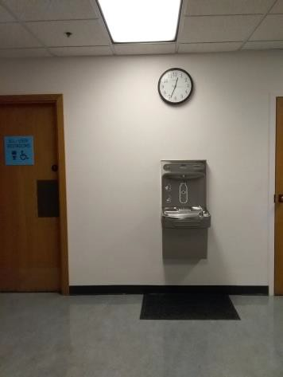

 | ID:  1195 | Facility:  Capitol Library

Location: 1st Floor Hays Auditorium Men's Restroom
Schedule: 2022
Estimated Cost: $2,000.00

Priority Score 7
Quick Fix: No
Built before ADA: Yes

VIOLATIONS
2010 ADA Standards for Accessible Design Codes: §604.8.1.1
The toilet compartment is 53" wide.

RECOMMENDATIONS
Relocate partition to provide a 60" wide wheelchair accessible toilet stall, complying with §604.8.

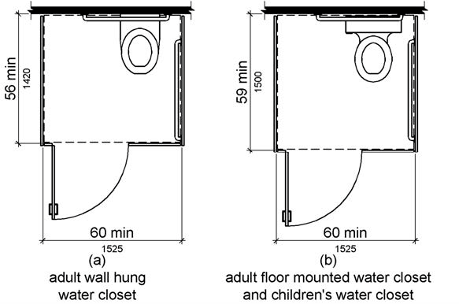

PHOTOGRAPH(S) OF THIS LOCATION

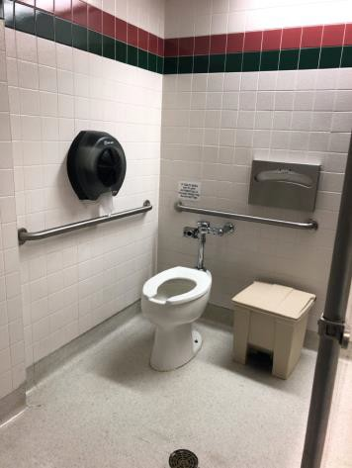

 | ID:  1216 | Facility:  Capitol Library

Location: 2nd Floor Drinking Fountain
Schedule: 2022
Estimated Cost: $2,000.00

Priority Score 6
Quick Fix: No
Built before ADA: Yes

VIOLATIONS
2010 ADA Standards for Accessible Design Codes: §211.2, §602.7
There is only one drinking fountain provided at a height of 32" above the floor.

RECOMMENDATIONS
Install an additional drinking fountain at a minimum height of 38" and maximum of 43" above the floor.

PHOTOGRAPH(S) OF THIS LOCATION

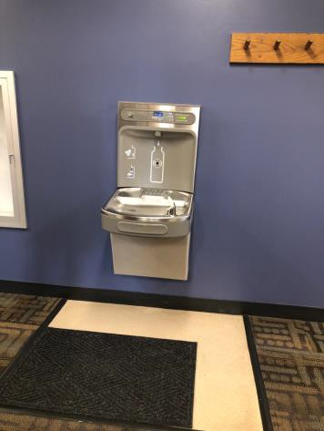

 | ID:  1261 | Facility:  Capitol Library

Location: Parking by Book Returns
Schedule: 2021
Estimated Cost: $2,000.00

Priority Score 3
Quick Fix: No
Built before ADA: Yes

VIOLATIONS
2010 ADA Standards for Accessible Design Codes: §502.4
The accessible parking space has a 3.1% slope.

RECOMMENDATIONS
Resurface the parking space to reduce the slope to less than 2% in all directions.
Relocate the accessible space to be located near the entrance.

PHOTOGRAPH(S) OF THIS LOCATION

 | ID:  1259 | Facility:  Capitol Library

Location: Curb Ramp by Book Returns
Schedule: 2022
Estimated Cost: $2,500.00

Priority Score 7
Quick Fix: No
Built before ADA: Yes

VIOLATIONS
2010 ADA Standards for Accessible Design Codes: §405.2
The running slope of the curb ramp is 11.6%.

RECOMMENDATIONS
Reconstruct the curb ramp to reduce the running slope to a maximum of 8.3%.
if the accessible parking space is relocated, the is remediation will be required only if requested by a qualified employee.

PHOTOGRAPH(S) OF THIS LOCATION

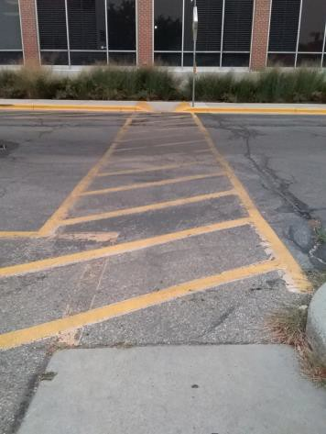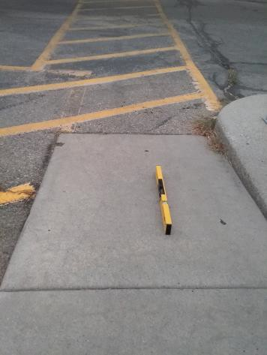

 | ID:  1250 | Facility:  Capitol Library

Location: SW of the Library Building
Schedule: 2021
Estimated Cost: $4,000.00

Priority Score 3
Quick Fix: No
Built before ADA: Yes

VIOLATIONS
2010 ADA Standards for Accessible Design Codes: §502.4
The access aisle has a 3% cross slope. Parking by Idaho Anne Frank Human Rights Memorial.

RECOMMENDATIONS
Resurface the access aisle to reduce the slope to less than 2% in all directions.

PHOTOGRAPH(S) OF THIS LOCATION

 | ID:  1126 | Facility:  Capitol Library

Location: 3rd Floor All Users Restroom
Schedule: 2022
Estimated Cost: $5,000.00

Priority Score 6
Quick Fix: No
Built before ADA: Yes

VIOLATIONS
2010 ADA Standards for Accessible Design Codes: §213.3.6
There is a 5.25" step at the shower entrance, rendering the shower inaccessible.

RECOMMENDATIONS
Install at least one accessible shower complying with §607 or §608.

PHOTOGRAPH(S) OF THIS LOCATION

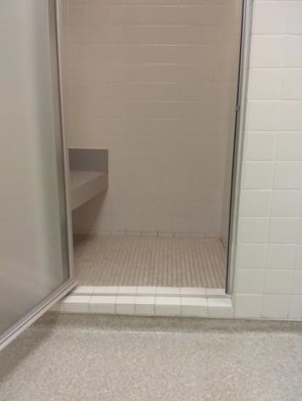

 | ID:  1169 | Facility:  Capitol Library

Location: 4th Floor Women's Ambulatory Restroom
Schedule: 2022
Estimated Cost: $5,000.00

Priority Score 7
Quick Fix: No
Built before ADA: Yes

VIOLATIONS
2010 ADA Standards for Accessible Design Codes: §604.8.1.1
The toilet compartment size is too small at 37.5" wide and 55.5" deep.

RECOMMENDATIONS
Combine the two non-accessible stalls into one 60" wide wheelchair accessible toilet stall, complying with §604.8.

PHOTOGRAPH(S) OF THIS LOCATION

 | ID:  1191 | Facility:  Capitol Library

Location: Entire Facility
Schedule: 2022
Estimated Cost: $5,000.00

Priority Score 7
Quick Fix: No
Built before ADA: Yes

VIOLATIONS
2010 ADA Standards for Accessible Design Codes: §309.4
There are 50 door knobs throughout the facility that require twisting of the wrist.

RECOMMENDATIONS
Replace the door knobs with lever handles that can be operated with a closed fist and without twisting the wrist.

PHOTOGRAPH(S) OF THIS LOCATION

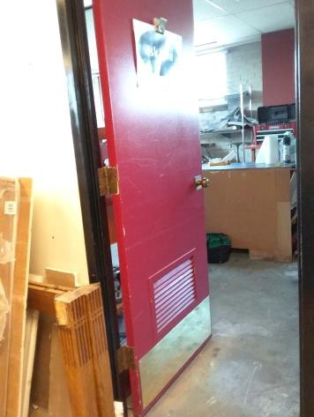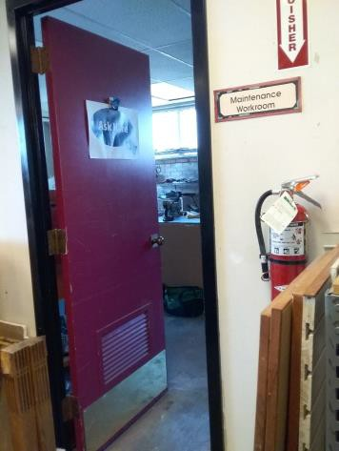

 | ID:  1203 | Facility:  Capitol Library

Location: 1st Floor Youth Services Boy's Restroom
Schedule: 2022
Estimated Cost: $5,000.00

Priority Score 7
Quick Fix: No
Built before ADA: Yes

VIOLATIONS
2010 ADA Standards for Accessible Design Codes: §604.8.1.1
The toilet compartment size is too small.

RECOMMENDATIONS
Combine the two non-accessible stalls into one single use unisex 60" wide wheelchair accessible toilet stall, complying with §604.8.

PHOTOGRAPH(S) OF THIS LOCATION

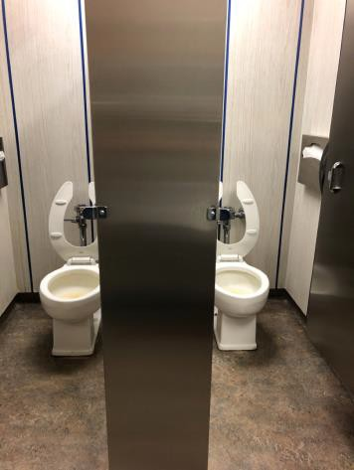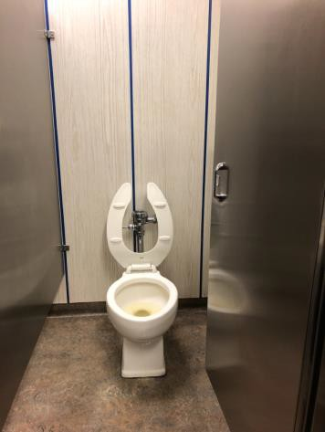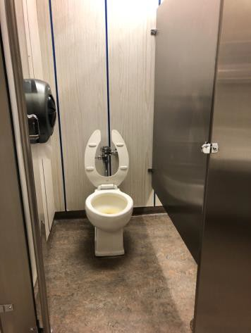

 | ID:  1213 | Facility:  Capitol Library

Location: 2nd Floor Men's Restroom
Schedule: 2022
Estimated Cost: $5,000.00

Priority Score 7
Quick Fix: No
Built before ADA: Yes

VIOLATIONS
2010 ADA Standards for Accessible Design Codes: §604.8.1.1
The toilet compartment size is too small at 40" wide.

RECOMMENDATIONS
Combine the two non-accessible stalls into one 60" wide wheelchair accessible toilet stall, complying with §604.8.

PHOTOGRAPH(S) OF THIS LOCATION

 | ID: | Facility:  Capitol Library

Location:
Schedule:
Estimated Cost:

Priority Score 7
Quick Fix: No
Built before ADA: Yes

VIOLATIONS
2010 ADA Standards for Accessible Design Codes §308.2.1

RECOMMENDATIONS

PHOTOGRAPH(S) OF THIS LOCATION

 | ID:  1241 | Facility:  Capitol Library

Location: Bike Parking
Schedule: 2022
Estimated Cost: $5,000.00

Priority Score 5
Quick Fix: No
Built before ADA: Yes

VIOLATIONS
2010 ADA Standards for Accessible Design Codes: §403.5.3
Due to the location of the bike rack in the accessible route, there is the possibility that the 36" clear width for wheelchairs to pass may be reduced based upon the placement of the bicycles.

RECOMMENDATIONS
Consider shifting the bike rack all the way to one side of the sidewalk to ensure that there is enough space.

PHOTOGRAPH(S) OF THIS LOCATION

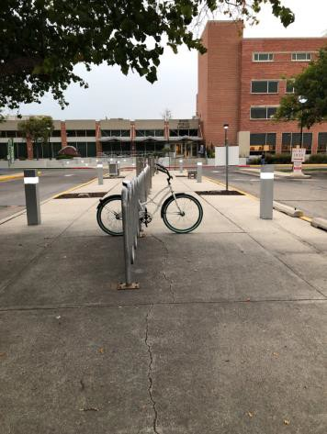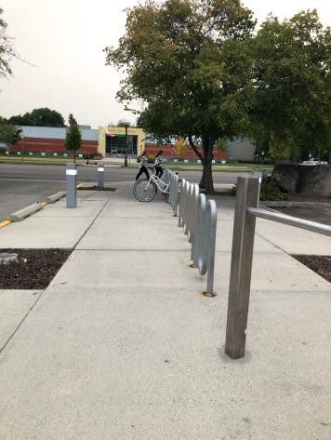

 | ID:  4458 | Facility:  Capitol Library

Location: Restrooms
Schedule: 2022
Estimated Cost: $5,000.00

Priority Score 5
Quick Fix: No
Built before ADA: Yes

VIOLATIONS
2010 ADA Standards for Accessible Design Codes: ICC A117.1 §604.5.1
The accessible water closets do not have a vertical grab bars.

RECOMMENDATIONS
Install vertical grab bars with a minimum length of 18". The grab bars shall be mounted with the bottom located at 39" minimum and 41" maximum above the floor.
The centerline of the vertical grab bars shall be located 39" minimum and 41" maximum from the real wall.

PHOTOGRAPH(S) OF THIS LOCATION

 | ID:  1205 | Facility:  Capitol Library

Location: 1st Floor Counters
Schedule: 2021
Estimated Cost: $5,000.00

Priority Score 4
Quick Fix: No
Built before ADA: Yes

VIOLATIONS
2010 ADA Standards for Accessible Design Codes: §904.4.1
The checkout counter is 39.5" above the floor.

RECOMMENDATIONS
A portion of the service counter must be no higher than 36” above the floor for a horizontal distance of 36”.

PHOTOGRAPH(S) OF THIS LOCATION

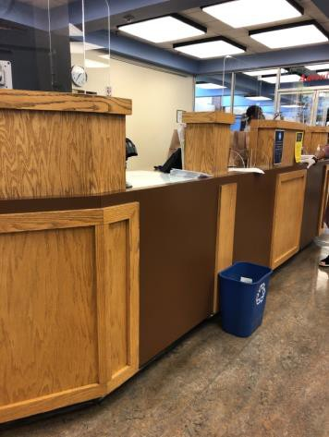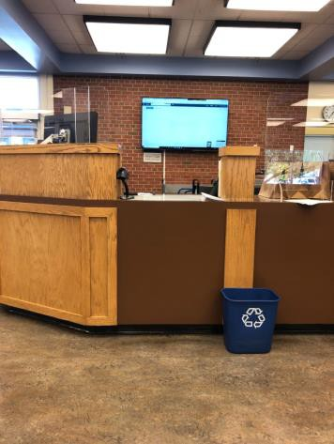

 | ID:  1219 | Facility:  Capitol Library

Location: 3rd Floor Men's Restroom
Schedule: 2021
Estimated Cost: $5,000.00

Priority Score 3
Quick Fix: No
Built before ADA: Yes

VIOLATIONS
2010 ADA Standards for Accessible Design Codes: §404.2.4.1 (h)
The hallway width is 45.5" wide, providing inadequate maneuvering clearance in front of the door.

RECOMMENDATIONS
Remove the hallway to provide a minimum of 48" maneuvering clearance in front of the door. In the meantime, provide signage directing users to the nearest accessible restroom.

PHOTOGRAPH(S) OF THIS LOCATION

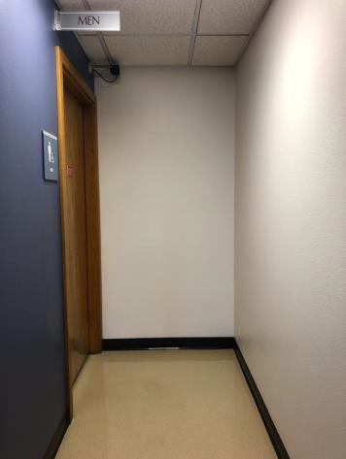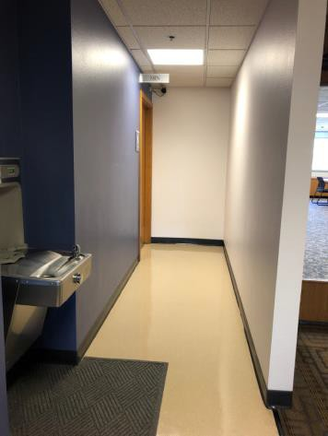

 | ID:  1244 | Facility:  Capitol Library

Location: Employee Parking
Schedule: 2021
Estimated Cost: $5,000.00

Priority Score 3
Quick Fix: No
Built before ADA: Yes

VIOLATIONS
2010 ADA Standards for Accessible Design Codes: §208.2, §206.2.1
There are no accessible parking spaces or an accessible route provided from the employee parking lot to the employee entrance.

RECOMMENDATIONS
Ensure that the library has a policy that either allows qualified employees with disabilities to park in the patron lot or provide an accessible parking space for employees with disabilities upon request of accommodation.

PHOTOGRAPH(S) OF THIS LOCATION

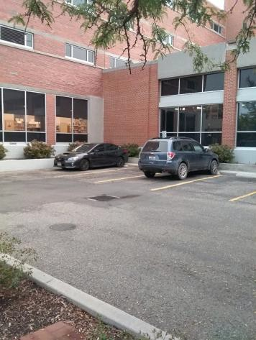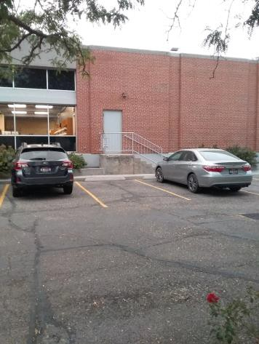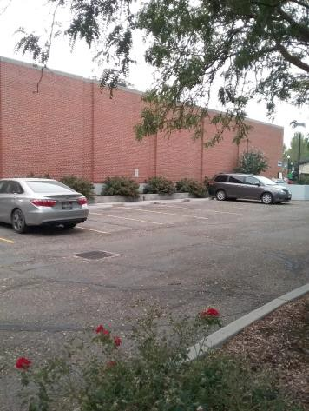

 | ID:  1257 | Facility:  Capitol Library

Location: Curb Ramp by Book Returns
Schedule: 2021
Estimated Cost: $5,000.00

Priority Score 3
Quick Fix: No
Built before ADA: Yes

VIOLATIONS
2010 ADA Standards for Accessible Design Codes: §403.5.1, §405.7
The curb ramp is not wide enough to provide access to wheelchairs and does not provide a level turning space at the top of

RECOMMENDATIONS
Reconstruct the curb ramp to provide a 36" wide accessible route. Pave a level landing with a minimum length of 60" and as wide as the ramp. The maximum slope shall be 2% in all directions.
Ensure that the maximum running and cross slopes of the sidewalk are 5% and 2% respectively.

PHOTOGRAPH(S) OF THIS LOCATION

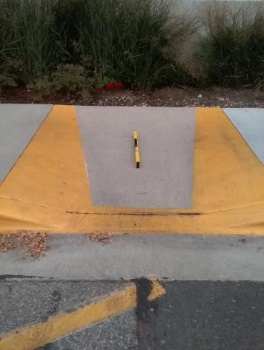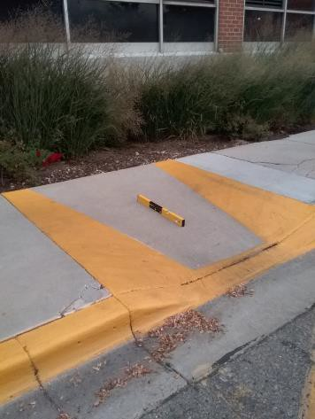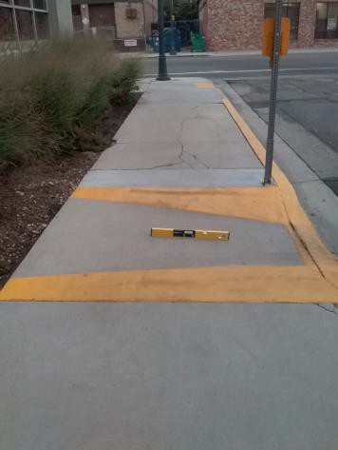

 | ID:  1263 | Facility:  Capitol Library

Location: Curbside Parking
Schedule: 2021
Estimated Cost: $5,000.00

Priority Score 3
Quick Fix: No
Built before ADA: Yes

VIOLATIONS
2010 ADA Standards for Accessible Design Codes: §502.4
The passenger loading zones have a 3.5% cross slope. The different colors of the curbside spaces may confuse the user.

RECOMMENDATIONS
Resurface the accessible passenger loading zones to reduce the slope to less than 2% in all directions.

PHOTOGRAPH(S) OF THIS LOCATION

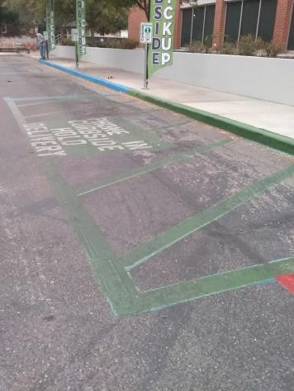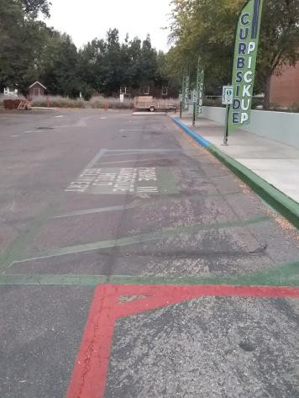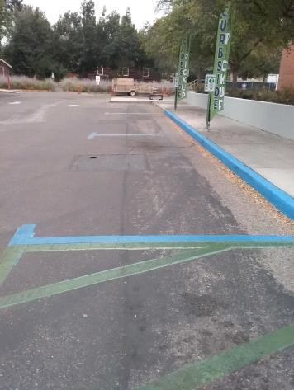

 | ID:  1265 | Facility:  Capitol Library

Location: Parking
Schedule: 2021
Estimated Cost: $5,000.00

Priority Score 3
Quick Fix: No
Built before ADA: Yes

VIOLATIONS
2010 ADA Standards for Accessible Design Codes: §502.4
Portions of the parking spaces and access aisle have a 3% running slope and 3.5% cross slope.

RECOMMENDATIONS
Resurface the parking spaces and access aisle to reduce the slope to less than 2% in all directions.

PHOTOGRAPH(S) OF THIS LOCATION

 | ID:  1140 | Facility:  Capitol Library

Location: 3rd Floor All Users Restroom
Schedule: 2021
Estimated Cost: $6,000.00

Priority Score 3
Quick Fix: No
Built before ADA: Yes

VIOLATIONS
2010 ADA Standards for Accessible Design Codes: §404.2.5, §607.6
There is a 5.25" step at the shower entrance and the spray unit is fixed.

RECOMMENDATIONS
Reconstruct the entrance to reduce the threshold to a maximum to 1/2". Install a new shower spray unit that has a 59" long minimum hose to be used both as a fixed-position shower head and as a hand-held shower.

PHOTOGRAPH(S) OF THIS LOCATION

 | ID:  1217 | Facility:  Capitol Library

Location: 2nd Floor Aisle by Wall
Schedule: 2022
Estimated Cost: $10,000.00

Priority Score 5
Quick Fix: No
Built before ADA: Yes

VIOLATIONS
2010 ADA Standards for Accessible Design Codes: §403.5.1
The wall columns reduce the width of the aisles to 34" wide for over 24" in length.

RECOMMENDATIONS
Move the shelves to provide a minimum distance of 36” between the shelves. Ensure that the library has a policy that provides assistance to patrons reaching for shelves that are located beyond 48” above the floor.

PHOTOGRAPH(S) OF THIS LOCATION

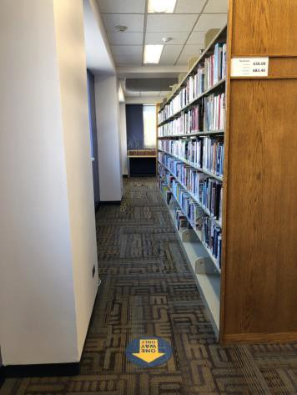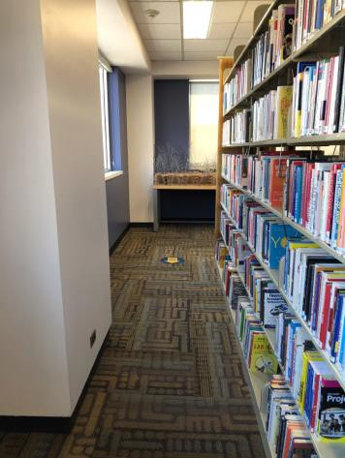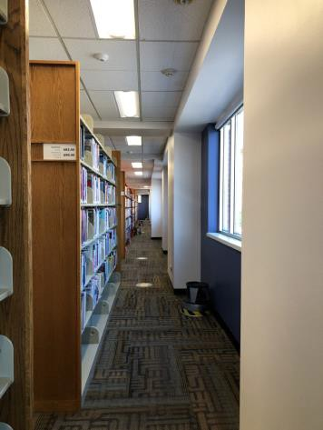

 | ID:  1227 | Facility:  Capitol Library

Location: 4th Floor
Schedule: 2022
Estimated Cost: $10,000.00

Priority Score 5
Quick Fix: No
Built before ADA: Yes

VIOLATIONS
2010 ADA Standards for Accessible Design Codes: §505.10, §505.7.2, §505.3
Handrails are not continuous for the full length of the stairwell. There are no handrail extensions for the stairs. The handrails are flat and therefore do not have a compliant non-circular or circular cross section.

RECOMMENDATIONS
Extend the handrails to be continuous for the entire length of the stairwell. Extend the stairwell handrails 12” horizontally beyond the top and bottom of ramp runs.
Install new handrails with a non-circular cross section diameter of 4" minimum and 6.25" maximum OR install new handrails with a circular cross section diameter of 1.25" minimum and 2" maximum.

PHOTOGRAPH(S) OF THIS LOCATION

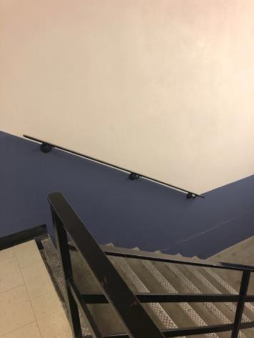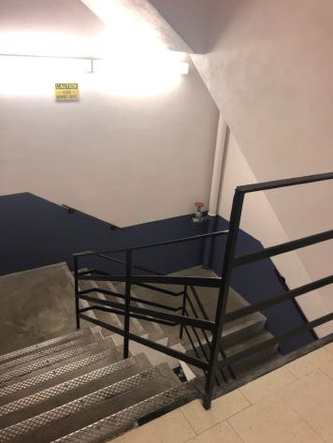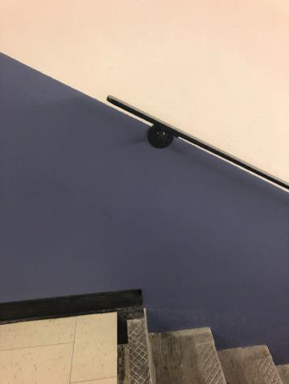

 | ID:  1114 | Facility:  Capitol Library

Location: 2nd Floor Laptop Station
Schedule: 2021
Estimated Cost: $10,000.00

Priority Score 2
Quick Fix: No
Built before ADA: Yes

VIOLATIONS
2010 ADA Standards for Accessible Design Codes: §707
The interactive touch screen does not have any audio or tactile components. Therefore, a visually impaired person would not be able to access the laptop station.

RECOMMENDATIONS
Audio instructions must be provided that guide the user through all the functions of the machine. Tactile instructions must be provided informing the user on the method of activating the audio instructions.
Controls to operate the laptop station must meet the requirements in § 707.

PHOTOGRAPH(S) OF THIS LOCATION

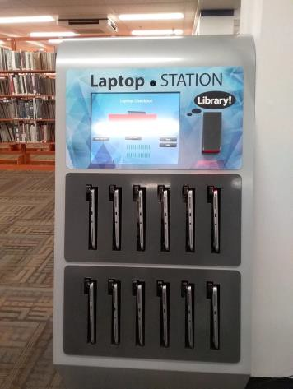

 | ID:  1154 | Facility:  Capitol Library

Location: Entire Facility
Schedule: 2021
Estimated Cost: $11,000.00

Priority Score 3
Quick Fix: No
Built before ADA: Yes

VIOLATIONS
2010 ADA Standards for Accessible Design Codes: §216.2, §703
There are no tactile signs identifying 110 permanent rooms.

RECOMMENDATIONS
Install tactile signage on the latch side of the doorways at a height of 48” minimum to 60” maximum above the floor, identifying room by name or room number.
Signs shall be Braille with raised lettering and should be placed on the wall in the center of an 18"x18" clear floor space.

PHOTOGRAPH(S) OF THIS LOCATION

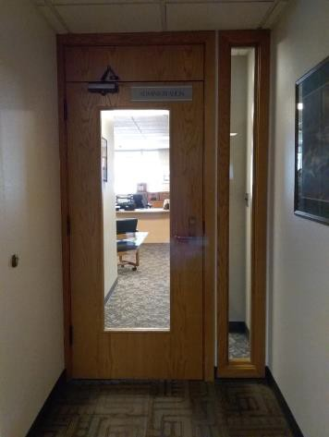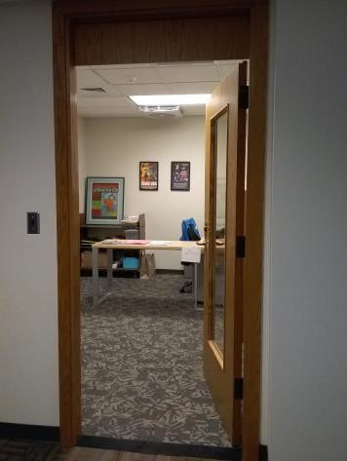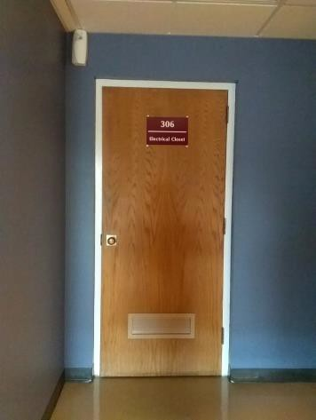

 | ID:  1254 | Facility:  Capitol Library

Location: Main Entrance
Schedule: 2021
Estimated Cost: $20,000.00

Priority Score 3
Quick Fix: No
Built before ADA: Yes

VIOLATIONS
2010 ADA Standards for Accessible Design Codes: §405, §405.7.3
Curvilinear ramps can create compound slopes that cannot meet the requirements for accessible routes. The landing is 58" long.

RECOMMENDATIONS
It is recommended that the curvilinear ramp be redesigned in the future so as to not be curved if the running slope exceeds 5%.
Expand the provided landing to ensure that the clear length is 60" long minimum to allow adequate turning space.

PHOTOGRAPH(S) OF THIS LOCATION

