City of Boise ADA Assessment

Appendix A –Idaho Ice World

03/12/2021
Report #TO21-B026

Prepared by:

 | ID:  1746 | Facility:  Idaho Ice World

Location: 1st Floor Restrooms
Schedule: 2021
Estimated Cost: $200.00

Priority Score 6
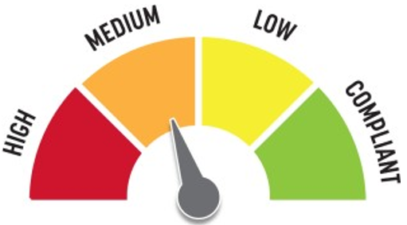
Quick Fix: Yes
Built before ADA: No

VIOLATIONS
2010 ADA Standards for Accessible Design Codes §703.4
The tactile sign identifying the room is not in the correct location.

RECOMMENDATIONS
Reinstall the sign on the latch side of the door at 48" minimum above the floor measured from the baseline of the lowest character and 60" maximum measured from the baseline of the highest character.

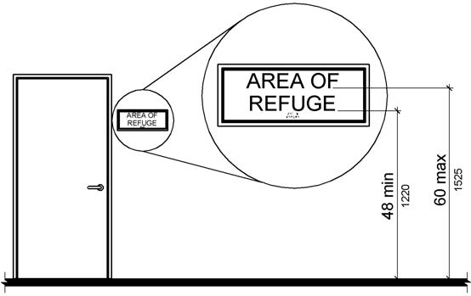

PHOTOGRAPH(S) OF THIS LOCATION

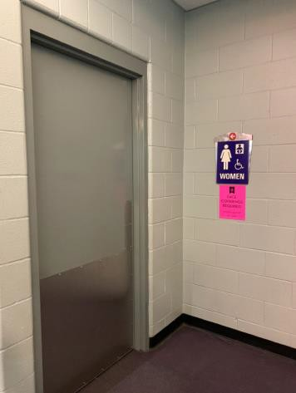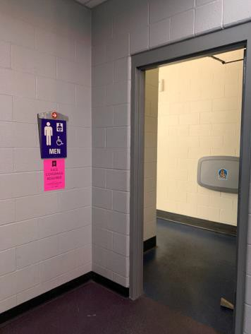
 | ID:  2946 | Facility:  Idaho Ice World

Location: 1st Floor Women's Restroom
Schedule: 2023
Estimated Cost: $100.00

Priority Score 8
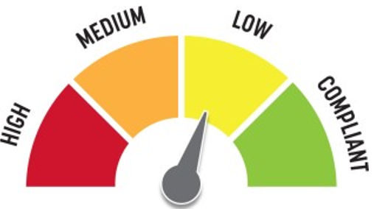
Quick Fix: No
Built before ADA: No

VIOLATIONS
2010 ADA Standards for Accessible Design Codes §604.8.3
The coat hook is outside of the unobstructed forward reach range at 61.25" above the floor.

RECOMMENDATIONS
Lower the coat hook by 13.25" to meet the accessible reach range of 48" maximum above the floor.

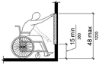

PHOTOGRAPH(S) OF THIS LOCATION

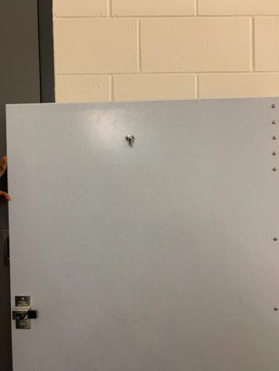

 | ID:  2951 | Facility:  Idaho Ice World

Location: 1st Floor Women's Restroom
Schedule: 2022
Estimated Cost: $100.00

Priority Score 5
Quick Fix: Yes
Built before ADA: No

VIOLATIONS
2010 ADA Standards for Accessible Design Codes §604.7
The toilet paper dispenser is located out of the accessible reach range.

RECOMMENDATIONS
Remount the toilet paper dispenser to 7” minimum and 9” maximum in front of the water closet measured to the centerline of the dispenser.
The outlet of the dispenser shall be 15” minimum and 48” maximum above the floor and shall not be located behind the water closet.

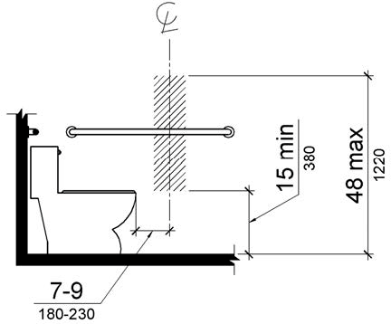

PHOTOGRAPH(S) OF THIS LOCATION

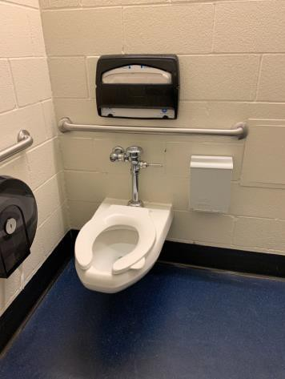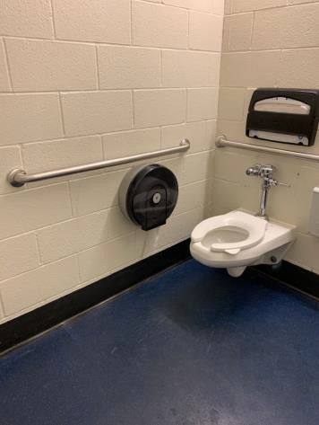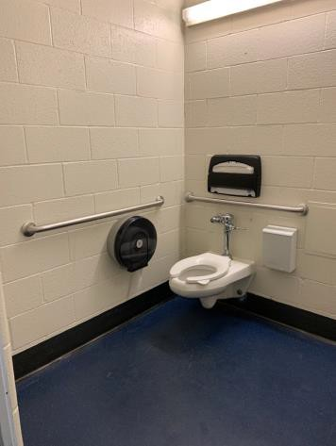
 | ID:  2952 | Facility:  Idaho Ice World

Location: 1st Floor Women's Restroom
Schedule: 2021
Estimated Cost: $100.00

Priority Score 5
Quick Fix: Yes
Built before ADA: No

VIOLATIONS
2010 ADA Standards for Accessible Design Codes §609.3
The space between the grab bar and the toilet seat cover dispenser is 1.5".

RECOMMENDATIONS
Relocate the toilet seat cover dispenser to a location that is at least a distance of 12" or greater above the grab bar. Ensure that the toilet seat cover dispenser is not greater than 48" above the floor.

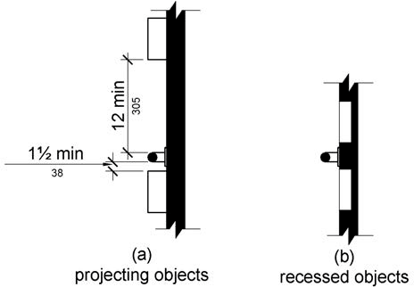

PHOTOGRAPH(S) OF THIS LOCATION

 | ID:  2942 | Facility:  Idaho Ice World

Location: 1st Floor Women's Restroom Ambulatory Stall
Schedule: 2021
Estimated Cost: $100.00

Priority Score 8
Quick Fix: Yes
Built before ADA: No

VIOLATIONS
2010 ADA Standards for Accessible Design Codes 604.8.3
The coat hook is outside of the unobstructed forward reach range at 64.25" above the floor.

RECOMMENDATIONS
Lower the coat hook by 16.25" to meet the accessible reach range of 48" maximum above the floor.

PHOTOGRAPH(S) OF THIS LOCATION

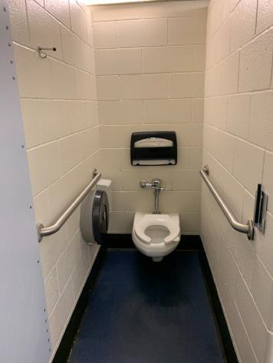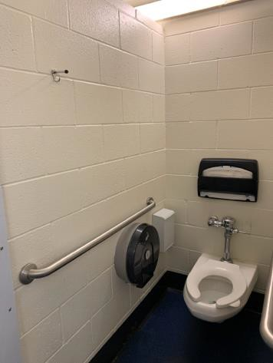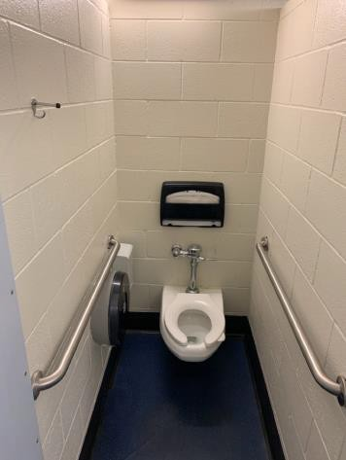

 | ID:  2944 | Facility:  Idaho Ice World

Location: 1st Floor Women's Restroom Ambulatory Stall
Schedule: 2022
Estimated Cost: $1,000.00

Priority Score 5
Quick Fix: No
Built before ADA: No

VIOLATIONS
2010 ADA Standards for Accessible Design Codes §604.2
The centerline of the toilet is located 20" from the sidewall.

RECOMMENDATIONS
Reposition the centerline of the toilet to be within 17" minimum and 19" maximum from the sidewall.

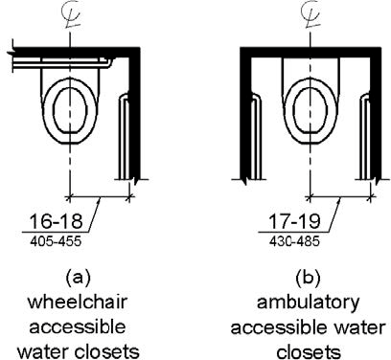

PHOTOGRAPH(S) OF THIS LOCATION

 | ID:  2977 | Facility:  Idaho Ice World

Location: 2nd Floor Elevator
Schedule: 2021
Estimated Cost: $100.00

Priority Score 5
Quick Fix: No
Built before ADA: No

VIOLATIONS
2010 ADA Standards for Accessible Design Codes §307.2
The fire extinguisher protrudes 4.75" into the circulation space at 29.75" above the floor

RECOMMENDATIONS
Recess the fire extinguisher so it protrudes a maximum of 4", lower it so the bottom edge is 27" maximum above the floor, or place a cane detectable object beneath it

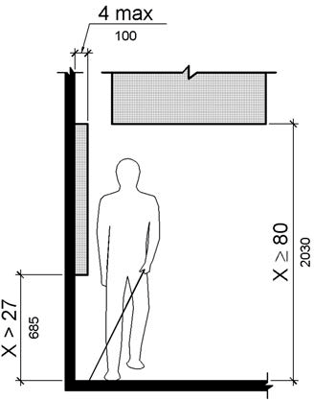

PHOTOGRAPH(S) OF THIS LOCATION

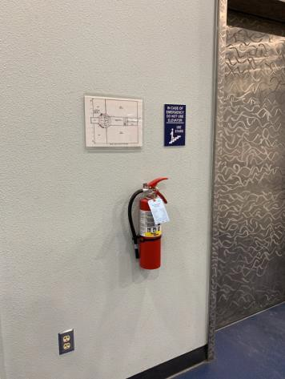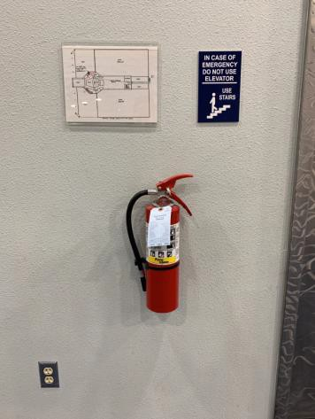

 | ID:  2981 | Facility:  Idaho Ice World

Location: 2nd Floor Kitchen
Schedule: 2021
Estimated Cost: $100.00

Priority Score 8
Quick Fix: Yes
Built before ADA: No

VIOLATIONS
2010 ADA Standards for Accessible Design Codes 308.2.2
The paper towel dispenser is outside of the obstructed forward reach range at 49" above the floor.

RECOMMENDATIONS
Lower the paper towel dispenser by 1" to meet the accessible reach range of 15" minimum and 48" maximum above the floor.

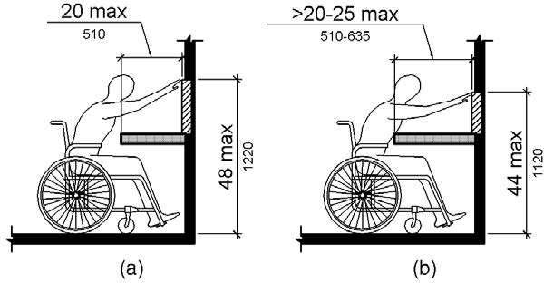

PHOTOGRAPH(S) OF THIS LOCATION

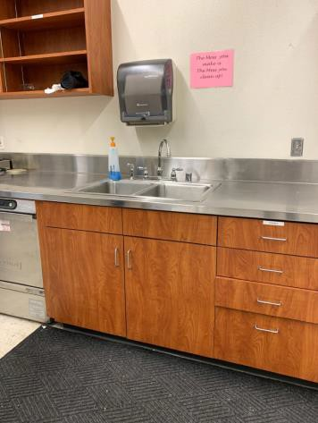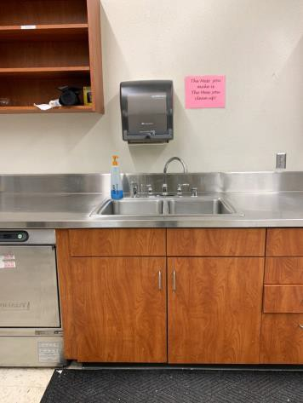
 | ID:  2979 | Facility:  Idaho Ice World

Location: 2nd Floor Kitchen
Schedule: 2023
Estimated Cost: $2,000.00

Priority Score 5
Quick Fix: No
Built before ADA: No

VIOLATIONS
2010 ADA Standards for Accessible Design Codes §902.3, §306.3.3, §606.3
The sink is 36.25" above the floor. The dining and work surface counter is 36.25" above the floor. There is no knee clearance underneath the sink.

RECOMMENDATIONS
Lower the sink to the maximum height of 34" above the floor. A 30" portion of the dining and work surface must be no higher than 34” above the floor.
Provide knee clearance underneath the counter at the sink that is a minimum of 11" deep at 9" above the floor and 8" deep at 27" above the floor.

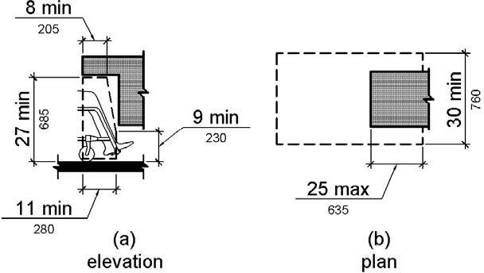

PHOTOGRAPH(S) OF THIS LOCATION

 | ID:  2318 | Facility:  Idaho Ice World

Location: 2nd Floor Men's Restroom
Schedule: 2021
Estimated Cost: $100.00

Priority Score 8
Quick Fix: Yes
Built before ADA: Yes

VIOLATIONS
2010 ADA Standards for Accessible Design Codes §308.2.1
The hook is outside of the unobstructed forward reach range at 64" above the floor.

RECOMMENDATIONS
Lower the hook by 16" to meet the accessible reach range of 48" maximum above the floor.

PHOTOGRAPH(S) OF THIS LOCATION

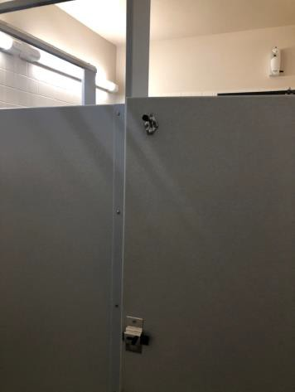
 | ID:  2319 | Facility:  Idaho Ice World

Location: 2nd Floor Men's Restroom
Schedule: 2021
Estimated Cost: $100.00

Priority Score 5
Quick Fix: Yes
Built before ADA: Yes

VIOLATIONS
2010 ADA Standards for Accessible Design Codes §604.8.1.2
The door to the accessible water closet is not self closing. Either self-closing hinges are not installed on the door or if installed, they are defective.

RECOMMENDATIONS
Install or reinstall self-closing hinges on the door to ensure that the door is self-closing per the ADA requirements.

PHOTOGRAPH(S) OF THIS LOCATION

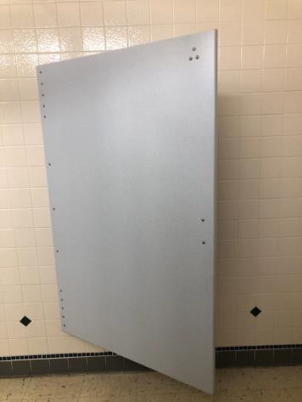

 | ID:  2320 | Facility:  Idaho Ice World

Location: 2nd Floor Men's Restroom
Schedule: 2022
Estimated Cost: $1,000.00

Priority Score 5
Quick Fix: No
Built before ADA: Yes

VIOLATIONS
2010 ADA Standards for Accessible Design Codes §604.2
The centerline of the toilet is located 19.5" from the sidewall.

RECOMMENDATIONS
Reposition the centerline of the toilet to be within 16" minimum and 18" maximum from the sidewall.

PHOTOGRAPH(S) OF THIS LOCATION

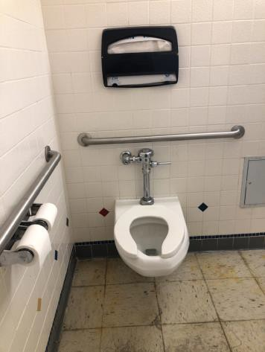
 | ID:  2321 | Facility:  Idaho Ice World

Location: 2nd Floor Men's Restroom
Schedule: 2022
Estimated Cost: $1,000.00

Priority Score 5
Quick Fix: No
Built before ADA: Yes

VIOLATIONS
2010 ADA Standards for Accessible Design Codes ICC A117.1 §604.5.1
The accessible water closet does not have a vertical grab bar.

RECOMMENDATIONS
Install an 18" long (minimum) vertical grab bar on the side wall. The grab bar shall be mounted with the bottom located at 39" minimum and 41" maximum above the floor.
The centerline of the vertical grab bar shall be located 39" minimum and 41" maximum from the rear wall.

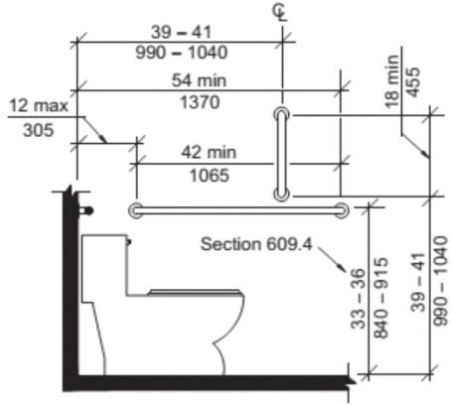

PHOTOGRAPH(S) OF THIS LOCATION

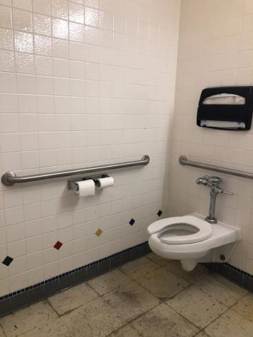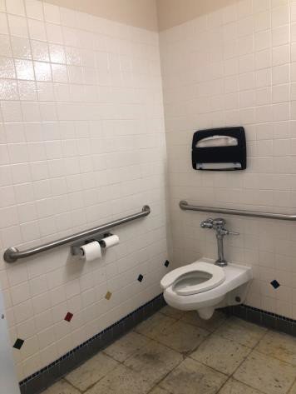
 | ID: | Facility:  Idaho Ice World

Location:
Schedule:
Estimated Cost:

Priority Score 5
Quick Fix: No
Built before ADA: Yes

VIOLATIONS
2010 ADA Standards for Accessible Design Codes §605.2
The urinal is 24" above the floor.

RECOMMENDATIONS
Lower the urinal to a maximum height of 17" above the floor.

PHOTOGRAPH(S) OF THIS LOCATION

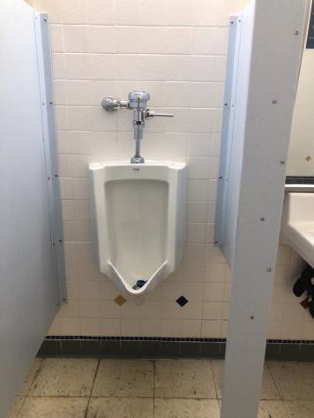
 | ID:  2986 | Facility:  Idaho Ice World

Location: 2nd Floor Women's Restroom
Schedule: 2021
Estimated Cost: $100.00

Priority Score 5
Quick Fix: Yes
Built before ADA: No

VIOLATIONS
2010 ADA Standards for Accessible Design Codes §604.7
The toilet paper dispenser is located out of the accessible reach range.

RECOMMENDATIONS
Remount the toilet paper dispenser to 7” minimum and 9” maximum in front of the water closet measured to the centerline of the dispenser.
The outlet of the dispenser shall be 15” minimum and 48” maximum above the floor and shall not be located behind the water closet.

PHOTOGRAPH(S) OF THIS LOCATION

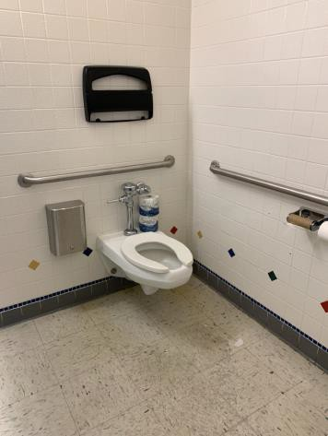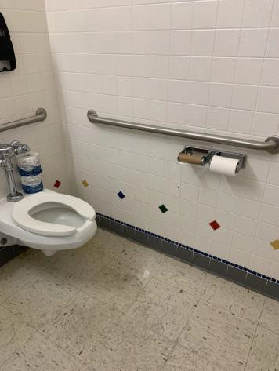
 | ID:  2987 | Facility:  Idaho Ice World

Location: 2nd Floor Women's Restroom
Schedule: 2021
Estimated Cost: $100.00

Priority Score 5
Quick Fix: Yes
Built before ADA: No

VIOLATIONS
2010 ADA Standards for Accessible Design Codes §604.8.1.2
The door to the accessible water closet is not self closing. Either self-closing hinges are not installed on the door or if installed, they are defective.

RECOMMENDATIONS
Install or reinstall self-closing hinges on the door to ensure that the door is self-closing per the ADA requirements.

PHOTOGRAPH(S) OF THIS LOCATION

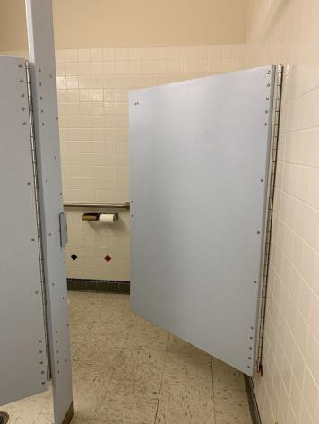
 | ID:  2988 | Facility:  Idaho Ice World

Location: 2nd Floor Women's Restroom
Schedule: 2021
Estimated Cost: $100.00

Priority Score 5
Quick Fix: Yes
Built before ADA: No

VIOLATIONS
2010 ADA Standards for Accessible Design Codes §609.3
The space between the grab bar and the toilet seat cover dispenser is 10.5".

RECOMMENDATIONS
Relocate the toilet seat cover dispenser to a location that is at least a distance of 12" or greater above the grab bar. Ensure that the toilet seat cover dispenser is not greater than 48" above the floor.

PHOTOGRAPH(S) OF THIS LOCATION

 | ID:  2989 | Facility:  Idaho Ice World

Location: 2nd Floor Women's Restroom
Schedule: 2021
Estimated Cost: $100.00

Priority Score 8
Quick Fix: Yes
Built before ADA: No

VIOLATIONS
2010 ADA Standards for Accessible Design Codes §308.2.1
The hook is outside of the unobstructed forward reach range at 64" above the floor.

RECOMMENDATIONS
Lower the hook by 16" to meet the accessible reach range of 48" maximum above the floor.

PHOTOGRAPH(S) OF THIS LOCATION

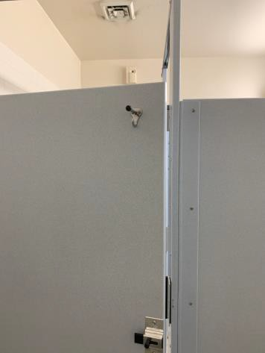

 | ID:  2990 | Facility:  Idaho Ice World

Location: 2nd Floor Women's Restroom
Schedule: 2021
Estimated Cost: $100.00

Priority Score 6
Quick Fix: Yes
Built before ADA: No

VIOLATIONS
2010 ADA Standards for Accessible Design Codes §703.4
The tactile sign identifying the room is not in the correct location at 52.5" above the floor.

RECOMMENDATIONS
Reinstall the sign on the latch side of the door at 48" minimum above the floor measured from the baseline of the lowest character and 60" maximum measured from the baseline of the highest character.

PHOTOGRAPH(S) OF THIS LOCATION

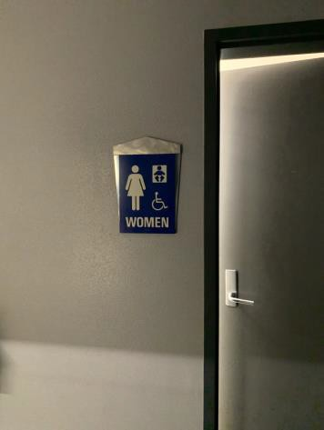
 | ID:  4489 | Facility:  Idaho Ice World

Location: 2nd Floor Women's Restroom
Schedule: 2021
Estimated Cost: $500.00

Priority Score 6
Quick Fix: Yes
Built before ADA: No

VIOLATIONS
2010 ADA Standards for Accessible Design Codes §604.5.2
The rear grab bar is located 11" to the center of the toilet.

RECOMMENDATIONS
Remount the rear grab bar to extend from the centerline of the water closet 12" minimum on one side and 24" minimum on the other.

PHOTOGRAPH(S) OF THIS LOCATION

 | ID:  2983 | Facility:  Idaho Ice World

Location: 2nd Floor Women's Restroom
Schedule: 2022
Estimated Cost: $1,000.00

Priority Score 5
Quick Fix: No
Built before ADA: No

VIOLATIONS
2010 ADA Standards for Accessible Design Codes ICC A117.1 §604.5.1
The accessible water closet does not have a vertical grab bar.

RECOMMENDATIONS
Install an 18" long (minimum) vertical grab bar on the side wall. The grab bar shall be mounted with the bottom located at 39" minimum and 41" maximum above the floor.
The centerline of the vertical grab bar shall be located 39" minimum and 41" maximum from the rear wall.

PHOTOGRAPH(S) OF THIS LOCATION

 | ID:  2985 | Facility:  Idaho Ice World

Location: 2nd Floor Women's Restroom
Schedule: 2022
Estimated Cost: $1,000.00

Priority Score 5
Quick Fix: No
Built before ADA: No

VIOLATIONS
2010 ADA Standards for Accessible Design Codes §604.2
The centerline of the toilet is located 20" from the sidewall.

RECOMMENDATIONS
Reposition the centerline of the toilet to be within 16" minimum and 18" maximum from the sidewall.

PHOTOGRAPH(S) OF THIS LOCATION

 | ID:  2304 | Facility:  Idaho Ice World

Location: Arcade
Schedule: 2021
Estimated Cost: $300.00

Priority Score 3
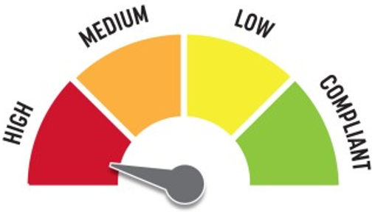
Quick Fix: Yes
Built before ADA: Yes

VIOLATIONS
2010 ADA Standards for Accessible Design Codes §216.4, §703
Doors serving as exits are not marked by tactile signage.

RECOMMENDATIONS
Place a tactile exit sign, that complies with §703.1, §703.2 and §703.5, identifying the exit doors.
Install missing signage at 48" minimum above the floor measured from the baseline of the lowest character and 60" maximum measured from the baseline of the highest character.

PHOTOGRAPH(S) OF THIS LOCATION

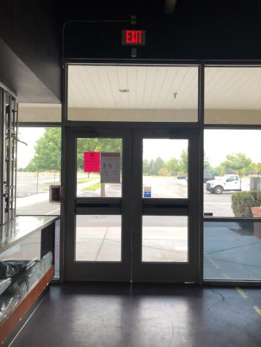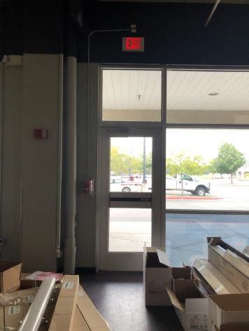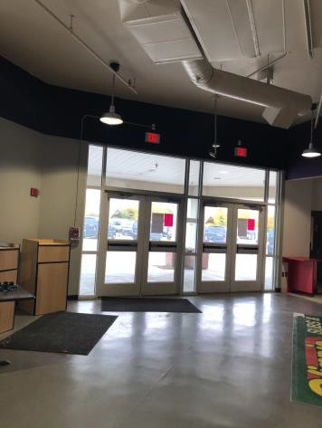
 | ID:  2306 | Facility:  Idaho Ice World

Location: Arcade Men's Restroom
Schedule: 2021
Estimated Cost: $100.00

Priority Score 5
Quick Fix: Yes
Built before ADA: Yes

VIOLATIONS
2010 ADA Standards for Accessible Design Codes §609.3
The space between the grab bar and the toilet seat cover dispenser is 7".

RECOMMENDATIONS
Relocate the toilet seat cover dispenser to a location that is at least a distance of 12" or greater above the grab bar. Ensure that the toilet seat cover dispenser is not greater than 48" above the floor.

PHOTOGRAPH(S) OF THIS LOCATION

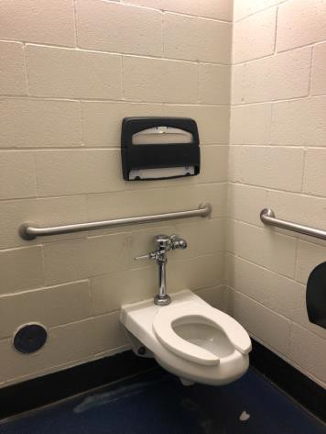
 | ID:  2307 | Facility:  Idaho Ice World

Location: Arcade Men's Restroom
Schedule: 2021
Estimated Cost: $100.00
2021

Priority Score 5
Quick Fix: Yes
Built before ADA: Yes

VIOLATIONS
2010 ADA Standards for Accessible Design Codes §604.8.1.2
The door to the accessible water closet is not self closing. Either self-closing hinges are not installed on the door or if installed, they are defective.

RECOMMENDATIONS
Install or reinstall self-closing hinges on the door to ensure that the door is self-closing per the ADA requirements.

PHOTOGRAPH(S) OF THIS LOCATION

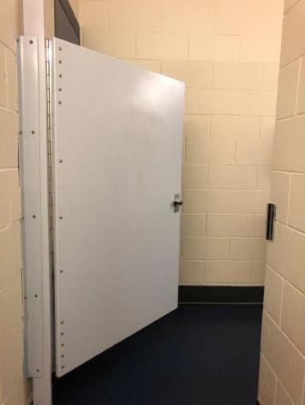
 | ID:  2309 | Facility:  Idaho Ice World

Location: Arcade Men's Restroom
Schedule: 2021
Estimated Cost:$100.00

Priority Score 5
Quick Fix: Yes
Built before ADA: Yes

VIOLATIONS
2010 ADA Standards for Accessible Design Codes §604.7
The toilet paper dispenser is located out of the accessible reach range.

RECOMMENDATIONS
Remount the toilet paper dispenser to 7” minimum and 9” maximum in front of the water closet measured to the centerline of the dispenser.
The outlet of the dispenser shall be 15” minimum and 48” maximum above the floor and shall not be located behind the water closet.

PHOTOGRAPH(S) OF THIS LOCATION

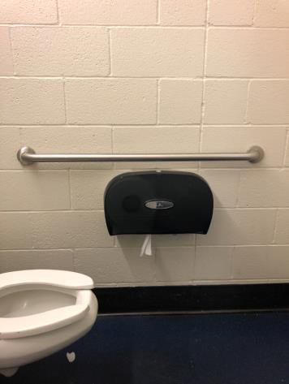
 | ID:  2309 | Facility:  Idaho Ice World

Location: Arcade Men's Restroom
Schedule: 2021
Estimated Cost: $100.00

Priority Score 5
Quick Fix: Yes
Built before ADA: Yes

VIOLATIONS
2010 ADA Standards for Accessible Design Codes §604.7
The toilet paper dispenser is located out of the accessible reach range.

RECOMMENDATIONS
Remount the toilet paper dispenser to 7” minimum and 9” maximum in front of the water closet measured to the centerline of the dispenser.
The outlet of the dispenser shall be 15” minimum and 48” maximum above the floor and shall not be located behind the water closet.

PHOTOGRAPH(S) OF THIS LOCATION

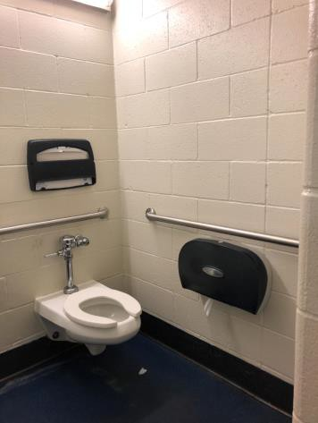
 | ID:  2305 | Facility:  Idaho Ice World

Location: Arcade Men's Restroom
Schedule: 2022
Estimated Cost: $2,500.00

Priority Score 5
Quick Fix: No
Built before ADA: Yes

VIOLATIONS
2010 ADA Standards for Accessible Design Codes §903.3, §903.4
Two benches do not provide back support.
The benches are not deep enough at 14.5" deep.

RECOMMENDATIONS
Provide back support that is 42” long minimum and extends from a point 2” maximum above the seat surface to a point 18” minimum above the seat surface.
Install new benches that are at least 42" long and 20" to 24" inches deep.
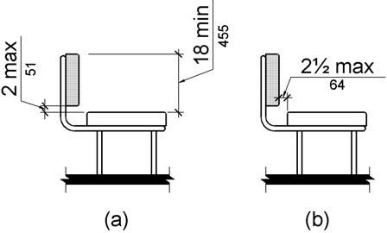

PHOTOGRAPH(S) OF THIS LOCATION

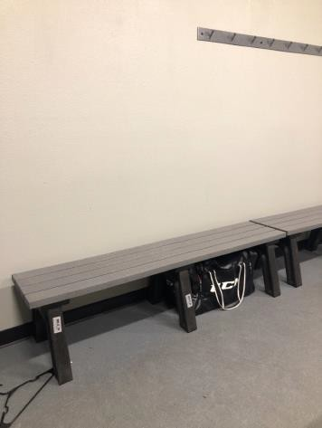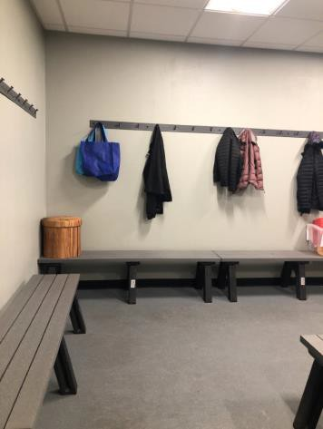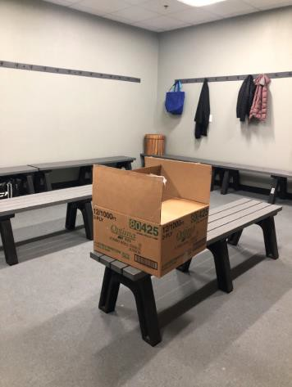
 | ID:  2909 | Facility:  Idaho Ice World

Location: Bleachers Ramp
Schedule: 2021
Estimated Cost: $500.00

Priority Score 8
Quick Fix: Yes
Built before ADA: No

VIOLATIONS
2010 ADA Standards for Accessible Design Codes §802.4.2
The designated aisle seats are not identified with a sign or marker.

RECOMMENDATIONS
Install a sign at the designated aisle seats. Such signs shall be high contrast and photo luminescent.

PHOTOGRAPH(S) OF THIS LOCATION

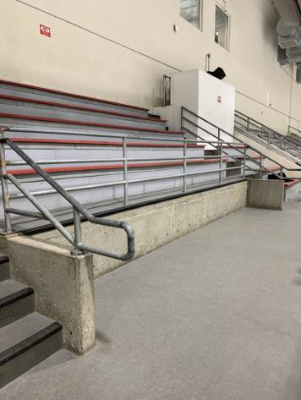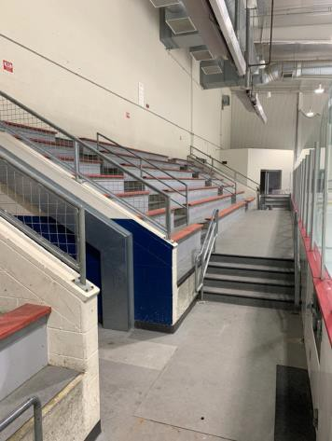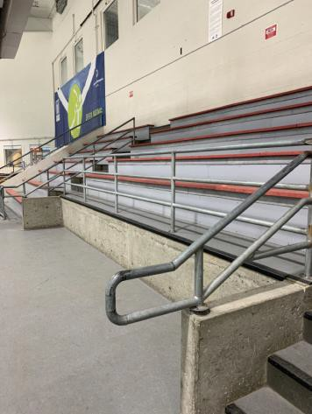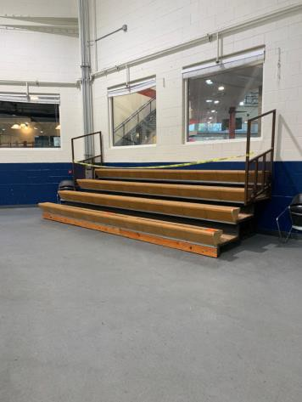
 | ID:  2910 | Facility:  Idaho Ice World

Location: Bleachers Ramp
Schedule: 2022
Estimated Cost: $1,000.00

Priority Score 7
Quick Fix: No
Built before ADA: No

VIOLATIONS
2010 ADA Standards for Accessible Design Codes §405.2
The running slope at the top of the ramp is 8.8%.

RECOMMENDATIONS
Resurface the ramp to reduce the running slope to a maximum of 8.3%.

PHOTOGRAPH(S) OF THIS LOCATION

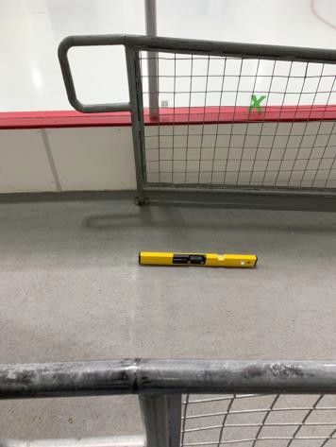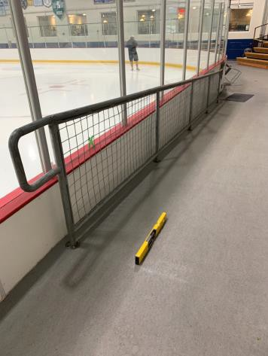
 | ID:  2292 | Facility:  Idaho Ice World

Location: Blimpie
Schedule: 2021
Estimated Cost: $500.00

Priority Score 4
Quick Fix: Yes
Built before ADA: Yes

VIOLATIONS
2010 ADA Standards for Accessible Design Codes §404.2.9
The opening and closing force of the door is 8 to 10 pounds.

RECOMMENDATIONS
For the purposes of achieving greater accessibility and Human Centric Design, adjust the resistance on the door so that it allows the doors to be continuously opened at a maximum force of 5 pounds.

PHOTOGRAPH(S) OF THIS LOCATION

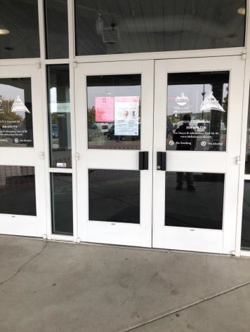
 | ID:  2096 | Facility:  Idaho Ice World

Location: Change Machine
Schedule: 2021
Estimated Cost: $100.00

Priority Score 5
Quick Fix: Yes
Built before ADA: No

VIOLATIONS
2010 ADA Standards for Accessible Design Codes §307.2
The change machine protrudes 13.25" into the circulation space at 43" above the floor.

RECOMMENDATIONS
Recess the change machine so it protrudes a maximum of 4", lower it so the bottom edge is 27" maximum above the floor, or place a cane detectable object beneath it.

PHOTOGRAPH(S) OF THIS LOCATION

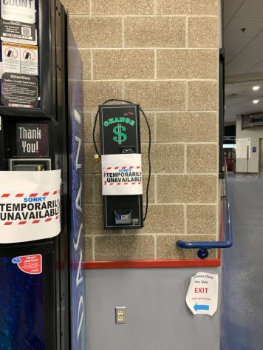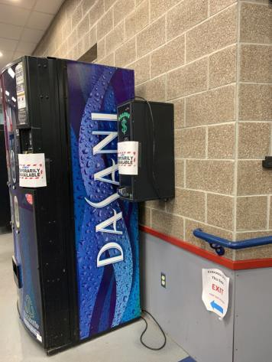

 | ID:  2962 | Facility:  Idaho Ice World

Location: Comment Box
Schedule: 2021
Estimated Cost: $100.00

Priority Score 3
Quick Fix: Yes
Built before ADA: No

VIOLATIONS
2010 ADA Standards for Accessible Design Codes §308.2.1, §307.2
The comment box is outside of the unobstructed forward reach range at 62" above the floor. The comment box protrudes 6" into the circulation space at 55" above the floor.

RECOMMENDATIONS
Lower the comment box by 14" to meet the accessible reach range of 15" minimum and 48" maximum above the floor.
Recess the comment box so it protrudes a maximum of 4", lower it so the bottom edge is 27" maximum above the floor, or place a cane detectable object beneath it.

PHOTOGRAPH(S) OF THIS LOCATION

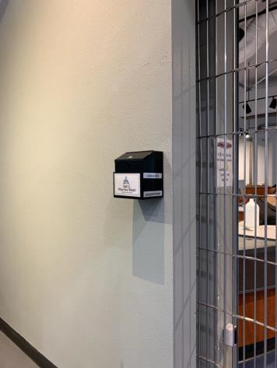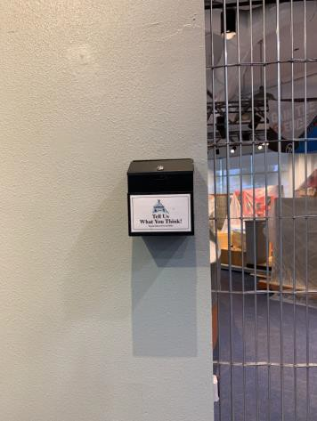
 | ID:  2960 | Facility:  Idaho Ice World

Location: Counter at Entrance
Schedule: 2021
Estimated Cost: $1,000.00

Priority Score 4
Quick Fix: No
Built before ADA: No

VIOLATIONS
2010 ADA Standards for Accessible Design Codes §904.4.1
The counter is 41" above the floor.

RECOMMENDATIONS
A portion of the service counter must be no higher than 36" above the floor for a horizontal distance of 36".

PHOTOGRAPH(S) OF THIS LOCATION

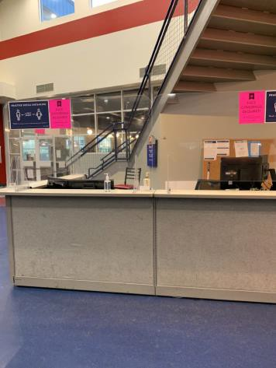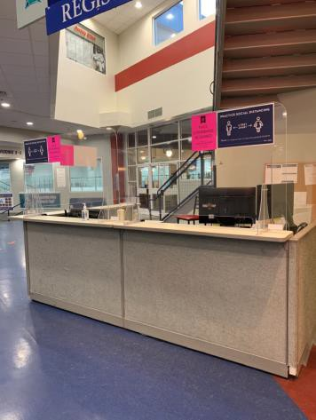
 | ID:  2894 | Facility:  Idaho Ice World

Location: Cutting Edge Sports Parking
Schedule: 2021
Estimated Cost: $1,000.00

Priority Score 3
Quick Fix: No
Built before ADA: No

VIOLATIONS
2010 ADA Standards for Accessible Design Codes §502.4
The parking space has a 2.6% slope at the ISA symbol.

RECOMMENDATIONS
Resurface the parking space to reduce the slope to a maximum of 2% in all directions.

PHOTOGRAPH(S) OF THIS LOCATION

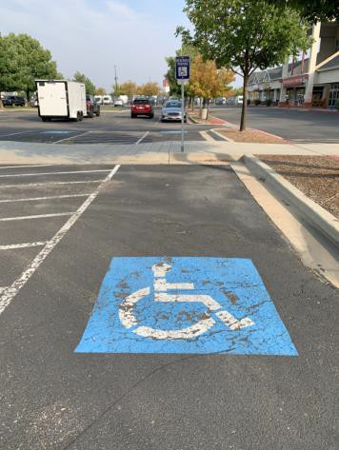
 | ID:  2896 | Facility:  Idaho Ice World

Location: Cutting Edge Sports Parking
Schedule: 2021
Estimated Cost: $3,000.00

Priority Score 3
Quick Fix: No
Built before ADA: No

VIOLATIONS
2010 ADA Standards for Accessible Design Codes §502.4
The parking space has a 3.1% slope and the access aisle has a 2.5% slope.

RECOMMENDATIONS
Resurface the parking space and access aisle to reduce the slope to a maximum of 2% in all directions.

PHOTOGRAPH(S) OF THIS LOCATION

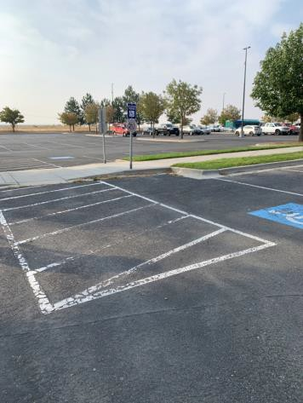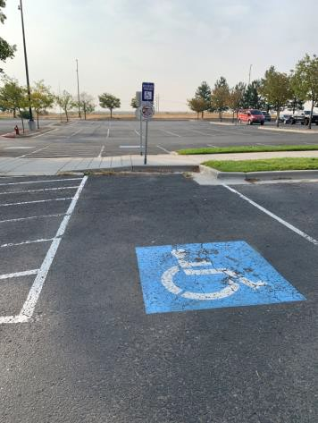
 | ID:  2905 | Facility:  Idaho Ice World

Location: Dasani Vending Machine
Schedule: 2023
Estimated Cost: $3,000.00

Priority Score 8
Quick Fix: No
Built before ADA: No

VIOLATIONS
2010 ADA Standards for Accessible Design Codes §308.2.1
The vending machine controls are outside of the unobstructed forward reach range at 49" above the floor.

RECOMMENDATIONS
Lower the vending machine controls by 1" to meet the accessible reach range of 15" minimum and 48" maximum above the floor.
This may require replacing the vending machine.

PHOTOGRAPH(S) OF THIS LOCATION

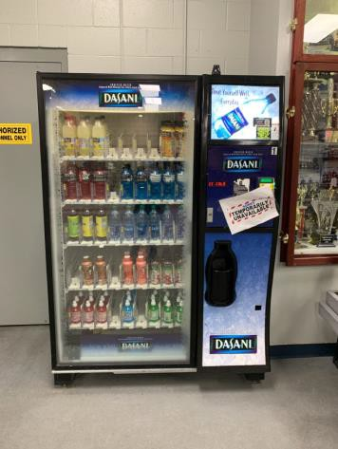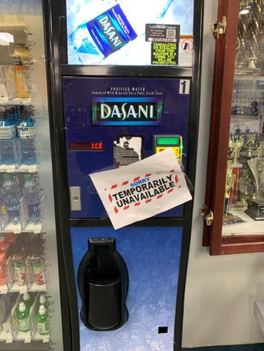
 | ID:  2310 | Facility:  Idaho Ice World

Location: Elevator
Schedule: 2021
Estimated Cost: $200.00

Priority Score 3
Quick Fix: Yes
Built before ADA: Yes

VIOLATIONS
2010 ADA Standards for Accessible Design Codes §407.2.3.1
There is no first floor elevator door tactile star sign.

RECOMMENDATIONS
Install a tactile sign with a tactile star on the door jambs of the main level.

PHOTOGRAPH(S) OF THIS LOCATION

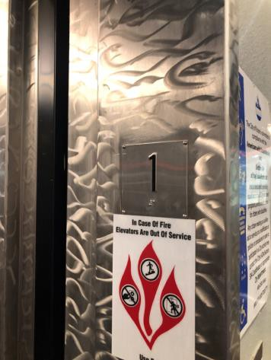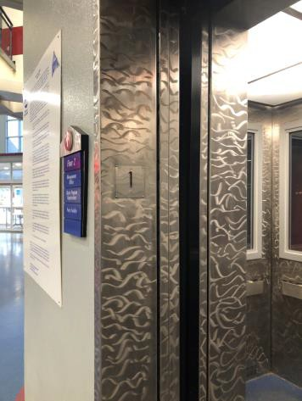
 | ID:  2955 | Facility:  Idaho Ice World

Location: Entrance
Schedule: 2021
Estimated Cost: $100.00

Priority Score 5
Quick Fix: Yes
Built before ADA: No

VIOLATIONS
2010 ADA Standards for Accessible Design Codes §307.2
The fire alarm protrudes 6" into the circulation space at 45.5" above the floor.

RECOMMENDATIONS
Recess the fire alarm so it protrudes a maximum of 4" or place a cane detectable object beneath it.

PHOTOGRAPH(S) OF THIS LOCATION

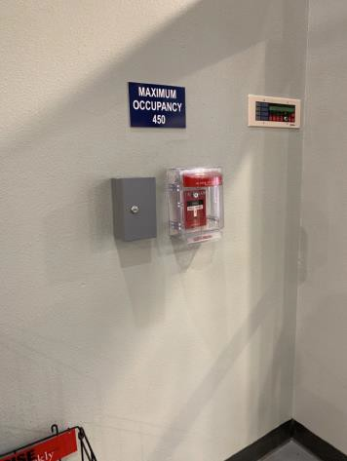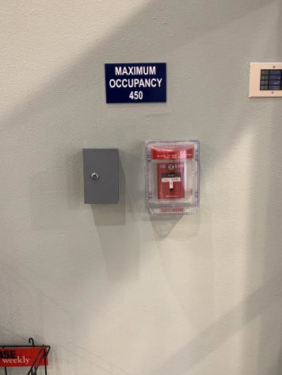
 | ID:  2291 | Facility:  Idaho Ice World

Location: Exterior Restaurant Door
Schedule: 2021
Estimated Cost: $500.00

Priority Score 4
Quick Fix: Yes
Built before ADA: Yes

VIOLATIONS
2010 ADA Standards for Accessible Design Codes §404.2.9
The opening and closing force of the door exceeds 5 pounds.

RECOMMENDATIONS
For the purposes of achieving greater accessibility and Human Centric Design, adjust the resistance on the door so that it allows the doors to be continuously opened at a maximum force of 5 pounds.

PHOTOGRAPH(S) OF THIS LOCATION

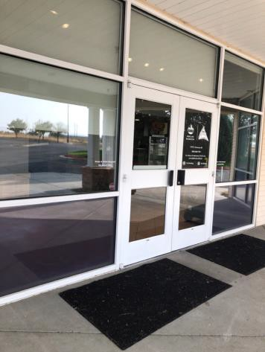
 | ID:  2941 | Facility:  Idaho Ice World

Location: Food Court Ramp
Schedule: 2022
Estimated Cost: $4,000.00

Priority Score 3
Quick Fix: No
Built before ADA: No

VIOLATIONS
2010 ADA Standards for Accessible Design Codes §405.2, §505.2
There are no handrails.
The running slope of the ramp ranges from 9.3% to 9.6%.

RECOMMENDATIONS
Install handrails at a minimum height of 34” and maximum of 38” above the ground. Make sure there are adequate handrail extensions both at the top and bottom of the handrail.
Reconstruct the ramp to reduce the running slope to a maximum of 8.3%.

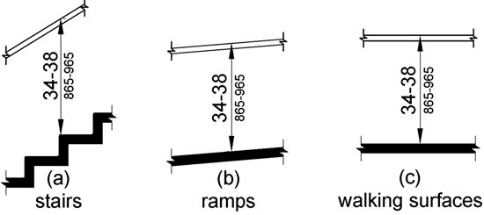

PHOTOGRAPH(S) OF THIS LOCATION

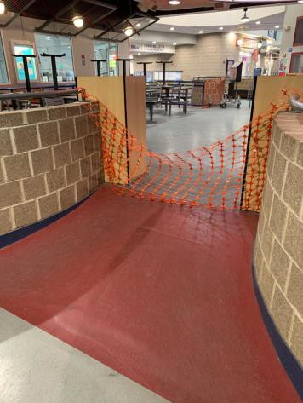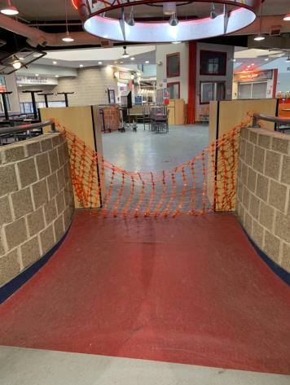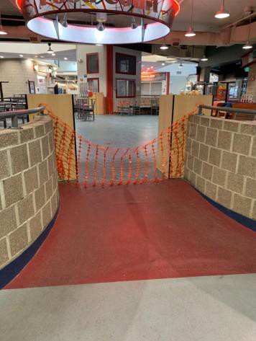
 | ID:  2901 | Facility:  Idaho Ice World

Location: Game Room
Schedule: 2021
Estimated Cost: $100.00

Priority Score 5
Quick Fix:Yes
Built before ADA: No

VIOLATIONS
2010 ADA Standards for Accessible Design Codes §307.2
The fire extinguisher protrudes 4.5" into the circulation space at 30" above the floor.

RECOMMENDATIONS
Recess the fire extinguisher so it protrudes a maximum of 4", lower it so the bottom edge is 27" maximum above the floor, or place a cane detectable object beneath it.

PHOTOGRAPH(S) OF THIS LOCATION

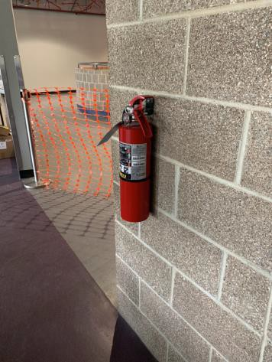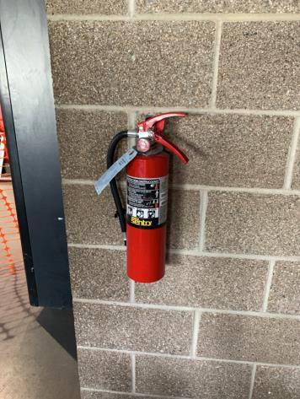
 | ID:  2302 | Facility:  Idaho Ice World

Location: Header Rink Plumbing
Schedule: 2021
Estimated Cost: $500.00

Priority Score 3
Quick Fix: Yes
Built before ADA: Yes

VIOLATIONS
2010 ADA Standards for Accessible Design Codes §303.3
The change in level between 0.25" and 0.5" is not beveled.

RECOMMENDATIONS
Bevel the change in level with a slope not steeper than 1:2.

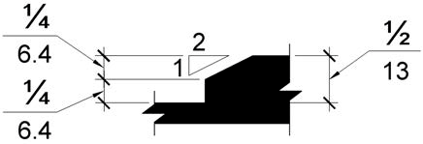

PHOTOGRAPH(S) OF THIS LOCATION

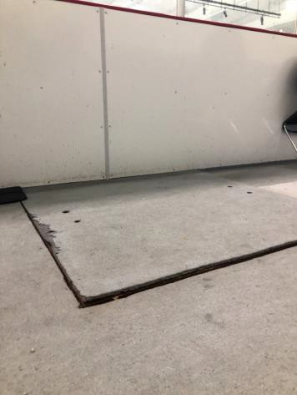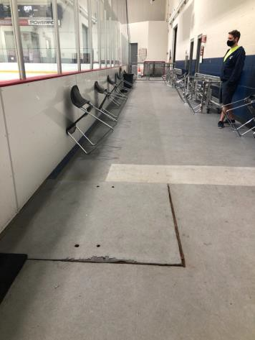
 | ID:  2903 | Facility:  Idaho Ice World

Location: Hockey Information Board
Schedule: 2021
Estimated Cost: $100.00

Priority Score 5
Quick Fix:Yes
Built before ADA: No

VIOLATIONS
2010 ADA Standards for Accessible Design Codes §307.2
The fire extinguisher protrudes 5.25" into the circulation space at 28" above the floor.

RECOMMENDATIONS
Recess the fire extinguisher so it protrudes a maximum of 4", lower it so the bottom edge is 27" maximum above the floor, or place a cane detectable object beneath it.

PHOTOGRAPH(S) OF THIS LOCATION

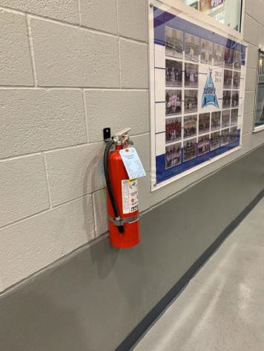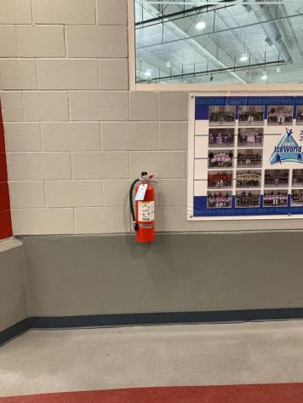
 | ID:  2927 | Facility:  Idaho Ice World

Location: Locker Room 4
Schedule: 2022
Estimated Cost: $1,000.00

Priority Score 5
Quick Fix: No
Built before ADA: No

VIOLATIONS
2010 ADA Standards for Accessible Design Codes §605.2
The urinal is 30.25" above the floor.

RECOMMENDATIONS
Lower the urinal to a maximum height of 17" above the floor.

PHOTOGRAPH(S) OF THIS LOCATION

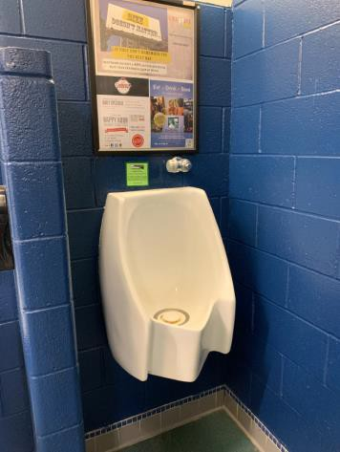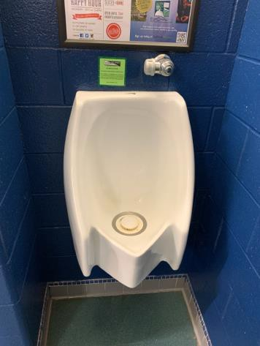
 | ID:  2926 | Facility:  Idaho Ice World

Location: Locker Room 6
Schedule: 2021
Estimated Cost: $100.00

Priority Score 7
Quick Fix: Yes
Built before ADA: No

VIOLATIONS
2010 ADA Standards for Accessible Design Codes §309.4
The faucet requires twisting of the wrist.

RECOMMENDATIONS
Replace the faucet with one that can be operated with a closed fist and without twisting the wrist.

PHOTOGRAPH(S) OF THIS LOCATION

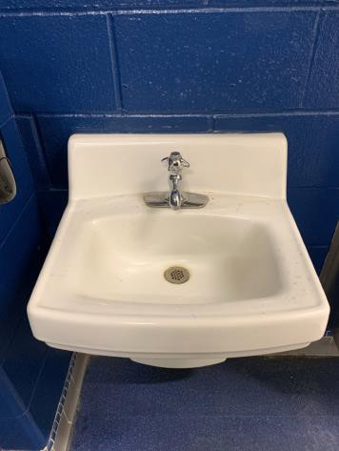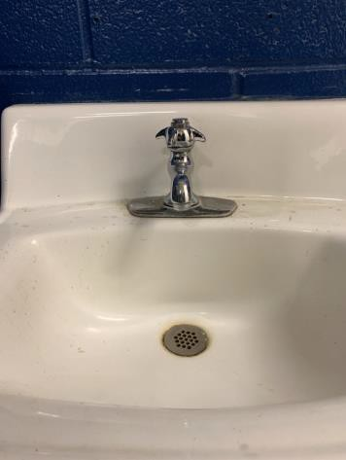
 | ID:  2929 | Facility:  Idaho Ice World

Location: Locker Room 6
Schedule: 2022
Estimated Cost: $1,000.00

Priority Score 5
Quick Fix: No
Built before ADA: No

VIOLATIONS
2010 ADA Standards for Accessible Design Codes §605.2
The urinal is 30.25" above the floor.

RECOMMENDATIONS
Lower the urinal to a maximum height of 17" above the floor.

PHOTOGRAPH(S) OF THIS LOCATION

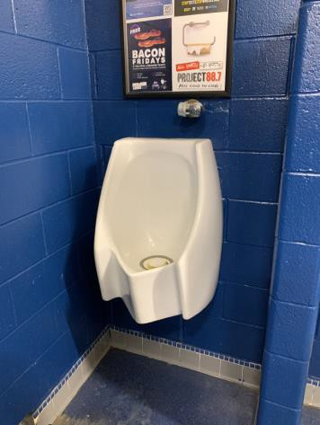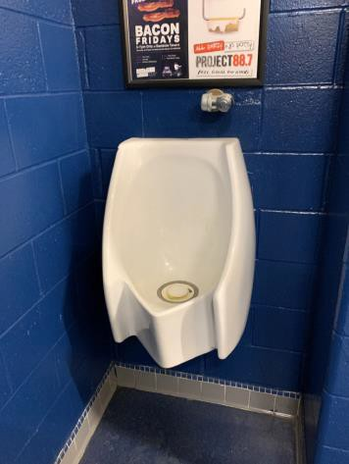
 | ID:  2923 | Facility:  Idaho Ice World

Location: Locker Room 7
Schedule: 2022
Estimated Cost: $1,000.00

Priority Score 5
Quick Fix: No
Built before ADA: No

VIOLATIONS
2010 ADA Standards for Accessible Design Codes §605.2
The urinal is 25" above the floor.

RECOMMENDATIONS
Lower the urinal to a maximum height of 17" above the floor.

PHOTOGRAPH(S) OF THIS LOCATION

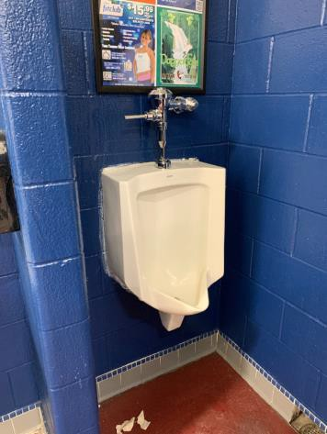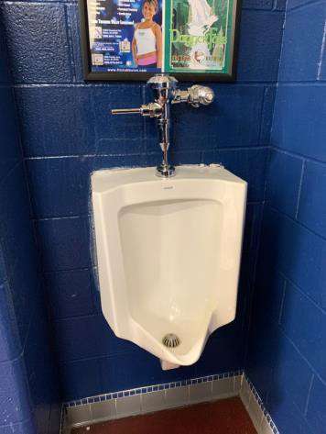
 | ID:  2925 | Facility:  Idaho Ice World

Location: Locker Room 8
Schedule: 2022
Estimated Cost: $1,000.00

Priority Score 5
Quick Fix: No
Built before ADA: No

VIOLATIONS
2010 ADA Standards for Accessible Design Codes §605.2
The urinal is 29" above the floor.

RECOMMENDATIONS
Lower the urinal to a maximum height of 17" above the floor.

PHOTOGRAPH(S) OF THIS LOCATION

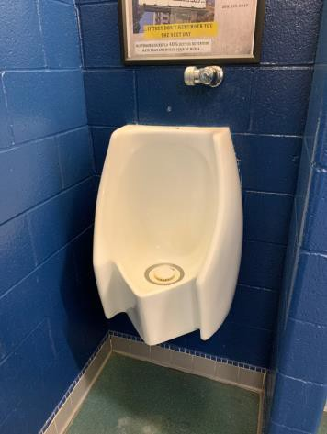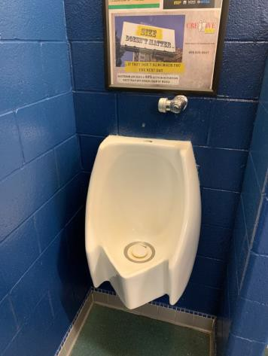
 | ID:  2917 | Facility:  Idaho Ice World

Location: Locker Rooms 1, 2, 3, 4, 5, 6, 7, and 8
Schedule: 2022
Estimated Cost: $10,000.00

Priority Score 6
Quick Fix: No
Built before ADA: No

VIOLATIONS
2010 ADA Standards for Accessible Design Codes §213.3.6, §405, §607.6
None of the locker rooms have an accessible shower due to the lack of accessible features and the presence of a 4.5" step.

RECOMMENDATIONS
Ensure that there is at least one accessible shower available for each ice rink complying with §607 or §608 in one of the locker rooms.
However, for the purposes of achieving greater accessibility and Human Centric Design, ensure that all of the locker rooms have an accessible shower.

PHOTOGRAPH(S) OF THIS LOCATION

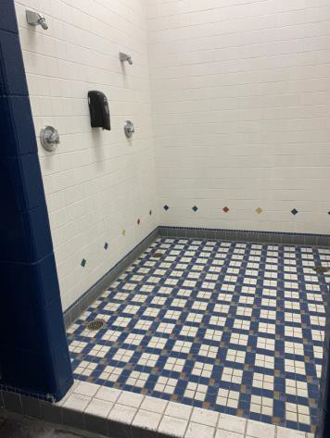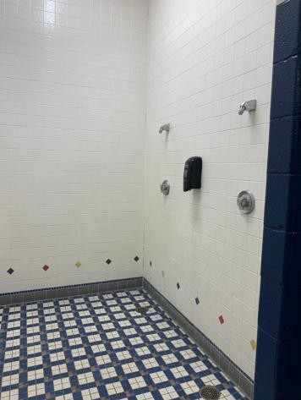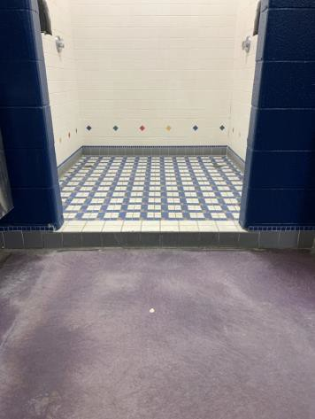
 | ID:  2935 | Facility:  Idaho Ice World

Location: Locker Rooms 1, 2, 3, 4, 6, 7, and 8
Schedule: 2021
Estimated Cost: $100.00

Priority Score 8
Quick Fix: Yes
Built before ADA: No

VIOLATIONS
2010 ADA Standards for Accessible Design Codes §308.2.1
The hook is outside of the unobstructed forward reach range at 64" above the floor.

RECOMMENDATIONS
Lower the hook by 16" to meet the accessible reach range of 15" minimum and 48" maximum above the floor.

PHOTOGRAPH(S) OF THIS LOCATION

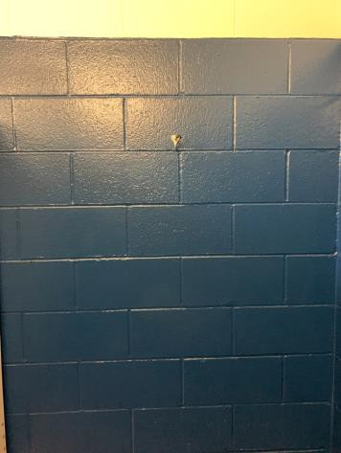
 | ID:  2934 | Facility:  Idaho Ice World

Location: Locker Rooms 1, 2, 3, 4, 6, 7, and 8
Schedule: 2021
Estimated Cost: $700.00

Priority Score 8
Quick Fix: No
Built before ADA: No

VIOLATIONS
2010 ADA Standards for Accessible Design Codes §308.2.1
The toilet seat covers in Locker Rooms 1, 2, 3, 4, 6, 7, and 8 are outside of the unobstructed forward reach range at 51" above the floor.

RECOMMENDATIONS
Lower the toilet seat covers by 3" to meet the accessible reach range of 15" minimum and 48" maximum above the floor.

PHOTOGRAPH(S) OF THIS LOCATION

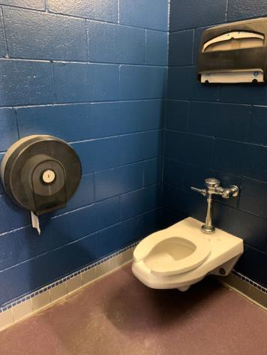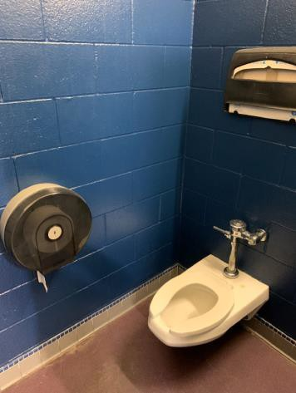
 | ID:  2932 | Facility:  Idaho Ice World

Location: Locker Rooms 1, 2, 3, 4, 6, 7, and 8
Schedule: 2022
Estimated Cost: $7,000.00

Priority Score 5
Quick Fix: No
Built before ADA: No

VIOLATIONS
2010 ADA Standards for Accessible Design Codes §604.2
The centerlines of the toilets in locker rooms 1, 2, 3, 4, 6, 7, and 8 are 19" from the sidewall.

RECOMMENDATIONS
Reposition the centerlines of the toilets to be within 16" minimum and 18" maximum from the sidewall.

PHOTOGRAPH(S) OF THIS LOCATION

 | ID:  2931 | Facility:  Idaho Ice World

Location: Locker Rooms 1, 2, 3, 4, 6, 7, and 8
Schedule: 2022
Estimated Cost: $15,000.00

Priority Score 5
Quick Fix: No
Built before ADA: No

VIOLATIONS
2010 ADA Standards for Accessible Design Codes §604.5, ICC A117.1 §604.5.1
There are no grab bars in Locker Rooms 1, 2, 3, 4, 6, 7, and 8.

RECOMMENDATIONS
Install a side and rear grab bar at a minimum height of 33” and maximum height of 36” above the finish floor. The side grab bar shall have a minimum length of 42" at a maximum of 12” from the back wall. Install an 18" long (minimum) vertical grab bar on the side wall at 39" minimum and 41" maximum above the floor.

PHOTOGRAPH(S) OF THIS LOCATION

 | ID:  2930 | Facility:  Idaho Ice World

Location: Locker Rooms 1, 2, 3, 4, 6, 7, and 8
Schedule: 2022
Estimated Cost: $35,000.00

Priority Score 7
Quick Fix: No
Built before ADA: No

VIOLATIONS
2010 ADA Standards for Accessible Design Codes §604.8.1.1
The toilet compartments in Locker Rooms 1, 2, 3, 4, 6, 7, and 8 are 49" wide and 70

RECOMMENDATIONS
Expand the non-accessible stalls into 60" wide wheelchair accessible toilet stalls, complying with §604.8.

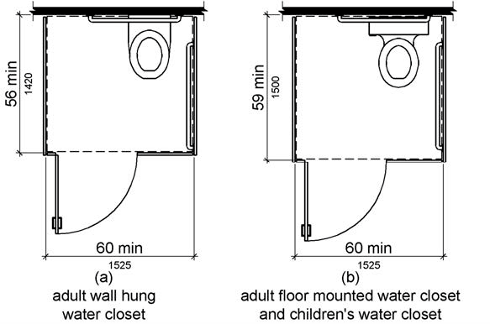

PHOTOGRAPH(S) OF THIS LOCATION

 | ID:  2924 | Facility:  Idaho Ice World

Location: Locker Rooms 1, 2, 3, 4, and 8
Schedule: 2021
Estimated Cost: $500.00

Priority Score 8
Quick Fix: Yes
Built before ADA: No

VIOLATIONS
2010 ADA Standards for Accessible Design Codes §308.2.1
The paper towel dispensers in Locker Rooms 1, 2, 3, 4, and 8 are outside of the unobstructed forward reach range at 51" above the floor.

RECOMMENDATIONS
Lower the paper towel dispensers by 3" to meet the accessible reach range of 15" minimum and 48" maximum above the floor.

PHOTOGRAPH(S) OF THIS LOCATION

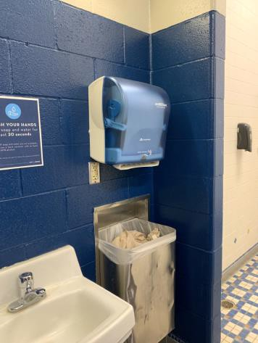

 | ID:  2920 | Facility:  Idaho Ice World

Location: Locker Rooms 1, 2, 3, and 4
Schedule: 2022
Estimated Cost: $4,000.00

Priority Score 5
Quick Fix: No
Built before ADA: No

VIOLATIONS
2010 ADA Standards for Accessible Design Codes §605.2
The urinals in Locker Rooms 1, 2, 3, and 4 are 23.5" above the floor.

RECOMMENDATIONS
Lower the urinals to a maximum height of 17" above the floor.

PHOTOGRAPH(S) OF THIS LOCATION

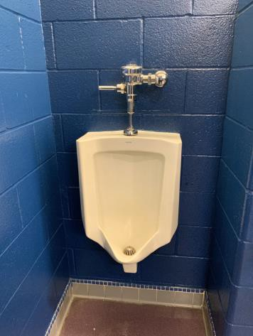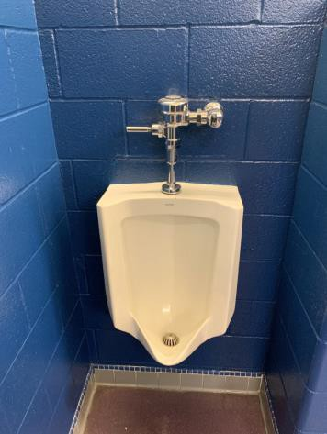
 | ID:  2299 | Facility:  Idaho Ice World

Location: Locker Rooms 7 and 8
Schedule: 2021
Estimated Cost: $200.00

Priority Score 6
Quick Fix: Yes
Built before ADA: No

VIOLATIONS
2010 ADA Standards for Accessible Design Codes §703.4
The tactile signs identifying the rooms are not in the correct location at 63" above the floor.

RECOMMENDATIONS
Reinstall the signs on the latch side of the door at 48" minimum above the floor measured from the baseline of the lowest character and 60" maximum measured from the baseline of the highest character.

PHOTOGRAPH(S) OF THIS LOCATION

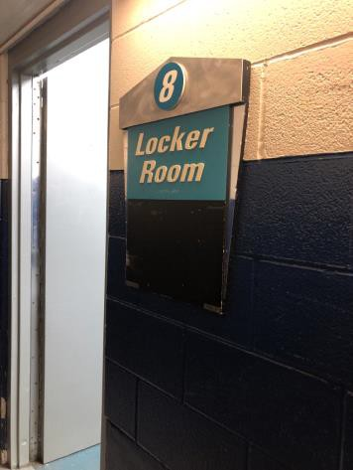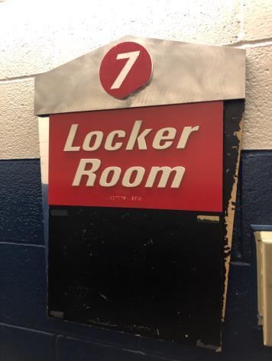

 | ID:  2939 | Facility:  Idaho Ice World

Location: Main Entrance
Schedule: 2021
Estimated Cost: $100.00

Priority Score 3
Quick Fix: Yes
Built before ADA: No

VIOLATIONS
2010 ADA Standards for Accessible Design Codes §303.3
The mats cause a 0.5" change in level at the entrance.

RECOMMENDATIONS
Remove the mats or ensure that the edges are beveled.

PHOTOGRAPH(S) OF THIS LOCATION

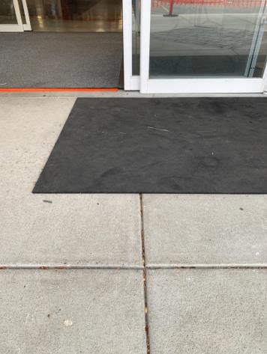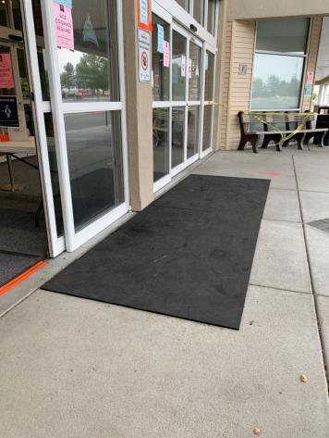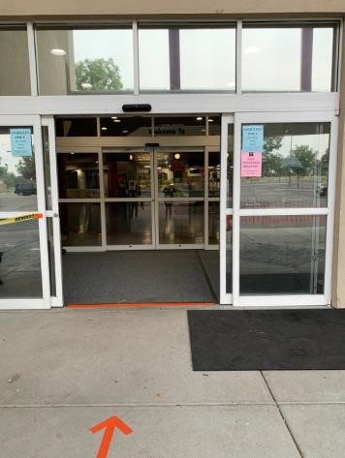
 | ID:  2298 | Facility:  Idaho Ice World

Location: Officials Locker Room
Schedule: 2021
Estimated Cost: $100.00

Priority Score 6
Quick Fix:Yes
Built before ADA: Yes

VIOLATIONS
2010 ADA Standards for Accessible Design Codes §703.4
The tactile sign identifying the room is not in the correct location.

RECOMMENDATIONS
Reinstall the sign on the latch side of the door at 48" minimum above the floor measured from the baseline of the lowest character and 60" maximum measured from the baseline of the highest character.

PHOTOGRAPH(S) OF THIS LOCATION

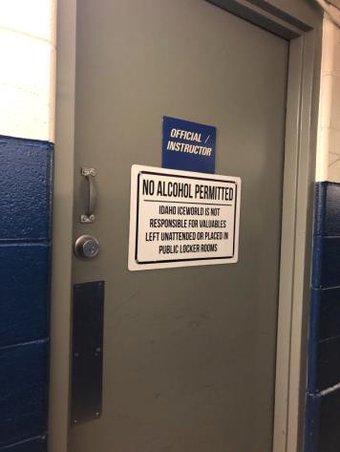
 | ID:  2293 | Facility:  Idaho Ice World

Location: Officials Locker Room
Schedule: 2021
Estimated Cost: $500.00

Priority Score 4
Quick Fix:Yes
Built before ADA: Yes

VIOLATIONS
2010 ADA Standards for Accessible Design Codes §404.2.9
The opening and closing force of the door is 5 to 7 pounds.

RECOMMENDATIONS
For the purposes of achieving greater accessibility and Human Centric Design, adjust the resistance on the door so that it allows the doors to be continuously opened at a maximum force of 5 pounds.

PHOTOGRAPH(S) OF THIS LOCATION

No photograph provided.
 | ID:  2912 | Facility:  Idaho Ice World

Location: Officials/Instructor Locker Room
Schedule: 2021
Estimated Cost: $100.00

Priority Score 5
Quick Fix: Yes
Built before ADA: No

VIOLATIONS
2010 ADA Standards for Accessible Design Codes §604.8.1.2
The door to the accessible water closet is not self closing. Either self-closing hinges are not installed on the door or if installed, they are defective.

RECOMMENDATIONS
Install or reinstall self-closing hinges on the door to ensure that the door is self-closing per the ADA requirements.

PHOTOGRAPH(S) OF THIS LOCATION

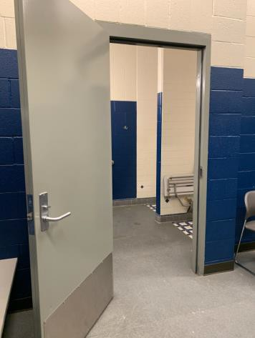
 | ID:  2914 | Facility:  Idaho Ice World

Location: Officials/Instructor Locker Room
Schedule: 2021
Estimated Cost: $100.00

Priority Score 6
Quick Fix: Yes
Built before ADA: No

VIOLATIONS
2010 ADA Standards for Accessible Design Codes §607.6
The shower spray unit holder is broken off.

RECOMMENDATIONS
Install a new shower spray unit holder.

PHOTOGRAPH(S) OF THIS LOCATION

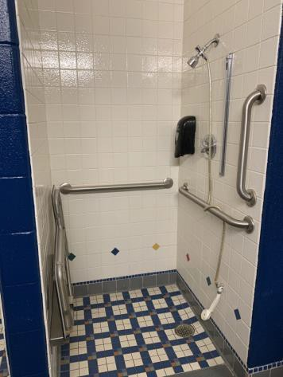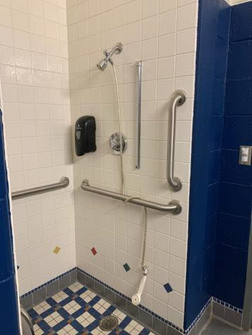
 | ID:  2915 | Facility:  Idaho Ice World

Location: Officials/Instructor Locker Room
Schedule: 2021
Estimated Cost: $100.00

Priority Score 8
Quick Fix: Yes
Built before ADA: No

VIOLATIONS
2010 ADA Standards for Accessible Design Codes §308.2.1
The hook is outside of the unobstructed forward reach range at 58" above the floor.

RECOMMENDATIONS
Lower the hook by 10" to meet the accessible reach range of 48" maximum above the floor.

PHOTOGRAPH(S) OF THIS LOCATION

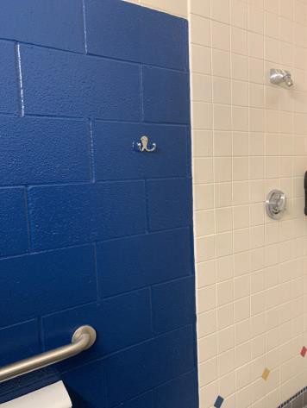

 | ID:  2916 | Facility:  Idaho Ice World

Location: Officials/Instructor Locker Room
Schedule: 2021
Estimated Cost: $100.00

Priority Score 5
Quick Fix: Yes
Built before ADA: No

VIOLATIONS
2010 ADA Standards for Accessible Design Codes §609.3
The space between the grab bar and the toilet seat cover dispenser is 8".

RECOMMENDATIONS
Relocate the toilet seat cover dispenser to a location that is at least a distance of 12" or greater above the grab bar. Ensure that the toilet seat cover dispenser is not greater than 48" above the floor.

PHOTOGRAPH(S) OF THIS LOCATION

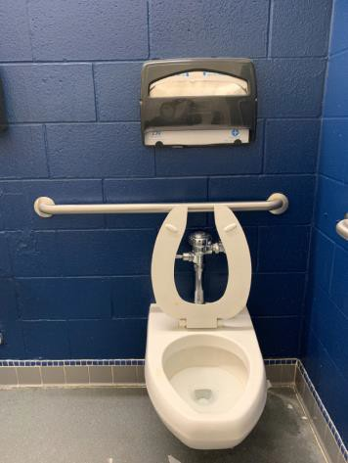
 | ID:  2913 | Facility:  Idaho Ice World

Location: Officials/Instructor Locker Room
Schedule: 2021
Estimated Cost: $500.00

Priority Score 6
Quick Fix: Yes
Built before ADA: No

VIOLATIONS
2010 ADA Standards for Accessible Design Codes §608.5.1
The shower controls are 50" above the floor.

RECOMMENDATIONS
Adjust the height of shower controls to a minimum height of 38" and a maximum height of 48" above the floor.

PHOTOGRAPH(S) OF THIS LOCATION

 | ID:  2899 | Facility:  Idaho Ice World

Location: Parking
Schedule: 2021
Estimated Cost: $1,000.00

Priority Score 3
Quick Fix: No
Built before ADA: No

VIOLATIONS
2010 ADA Standards for Accessible Design Codes §502.4
The parking space has a 2.5% slope.

RECOMMENDATIONS
Resurface the parking space to reduce the slope to a maximum of 2% in all directions.

PHOTOGRAPH(S) OF THIS LOCATION
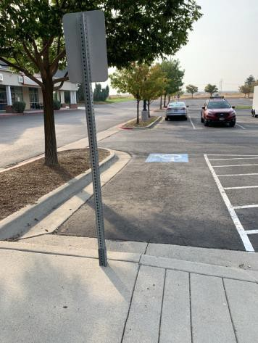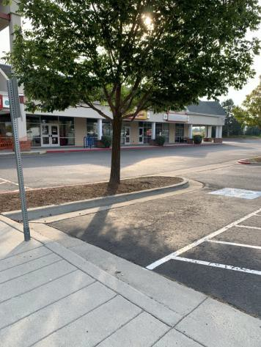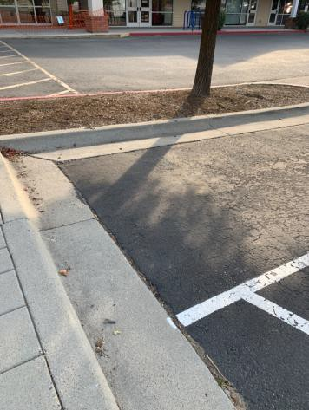
 | ID:  2897 | Facility:  Idaho Ice World

Location: Parking
Schedule: 2021
Estimated Cost: $2,000.00

Priority Score 2
Quick Fix: No
Built before ADA: No

VIOLATIONS
2010 ADA Standards for Accessible Design Codes §208.2.4
There is a total of eight accessible parking spaces and none of them are marked as "Van Accessible" spaces.

RECOMMENDATIONS
Install two 132" wide van accessible parking spaces. Add a “van accessible” parking sign at a minimum height of 60" above the ground.

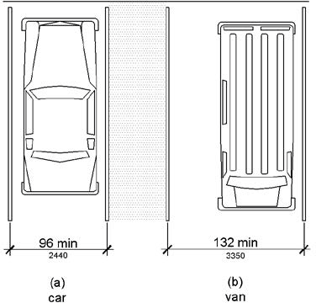

PHOTOGRAPH(S) OF THIS LOCATION

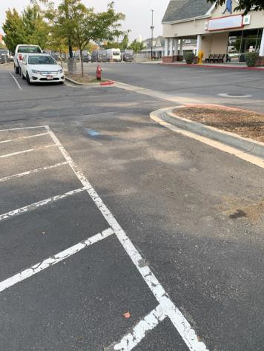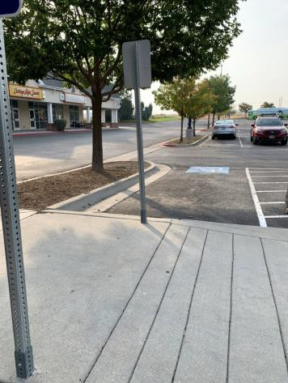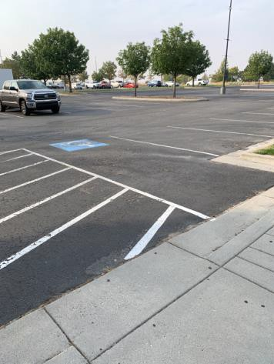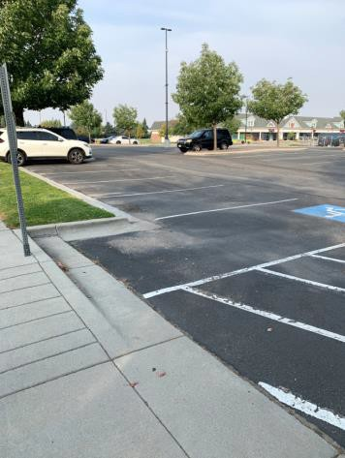
 | ID:  2898 | Facility:  Idaho Ice World

Location: Parking
Schedule: 2021
Estimated Cost: $2,500.00

Priority Score 3
Quick Fix: No
Built before ADA: No

VIOLATIONS
2010 ADA Standards for Accessible Design Codes §502.4
The parking space has a 3.8% slope.

RECOMMENDATIONS
Reconstruct the parking space to reduce the slope to a maximum of 2% in all directions.

PHOTOGRAPH(S) OF THIS LOCATION

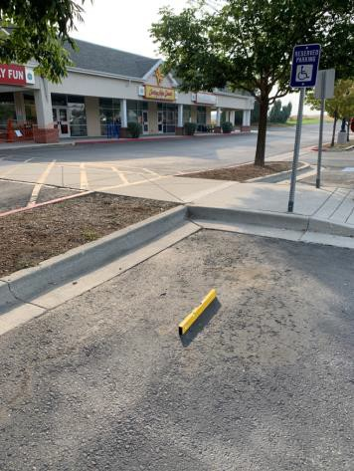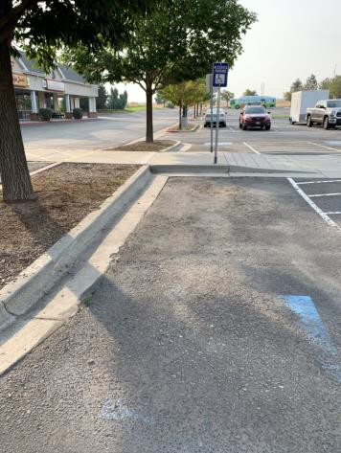
 | ID:  2970 | Facility:  Idaho Ice World

Location: Pilot Lounge
Schedule: 2021
Estimated Cost: $100.00

Priority Score 5
Quick Fix: Yes
Built before ADA: No

VIOLATIONS
2010 ADA Standards for Accessible Design Codes §307.2
The fire extinguisher protrudes 6.25" into the circulation space at 25" above the floor.

RECOMMENDATIONS
Recess the fire extinguisher so it protrudes a maximum of 4", lower it so the bottom edge is 27" maximum above the floor, or place a cane detectable object beneath it.

PHOTOGRAPH(S) OF THIS LOCATION

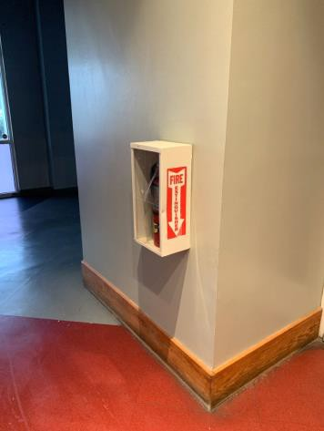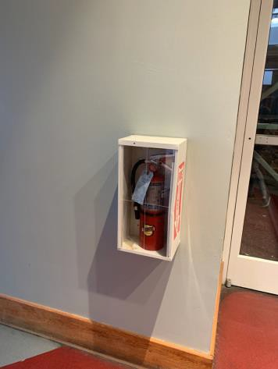
 | ID: | Facility:  Idaho Ice World

Location:
Schedule:
Estimated Cost:

Priority Score 5
Quick Fix: Yes
Built before ADA: No

VIOLATIONS
2010 ADA Standards for Accessible Design Codes §307.2
The fire extinguisher protrudes 6.75" into the circulation space at 31" above the floor.

RECOMMENDATIONS
Recess the fire extinguisher so it protrudes a maximum of 4", lower it so the bottom edge is 27" maximum above the floor, or place a cane detectable object beneath it.

PHOTOGRAPH(S) OF THIS LOCATION

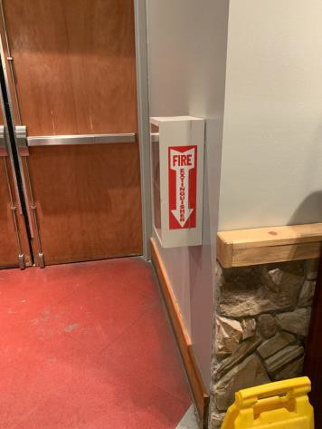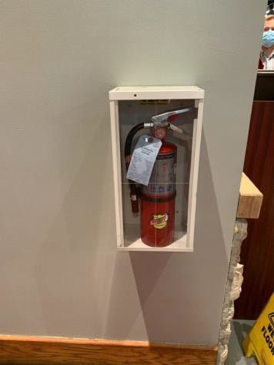
 | ID:  2971 | Facility:  Idaho Ice World

Location: Pilot Lounge
Schedule: 2021
Estimated Cost: $500.00

Priority Score 8
Quick Fix: Yes
Built before ADA: No

VIOLATIONS
2010 ADA Standards for Accessible Design Codes §308.2.1
The drink dispensers are outside of the unobstructed forward reach range at 51" above the floor.

RECOMMENDATIONS
Lower the drink dispensers by 3" to meet the accessible reach range of 15" minimum and 48" maximum above the floor.

PHOTOGRAPH(S) OF THIS LOCATION

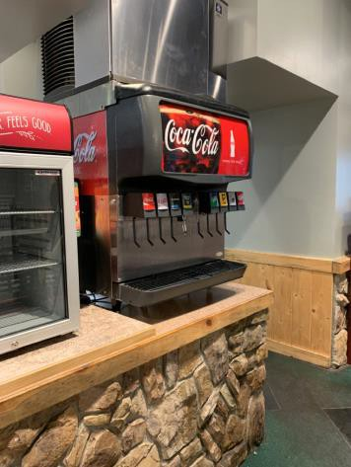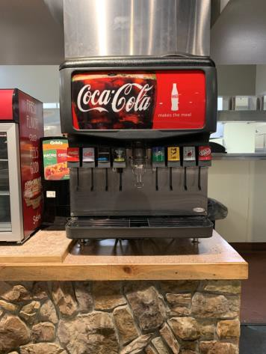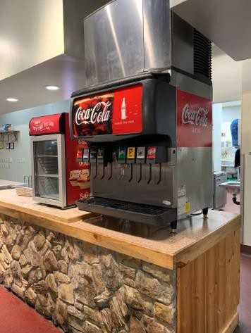
 | ID:  2972 | Facility:  Idaho Ice World

Location: Pilot Lounge
Schedule: 2021
Estimated Cost: $1,000.00

Priority Score 4
Quick Fix: No
Built before ADA: No

VIOLATIONS
2010 ADA Standards for Accessible Design Codes §904.4.1
The counter is 40" above the floor.

RECOMMENDATIONS
A portion of the service counter must be no higher than 36" above the floor for a horizontal distance of 36".

PHOTOGRAPH(S) OF THIS LOCATION

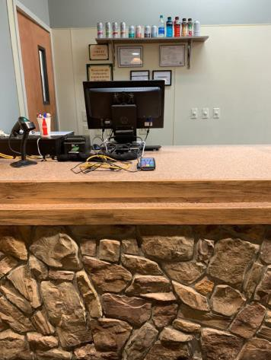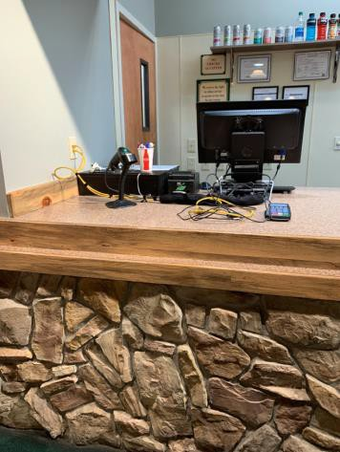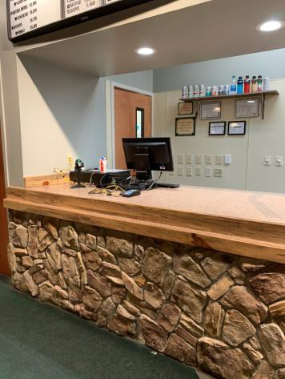
 | ID:  2969 | Facility:  Idaho Ice World

Location: Pilot Lounge Ramp
Schedule: 2022
Estimated Cost: $1,000.00

Priority Score 4
Quick Fix: No
Built before ADA: No

VIOLATIONS
2010 ADA Standards for Accessible Design Codes §505.10
There are no handrail extensions for the ramp.

RECOMMENDATIONS
Extend the ramp handrails 12” horizontally beyond the top and bottom of ramp runs.

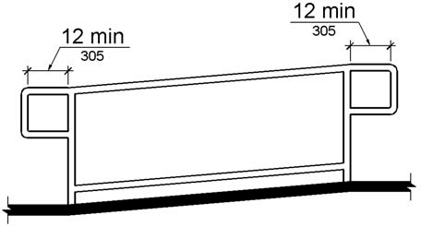

PHOTOGRAPH(S) OF THIS LOCATION

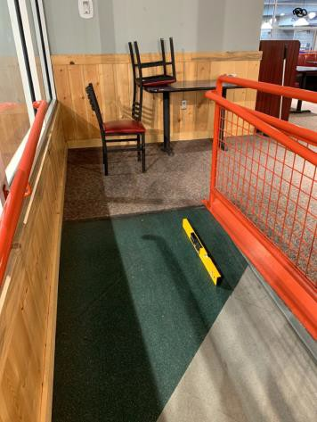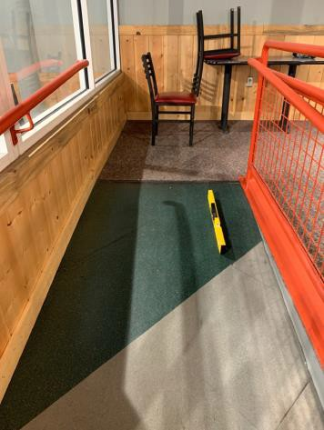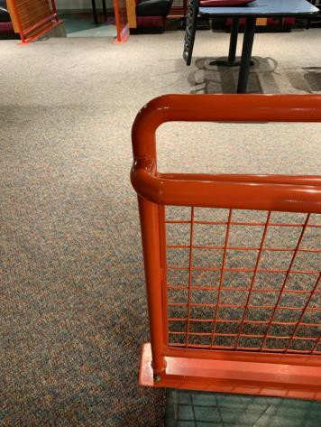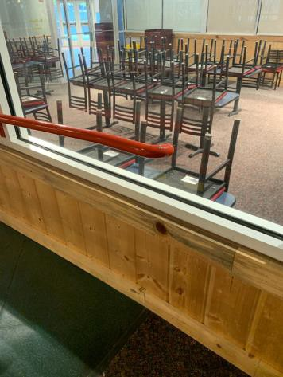
 | ID:  2963 | Facility:  Idaho Ice World

Location: Pilot Lounge Ramp
Schedule: 2022
Estimated Cost: $2,000.00

Priority Score 5
Quick Fix: No
Built before ADA: No

VIOLATIONS
2010 ADA Standards for Accessible Design Codes §505.10, §505.6
The distance between the handrail gripping surface and the wall is less than 1.5". There are no handrail extensions for the ramp.

RECOMMENDATIONS
Remount the handrails a minimum of 1.5" away from the wall.
Extend the ramp handrails 12” horizontally beyond the top and bottom of ramp runs.

PHOTOGRAPH(S) OF THIS LOCATION

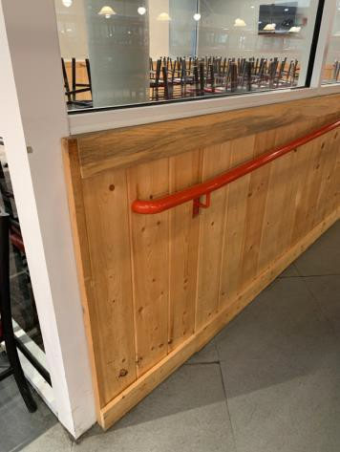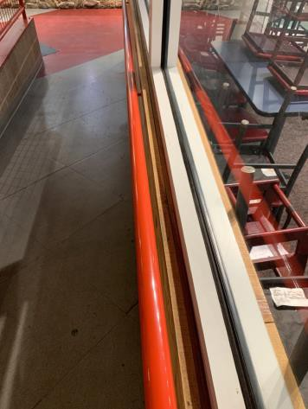
 | ID:  2968 | Facility:  Idaho Ice World

Location: Pilot Lounge Ramp
Schedule: 2022
Estimated Cost: $5,000.00

Priority Score 7
Quick Fix: No
Built before ADA: No

VIOLATIONS
2010 ADA Standards for Accessible Design Codes §405.2
The running slope at the top of the ramp is 8.8%.

RECOMMENDATIONS
Reconstruct the ramp to reduce the running slope to a maximum of 8.3%.
Ensure that there are 60" level landings at the top and bottom of the ramp.

PHOTOGRAPH(S) OF THIS LOCATION

 | ID:  2959 | Facility:  Idaho Ice World

Location: Pro Shop
Schedule: 2021
Estimated Cost: $100.00

Priority Score 5
Quick Fix: Yes
Built before ADA: No

VIOLATIONS
2010 ADA Standards for Accessible Design Codes §307.2
The electrical boxes protrude 6" into the circulation space at 36" above the floor.

RECOMMENDATIONS
Place a cane detectable object beneath the electrical boxes.

PHOTOGRAPH(S) OF THIS LOCATION

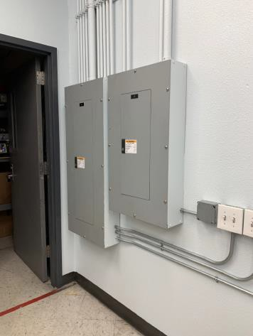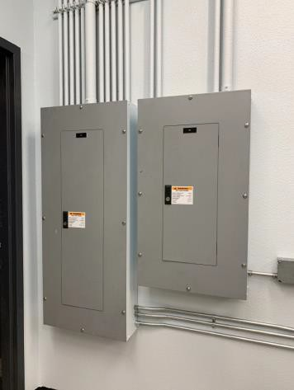
 | ID:  2957 | Facility:  Idaho Ice World

Location: Pro Shop
Schedule: 2021
Estimated Cost: $1,000.00

Priority Score 4
Quick Fix: No
Built before ADA: No

VIOLATIONS
2010 ADA Standards for Accessible Design Codes §904.4.1
The counter is 37.75" above the floor.

RECOMMENDATIONS
A portion of the service counter must be no higher than 36" above the floor for a horizontal distance of 36".

PHOTOGRAPH(S) OF THIS LOCATION

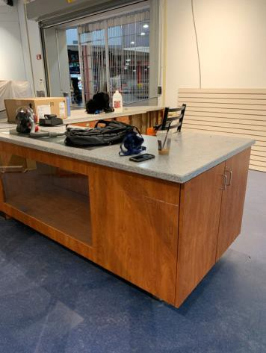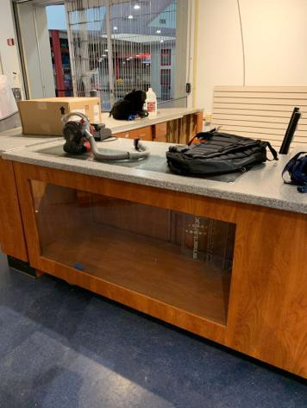
 | ID:  2311 | Facility:  Idaho Ice World

Location: Pro Shop Restroom
Schedule: 2021
Estimated Cost: $100.00

Priority Score 6
Quick Fix: Yes
Built before ADA: Yes

VIOLATIONS
2010 ADA Standards for Accessible Design Codes §703.4
The tactile sign identifying the room is not in the correct location.

RECOMMENDATIONS
Reinstall the sign on the latch side of the door at 48" minimum above the floor measured from the baseline of the lowest character and 60" maximum measured from the baseline of the highest character.

PHOTOGRAPH(S) OF THIS LOCATION

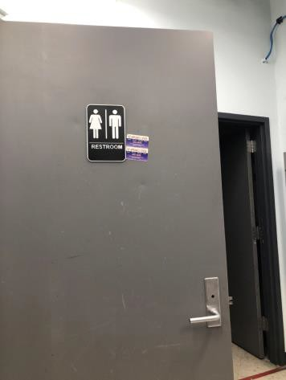
 | ID:  2312 | Facility:  Idaho Ice World

Location: Pro Shop Restroom
Schedule: 2021
Estimated Cost: $100.00

Priority Score 5
Quick Fix: Yes
Built before ADA: Yes

VIOLATIONS
2010 ADA Standards for Accessible Design Codes §604.8.1.2
The door to the accessible water closet is not self closing. Either self-closing hinges are not installed on the door or if installed, they are defective.

RECOMMENDATIONS
Install or reinstall self-closing hinges on the door to ensure that the door is self-closing per the ADA requirements.

PHOTOGRAPH(S) OF THIS LOCATION

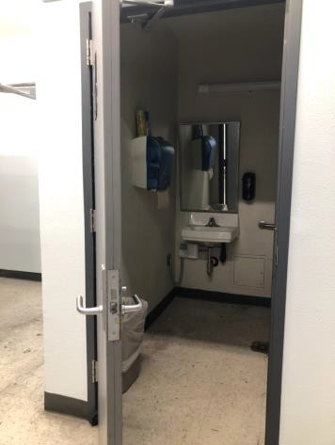

 | ID:  2313 | Facility:  Idaho Ice World

Location: Pro Shop Restroom
Schedule: 2021
Estimated Cost: $100.00

Priority Score 5
Quick Fix: Yes
Built before ADA: Yes

VIOLATIONS
2010 ADA Standards for Accessible Design Codes §609.3
The space between the grab bar and the toilet seat cover dispenser is 9".

RECOMMENDATIONS
Relocate the toilet seat cover dispenser to a location that is at least a distance of 12" or greater above the grab bar. Ensure that the toilet seat cover dispenser is not greater than 48" above the floor.

PHOTOGRAPH(S) OF THIS LOCATION

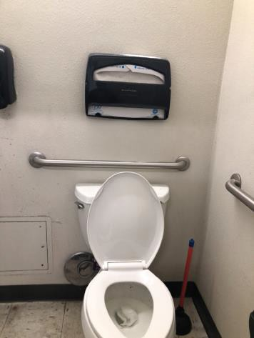
 | ID:  2317 | Facility:  Idaho Ice World

Location: Pro Shop Restroom
Schedule: 2021
Estimated Cost: $100.00

Priority Score 7
Quick Fix: Yes
Built before ADA: Yes

VIOLATIONS
2010 ADA Standards for Accessible Design Codes §606.5
The pipes under the sink are not covered.

RECOMMENDATIONS
Wrap the pipes beneath the sink with soft protective wrap or plastic.

PHOTOGRAPH(S) OF THIS LOCATION

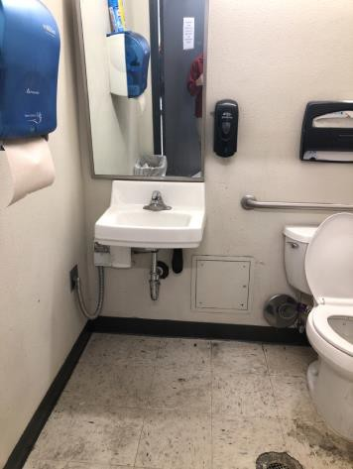
 | ID:  2314 | Facility:  Idaho Ice World

Location: Pro Shop Restroom
Schedule: 2022
Estimated Cost: $1,000.00

Priority Score 5
Quick Fix: No
Built before ADA: Yes

VIOLATIONS
2010 ADA Standards for Accessible Design Codes §604.5.2
The rear grab bar is 30" long.

RECOMMENDATIONS
Replace the rear grab bar with one that is a minimum of 36" long minimum and extends from the centerline of the water closet 12" minimum on one side and 24" minimum on the other.

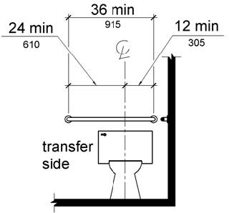

PHOTOGRAPH(S) OF THIS LOCATION

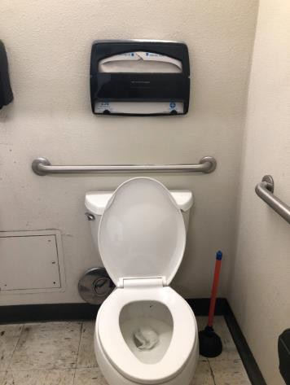
 | ID:  2315 | Facility:  Idaho Ice World

Location: Pro Shop Restroom
Schedule: 2022
Estimated Cost: $1,000.00

Priority Score 5
Quick Fix: No
Built before ADA: Yes

VIOLATIONS
2010 ADA Standards for Accessible Design Codes §604.5.1
The side grab bar extends 48" from the rear wall and is 36" long.

RECOMMENDATIONS
Replace the side grab bar with one that is a minimum of 42" long minimum, located 12" maximum from the rear wall and extending 54" minimum from the rear wall.

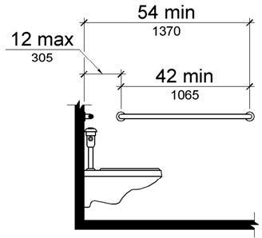

PHOTOGRAPH(S) OF THIS LOCATION

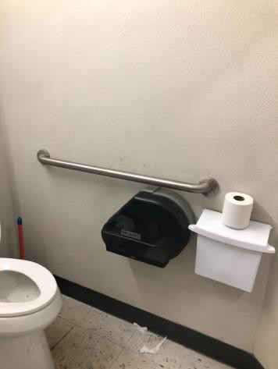
 | ID:  2316 | Facility:  Idaho Ice World

Location: Pro Shop Restroom
Schedule: 2022
Estimated Cost: $1000.00

Priority Score 5
Quick Fix: No
Built before ADA: Yes

VIOLATIONS
2010 ADA Standards for Accessible Design Codes ICC A117.1 §604.5.1
The accessible water closet does not have a vertical grab bar.

RECOMMENDATIONS
Install an 18" long (minimum) vertical grab bar on the side wall. The grab bar shall be mounted with the bottom located at 39" minimum and 41" maximum above the floor.
The centerline of the vertical grab bar shall be located 39" minimum and 41" maximum from the rear wall.

PHOTOGRAPH(S) OF THIS LOCATION

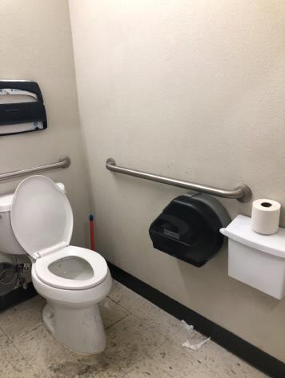

 | ID:  2937 | Facility:  Idaho Ice World

Location: Ramp to Locker Rooms 1-4
Schedule: 2022
Estimated Cost: $2,000.00

Priority Score 5
Quick Fix: No
Built before ADA: No

VIOLATIONS
2010 ADA Standards for Accessible Design Codes §505.10.1
The handrail extensions are 6.5".

RECOMMENDATIONS
Install new handrails that have handrail extensions that either return to a wall, guard, or the landing surface which extend at least 12" beyond the ramp run.

PHOTOGRAPH(S) OF THIS LOCATION

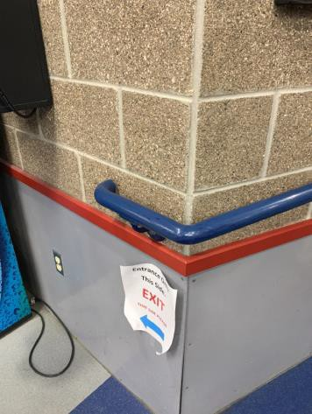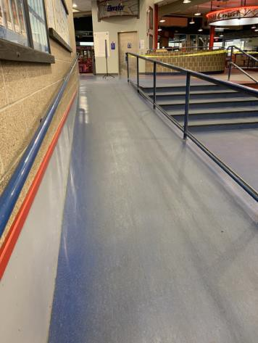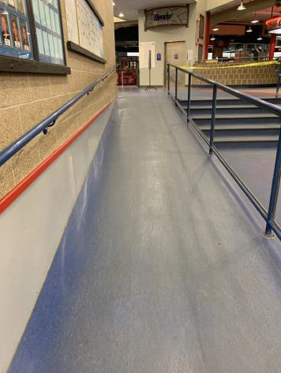

 | ID:  2938 | Facility:  Idaho Ice World

Location: Ramp to Locker Rooms 1-4
Schedule: 2022
Estimated Cost: $5,000.00

Priority Score 7
Quick Fix: No
Built before ADA: No

VIOLATIONS
2010 ADA Standards for Accessible Design Codes §405.2
The running slopes of the ramp at the top is 10.1% and the bottom is 8.4%.

RECOMMENDATIONS
Reconstruct the ramp to reduce the running slope to a maximum of 8.3%.

PHOTOGRAPH(S) OF THIS LOCATION

 | ID:  2295 | Facility:  Idaho Ice World

Location: Restaurant Door
Schedule: 2021
Estimated Cost: $500.00

Priority Score 4
Quick Fix: Yes
Built before ADA: Yes

VIOLATIONS
2010 ADA Standards for Accessible Design Codes §404.2.9
The opening and closing force of the door is 7.5 pounds.

RECOMMENDATIONS
For the purposes of achieving greater accessibility and Human Centric Design, adjust the resistance on the door so that it allows the doors to be continuously opened at a maximum force of 5 pounds.

PHOTOGRAPH(S) OF THIS LOCATION

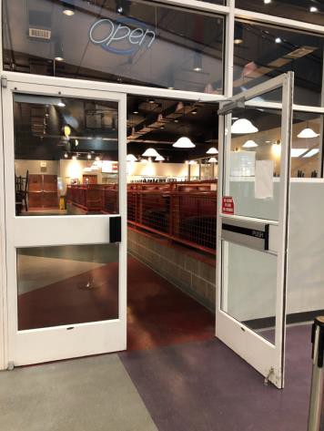

 | ID:  2096 | Facility:  Idaho Ice World

Location: Rink Entrance
Schedule: 2021
Estimated Cost: $500.00

Priority Score 4
Quick Fix: Yes
Built before ADA: Yes

VIOLATIONS
2010 ADA Standards for Accessible Design Codes §404.2.4.1
The automatic doors open into the maneuvering clearance.

RECOMMENDATIONS
For the purposes of achieving greater accessibility and Human Centric Design, adjust the right set of automatic doors to open outward.

PHOTOGRAPH(S) OF THIS LOCATION

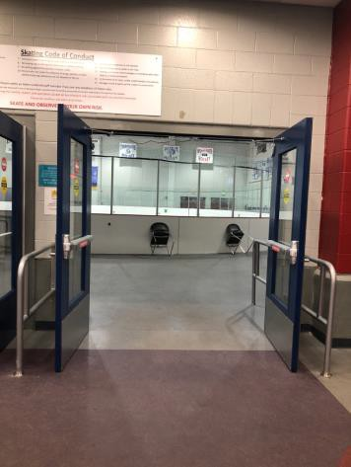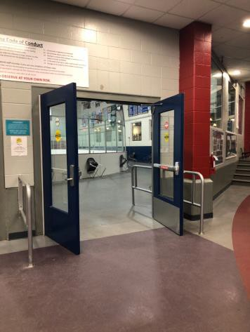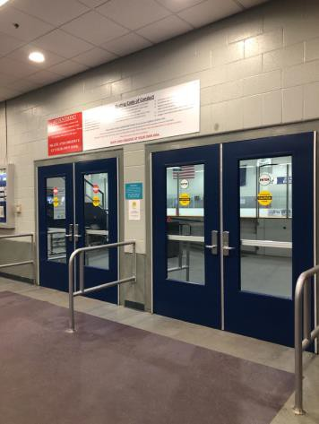

 | ID:  2954 | Facility:  Idaho Ice World

Location: Skate Rental Counters
Schedule: 2021
Estimated Cost: $100.00

Priority Score 5
Quick Fix: Yes
Built before ADA: No

VIOLATIONS
2010 ADA Standards for Accessible Design Codes §307.2
The AED protrudes 6" into the circulation space at 42" above the floor.

RECOMMENDATIONS
Recess the AED so it protrudes a maximum of 4", lower it so the bottom edge is 27" maximum above the floor, or place a cane detectable

PHOTOGRAPH(S) OF THIS LOCATION

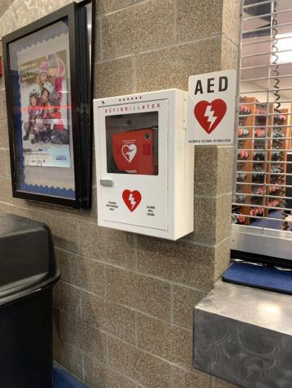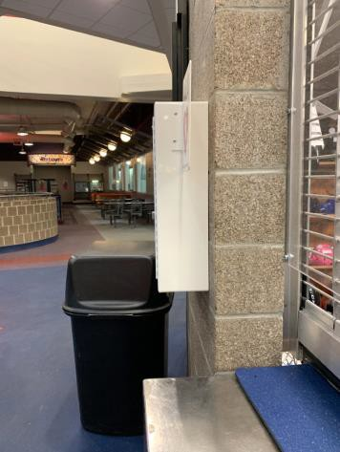

 | ID:  2908 | Facility:  Idaho Ice World

Location: Sled Skating Ramp
Schedule: 2021
Estimated Cost: $500.00

Priority Score 7
Quick Fix: Yes
Built before ADA: No

VIOLATIONS
2010 ADA Standards for Accessible Design Codes §405.2
The running slope of the sled skating ramp is 9.7%.

RECOMMENDATIONS
Replace the sled skating ramps to reduce the running slope to a maximum of 8.3%.

PHOTOGRAPH(S) OF THIS LOCATION

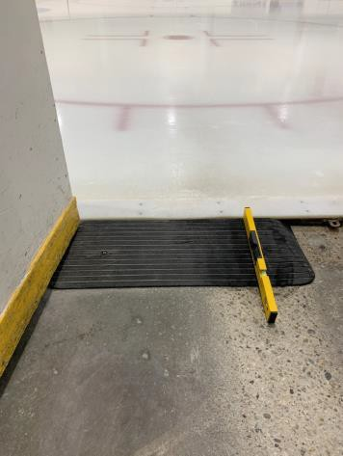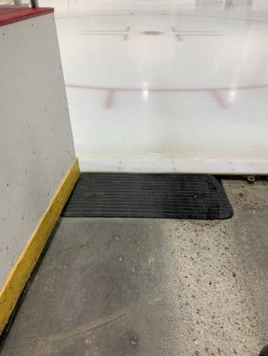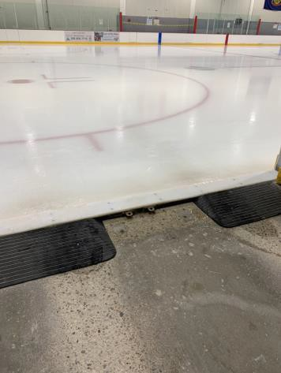

 | ID:  2974 | Facility:  Idaho Ice World

Location: Stairwell
Schedule: 2022
Estimated Cost: $5,000.00

Priority Score 5
Quick Fix: No
Built before ADA: No

VIOLATIONS
2010 ADA Standards for Accessible Design Codes §505.4
The handrails are 39" above the floor.

RECOMMENDATIONS
Lower the handrails to a minimum height of 34" and a maximum of 38" above the ground. Ensure that the handrails are at a consistent height along the walking surface.

PHOTOGRAPH(S) OF THIS LOCATION

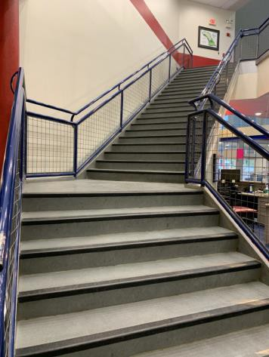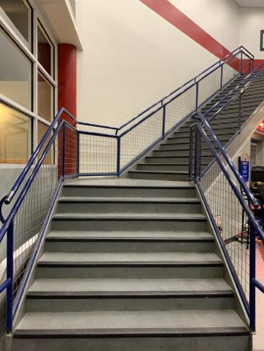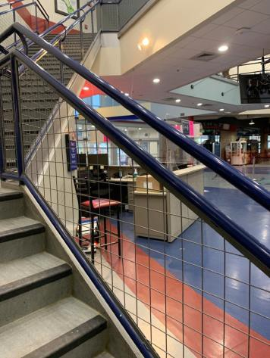

 | ID:  2907 | Facility:  Idaho Ice World

Location: Vending Machines
Schedule: 2023
Estimated Cost: $3,000.00

Priority Score 8
Quick Fix: No
Built before ADA: No

VIOLATIONS
2010 ADA Standards for Accessible Design Codes §308.2.1
The vending machine controls are outside of the unobstructed forward reach range at 56" above the floor.

RECOMMENDATIONS
Lower the vending machine controls by 8" to meet the accessible reach range of 15" minimum and 48" maximum above the floor.
This may require replacing the vending machines.

PHOTOGRAPH(S) OF THIS LOCATION

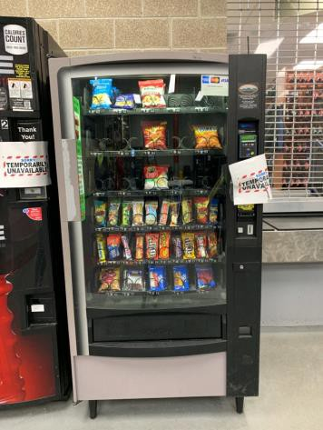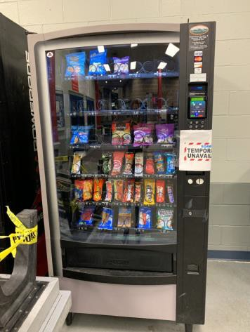

 | ID:  2936 | Facility:  Idaho Ice World

Location: Women's Locker Room
Schedule: 2021
Estimated Cost: $100.00

Priority Score 8
Quick Fix: No
Built before ADA: No

VIOLATIONS
2010 ADA Standards for Accessible Design Codes §308.2.1
The hook adjacent to the shower is outside of the unobstructed forward reach range at 54" above the

RECOMMENDATIONS
Lower the hook by 6" to meet the accessible reach range of 48" maximum above the floor.

PHOTOGRAPH(S) OF THIS LOCATION

No photograph provided.
 | ID:  2303 | Facility:  Idaho Ice World

Location: Women's Locker Room
Schedule: 2021
Estimated Cost: $100.00

Priority Score 4
Quick Fix: Yes
Built before ADA: Yes

VIOLATIONS
2010 ADA Standards for Accessible Design Codes §404.2.4.1
There is not adequate maneuvering clearance to operate the door.

RECOMMENDATIONS
Change the direction that the door swings or expand the area for which the door opens by removing obstructions to provide 54" of maneuvering clearance.
However, if direction of the door swing were changed, the current maneuvering clearance of 49" is sufficient.

PHOTOGRAPH(S) OF THIS LOCATION

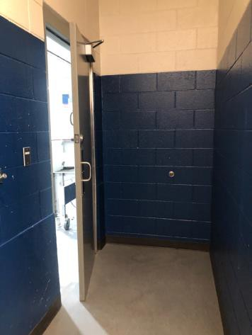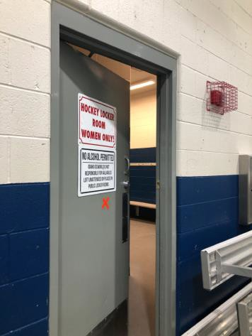

 | ID:  2294 | Facility:  Idaho Ice World

Location: Women's Locker Room
Schedule: 2021
Estimated Cost: $500.00

Priority Score 4
Quick Fix: Yes
Built before ADA: Yes

VIOLATIONS
2010 ADA Standards for Accessible Design Codes §404.2.9
The opening and closing force of the door is 5 to 7 pounds.

RECOMMENDATIONS
For the purposes of achieving greater accessibility and Human Centric Design, adjust the resistance on the door so that it allows the doors to be continuously opened at a maximum force of 5 pounds.

PHOTOGRAPH(S) OF THIS LOCATION

