City of Boise ADA Assessment

Appendix A –
City Hall West

02/19/2021
Report #TO21-B021

Prepared by:
 | ID:  3406 | Facility:  City Hall West

Location: AED
Schedule: 2021
Estimated Cost: $100.00

Priority Score 5
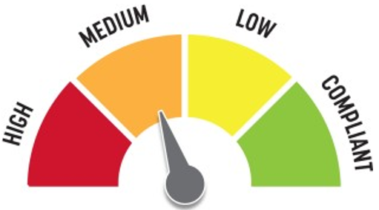
Quick Fix: Yes
Built before ADA: No

VIOLATIONS
2010 ADA Standards for Accessible Design Codes §307.2
The AED protrudes 8.5" into the circulation space at 31" above the floor.

RECOMMENDATIONS
Recess the AED so it protrudes a maximum of 4", lower it so the bottom edge is 27" maximum above the floor, or place a cane detectable object beneath it.

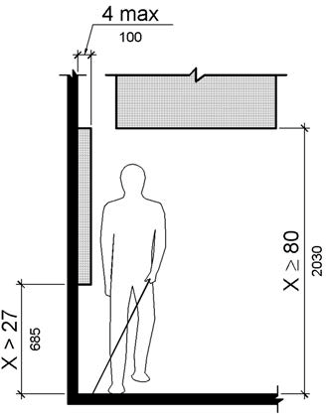

PHOTOGRAPH(S) OF THIS LOCATION

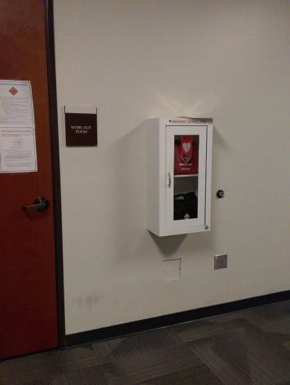

 | ID:  3569 | Facility:  City Hall West

Location: Back Lot
Schedule: 2021
Estimated Cost: $100.00

Priority Score 7
Quick Fix: Yes
Built before ADA: No

VIOLATIONS
2010 ADA Standards for Accessible Design Codes §302.1, §305
There is not a firm, stable, and slip resistant route to the garbage can.

RECOMMENDATIONS
Relocate the garbage can adjacent to the accessible route.

PHOTOGRAPH(S) OF THIS LOCATION

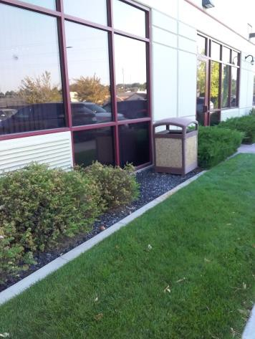

 | ID:  3611 | Facility:  City Hall West

Location: Body Camera Room
Schedule: 2021
Estimated Cost: $100.00

Priority Score 5
Quick Fix: Yes
Built before ADA: No

VIOLATIONS
2010 ADA Standards for Accessible Design Codes §307.2
The shelf protrudes 6" into the circulation space at 42.5" above the floor.

RECOMMENDATIONS
Recess the shelf so it protrudes a maximum of 4", lower it so the bottom edge is 27" maximum above the floor, or place a cane detectable object beneath it.

PHOTOGRAPH(S) OF THIS LOCATION

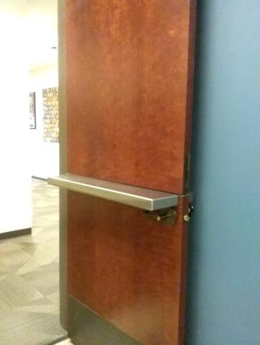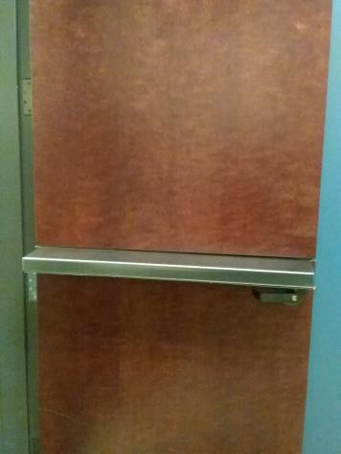

 | ID:  3376 | Facility:  City Hall West

Location: Cafeteria
Schedule: 2023
Estimated Cost: $1,000.00

Priority Score 8
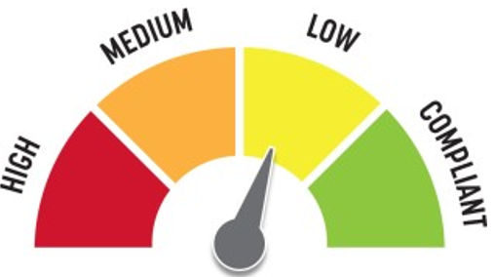
Quick Fix: No
Built before ADA: No

VIOLATIONS
2010 ADA Standards for Accessible Design Codes §902.3
The dining and work surface counter is 37" above the floor.

RECOMMENDATIONS
A 30" portion of the dining and work surface must be no higher than 34” above the floor.

PHOTOGRAPH(S) OF THIS LOCATION

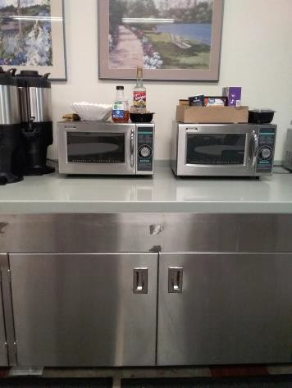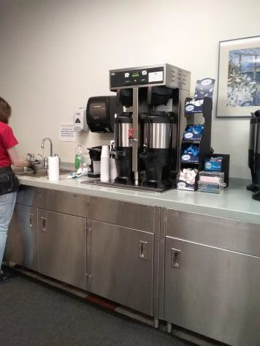

 | ID:  3118 | Facility:  City Hall West

Location: Cafeteria Entrance
Schedule: 2021
Estimated Cost: $1,000.00

Priority Score 3
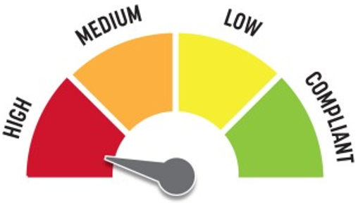
Quick Fix: No
Built before ADA: No

VIOLATIONS
2010 ADA Standards for Accessible Design Codes §404.2.4.4
The entrance has a 3.5% slope.

RECOMMENDATIONS
Resurface the entryway to reduce the running slope to a maximum of 2% in all directions.

PHOTOGRAPH(S) OF THIS LOCATION

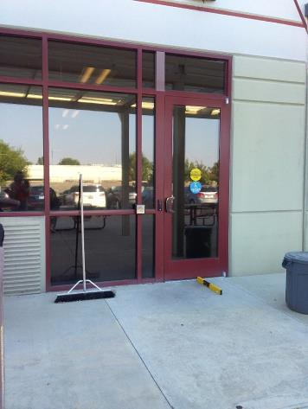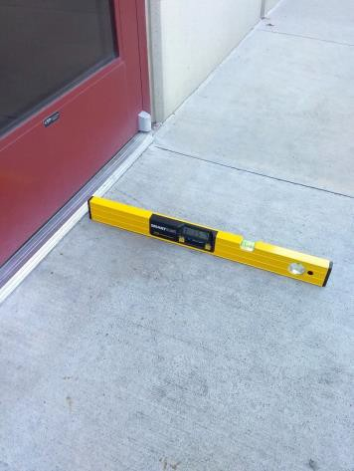

 | ID:  3730 | Facility:  City Hall West

Location: Chief Assistant
Schedule: 2021
Estimated Cost: $1,000.00

Priority Score 4
Quick Fix: No
Built before ADA: No

VIOLATIONS
2010 ADA Standards for Accessible Design Codes §904.4.1
The counter is 42" above the floor.

RECOMMENDATIONS
A portion of the service counter must be no higher than 36" above the floor for a horizontal distance of 36".

PHOTOGRAPH(S) OF THIS LOCATION

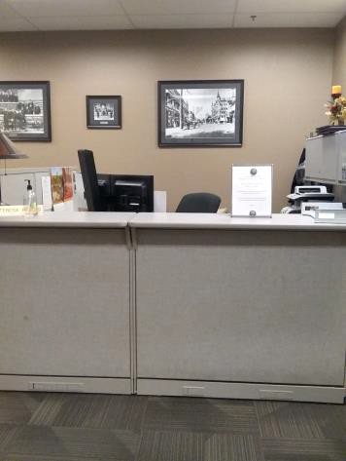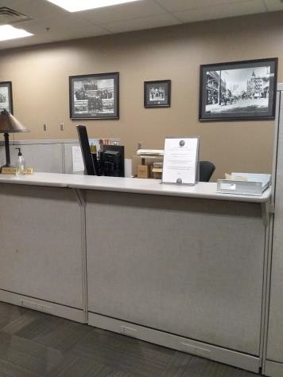

 | ID:  3072 | Facility:  City Hall West

Location: CID Women's Restroom
Schedule: 2021
Estimated Cost: $100.00

Priority Score 5
Quick Fix: Yes
Built before ADA: No

VIOLATIONS
2010 ADA Standards for Accessible Design Codes §307.2
The dispenser protrudes 6.75" into the circulation space at 45" above the floor.

RECOMMENDATIONS
Recess the dispenser so it protrudes a maximum of 4" or place a cane detectable object beneath it.

PHOTOGRAPH(S) OF THIS LOCATION

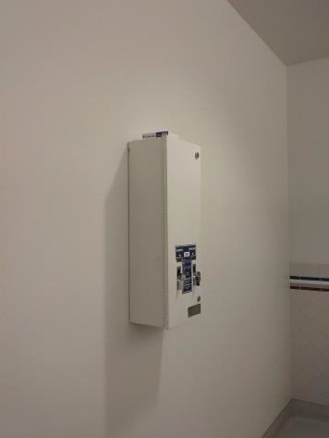

 | ID:  3443 | Facility:  City Hall West

Location: CID Women's Restroom
Schedule: 2021
Estimated Cost: $100.00

Priority Score 5
Quick Fix: Yes
Built before ADA: No

VIOLATIONS
2010 ADA Standards for Accessible Design Codes §604.8.1.2
The door to the accessible water closet is not self closing. Either self-closing hinges are not installed on the door or if installed, they are defective.

RECOMMENDATIONS
Install or reinstall self-closing hinges on the door to ensure that the door is self-closing per the ADA requirements.

PHOTOGRAPH(S) OF THIS LOCATION

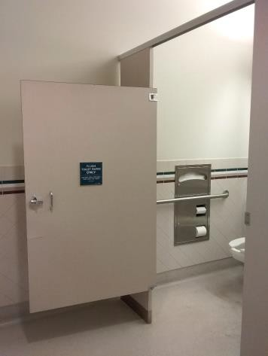

 | ID:  3444 | Facility:  City Hall West

Location: CID Women's Restroom
Schedule: 2021
Estimated Cost: $100.00

Priority Score 8
Quick Fix: Yes
Built before ADA: No

VIOLATIONS
2010 ADA Standards for Accessible Design Codes §308.2.1
The basket is outside of the unobstructed forward reach range at 51" above the floor.

RECOMMENDATIONS
Lower the basket by 3" to meet the accessible reach range of 15" minimum and 48" maximum above the floor.

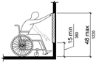

PHOTOGRAPH(S) OF THIS LOCATION

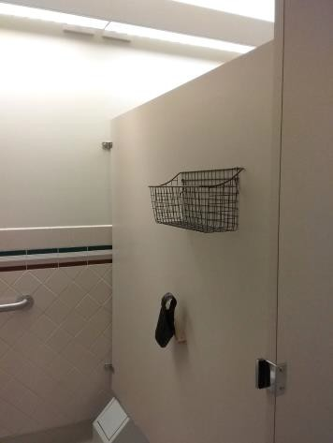

 | ID:  3445 | Facility:  City Hall West

Location: CID Women's Restroom
Schedule: 2021
Estimated Cost: $100.00

Priority Score 8
Quick Fix: Yes
Built before ADA: No

VIOLATIONS
2010 ADA Standards for Accessible Design Codes §308.2.1
The hook is outside of the unobstructed forward reach range at 65" above the floor.

RECOMMENDATIONS
Lower the hook by 17" to meet the accessible reach range of 48" maximum above the floor.

PHOTOGRAPH(S) OF THIS LOCATION

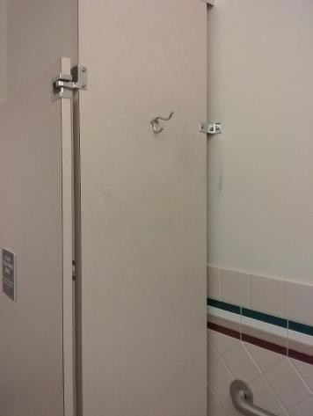

 | ID:  3449 | Facility:  City Hall West

Location: CID Women's Restroom
Schedule: 2021
Estimated Cost: $100.00

Priority Score 5
Quick Fix: Yes
Built before ADA: No

VIOLATIONS
2010 ADA Standards for Accessible Design Codes §604.7
The toilet paper dispenser is located out of the accessible reach range.

RECOMMENDATIONS
Remount the toilet paper dispenser to 7” minimum and 9” maximum in front of the water closet measured to the centerline of the dispenser.
The outlet of the dispenser shall be 15” minimum and 48” maximum above the floor and shall not be located behind.

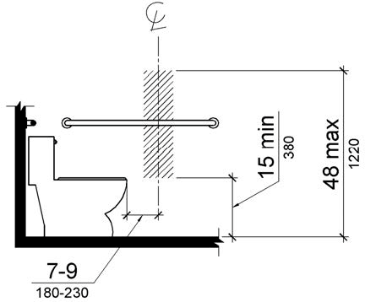

PHOTOGRAPH(S) OF THIS LOCATION

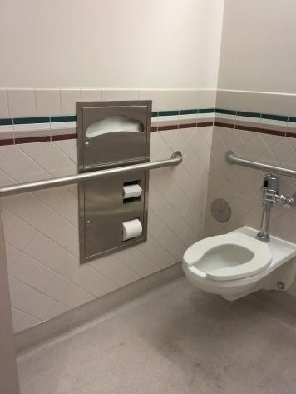

 | ID:  3496 | Facility:  City Hall West

Location: CID Women's Restroom
Schedule: 2021
Estimated Cost: $100.00

Priority Score 5
Quick Fix: Yes
Built before ADA: No

VIOLATIONS
2010 ADA Standards for Accessible Design Codes §307.2
The paper towel dispenser protrudes 7" into the circulation space at 48" above the floor.

RECOMMENDATIONS
Recess the paper towel dispenser so it protrudes a maximum of 4" or place a cane detectable object beneath it.

PHOTOGRAPH(S) OF THIS LOCATION

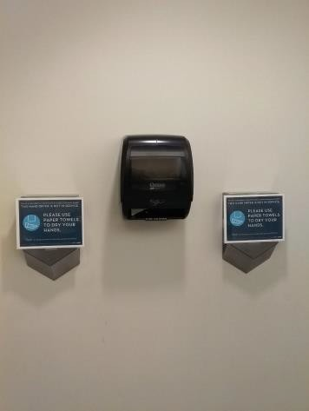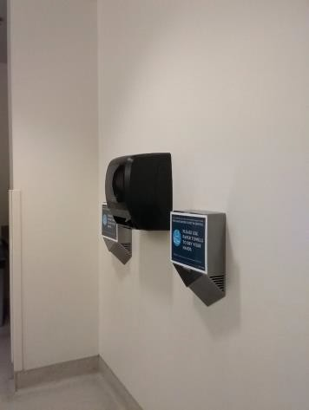

 | ID:  3659 | Facility:  City Hall West

Location: Coeur D'Alene
Schedule: 2021
Estimated Cost: $300.00

Priority Score 3
Quick Fix: Yes
Built before ADA: No

VIOLATIONS
2010 ADA Standards for Accessible Design Codes §302.3
There are 1" wide and 5" deep gaps in the floor.

RECOMMENDATIONS
Replace the floor covers with ones that have gaps that are a maximum of 0.5" wide.

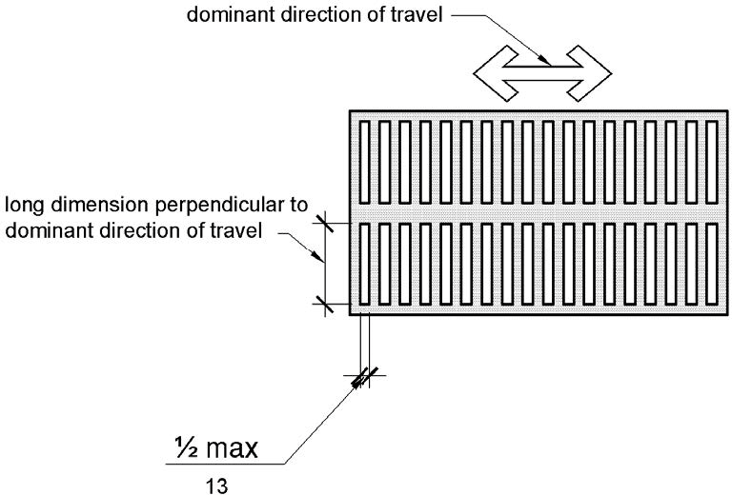

PHOTOGRAPH(S) OF THIS LOCATION

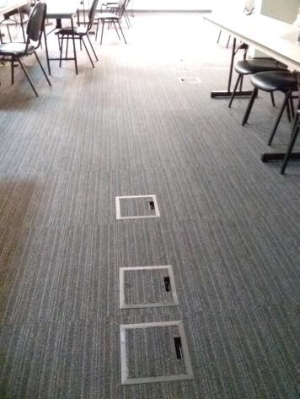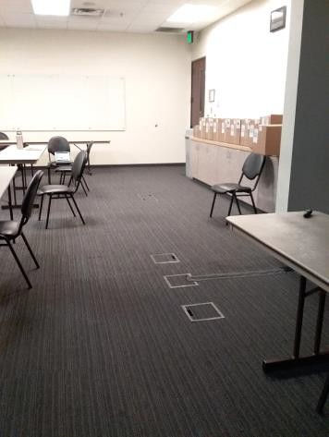

 | ID:  3497 | Facility:  City Hall West

Location: Entire Facility
Schedule: 2021
Estimated Cost: $17,600.00

Priority Score 3
Quick Fix: Yes
Built before ADA: No

VIOLATIONS
2010 ADA Standards for Accessible Design Codes §216.2, §703
There are no tactile signs identifying 176 permanent rooms.

RECOMMENDATIONS
Install tactile signage on the latch side of the doorway at a height of 48” minimum to 60” maximum above the floor, identifying room by name or room number.
Signs shall be Braille with raised lettering and should be placed on the wall in the center of an 18"x18" clear floor space.

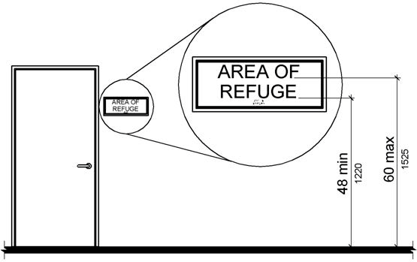

PHOTOGRAPH(S) OF THIS LOCATION

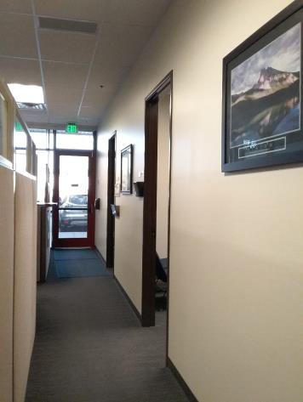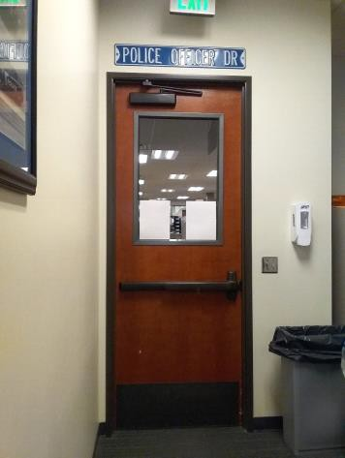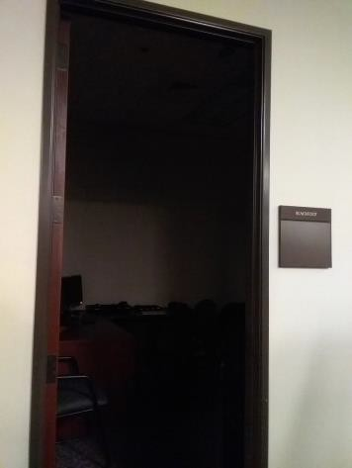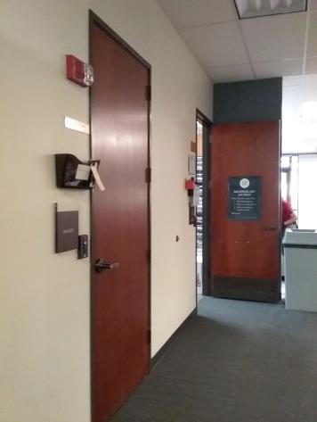

 | ID:  3362 | Facility:  City Hall West

Location: Exit
Schedule: 2021
Estimated Cost: $100.00

Priority Score 6
Quick Fix: Yes
Built before ADA: No

VIOLATIONS
2010 ADA Standards for Accessible Design Codes §703.4
The tactile sign identifying the room is not in the correct location.

RECOMMENDATIONS
Reinstall the sign on the latch side of the door at 48" minimum above the floor measured from the baseline of the lowest character and 60" maximum measured from the baseline of the highest character.

PHOTOGRAPH(S) OF THIS LOCATION

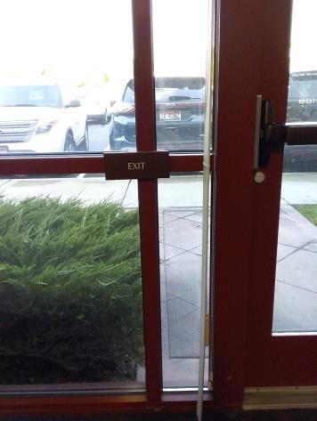

 | ID:  3289 | Facility:  City Hall West

Location: Exit by Kim
Schedule: 2021
Estimated Cost: $100.00

Priority Score 6
Quick Fix: Yes
Built before ADA: No

VIOLATIONS
2010 ADA Standards for Accessible Design Codes §703.4
The tactile sign identifying the room is not in the correct location.

RECOMMENDATIONS
Reinstall the sign on the latch side of the door at 48" minimum above the floor measured from the baseline of the lowest character and 60" maximum measured from the baseline of the highest character.

PHOTOGRAPH(S) OF THIS LOCATION

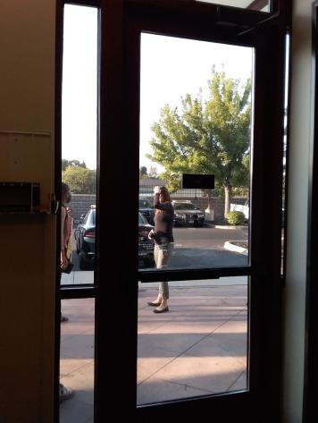

 | ID:  3022 | Facility:  City Hall West

Location: Exit by Lobby
Schedule: 2021
Estimated Cost: $100.00

Priority Score 6
Quick Fix: Yes
Built before ADA: No

VIOLATIONS
2010 ADA Standards for Accessible Design Codes §703.4
The tactile sign identifying the room is not in the correct location.

RECOMMENDATIONS
Reinstall the sign on the latch side of the door at 48" minimum above the floor measured from the baseline of the lowest character and 60" maximum measured from the baseline of the highest character.

PHOTOGRAPH(S) OF THIS LOCATION

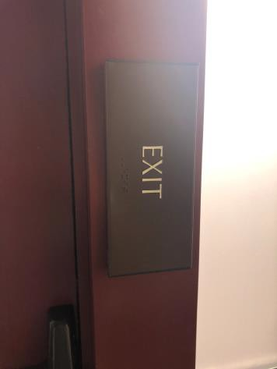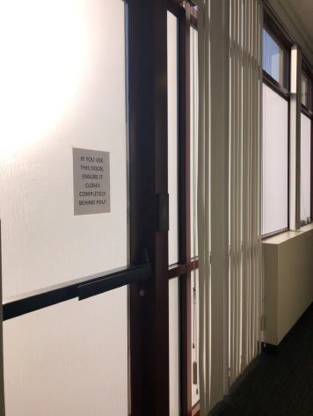

 | ID:  3542 | Facility:  City Hall West

Location: Facilities Office
Schedule: 2021
Estimated Cost: $100.00

Priority Score 8
Quick Fix: Yes
Built before ADA: No

VIOLATIONS
2010 ADA Standards for Accessible Design Codes §308.2.1
The first aid box is outside of the unobstructed forward reach range at 51.75" above the floor.

RECOMMENDATIONS
Lower the first aid box by 3.75" to meet the accessible reach range of 48" maximum above the floor.

PHOTOGRAPH(S) OF THIS LOCATION

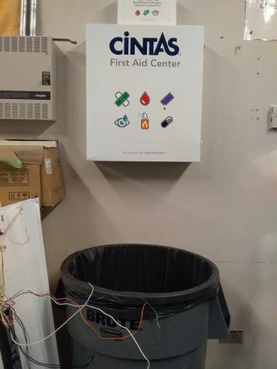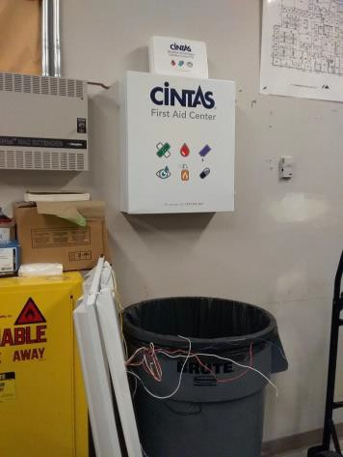

 | ID:  3605 | Facility:  City Hall West

Location: Fire Academy Classroom
Schedule: 2021
Estimated Cost: $200.00

Priority Score 5
Quick Fix: Yes
Built before ADA: No

VIOLATIONS
2010 ADA Standards for Accessible Design Codes §307.2
The TVs protrude 5.5" into the circulation space at 57" above the floor.

RECOMMENDATIONS
Recess the TVs so they protrude a maximum of 4", raise them so the bottom edge is 80" maximum above the floor, or place a cane detectable object beneath them.

PHOTOGRAPH(S) OF THIS LOCATION

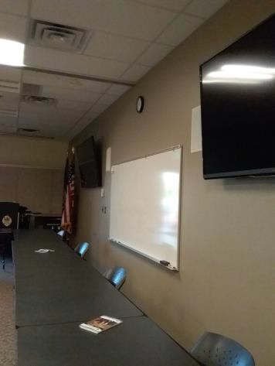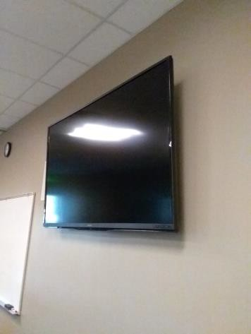

 | ID: | Facility:  City Hall West

Location: Fire Academy Classroom
Schedule: 2021
Estimated Cost: $300.00

Priority Score 3
Quick Fix: Yes
Built before ADA: No

VIOLATIONS
2010 ADA Standards for Accessible Design Codes §302.3
There are 1" wide and 5" deep gaps in the floor.

RECOMMENDATIONS
Replace the floor covers with ones that have a maximum width of 0.5".

PHOTOGRAPH(S) OF THIS LOCATION

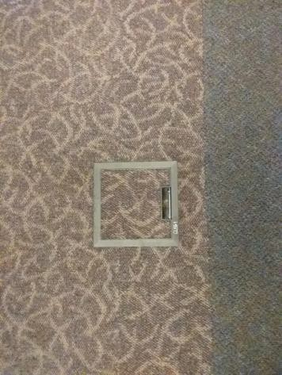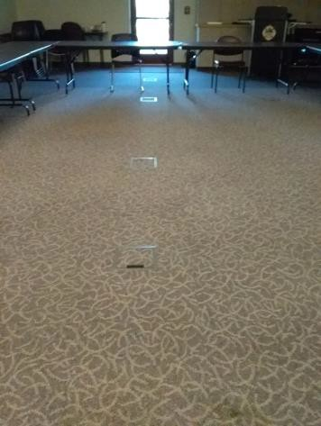

 | ID:  3183 | Facility:  City Hall West

Location: Fire Academy Classroom
Schedule: 2023
Estimated Cost: $1,000.00

Priority Score 8
Quick Fix: No
Built before ADA: No

VIOLATIONS
2010 ADA Standards for Accessible Design Codes §902.3
The podium is 40" above the floor.

RECOMMENDATIONS
Lower the podium to a maximum of 34" above the floor or have a secondary 34" high surface available adjacent to the podium.

PHOTOGRAPH(S) OF THIS LOCATION

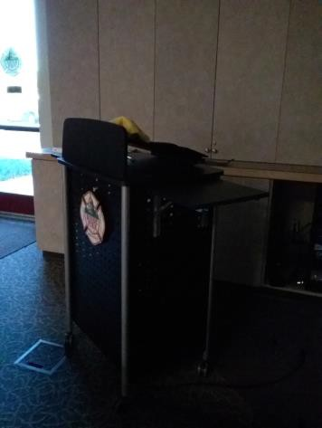

 | ID:  3614 | Facility:  City Hall West

Location: Fire Administration Front Counter
Schedule: 2021
Estimated Cost: $1,000.00

Priority Score 4
Quick Fix: No
Built before ADA: No

VIOLATIONS
2010 ADA Standards for Accessible Design Codes §904.4.1
The counter is 49" above the ground.

RECOMMENDATIONS
A portion of the service counter must be no higher than 36" above the floor for a horizontal distance of 36".

PHOTOGRAPH(S) OF THIS LOCATION

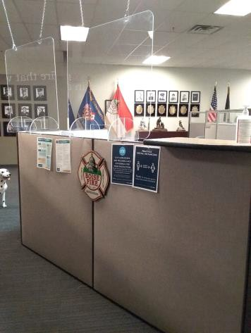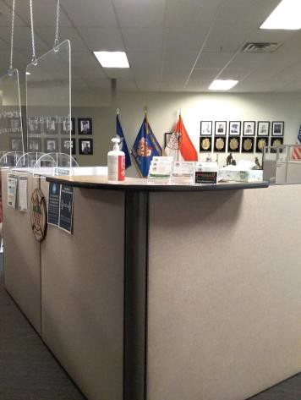

 | ID:  35283528 | Facility:  City Hall West

Location: Fire Break Room
Schedule: 2021
Estimated Cost: $100.00

Priority Score 8
Quick Fix: Yes
Built before ADA: No

VIOLATIONS
2010 ADA Standards for Accessible Design Codes §308.2.2
The paper towel dispenser is outside of the obstructed forward reach range at 54" above the floor.

RECOMMENDATIONS
Lower the paper towel dispenser by 6" to meet the accessible reach range of 48" maximum above the floor.

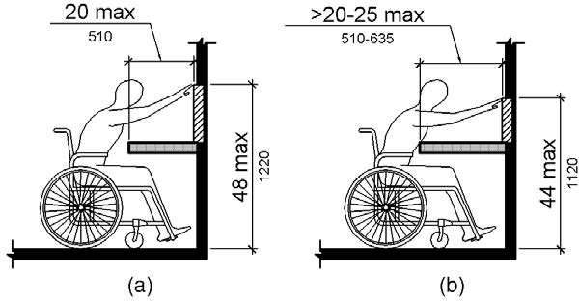

PHOTOGRAPH(S) OF THIS LOCATION

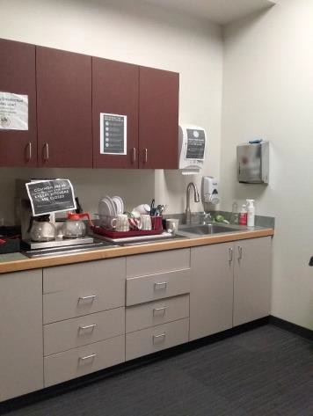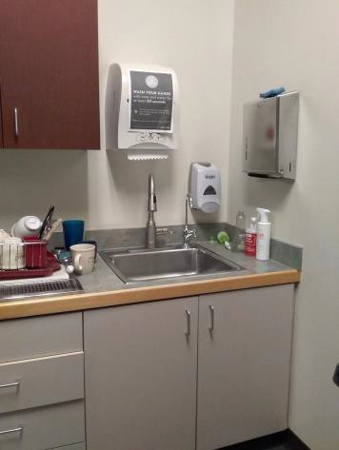

 | ID: | Facility:  City Hall West

Location: Fire Break Room
Schedule: 2022
Estimated Cost: $1,000.00

Priority Score 5
Quick Fix: No
Built before ADA: No

VIOLATIONS
2010 ADA Standards for Accessible Design Codes §306.3.3
There is no knee clearance underneath the counter.

RECOMMENDATIONS
Provide knee clearance underneath the counter at the sink that is a minimum of 11" deep at 9" above the floor and 8" deep at 27" above the floor.

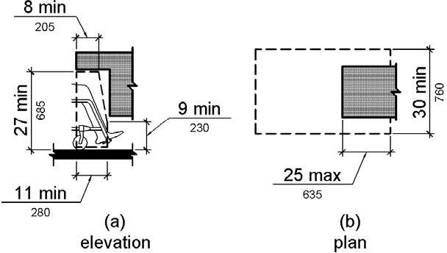

PHOTOGRAPH(S) OF THIS LOCATION

 | ID:  3003 | Facility:  City Hall West

Location: Fire Side Men's Restroom
Schedule: 2021
Estimated Cost: $100.00

Priority Score 8
Quick Fix: Yes
Built before ADA: No

VIOLATIONS
The coat hook is outside of the unobstructed forward reach range at 64" above the floor.

RECOMMENDATIONS
Lower the coat hook by 16" to meet the accessible reach range of 48" maximum above the floor.

PHOTOGRAPH(S) OF THIS LOCATION

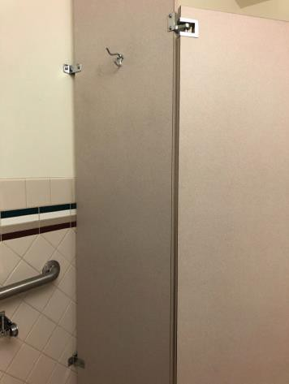

 | ID:  3174 | Facility:  City Hall West

Location: Fire Side Men's Restroom
Schedule: 2021
Estimated Cost: $100.00

Priority Score 5
Quick Fix: Yes
Built before ADA: No

VIOLATIONS
2010 ADA Standards for Accessible Design Codes §604.7
The toilet paper dispenser is located out of the accessible reach range.

RECOMMENDATIONS
Remount the toilet paper dispenser to 7” minimum and 9” maximum in front of the water closet measured to the centerline of the dispenser.
The outlet of the dispenser shall be 15” minimum and 48” maximum above the floor and shall not be located behind.

PHOTOGRAPH(S) OF THIS LOCATION

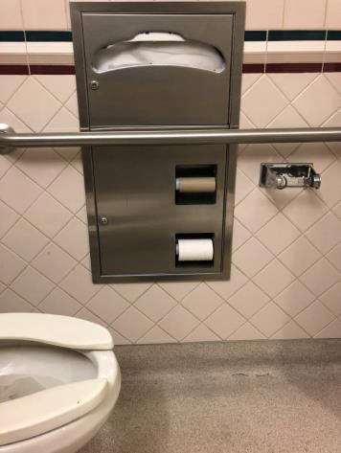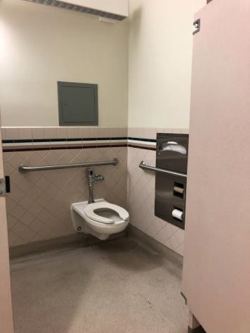

 | ID:  3403 | Facility:  City Hall West

Location: Fire Side Men's Restroom
Schedule: 2021
Estimated Cost: $100.00

Priority Score 5
Quick Fix: Yes
Built before ADA: No

VIOLATIONS
2010 ADA Standards for Accessible Design Codes §307.2, §308.2.1
The paper towel dispenser is outside of the unobstructed forward reach range at 48.5" above the floor. The paper towels protrude 9" into the circulation space at 48.5" above the floor.

RECOMMENDATIONS
Lower the paper towel dispenser by 0.5" to meet the accessible reach range of 48" maximum above the floor.
Recess the paper towels so it protrudes a maximum of 4" or place a cane detectable object beneath it.

PHOTOGRAPH(S) OF THIS LOCATION

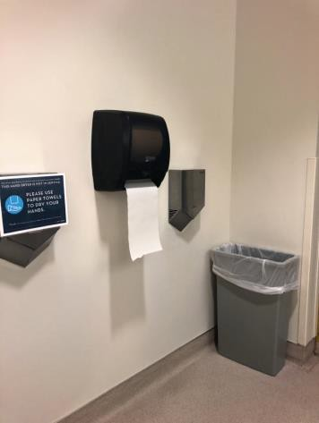
 | ID:  3618 | Facility:  City Hall West

Location: Fire Side Men's Restroom
Schedule: 2021
Estimated Cost: $100.00

Priority Score 5
Quick Fix:Yes
Built before ADA: No

VIOLATIONS
2010 ADA Standards for Accessible Design Codes §604.8.1.2
The door to the accessible water closet is not self closing. Either self-closing hinges are not installed on the door or if installed, they are defective.

RECOMMENDATIONS
Install or reinstall self-closing hinges on the door to ensure that the door is self-closing per the ADA requirements.

PHOTOGRAPH(S) OF THIS LOCATION

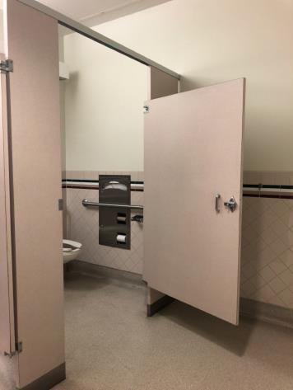

 | ID:  3165 | Facility:  City Hall West

Location: Fire Side Men's Restroom
Schedule: 2021
Estimated Cost: $200.00

Priority Score 7
Quick Fix: Yes
Built before ADA: No

VIOLATIONS
2010 ADA Standards for Accessible Design Codes §606.5
The pipes under the sinks are not covered.

RECOMMENDATIONS
Wrap the pipes beneath the sinks with soft protective wrap or plastic.

PHOTOGRAPH(S) OF THIS LOCATION

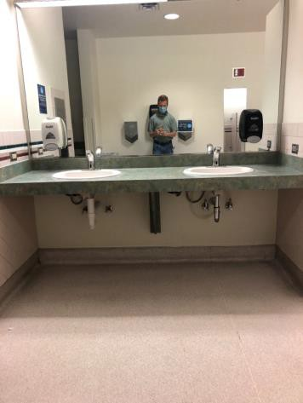

 | ID:  3383 | Facility:  City Hall West

Location: Fire Side Men's Restroom
Schedule: 2022
Estimated Cost: $1,000.00

Priority Score 5
Quick Fix: No
Built before ADA: No

VIOLATIONS
2010 ADA Standards for Accessible Design Codes ICC A117.1 §604.5.1
The accessible water closet does not have a vertical grab bar.

RECOMMENDATIONS
Install an 18" long (minimum) vertical grab bar on the side wall. The grab bar shall be mounted with the bottom located at 39" minimum and 41" maximum above the floor.
The centerline of the vertical grab bar shall be located 39" minimum and 41" maximum from the real wall.

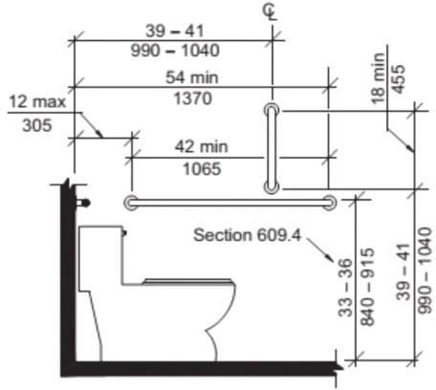

PHOTOGRAPH(S) OF THIS LOCATION

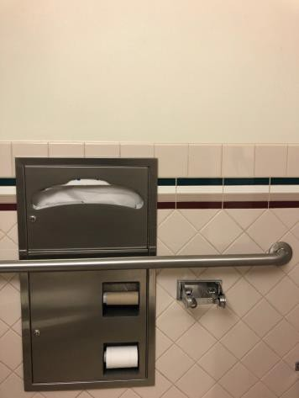

 | ID:  3604 | Facility:  City Hall West

Location: Fire Side Men's Restroom
Schedule: 2022
Estimated Cost: $1,000.00

Priority Score 5
Quick Fix: No
Built before ADA: No

VIOLATIONS
2010 ADA Standards for Accessible Design Codes §605.2
The urinal is 18" above the floor.

RECOMMENDATIONS
Lower the urinal to a maximum height of 17" above the floor.

PHOTOGRAPH(S) OF THIS LOCATION

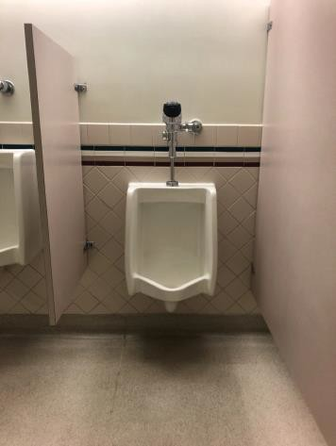

 | ID:  3201 | Facility:  City Hall West

Location: Fire Side Women's Restroom
Schedule: 2021
Estimated Cost: $100.00

Priority Score 5
Quick Fix: Yes
Built before ADA: No

VIOLATIONS
2010 ADA Standards for Accessible Design Codes §604.8.1.2
The door to the accessible water closet is not self closing. Either self-closing hinges are not installed on the door or if installed, they are defective.

RECOMMENDATIONS
Install or reinstall self-closing hinges on the door to ensure that the door is self-closing per the ADA requirements.

PHOTOGRAPH(S) OF THIS LOCATION

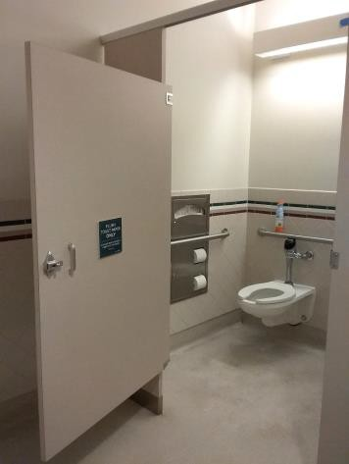

 | ID:  3232 | Facility:  City Hall West

Location: Fire Side Women's Restroom
Schedule: 2021
Estimated Cost: $100.00

Priority Score 8
Quick Fix: Yes
Built before ADA: No

VIOLATIONS
2010 ADA Standards for Accessible Design Codes §308.2.1
The bin is outside of the unobstructed forward reach range at 51" above the floor.

RECOMMENDATIONS
Lower the bin by 3" to meet the accessible reach range of 15" minimum and 48" maximum above the floor.

PHOTOGRAPH(S) OF THIS LOCATION

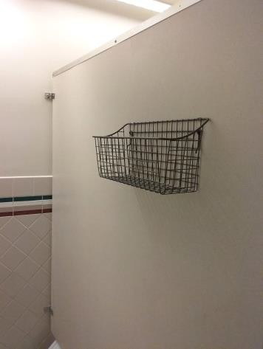

 | ID:  3203 | Facility:  City Hall West

Location: Fire Side Women's Restroom
Schedule: 2021
Estimated Cost: $100.00

Priority Score 8
Quick Fix: Yes
Built before ADA: No

VIOLATIONS
2010 ADA Standards for Accessible Design Codes §308.2.1
The hook is outside of the unobstructed forward reach range at 65" above the floor.

RECOMMENDATIONS
Lower the hook by 13" to meet the accessible reach range of 48" maximum above the floor.

PHOTOGRAPH(S) OF THIS LOCATION

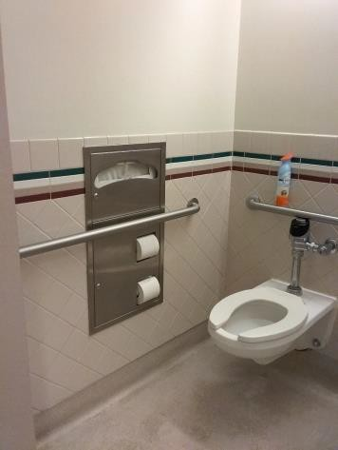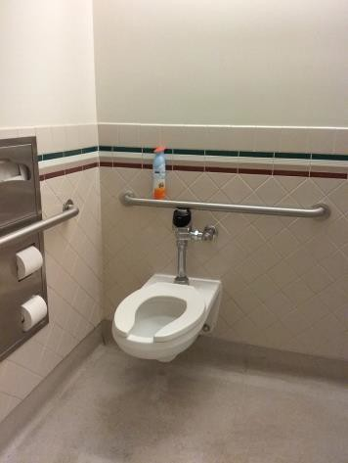

 | ID:  3207 | Facility:  City Hall West

Location: Fire Side Women's Restroom
Schedule: 2021
Estimated Cost: $100.00

Priority Score 5
Quick Fix: Yes
Built before ADA: No

VIOLATIONS
2010 ADA Standards for Accessible Design Codes §604.7
The toilet paper dispenser is located out of the accessible reach range.

RECOMMENDATIONS
Remount the toilet paper dispenser to 7” minimum and 9” maximum in front of the water closet measured to the centerline of the dispenser.
The outlet of the dispenser shall be 15” minimum and 48” maximum above the floor and shall not be located behind.

PHOTOGRAPH(S) OF THIS LOCATION

 | ID:  3635 | Facility:  City Hall West

Location: Fire Side Women's Restroom
Schedule: 2021
Estimated Cost: $100.00

Priority Score 5
Quick Fix: Yes
Built before ADA: No

VIOLATIONS
2010 ADA Standards for Accessible Design Codes §307.2
The dispenser protrudes 5.75" into the circulation space at 39.75" above the floor.

RECOMMENDATIONS
Recess the dispenser so it protrudes a maximum of 4" or place a cane detectable object beneath it.

PHOTOGRAPH(S) OF THIS LOCATION

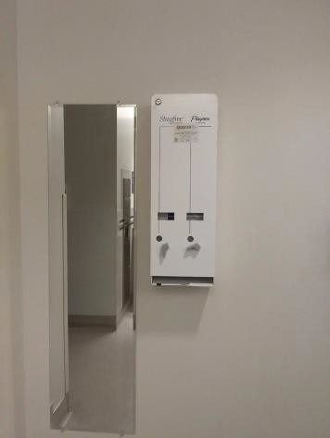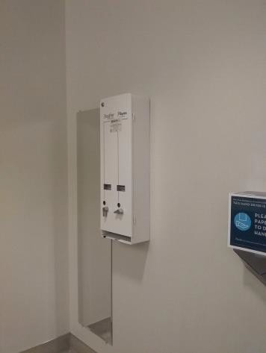

 | ID:  3204 | Facility:  City Hall West

Location: Fire Side Women's Restroom
Schedule: 2022
Estimated Cost: $1,000.00

Priority Score 5
Quick Fix: No
Built before ADA: No

VIOLATIONS
2010 ADA Standards for Accessible Design Codes ICC A117.1 §604.5.1
The accessible water closet does not have a vertical grab bar.

RECOMMENDATIONS
Install an 18" long (minimum) vertical grab bar on the side wall. The grab bar shall be mounted with the bottom located at 39" minimum and 41" maximum above the floor.
The centerline of the vertical grab bar shall be located 39" minimum and 41" maximum from the rear wall.

PHOTOGRAPH(S) OF THIS LOCATION

 | ID:  3771 | Facility:  City Hall West

Location: Front Desk
Schedule: 2021
Estimated Cost: $100.00

Priority Score 5
Quick Fix: Yes
Built before ADA: No

VIOLATIONS
2010 ADA Standards for Accessible Design Codes §307.2
The front desk protrudes 12.75" into the circulation space at 34" above the floor.

RECOMMENDATIONS
Extend the sides of the counter down to a maximum of 27" above the floor to provide cane detectability.

PHOTOGRAPH(S) OF THIS LOCATION

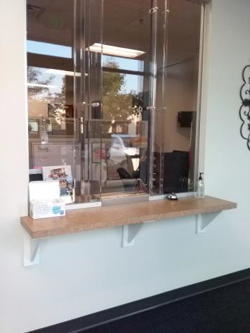

 | ID:  3619 | Facility:  City Hall West

Location: Gun Shot Trauma Kit
Schedule: 2021
Estimated Cost: $100.00

Priority Score 5
Quick Fix: Yes
Built before ADA: No

VIOLATIONS
2010 ADA Standards for Accessible Design Codes §307.2
The gun shot trauma kit protrudes 14" into the circulation space at 40.5" above the floor.

RECOMMENDATIONS
Recess the gun shot trauma kit so it protrudes a maximum of 4", lower it so the bottom edge is 27" maximum above the floor, or place a cane detectable object beneath it.

PHOTOGRAPH(S) OF THIS LOCATION

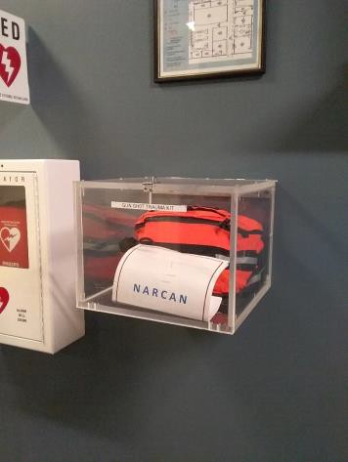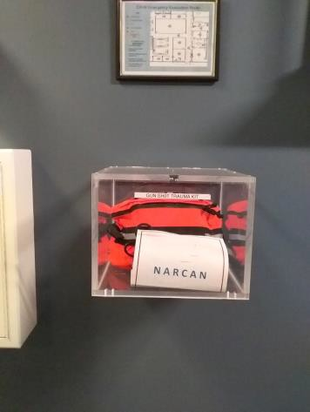

 | ID:  3245 | Facility:  City Hall West

Location: Gym
Schedule: 2021
Estimated Cost: $100.00

Priority Score 3
Quick Fix: Yes
Built before ADA: No

VIOLATIONS
2010 ADA Standards for Accessible Design Codes §216.2, §703
There is no tactile sign identifying the permanent room.

RECOMMENDATIONS
Install tactile signage on the latch side of the doorway at a height of 48” minimum to 60” maximum above the floor, identifying room by name or room number.
Signs shall be Braille with raised lettering and should be placed on the wall in the center of an 18"x18" clear floor space.

PHOTOGRAPH(S) OF THIS LOCATION

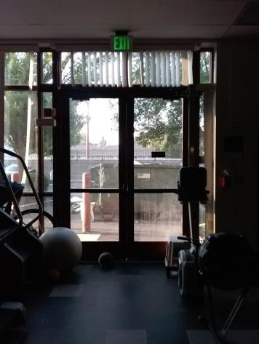

 | ID:  3704 | Facility:  City Hall West

Location: Gym
Schedule: 2021
Estimated Cost: $100.00

Priority Score 3
Quick Fix: Yes
Built before ADA: No

VIOLATIONS
2010 ADA Standards for Accessible Design Codes §308.2.1, §305.5
There is no clear floor space to access the paper towel dispenser.
The paper towel dispenser is outside of the unobstructed forward reach range at 50.5" above the floor.

RECOMMENDATIONS
Relocate the paper towel dispenser to a location that allows for a 30"x48" clear floor space.
Lower the paper towel dispenser by 2.5" to meet the accessible reach range of 48" maximum above the floor.

PHOTOGRAPH(S) OF THIS LOCATION

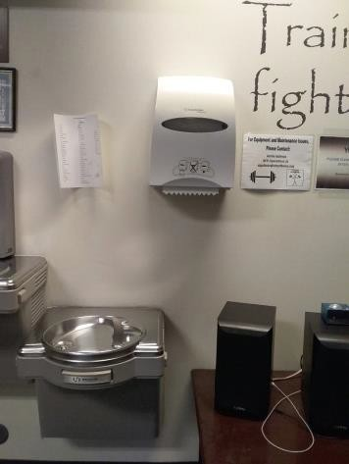

 | ID:  3488 | Facility:  City Hall West

Location: Holding Cell Restroom
Schedule: 2021
Estimated Cost: $100.00

Priority Score 5
Quick Fix: Yes
Built before ADA: No

VIOLATIONS
2010 ADA Standards for Accessible Design Codes §604.7
The toilet paper dispenser is located out of the accessible reach range.

RECOMMENDATIONS
Remount the toilet paper dispenser to 7” minimum and 9” maximum in front of the water closet measured to the centerline of the dispenser.
The outlet of the dispenser shall be 15” minimum and 48” maximum above the floor and shall not be located behind.

PHOTOGRAPH(S) OF THIS LOCATION

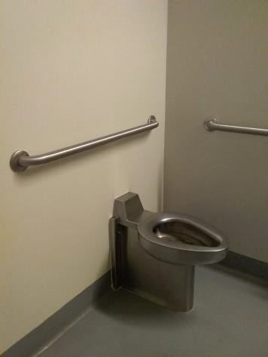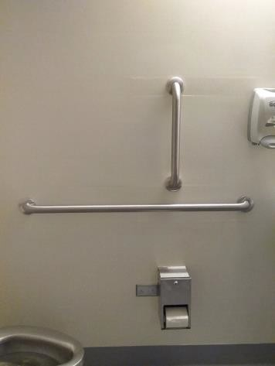

 | ID:  3441 | Facility:  City Hall West

Location: HR Curb Ramp
Schedule: 2022
Estimated Cost: $1,000.00

Priority Score 6
Quick Fix: No
Built before ADA: No

VIOLATIONS
2010 ADA Standards for Accessible Design Codes §505.2
The curb ramp has a 7% slope and there is only one handrail.

RECOMMENDATIONS
Install another handrail at a minimum height of 34” and maximum of 38” above the ground. Make sure there are adequate handrail extensions both at the top and bottom of the handrail.

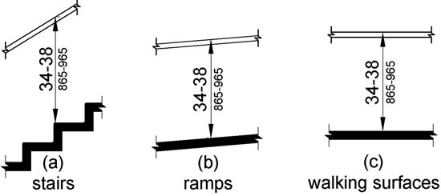

PHOTOGRAPH(S) OF THIS LOCATION

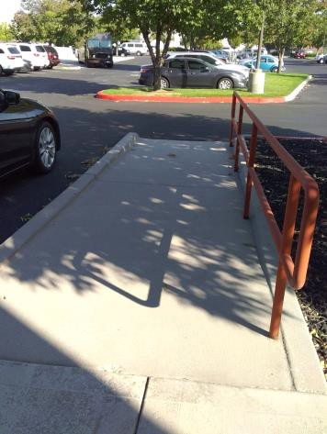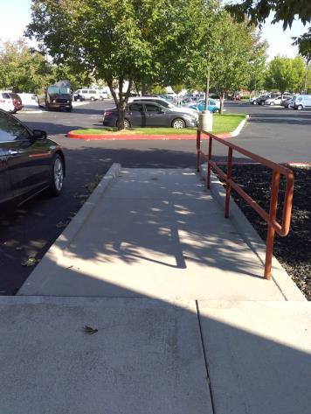

 | ID:  3363 | Facility:  City Hall West

Location: HR Curb Ramp
Schedule: 2021
Estimated Cost: $1,000.00

Priority Score 3
Quick Fix: No
Built before ADA: No

VIOLATIONS
2010 ADA Standards for Accessible Design Codes §403.3
The cross slope is 3.5%.

RECOMMENDATIONS
Resurface the route to reduce the cross slope to a maximum of 2%.

PHOTOGRAPH(S) OF THIS LOCATION

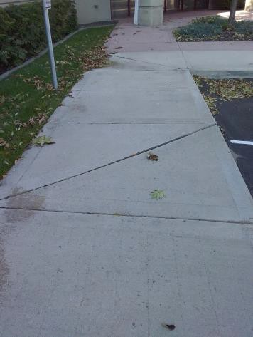

 | ID:  3538 | Facility:  City Hall West

Location: HR Door
Schedule: 2021
Estimated Cost: $2,500.00

Priority Score 3
Quick Fix: No
Built before ADA: No

VIOLATIONS
2010 ADA Standards for Accessible Design Codes §404.2.4.4
The entrance has a 4% slope.

RECOMMENDATIONS
Reconstruct the entryway to reduce the running slope to a maximum of 2% in all directions for a distance of 60".

PHOTOGRAPH(S) OF THIS LOCATION

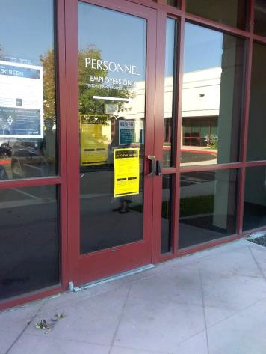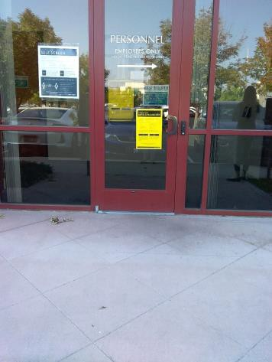

 | ID:  3151 | Facility:  City Hall West

Location: IT Help Desk
Schedule: 2023
Estimated Cost: $1,000.00

Priority Score 8
Quick Fix: No
Built before ADA: No

VIOLATIONS
2010 ADA Standards for Accessible Design Codes §902.3
The dining and work surface counter is 36" above the floor.

RECOMMENDATIONS
A 30" portion of the dining and work surface must be no higher than 34” above the floor.

PHOTOGRAPH(S) OF THIS LOCATION

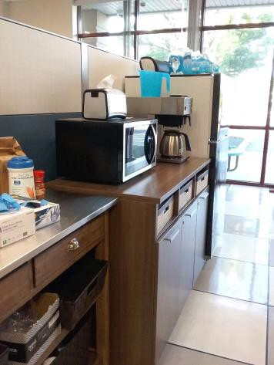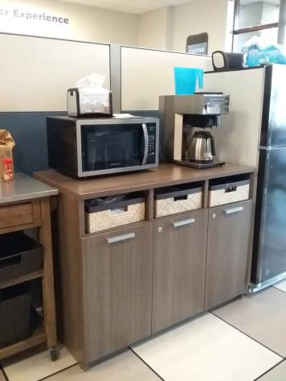

 | ID:  3066 | Facility:  City Hall West

Location: Lobby
Schedule: 2021
Estimated Cost: $100.00

Priority Score 5
Quick Fix: Yes
Built before ADA: No

VIOLATIONS
2010 ADA Standards for Accessible Design Codes §307.2
The lobby counter protrudes 12" into the circulation space at 33" above the floor.

RECOMMENDATIONS
Extend the sides of the counter down to a maximum of 27" above the floor to provide cane detectability.

PHOTOGRAPH(S) OF THIS LOCATION

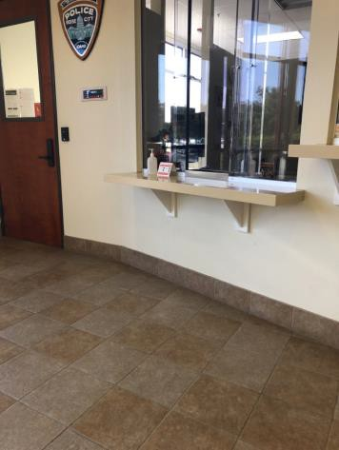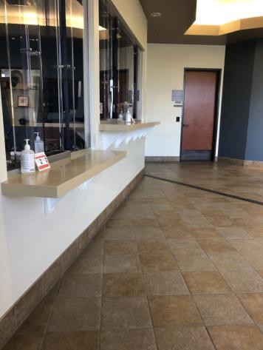

 | ID:  3265 | Facility:  City Hall West

Location: Lobby
Schedule: 2021
Estimated Cost: $100.00

Priority Score 5
Quick Fix: Yes
Built before ADA: No

VIOLATIONS
2010 ADA Standards for Accessible Design Codes §307.2
The AED protrudes 6" into the circulation space at 32" above the floor.

RECOMMENDATIONS
Recess the AED so it protrudes a maximum of 4", lower it so the bottom edge is 27" maximum above the floor, or place a cane detectable object beneath it.

PHOTOGRAPH(S) OF THIS LOCATION

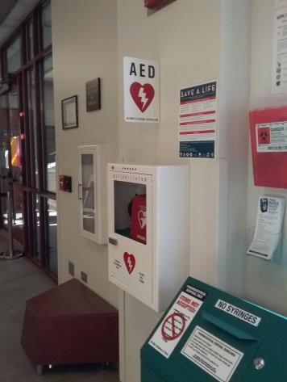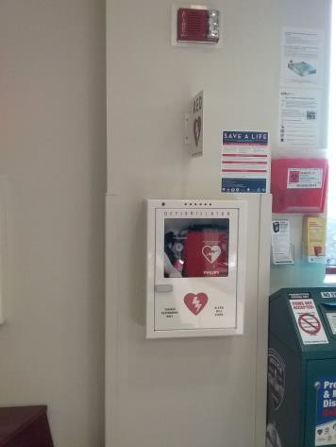

 | ID:  3617 | Facility:  City Hall West

Location: Lobby
Schedule: 2021
Estimated Cost: $500.00

Priority Score 10
Quick Fix: Yes
Built before ADA: No

VIOLATIONS
2010 ADA Standards for Accessible Design Codes §602, §307.2
The drinking fountain protrudes 17" into the circulation path.

RECOMMENDATIONS
Place a drinking fountain skirt at this location to provide cane detectability.

PHOTOGRAPH(S) OF THIS LOCATION

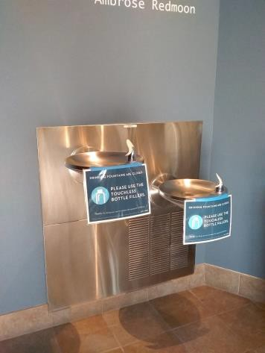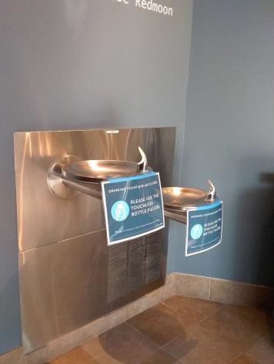

 | ID: | Facility:  City Hall West

Location: Lobby
Schedule: 2023
Estimated Cost: $3,000.00

Priority Score 8
Quick Fix: No
Built before ADA: No

VIOLATIONS
2010 ADA Standards for Accessible Design Codes §308.2.1
The vending machine controls are outside of the unobstructed forward reach range at 55" above the floor.

RECOMMENDATIONS
Lower the vending machine controls by 7" to meet the accessible reach range of 15" minimum and 48" maximum above the floor.
This may require replacing the vending machine.

PHOTOGRAPH(S) OF THIS LOCATION

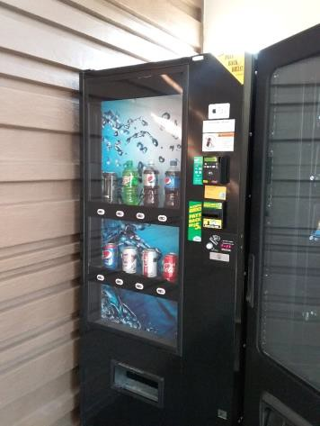

 | ID:  3270 | Facility:  City Hall West

Location: Lobby Gun Shot Trauma Kit
Schedule: 2021
Estimated Cost: $100.00

Priority Score 5
Quick Fix: Yes
Built before ADA: No

VIOLATIONS
2010 ADA Standards for Accessible Design Codes §307.2
The gun shot trauma kit protrudes 15" into the circulation space at 40" above the floor.

RECOMMENDATIONS
Recess the gun shot trauma kit so it protrudes a maximum of 4" or place a cane detectable object beneath it.

PHOTOGRAPH(S) OF THIS LOCATION

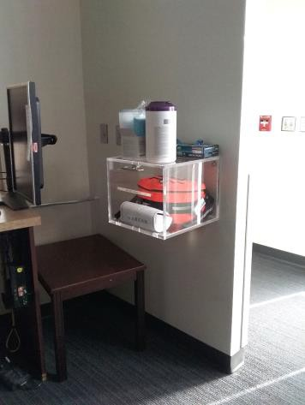

 | ID:  3056 | Facility:  City Hall West

Location: Lobby Women's Restroom
Schedule: 2021
Estimated Cost: $100.00

Priority Score 5
Quick Fix: Yes
Built before ADA: No

VIOLATIONS
2010 ADA Standards for Accessible Design Codes §307.2
The sharps container protrudes 5" into the circulation space at 37.75" above the floor.

RECOMMENDATIONS
Recess the sharps container so it protrudes a maximum of 4" or place a cane detectable object beneath it.

PHOTOGRAPH(S) OF THIS LOCATION

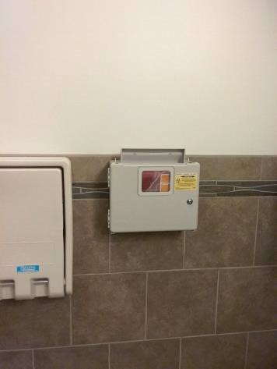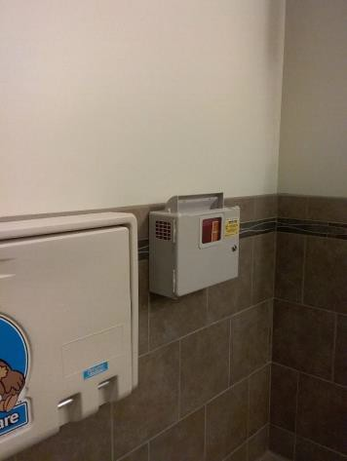

 | ID:  3275 | Facility:  City Hall West

Location: Lobby Women's Restroom
Schedule: 2021
Estimated Cost: $100.00

Priority Score 5
Quick Fix: Yes
Built before ADA: No

VIOLATIONS
2010 ADA Standards for Accessible Design Codes §604.7
The toilet paper dispenser is located out of the accessible reach range.

RECOMMENDATIONS
Remount the toilet paper dispenser to 7” minimum and 9” maximum in front of the water closet measured to the centerline of the dispenser.
The outlet of the dispenser shall be 15” minimum and 48” maximum above the floor and shall not be located behind

PHOTOGRAPH(S) OF THIS LOCATION

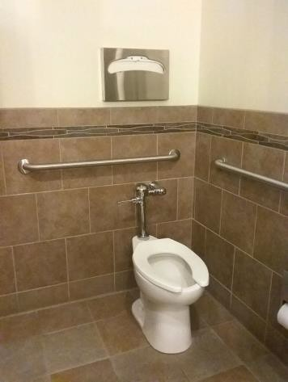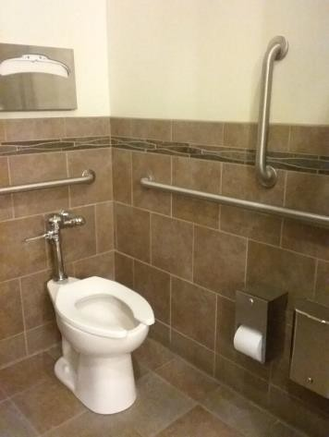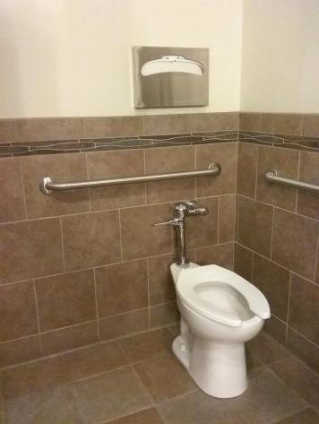

 | ID:  3424 | Facility:  City Hall West

Location: Lobby Women's Restroom
Schedule: 2021
Estimated Cost: $100.00

Priority Score 6
Quick Fix: Yes
Built before ADA: No

VIOLATIONS
2010 ADA Standards for Accessible Design Codes §703.4
The tactile sign identifying the room is not in the correct location.

RECOMMENDATIONS
Reinstall the sign on the latch side of the door at 48" minimum above the floor measured from the baseline of the lowest character and 60" maximum measured from the baseline of the highest character.

PHOTOGRAPH(S) OF THIS LOCATION

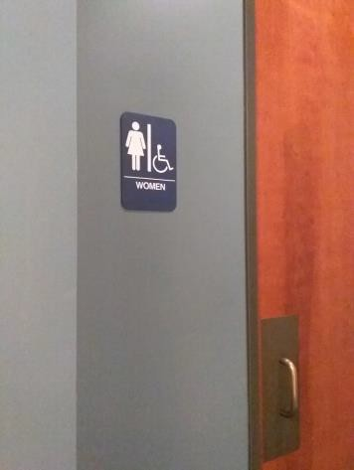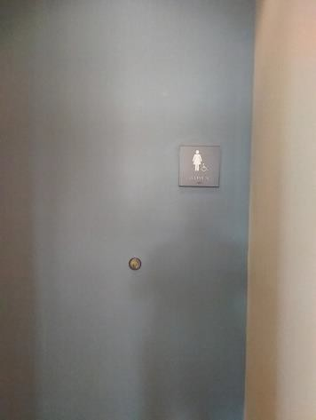

 | ID:  3727 | Facility:  City Hall West

Location: Locker Room AED
Schedule: 2021
Estimated Cost: $100.00

Priority Score 5
Quick Fix: Yes
Built before ADA: No

VIOLATIONS
2010 ADA Standards for Accessible Design Codes §307.2
The AED protrudes 6.25" into the circulation space at 32" above the floor.

RECOMMENDATIONS
Recess the AED so it protrudes a maximum of 4", lower it so the bottom edge is 27" maximum above the floor, or place a cane detectable object beneath it.

PHOTOGRAPH(S) OF THIS LOCATION

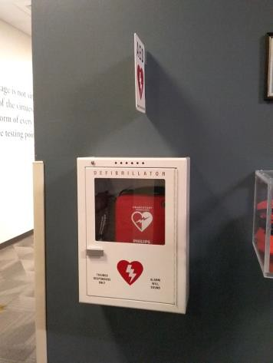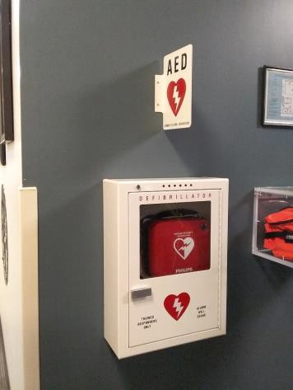

 | ID:  3301 | Facility:  City Hall West

Location: Locker Room Shelves
Schedule: 2021
Estimated Cost: $100.00

Priority Score 5
Quick Fix: Yes
Built before ADA: No

VIOLATIONS
2010 ADA Standards for Accessible Design Codes §307.2
The low shelf protrudes 9.75" into the circulation space at 67.5" above the floor.

RECOMMENDATIONS
Recess the low shelf so it protrudes a maximum of 4" or place a cane detectable object beneath it.

PHOTOGRAPH(S) OF THIS LOCATION

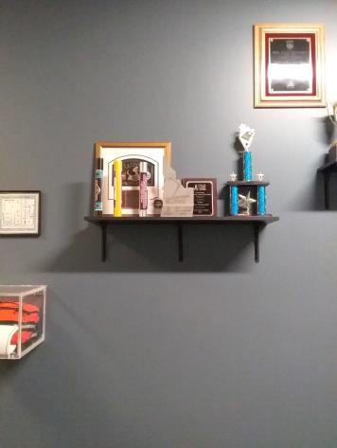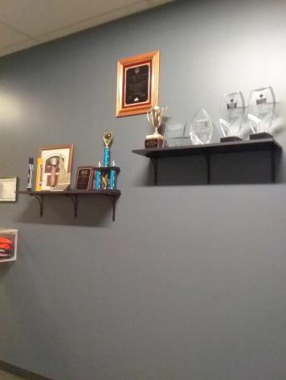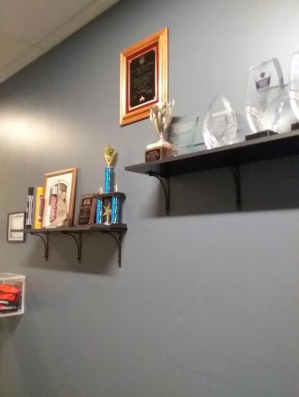

 | ID:  3302 | Facility:  City Hall West

Location: Locker Room Shelves
Schedule: 2021
Estimated Cost: $100.00

Priority Score 5
Quick Fix: Yes
Built before ADA: No

VIOLATIONS
2010 ADA Standards for Accessible Design Codes §307.2
The high shelf protrudes 9.75" into the circulation space at 75.75" above the floor.

RECOMMENDATIONS
Recess the high shelf so it protrudes a maximum of 4" or place a cane detectable object beneath it.

PHOTOGRAPH(S) OF THIS LOCATION

 | ID:  3269 | Facility:  City Hall West

Location: Men's Locker Room
Schedule: 2021
Estimated Cost: $100.00

Priority Score 6
Quick Fix: Yes
Built before ADA: No

VIOLATIONS
2010 ADA Standards for Accessible Design Codes §703.4
The tactile sign identifying the room is not in the correct location.

RECOMMENDATIONS
Reinstall the sign on the latch side of the door at 48" minimum above the floor measured from the baseline of the lowest character and 60" maximum measured from the baseline of the highest character.

PHOTOGRAPH(S) OF THIS LOCATION

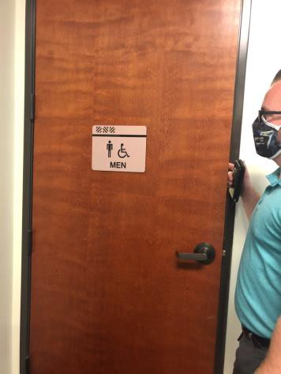

 | ID:  3643 | Facility:  City Hall West

Location: Men's Locker Room
Schedule: 2021
Estimated Cost: $100.00

Priority Score 6
Quick Fix: Yes
Built before ADA: No

VIOLATIONS
2010 ADA Standards for Accessible Design Codes §607.6
The shower head is fixed.

RECOMMENDATIONS
Install a secondary handheld shower that is mounted a maximum of 48" above the floor.

PHOTOGRAPH(S) OF THIS LOCATION

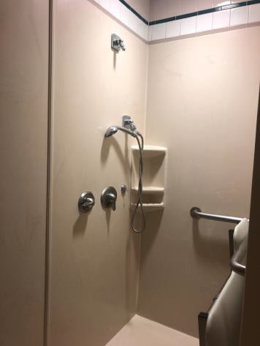

 | ID:  4487 | Facility:  City Hall West

Location: Men's Locker Room
Schedule: 2021
Estimated Cost: $200.00

Priority Score 8
Quick Fix: Yes
Built before ADA: No

VIOLATIONS
2010 ADA Standards for Accessible Design Codes §308.2.1
The locks and hooks are outside of the unobstructed forward reach range at 57" and 73.5" above the floor.

RECOMMENDATIONS
Lower the locks and hooks by 9" and 25.5" to meet the accessible reach range of 15" minimum and 48" maximum above the floor.
At least 5%, but no fewer than one, locker shall be provided complying with §803.

PHOTOGRAPH(S) OF THIS LOCATION

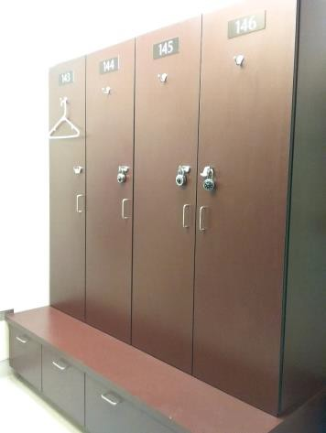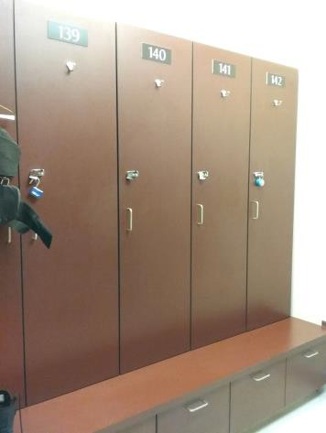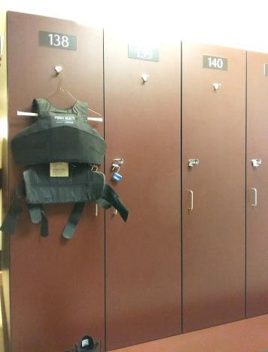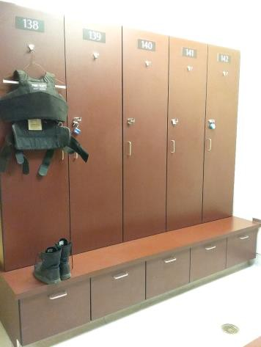

 | ID:  3580 | Facility:  City Hall West

Location: Men's Locker Room
Schedule: 2022
Estimated Cost: $1,000.00

Priority Score 5
Quick Fix: No
Built before ADA: No

VIOLATIONS
2010 ADA Standards for Accessible Design Codes §903.3
The bench is not deep enough at 12" deep.

RECOMMENDATIONS
Install a supplementary accessible bench that is 42" long and 20" to 24" deep.
Provide back support that is 42” long minimum and extends from a point 2” maximum above the seat surface to a point 18” minimum above the seat surface.

PHOTOGRAPH(S) OF THIS LOCATION

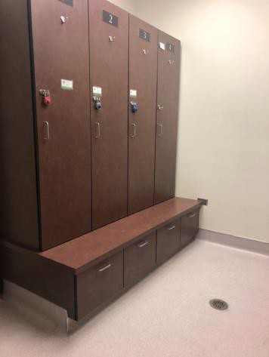

 | ID:  3789 | Facility:  City Hall West

Location: Men's Locker Room
Schedule: 2022
Estimated Cost: $1,000.00

Priority Score 5
Quick Fix: No
Built before ADA: No

VIOLATIONS
2010 ADA Standards for Accessible Design Codes ICC A117.1 §604.5.1
The accessible water closet does not have a vertical grab bar.

RECOMMENDATIONS
Install an 18" long (minimum) vertical grab bar on the side wall. The grab bar shall be mounted with the bottom located at 39" minimum and 41" maximum above the floor.
The centerline of the vertical grab bar shall be located 39" minimum and 41" maximum from the real wall.

PHOTOGRAPH(S) OF THIS LOCATION

(No photographs provided)

 | ID:  3317 | Facility:  City Hall West

Location: Men's Locker Room
Schedule: 2022
Estimated Cost: $5,000.00

Priority Score 6
Quick Fix: No
Built before ADA: No

VIOLATIONS
2010 ADA Standards for Accessible Design Codes §608.2.1
The shower dimensions do not meet the requirements for a transfer type shower at 35" wide.

RECOMMENDATIONS
Expand the transfer type shower compartment to meet the minimum dimensions of 36"x36" measured at the center points of opposing sides with a 36" wide minimum entry on the face of the shower compartment.

PHOTOGRAPH(S) OF THIS LOCATION

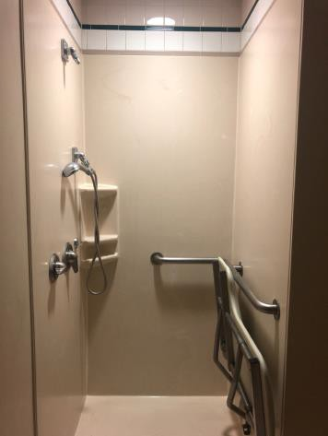

 | ID:  3364 | Facility:  City Hall West

Location: Men's Restroom
Schedule: 2021
Estimated Cost: $100.00

Priority Score 5
Quick Fix: Yes
Built before ADA: No

VIOLATIONS
2010 ADA Standards for Accessible Design Codes §307.2
The shelf protrudes 18" into the circulation space at 33" above the floor.

RECOMMENDATIONS
Extend the sides of the shelf down to a maximum of 27" above the floor to provide cane detectability.

PHOTOGRAPH(S) OF THIS LOCATION

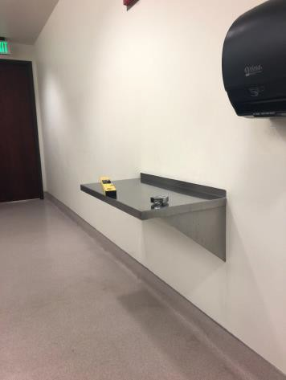

 | ID:  3414 | Facility:  City Hall West

Location: Men's Restroom
Schedule: 2021
Estimated Cost: $100.00

Priority Score 5
Quick Fix: Yes
Built before ADA: No

VIOLATIONS
2010 ADA Standards for Accessible Design Codes §307.2
The paper towel dispenser protrudes 8" into the circulation space at 48.5" above the floor.

RECOMMENDATIONS
Recess the paper towel dispenser so it protrudes a maximum of 4" or place a cane detectable object beneath it.

PHOTOGRAPH(S) OF THIS LOCATION

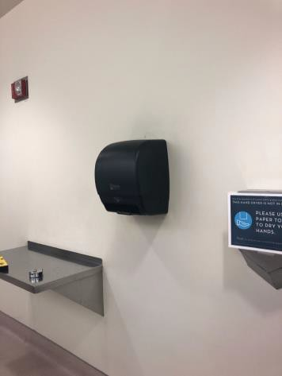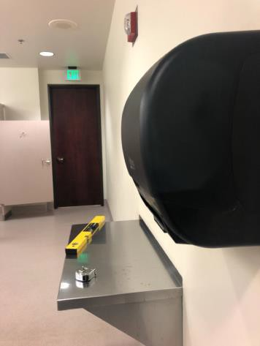

 | ID:  3541 | Facility:  City Hall West

Location: Men's Restroom
Schedule: 2021
Estimated Cost: $100.00

Priority Score 8
Quick Fix: Yes
Built before ADA: No

VIOLATIONS
2010 ADA Standards for Accessible Design Codes §308.2.1
The hook is outside of the unobstructed forward reach range at 60" above the floor.

RECOMMENDATIONS
Lower the hook by 12" to meet the accessible reach range of 48" maximum above the floor.

PHOTOGRAPH(S) OF THIS LOCATION

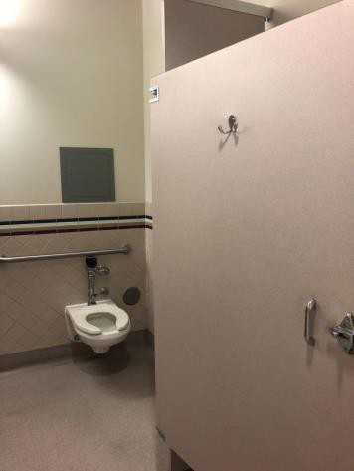

 | ID:  3681 | Facility:  City Hall West

Location: Men's Restroom
Schedule: 2021
Estimated Cost: $100.00

Priority Score 5
Quick Fix: Yes
Built before ADA: No

VIOLATIONS
2010 ADA Standards for Accessible Design Codes §604.8.1.2
The door to the accessible water closet is not self closing. Either self-closing hinges are not installed on the door or if installed, they are defective.

RECOMMENDATIONS
Install or reinstall self-closing hinges on the door to ensure that the door is self-closing per the ADA requirements.

PHOTOGRAPH(S) OF THIS LOCATION

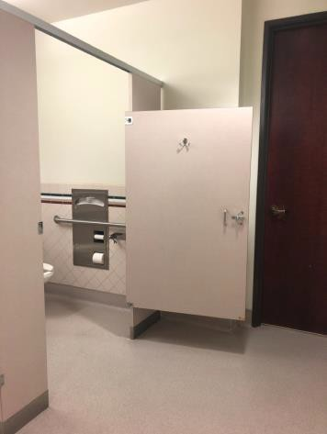

 | ID:  3384 | Facility:  City Hall West

Location: Men's Restroom
Schedule: 2022
Estimated Cost: $1,000.00

Priority Score 5
Quick Fix: No
Built before ADA: No

VIOLATIONS
2010 ADA Standards for Accessible Design Codes §605.2
The urinal is 17.5" above the floor.

RECOMMENDATIONS
Lower the urinal to a maximum height of 17" above the floor.

PHOTOGRAPH(S) OF THIS LOCATION

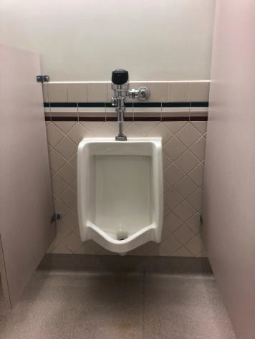

 | ID:  3574 | Facility:  City Hall West

Location: Men's Restroom by Lobby
Schedule: 2021
Estimated Cost: $100.00

Priority Score 8
Quick Fix: No
Built before ADA: No

VIOLATIONS
2010 ADA Standards for Accessible Design Codes §308.2.1
The toilet seat covers are outside of the unobstructed forward reach range at 58" above the floor.

RECOMMENDATIONS
Lower the toilet seat covers by 10" to meet the accessible reach range of 15" minimum and 48" maximum above the floor.

PHOTOGRAPH(S) OF THIS LOCATION

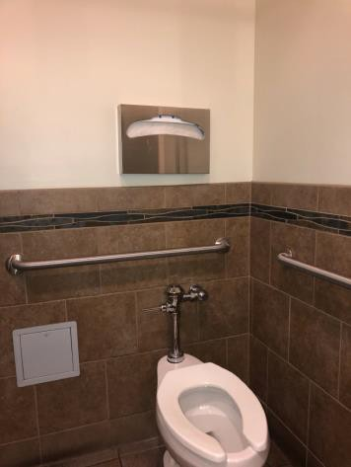

 | ID:  3577 | Facility:  City Hall West

Location: Men's Restroom by Lobby
Schedule: 2021
Estimated Cost: $100.00

Priority Score 5
Quick Fix: Yes
Built before ADA: No

VIOLATIONS
2010 ADA Standards for Accessible Design Codes §604.7
The toilet paper dispenser is located out of the accessible reach range.

RECOMMENDATIONS
Remount the toilet paper dispenser to 7” minimum and 9” maximum in front of the water closet measured to the centerline of the dispenser.
The outlet of the dispenser shall be 15” minimum and 48” maximum above the floor and shall not be located behind.

PHOTOGRAPH(S) OF THIS LOCATION

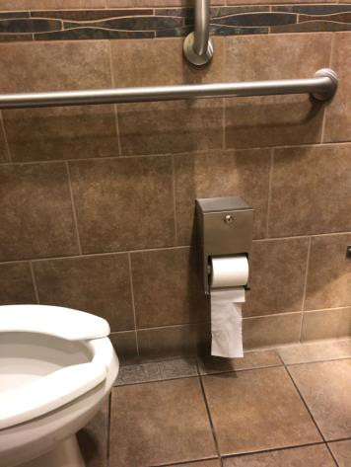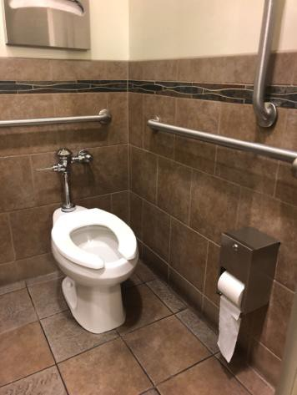

 | ID:  3358 | Facility:  City Hall West

Location: Men's Restroom by Lobby
Schedule: 2021
Estimated Cost: $500.00

Priority Score 10
Quick Fix: Yes
Built before ADA: No

VIOLATIONS
2010 ADA Standards for Accessible Design Codes §602, §307.2
The drinking fountain protrudes 18" into the circulation path.

RECOMMENDATIONS
Place a drinking fountain skirt at this location to provide cane detectability.

PHOTOGRAPH(S) OF THIS LOCATION

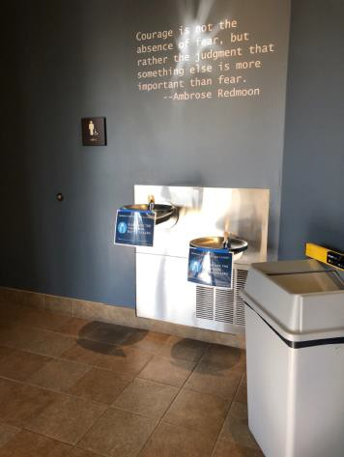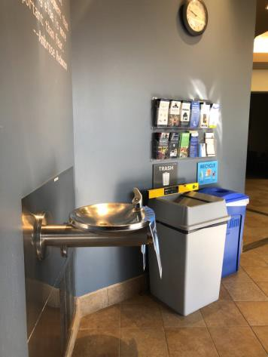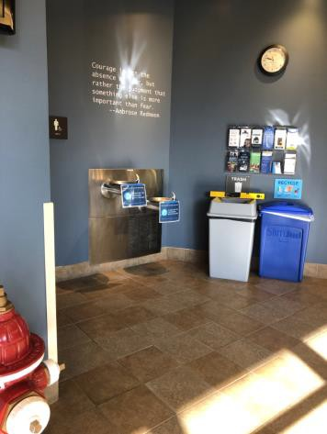

 | ID:  3081 | Facility:  City Hall West

Location: Men's Restroom in CID
Schedule: 2021
Estimated Cost: $100.00

Priority Score 5
Quick Fix: Yes
Built before ADA: No

VIOLATIONS
2010 ADA Standards for Accessible Design Codes §307.2
The dryer protrudes 9" into the circulation space at 48" above the floor.

RECOMMENDATIONS
Recess the dryer so it protrudes a maximum of 4" or place a cane detectable object beneath it.

PHOTOGRAPH(S) OF THIS LOCATION

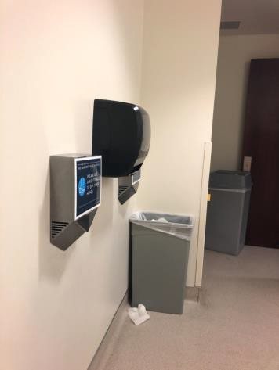

 | ID:  3356 | Facility:  City Hall West

Location: Men's Restroom in CID
Schedule: 2021
Estimated Cost: $100.00

Priority Score 5
Quick Fix: Yes
Built before ADA: No

VIOLATIONS
2010 ADA Standards for Accessible Design Codes §604.8.1.2
The door to the accessible water closet is not self closing. Either self-closing hinges are not installed on the door or if installed, they are defective.

RECOMMENDATIONS
Install or reinstall self-closing hinges on the door to ensure that the door is self-closing per the ADA requirements.

PHOTOGRAPH(S) OF THIS LOCATION

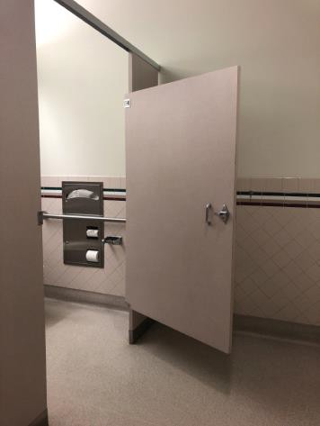

 | ID:  3778 | Facility:  City Hall West

Location: Men's Restroom in CID
Schedule: 2021
Estimated Cost: $100.00

Priority Score 8
Quick Fix: Yes
Built before ADA: No

VIOLATIONS
2010 ADA Standards for Accessible Design Codes §308.2.1
The hook is outside of the unobstructed forward reach range at 64" above the floor.

RECOMMENDATIONS
Lower the hook by 16" to meet the accessible reach range of 48" maximum above the floor.

PHOTOGRAPH(S) OF THIS LOCATION

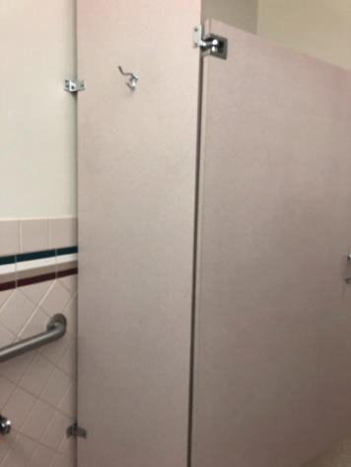

 | ID:  3499 | Facility:  City Hall West

Location: Men's Restroom in CID
Schedule: 2022
Estimated Cost: $1,000.00

Priority Score 5
Quick Fix: No
Built before ADA: No

VIOLATIONS
2010 ADA Standards for Accessible Design Codes ICC A117.1 §604.5.1
The accessible water closet does not have a vertical grab bar.

RECOMMENDATIONS
Install an 18" long (minimum) vertical grab bar on the side wall. The grab bar shall be mounted with the bottom located at 39" minimum and 41" maximum above the floor.
The centerline of the vertical grab bar shall be located 39" minimum and 41" maximum from the real wall.

PHOTOGRAPH(S) OF THIS LOCATION

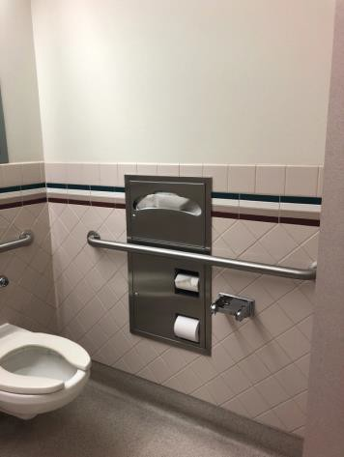

 | ID:  3772 | Facility:  City Hall West

Location: Men's Restroom in CID
Schedule: 2022
Estimated Cost: $1,000.00

Priority Score 5
Quick Fix: No
Built before ADA: No

VIOLATIONS
2010 ADA Standards for Accessible Design Codes §605.2
The urinal is 18" above the floor.

RECOMMENDATIONS
Lower the urinal to a maximum height of 17" above the floor.

PHOTOGRAPH(S) OF THIS LOCATION

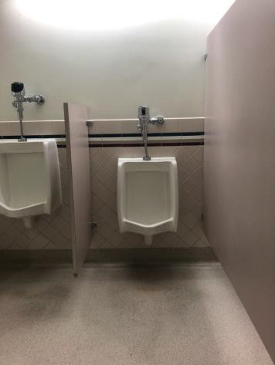

 | ID:  3401 | Facility:  City Hall West

Location: Parking
Schedule: 2021
Estimated Cost: $500.00

Priority Score 6
Quick Fix: Yes
Built before ADA: No

VIOLATIONS
2010 ADA Standards for Accessible Design Codes §216.5
The parking signs identifying the accessible parking space do not meet the minimum height requirement of 60" from the ground

RECOMMENDATIONS
Remount the accessible parking signs to ensure 60" minimum height from the ground.

PHOTOGRAPH(S) OF THIS LOCATION

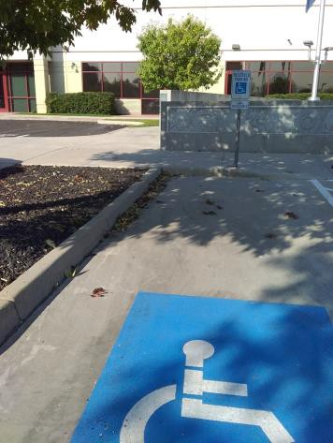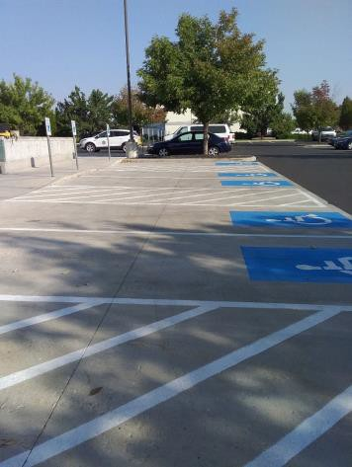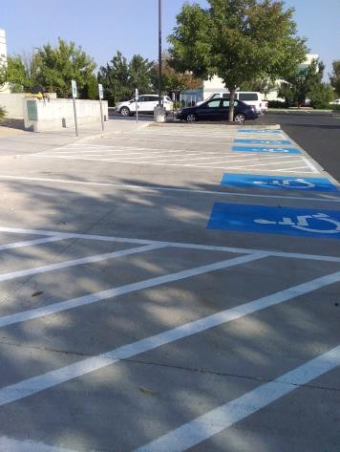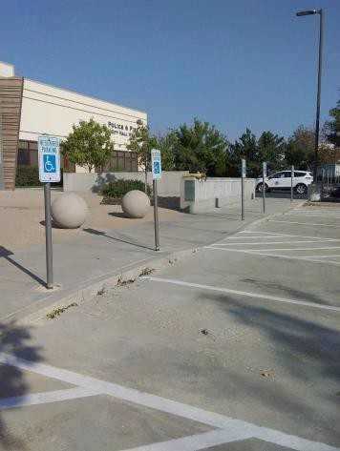

 | ID:  3139 | Facility:  City Hall West

Location: Parking
Schedule: 2021
Estimated Cost: $3,000.00

Priority Score 3
Quick Fix: No
Built before ADA: No

VIOLATIONS
2010 ADA Standards for Accessible Design Codes §304.3.1
There is no level turning space at each of the three curb ramps.

RECOMMENDATIONS
Reconstruct the curb ramps to ensure that there is a level landing, a minimum of 60" deep, with slopes no greater than 2% in all directions.

PHOTOGRAPH(S) OF THIS LOCATION

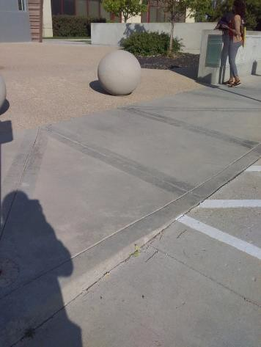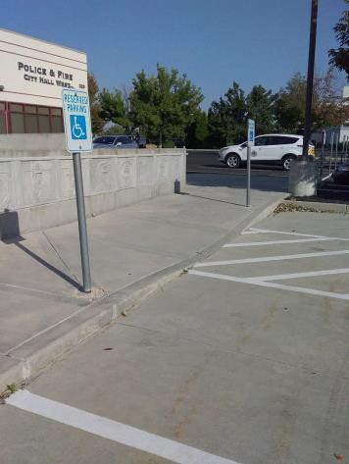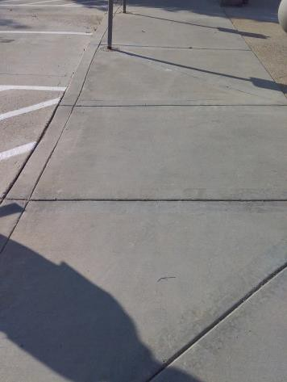

 | ID:  3399 | Facility:  City Hall West

Location: Parking
Schedule: 2021
Estimated Cost: $5,000.00

Priority Score 3
Quick Fix: No
Built before ADA: No

VIOLATIONS
2010 ADA Standards for Accessible Design Codes §208.2.4, §502.4, §502.2
The first accessible parking space is not of sufficient width at 93" wide. The parking space has a 3% running slope.

RECOMMENDATIONS
Resurface the parking space to reduce the slope to a maximum of 2% in all directions. Restripe the first accessible parking space to a minimum of 96" wide.

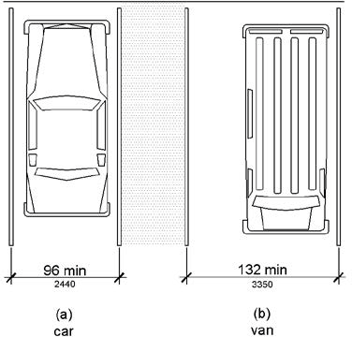

PHOTOGRAPH(S) OF THIS LOCATION

 | ID:  3762 | Facility:  City Hall West

Location: Patrol Academy Classroom
Schedule: 2021
Estimated Cost: $100.00

Priority Score 5
Quick Fix: Yes
Built before ADA: No

VIOLATIONS
2010 ADA Standards for Accessible Design Codes §307.2
The TV protrudes 7" into the circulation space at 57" above the floor.

RECOMMENDATIONS
Recess the TV so it protrudes a maximum of 4", raise it so the bottom edge is 80" maximum above the floor, or place a cane detectable object beneath it.

PHOTOGRAPH(S) OF THIS LOCATION

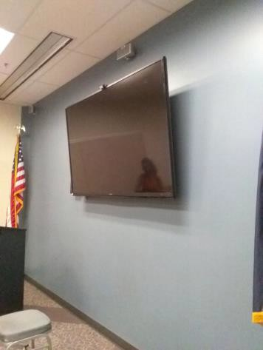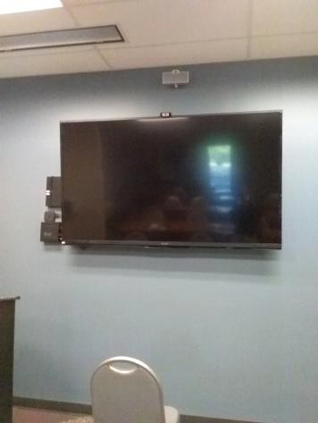

 | ID: | Facility:  City Hall West

Location: Patrol Academy Classroom
Schedule: 2021
Estimated Cost: $200.00

Priority Score 3
Quick Fix: Yes
Built before ADA: No

VIOLATIONS
2010 ADA Standards for Accessible Design Codes §302.3
There are 1" wide and 5" deep gaps in the floor.

RECOMMENDATIONS
Replace the floor covers with one that have gaps that are a maximum of 0.5" wide.

PHOTOGRAPH(S) OF THIS LOCATION

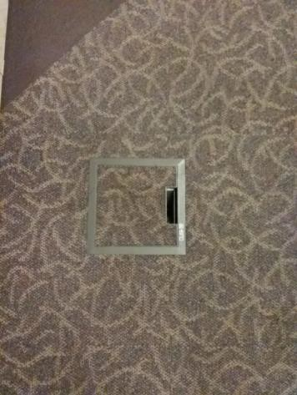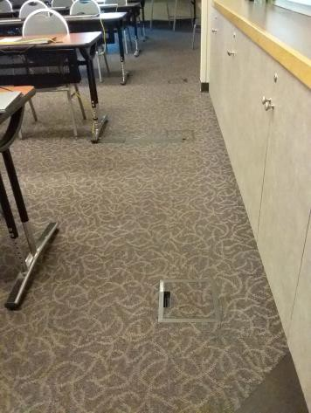

 | ID:  3510 | Facility:  City Hall West

Location: Patrol Briefing
Schedule: 2021
Estimated Cost: $100.00

Priority Score 5
Quick Fix: Yes
Built before ADA: No

VIOLATIONS
2010 ADA Standards for Accessible Design Codes §307.2
The TV protrudes 4.5" to 8" into the circulation space at 53" above the floor.

RECOMMENDATIONS
Recess the TV so it protrudes a maximum of 4", raise it so the bottom edge is 27" maximum above the floor, or place a cane detectable object beneath it.

PHOTOGRAPH(S) OF THIS LOCATION

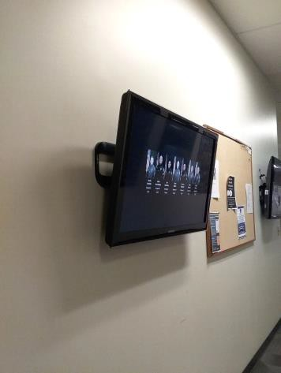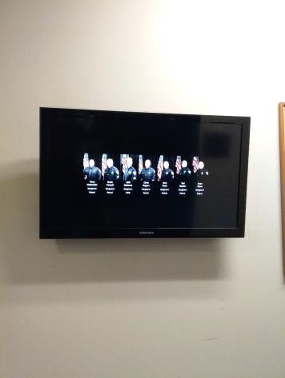

 | ID:  3590 | Facility:  City Hall West

Location: Patrol Briefing Room
Schedule: 2023
Estimated Cost: $1,000.00

Priority Score 8
Quick Fix: No
Built before ADA: No

VIOLATIONS
2010 ADA Standards for Accessible Design Codes §902.3
The dining and work surface counter is 42" above the floor.

RECOMMENDATIONS
A 30" portion of the dining and work surface must be no higher than 34” above the floor.

PHOTOGRAPH(S) OF THIS LOCATION

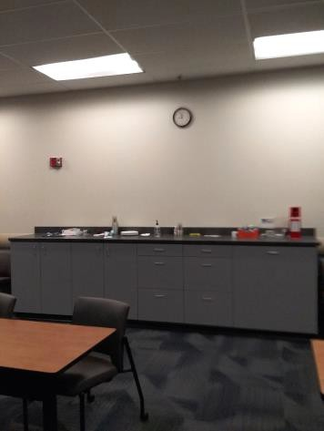

 | ID: | Facility:  City Hall West

Location: Personnel Entrance Lobby
Schedule: 2021
Estimated Cost: $100.00

Priority Score 6
Quick Fix: Yes
Built before ADA: No

VIOLATIONS
2010 ADA Standards for Accessible Design Codes §703.4
The tactile sign identifying the room is not in the correct location.

RECOMMENDATIONS
Reinstall the sign on the latch side of the door at 48" minimum above the floor measured from the baseline of the lowest character and 60" maximum measured from the baseline of the highest character.

PHOTOGRAPH(S) OF THIS LOCATION

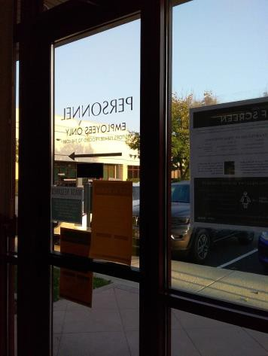

 | ID: | Facility:  City Hall West

Location: Quarter Master Room
Schedule: 2021
Estimated Cost: $100.00

Priority Score 8
Quick Fix: Yes
Built before ADA: No

VIOLATIONS
2010 ADA Standards for Accessible Design Codes §308.2.1
The paper towel dispenser is outside of the unobstructed forward reach range at 53" above the floor.

RECOMMENDATIONS
Lower the paper towel dispenser by 5" to meet the accessible reach range of 48" maximum above the floor.

PHOTOGRAPH(S) OF THIS LOCATION

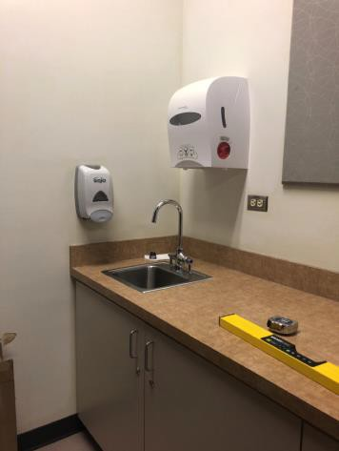

 | ID:  3568 | Facility:  City Hall West

Location: Quarter Master Room
Schedule: 2022
Estimated Cost: $1,000.00

Priority Score 5
Quick Fix: No
Built before ADA: No

VIOLATIONS
2010 ADA Standards for Accessible Design Codes §306.3.3
There is no knee clearance underneath

RECOMMENDATIONS
Provide knee clearance underneath the counter at the sink that is a minimum of 11" deep at 9" above the floor and 8" deep at 27" above the floor.

PHOTOGRAPH(S) OF THIS LOCATION

 | ID:  3726 | Facility:  City Hall West

Location: Room 10
Schedule: 2021
Estimated Cost: $100.00

Priority Score 5
Quick Fix: Yes
Built before ADA: No

VIOLATIONS
2010 ADA Standards for Accessible Design Codes §307.2
The lock boxes protrude 6.5" into the circulation space at 47" above the floor.

RECOMMENDATIONS
Recess the lock boxes so they protrude a maximum of 4" or place a cane detectable object beneath them.

PHOTOGRAPH(S) OF THIS LOCATION

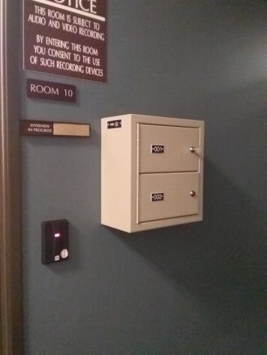

 | ID:  3055 | Facility:  City Hall West

Location: Sawtooth Auditorium
Schedule: 2021
Estimated Cost: $300.00

Priority Score 3
Quick Fix: Yes
Built before ADA: No

VIOLATIONS
2010 ADA Standards for Accessible Design Codes §302.3
There are 1" wide and 5" deep gaps in the floor.

RECOMMENDATIONS
Replace the floor covers with one that have gaps that are a maximum of 0.5" wide.

PHOTOGRAPH(S) OF THIS LOCATION

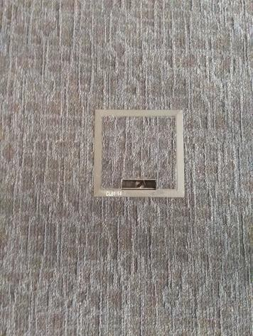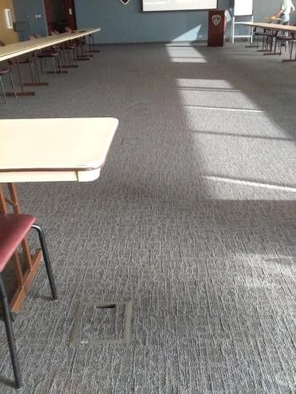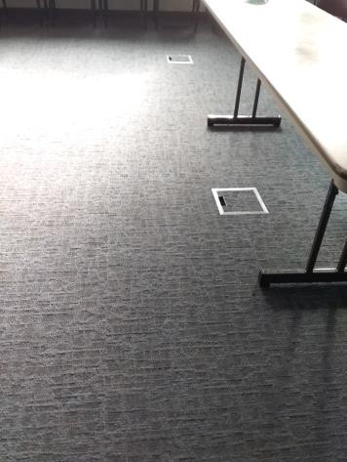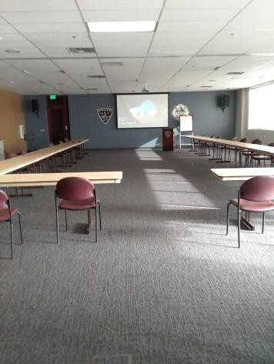

 | ID:  3734 | Facility:  City Hall West

Location: Sawtooth Auditorium
Schedule: 2022
Estimated Cost: $2,000.00

Priority Score 5
Quick Fix: No
Built before ADA: No

VIOLATIONS
2010 ADA Standards for Accessible Design Codes §902.3, §306.3.3, §606.3
The sink is 36" above the floor. There is no knee clearance underneath the counter. The dining and work surface counter

RECOMMENDATIONS
Lower the sink to the maximum height of 34" above the floor. Provide knee clearance underneath the counter at the sink that is a minimum of 11" deep at 9" above the floor and 8" deep at 27" above the floor.
A 30" portion of the dining and work surface must be no higher than 34” above the floor.

PHOTOGRAPH(S) OF THIS LOCATION

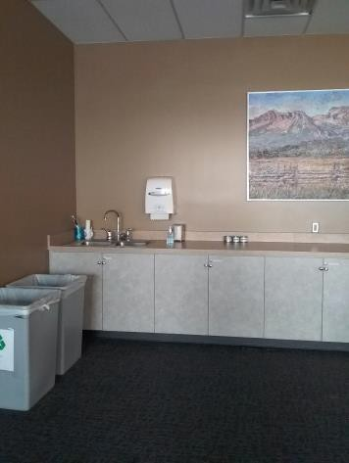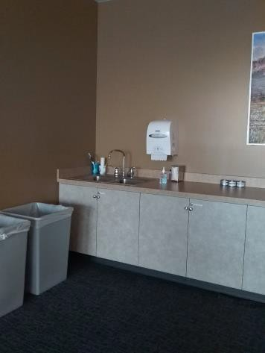

 | ID:  3439 | Facility:  City Hall West

Location: Sawtooth Conference Room
Schedule: 2021
Estimated Cost: $100.00

Priority Score 5
Quick Fix: Yes
Built before ADA: No

VIOLATIONS
2010 ADA Standards for Accessible Design Codes §307.2
The TV protrudes 7" into the circulation space at 72" above the floor.

RECOMMENDATIONS
Recess the TV so it protrudes a maximum of 4", raise it so the bottom edge is 80" maximum above the floor, or place a cane detectable object beneath it.

PHOTOGRAPH(S) OF THIS LOCATION

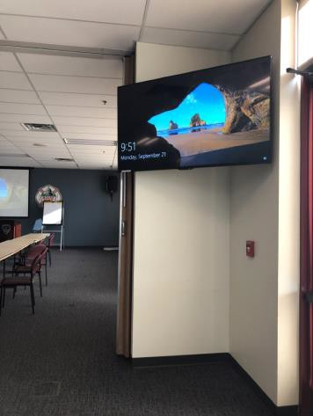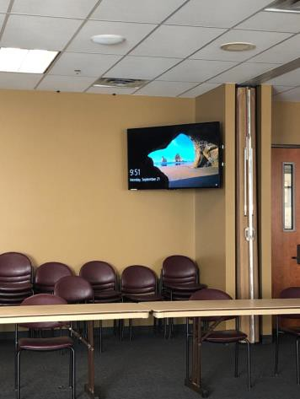

 | ID:  3216 | Facility:  City Hall West

Location: Sawtooth Conference Room
Schedule: 2023
Estimated Cost: $1,000.00

Priority Score 8
Quick Fix: No
Built before ADA: No

VIOLATIONS
2010 ADA Standards for Accessible Design Codes §902.3
The podium is 41" above the floor.

RECOMMENDATIONS
Lower the podium to a maximum of 34" above the floor or have a secondary 34" high surface available adjacent to the podium.

PHOTOGRAPH(S) OF THIS LOCATION

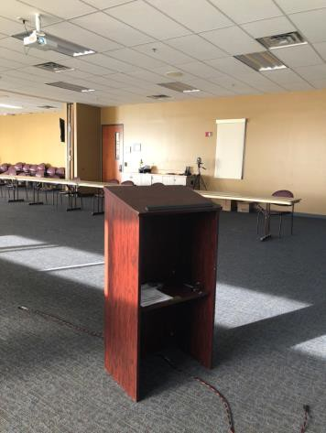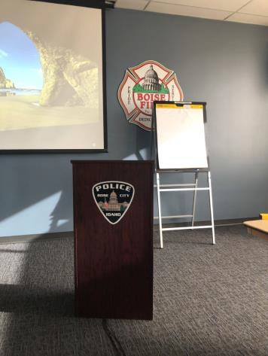

 | ID:  3656 | Facility:  City Hall West

Location: Secure Back Lot Employee Parking
Schedule: 2021
Estimated Cost: $100.00

Priority Score 9
Quick Fix: Yes
Built before ADA: No

VIOLATIONS
2010 ADA Standards for Accessible Design Codes §502.6
The accessible parking sign is 41.5" above the ground.

RECOMMENDATIONS
Remount the accessible parking sign at a minimum height of 60" above the ground.

PHOTOGRAPH(S) OF THIS LOCATION

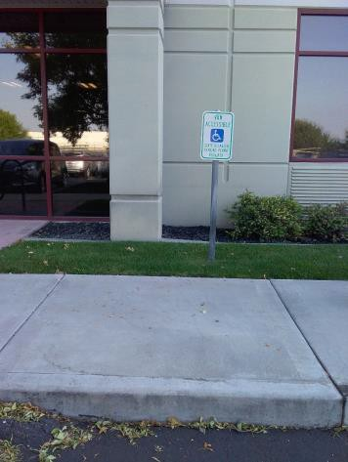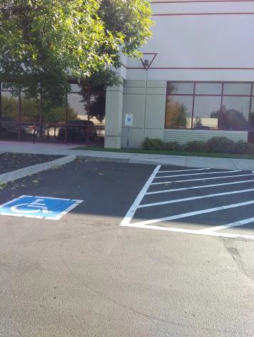

 | ID:  3211 | Facility:  City Hall West

Location: Secure Back Lot Employee Parking
Schedule: 2021
Estimated Cost: $200.00

Priority Score 6
Quick Fix: Yes
Built before ADA: No

VIOLATIONS
2010 ADA Standards for Accessible Design Codes §216.5
The parking signs identifying the accessible parking space do not meet the minimum height requirement of 60" from the ground.

RECOMMENDATIONS
Remount the accessible parking signs to ensure 60" minimum height from the ground.

PHOTOGRAPH(S) OF THIS LOCATION

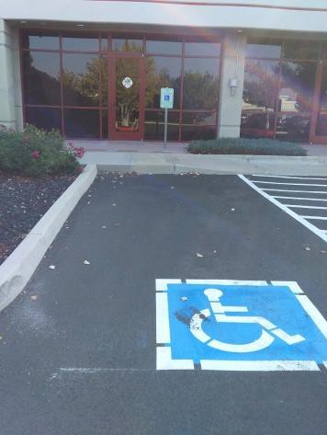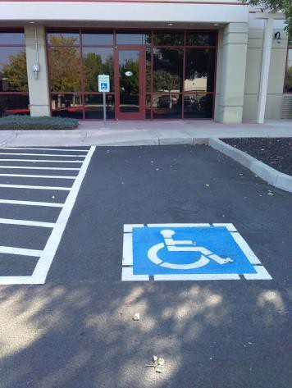

 | ID:  3210 | Facility:  City Hall West

Location: Secure Back Lot Employee Parking
Schedule: 2021
Estimated Cost: $500.00

Priority Score 3
Quick Fix: Yes
Built before ADA: No

VIOLATIONS
2010 ADA Standards for Accessible Design Codes §302.1
There are tripping hazards in the accessible route.

RECOMMENDATIONS
Repave the area of the sidewalk to remove the crack.

PHOTOGRAPH(S) OF THIS LOCATION

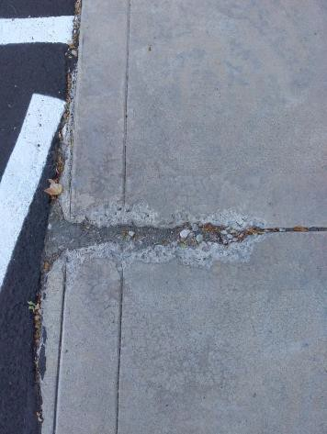

 | ID:  3208 | Facility:  City Hall West

Location: Secure Back Lot Employee Parking
Schedule: 2021
Estimated Cost: $1,000.00

Priority Score 2
Quick Fix: No
Built before ADA: No

VIOLATIONS
2010 ADA Standards for Accessible Design Codes §208.2.4
There are no marked "Van Accessible" spaces.

RECOMMENDATIONS
Install one 132" wide van accessible parking space. Add a “van accessible” parking sign at a minimum height of 60" above the ground.

PHOTOGRAPH(S) OF THIS LOCATION

 | ID:  3330 | Facility:  City Hall West

Location: Secure Back Lot Employee Parking
Schedule: 2021
Estimated Cost: $1,000.00

Priority Score 3
Quick Fix: No
Built before ADA: No

VIOLATIONS
2010 ADA Standards for Accessible Design Codes §403.3
The cross slope is 3.5%.

RECOMMENDATIONS
Resurface the route to reduce the cross slope to a maximum of 2%.

PHOTOGRAPH(S) OF THIS LOCATION

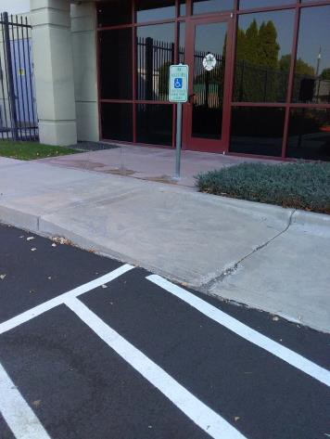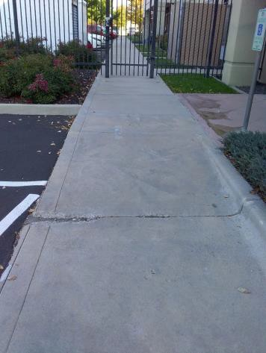

 | ID:  3197 | Facility:  City Hall West

Location: Secure Back Lot Employee Parking
Schedule: 2022
Estimated Cost: $2,500.00

Priority Score 7
Quick Fix: No
Built before ADA: No

VIOLATIONS
2010 ADA Standards for Accessible Design Codes §405.2
The running slope of the curb ramp is 10%.

RECOMMENDATIONS
Reconstruct the curb ramp to reduce the running slope to a maximum of 8.3%.

PHOTOGRAPH(S) OF THIS LOCATION

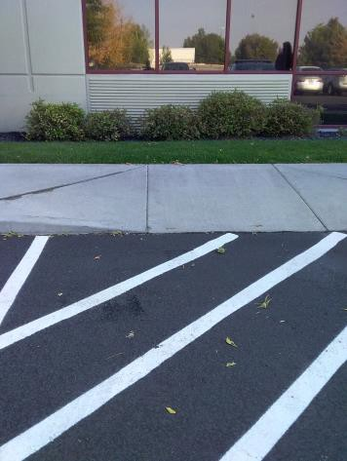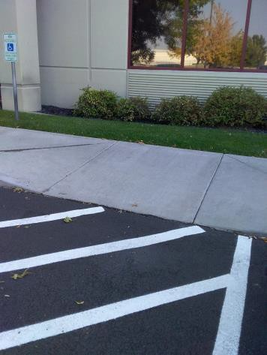

 | ID:  3127 | Facility:  City Hall West

Location: Secure Back Lot Employee Parking
Schedule: 2021
Estimated Cost: $2,500.00

Priority Score 3
Quick Fix: No
Built before ADA: No

VIOLATIONS
2010 ADA Standards for Accessible Design Codes §404.2.4.4
The entrance has a 3.5% slope.

RECOMMENDATIONS
Reconstruct the entryway to reduce the running slope to a maximum of 2% in all directions for a distance of 60".

PHOTOGRAPH(S) OF THIS LOCATION

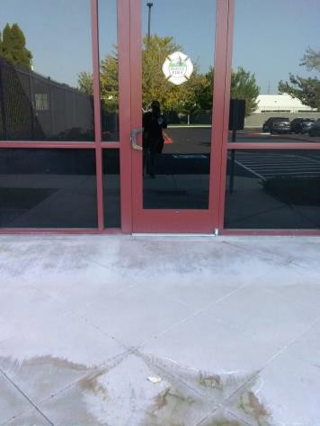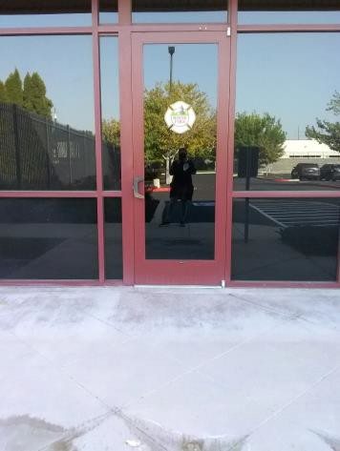

 | ID:  3198 | Facility:  City Hall West

Location: Secure Back Lot Employee Parking
Schedule: 2021
Estimated Cost: $5,000.00

Priority Score 3
Quick Fix: No
Built before ADA: No

VIOLATIONS
2010 ADA Standards for Accessible Design Codes §304.3.1, §405.2
The running slope of the curb ramp is 10%. There is not adequate turning space.

RECOMMENDATIONS
Reconstruct the curb ramp to reduce the running slope to a maximum of 8.3%.
Repave the curb ramp to ensure that there is a level turning space, a minimum of 60"x60" level space if the ramp in between the two sloped sides.

PHOTOGRAPH(S) OF THIS LOCATION

 | ID:  3264 | Facility:  City Hall West

Location: Swat Memorabilia Shelf
Schedule: 2021
Estimated Cost: $100.00

Priority Score 5
Quick Fix: Yes
Built before ADA: No

VIOLATIONS
2010 ADA Standards for Accessible Design Codes §307.2
The shelves protrude 15.25" into the circulation space at 30.5" above the floor.

RECOMMENDATIONS
Recess the shelves so they protrude a maximum of 4" or place a cane detectable object beneath them.

PHOTOGRAPH(S) OF THIS LOCATION

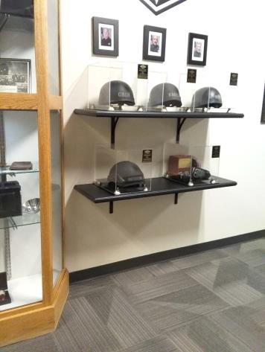

 | ID:  3337 | Facility:  City Hall West

Location: Temporary Holding Cell
Schedule: 2021
Estimated Cost: $100.00

Priority Score 5
Quick Fix: Yes
Built before ADA: No

VIOLATIONS
2010 ADA Standards for Accessible Design Codes §307.2
The table protrudes 24" into the circulation space at 29.5" above the floor.

RECOMMENDATIONS
Extend the sides of the table down to a maximum of 27" above the floor to provide cane detectability.

PHOTOGRAPH(S) OF THIS LOCATION

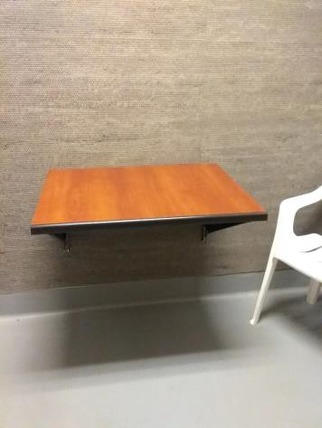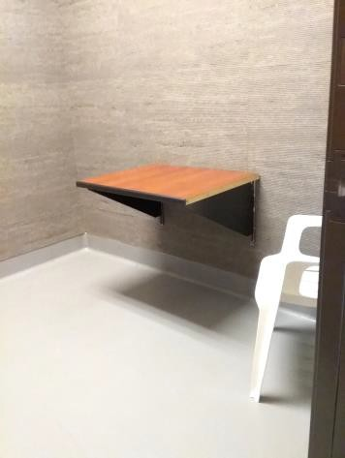

 | ID:  3124 | Facility:  City Hall West

Location: Union Board
Schedule: 2021
Estimated Cost: $100.00

Priority Score 5
Quick Fix: Yes
Built before ADA: No

VIOLATIONS
2010 ADA Standards for Accessible Design Codes §307.2
The shelf protrudes 9" into the circulation space at 29" above the floor.

RECOMMENDATIONS
Recess the shelf so it protrudes a maximum of 4" or place a cane detectable object beneath it.

PHOTOGRAPH(S) OF THIS LOCATION

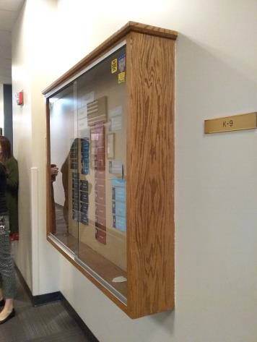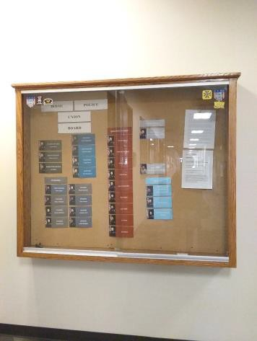

 | ID:  3040 | Facility:  City Hall West

Location: Women's Locker Room
Schedule: 2021
Estimated Cost: $100.00

Priority Score 6
Quick Fix: Yes
Built before ADA: No

VIOLATIONS
2010 ADA Standards for Accessible Design Codes §607.6
The shower spray unit hose is less than 59" long.

RECOMMENDATIONS
Install a new shower head with a 59" long minimum hose to allow for a user to sit or stand.

PHOTOGRAPH(S) OF THIS LOCATION

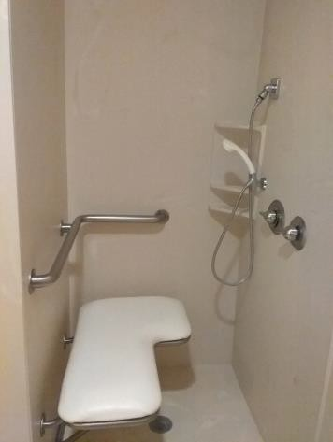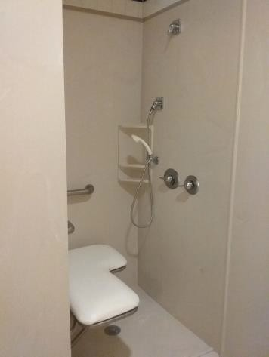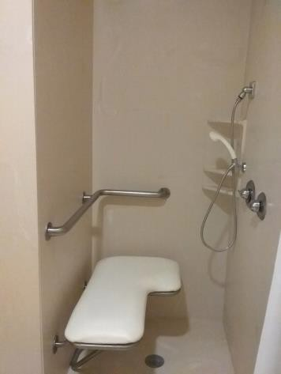

 | ID:  3061 | Facility:  City Hall West

Location: Women's Locker Room
Schedule: 2021
Estimated Cost: $100.00

Priority Score 5
Quick Fix: Yes
Built before ADA: No

VIOLATIONS
2010 ADA Standards for Accessible Design Codes §604.7
The toilet paper dispenser is located out of the accessible reach range.

RECOMMENDATIONS
Remount the toilet paper dispenser to 7” minimum and 9” maximum in front of the water closet measured to the centerline of the dispenser.
The outlet of the dispenser shall be 15” minimum and 48” maximum above the floor and shall not be located behind.

PHOTOGRAPH(S) OF THIS LOCATION

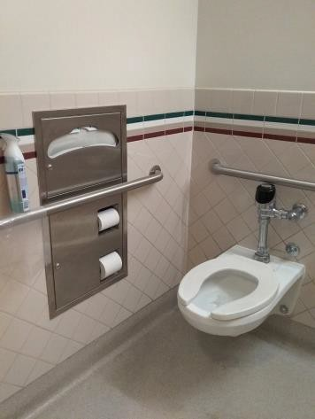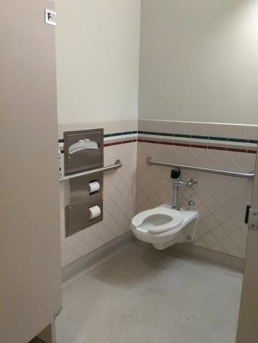

 | ID:  3062 | Facility:  City Hall West

Location: Women's Locker Room
Schedule: 2021
Estimated Cost: $100.00

Priority Score 8
Quick Fix: Yes
Built before ADA: No

VIOLATIONS
2010 ADA Standards for Accessible Design Codes §308.2.1
The basket is outside of the unobstructed forward reach range at 51" above the floor.

RECOMMENDATIONS
Lower the basket by 3" to meet the accessible reach range of 15" minimum and 48" maximum above the floor.

PHOTOGRAPH(S) OF THIS LOCATION

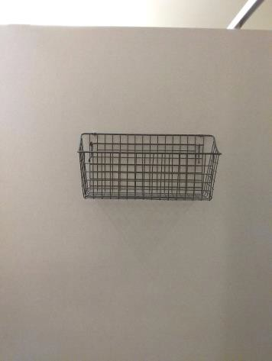

 | ID:  3063 | Facility:  City Hall West

Location: Women's Locker Room
Schedule: 2021
Estimated Cost: $100.00

Priority Score 8
Quick Fix: Yes
Built before ADA: No

VIOLATIONS
2010 ADA Standards for Accessible Design Codes §308.2.1
The hook is outside of the unobstructed forward reach range at 63" above the floor.

RECOMMENDATIONS
Lower the hook by 15" to meet the accessible reach range of 48" maximum above the floor.

PHOTOGRAPH(S) OF THIS LOCATION

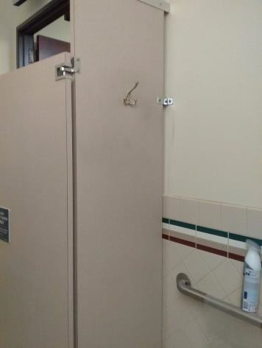

 | ID:  3064 | Facility:  City Hall West

Location: Women's Locker Room
Schedule: 2021
Estimated Cost: $100.00

Priority Score 5
Quick Fix: Yes
Built before ADA: No

VIOLATIONS
2010 ADA Standards for Accessible Design Codes §604.8.1.2
The door to the accessible water closet is not self closing. Either self-closing hinges are not installed on the door or if installed, they are defective.

RECOMMENDATIONS
Install or reinstall self-closing hinges on the door to ensure that the door is self-closing per the ADA requirements.

PHOTOGRAPH(S) OF THIS LOCATION

 | ID:  3120 | Facility:  City Hall West

Location: Women's Locker Room
Schedule: 2021
Estimated Cost: $100.00

Priority Score 5
Quick Fix: Yes
Built before ADA: No

VIOLATIONS
2010 ADA Standards for Accessible Design Codes §307.2
The shelf protrudes 6.75" into the circulation space at 49.5" above the floor.

RECOMMENDATIONS
Recess the shelf so it protrudes a maximum of 4" or place a cane detectable object beneath it.

PHOTOGRAPH(S) OF THIS LOCATION

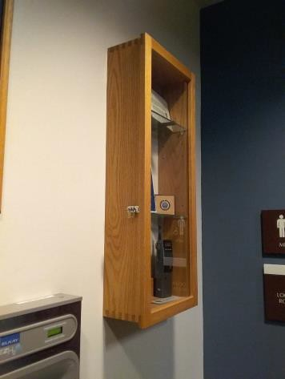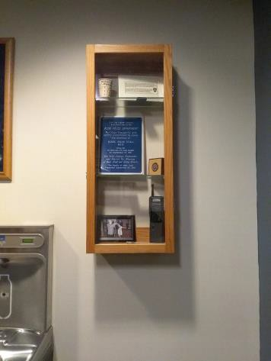

 | ID:  3157 | Facility:  City Hall West

Location: Women's Locker Room
Schedule: 2021
Estimated Cost: $100.00

Priority Score 8
Quick Fix: Yes
Built before ADA: No

VIOLATIONS
2010 ADA Standards for Accessible Design Codes §308.2.1
The hook is outside of the unobstructed forward reach range at 70" above the floor.

RECOMMENDATIONS
Lower the hook by 22" to meet the accessible reach range of 48" maximum above the floor.

PHOTOGRAPH(S) OF THIS LOCATION

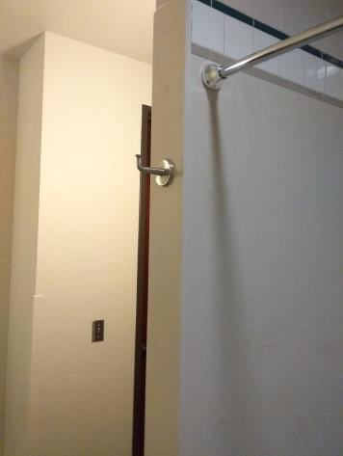

 | ID: | Facility:  City Hall West

Location: Women's Locker Room
Schedule: 2021
Estimated Cost: $100.00

Priority Score 8
Quick Fix: Yes
Built before ADA: No

VIOLATIONS
2010 ADA Standards for Accessible Design Codes §308.2.1
The paper towel dispenser is outside of the unobstructed forward reach range at 53.5" above the floor.

RECOMMENDATIONS
Lower the paper towel dispenser by 5.5" to meet the accessible reach range of 48" maximum above the floor.

PHOTOGRAPH(S) OF THIS LOCATION

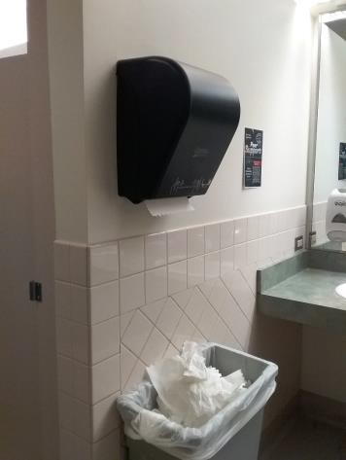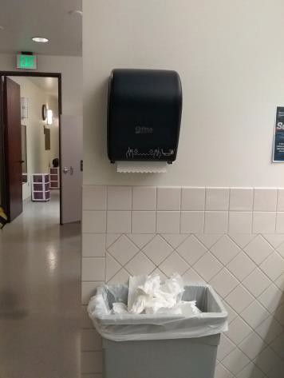

 | ID:  3761 | Facility:  City Hall West

Location: Women's Locker Room
Schedule: 2022
Estimated Cost: $1,000.00

Priority Score 5
Quick Fix: No
Built before ADA: No

VIOLATIONS
2010 ADA Standards for Accessible Design Codes §308.2.1, §903.3
The bench is not deep enough at 12" deep.
The locks and hooks are outside of the unobstructed forward reach range at 57" and 73.5" above the floor.

RECOMMENDATIONS
Install a supplementary accessible bench that is 42" long and 20" to 24" deep.
Lower the locks and hooks by 9" and 25.5" to meet the accessible reach range of 15" minimum and 48" maximum above the floor. At least 5%, but no fewer than one, locker shall be provided complying with § 803.

PHOTOGRAPH(S) OF THIS LOCATION

 | ID:  3511 | Facility:  City Hall West

Location: Women's Locker Room
Schedule: 2021
Estimated Cost: $1,000.00

Priority Score 3
Quick Fix: No
Built before ADA: No

VIOLATIONS
2010 ADA Standards for Accessible Design Codes §304.2
The turning space has a 3.6% slope.

RECOMMENDATIONS
Resurface the turning space to reduce the slope to the maximum allowable 2% in all directions.

PHOTOGRAPH(S) OF THIS LOCATION

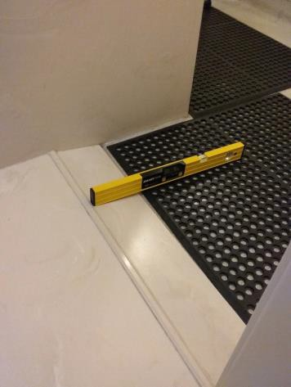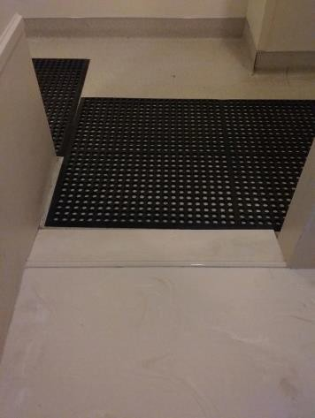

 | ID:  3042 | Facility:  City Hall West

Location: Women's Locker Room
Schedule: 2022
Estimated Cost: $5,000.00

Priority Score 6
Quick Fix: No
Built before ADA: No

VIOLATIONS
2010 ADA Standards for Accessible Design Codes §608.2.1
The shower dimensions do not meet the requirements for a transfer type shower at 36" deep and 35" wide.

RECOMMENDATIONS
Expand the transfer type shower compartment to meet the minimum dimensions of 36"x36" measured at the center points of opposing sides with a 36" wide minimum entry on the face of the shower compartment.

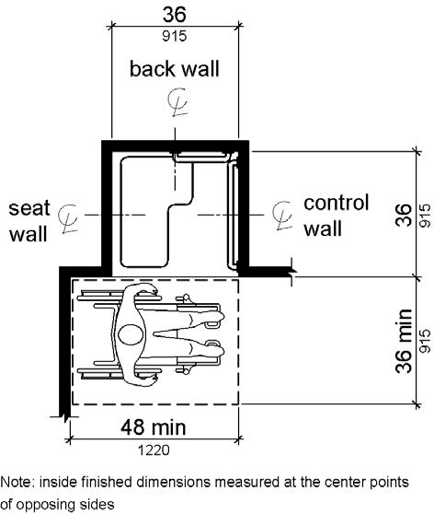

PHOTOGRAPH(S) OF THIS LOCATION

