City of Boise ADA Assessment

Appendix A –City Hall

11/11/2021
Report #TO21-B002

Prepared by:
 | ID:  4053 | Facility:  City Hall

Location: Main Plaza
Schedule: 2020
Estimated Cost: $0.00

Priority Score 0
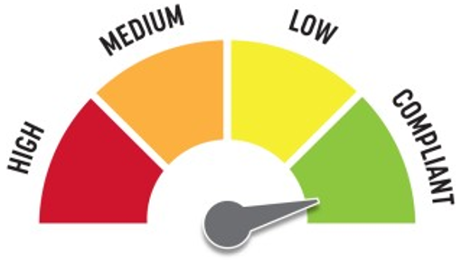
Quick Fix: Yes
Built before ADA: Yes

VIOLATIONS
2010 ADA Standards for Accessible Design Codes: §0.00
Boise staff notified us that previously a guide dog was circling around the plaza and could not find its way back to the street.

RECOMMENDATIONS
For the purpose of achieving greater accessibility and Human Centric Design, consider adding handrails to the ramp or painting the sloped walkway to distinguish it from the rest of the plaza.

PHOTOGRAPH(S) OF THIS LOCATION

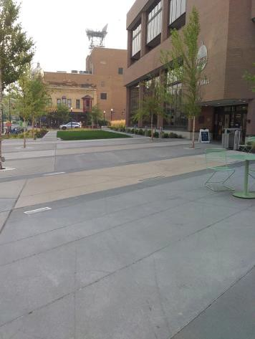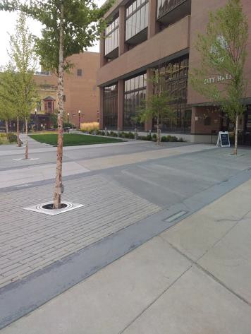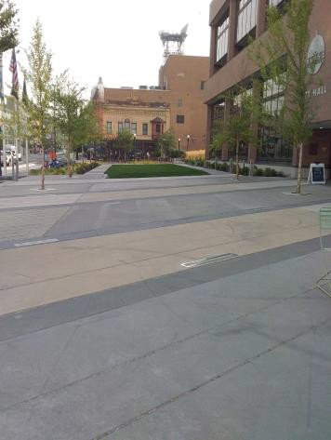

 | ID:  3921 | Facility:  City Hall

Location: HR Front Desk
Schedule: 2023
Estimated Cost: $100.00

Priority Score 8
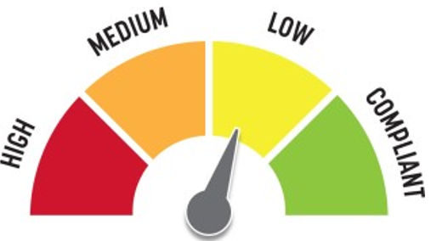
Quick Fix: Yes
Built before ADA: Yes

VIOLATIONS
2010 ADA Standards for Accessible Design Codes: §308.2.1
The fingerprint machine is outside of the unobstructed forward reach range at 54" above the floor.
Please note that assistance is provided at this location and a City of Boise staff will lower it to the appropriate height.

RECOMMENDATIONS
Ensure that the fingerprint machine is lowered to a maximum height of 48" when utilized by a person with a wheelchair.
White the current turning space is compliant, it could be extended to a 60" circle to provide a greater level of accessibility.

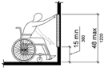

PHOTOGRAPH(S) OF THIS LOCATION

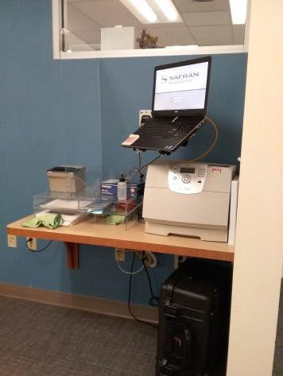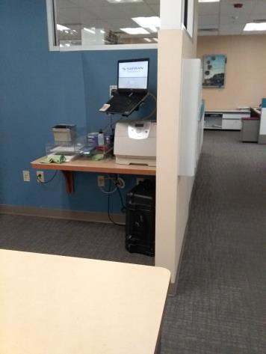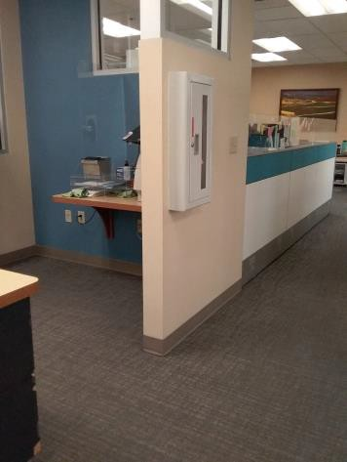

 | ID:  4010 | Facility:  City Hall

Location: 2nd Floor Housing and Community Development Women's Restroom
Schedule: 2023
Estimated Cost: $100.00

Priority Score 8
Quick Fix: Yes
Built before ADA: Yes

VIOLATIONS
2010 ADA Standards for Accessible Design Codes: §308.2.1
The coat hook is outside of the unobstructed forward reach range.

RECOMMENDATIONS
Lower the coat hook to meet the accessible reach range of 15" minimum and 48" maximum above the floor.

PHOTOGRAPH(S) OF THIS LOCATION

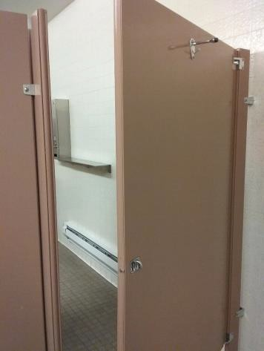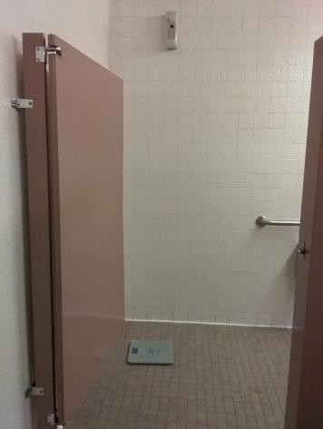

 | ID:  4096 | Facility:  City Hall

Location: 3rd Floor Men's Restroom by IT
Schedule: 2023
Estimated Cost: $100.00

Priority Score 8
Quick Fix: Yes
Built before ADA: Yes

VIOLATIONS
2010 ADA Standards for Accessible Design Codes: §308.2.1
The coat hook is outside of the unobstructed forward reach range at 66" above the floor.

RECOMMENDATIONS
Lower the coat hook by 18" to meet the accessible reach range of 15" minimum and 48" maximum above the floor.

PHOTOGRAPH(S) OF THIS LOCATION

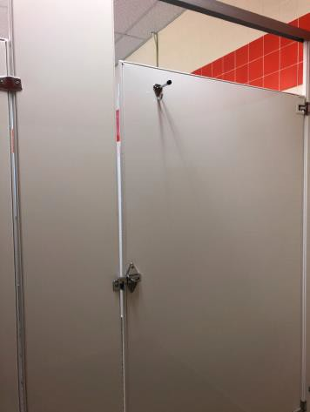

 | ID:  4173 | Facility:  City Hall

Location: Housing and Community Development
Schedule: 2023
Estimated Cost: $100.00

Priority Score 8
Quick Fix: Yes
Built before ADA: Yes

VIOLATIONS
2010 ADA Standards for Accessible Design Codes: §308.2.2
The microwave is outside of the obstructed forward reach range at 53" above the floor.

RECOMMENDATIONS
Place the microwave on the lower counter to ensure it is a maximum of 48" above the floor.

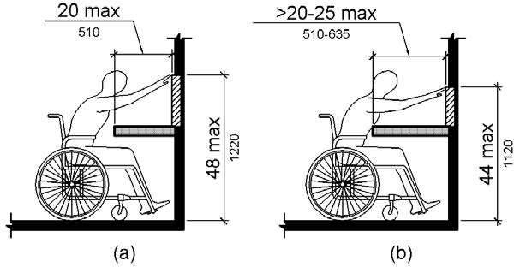

PHOTOGRAPH(S) OF THIS LOCATION

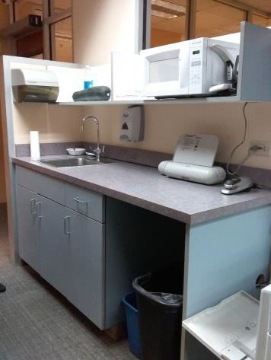

 | ID:  4409 | Facility:  City Hall

Location: 1st Floor Men's Restroom by Art Office
Schedule: 2023
Estimated Cost: $100.00

Priority Score 8
Quick Fix: Yes
Built before ADA: Yes

VIOLATIONS
2010 ADA Standards for Accessible Design Codes: §308.2.1
The coat hook is outside of the unobstructed forward reach range at 53" above the floor.

RECOMMENDATIONS
Lower the coat hook by 5" to meet the accessible reach range of 15" minimum and 48" maximum above the floor.

PHOTOGRAPH(S) OF THIS LOCATION

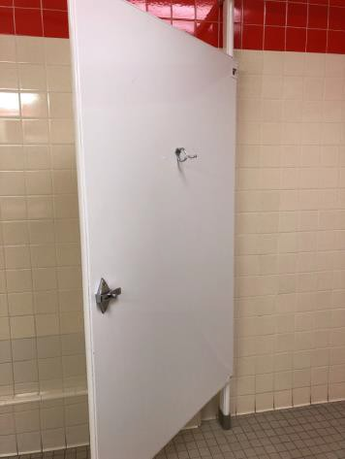

 | ID:  4420 | Facility:  City Hall

Location: 3rd Floor IT Women's Restroom
Schedule: 2023
Estimated Cost: $100.00

Priority Score 8
Quick Fix: Yes
Built before ADA: Yes

VIOLATIONS
2010 ADA Standards for Accessible Design Codes: §308.2.1
The coat hook is outside of the unobstructed forward reach range at 69" above the floor.

RECOMMENDATIONS
Lower the hook by 21" to meet the accessible reach range of 15" minimum and 48" maximum above the floor.

PHOTOGRAPH(S) OF THIS LOCATION

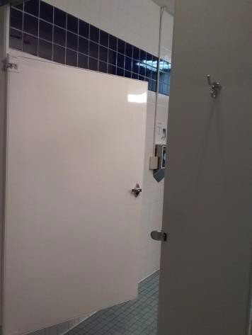

 | ID:  3794 | Facility:  City Hall

Location: 2nd Floor Housing and Community Development Women's Restroom
Schedule: 2022
Estimated Cost: $100.00

Priority Score 7
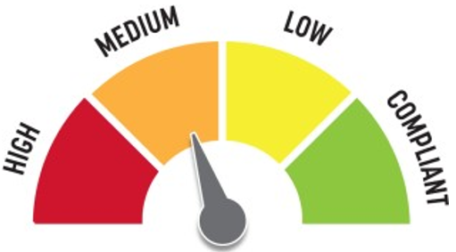
Quick Fix: Yes
Built before ADA: Yes

VIOLATIONS
2010 ADA Standards for Accessible Design Codes: §603.3
The left mirror is 41.5" above the floor.

RECOMMENDATIONS
Lower the mirror so its bottom edge is a maximum height of 40" above the floor.

PHOTOGRAPH(S) OF THIS LOCATION

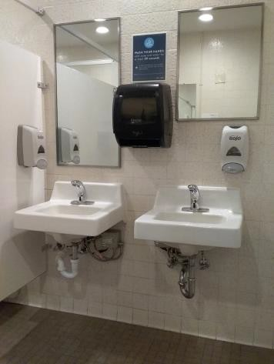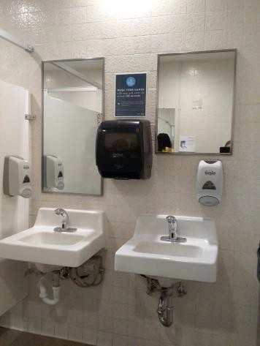

 | ID:  3801 | Facility:  City Hall

Location: Basement Garage
Schedule: 2022
Estimated Cost: $100.00

Priority Score 5
Quick Fix: Yes
Built before ADA: Yes

VIOLATIONS
2010 ADA Standards for Accessible Design Codes: §307.2
The fire extinguisher protrudes 6.75" into the circulation space at 32" above the floor.

RECOMMENDATIONS
Recess the fire extinguisher so it protrudes a maximum of 4", lower it so the bottom edge is 27" maximum above the floor, or place a cane detectable object beneath it.

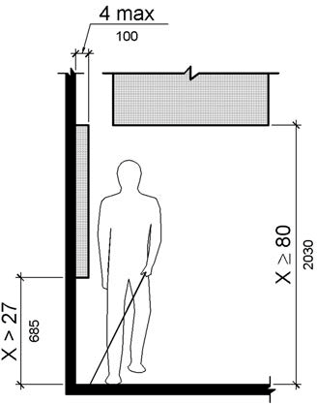

PHOTOGRAPH(S) OF THIS LOCATION

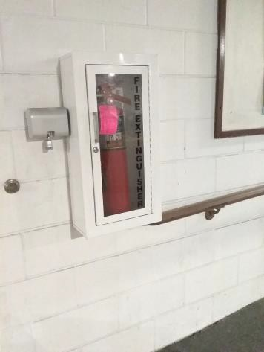

 | ID:  3802 | Facility:  City Hall

Location: 1st Floor Mail Hallway Women's Restroom
Schedule: 2022
Estimated Cost: $100.00

Priority Score 5
Quick Fix: Yes
Built before ADA: Yes

VIOLATIONS
2010 ADA Standards for Accessible Design Codes: §307.2
The dispenser protrudes 5.75" into the circulation space at 30" above the floor.

RECOMMENDATIONS
Recess the dispenser so it protrudes a maximum of 4", lower it so the bottom edge is 27" maximum above the floor, or place a cane detectable object beneath it.

PHOTOGRAPH(S) OF THIS LOCATION

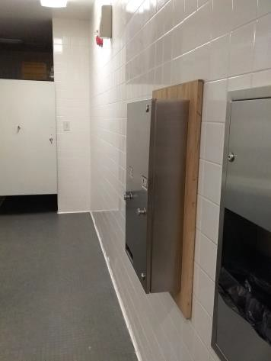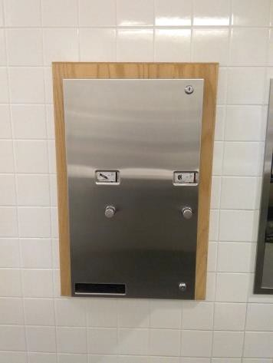

 | ID:  3821 | Facility:  City Hall

Location: 2nd Floor PDS Men's Restroom
Schedule: 2022
Estimated Cost: $100.00

Priority Score 5
Quick Fix: Yes
Built before ADA: Yes

VIOLATIONS
2010 ADA Standards for Accessible Design Codes: §307.2
The shelf protrudes 6" into the circulation space.

RECOMMENDATIONS
Recess the shelf so it protrudes a maximum of 4", lower it so the bottom edge is 27" maximum above the floor.
Another option would be to ensure that there is an object on both ends of the shelf to provide cane detectability object beneath it.

PHOTOGRAPH(S) OF THIS LOCATION

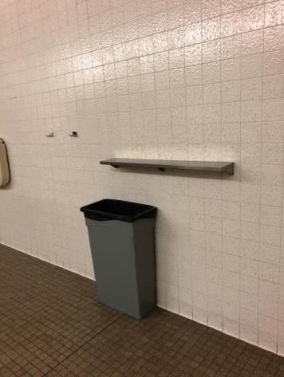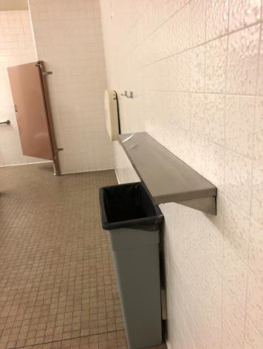

 | ID:  3827 | Facility:  City Hall

Location: 8th Floor Office of the City Attorney Women's Restroom
Schedule: 2022
Estimated Cost: $100.00

Priority Score 5
Quick Fix: Yes
Built before ADA: Yes

VIOLATIONS
2010 ADA Standards for Accessible Design Codes: §604.7
The toilet paper dispenser centerline is located 5" in front of the toilet.

RECOMMENDATIONS
Remount the toilet paper dispenser so that the centerline is located 7" minimum to 9" maximum in front of the toilet.
Ensure that the height is within the accessible reach range of 15" minimum to 48" maximum above the floor.

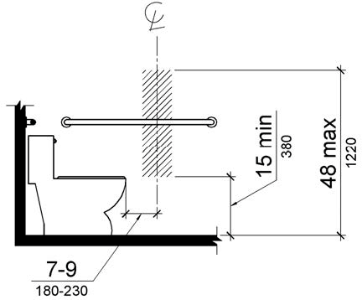

PHOTOGRAPH(S) OF THIS LOCATION

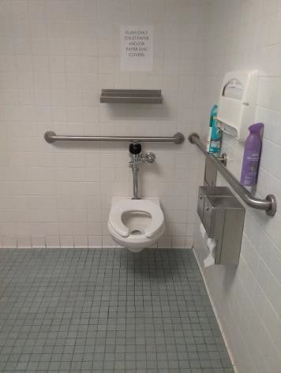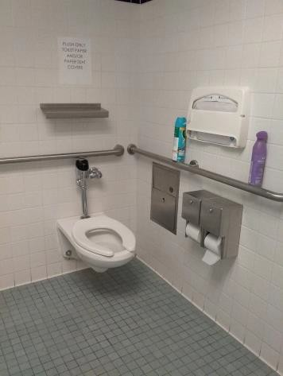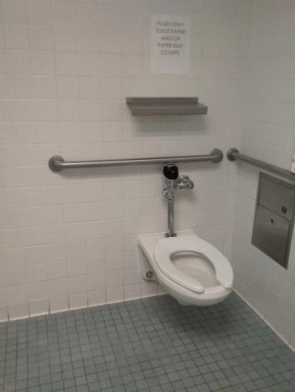

 | ID:  3843 | Facility:  City Hall

Location: 3rd Floor River Conference Room
Schedule: 2022
Estimated Cost: $100.00

Priority Score 6
Quick Fix: Yes
Built before ADA: Yes

VIOLATIONS
2010 ADA Standards for Accessible Design Codes: §703.4
The River Conference Room sign is located 62" above the floor.

RECOMMENDATIONS
Reinstall the sign on the right side of the right hand door at 48" minimum above the floor measured from the baseline of the lowest character and 60" maximum measured from the baseline of the highest character.

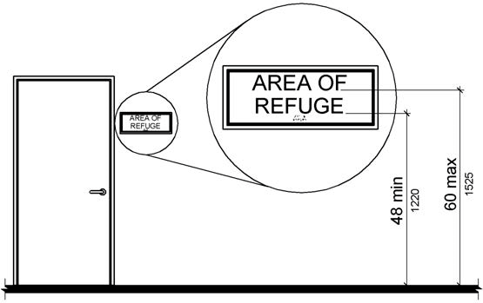

PHOTOGRAPH(S) OF THIS LOCATION

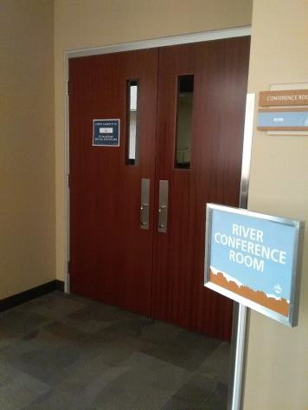

 | ID:  3846 | Facility:  City Hall

Location: 3rd Floor Men's Restroom by IT
Schedule: 2022
Estimated Cost: $100.00

Priority Score 5
Quick Fix: Yes
Built before ADA: Yes

VIOLATIONS
2010 ADA Standards for Accessible Design Codes: §604.8.1.2
The door to the accessible water closet is not self closing. Either self-closing hinges are not installed on the door or if installed, they are defective.

RECOMMENDATIONS
Install or reinstall self-closing hinges on the door to ensure that the door is self-closing per the ADA requirements.

PHOTOGRAPH(S) OF THIS LOCATION

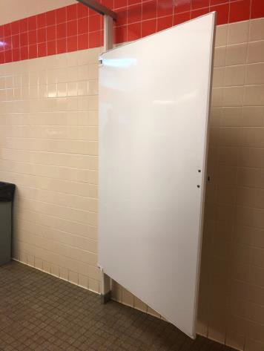

 | ID:  3850 | Facility:  City Hall

Location: 2nd Floor Men's Restroom by Bistro
Schedule: 2022
Estimated Cost: $100.00

Priority Score 6
Quick Fix: Yes
Built before ADA: Yes

VIOLATIONS
2010 ADA Standards for Accessible Design Codes: §216.6
The second floor men's restroom is not accessible and does not have a sign directing customers to the nearest accessible restroom.

RECOMMENDATIONS
Install a directional sign providing information to the nearest accessible restroom. The directional sign will comply with §703.5 and be between 48" and 60" above the floor, measured to the middle of the text.

PHOTOGRAPH(S) OF THIS LOCATION

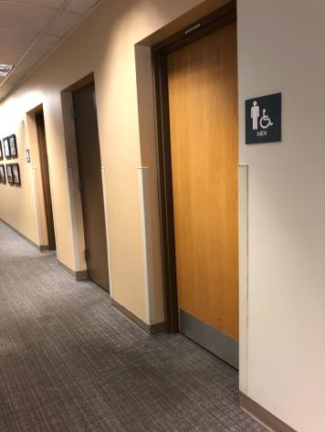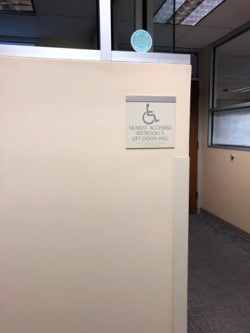

 | ID: | Facility:  City Hall

Location: Service Entrance
Schedule: 2022
Estimated Cost: $100.00

Priority Score 5
Quick Fix: NYes
Built before ADA: Yes

VIOLATIONS
2010 ADA Standards for Accessible Design Codes: §305.3
There is not adequate clear floor space in the front of the garbage and recycling cans.

RECOMMENDATIONS
Relocate the garbage and recycling cans to ensure that a minimum clear and level floor space of 30"x48" is available.

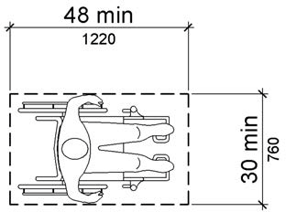

PHOTOGRAPH(S) OF THIS LOCATION

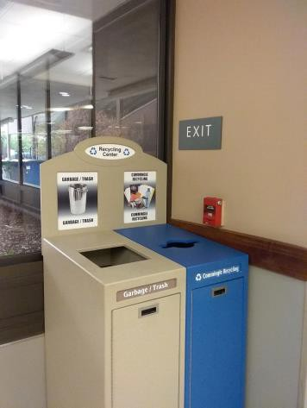

 | ID:  3781 | Facility:  City Hall

Location: 4th Floor Public Works Women's Restroom
Schedule: 2022
Estimated Cost: $100.00

Priority Score 5
Quick Fix: Yes
Built before ADA: Yes

VIOLATIONS
2010 ADA Standards for Accessible Design Codes: §604.8.1.2
The door to the accessible water closet is not self closing. Either self-closing hinges are not installed on the door or if installed, they are defective.

RECOMMENDATIONS
Install or reinstall self-closing hinges on the door to ensure that the door is self-closing per the ADA requirements.

PHOTOGRAPH(S) OF THIS LOCATION

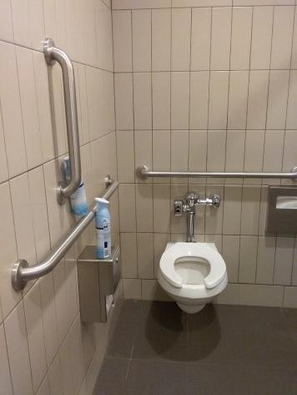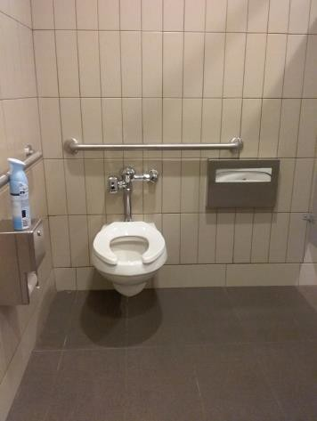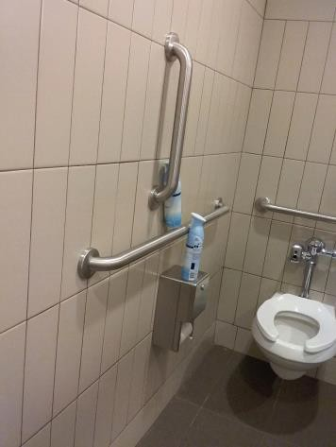

 | ID:  3877 | Facility:  City Hall

Location: 4th Floor Public Works Women's Restroom
Schedule: 2022
Estimated Cost: $100.00

Priority Score 5
Quick Fix: Yes
Built before ADA: Yes

VIOLATIONS
2010 ADA Standards for Accessible Design Codes: §604.7
The toilet paper dispenser centerline is located 6" in front of the toilet.

RECOMMENDATIONS
Remount the toilet paper dispenser centerline so that it is located 7" minimum to 9" maximum in front of the toilet.
Ensure that the height is within the accessible reach range of 15" minimum to 48" maximum above the floor.

PHOTOGRAPH(S) OF THIS LOCATION

 | ID:  3882 | Facility:  City Hall

Location: 4th Floor Office of the City Attorney Women's Restroom
Schedule: 2022
Estimated Cost: $100.00

Priority Score 5
Quick Fix: Yes
Built before ADA: Yes

VIOLATIONS
2010 ADA Standards for Accessible Design Codes: §307.2
The shelf protrudes 5" into the circulation space at 59" above the floor.

RECOMMENDATIONS
Recess the shelf so it protrudes a maximum of 4", lower it so the bottom edge is 27" maximum above the floor, or place a cane detectable object beneath it.

PHOTOGRAPH(S) OF THIS LOCATION

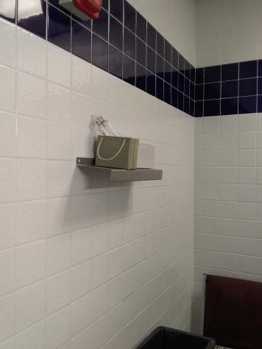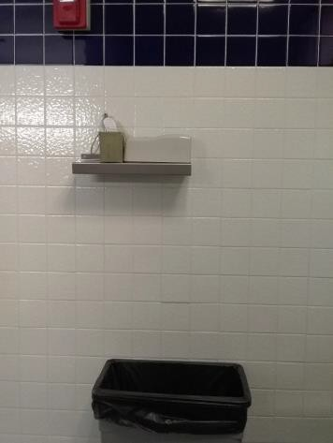

 | ID:  3888 | Facility:  City Hall

Location: 1st Floor Men's Restroom
Schedule: 2022
Estimated Cost: $100.00

Priority Score 7
Quick Fix: Yes
Built before ADA: Yes

VIOLATIONS
2010 ADA Standards for Accessible Design Codes: §603.3
The second mirror is 53" above the floor.

RECOMMENDATIONS
Lower the mirror to the maximum bottom edge height of 40" above the floor.

PHOTOGRAPH(S) OF THIS LOCATION

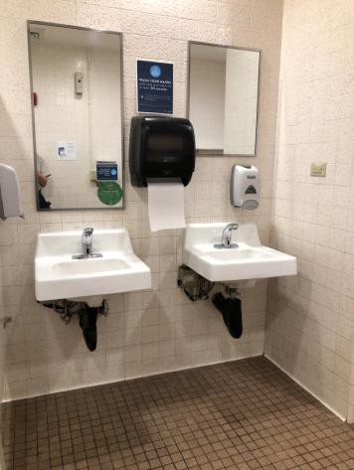

 | ID:  3913 | Facility:  City Hall

Location: 1st Floor Men's Restroom by Mini Market
Schedule: 2022
Estimated Cost: $100.00

Priority Score 5
Quick Fix: Yes
Built before ADA: Yes

VIOLATIONS
2010 ADA Standards for Accessible Design Codes: §604.8.1.2
The door to the accessible water closet is not self closing. Either self-closing hinges are not installed on the door or if installed, they are defective.

RECOMMENDATIONS
Install or reinstall self-closing hinges on the door to ensure that the door is self-closing per the ADA requirements.

PHOTOGRAPH(S) OF THIS LOCATION

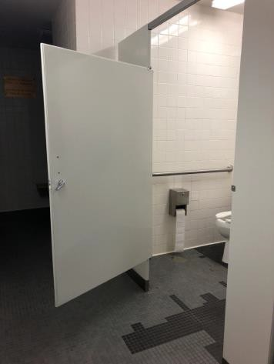

 | ID:  3916 | Facility:  City Hall

Location: 1st Floor Men's Restroom by Art Office
Schedule: 2022
Estimated Cost: $100.00

Priority Score 5
Quick Fix: Yes
Built before ADA: Yes

VIOLATIONS
2010 ADA Standards for Accessible Design Codes: §604.8.1.2
The door to the accessible water closet is not self closing. Either self-closing hinges are not installed on the door or if installed, they are defective.

RECOMMENDATIONS
Install or reinstall self-closing hinges on the door to ensure that the door is self-closing per the ADA requirements.

PHOTOGRAPH(S) OF THIS LOCATION

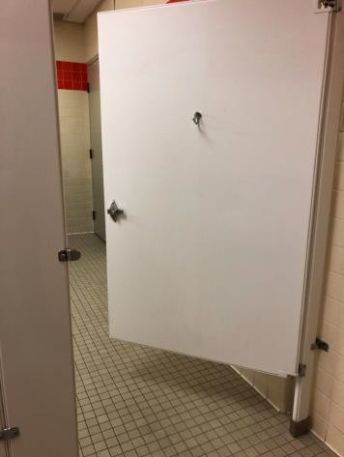

 | ID:  3966 | Facility:  City Hall

Location: 4th Floor Office of the City Attorney Women's Restroom
Schedule: 2022
Estimated Cost: $100.00

Priority Score 5
Quick Fix: Yes
Built before ADA: Yes

VIOLATIONS
2010 ADA Standards for Accessible Design Codes: §604.8.1.2
The door to the accessible water closet is not self closing. Either self-closing hinges are not installed on the door or if installed, they are defective.

RECOMMENDATIONS
Install or reinstall self-closing hinges on the door to ensure that the door is self-closing per the ADA requirements.

PHOTOGRAPH(S) OF THIS LOCATION

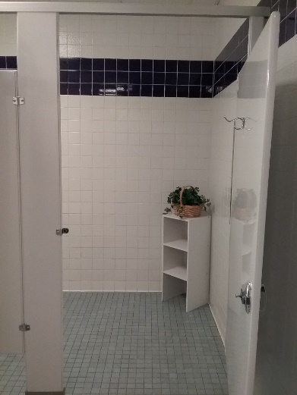

 | ID:  3967 | Facility:  City Hall

Location: 4th Floor Office of the City Attorney Women's Restroom
Schedule: 2022
Estimated Cost: $100.00

Priority Score 5
Quick Fix: Yes
Built before ADA: Yes

VIOLATIONS
2010 ADA Standards for Accessible Design Codes: §609.3
The space between the grab bar and toilet seat cover dispenser is 6".

RECOMMENDATIONS
Relocate the dispenser to a location that is at least a distance of 12" or greater above the grab bar.
Ensure that the dispenser is located 48" maximum above the floor.

PHOTOGRAPH(S) OF THIS LOCATION

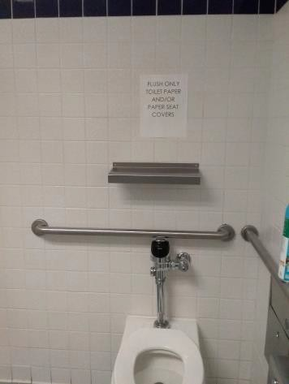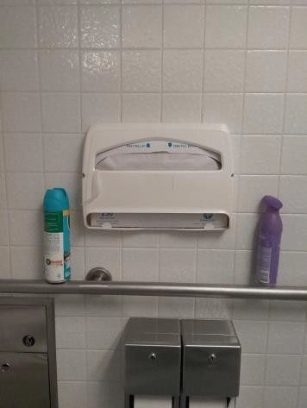

 | ID:  3968 | Facility:  City Hall

Location: 4th Floor Office of the City Attorney Women's Restroom
Schedule: 2022
Estimated Cost: $100.00

Priority Score 5
Quick Fix: Yes
Built before ADA: Yes

VIOLATIONS
2010 ADA Standards for Accessible Design Codes: §609.3
The space between the rear grab bar and shelf is 11".

RECOMMENDATIONS
Relocate the shelf to a location that is at least a distance of 12" or greater above the grab bar.
Ensure that the shelf is located 48" maximum above the floor.

PHOTOGRAPH(S) OF THIS LOCATION

 | ID:  3970 | Facility:  City Hall

Location: 1st Floor Men's Restroom by Mini Market
Schedule: 2022
Estimated Cost: $100.00

Priority Score 5
Quick Fix: Yes
Built before ADA: Yes

VIOLATIONS
2010 ADA Standards for Accessible Design Codes: ICC 604.5.1
The accessible water closet does not have a vertical grab bar.

RECOMMENDATIONS
Install an 18" long (minimum) vertical grab bar on the side wall. The grab bar shall be mounted with the bottom located at 39" minimum and 41" maximum above the floor.
The centerline of the vertical grab bar shall be located 39" minimum and 41" maximum from the real wall.

PHOTOGRAPH(S) OF THIS LOCATION

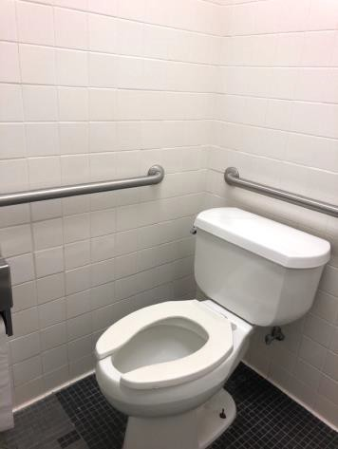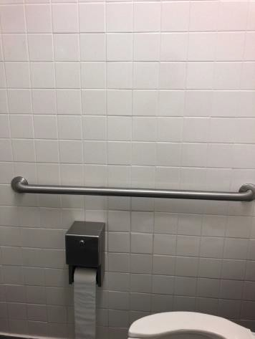

 | ID:  3979 | Facility:  City Hall

Location: 4th floor Men's Attorney Restroom
Schedule: 2022
Estimated Cost: $100.00

Priority Score 5
Quick Fix: Yes
Built before ADA: Yes

VIOLATIONS
2010 ADA Standards for Accessible Design Codes: §604.8.1.2
The door to the accessible water closet is not self closing. Either self-closing hinges are not installed on the door or if installed, they are defective.

RECOMMENDATIONS
Install or reinstall self-closing hinges on the door to ensure that the door is self-closing per the ADA requirements.

PHOTOGRAPH(S) OF THIS LOCATION

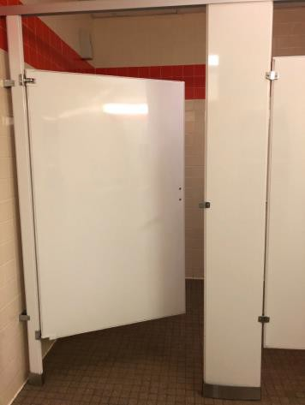

 | ID:  3988 | Facility:  City Hall

Location: 1st Floor Women's Restroom
Schedule: 2022
Estimated Cost: $100.00

Priority Score 5
Quick Fix: Yes
Built before ADA: Yes

VIOLATIONS
2010 ADA Standards for Accessible Design Codes: §604.8.1.2
The door to the accessible water closet is not self closing. Either self-closing hinges are not installed on the door or if installed, they are defective.

RECOMMENDATIONS
Install or reinstall self-closing hinges on the door to ensure that the door is self-closing per the ADA requirements.

PHOTOGRAPH(S) OF THIS LOCATION

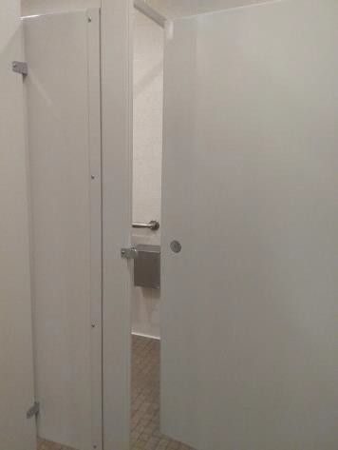

 | ID:  4005 | Facility:  City Hall

Location: 2nd Floor Housing and Community Development Women's Restroom
Schedule: 2022
Estimated Cost: $100.00

Priority Score 5
Quick Fix: Yes
Built before ADA: Yes

VIOLATIONS
2010 ADA Standards for Accessible Design Codes: §604.8.1.2
The door to the accessible water closet is not self closing. Either self-closing hinges are not installed on the door or if installed, they are defective.

RECOMMENDATIONS
Install or reinstall self-closing hinges on the door to ensure that the door is self-closing per the ADA requirements.

PHOTOGRAPH(S) OF THIS LOCATION

 | ID:  4011 | Facility:  City Hall

Location: 4th floor Men's Attorney Restroom
Schedule: 2022
Estimated Cost: $100.00

Priority Score 5
Quick Fix: Yes
Built before ADA: Yes

VIOLATIONS
2010 ADA Standards for Accessible Design Codes: §609.3
The space between the grab bar and toilet seat cover dispenser is 8".

RECOMMENDATIONS
Relocate the dispenser to a location that is at least a distance of 12" or greater away from the grab bar.

PHOTOGRAPH(S) OF THIS LOCATION

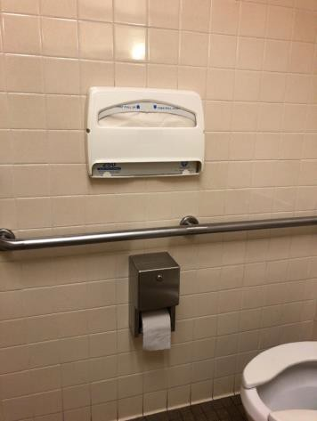

 | ID:  4022 | Facility:  City Hall

Location: 1st Floor Women's Restroom
Schedule: 2022
Estimated Cost: $100.00

Priority Score 7
Quick Fix: Yes
Built before ADA: Yes

VIOLATIONS
2010 ADA Standards for Accessible Design Codes: §606.5
The pipe cover is falling off.

RECOMMENDATIONS
Wrap the pipe beneath the sink with soft protective wrap or plastic.

PHOTOGRAPH(S) OF THIS LOCATION

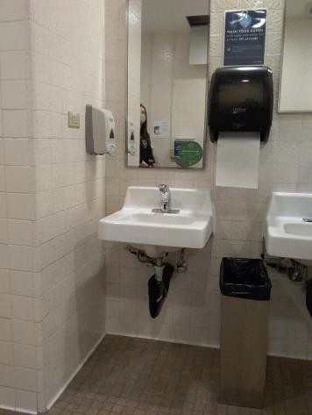

 | ID:  4049 | Facility:  City Hall

Location: North Stairwell 1
Schedule: 2022
Estimated Cost: $100.00

Priority Score 7
Quick Fix: Yes
Built before ADA: Yes

VIOLATIONS
2010 ADA Standards for Accessible Design Codes: §309.4
The door knob requires twisting of the wrist.

RECOMMENDATIONS
Replace the door knob with a lever handle that can be operated with a closed fist and without twisting the wrist.

PHOTOGRAPH(S) OF THIS LOCATION

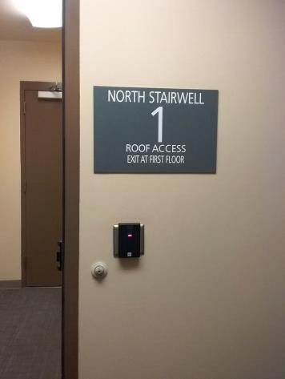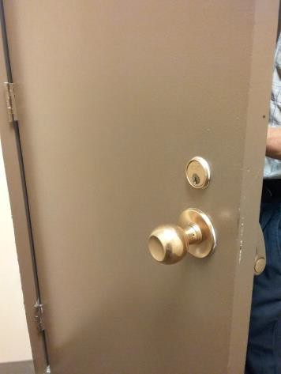

 | ID:  4100 | Facility:  City Hall

Location: 1st Floor Men's Restroom by Mini Market
Schedule: 2022
Estimated Cost: $100.00

Priority Score 5
Quick Fix: Yes
Built before ADA: Yes

VIOLATIONS
2010 ADA Standards for Accessible Design Codes: §307.2
The paper towel dispenser protrudes 9" into the circulation space at 46" above the floor.

RECOMMENDATIONS
Recess the dispenser so it protrudes a maximum of 4", lower it so the bottom edge is 27" maximum above the floor, or place a cane detectable object beneath it

PHOTOGRAPH(S) OF THIS LOCATION

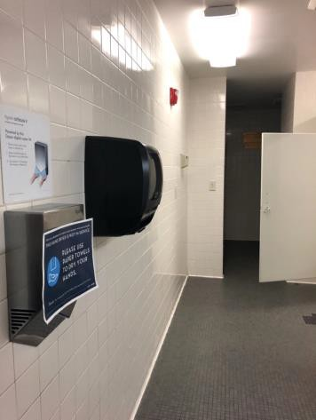

 | ID:  4147 | Facility:  City Hall

Location: 4th Floor Public Works Men's Restroom
Schedule: 2022
Estimated Cost: $100.00

Priority Score 5
Quick Fix: Yes
Built before ADA: Yes

VIOLATIONS
2010 ADA Standards for Accessible Design Codes: §307.2
The paper towel dispenser protrudes 9" into the circulation space.

RECOMMENDATIONS
Recess the paper towel dispenser so it protrudes a maximum of 4", lower it so the bottom edge is 27" maximum above the floor, or place a cane detectable object beneath it.

PHOTOGRAPH(S) OF THIS LOCATION

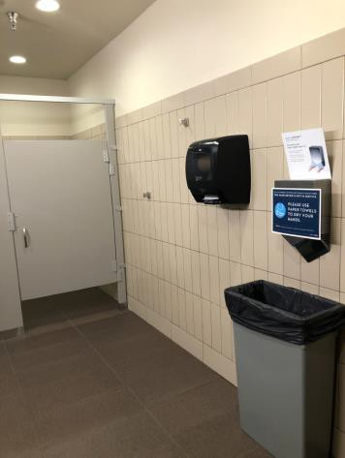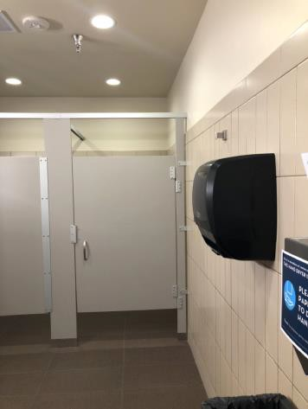

 | ID:  4166 | Facility:  City Hall

Location: 3rd Floor Men's Restroom by IT
Schedule: 2022
Estimated Cost: $100.00

Priority Score 5
Quick Fix: Yes
Built before ADA: Yes

VIOLATIONS
2010 ADA Standards for Accessible Design Codes: §609.3
The space between the grab bar and toilet seat cover dispenser is 4".

RECOMMENDATIONS
Relocate the dispenser to a location that is at least a distance of 12" or greater away from the grab bar.

PHOTOGRAPH(S) OF THIS LOCATION

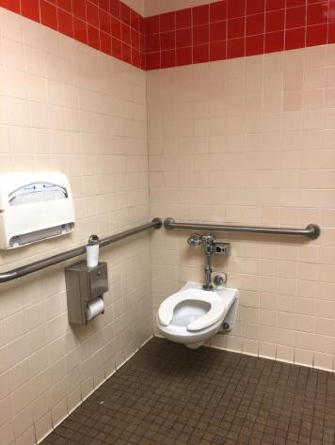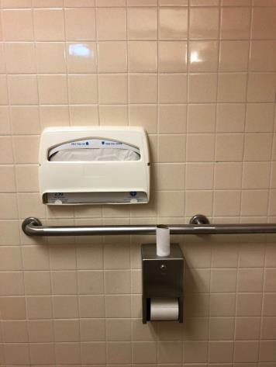

 | ID:  4168 | Facility:  City Hall

Location: 2nd Floor Engineering Men's Restroom
Schedule: 2022
Estimated Cost: $100.00

Priority Score 5
Quick Fix: Yes
Built before ADA: Yes

VIOLATIONS
2010 ADA Standards for Accessible Design Codes: §604.8.1.2
The door to the accessible water closet is not self closing. Either self-closing hinges are not installed on the door or if installed, they are defective.

RECOMMENDATIONS
Install or reinstall self-closing hinges on the door to ensure that the door is self-closing per the ADA requirements.

PHOTOGRAPH(S) OF THIS LOCATION

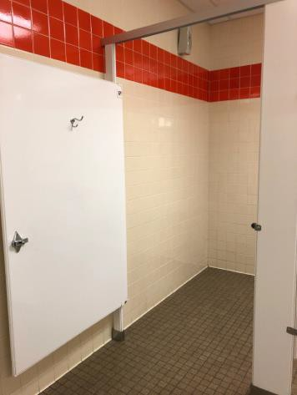

 | ID:  4181 | Facility:  City Hall

Location: 1st Floor Men's Restroom
Schedule: 2022
Estimated Cost: $100.00

Priority Score 5
Quick Fix: Yes
Built before ADA: Yes

VIOLATIONS
2010 ADA Standards for Accessible Design Codes: §604.8.1.2
The door to the accessible water closet is not self closing. Either self-closing hinges are not installed on the door or if installed, they are defective.

RECOMMENDATIONS
Install or reinstall self-closing hinges on the door to ensure that the door is self-closing per the ADA requirements.

PHOTOGRAPH(S) OF THIS LOCATION

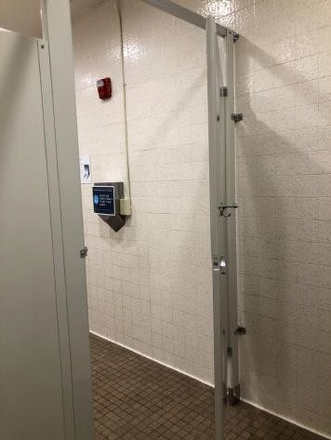

 | ID:  4192 | Facility:  City Hall

Location: 1st Floor Mail Hallway Women's Restroom
Schedule: 2022
Estimated Cost: $100.00

Priority Score 5
Quick Fix: Yes
Built before ADA: Yes

VIOLATIONS
2010 ADA Standards for Accessible Design Codes: §307.2
The paper towel dispenser protrudes 8" into the circulation space.

RECOMMENDATIONS
Recess the dispenser so it protrudes a maximum of 4", lower it so the bottom edge is 27" maximum above the floor, or place a cane detectable object beneath it.

PHOTOGRAPH(S) OF THIS LOCATION

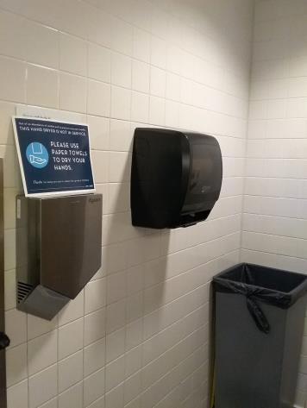

 | ID:  4194 | Facility:  City Hall

Location: 1st Floor Mail Hallway Women's Restroom
Schedule: 2022
Estimated Cost: $100.00

Priority Score 5
Quick Fix: Yes
Built before ADA: Yes

VIOLATIONS
2010 ADA Standards for Accessible Design Codes: §604.8.1.2
The door to the accessible water closet is not self closing. Either self-closing hinges are not installed on the door or if installed, they are defective.

RECOMMENDATIONS
Install or reinstall self-closing hinges on the door to ensure that the door is self-closing per the ADA requirements.

PHOTOGRAPH(S) OF THIS LOCATION

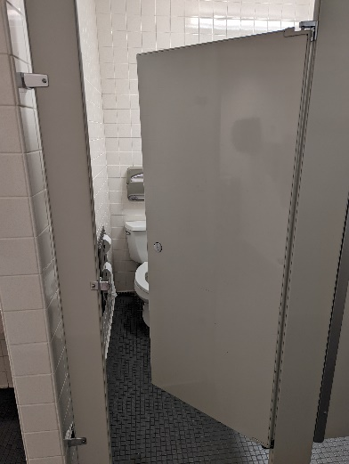

 | ID:  4195 | Facility:  City Hall

Location: 1st Floor Mail Hallway Women's Restroom
Schedule: 2022
Estimated Cost: $100.00

Priority Score 5
Quick Fix: Yes
Built before ADA: Yes

VIOLATIONS
2010 ADA Standards for Accessible Design Codes: §609.3
The space between the grab bar and toilet seat cover dispenser is less 5.5".

RECOMMENDATIONS
Relocate the dispenser to a location that is at least a distance of 12" or greater away from the grab bar.

PHOTOGRAPH(S) OF THIS LOCATION

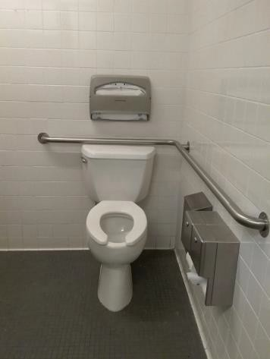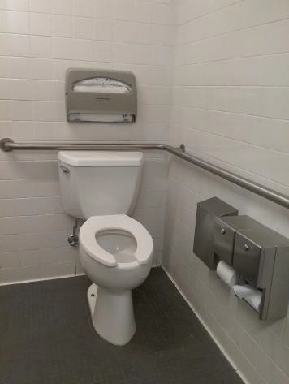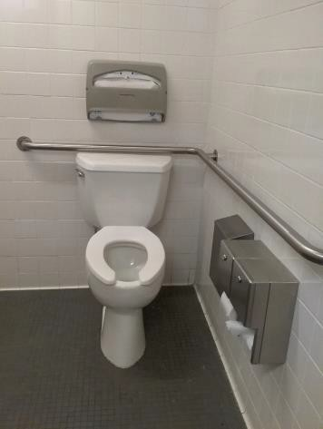

 | ID:  4200 | Facility:  City Hall

Location: 1st Floor Mail Hallway Women's Restroom
Schedule: 2022
Estimated Cost: $100.00

Priority Score 5
Quick Fix: Yes
Built before ADA: Yes

VIOLATIONS
2010 ADA Standards for Accessible Design Codes: §604.7
The toilet paper dispenser is located 6" in front of the toilet.

RECOMMENDATIONS
Remount the toilet paper dispenser so that it is located 7" minimum to 9" maximum in front of the toilet.
Ensure that the height is within the accessible reach range of 15" minimum to 48" maximum above the floor.

PHOTOGRAPH(S) OF THIS LOCATION

 | ID:  4257 | Facility:  City Hall

Location: 1st Floor Women's Restroom
Schedule: 2022
Estimated Cost: $100.00

Priority Score 5
Quick Fix: Yes
Built before ADA: Yes

VIOLATIONS
2010 ADA Standards for Accessible Design Codes: §307.2
The dispenser protrudes 6" into the circulation space.

RECOMMENDATIONS
Recess the dispenser so it protrudes a maximum of 4", lower it so the bottom edge is 27" maximum above the floor, or place a cane detectable object beneath it.

PHOTOGRAPH(S) OF THIS LOCATION

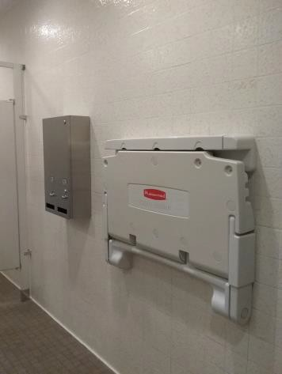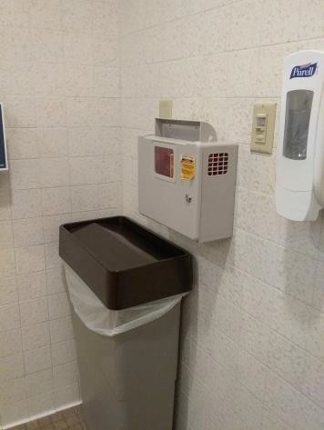

 | ID:  4258 | Facility:  City Hall

Location: 1st Floor Women's Restroom
Schedule: 2022
Estimated Cost: $100.00

Priority Score 5
Quick Fix: Yes
Built before ADA: Yes

VIOLATIONS
2010 ADA Standards for Accessible Design Codes: §307.2
The sharps dispenser protrudes 5" into the circulation space.

RECOMMENDATIONS
Ensure that the garbage can is always underneath the sharps dispenser to provide cane detectability.
Another option would be to recess the sharps dispenser so it protrudes a maximum of 4" or lower it so the bottom edge is 27" maximum above the floor.

PHOTOGRAPH(S) OF THIS LOCATION

 | ID:  4259 | Facility:  City Hall

Location: 4th floor Men's Attorney Restroom
Schedule: 2022
Estimated Cost: $100.00

Priority Score 5
Quick Fix: Yes
Built before ADA: Yes

VIOLATIONS
2010 ADA Standards for Accessible Design Codes: §307.2
The metal shelf protrudes 5" into the circulation space.

RECOMMENDATIONS
Recess the metal shelf so it protrudes a maximum of 4", lower it so the bottom edge is 27" maximum above the floor, or place a cane detectable object beneath it.

PHOTOGRAPH(S) OF THIS LOCATION

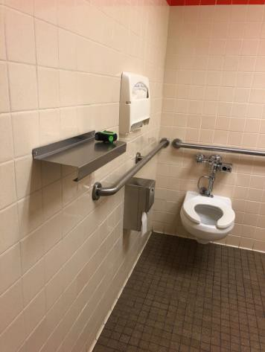

 | ID:  4262 | Facility:  City Hall

Location: Main Street Entrance
Schedule: 2022
Estimated Cost: $100.00

Priority Score 5
Quick Fix: Yes
Built before ADA: Yes

VIOLATIONS
2010 ADA Standards for Accessible Design Codes: §305.3
The clear floor space at the drop box has a 3.6% slope.

RECOMMENDATIONS
Relocate the drop box to an area with a minimum clear floor space of 30"x48" and a maximum slope of 2% in all directions.
If the drop box protrudes more than 4", ensure that the bottom edge is no higher than 27" above the ground or place an object underneath to provide cane detectability.

PHOTOGRAPH(S) OF THIS LOCATION

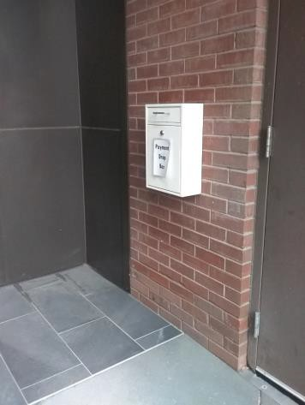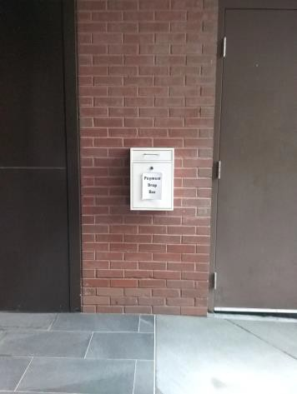

 | ID:  4265 | Facility:  City Hall

Location: 3rd Floor Office of Community Engagement
Schedule: 2022
Estimated Cost: $100.00

Priority Score 5
Quick Fix: Yes
Built before ADA: Yes

VIOLATIONS
2010 ADA Standards for Accessible Design Codes: §307.2
The AED protrudes 6" into the circulation space.

RECOMMENDATIONS
Recess the AED so it protrudes a maximum of 4", lower it so the bottom edge is 27" maximum above the floor, or place a cane detectable object beneath it.

PHOTOGRAPH(S) OF THIS LOCATION

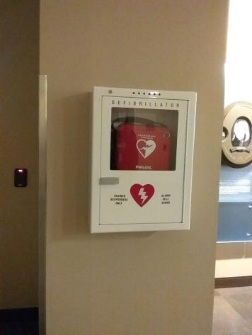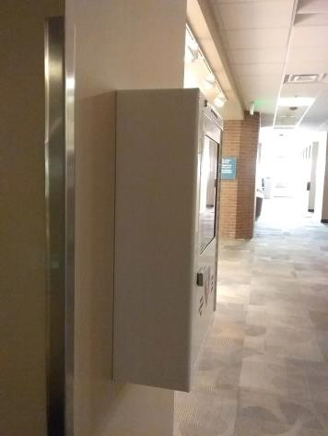

 | ID:  4267 | Facility:  City Hall

Location: 2nd Floor Public Works Engineering Women's Restroom
Schedule: 2022
Estimated Cost: $100.00

Priority Score 5
Quick Fix: Yes
Built before ADA: Yes

VIOLATIONS
2010 ADA Standards for Accessible Design Codes: §604.8.1.2
The door to the accessible water closet is not self closing. Either self-closing hinges are not installed on the door or if installed, they are defective.

RECOMMENDATIONS
Install or reinstall self-closing hinges on the door to ensure that the door is self-closing per the ADA requirements.

PHOTOGRAPH(S) OF THIS LOCATION

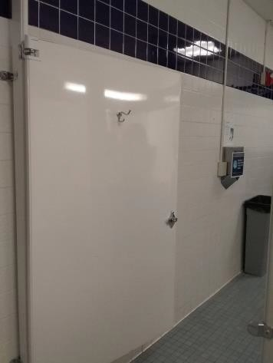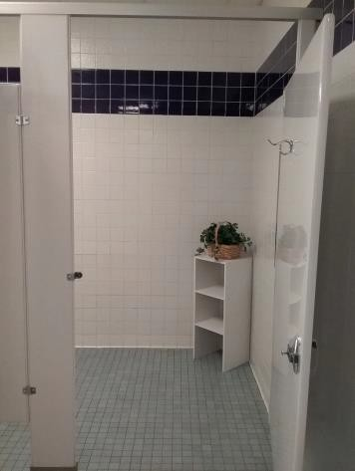

 | ID:  4287 | Facility:  City Hall

Location: 2nd Floor Engineering Men's Restroom
Schedule: 2022
Estimated Cost: $100.00

Priority Score 5
Quick Fix: Yes
Built before ADA: Yes

VIOLATIONS
2010 ADA Standards for Accessible Design Codes: §609.3
The space between the grab bar and toilet seat cover dispenser is 10".

RECOMMENDATIONS
Relocate the dispenser to a location that is at least a distance of 12" or greater away from the grab bar.

PHOTOGRAPH(S) OF THIS LOCATION

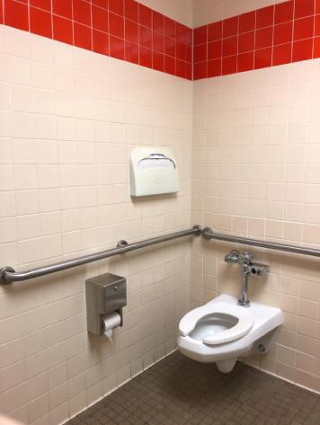

 | ID:  4295 | Facility:  City Hall

Location: 4th Floor Men's Attorney Break Room
Schedule: 2022
Estimated Cost: $100.00

Priority Score 5
Quick Fix: Yes
Built before ADA: Yes

VIOLATIONS
2010 ADA Standards for Accessible Design Codes: §307.2
The AED protrudes 6" into the circulation space at 39" above the floor.

RECOMMENDATIONS
Recess the AED so it protrudes a maximum of 4", lower it so the bottom edge is 27" maximum above the floor, or place a cane detectable object beneath it.

PHOTOGRAPH(S) OF THIS LOCATION

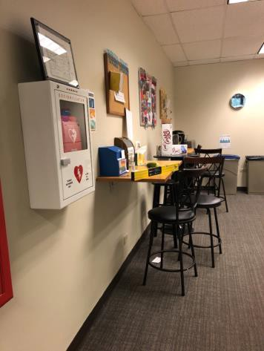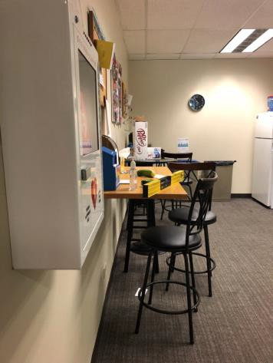

 | ID:  4321 | Facility:  City Hall

Location: 2nd Floor Housing and Community Development Women's Restroom
Schedule: 2022
Estimated Cost: $100.00

Priority Score 5
Quick Fix: Yes
Built before ADA: Yes

VIOLATIONS
2010 ADA Standards for Accessible Design Codes: §307.2
The dispenser protrudes 6" into the circulation space at 34.5" above the floor.

RECOMMENDATIONS
Recess the dispenser so it protrudes a maximum of 4", lower it so the bottom edge is 27" maximum above the floor, or place a cane detectable object beneath it.

PHOTOGRAPH(S) OF THIS LOCATION

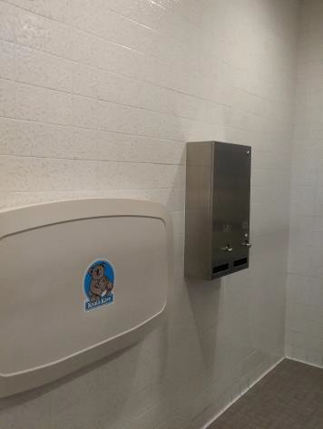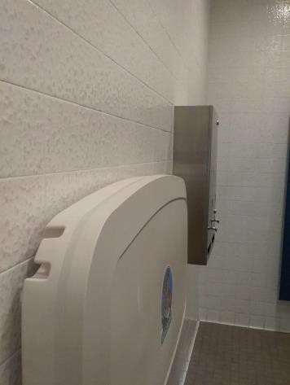

 | ID:  4331 | Facility:  City Hall

Location: 2nd Floor PDS Men's Restroom
Schedule: 2022
Estimated Cost: $100.00

Priority Score 5
Quick Fix: Yes
Built before ADA: Yes

VIOLATIONS
2010 ADA Standards for Accessible Design Codes: §604.8.1.2
The door to the accessible water closet is not self closing. Either self-closing hinges are not installed on the door or if installed, they are defective.

RECOMMENDATIONS
Install or reinstall self-closing hinges on the door to ensure that the door is self-closing per the ADA requirements.

PHOTOGRAPH(S) OF THIS LOCATION

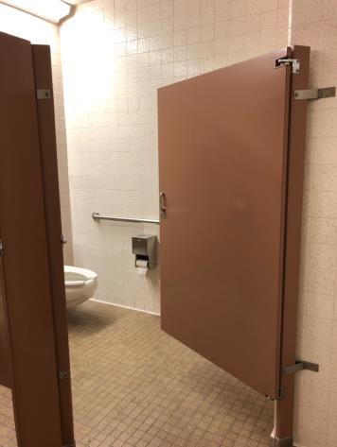

 | ID:  4339 | Facility:  City Hall

Location: Main Street Entrance
Schedule: 2022
Estimated Cost: $100.00

Priority Score 5
Quick Fix: Yes
Built before ADA: Yes

VIOLATIONS
2010 ADA Standards for Accessible Design Codes: §305.3
The clear floor space in front of the garbage cans has a 3.5% slope.

RECOMMENDATIONS
Relocate the garbage cans to ensure that a minimum clear and level floor space of 30"x48" is available in front of every can.

PHOTOGRAPH(S) OF THIS LOCATION

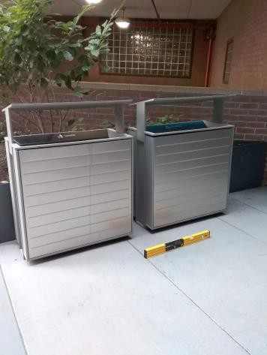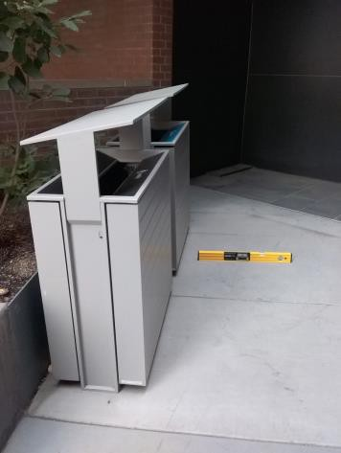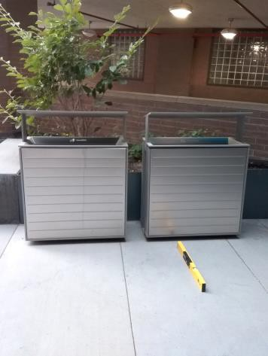

 | ID:  4345 | Facility:  City Hall

Location: 1st Floor Women's Restroom
Schedule: 2022
Estimated Cost: $100.00

Priority Score 7
Quick Fix: Yes
Built before ADA: Yes

VIOLATIONS
2010 ADA Standards for Accessible Design Codes: §603.3
The mirrors are 41" and 53" above the floor.

RECOMMENDATIONS
Lower one of the mirrors to the maximum height of 40" above the floor.

PHOTOGRAPH(S) OF THIS LOCATION

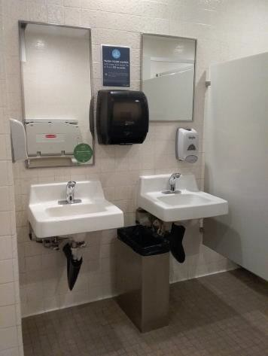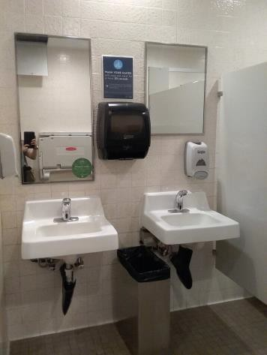

 | ID:  4373 | Facility:  City Hall

Location: Main street entrance
Schedule: 2022
Estimated Cost: $100.00

Priority Score 6
Quick Fix: Yes
Built before ADA: Yes

VIOLATIONS
2010 ADA Standards for Accessible Design Codes: §703.4.2
There is not adequate clear floor space in the front of the exit sign.

RECOMMENDATIONS
Relocate the garbage and recycling cans to ensure that a minimum clear and level floor space of 18"x18" is available by the push button.

PHOTOGRAPH(S) OF THIS LOCATION

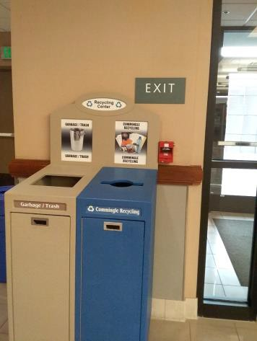

 | ID:  4377 | Facility:  City Hall

Location: 2nd Floor Men's Restroom by Bistro
Schedule: 2022
Estimated Cost: $100.00

Priority Score 7
Quick Fix: Yes
Built before ADA: Yes

VIOLATIONS
2010 ADA Standards for Accessible Design Codes: §603.3
The mirror closest to the accessible lavatory is 52" above the floor.

RECOMMENDATIONS
Lower the mirror to the maximum height of 40" above the floor.

PHOTOGRAPH(S) OF THIS LOCATION

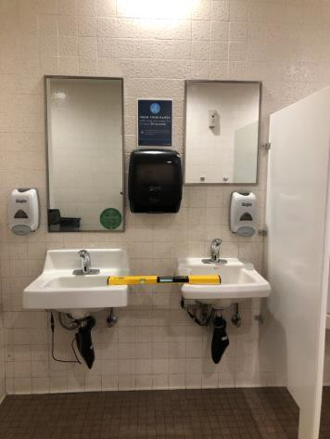

 | ID:  4415 | Facility:  City Hall

Location: 3rd Floor IT Women's Restroom
Schedule: 2022
Estimated Cost: $100.00

Priority Score 5
Quick Fix: Yes
Built before ADA: Yes

VIOLATIONS
2010 ADA Standards for Accessible Design Codes: §609.3
The space between the grab bar and toilet seat cover dispenser is 5.5".

RECOMMENDATIONS
Relocate the dispenser to a location that is at least a distance of 12" or greater away from the grab bar.

PHOTOGRAPH(S) OF THIS LOCATION

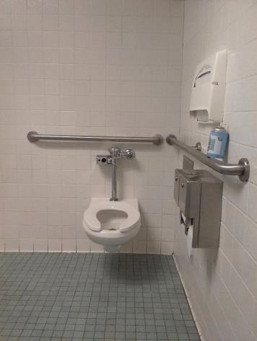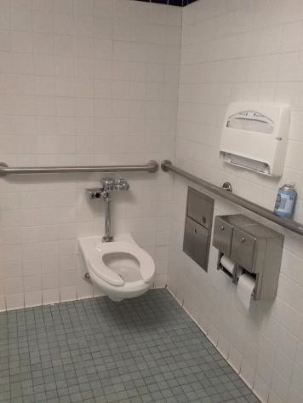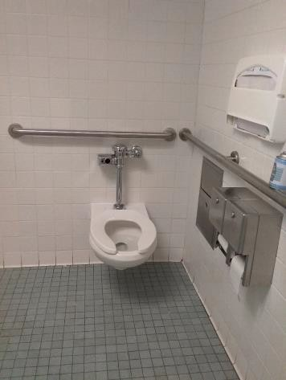

 | ID:  4419 | Facility:  City Hall

Location: 3rd Floor IT Women's Restroom
Schedule: 2022
Estimated Cost: $100.00

Priority Score 5
Quick Fix: Yes
Built before ADA: Yes

VIOLATIONS
2010 ADA Standards for Accessible Design Codes: §604.8.1.2
The door to the accessible water closet is not self closing. Either self-closing hinges are not installed on the door or if installed, they are defective.

RECOMMENDATIONS
Install or reinstall self-closing hinges on the door to ensure that the door is self-closing per the ADA requirements.

PHOTOGRAPH(S) OF THIS LOCATION

 | ID:  4421 | Facility:  City Hall

Location: Art and History Women's Restroom
Schedule: 2022
Estimated Cost: $100.00

Priority Score 5
Quick Fix: Yes
Built before ADA: Yes

VIOLATIONS
2010 ADA Standards for Accessible Design Codes: §604.8.1.2
The door to the accessible water closet is not self closing. Either self-closing hinges are not installed on the door or if installed, they are defective.

RECOMMENDATIONS
Install or reinstall self-closing hinges on the door to ensure that the door is self-closing per the ADA requirements.

PHOTOGRAPH(S) OF THIS LOCATION

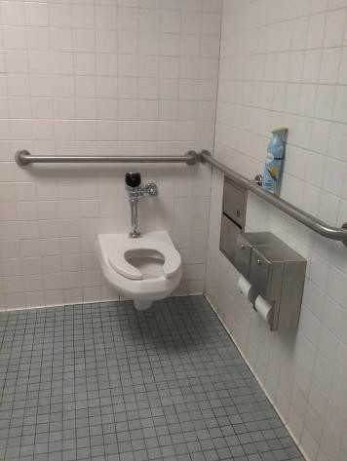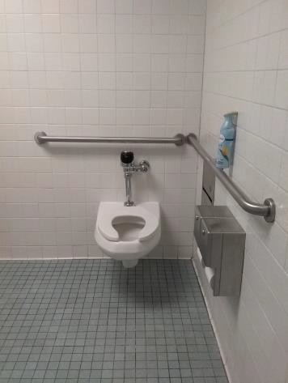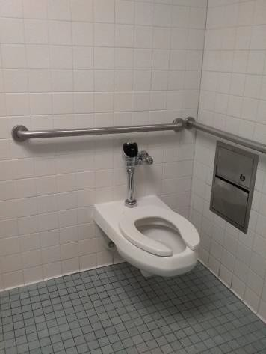

 | ID:  4427 | Facility:  City Hall

Location: 3rd Floor Greenbelt Conference Room
Schedule: 2022
Estimated Cost: $100.00

Priority Score 5
Quick Fix: Yes
Built before ADA: Yes

VIOLATIONS
2010 ADA Standards for Accessible Design Codes: §703.4
The Greenbelt Conference Room sign is located 62" above the floor.

RECOMMENDATIONS
Reinstall the sign closer to the door on the latch side at 48" minimum above the floor measured from the baseline of the lowest character and 60" maximum measured from the baseline of the highest character.

PHOTOGRAPH(S) OF THIS LOCATION

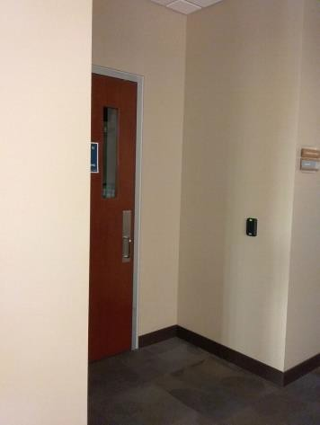

 | ID:  4442 | Facility:  City Hall

Location: 4th Floor Public Works Women's Restroom
Schedule: 2022
Estimated Cost: $100.00

Priority Score 5
Quick Fix: Yes
Built before ADA: Yes

VIOLATIONS
2010 ADA Standards for Accessible Design Codes: §307.2
The paper towel dispenser protrudes 7" into the circulation space.

RECOMMENDATIONS
Recess the dispenser so it protrudes a maximum of 4", lower it so the bottom edge is 27" maximum above the floor, or place a cane detectable object beneath it.

PHOTOGRAPH(S) OF THIS LOCATION

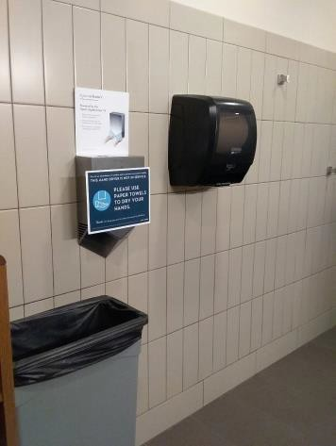

 | ID: | Facility:  City Hall

Location: North Stairwell 1
Schedule: 2022
Estimated Cost: $100.00

Priority Score 6
Quick Fix: Yes
Built before ADA: Yes

VIOLATIONS
2010 ADA Standards for Accessible Design Codes: §703.4
The tactile sign identifying the North Stairwell is at 64" above the floor.

RECOMMENDATIONS
Reinstall the sign on the latch side of the door at 48" minimum above the floor measured from the baseline of the lowest character and 60" maximum measured from the baseline of the highest character.

PHOTOGRAPH(S) OF THIS LOCATION

 | ID:  4148 | Facility:  City Hall

Location: Garage Entry
Schedule: 2020
Estimated Cost: $100.00

Priority Score 0
Quick Fix: Yes
Built before ADA: Yes

VIOLATIONS
2010 ADA Standards for Accessible Design Codes: §0.00
Although it is not in violation of the 2010 ADA Standards for Accessible Design, it must be noted that the maximum height of the garage is not posted for users.

RECOMMENDATIONS
To improve the user experience, install a sign indicating the clearance of the garage. Parking spaces for vans and access aisle shall have a minimum vertical clearance of 98".
If the internal clearance within the garage is less than 98", van accessible parking will need to be provided at another location.

PHOTOGRAPH(S) OF THIS LOCATION

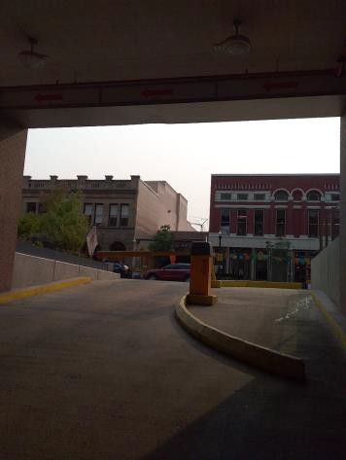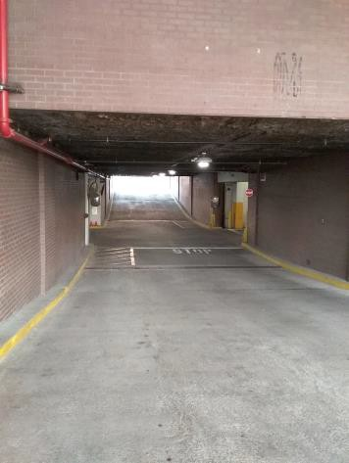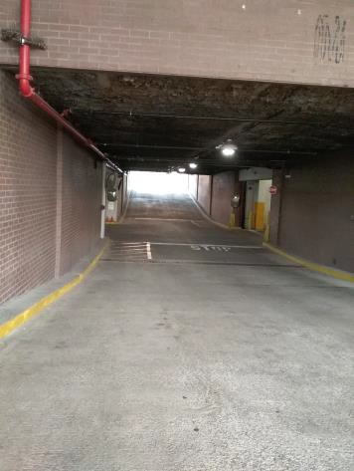

 | ID:  4182 | Facility:  City Hall

Location: 4th Floor Office of the City Attorney Restrooms
Schedule: 2023
Estimated Cost: $200.00

Priority Score 8
Quick Fix: Yes
Built before ADA: Yes

VIOLATIONS
2010 ADA Standards for Accessible Design Codes: §308.2.1
The coat hooks in the men and women's are outside of the unobstructed forward reach range at 67" above the floor.

RECOMMENDATIONS
Lower the coat hooks by 19" to meet the accessible reach range of 15" minimum and 48" maximum above the floor.

PHOTOGRAPH(S) OF THIS LOCATION

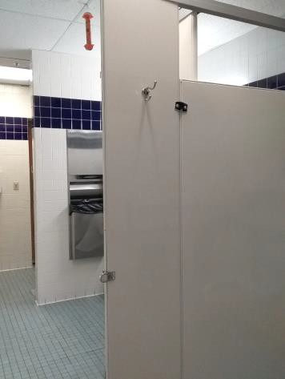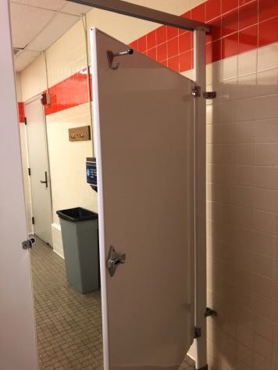

 | ID:  4273 | Facility:  City Hall

Location: 2nd Floor Public Works Engineering Restrooms
Schedule: 2023
Estimated Cost: $200.00

Priority Score 8
Quick Fix: Yes
Built before ADA: Yes

VIOLATIONS
2010 ADA Standards for Accessible Design Codes: §308.2.1
The coat hooks in the men and women's restrooms are outside of the unobstructed forward reach range at 58 and 59.5" above the floor respectively.

RECOMMENDATIONS
Lower the coat hooks by 10" and 11.5" to meet the accessible reach range of 15" minimum and 48" maximum above the floor.

PHOTOGRAPH(S) OF THIS LOCATION

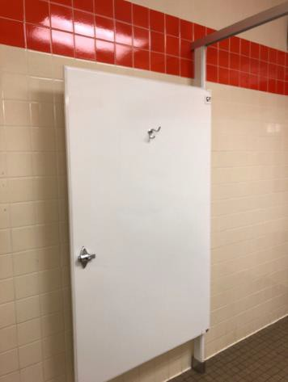

 | ID:  3793 | Facility:  City Hall

Location: 2nd Floor Housing and Community Development Women's Restroom
Schedule: 2022
Estimated Cost: $200.00

Priority Score 7
Quick Fix: Yes
Built before ADA: Yes

VIOLATIONS
2010 ADA Standards for Accessible Design Codes: §606.5
The pipes under the sink are not covered.

RECOMMENDATIONS
Wrap the pipes beneath the sink with soft protective wrap or plastic.

PHOTOGRAPH(S) OF THIS LOCATION

 | ID:  3893 | Facility:  City Hall

Location: 2nd Floor Housing and Community Development Women's Restroom
Schedule: 2022
Estimated Cost: $200.00

Priority Score 7
Quick Fix: Yes
Built before ADA: Yes

VIOLATIONS
2010 ADA Standards for Accessible Design Codes: §606.5
The pipe covers are falling off.

RECOMMENDATIONS
Wrap the pipes beneath the sink with soft protective wrap or plastic.

PHOTOGRAPH(S) OF THIS LOCATION

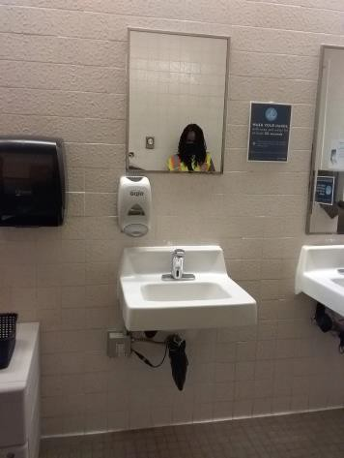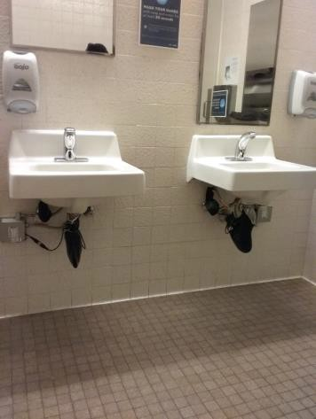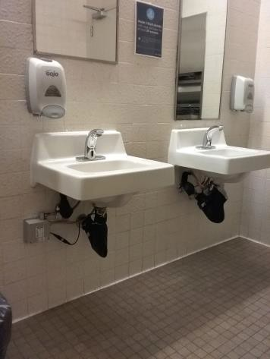

 | ID:  4090 | Facility:  City Hall

Location: 4th Floor Public Works Outside Restrooms
Schedule: 2022
Estimated Cost: $200.00

Priority Score 5
Quick Fix: Yes
Built before ADA: Yes

VIOLATIONS
2010 ADA Standards for Accessible Design Codes: §307.2
The AED and fire extinguisher protrude 6" into the circulation space at 28" and 29" above the floor.

RECOMMENDATIONS
Recess the AED and fire extinguisher so they protrude a maximum of 183", lower them so the bottom edge is 27" maximum above the floor, or place a cane detectable object beneath them.

PHOTOGRAPH(S) OF THIS LOCATION

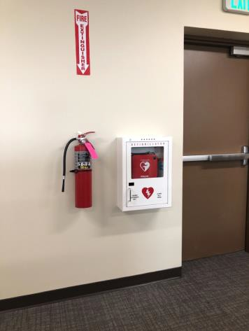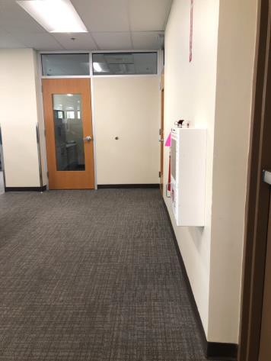

 | ID:  4296 | Facility:  City Hall

Location: 4th Floor Men's Attorney Break Roon
Schedule: 2022
Estimated Cost: $200.00

Priority Score 5
Quick Fix: Yes
Built before ADA: Yes

VIOLATIONS
2010 ADA Standards for Accessible Design Codes: §307.2
The table protrudes 20" into the circulation space at 38" above the floor.

RECOMMENDATIONS
Add table legs on the end corners to provide cane detectability beneath the table.

PHOTOGRAPH(S) OF THIS LOCATION

 | ID:  3963 | Facility:  City Hall

Location: Art and History
Schedule: 2022
Estimated Cost: $300.00

Priority Score 6
Quick Fix: Yes
Built before ADA: Yes

VIOLATIONS
2010 ADA Standards for Accessible Design Codes: §703.4
The tactile signs identifying the rooms are at 62" above the floor.

RECOMMENDATIONS
Reinstall the signs on the latch side of the doors at 48" minimum above the floor measured from the baseline of the lowest character and 60" maximum measured from the baseline of the highest character.

PHOTOGRAPH(S) OF THIS LOCATION

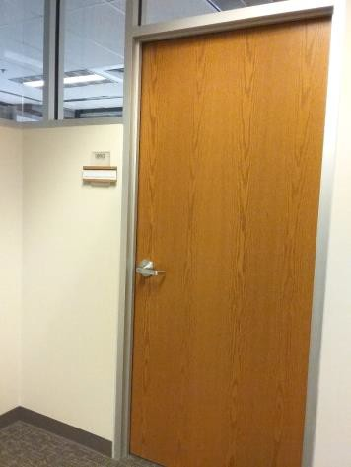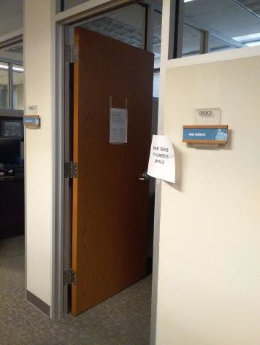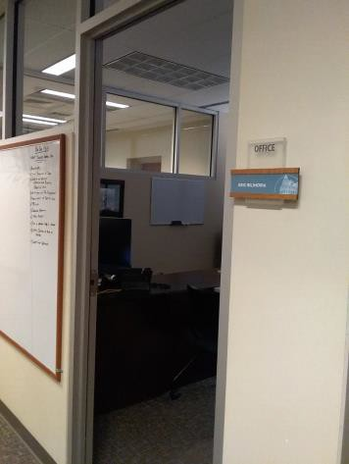

 | ID:  4003 | Facility:  City Hall

Location: Lobby Doors
Schedule: 2022
Estimated Cost: $300.00

Priority Score 6
Quick Fix: Yes
Built before ADA: Yes

VIOLATIONS
2010 ADA Standards for Accessible Design Codes: §703.4
The conference room sign is 62.75" above the floor. Two other lobby doors are lacking signage.

RECOMMENDATIONS
Reinstall and install the sign on the latch side of the door at 48" minimum above the floor measured from the baseline of the lowest character and 60" maximum measured from the baseline of the highest character.

PHOTOGRAPH(S) OF THIS LOCATION

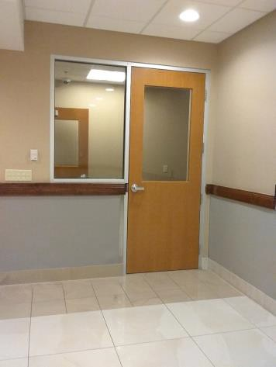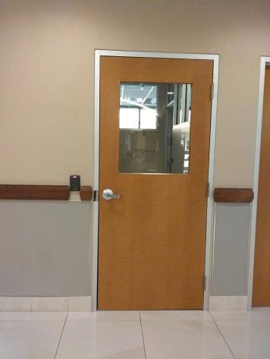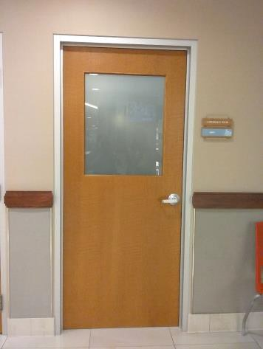

 | ID:  3830 | Facility:  City Hall

Location: Purchasing Department
Schedule: 2021
Estimated Cost: $300.00

Priority Score 3
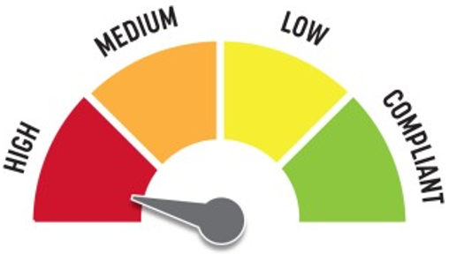
Quick Fix: Yes
Built before ADA: Yes

VIOLATIONS
2010 ADA Standards for Accessible Design Codes: §216.2, §703
There is no tactile sign identifying the permanent rooms.

RECOMMENDATIONS
Install tactile signage on the latch side of the doorways at a height of 48” minimum to 60” maximum above the floor, identifying room by name or room number.
Signs shall be Braille with raised lettering and should be placed on the wall in the center of an 18"x18" clear floor space.

PHOTOGRAPH(S) OF THIS LOCATION

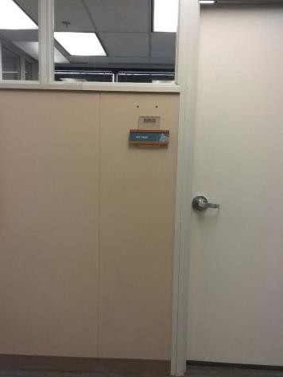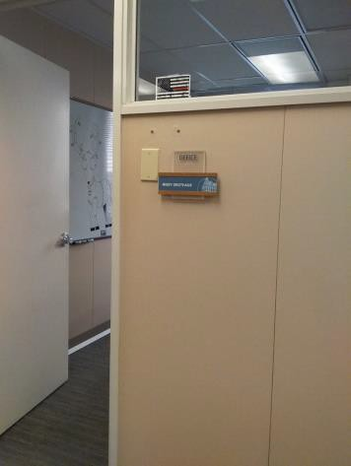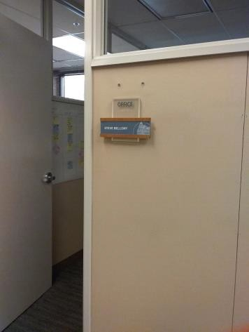

 | ID:  3097 | Facility:  City Hall

Location: Finger Print Station at the Customer Service Counter 5
Schedule: 2023
Estimated Cost: $500.00

Priority Score 8
Quick Fix: Yes
Built before ADA: Yes

VIOLATIONS
2010 ADA Standards for Accessible Design Codes: §902.3
The counter is located at 34.5" above the floor, and the finger print machine is 39" above the floor.

RECOMMENDATIONS
Lower the counter so it is located at a maximum height of 34" above the floor.
Provide a lower table for the finger printer machine to ensure a maximum height of 34" above the floor.

PHOTOGRAPH(S) OF THIS LOCATION

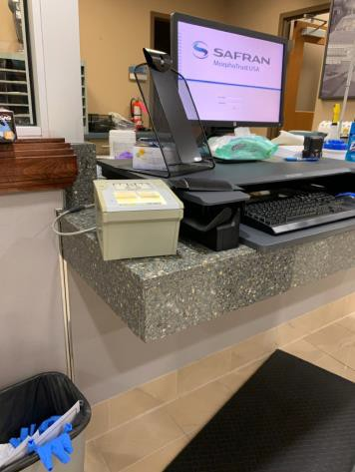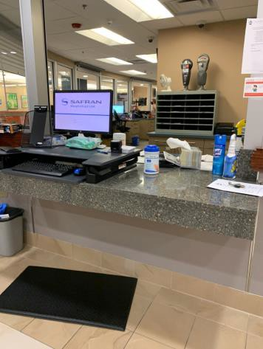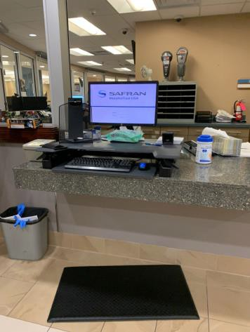

 | ID:  3969 | Facility:  City Hall

Location: Main Plaza Payment Depository
Schedule: 2023
Estimated Cost: $500.00

Priority Score 8
Quick Fix: Yes
Built before ADA: Yes

VIOLATIONS
2010 ADA Standards for Accessible Design Codes: §308.2.1
The payment depository is outside of the unobstructed forward reach range at 52" above the floor.

RECOMMENDATIONS
Lower the payment depository by at least 4" to meet the accessible reach range of 15" minimum and 48" maximum above the floor.

PHOTOGRAPH(S) OF THIS LOCATION

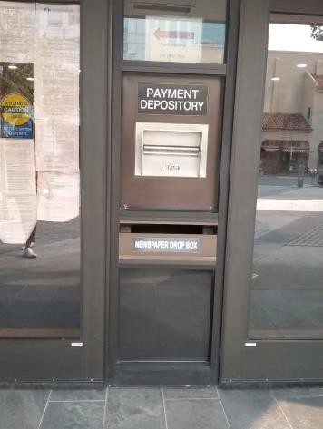

 | ID:  4051 | Facility:  City Hall

Location: Lobby Kiosk
Schedule: 2023
Estimated Cost: $500.00

Priority Score 8
Quick Fix: Yes
Built before ADA: Yes

VIOLATIONS
2010 ADA Standards for Accessible Design Codes: §308.2.2
The top two selection options are 52" above the floor.

RECOMMENDATIONS
Lower the machine by 4" to ensure the top two selection options are at a maximum height of 48" above the floor.

PHOTOGRAPH(S) OF THIS LOCATION

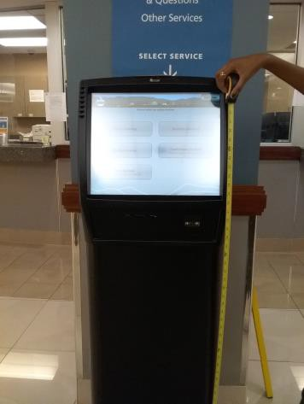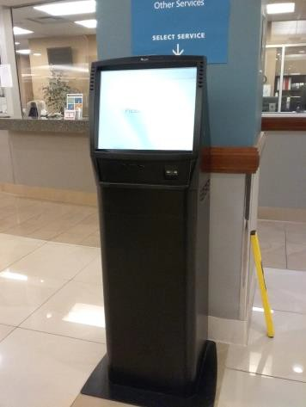

 | ID:  3831 | Facility:  City Hall

Location: 2nd Floor Housing and Community Development Women's Restroom
Schedule: 2022
Estimated Cost: $500.00

Priority Score 5
Quick Fix: Yes
Built before ADA: Yes

VIOLATIONS
2010 ADA Standards for Accessible Design Codes: §307.2
The shelf and dispenser protrude 6" into the circulation space at 42.5" above the floor.

RECOMMENDATIONS
Recess the shelf and dispenser so they protrude a maximum of 4", lower them so the bottom edge is 27" maximum above the floor, or place a cane detectable object beneath it.

PHOTOGRAPH(S) OF THIS LOCATION

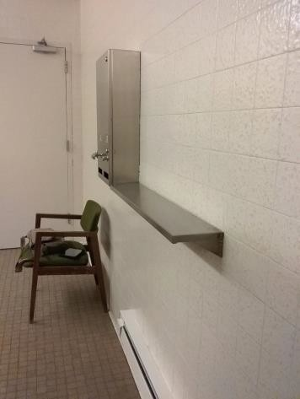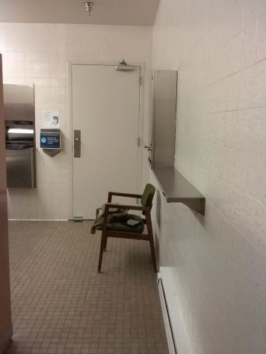

 | ID:  3890 | Facility:  City Hall

Location: 1st Floor Men's Restroom by Mini Market
Schedule: 2022
Estimated Cost: $500.00

Priority Score 5
Quick Fix: Yes
Built before ADA: Yes

VIOLATIONS
2010 ADA Standards for Accessible Design Codes: §604.6
The flush control is located on the wall side of the toilet.

RECOMMENDATIONS
Either make the toilet flush automatically or relocate the flush control to be operated on the open side of the toilet.

PHOTOGRAPH(S) OF THIS LOCATION

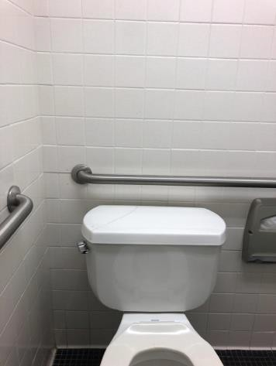

 | ID:  3926 | Facility:  City Hall

Location: 3rd Floor Map
Schedule: 2022
Estimated Cost: $500.00

Priority Score 5
Quick Fix: Yes
Built before ADA: Yes

VIOLATIONS
2010 ADA Standards for Accessible Design Codes: §307.2
The desk protrudes 8" into the circulation space.

RECOMMENDATIONS
Replace the desk's granite surface with one that has a maximum protrusion depth 4".

PHOTOGRAPH(S) OF THIS LOCATION

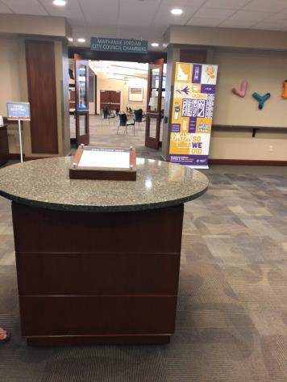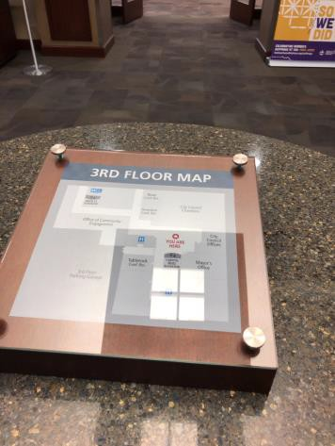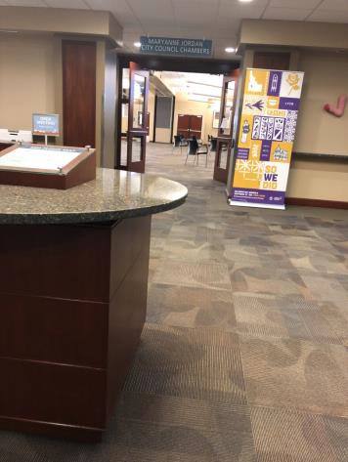

 | ID:  4008 | Facility:  City Hall

Location: 2nd Floor Housing and Community Development Women's Restroom
Schedule: 2022
Estimated Cost: $500.00

Priority Score 5
Quick Fix: Yes
Built before ADA: Yes

VIOLATIONS
2010 ADA Standards for Accessible Design Codes: §604.5.2
The rear grab bar is located 6" to the center of the toilet.

RECOMMENDATIONS
Adjust the rear grab bar so that it extends from the centerline of the water closet 12" minimum on one side and 24" minimum on the other.

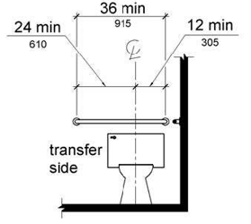

PHOTOGRAPH(S) OF THIS LOCATION

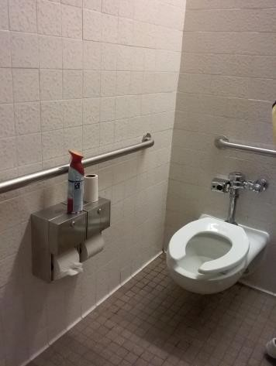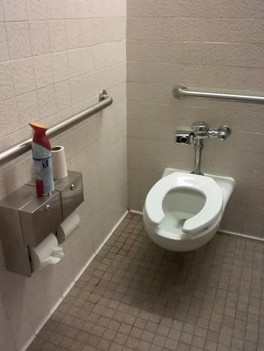

 | ID:  4335 | Facility:  City Hall

Location: 3rd Floor Men's Restroom by IT
Schedule: 2022
Estimated Cost: $500.00

Priority Score 5
Quick Fix: Yes
Built before ADA: Yes

VIOLATIONS
2010 ADA Standards for Accessible Design Codes: §604.5.1
The side grab bar is located 52" from the rear wall.

RECOMMENDATIONS
Replace the side grab bar with one that is a minimum of 42" long minimum, located 12" maximum from the rear wall and extending 54" minimum from the rear wall.

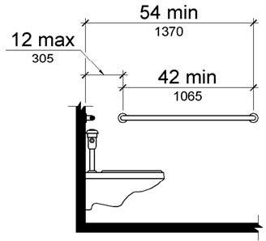

PHOTOGRAPH(S) OF THIS LOCATION

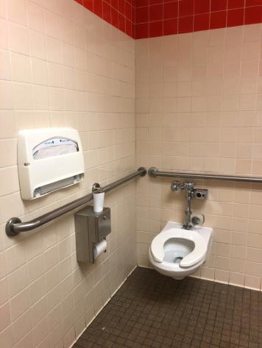

 | ID:  4336 | Facility:  City Hall

Location: 2nd Floor PDS Men's Restroom
Schedule: 2022
Estimated Cost: $500.00

Priority Score 5
Quick Fix: Yes
Built before ADA: Yes

VIOLATIONS
2010 ADA Standards for Accessible Design Codes: §604.5.2
The rear grab bar is located 52" from the side wall and is not located 12" from the centerline of the toilet to the side wall.

RECOMMENDATIONS
Relocate the rear grab bar so that it extends from the centerline of the water closet 12" minimum on one side and 24" minimum on the other.

PHOTOGRAPH(S) OF THIS LOCATION

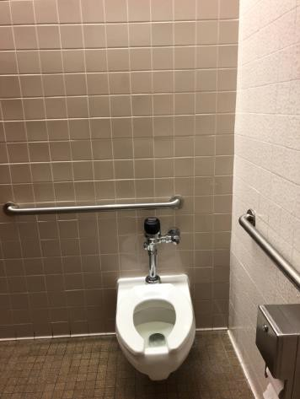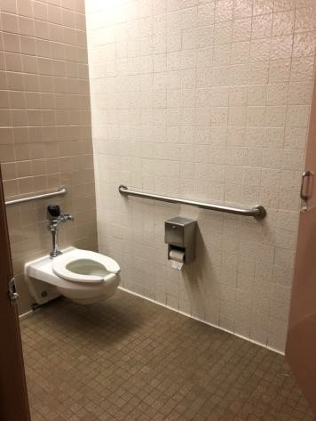

 | ID:  3847 | Facility:  City Hall

Location: 1st Floor Entrance
Schedule: 2021
Estimated Cost: $500.00

Priority Score 2
Quick Fix: Yes
Built before ADA: Yes

VIOLATIONS
2010 ADA Standards for Accessible Design Codes: §307.4
Low hanging branches are 60" high above the ground.

RECOMMENDATIONS
Trim the low hanging branches to provide a minimum vertical clearance of 80".

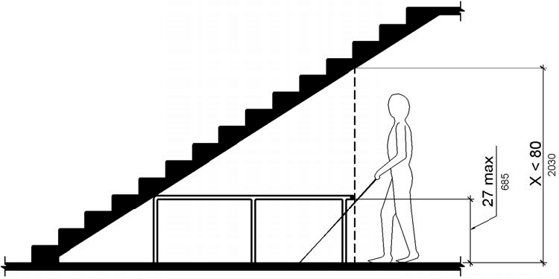

PHOTOGRAPH(S) OF THIS LOCATION

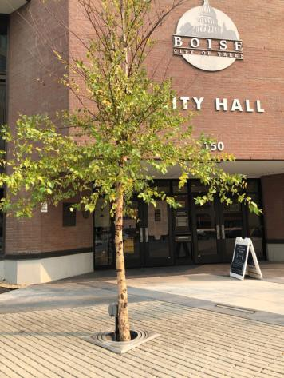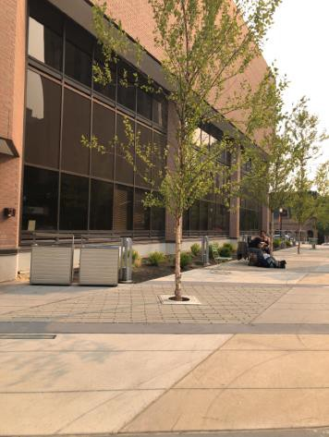

 | ID:  4006 | Facility:  City Hall

Location: 2nd Floor Housing and Community Development Women's Restroom
Schedule: 2021
Estimated Cost: $500.00

Priority Score 3
Quick Fix: Yes
Built before ADA: Yes

VIOLATIONS
2010 ADA Standards for Accessible Design Codes: §604.4
The toilet is 16.5" above the floor.

RECOMMENDATIONS
Adjust the toilet seat to comply with the minimum height of 17" and maximum of 19” above the floor measured to the top of the seat.

PHOTOGRAPH(S) OF THIS LOCATION

 | ID:  4429 | Facility:  City Hall

Location: 1st Floor Elevator
Schedule: 2021
Estimated Cost: $500.00

Priority Score 3
Quick Fix: Yes
Built before ADA: Yes

VIOLATIONS
2010 ADA Standards for Accessible Design Codes: §407.2.3.1
There is no first floor elevator door tactile star sign and the other floors have signs located at a low height.

RECOMMENDATIONS
Install a tactile sign with a tactile star on the door jambs of the main level. Reinstall elevator door jamb signage centered at 72" minimum above the floor.

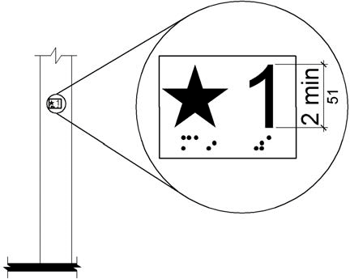

PHOTOGRAPH(S) OF THIS LOCATION

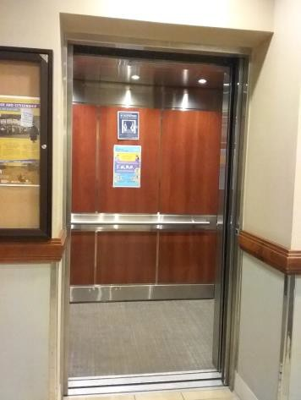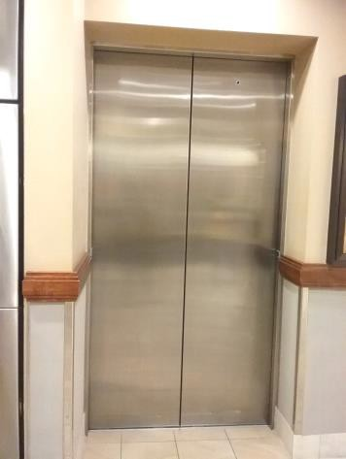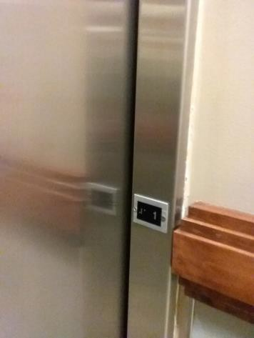

 | ID:  3938 | Facility:  City Hall

Location: Main Plaza along W Idaho Street
Schedule: 2021
Estimated Cost: $800.00

Priority Score 3
Quick Fix: No
Built before ADA: Yes

VIOLATIONS
2010 ADA Standards for Accessible Design Codes: §302.3
There are 8 planter openings 7.5" wide, posing a tripping hazard.

RECOMMENDATIONS
Fill in the openings with mulch, stone, or soil to ensure that the openings in the ground surface do not exceed 0.5".

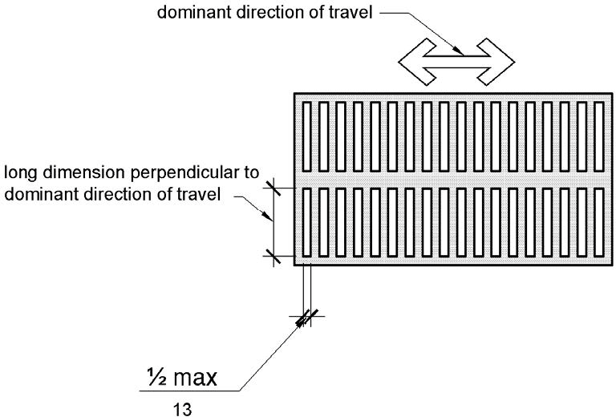

PHOTOGRAPH(S) OF THIS LOCATION

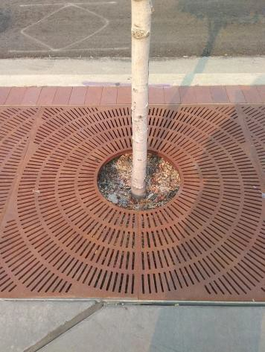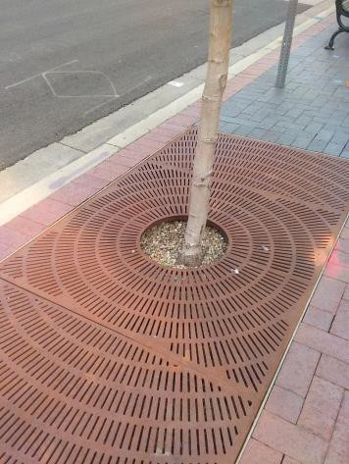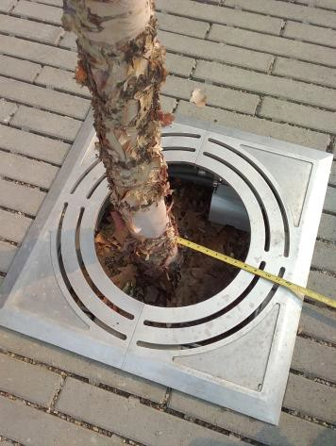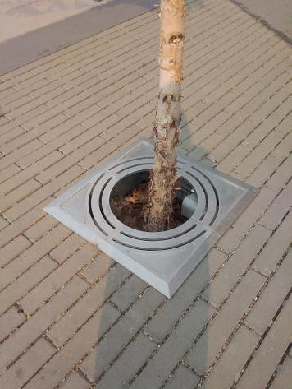

 | ID:  4207 | Facility:  City Hall

Location: Mayor's Office Part 3
Schedule: 2023
Estimated Cost: $1,000.00

Priority Score 8
Quick Fix: No
Built before ADA: Yes

VIOLATIONS
2010 ADA Standards for Accessible Design Codes: §902.3
The dining and work surface counter is 36.75" above the floor.

RECOMMENDATIONS
The dining and work surface must be no higher than 34” above the floor for a horizontal length of 36" minimum.

PHOTOGRAPH(S) OF THIS LOCATION

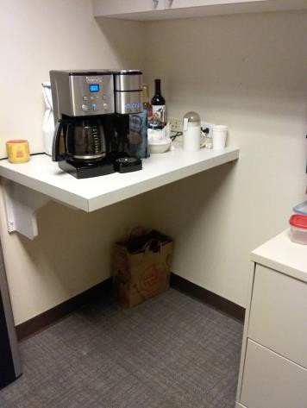

 | ID:  3491 | Facility:  City Hall

Location: Drinking Fountain
Schedule: 2022
Estimated Cost: $1,000.00

Priority Score 6
Quick Fix: No
Built before ADA: Yes

VIOLATIONS
2010 ADA Standards for Accessible Design Codes: §211.2, §602.7
There is only one drinking fountain provided at 34" above the ground.

RECOMMENDATIONS
Install an additional drinking fountain at a minimum height of 38" and maximum of 43" above the ground.

PHOTOGRAPH(S) OF THIS LOCATION

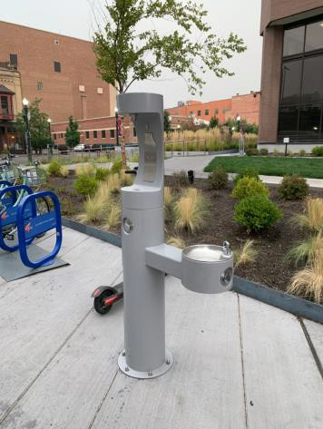

 | ID:  3803 | Facility:  City Hall

Location: Purchasing Department
Schedule: 2022
Estimated Cost: $1,000.00

Priority Score 6
Quick Fix: No
Built before ADA: Yes

VIOLATIONS
2010 ADA Standards for Accessible Design Codes: §307.2, §703.4
The tactile sign identifying the room does not have an 18"x18" clear floor space. The fire hose connector protrudes 4.75" into the circulation space.

RECOMMENDATIONS
Relocate the fire extinguisher and fire hose connector to provide an 18"x18" clear floor space in front of the sign.
Recess the fire hose connector so it protrudes a maximum of 4", or lower it so the bottom edge is 27" maximum above the floor to provide cane detectability.

PHOTOGRAPH(S) OF THIS LOCATION

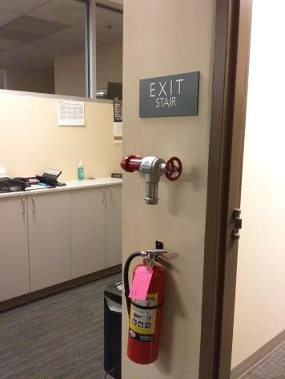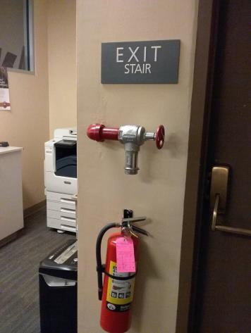

 | ID:  3814 | Facility:  City Hall

Location: 1st Floor Garage by Motor Pool
Schedule: 2022
Estimated Cost: $1,000.00

Priority Score 6
Quick Fix: No
Built before ADA: Yes

VIOLATIONS
2010 ADA Standards for Accessible Design Codes: §505.2
Handrails are located on one side, and there are no handrail extensions.

RECOMMENDATIONS
Install a second handrail on the other wall at a minimum height of 34” and maximum of 38” above the ground. Make sure there are adequate handrail extensions both at the top and bottom of the handrail.

PHOTOGRAPH(S) OF THIS LOCATION

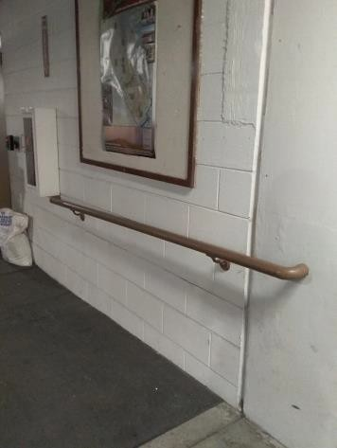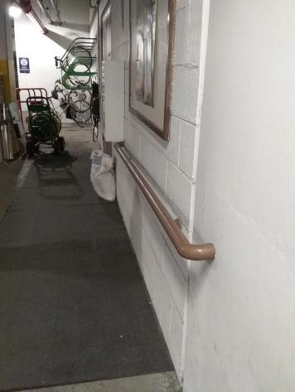

 | ID:  3828 | Facility:  City Hall

Location: 2nd Floor Housing and Community Development Lactation Room
Schedule: 2022
Estimated Cost: $1,000.00

Priority Score 5
Quick Fix: No
Built before ADA: Yes

VIOLATIONS
2010 ADA Standards for Accessible Design Codes: §306.3.3
There is no knee clearance underneath the counter.

RECOMMENDATIONS
Provide knee clearance underneath the counter at the sink that is a minimum of 11" deep at 9" above the floor and 8" deep at 27" above the floor.

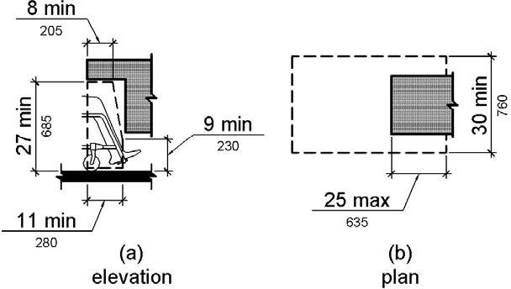

PHOTOGRAPH(S) OF THIS LOCATION

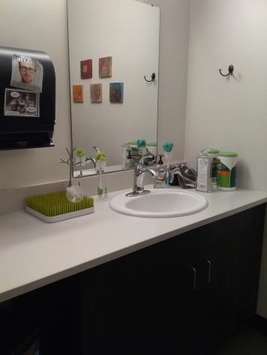

 | ID:  3832 | Facility:  City Hall

Location: 1st Floor Mail Hallway
Schedule: 2022
Estimated Cost: $1,000.00

Priority Score 6
Quick Fix: No
Built before ADA: Yes

VIOLATIONS
2010 ADA Standards for Accessible Design Codes: §211.2, §602.7
There is only one drinking fountain provided at 31.5" above the floor.

RECOMMENDATIONS
Install an additional drinking fountain with a spout height at a minimum height of 38" and maximum of 43" above the ground.

PHOTOGRAPH(S) OF THIS LOCATION

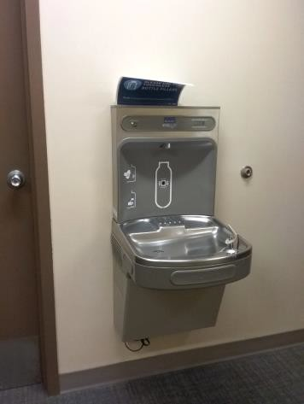

 | ID:  3833 | Facility:  City Hall

Location: 1st Floor Arts & History
Schedule: 2022
Estimated Cost: $1,000.00

Priority Score 5
Quick Fix: No
Built before ADA: Yes

VIOLATIONS
2010 ADA Standards for Accessible Design Codes: §306.3.3
There is no knee clearance underneath the sink.

RECOMMENDATIONS
Provide knee clearance for a forward approach underneath the counter at the sink that is a minimum of 11" deep at 9" above the floor and 8" deep at 27" above the floor.

PHOTOGRAPH(S) OF THIS LOCATION

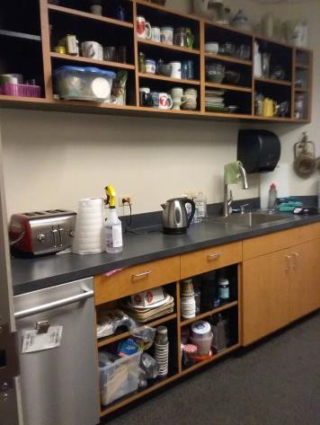

 | ID:  3841 | Facility:  City Hall

Location: 4th Floor Men's Attorney Break Room
Schedule: 2022
Estimated Cost: $1,000.00

Priority Score 5
Quick Fix: No
Built before ADA: Yes

VIOLATIONS
2010 ADA Standards for Accessible Design Codes: §306.3.3
There is no knee clearance underneath the sink.

RECOMMENDATIONS
Provide knee clearance for a forward approach underneath the counter at the sink that is a minimum of 11" deep at 9" above the floor and 8" deep at 27" above the floor.

PHOTOGRAPH(S) OF THIS LOCATION

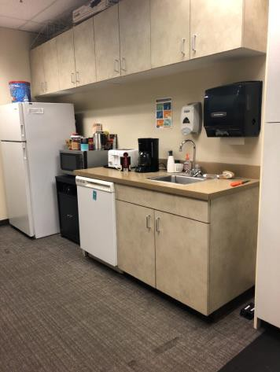

 | ID:  3842 | Facility:  City Hall

Location: Mail Room 1st Floor
Schedule: 2022
Estimated Cost: $1,000.00

Priority Score 5
Quick Fix: No
Built before ADA: Yes

VIOLATIONS
2010 ADA Standards for Accessible Design Codes: §306.3.3
There is no knee clearance underneath the sink.

RECOMMENDATIONS
Provide knee clearance for a forward approach underneath the counter at the sink that is a minimum of 11" deep at 9" above the floor and 8" deep at 27" above the floor.

PHOTOGRAPH(S) OF THIS LOCATION

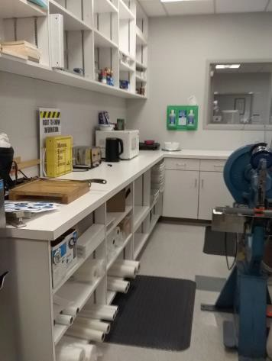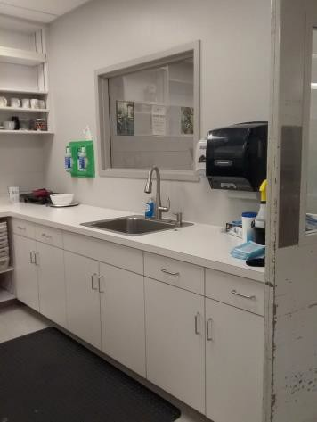

 | ID:  3845 | Facility:  City Hall

Location: 2nd Floor Men's Restroom by Bistro
Schedule: 2022
Estimated Cost: $1,000.00

Priority Score 5
Quick Fix: No
Built before ADA: Yes

VIOLATIONS
2010 ADA Standards for Accessible Design Codes: §605.2
The urinal height is at 23" above the floor.

RECOMMENDATIONS
Lower the urinal to a maximum height of 17"above the floor.

PHOTOGRAPH(S) OF THIS LOCATION

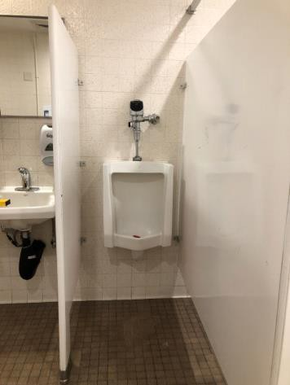

 | ID:  3848 | Facility:  City Hall

Location: HR 1st Floor
Schedule: 2022
Estimated Cost: $1,000.00

Priority Score 5
Quick Fix: No
Built before ADA: Yes

VIOLATIONS
2010 ADA Standards for Accessible Design Codes: §306.3.3
There is no knee clearance underneath the sink.

RECOMMENDATIONS
Provide knee clearance for a forward approach underneath the counter at the sink that is a minimum of 11" deep at 9" above the floor and 8" deep at 27" above the floor.

PHOTOGRAPH(S) OF THIS LOCATION

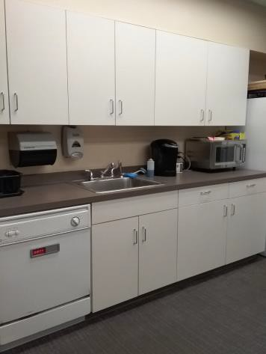

 | ID:  3852 | Facility:  City Hall

Location: 2nd Floor Engineering Men's Restroom
Schedule: 2022
Estimated Cost: $1,000.00

Priority Score 5
Quick Fix: No
Built before ADA: Yes

VIOLATIONS
2010 ADA Standards for Accessible Design Codes: ICC 604.5.1
The accessible water closet does not have a vertical grab bar.

RECOMMENDATIONS
Install an 18" long (minimum) vertical grab bar on the side wall. The grab bar shall be mounted with the bottom located at 39" minimum and 41" maximum above the floor.
The centerline of the vertical grab bar shall be located 39" minimum and 41" maximum from the real wall.

PHOTOGRAPH(S) OF THIS LOCATION

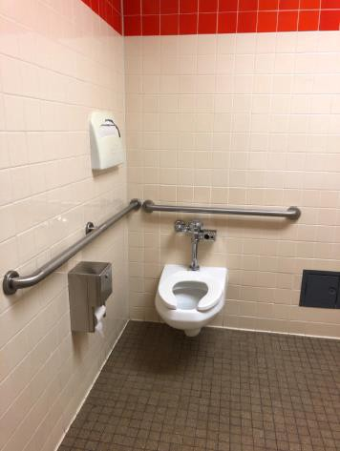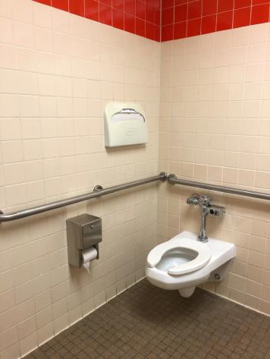

 | ID:  3853 | Facility:  City Hall

Location: 2nd Floor Engineering Men's Restroom
Schedule: 2022
Estimated Cost: $1,000.00

Priority Score 5
Quick Fix: No
Built before ADA: Yes

VIOLATIONS
2010 ADA Standards for Accessible Design Codes: §604.5.1
The side grab bar is 52" from the rear wall.

RECOMMENDATIONS
Replace the side grab bar with one that is a minimum of 42" long minimum, located 12" maximum from the rear wall and extending 54" minimum from the rear wall.

PHOTOGRAPH(S) OF THIS LOCATION

 | ID:  3855 | Facility:  City Hall

Location: 3rd Floor City Council Chambers Break Room
Schedule: 2022
Estimated Cost: $1,000.00

Priority Score 5
Quick Fix: No
Built before ADA: Yes

VIOLATIONS
2010 ADA Standards for Accessible Design Codes: §306.3.3
There is no knee clearance underneath the sink.

RECOMMENDATIONS
Provide knee clearance for a forward approach underneath the counter at the sink that is a minimum of 11" deep at 9" above the floor and 8" deep at 27" above the floor.

PHOTOGRAPH(S) OF THIS LOCATION

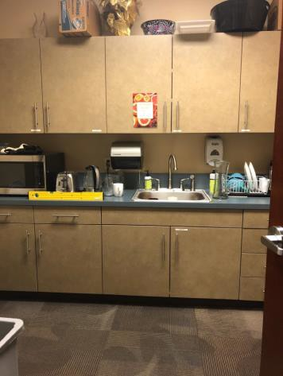

 | ID:  3864 | Facility:  City Hall

Location: 4th Floor Public Works
Schedule: 2022
Estimated Cost: $1,000.00

Priority Score 6
Quick Fix: No
Built before ADA: Yes

VIOLATIONS
2010 ADA Standards for Accessible Design Codes: §211.2, §602.7
There is only one drinking fountain provided at 34" above the floor.

RECOMMENDATIONS
Install an additional drinking fountain at a minimum height of 38" and maximum of 43" above the ground.

PHOTOGRAPH(S) OF THIS LOCATION

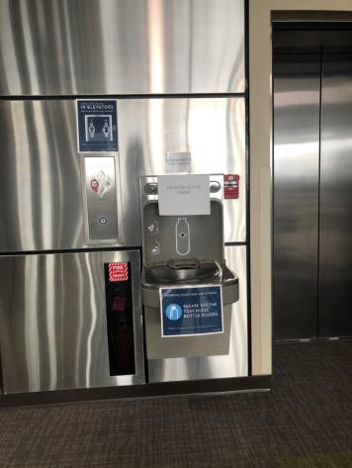

 | ID:  3874 | Facility:  City Hall

Location: 4th Floor Public Works Women's Restroom
Schedule: 2022
Estimated Cost: $1,000.00

Priority Score 5
Quick Fix: No
Built before ADA: Yes

VIOLATIONS
2010 ADA Standards for Accessible Design Codes: §604.5.1
The side grab bar extends 53.5" from the rear wall.

RECOMMENDATIONS
Replace the side grab bar with one that is a minimum of 42" long minimum, located 12" maximum from the rear wall and extending 54" minimum from the rear wall.

PHOTOGRAPH(S) OF THIS LOCATION

 | ID:  3878 | Facility:  City Hall

Location: 4th floor Men's Attorney Restroom
Schedule: 2022
Estimated Cost: $1,000.00

Priority Score 5
Quick Fix: No
Built before ADA: Yes

VIOLATIONS
2010 ADA Standards for Accessible Design Codes: ICC 604.5.1
The accessible water closet does not have a vertical grab bar.

RECOMMENDATIONS
Install an 18" long (minimum) vertical grab bar on the side wall. The grab bar shall be mounted with the bottom located at 39" minimum and 41" maximum above the floor.
The centerline of the vertical grab bar shall be located 39" minimum and 41" maximum from the real wall.

PHOTOGRAPH(S) OF THIS LOCATION

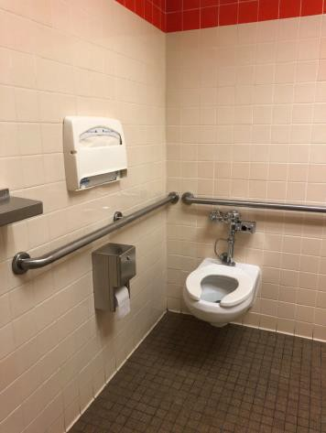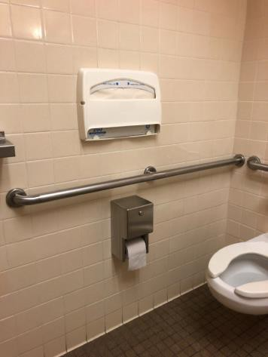

 | ID:  3878 | Facility:  City Hall

Location: 4th Floor Men's Attorney Restroom
Schedule: 2022
Estimated Cost: $1,000.00

Priority Score 5
Quick Fix: No
Built before ADA: Yes

VIOLATIONS
2010 ADA Standards for Accessible Design Codes: §604.5.1
The side grab bar is 52" from the rear wall.

RECOMMENDATIONS
Replace the side grab bar with one that is a minimum of 42" long minimum, located 12" maximum from the rear wall and extending 54" minimum from the rear wall.

PHOTOGRAPH(S) OF THIS LOCATION

 | ID:  3880 | Facility:  City Hall

Location: Lobby 1st Floor Capitol Blvd. Elevator
Schedule: 2022
Estimated Cost: $1,000.00

Priority Score 6
Quick Fix: No
Built before ADA: Yes

VIOLATIONS
2010 ADA Standards for Accessible Design Codes: §211.2, §602.7
There is only one drinking fountain provided at 34" above the floor.

RECOMMENDATIONS
Install an additional drinking fountain at a minimum height of 38" and maximum of 43" above the ground.

PHOTOGRAPH(S) OF THIS LOCATION

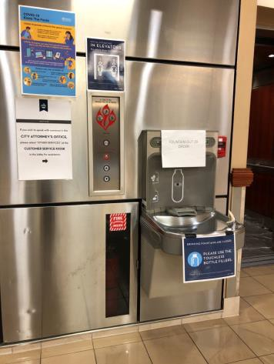

 | ID:  3947 | Facility:  City Hall

Location: 1st Floor Lobby by Main St. Elevator
Schedule: 2022
Estimated Cost: $1,000.00

Priority Score 6
Quick Fix: No
Built before ADA: Yes

VIOLATIONS
2010 ADA Standards for Accessible Design Codes: §211.2, §602.4
There is only one drinking fountain provided at 38" above the floor.

RECOMMENDATIONS
Install an additional lower drinking fountain at a maximum of 36" above the ground.

PHOTOGRAPH(S) OF THIS LOCATION

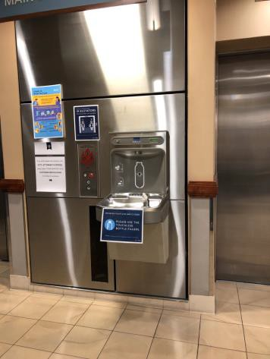

 | ID:  3977 | Facility:  City Hall

Location: Bogus Basin Conference Room
Schedule: 2022
Estimated Cost: $1,000.00

Priority Score 5
Quick Fix: No
Built before ADA: Yes

VIOLATIONS
2010 ADA Standards for Accessible Design Codes: §306.3.3
There is no knee clearance underneath the sink.

RECOMMENDATIONS
Provide knee clearance for a forward approach underneath the sink that is a minimum of 11" deep at 9" above the floor and 8" deep at 27" above the floor.

PHOTOGRAPH(S) OF THIS LOCATION

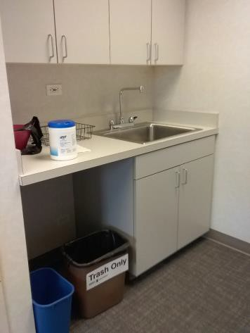

 | ID:  3992 | Facility:  City Hall

Location: 1st Floor Arts & History
Schedule: 2022
Estimated Cost: $1,000.00

Priority Score 6
Quick Fix: No
Built before ADA: Yes

VIOLATIONS
2010 ADA Standards for Accessible Design Codes: §211.2, §602.7
There is only one drinking fountain provided at a spout height of 36" above the floor.

RECOMMENDATIONS
Install an additional drinking fountain at a minimum spout height of 38" and maximum of 43" above the ground.

PHOTOGRAPH(S) OF THIS LOCATION

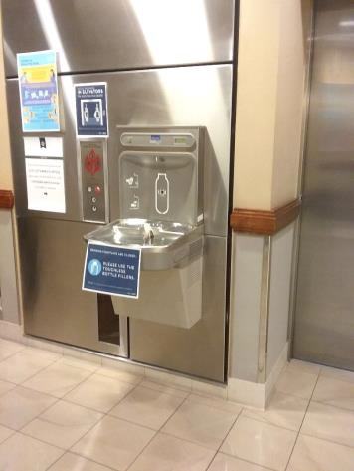

 | ID:  4083 | Facility:  City Hall

Location: 3rd Floor Council Offices
Schedule: 2022
Estimated Cost: $1,000.00

Priority Score 5
Quick Fix: No
Built before ADA: Yes

VIOLATIONS
2010 ADA Standards for Accessible Design Codes: §306.3.3
There is no knee clearance underneath the sink.

RECOMMENDATIONS
Provide knee clearance underneath the counter at the sink that is a minimum of 11" deep at 9" above the floor and 8" deep at 27" above the floor.

PHOTOGRAPH(S) OF THIS LOCATION

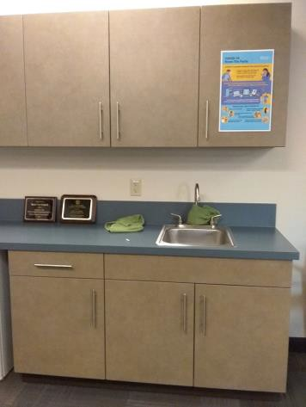

 | ID:  4103 | Facility:  City Hall

Location: 3rd Floor City Council Chambers
Schedule: 2022
Estimated Cost: $1,000.00

Priority Score 7
Quick Fix: No
Built before ADA: Yes

VIOLATIONS
2010 ADA Standards for Accessible Design Codes: §405.2
The running slope of the ramp is 8.7%.

RECOMMENDATIONS
Resurface the ramp to reduce the running slope to less than 8.3%.

PHOTOGRAPH(S) OF THIS LOCATION

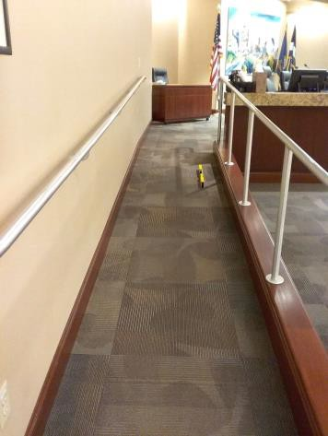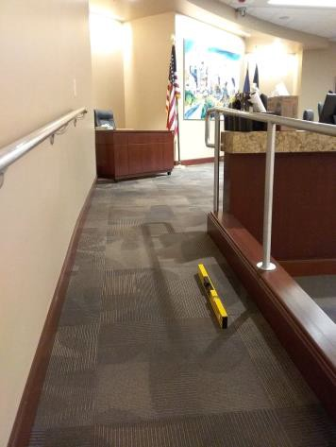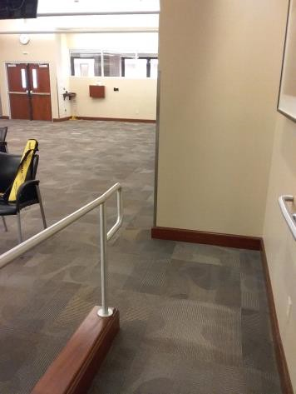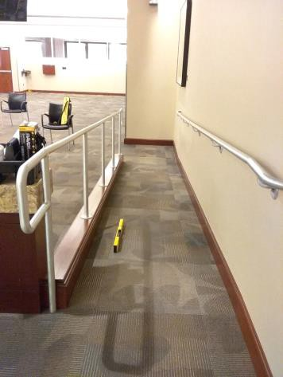

 | ID:  4143 | Facility:  City Hall

Location: 1st Floor IT
Schedule: 2022
Estimated Cost: $1,000.00

Priority Score 5
Quick Fix: No
Built before ADA: Yes

VIOLATIONS
2010 ADA Standards for Accessible Design Codes: §306.3.3
There is no knee clearance underneath the sink.

RECOMMENDATIONS
Provide knee clearance underneath the counter at the sink that is a minimum of 11" deep at 9" above the floor and 8" deep at 27" above the floor.

PHOTOGRAPH(S) OF THIS LOCATION

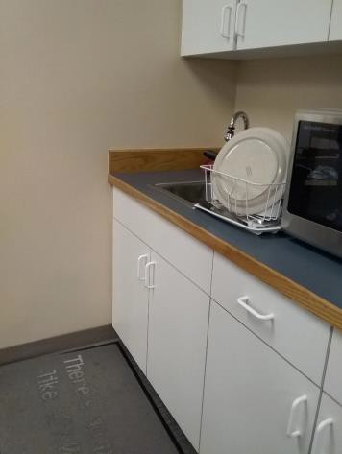

 | ID:  4158 | Facility:  City Hall

Location: Office of the Mayor
Schedule: 2022
Estimated Cost: $1,000.00

Priority Score 5
Quick Fix: No
Built before ADA: Yes

VIOLATIONS
2010 ADA Standards for Accessible Design Codes: §306.3.3
There is no knee clearance underneath the counter.

RECOMMENDATIONS
Provide knee clearance underneath the counter at the sink that is a minimum of 11" deep at 9" above the floor and 8" deep at 27" above the floor.

PHOTOGRAPH(S) OF THIS LOCATION

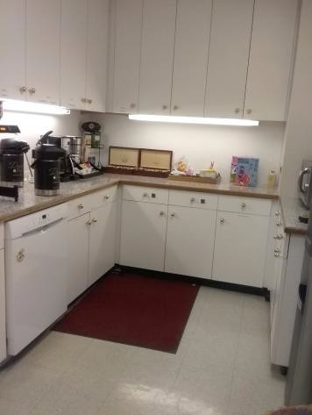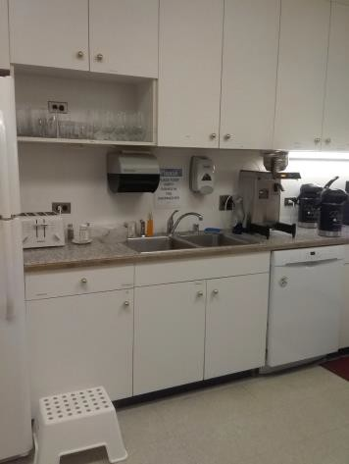

 | ID:  4172 | Facility:  City Hall

Location: Housing and Community Development
Schedule: 2022
Estimated Cost: $1,000.00

Priority Score 5
Quick Fix: No
Built before ADA: Yes

VIOLATIONS
2010 ADA Standards for Accessible Design Codes: §306.3.3
There is no knee clearance underneath the sink.

RECOMMENDATIONS
Provide knee clearance underneath the counter at the sink that is a minimum of 11" deep at 9" above the floor and 8" deep at 27" above the floor.

PHOTOGRAPH(S) OF THIS LOCATION

 | ID:  4198 | Facility:  City Hall

Location: 1st Floor Mail Hallway Women's Restroom
Schedule: 2022
Estimated Cost: $1,000.00

Priority Score 5
Quick Fix: No
Built before ADA: Yes

VIOLATIONS
2010 ADA Standards for Accessible Design Codes: §604.5.1
The side grab bar is located 53" from the rear wall.

RECOMMENDATIONS
Replace the side grab bar with one that is a minimum of 42" long minimum, located 12" maximum from the rear wall and extending 54" minimum from the rear wall.

PHOTOGRAPH(S) OF THIS LOCATION

 | ID:  4206 | Facility:  City Hall

Location: Mayor's Office Part 2
Schedule: 2022
Estimated Cost: $1,000.00

Priority Score 5
Quick Fix: No
Built before ADA: Yes

VIOLATIONS
2010 ADA Standards for Accessible Design Codes: §306.3.3
There is no knee clearance underneath the sink.
The shelf protrudes more than 4" into the circulation space.

RECOMMENDATIONS
Provide knee clearance underneath the counter at the sink that is a minimum of 11" deep at 9" above the floor and 8" deep at 27" above the floor. Lower the shelf so the bottom edge is 27" maximum above the floor, or place a cane detectable object beneath it.

PHOTOGRAPH(S) OF THIS LOCATION

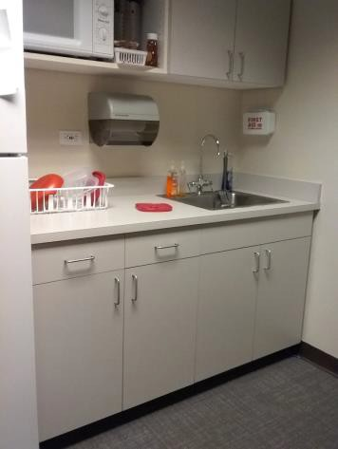

 | ID:  4211 | Facility:  City Hall

Location: 3rd Floor IT Back Kitchen
Schedule: 2022
Estimated Cost: $1,000.00

Priority Score 5
Quick Fix: No
Built before ADA: Yes

VIOLATIONS
2010 ADA Standards for Accessible Design Codes: §306.3.3
There is no knee clearance underneath the sink.

RECOMMENDATIONS
Provide knee clearance underneath the counter at the sink that is a minimum of 11" deep at 9" above the floor and 8" deep at 27" above the floor.

PHOTOGRAPH(S) OF THIS LOCATION

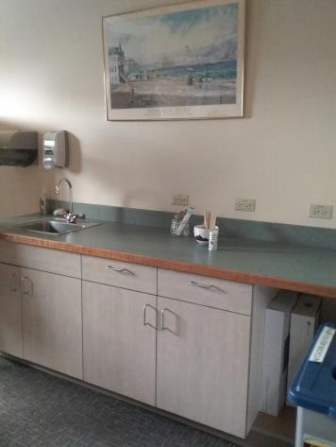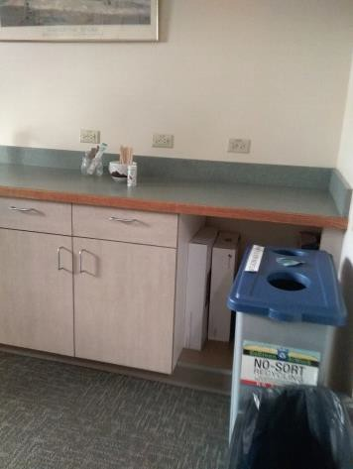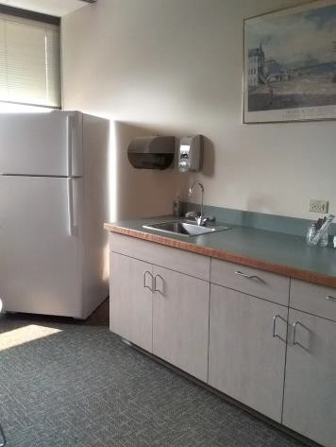

 | ID:  4219 | Facility:  City Hall

Location: 1st Floor Men's Restroom by Art Office
Schedule: 2022
Estimated Cost: $1,000.00

Priority Score 5
Quick Fix: No
Built before ADA: Yes

VIOLATIONS
2010 ADA Standards for Accessible Design Codes: ICC 604.5.1
The accessible water closet does not have a vertical grab bar.

RECOMMENDATIONS
Install an 18" long (minimum) vertical grab bar on the side wall. The grab bar shall be mounted with the bottom located at 39" minimum and 41" maximum above the floor.
The centerline of the vertical grab bar shall be located 39" minimum and 41" maximum from the real wall.

PHOTOGRAPH(S) OF THIS LOCATION

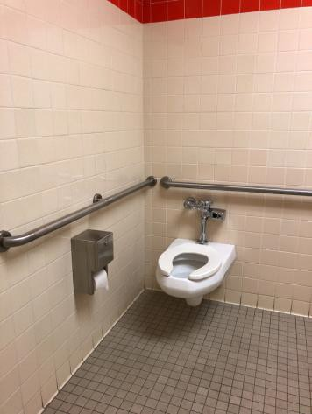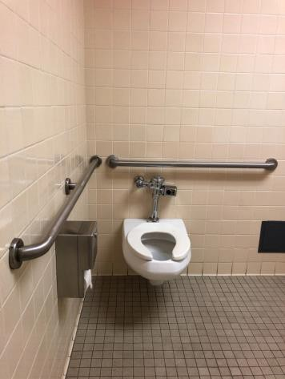

 | ID:  4220 | Facility:  City Hall

Location: 1st Floor Men's Restroom by Art Office
Schedule: 2022
Estimated Cost: $1,000.00

Priority Score 5
Quick Fix: No
Built before ADA: Yes

VIOLATIONS
2010 ADA Standards for Accessible Design Codes: §604.5.1
The side grab bar is located 52" from the rear wall.

RECOMMENDATIONS
Replace the side grab bar with one that is a minimum of 42" long minimum, located 12" maximum from the rear wall and extending 54" minimum from the rear wall.

PHOTOGRAPH(S) OF THIS LOCATION

 | ID:  4303 | Facility:  City Hall

Location: 1st Floor HR
Schedule: 2022
Estimated Cost: $1,000.00

Priority Score 6
Quick Fix: No
Built before ADA: Yes

VIOLATIONS
2010 ADA Standards for Accessible Design Codes: §505.2
Due to an 8% slope, this accessible route is considered a ramp and there are no handrails.

RECOMMENDATIONS
Install handrails at a minimum height of 34” and maximum of 38” above the ground. Make sure there are adequate handrail extensions both at the top and bottom of the handrail.

PHOTOGRAPH(S) OF THIS LOCATION

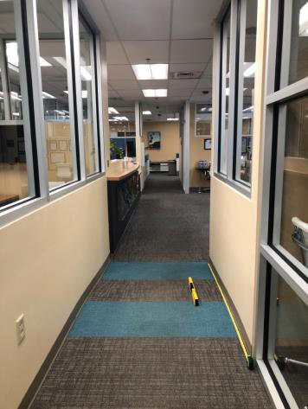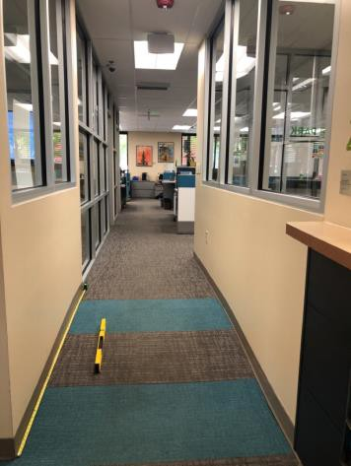

 | ID:  4326 | Facility:  City Hall

Location: Planning and Development Services
Schedule: 2022
Estimated Cost: $1,000.00

Priority Score 6
Quick Fix: No
Built before ADA: Yes

VIOLATIONS
2010 ADA Standards for Accessible Design Codes: §211.2, §602.7
There is only one drinking fountain provided at 32" above the floor.

RECOMMENDATIONS
Install an additional drinking fountain at a minimum height of 38" and maximum of 43" above the floor.

PHOTOGRAPH(S) OF THIS LOCATION

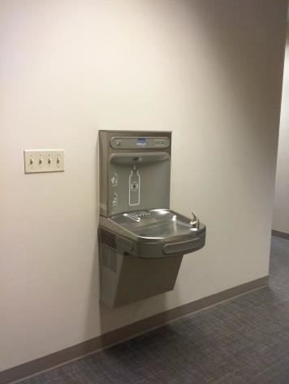

 | ID:  4334 | Facility:  City Hall

Location: 3rd Floor Men's Restroom by IT
Schedule: 2022
Estimated Cost: $1,000.00

Priority Score 5
Quick Fix: No
Built before ADA: Yes

VIOLATIONS
2010 ADA Standards for Accessible Design Codes: ICC 604.5.1
The accessible water closet does not have a vertical grab bar.

RECOMMENDATIONS
Install an 18" long (minimum) vertical grab bar on the side wall. The grab bar shall be mounted with the bottom located at 39" minimum and 41" maximum above the floor.
The centerline of the vertical grab bar shall be located 39" minimum and 41" maximum from the real wall.

PHOTOGRAPH(S) OF THIS LOCATION

 | ID:  4338 | Facility:  City Hall

Location: 2nd Floor PDS Men's Restroom
Schedule: 2022
Estimated Cost: $1,000.00

Priority Score 5
Quick Fix: No
Built before ADA: Yes

VIOLATIONS
2010 ADA Standards for Accessible Design Codes: ICC A117.1 §604.5.1
The accessible water closet does not have a vertical grab bar.

RECOMMENDATIONS
Install an 18" long (minimum) vertical grab bar on the side wall. The grab bar shall be mounted with the bottom located at 39" minimum and 41" maximum above the floor.
The centerline of the vertical grab bar shall be located 39" minimum and 41" maximum from the real wall.

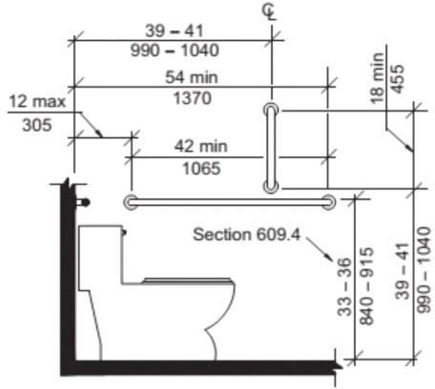

PHOTOGRAPH(S) OF THIS LOCATION

 | ID:  4343 | Facility:  City Hall

Location: 2nd Floor PDS Men's Restroom
Schedule: 2022
Estimated Cost: $1,000.00

Priority Score 5
Quick Fix: No
Built before ADA: Yes

VIOLATIONS
2010 ADA Standards for Accessible Design Codes: §604.4
The toilet is 16" above the ground.

RECOMMENDATIONS
Adjust the toilet seat to comply with the minimum height of 17" and maximum of 19” above the ground measured to the top of the seat.

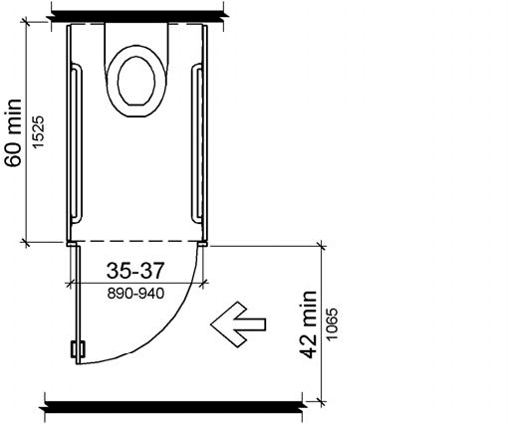

PHOTOGRAPH(S) OF THIS LOCATION

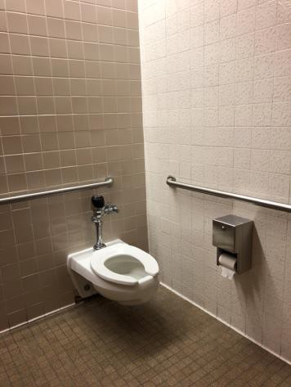

 | ID:  4351 | Facility:  City Hall

Location: 4th Floor Public Works Break Room
Schedule: 2022
Estimated Cost: $1,000.00

Priority Score 5
Quick Fix: No
Built before ADA: Yes

VIOLATIONS
2010 ADA Standards for Accessible Design Codes: §306.3.3
There is no knee clearance underneath the sink.

RECOMMENDATIONS
Provide knee clearance underneath the sink that is a minimum of 11" deep at 9" above the floor and 8" deep at 27" above the floor.

PHOTOGRAPH(S) OF THIS LOCATION

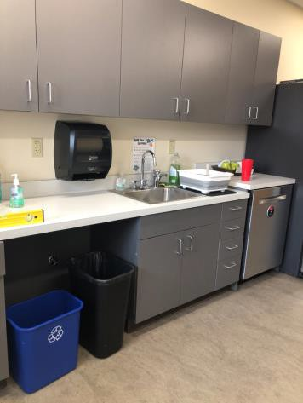

 | ID:  4364 | Facility:  City Hall

Location: Main Lobby
Schedule: 2022
Estimated Cost: $1,000.00

Priority Score 6
Quick Fix: No
Built before ADA: Yes

VIOLATIONS
2010 ADA Standards for Accessible Design Codes: §211.2, §602.7
There is only one drinking fountain provided at 36" above the floor.

RECOMMENDATIONS
Install an additional drinking fountain at a minimum height of 38" and maximum of 43" above the floor.

PHOTOGRAPH(S) OF THIS LOCATION

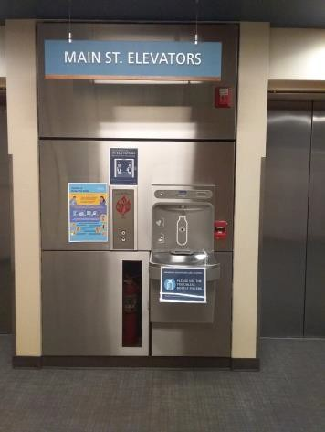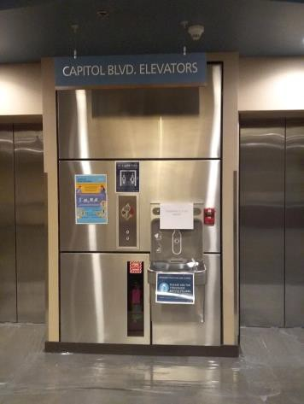

 | ID:  4372 | Facility:  City Hall

Location: 4th Floor Office of the City Attorney
Schedule: 2022
Estimated Cost: $1,000.00

Priority Score 6
Quick Fix: No
Built before ADA: Yes

VIOLATIONS
2010 ADA Standards for Accessible Design Codes: §211.2, §602.7
There is only one drinking fountain provided at 34.75" above the floor.

RECOMMENDATIONS
Install an additional drinking fountain at a minimum height of 38" and maximum of 43" above the floor.

PHOTOGRAPH(S) OF THIS LOCATION

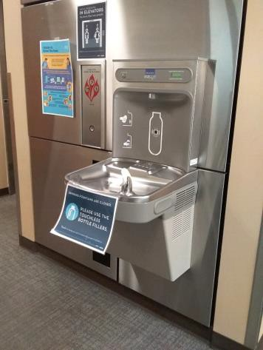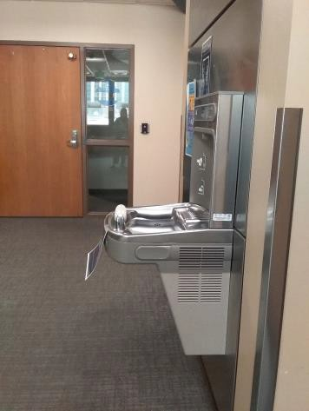

 | ID:  4408 | Facility:  City Hall

Location: 3rd Floor IT Break Room
Schedule: 2022
Estimated Cost: $1,000.00

Priority Score 5
Quick Fix: No
Built before ADA: Yes

VIOLATIONS
2010 ADA Standards for Accessible Design Codes: §306.3.3
There is no knee clearance underneath the sink.

RECOMMENDATIONS
Provide knee clearance underneath the counter at the sink that is a minimum of 11" deep at 9" above the floor and 8" deep at 27" above the floor.

PHOTOGRAPH(S) OF THIS LOCATION

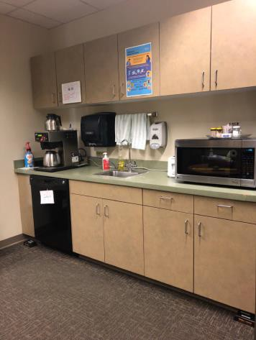

 | ID:  4414 | Facility:  City Hall

Location: 3rd Floor IT Women's Restroom
Schedule: 2022
Estimated Cost: $1,000.00

Priority Score 5
Quick Fix: No
Built before ADA: Yes

VIOLATIONS
2010 ADA Standards for Accessible Design Codes: §604.5.1
The side grab bar is located 51.5" from the rear wall.

RECOMMENDATIONS
Replace the side grab bar with one that is a minimum of 42" long minimum, located 12" maximum from the rear wall and extending 54" minimum from the rear wall.

PHOTOGRAPH(S) OF THIS LOCATION

 | ID:  4423 | Facility:  City Hall

Location: Art and History Women's Restroom
Schedule: 2022
Estimated Cost: $1,000.00

Priority Score 5
Quick Fix: No
Built before ADA: Yes

VIOLATIONS
2010 ADA Standards for Accessible Design Codes: §604.5.1
The side grab bar is located 52.5" from the rear wall.

RECOMMENDATIONS
Replace the side grab bar with one that is a minimum of 42" long minimum, located 12" maximum from the rear wall and extending 54" minimum from the rear wall.

PHOTOGRAPH(S) OF THIS LOCATION

 | ID:  4425 | Facility:  City Hall

Location: Art and History Women's Restroom
Schedule: 2022
Estimated Cost: $1,000.00

Priority Score 5
Quick Fix: No
Built before ADA: Yes

VIOLATIONS
2010 ADA Standards for Accessible Design Codes: §604.2
The toilet is located 19" from the sidewall.

RECOMMENDATIONS
Reposition the toilet to be within 16" minimum and 18" maximum from the sidewall.

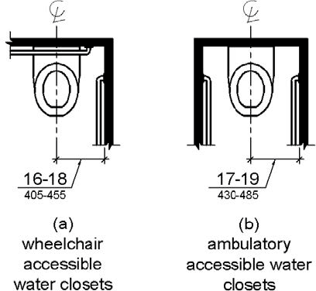

PHOTOGRAPH(S) OF THIS LOCATION

 | ID:  3390 | Facility:  City Hall

Location: 2nd Floor PDS Garage
Schedule: 2021
Estimated Cost: $1,000.00

Priority Score 3
Quick Fix: No
Built before ADA: Yes

VIOLATIONS
2010 ADA Standards for Accessible Design Codes: §404.2.4.4
The entrance from the garage has a 2.5% slope.

RECOMMENDATIONS
Resurface the entryway to reduce the running slope to a maximum of 2% in all directions.

PHOTOGRAPH(S) OF THIS LOCATION

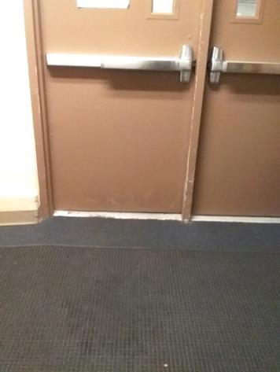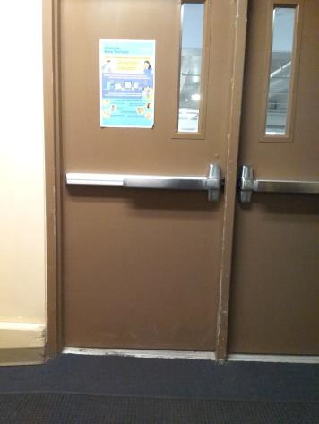

 | ID:  4294 | Facility:  City Hall

Location: 1st Floor Garage
Schedule: 2021
Estimated Cost: $1,000.00

Priority Score 3
Quick Fix: No
Built before ADA: Yes

VIOLATIONS
2010 ADA Standards for Accessible Design Codes: §403.3, §505.2
The walking surface has a running slope of 8.5%.

RECOMMENDATIONS
Resurface the route to reduce the running slope to a maximum slope of 8.3%.

PHOTOGRAPH(S) OF THIS LOCATION

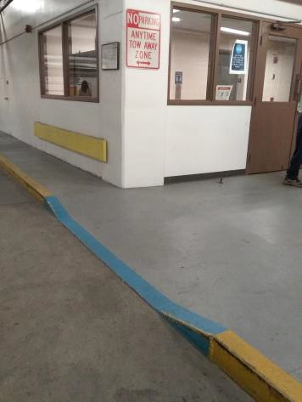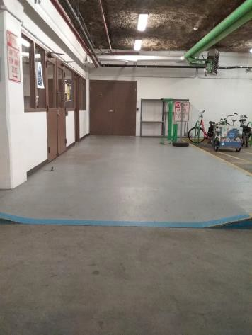

 | ID:  4367 | Facility:  City Hall

Location: Purchasing Department
Schedule: 2021
Estimated Cost: $1,000.00

Priority Score 4
Quick Fix: No
Built before ADA: Yes

VIOLATIONS
2010 ADA Standards for Accessible Design Codes: §904.4.1
The purchasing department counter height is 49" above the ground.

RECOMMENDATIONS
A portion of the service counter must be no higher than 36” above the ground for a horizontal distance of 36”.

PHOTOGRAPH(S) OF THIS LOCATION

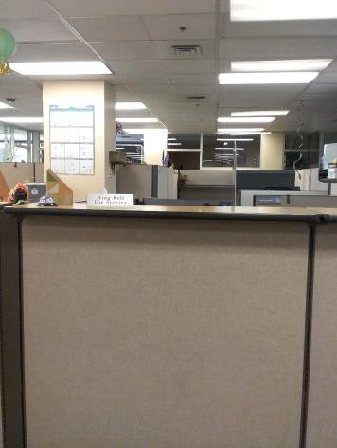
 | ID:  4395 | Facility:  City Hall

Location: W Idaho Street
Schedule: 2021
Estimated Cost: $1,000.00

Priority Score 3
Quick Fix: No
Built before ADA: Yes

VIOLATIONS
2010 ADA Standards for Accessible Design Codes: §404.2.4.4
The entrance on west Idaho Street has a 2.6% slope.

RECOMMENDATIONS
Resurface the entryway to reduce the running slope to a maximum of 2% in all directions. Ensure that the maneuvering clearance is 60" minimum.

PHOTOGRAPH(S) OF THIS LOCATION

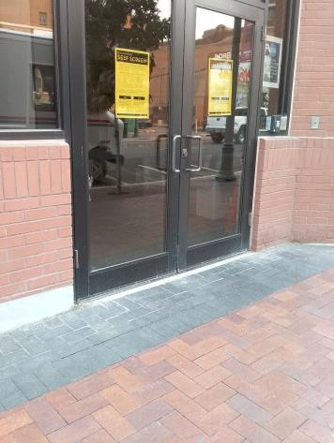

 | ID:  3925 | Facility:  City Hall

Location: 3rd Floor Map
Schedule: 2020
Estimated Cost: $1,000.00

Priority Score 0
Quick Fix: No
Built before ADA: Yes

VIOLATIONS
2010 ADA Standards for Accessible Design Codes: §904.4.1
The table height is at 36" and the map is at 39" above the floor. The map is flat on the table so that a person using a wheelchair wouldn’t be able to read it.

RECOMMENDATIONS
Reinstall the map in a vertical orientation to ensure that it is readable by a person using a wheelchair.

PHOTOGRAPH(S) OF THIS LOCATION

 | ID:  4230 | Facility:  City Hall

Location: Entire Facility
Schedule: 2022
Estimated Cost: $1,200.00

Priority Score 7
Quick Fix: No
Built before ADA: Yes

VIOLATIONS
2010 ADA Standards for Accessible Design Codes: §309.4
There are approximately 12 door knobs that require twisting of the wrist.

RECOMMENDATIONS
Replace the door knobs with a lever handle that can be operated with a closed fist and without twisting the wrist.

PHOTOGRAPH(S) OF THIS LOCATION

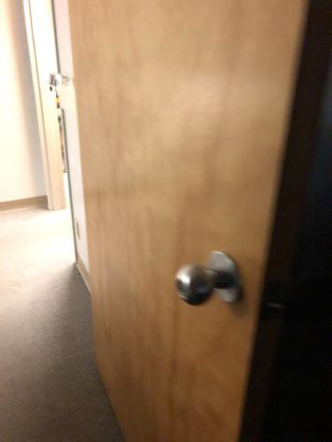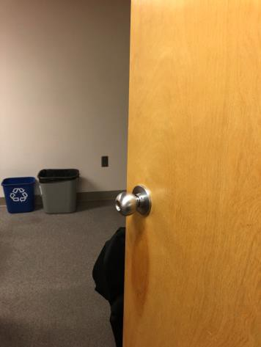

 | ID:  4303 | Facility:  City Hall

Location: 1st Floor Arts & History
Schedule: 2023
Estimated Cost: $1,500.00

Priority Score 8
Quick Fix: No
Built before ADA: Yes

VIOLATIONS
2010 ADA Standards for Accessible Design Codes: §902.3, §306.3.3
The work surface/sink counter height is at 36" above the floor, exceeding the maximum height of 34" above the floor.

RECOMMENDATIONS
The dining and work surface must be no higher than 34” above the floor for a minimum width of 36".
Provide knee clearance for a forward approach under the sink that is a minimum of 11" deep at 9" above the floor and 8" deep at 27" above the floor.

PHOTOGRAPH(S) OF THIS LOCATION

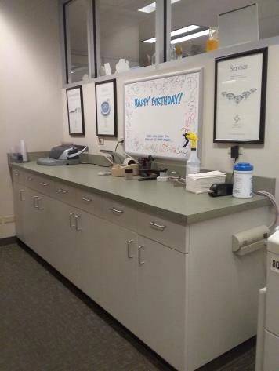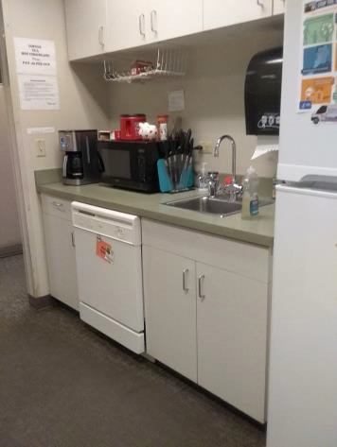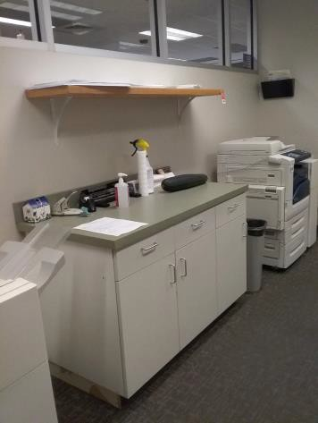

 | ID:  4398 | Facility:  City Hall

Location: 2nd Floor Garage North Space 222
Schedule: 2023
Estimated Cost: $1,500.00

Priority Score 3
Quick Fix: No
Built before ADA: Yes

VIOLATIONS
2010 ADA Standards for Accessible Design Codes: §216.5
There is no parking sign identifying the accessible parking space.
There are a total of 192 parking spaces, two accessible spaces, and zero van accessible spaces.

RECOMMENDATIONS
Remount the accessible parking signs to ensure 60" minimum height from the ground. Paint three additional accessible parking spaces and one van accessible space.

PHOTOGRAPH(S) OF THIS LOCATION

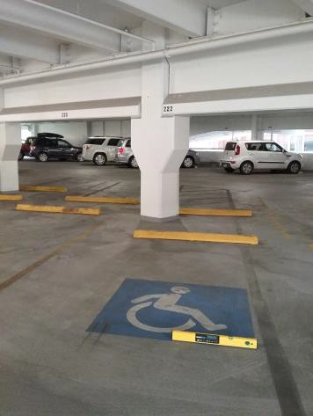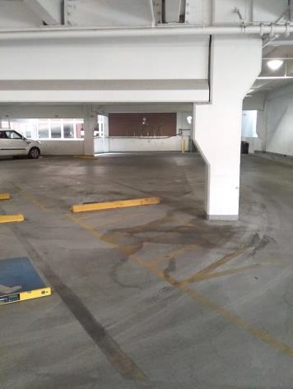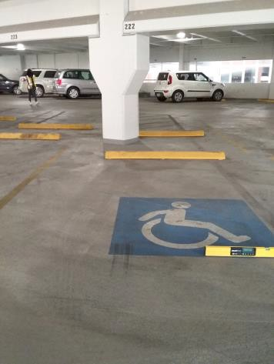

 | ID:  4087 | Facility:  City Hall

Location: 2nd Floor Housing and Community Development Wellness Alley
Schedule: 2023
Estimated Cost: $2,000.00

Priority Score 8
Quick Fix: No
Built before ADA: Yes

VIOLATIONS
2010 ADA Standards for Accessible Design Codes: §902.3, §306.3.3
The counter surface and sink height is at 36" above the floor, exceeding the maximum height of 34" above the ground.

RECOMMENDATIONS
The counter surface must be no higher than 34” above the ground for a minimum width of 36".
Provide knee clearance underneath the counter at the sink that is a minimum of 11" deep at 9" above the floor and 8" deep at 27" above the floor.

PHOTOGRAPH(S) OF THIS LOCATION

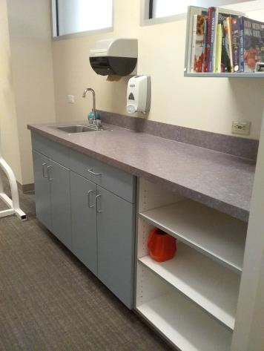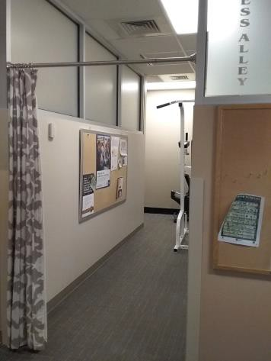

 | ID:  3824 | Facility:  City Hall

Location: 5th Floor Office of the City Attorney Women's Restroom
Schedule: 2022
Estimated Cost: $2,000.00

Priority Score 5
Quick Fix: No
Built before ADA: Yes

VIOLATIONS
2010 ADA Standards for Accessible Design Codes: §604.5.1, ICC/ANSI 604.5.1
The side grab bar is located 51.5" from the rear wall.
The accessible water closet does not have a vertical grab bar.

RECOMMENDATIONS
Replace the side grab bar with one that is a minimum of 42" long minimum, located 12" maximum from the rear wall and extending 54" minimum from the rear wall.
Install an 18" long (minimum) vertical grab bar on the side wall. The grab bar shall be mounted with the bottom located at 39" minimum and 41" maximum above the floor.

PHOTOGRAPH(S) OF THIS LOCATION

 | ID:  3860 | Facility:  City Hall

Location: 1st Floor Men's Restroom
Schedule: 2022
Estimated Cost: $2,000.00

Priority Score 5
Quick Fix: No
Built before ADA: Yes

VIOLATIONS
2010 ADA Standards for Accessible Design Codes: §604.5.1, ICC/ANSI 604.5.1
The accessible water closet does not have a vertical grab bar. The side grab bar is 52" from the rear wall.

RECOMMENDATIONS
Install an 18" long minimum vertical grab bar, with the bottom located at 39" minimum and 41" maximum above the floor. The centerline shall be located 39" minimum and 41" maximum from the real wall.
Replace the side grab bar with one that is a minimum of 42" long minimum, located 12" maximum from the rear wall and extending 54" minimum from the rear wall.

PHOTOGRAPH(S) OF THIS LOCATION

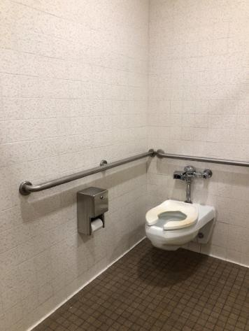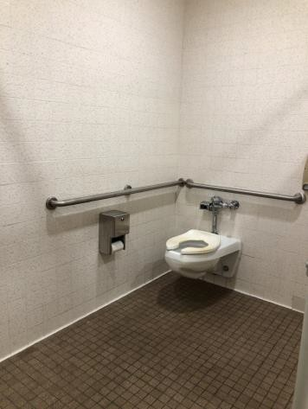

 | ID:  3978 | Facility:  City Hall

Location: 3rd Floor Mayors Supply Room
Schedule: 2022
Estimated Cost: $2,000.00

Priority Score 5
Quick Fix: No
Built before ADA: Yes

VIOLATIONS
2010 ADA Standards for Accessible Design Codes: §306.3.3, §902.3
The dining and work surface counter is 36" above the floor. There is no knee clearance underneath the sink.

RECOMMENDATIONS
A portion of the dining and work surface must be no higher than 34” above the floor.
Provide knee clearance for a forward approach underneath the counter at the sink that is a minimum of 11" deep at 9" above the floor and 8" deep at 27" above the floor.

PHOTOGRAPH(S) OF THIS LOCATION

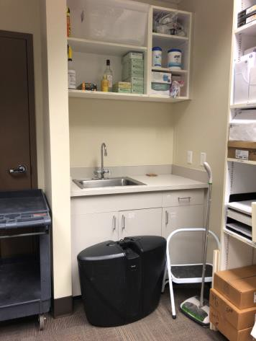
 | ID:  4224 | Facility:  City Hall

Location: 1st Floor Mail Hallway Women's Restroom
Schedule: 2022
Estimated Cost: $2,000.00

Priority Score 5
Quick Fix: No
Built before ADA: Yes

VIOLATIONS
2010 ADA Standards for Accessible Design Codes: §403.5.1
The accessible route to the showers is 33" wide.

RECOMMENDATIONS
Widen the accessible route to 36" wide and allow for a turning space of 60"x60".

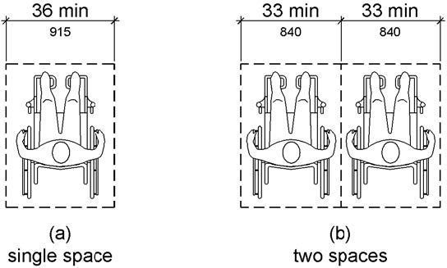

PHOTOGRAPH(S) OF THIS LOCATION

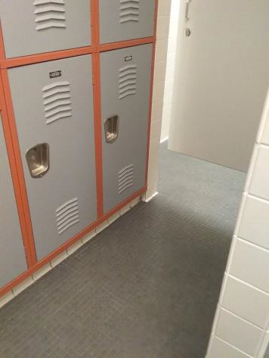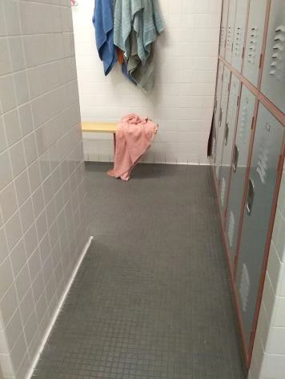

 | ID:  4250 | Facility:  City Hall

Location: 2nd Floor Housing and Community Development Women's Restroom
Schedule: 2022
Estimated Cost: $2,000.00

Priority Score 5
Quick Fix: No
Built before ADA: Yes

VIOLATIONS
2010 ADA Standards for Accessible Design Codes: §604.5.1
The side grab bars are located 52" from the rear wall.

RECOMMENDATIONS
Replace the side grab bars with ones that are a minimum of 42" long, located 12" maximum from the rear wall and extending 54" minimum from the rear wall.

PHOTOGRAPH(S) OF THIS LOCATION

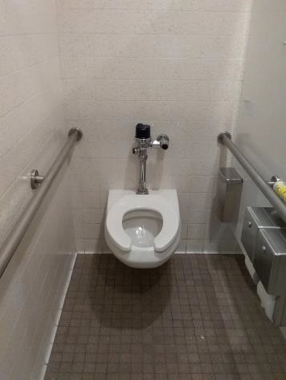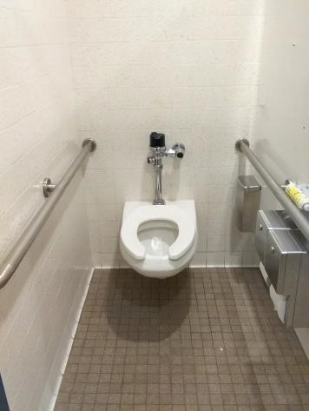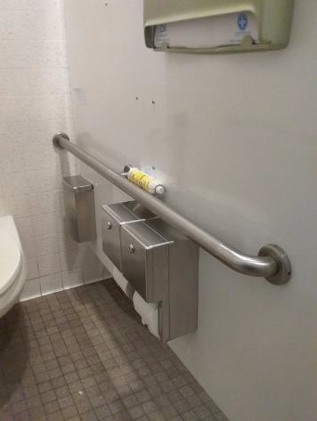

 | ID:  3915 | Facility:  City Hall

Location: 2nd Floor Public Works Engineering
Schedule: 2021
Estimated Cost: $2,000.00

Priority Score 4
Quick Fix: No
Built before ADA: Yes

VIOLATIONS
2010 ADA Standards for Accessible Design Codes: §904.4.1
The counter height is at 38" above the floor, exceeding the maximum height of 36" above the ground.

RECOMMENDATIONS
A portion of the service counter must be no higher than 36” above the ground for a horizontal distance of 36”.

PHOTOGRAPH(S) OF THIS LOCATION

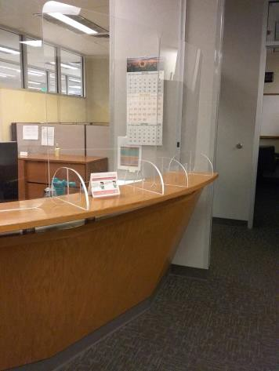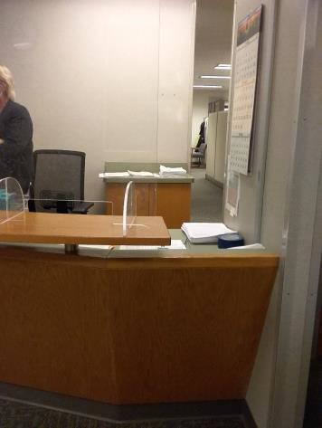

 | ID:  4311 | Facility:  City Hall

Location: Main Street Entrance
Schedule: 2021
Estimated Cost: $2,000.00

Priority Score 3
Quick Fix: No
Built before ADA: Yes

VIOLATIONS
2010 ADA Standards for Accessible Design Codes: §404.2.4.1
At the entrance doors, there is a 48" leveled maneuvering clearance. Beyond that, the concrete has a slope exceeding 2%.

RECOMMENDATIONS
Repave the area in front of the entrance to provide a 60" minimum maneuvering clearance with a maximum slope of 2%.
Ensure that the 30"x48" clear floor space in front of the push button has a maximum slope of 2%.

PHOTOGRAPH(S) OF THIS LOCATION

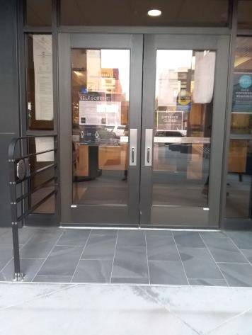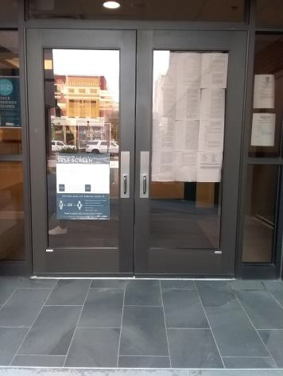

 | ID:  4400 | Facility:  City Hall

Location: 2nd Floor Garage North Space 222
Schedule: 2021
Estimated Cost: $2,000.00

Priority Score 3
Quick Fix: No
Built before ADA: Yes

VIOLATIONS
2010 ADA Standards for Accessible Design Codes: §502.5
There are beams in the accessible parking space reducing the vertical clearance to 76".

RECOMMENDATIONS
Relocate the accessible parking space to the back corner to allow the accessible route to not conflict with the traffic coming up the ramp. Ensure that there is a minimum vertical clearance of 98”.
Since the garage does not have an elevator, ensure that the accessible parking space is located on the shortest accessible route from parking to an accessible entrance.

PHOTOGRAPH(S) OF THIS LOCATION

 | ID:  4457 | Facility:  City Hall

Location: Entrance on Idaho St
Schedule: 2021
Estimated Cost: $2,000.00

Priority Score 3
Quick Fix: No
Built before ADA: Yes

VIOLATIONS
2010 ADA Standards for Accessible Design Codes: §404.2.4.4
The entrance on Idaho Street next to the Human Resources main entrance has a 4% slope.

RECOMMENDATIONS
Resurface the entryway to provide a maneuvering clearance with a maximum running slope of 2% in all directions.
Ensure that the maneuvering clearance is 60" minimum.

PHOTOGRAPH(S) OF THIS LOCATION

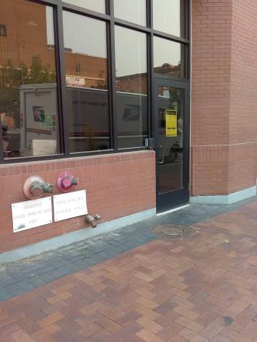

 | ID:  4050 | Facility:  City Hall

Location: Lobby Kiosk
Schedule: 2023
Estimated Cost: $3,000.00

Priority Score 8
Quick Fix: No
Built before ADA: Yes

VIOLATIONS
2010 ADA Standards for Accessible Design Codes: §707
The interactive touch screen does not have any sound or tactile components. Therefore, a visually impaired person would not be able to access the information provided by the kiosk.

RECOMMENDATIONS
Audio instructions must be provided that guide the user through all functions of the machine. Tactile instructions must be provided informing the user on the method of activating the audio instructions.
Controls to operate the kiosk must meet the requirements of §707.

PHOTOGRAPH(S) OF THIS LOCATION

 | ID:  4137 | Facility:  City Hall

Location: 1st Floor Micro Market
Schedule: 2023
Estimated Cost: $3,000.00

Priority Score 8
Quick Fix: No
Built before ADA: Yes

VIOLATIONS
2010 ADA Standards for Accessible Design Codes: §707
The interactive touch screen does not have any sound or tactile components. Therefore, a visually impaired person would not be able to access the information provided by the kiosk.

RECOMMENDATIONS
Audio instructions must be provided that guide the user through all functions of the machine. Tactile instructions must be provided informing the user on the method of activating the audio instructions.
Controls to operate the kiosk must meet the requirements of §707.

PHOTOGRAPH(S) OF THIS LOCATION

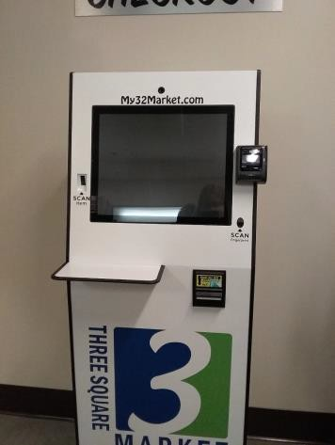

 | ID: | Facility:  City Hall

Location: 3rd Floor Main Street Elevators
Schedule: 2023
Estimated Cost: $3,000.00

Priority Score 8
Quick Fix: No
Built before ADA: Yes

VIOLATIONS
2010 ADA Standards for Accessible Design Codes: §308.2
The vending machine controls are 51" above the floor.

RECOMMENDATIONS
Replace the vending machine with one that has controls located within the accessible reach range of 15" minimum and 48" maximum above the floor.

PHOTOGRAPH(S) OF THIS LOCATION

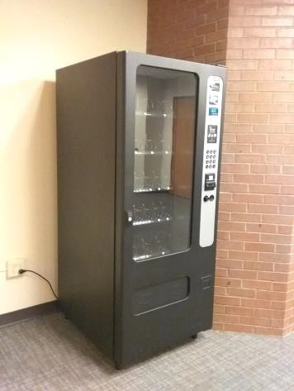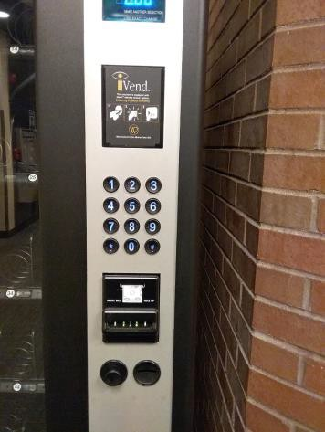

 | ID:  4116 | Facility:  City Hall

Location: 1st Floor Men's Restroom by Mini Market
Schedule: 2022
Estimated Cost: $5,000.00

Priority Score 6
Quick Fix: No
Built before ADA: Yes

VIOLATIONS
2010 ADA Standards for Accessible Design Codes: §213.3.6
There is a 6" step at the shower entrance.

RECOMMENDATIONS
Install at least one accessible shower complying with §607 or §608.

PHOTOGRAPH(S) OF THIS LOCATION

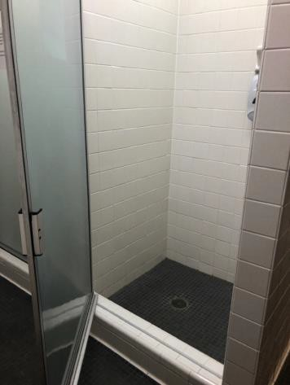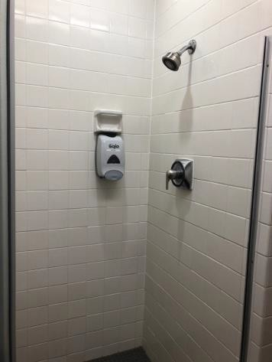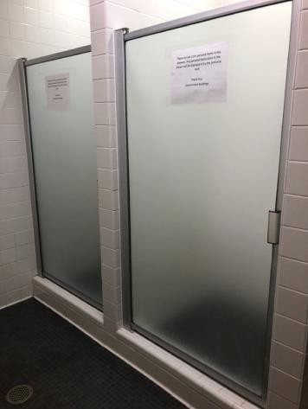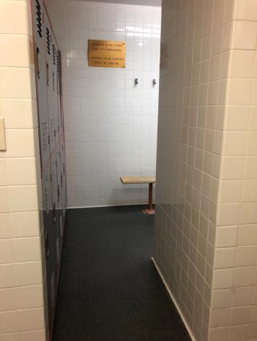

 | ID:  4124 | Facility:  City Hall

Location: 2nd Floor Men's Restroom by Bistro
Schedule: 2022
Estimated Cost: $5,000.00

Priority Score 7
Quick Fix: No
Built before ADA: Yes

VIOLATIONS
2010 ADA Standards for Accessible Design Codes: §604.8.1.1
The toilet compartment size is too small.

RECOMMENDATIONS
Combine the two non-accessible stalls into one 60" wide wheelchair accessible toilet stall, complying with §604.8.

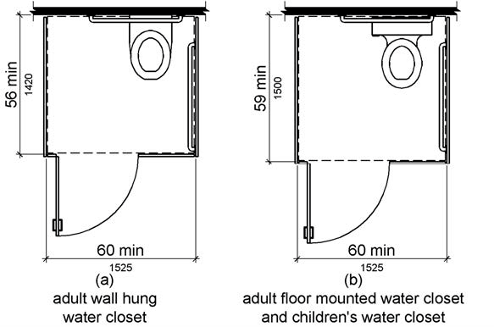

PHOTOGRAPH(S) OF THIS LOCATION

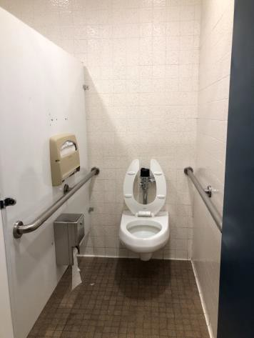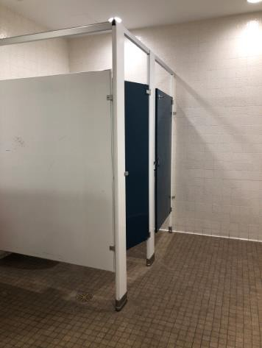

 | ID:  4052 | Facility:  City Hall

Location: 3rd Floor Garage
Schedule: 2021
Estimated Cost: $5,000.00

Priority Score 1
Quick Fix: No
Built before ADA: Yes

VIOLATIONS
2010 ADA Standards for Accessible Design Codes: §405.3
The ramp has a 3.1% cross slope.

RECOMMENDATIONS
Reconstruct the ramp to have a cross slope of 2% or less. Ensure that the maximum running slope is 8.3%.

PHOTOGRAPH(S) OF THIS LOCATION

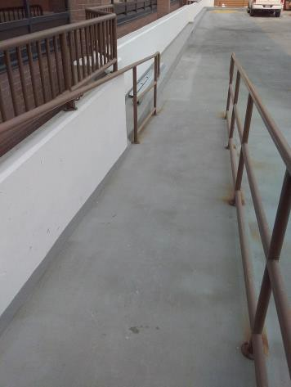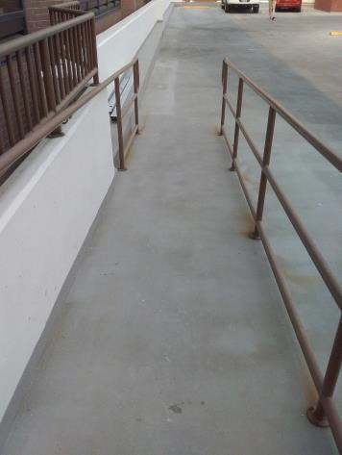

 | ID:  3856 | Facility:  City Hall

Location: 1st Floor Mail Hallway Women's Restroom
Schedule: 2022
Estimated Cost: $10,000.00

Priority Score 6
Quick Fix: No
Built before ADA: Yes

VIOLATIONS
2010 ADA Standards for Accessible Design Codes: §213.3.6
The showers are not accessible due to the 6" step at the entrance.

RECOMMENDATIONS
Reconstruct at least one accessible shower complying with §607 for a Bathtub or §608 for shower compartments.
Ensure that the change in level is a maximum of 1/4".

PHOTOGRAPH(S) OF THIS LOCATION

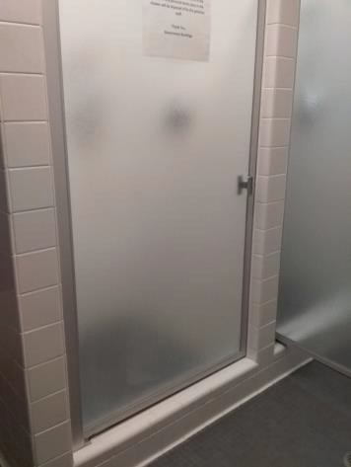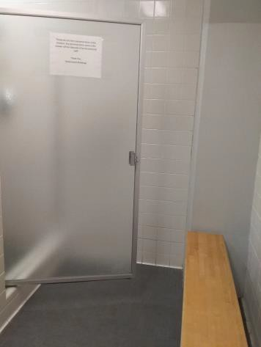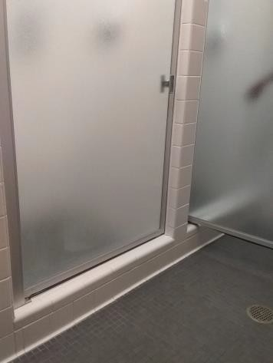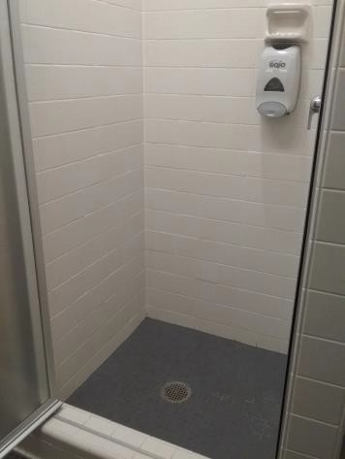

 | ID:  4356 | Facility:  City Hall

Location: Entire Facility
Schedule: 2021
Estimated Cost: $28,000.00

Priority Score 3
Quick Fix: No
Built before ADA: Yes

VIOLATIONS
2010 ADA Standards for Accessible Design Codes: §216.2, §703
There is no tactile sign identifying approximately 280 permanent rooms.

RECOMMENDATIONS
Install tactile signage on the latch side of the doorway at a height of 48” minimum to 60” maximum above the floor, identifying room by name or room number.
Signs shall be Braille with raised lettering and should be placed on the wall in the center of an 18"x18" clear floor space.

PHOTOGRAPH(S) OF THIS LOCATION

