City of Boise ADA Assessment

Appendix A –Boise Urban Garden School

12/30/2020
Report #TO21-B011

Prepared by:
 | ID:  1866 | Facility:  Boise Urban Garden School

Location: Accessible Garden Plot
Schedule: 2021
Estimated Cost: $500.00

Priority Score 5
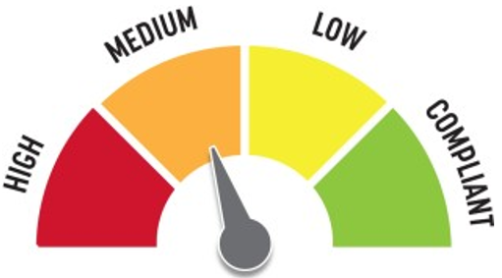
Quick Fix: Yes
Built before ADA: No

VIOLATIONS
2010 ADA Standards for Accessible Design Codes: §302.1, §305
There is not a firm, stable, and slip resistant route to the accessible garden plot. Currently, the plot has a 12.2% running slope.

RECOMMENDATIONS
Remove the excessive mulch and replace it with Engineered Wood Fiber so that the running and cross slopes do not exceed 2%.

PHOTOGRAPH(S) OF THIS LOCATION

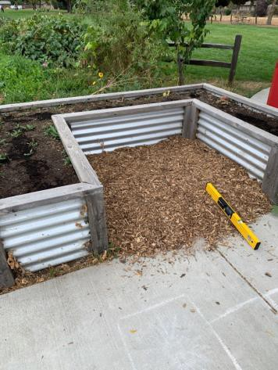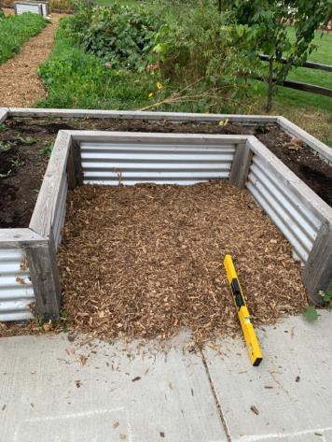

 | ID:  1850 | Facility:  Boise Urban Garden School

Location: Barn
Schedule: 2021
Estimated Cost: $100.00

Priority Score 3
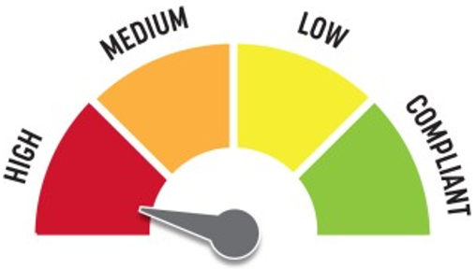
Quick Fix: Yes
Built before ADA: No

VIOLATIONS
2010 ADA Standards for Accessible Design Codes: §216.2, §703
There is no tactile sign identifying the permanent room.

RECOMMENDATIONS
Install tactile signage on the latch side of the doorway at a height of 48” minimum to 60” maximum above the floor, identifying room by name or room number.
Signs shall be Braille with raised lettering and should be placed on the wall in the center of an 18"x18" clear floor space.

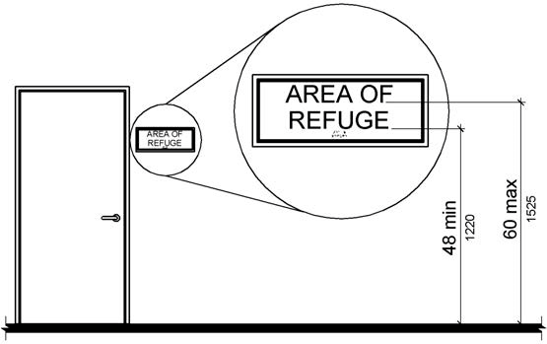

PHOTOGRAPH(S) OF THIS LOCATION

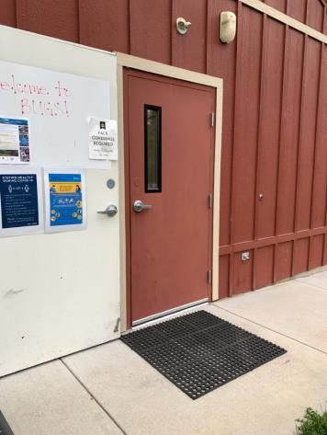

 | ID:  1870 | Facility:  Boise Urban Garden School

Location: Barn
Schedule: 2021
Estimated Cost: $100.00

Priority Score 5
Quick Fix: Yes
Built before ADA: No

VIOLATIONS
2010 ADA Standards for Accessible Design Codes: §403.5.1
Due to the foliage, there is not a clear 36" width for wheelchairs to pass.

RECOMMENDATIONS
Trim and continue to maintain the foliage as to keep it out of the accessible route.

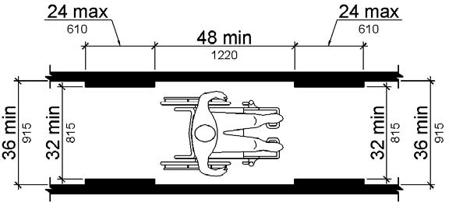

PHOTOGRAPH(S) OF THIS LOCATION

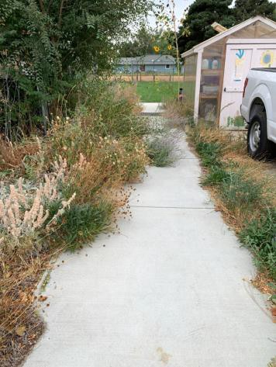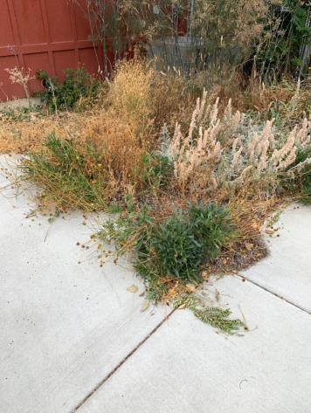

 | ID:  1873 | Facility:  Boise Urban Garden School

Location: Barn
Schedule: 2021
Estimated Cost: $100.00

Priority Score 3
Quick Fix: Yes
Built before ADA: No

VIOLATIONS
2010 ADA Standards for Accessible Design Codes: §216.2, §703
There is no tactile sign identifying the permanent room.

RECOMMENDATIONS
Install tactile signage on the latch side of the doorway at a height of 48” minimum to 60” maximum above the floor, identifying room by name or room number.
Signs shall be Braille with raised lettering and should be placed on the wall in the center of an 18"x18" clear floor space.

PHOTOGRAPH(S) OF THIS LOCATION

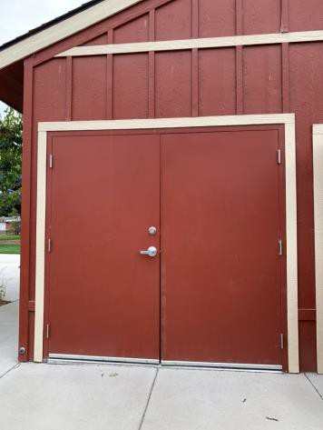

 | ID:  1878 | Facility:  Boise Urban Garden School

Location: Barn
Schedule: 2021
Estimated Cost: $100.00

Priority Score 8
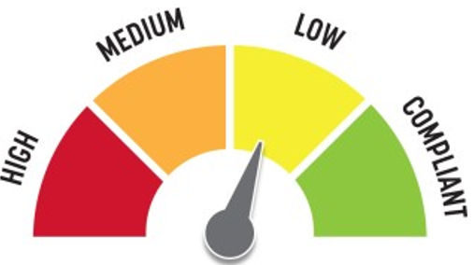
Quick Fix: Yes
Built before ADA: No

VIOLATIONS
2010 ADA Standards for Accessible Design Codes: §308.2.1
The hooks are outside of the unobstructed forward reach range at 50.5" above the floor.

RECOMMENDATIONS
Lower the hooks by 2.5" to meet the accessible reach range of 48" maximum above the floor.

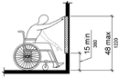

PHOTOGRAPH(S) OF THIS LOCATION

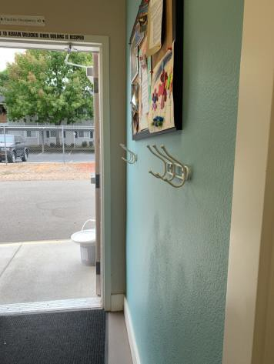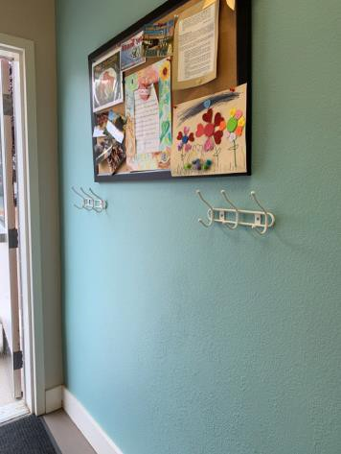

 | ID:  1888 | Facility:  Boise Urban Garden School

Location: Barn
Schedule: 2021
Estimated Cost: $100.00

Priority Score 5
Quick Fix: Yes
Built before ADA: No

VIOLATIONS
2010 ADA Standards for Accessible Design Codes: §307.2
The silver fire extinguisher protrudes 7" into the circulation space at 29.25" above the floor.

RECOMMENDATIONS
Recess the silver fire extinguisher so it protrudes a maximum of 4", lower it so the bottom edge is 27" maximum above the floor, or place a cane detectable object beneath it.

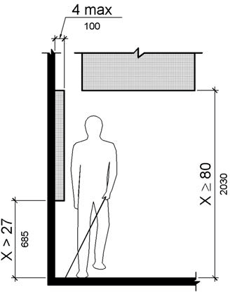

PHOTOGRAPH(S) OF THIS LOCATION

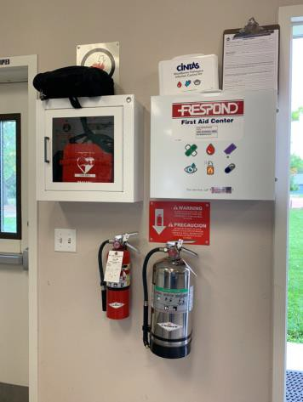

 | ID:  1889 | Facility:  Boise Urban Garden School

Location: Barn
Schedule: 2021
Estimated Cost: $100.00

Priority Score 5
Quick Fix: Yes
Built before ADA: No

VIOLATIONS
2010 ADA Standards for Accessible Design Codes: §307.2
The red fire extinguisher protrudes 4.25" into the circulation space at 33.5" above the floor.

RECOMMENDATIONS
Recess the red fire extinguisher so it protrudes a maximum of 4", lower it so the bottom edge is 27" maximum above the floor, or place a cane detectable object beneath it.

PHOTOGRAPH(S) OF THIS LOCATION

 | ID:  1890 | Facility:  Boise Urban Garden School

Location: Barn
Schedule: 2021
Estimated Cost: $100.00

Priority Score 5
Quick Fix: Yes
Built before ADA: No

VIOLATIONS
2010 ADA Standards for Accessible Design Codes: §308.2.1, §307.2
The first aid box protrudes 5.5" into the circulation space at 54.75" above the floor.
The first aid box is outside of the unobstructed forward reach range at 54.75" above the floor.

RECOMMENDATIONS
Recess the first aid box so it protrudes a maximum of 4", lower it so the bottom edge is 27" maximum above the floor, or place a cane detectable object beneath it.
Lower the first aid box by 6.75" to meet the accessible reach range of 15" minimum and 48" maximum above the floor.

PHOTOGRAPH(S) OF THIS LOCATION

 | ID:  1891 | Facility:  Boise Urban Garden School

Location: Barn
Schedule: 2021
Estimated Cost: $100.00

Priority Score 5
Quick Fix: Yes
Built before ADA: No

VIOLATIONS
2010 ADA Standards for Accessible Design Codes: §307.2, §308.2.1
The AED is outside of the unobstructed forward reach range at 54.25" above the floor. The AED protrudes 7" into the circulation space at 54.25" above the floor.

RECOMMENDATIONS
Lower the AED by 6.25" to meet the accessible reach range of 15" minimum and 48" maximum above the floor.
Recess the AED so it protrudes a maximum of 4", lower it so the bottom edge is 27" maximum above the floor, or place a cane detectable object beneath it.

PHOTOGRAPH(S) OF THIS LOCATION

 | ID:  1876 | Facility:  Boise Urban Garden School

Location: Barn
Schedule: 2023
Estimated Cost: $1,000.00

Priority Score 5
Quick Fix: No
Built before ADA: No

VIOLATIONS
2010 ADA Standards for Accessible Design Codes: §902.3, §306.3.3
There is no knee clearance underneath the sink.
The sink and work surface counter is 36" above the floor.

RECOMMENDATIONS
Provide knee clearance underneath the counter at the sink that is a minimum of 11" deep at 9" above the floor and 8" deep at 27" above the floor.
A 30" portion of the work surface must be no higher than 34” above the floor. Lower the sink to the maximum height of 34" above the floor.

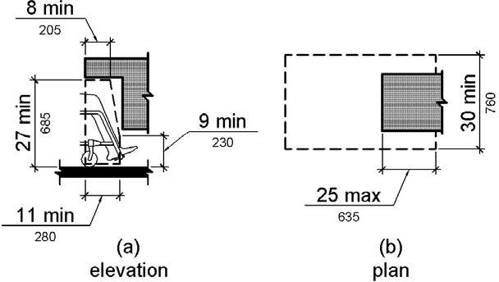

PHOTOGRAPH(S) OF THIS LOCATION

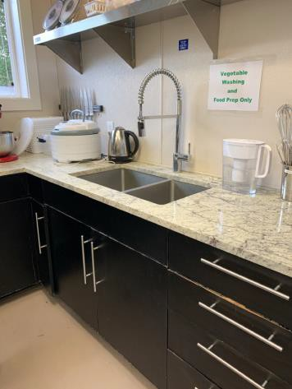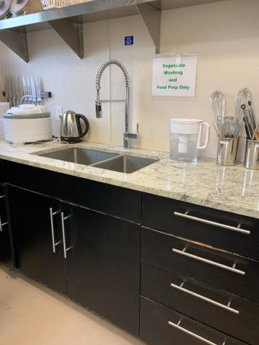

 | ID:  1874 | Facility:  Boise Urban Garden School

Location: Barn
Schedule: 2022
Estimated Cost: $1,000.00

Priority Score 5
Quick Fix: No
Built before ADA: No

VIOLATIONS
2010 ADA Standards for Accessible Design Codes: §606.3
The sink is 39" above the floor.

RECOMMENDATIONS
Lower the sink to a maximum height of 34" above the floor. Please note that this sink does not accommodate knee clearance. Consider adding another accessible sink nearby.

PHOTOGRAPH(S) OF THIS LOCATION

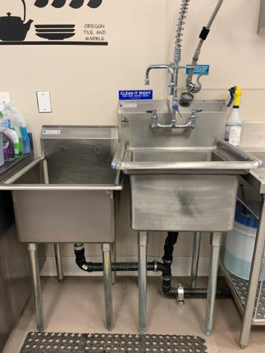

 | ID:  1893 | Facility:  Boise Urban Garden School

Location: Barn
Schedule: 2022
Estimated Cost: $1,000.00

Priority Score 6
Quick Fix: No
Built before ADA: No

VIOLATIONS
2010 ADA Standards for Accessible Design Codes: §602.4, §602.7
The spout heights of the drinking fountains are not compliant at 31.5" and 37" above the floor.

RECOMMENDATIONS
Raise the existing tall drinking fountain in order to comply with the 38" minimum to 43" maximum spout height above the floor.

PHOTOGRAPH(S) OF THIS LOCATION

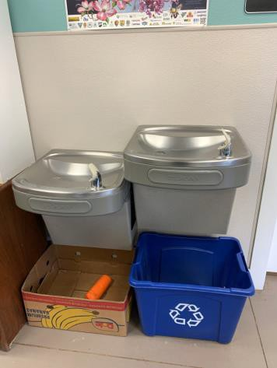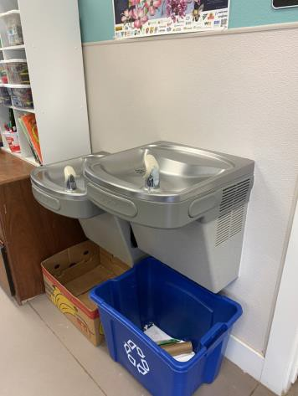

 | ID: | Facility:  Boise Urban Garden School

Location: Barn
Schedule: 2021
Estimated Cost: $1,000.00

Priority Score 3
Quick Fix: No
Built before ADA: No

VIOLATIONS
2010 ADA Standards for Accessible Design Codes: §403.3
The running slope is 8.5%.

RECOMMENDATIONS
Although this sidewalk follows the slope of the adjacent road, it would provide greater access if the slope were reduced.
Consider reconstructing this portion of the sidewalk to have a maximum running slope of 5%.

PHOTOGRAPH(S) OF THIS LOCATION

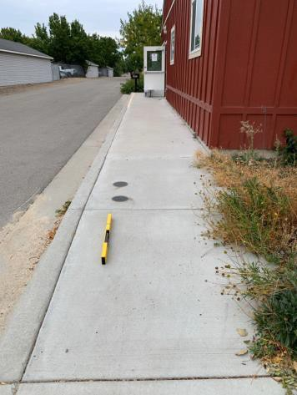

 | ID:  1872 | Facility:  Boise Urban Garden School

Location: Barn
Schedule: 2021
Estimated Cost: $2,000.00

Priority Score 3
Quick Fix: No
Built before ADA: No

VIOLATIONS
2010 ADA Standards for Accessible Design Codes: §404.2.4.1
There is not adequate maneuvering clearance to operate the door. The maneuvering clearance to operate the door has a 5.3% slope.

RECOMMENDATIONS
Reconstruct the sidewalk to ensure that the maneuvering clearance extends 24" to the latch side of the door and has a maximum slope of 2% in all directions.

PHOTOGRAPH(S) OF THIS LOCATION

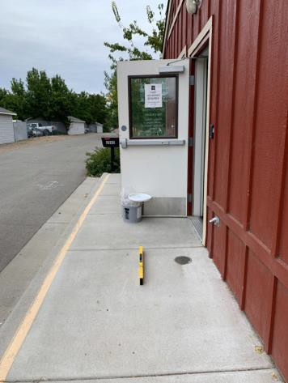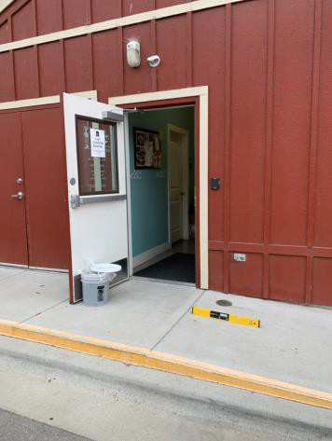

 | ID:  1849 | Facility:  Boise Urban Garden School

Location: Barn
Schedule: 2021
Estimated Cost: $2,500.00

Priority Score 3
Quick Fix: No
Built before ADA: No

VIOLATIONS
2010 ADA Standards for Accessible Design Codes: §403.3
The running slope is 5.8%.

RECOMMENDATIONS
Either reconstruct the sidewalk to have a maximum running slope of 5% or add handrails on either side.

PHOTOGRAPH(S) OF THIS LOCATION

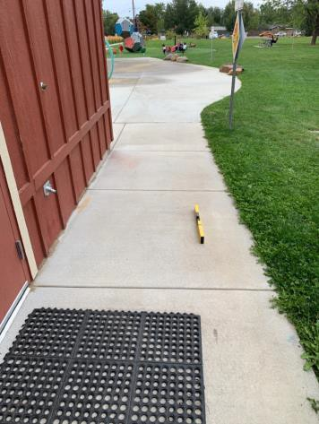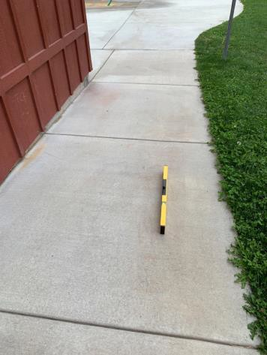

 | ID:  1855 | Facility:  Boise Urban Garden School

Location: Barn Parking
Schedule: 2021
Estimated Cost: $100.00

Priority Score 3
Quick Fix: Yes
Built before ADA: No

VIOLATIONS
2010 ADA Standards for Accessible Design Codes: §302.1
The weeds at the access aisle are causing a change in level posing a tripping hazard for users.

RECOMMENDATIONS
Remove the weeds.

PHOTOGRAPH(S) OF THIS LOCATION

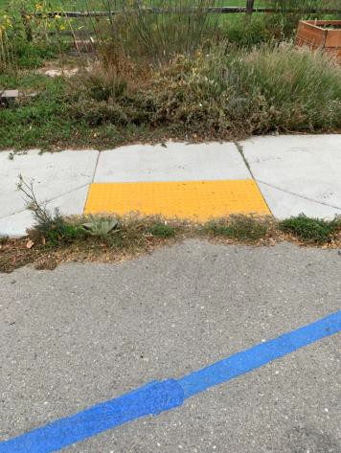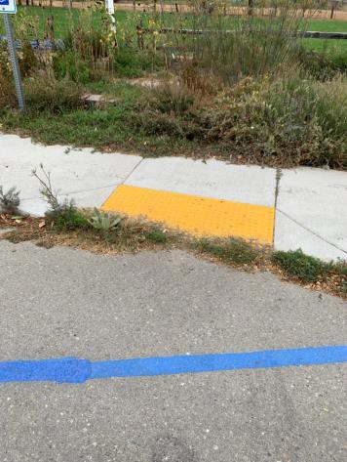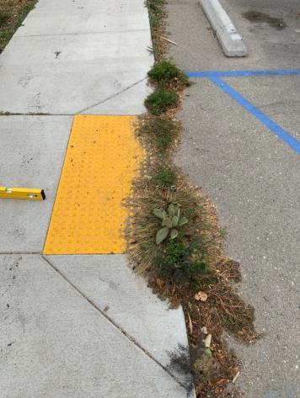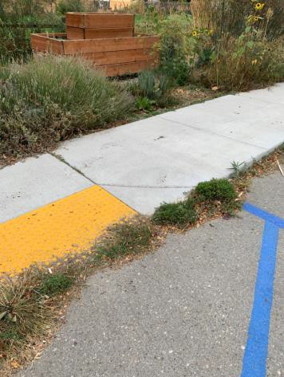

 | ID:  1857 | Facility:  Boise Urban Garden School

Location: Barn Parking
Schedule: 2021
Estimated Cost: $100.00

Priority Score 9
Quick Fix: Yes
Built before ADA: No

VIOLATIONS
2010 ADA Standards for Accessible Design Codes: §208.2.4
There are no marked "Van Accessible" spaces.

RECOMMENDATIONS
Add a “van accessible” parking sign at a minimum height of 60" above the ground.

PHOTOGRAPH(S) OF THIS LOCATION

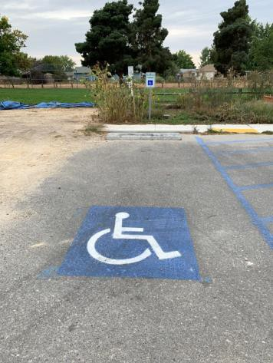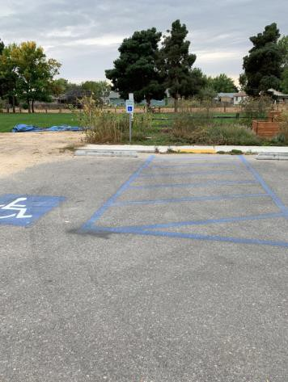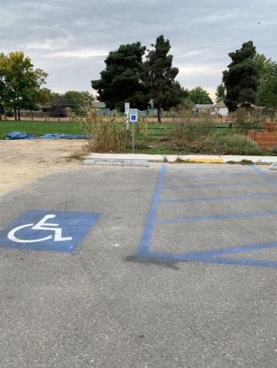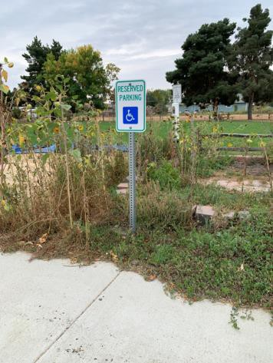

 | ID:  1860 | Facility:  Boise Urban Garden School

Location: Barn Parking
Schedule: 2021
Estimated Cost: $100.00

Priority Score 6
Quick Fix: Yes
Built before ADA: No

VIOLATIONS
2010 ADA Standards for Accessible Design Codes: §216.5
The parking sign identifying the accessible parking space does not meet the minimum height requirement of 60" from the ground at 43.5" above the ground.

RECOMMENDATIONS
Remount the accessible parking sign to ensure 60" minimum height from the ground.

PHOTOGRAPH(S) OF THIS LOCATION

 | ID:  1858 | Facility:  Boise Urban Garden School

Location: Barn Parking
Schedule: 2023
Estimated Cost: $1,000.00

Priority Score 9
Quick Fix: No
Built before ADA: No

VIOLATIONS
2010 ADA Standards for Accessible Design Codes: §502
There is no painted line on the left side of the accessible parking space.

RECOMMENDATIONS
Restripe the accessible parking space.

PHOTOGRAPH(S) OF THIS LOCATION

 | ID:  1853 | Facility:  Boise Urban Garden School

Location: Barn Parking
Schedule: 2021
Estimated Cost: $2,500.00

Priority Score 3
Quick Fix: No
Built before ADA: No

VIOLATIONS
2010 ADA Standards for Accessible Design Codes: §406.4, §406.3
The curb ramp flares have a 10.9% slope.
There is no landing provided at the top of the curb ramp.

RECOMMENDATIONS
Resurface the curb ramp flares to ensure a maximum slope of 10%. Create a parallel curb ramp to allow for a wheelchair user to turn within the ramp to go left or right out of the detectable warning area.

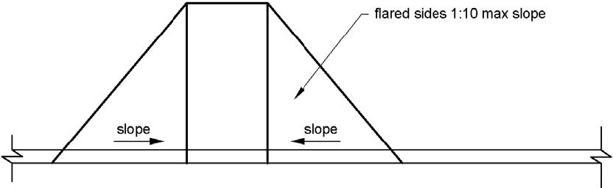

PHOTOGRAPH(S) OF THIS LOCATION

 | ID:  1883 | Facility:  Boise Urban Garden School

Location: Barn Restroom
Schedule: 2021
Estimated Cost: $100.00

Priority Score 7
Quick Fix: Yes
Built before ADA: No

VIOLATIONS
2010 ADA Standards for Accessible Design Codes: §606.5
The pipes under the sink are not covered.

RECOMMENDATIONS
Wrap the pipes beneath the sink with soft protective wrap or plastic.

PHOTOGRAPH(S) OF THIS LOCATION

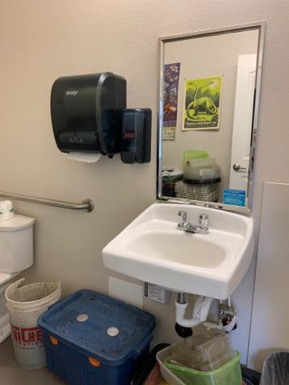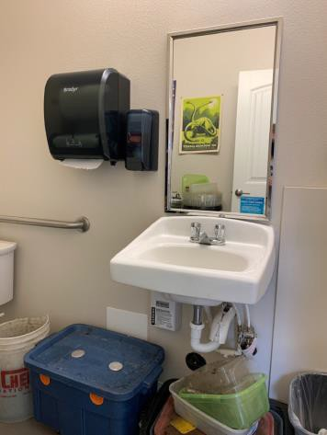

 | ID:  1885 | Facility:  Boise Urban Garden School

Location: Barn Restroom
Schedule: 2021
Estimated Cost: $100.00

Priority Score 8
Quick Fix: Yes
Built before ADA: No

VIOLATIONS
2010 ADA Standards for Accessible Design Codes: §308.2.1
The paper towel dispenser is outside of the unobstructed forward reach range at 49" above the floor.

RECOMMENDATIONS
Lower the paper towel dispenser by 1" to meet the accessible reach range of 48" maximum above the floor.

PHOTOGRAPH(S) OF THIS LOCATION

 | ID: | Facility:  Boise Urban Garden School

Location: Barn Restroom
Schedule: 2021
Estimated Cost: $100.00

Priority Score 5
Quick Fix: Yes
Built before ADA: No

VIOLATIONS
2010 ADA Standards for Accessible Design Codes: §604.3.1
The clearance around the water closet is less than 60"x56" when measured perpendicular from the side wall and rear wall due to the stored items.

RECOMMENDATIONS
Remove the boxes and other stored items from the restroom.

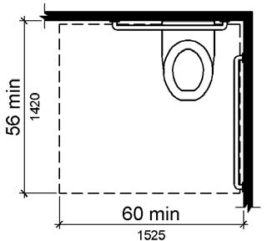

PHOTOGRAPH(S) OF THIS LOCATION

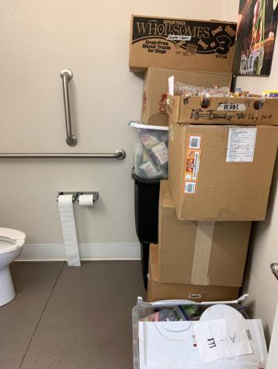

 | ID:  4473 | Facility:  Boise Urban Garden School

Location: Barn Restroom
Schedule: 2021
Estimated Cost: $100.00

Priority Score 5
Quick Fix: Yes
Built before ADA: No

VIOLATIONS
2010 ADA Standards for Accessible Design Codes: §604.3.1
The clearance around the water closet is less than 60"x56" when measured perpendicular from the side wall and rear wall due to the stored items.

RECOMMENDATIONS
Remove the stored items from the restroom.

PHOTOGRAPH(S) OF THIS LOCATION

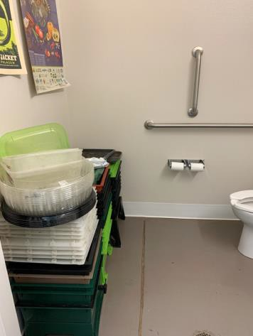

 | ID:  1884 | Facility:  Boise Urban Garden School

Location: Barn Restroom
Schedule: 2022
Estimated Cost: $1,000.00

Priority Score 5
Quick Fix: No
Built before ADA: No

VIOLATIONS
2010 ADA Standards for Accessible Design Codes: §606.3
The sink is 35" above the floor.

RECOMMENDATIONS
Lower the sink to a maximum height of 34" above the floor.

PHOTOGRAPH(S) OF THIS LOCATION

 | ID:  1901 | Facility:  Boise Urban Garden School

Location: Barn Restroom
Schedule: 2021
Estimated Cost: $1,000.00

Priority Score 3
Quick Fix: No
Built before ADA: No

VIOLATIONS
2010 ADA Standards for Accessible Design Codes: §305.2
The clear floor space by the drain has a 5.1% slope.

RECOMMENDATIONS
Resurface the 30"x48" clear floor space to have a maximum slope of 2% slope.

PHOTOGRAPH(S) OF THIS LOCATION

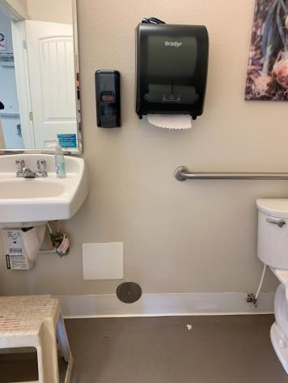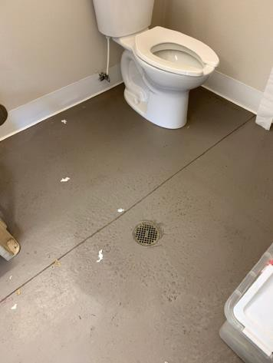

 | ID:  1869 | Facility:  Boise Urban Garden School

Location: Barn to Garden
Schedule: 2021
Estimated Cost: $10,000.00

Priority Score 3
Quick Fix: No
Built before ADA: No

VIOLATIONS
2010 ADA Standards for Accessible Design Codes: §302.1, §305
There is not a firm, stable, and slip resistant route to the garden from the barn.

RECOMMENDATIONS
Construct a firm, stable, and slip resistant accessible route with a maximum cross slope of 2% and maximum running slope of 5%.

PHOTOGRAPH(S) OF THIS LOCATION

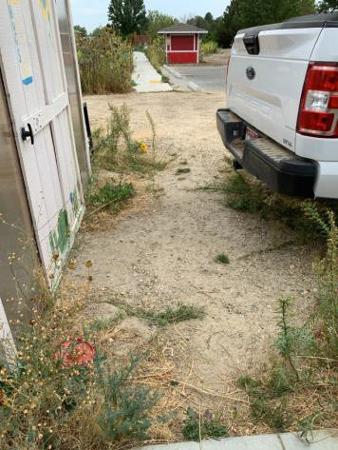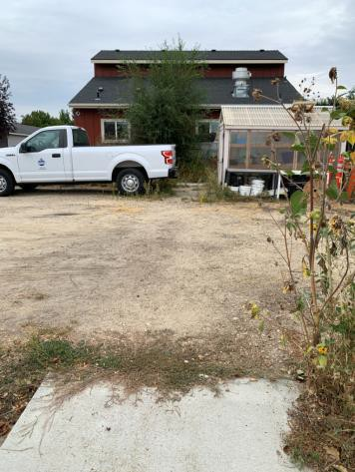

 | ID:  1892 | Facility:  Boise Urban Garden School

Location: Entire Facility
Schedule: 2021
Estimated Cost: $800.00

Priority Score 3
Quick Fix: Yes
Built before ADA: No

VIOLATIONS
2010 ADA Standards for Accessible Design Codes: §216.2, §703
There are no tactile signs identifying eight permanent rooms.

RECOMMENDATIONS
Install tactile signage on the latch side of the doorway at a height of 48” minimum to 60” maximum above the floor, identifying room by name or room number.
Signs shall be Braille with raised lettering and should be placed on the wall in the center of an 18"x18" clear floor space.

PHOTOGRAPH(S) OF THIS LOCATION

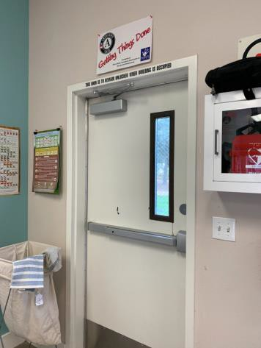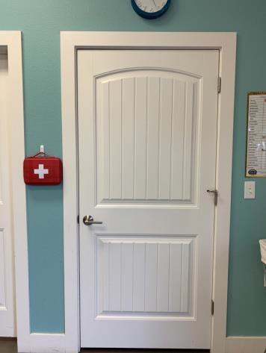

 | ID:  1851 | Facility:  Boise Urban Garden School

Location: Garden
Schedule: 2021
Estimated Cost: $5,000.00

Priority Score 3
Quick Fix: No
Built before ADA: No

VIOLATIONS
2010 ADA Standards for Accessible Design Codes: §302.1, §305
There is not a firm, stable, and slip resistant route to the green house.

RECOMMENDATIONS
Construct a firm, stable, and slip resistant accessible route with a maximum cross slope of 2% and maximum running slope of 5%.

PHOTOGRAPH(S) OF THIS LOCATION

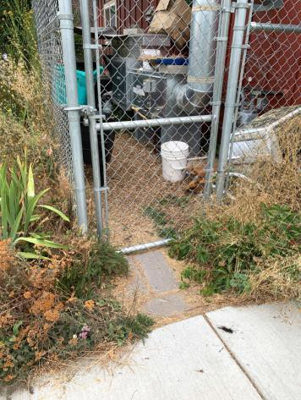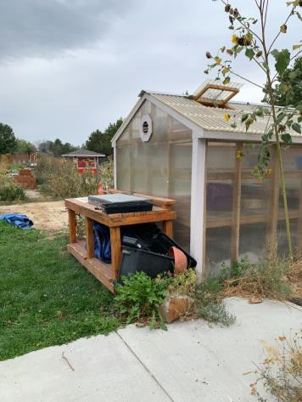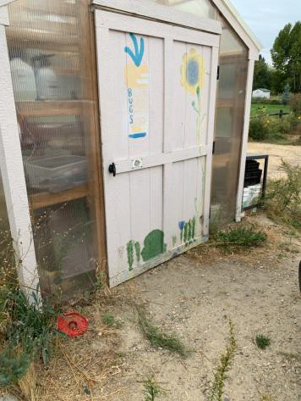

 | ID:  1863 | Facility:  Boise Urban Garden School

Location: Garden Barn
Schedule: 2021
Estimated Cost: $2,500.00

Priority Score 3
Quick Fix: No
Built before ADA: No

VIOLATIONS
2010 ADA Standards for Accessible Design Codes: §404.2.4.4
The barn entrance has an 8.3% slope.

RECOMMENDATIONS
Reconstruct the entryway to reduce the running slope to a maximum of 2% in all directions.

PHOTOGRAPH(S) OF THIS LOCATION

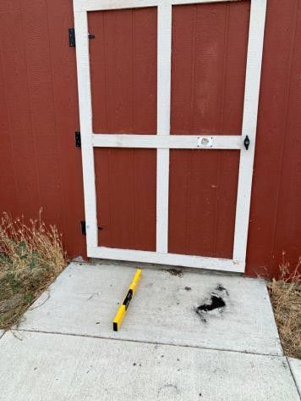

 | ID:  1852 | Facility:  Boise Urban Garden School

Location: Garden Barn
Schedule: 2021
Estimated Cost: $5,000.00

Priority Score 3
Quick Fix: No
Built before ADA: No

VIOLATIONS
2010 ADA Standards for Accessible Design Codes: §302.1, §305
There is not a firm, stable, and slip resistant route to the garden barn used by volunteers and staff.

RECOMMENDATIONS
Construct a firm, stable, and slip resistant accessible route with a maximum cross slope of 2% and maximum running slope of 5%. Or remove the excessive mulch and replace it with Engineered Wood Fiber so that the running and cross slopes do not exceed 2%.

PHOTOGRAPH(S) OF THIS LOCATION

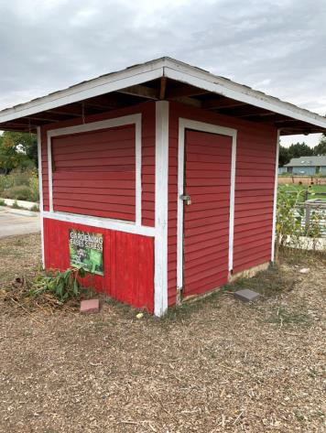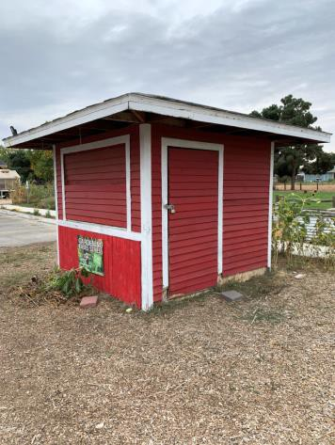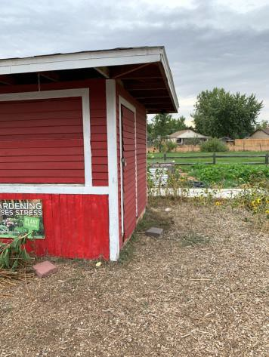

 | ID:  1862 | Facility:  Boise Urban Garden School

Location: Garden By the Bees
Schedule: 2021
Estimated Cost: $1,000.00

Priority Score 3
Quick Fix: No
Built before ADA: No

VIOLATIONS
2010 ADA Standards for Accessible Design Codes: §403.3
The cross slope is 2.4%.

RECOMMENDATIONS
Resurface the route to reduce the cross slope to a maximum of 2%.

PHOTOGRAPH(S) OF THIS LOCATION

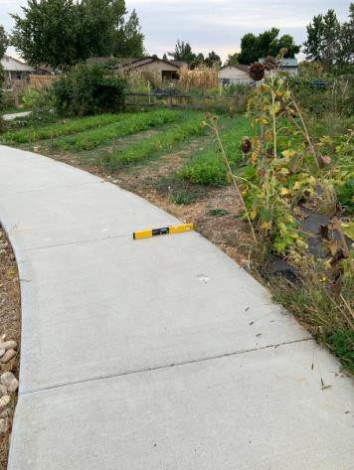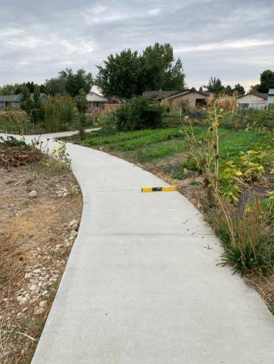

 | ID:  1861 | Facility:  Boise Urban Garden School

Location: Garden From Gazebo to Pollinators
Schedule: 2021
Estimated Cost: $2,500.00

Priority Score 3
Quick Fix: No
Built before ADA: No

VIOLATIONS
2010 ADA Standards for Accessible Design Codes: §403.3
The running slope of the route from the gazebo to the pollinators ranges from 5.5% to 6.3%.

RECOMMENDATIONS
Resurface the route to reduce the running slope to a maximum of 5%.

PHOTOGRAPH(S) OF THIS LOCATION

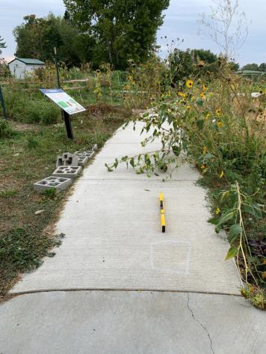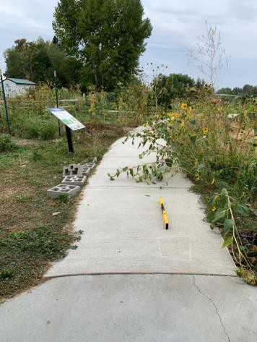

 | ID:  1868 | Facility:  Boise Urban Garden School

Location: Garden From Standing Plots To Barn
Schedule: 2021
Estimated Cost: $2,500.00

Priority Score 3
Quick Fix: No
Built before ADA: No

VIOLATIONS
2010 ADA Standards for Accessible Design Codes: §403.3
The cross slope is 4.5%.

RECOMMENDATIONS
Reconstruct the route to reduce the cross slope to a maximum of 2%.

PHOTOGRAPH(S) OF THIS LOCATION

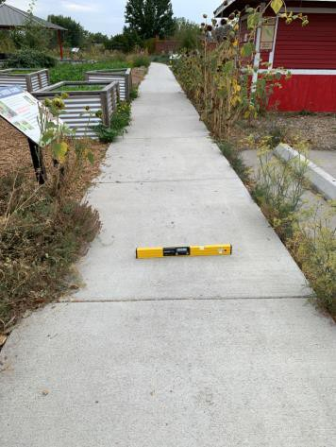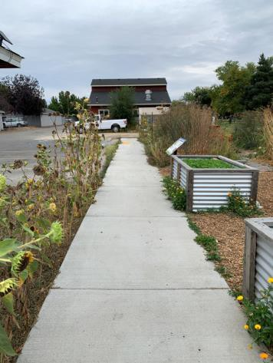

 | ID:  1864 | Facility:  Boise Urban Garden School

Location: Garden Next to Plant Cycle
Schedule: 2021
Estimated Cost: $1,000.00

Priority Score 3
Quick Fix: No
Built before ADA: No

VIOLATIONS
2010 ADA Standards for Accessible Design Codes: §403.3
The cross slope is 2.6%.

RECOMMENDATIONS
Resurface the route to reduce the cross slope to a maximum of 2%.

PHOTOGRAPH(S) OF THIS LOCATION

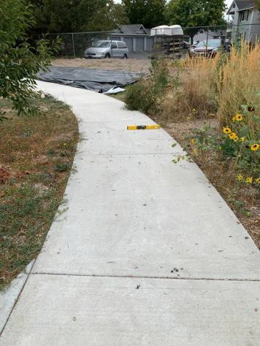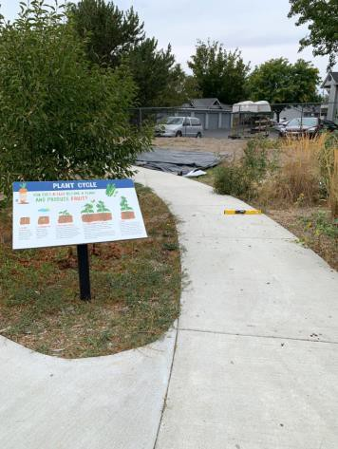

 | ID:  1865 | Facility:  Boise Urban Garden School

Location: Garden Picnic Table
Schedule: 2021
Estimated Cost: $1,000.00

Priority Score 3
Quick Fix: No
Built before ADA: No

VIOLATIONS
2010 ADA Standards for Accessible Design Codes: §226.1, §902, §305, §306
The provided picnic table does not have an accessible clear space for a wheelchair user.

RECOMMENDATIONS
Add/replace picnic tables so that at least 5% of the seating is wheelchair accessible.
Ensure that the wheelchair accessible seating has a clear floor space of 30" x 48" with a slope not steeper than 2% and that the tables have sufficient knee and toe clearance.

PHOTOGRAPH(S) OF THIS LOCATION

